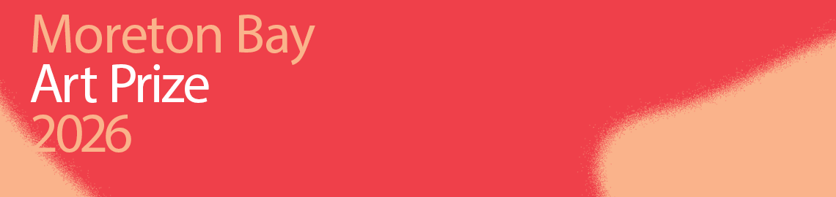
Frequently Asked Questions for submitting artworks into Moreton Bay Art Prize
To enter the Moreton Bay Art Prize, all applications must be submitted online via Council’s website.

This document aims to provide insight into the application form requirements for entrants. Please note that the information provided in your application forms the information provided to the selection panel. It is essential that you provide accurate and up-to-date information.

Key Dates:
Applications open: Monday 12 January 2026
Applications close: 11:59pm Saturday 11 April 2026
Shortlisted entrants notified: by 5pm Thursday 30 May 2026
Exhibition: Saturday 30 May – Saturday 18 July 2026
Awards Night: Saturday 11th July 2026, 6pm – 8pm
Artwork collection: Saturday 19 July 2026, 4:30pm – 6:30pm

Personal details
- Full name, postal address, postcode, and phone number.
- An active email address. All correspondence from Pine Rivers Art Gallery regarding your application will take place via email.
- You will need to confirm you are 18 years of age or over at time of application.
- Confirm that you live in City of Moreton Bay or if not, that you identify as Kabi Kabi, Turrbal or Jinibara and live in Australia.
- Confirm that you have read and agree to the terms and conditions.

Artwork details
Please note that in any year, the artist may enter ONE WORK to each exhibition opportunity. Artists may enter a separate artwork for consideration in the Outdoor Art Prize.
- The title of the artwork.
- The medium(s) of the artwork and year it was created (must be within the last 24 months).
- The main artform of the work. You can select from options: painting, drawing, printmaking, ceramics, sculpture, textile, new media, photography, other)
- For artworks created digitally (i.e. painting or illustration using Procreate or similar software) please include information about how the work will be printed, if applicable.
- The artwork dimensions in millimeters including any frame or external hanging elements. (Width x Height x Depth e.g. 450x1200x30 mm).
- Artist statement - a brief statement no more than 150 words about yourself and art practice.
- Artwork statement - a brief statement, no more than 150 words, about the artwork you are entering into the art prize.
- A photograph of your artwork in JPEG format. File must not exceed 4MB. Please see technical guidance specification below.
- For Outdoor Gallery applications - uploaded images should be formatted to fit banner print size 320cm x 100cm. Photographs that do not satisfy these specifications may need to be cropped to fit if selected.

Note: Please keep in mind that the details you include in your artist and artwork statements are crucial, as they will be used to create labels for your work if it is shortlisted for exhibition. Additionally, this information may be utilized for marketing purposes. We encourage you to provide as much relevant information as possible. For your convenience, we suggest drafting your statements in a Word document first, allowing you to easily check the word count before copying and pasting them into your online application.

How to measure your artwork
All artworks will be measured Height(cm) x Width(cm) x Depth(cm).
Artworks entered must be no larger than 300cm wide x 250cm high or occupy more than 3sq meters of floor space. If the work is to be wall mounted, it must weigh no more than 10kg.

Framed artworks (including stretched canvases) will be measured by their external edge to edge.

Tip: Prefabricated frames or store-bought frames are often sold at the 'window' size, i.e.: the size of the artwork they are framing, so ensure to check all external measurements of frames before purchase.

Photographing your work
The photograph you submit with your application will be used for the pre-selection process so it is important that the image is of good quality and reflects your artwork in an honest and true manner as no further opportunities will be given to amend these or submit an alternative image.
There are a number of photographers who specialize in art photography or websites with relevant information.

If you choose to photograph your work yourself, please refer to the tips below:
- Stand squarely in front of the artwork. Do not take photographs from an angle as it will distort the image. You may submit several photographs, so texture, details, or other elements you wish to highlight in your application can be captured in a separate photograph.
- Consider using a tripod or camera support to ensure a steady image.
- Make sure the artwork fills as much of the frame as possible. Avoid cluttered shots and stylised long-shots.
- Make sure the artwork is in focus with no blur or warping.
- Photograph your work against a neutral background to ensure the qualities of your work are captured without distraction. Avoid busy backgrounds, other artworks, or stylised backgrounds.
- Photograph your work in natural light, where possible. Avoid intense spotlights or flash photography. Be conscious of shadows and harsh lines.
- For works framed with glass, consider photographing your work without glass, to prevent unwanted reflection, shadows, or glare.

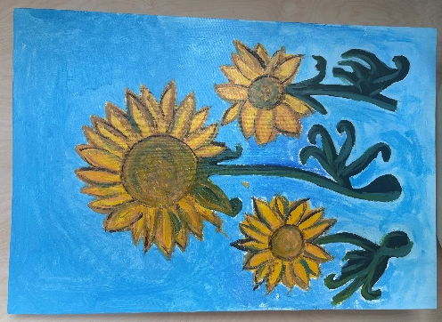
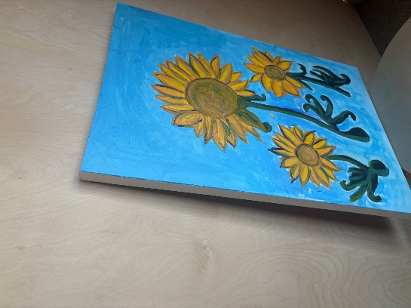
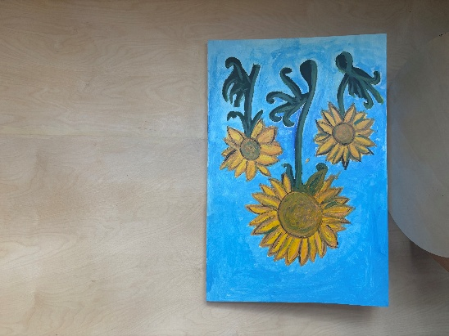
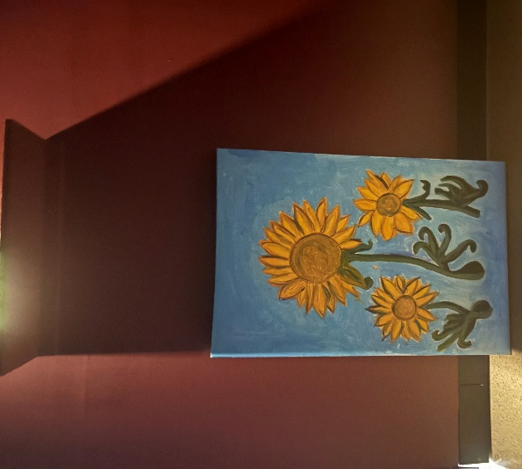
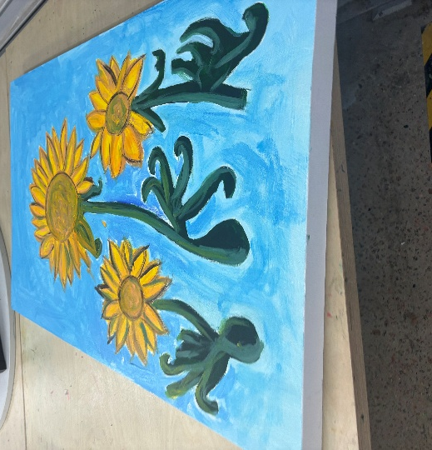
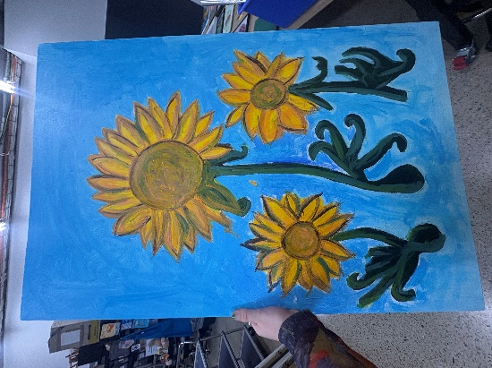
When photographing, make sure to include a wide range of images including close up photographs to emphasize certain detail or texture. For example, if your artwork was a painting, you could emphasize the texture and thickness of the brushstrokes you have made.
This image isn’t front-on to the artwork, is warped, and out of focus.
This image is front-on, in natural light, with a neutral background and is against a wall.
This is not the correct orientation of the artwork.
This image is too dark, and too far away from the artwork.
This image has been taken on an angle, with a wall-based artwork flat on a table and hasn’t included the full artwork.
This image is unstable, has a messy background and the artwork is held in a person’s hand.

Exhibition ready
All artworks shortlisted for exhibition in the Moreton Bay Art Prize must be exhibition ready.
If you have specific installation requirements, this information must be provided to the gallery in advance of delivery.
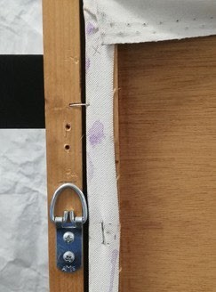
Correct placement, style, and orientation of a d-ring on a stretched canvas.
Work needs to arrive at the gallery ready to hang.

This includes framed works affixed with d-rings or appropriate fixtures on the back to hang, canvases able to be hung by their stretcher bars or works on paper that can be pinned through/have adhesive tabs affixed to them.

Preparing artworks for hanging
All wall-based artwork including works on paper, photography and digital painting or drawing, must be prepared for hanging. Please secure D-Ring hooks to each side of the frame or canvas, 8cm from the top of the work as shown. Wire is not required.

If your work is unframed, you must provide instruction for its installation to the gallery team in advance of delivery, to ensure it is suitable for the exhibition space.

Installation specifications for sculpture and/or multimedia artwork
The gallery has a limited selection of exhibition furniture and audio-visual equipment, which may or may not be available for your presentation. If your artwork requires specific furniture, such as a particular size of plinth or a shelf, or specialized equipment like a TV screen, speakers, headphones, or tested lighting, it is advisable to provide these items yourself, as the availability of specific equipment from the gallery cannot be guaranteed.

Please reach out to the Pine Rivers Art Gallery team if you require additional assistance or support.

Writing your artist statement
Your artist statement accompanies your work to tell the audience about its maker. Sometimes, this is also called an artist biography. It should describe:
- what you make and why you make it
- key contextual information about yourself as an artist or your creative practice
- any formal study you have participated in, professional experience, or mentoring.
- what medium you work in, or a genre of artmaking you identify with

i.e. Jane Smith is a painter and sculptor based in Margate, where she draws inspiration from the natural environment that surrounds her. With a keen eye for detail and a profound desire to understand her place within the world, Jane's practice reflects her journey to make sense of the complexities of life. She has exhibited extensively, including recent exhibitions at the Very Cool Art Gallery in 2020 and My Local Gallery in 2024, where her pieces have garnered positive attention for their thought-provoking themes and vibrant aesthetics. Jane holds a Bachelor of Arts in Fine Art and Curatorial Studies from the University of Queensland. In 2023, Smith received the Development Grant from the Arts Center for Encouraging Artists. Through her art, she invites viewers to reflect on their own connections to nature and the world, encouraging a deeper appreciation for the beauty and intricacies of life. (145 words)

Writing your artwork statement
- An explanation of your style, approach, philosophy, subject, and/or theme
- A statement of your intention through your work
- Insight into how this specific work relates to your broader artistic practice.

i.e. Self-portrait (2024) is a profound exploration of Jane Smith's intricate relationship with herself, delving deeply into themes of identity and connection. In this piece, Smith captures her own essence on canvas, portraying herself alongside a frangipani tree—a poignant symbol representing her mother. The frangipani, with its delicate blooms and lush foliage, serves as a reminder of the nurturing bond they share, and the memories rooted in her childhood. Through this work, Smith not only reflects on her relationship with her mother but also emphasizes the healing power of nature. As she immerses herself in the natural world, she discovers a sense of continuity and connection to her loved ones, even in their absence. The vibrant colors and thoughtful composition invite viewers to consider their own familial ties and the lasting impact of those relationships, showcasing how nature can serve as a bridge to our cherished memories and emotions.

Delivering your artwork
The delivery process and requirements are as follows:
- Visit Pine Rivers Art Gallery on the specified time and day to drop off your work.
- You must check in with Gallery Staff so we can confirm delivery and review your artwork label.
- All works must be labelled clearly on the back of each artwork with the ARTIST NAME and ARTWORK NAME.
- Ensure all framed works are ready to hang.
- Complete a brief delivery condition report with staff.
- We recommend a light layer of bubble left on your artwork for drop off, so they are safe at drop off and in storage. Please note: Staff will need to unwrap your work to confirm the condition it has arrived in.
- Name and label any packaging materials you would like to retain following the exhibition. This includes but is not limited to bubble wrap, crates, boxes, tubs, buckets, or bags.

Contact:
Pine Rivers Art Gallery
E: Pinerivers.gallery@moretonbay.qld.gov.au
Ph: 07 3480 3905
130 - 134 Gympie Road, Strathpine QLD, 4500.

Open Tuesday - Saturday, 10am - 4pm (Closed Sunday and Monday)
Please note that the Gallery team are contactable during business hours only.

