Table 7.2.3.7.1.1 - Reconfiguring a lot code - Urban living precinct
Performance outcomes | Examples that achieve aspects of the Performance Outcome | E Compliance  - Yes  - No see PO or  - NA | Justification for compliance
Where on a developable lot or creating developable lots
Lot size and design
PO1  Reconfiguring a lot does not result in additional lots. | No example provided.
Boundary realignment
PO2  Boundary realignments do not result in the:  - fragmentation or alienation of the land or result in the loss of land for future urban purposes;  - delay the use of the land for urban purposes;  - adverse impacts on the quality and integrity of the biodiversity and ecological values inherent to a High Value Area identified in Overlay map - Environmental areas;  - existing land uses on-site becoming non-compliant due to:  - lot size;  - parking requirements;  - servicing;  - dependant elements of an existing or approved land use being separately titled.  Note - An example may include but are not limited to where a Dwelling house⁽²²⁾ includes a secondary dwelling or associated outbuildings, they cannot be separately titled as they are dependent on the Dwelling house⁽²²⁾ use. | No example provided.
Where on a developed lot or creating developed lots
Site density
PO3  Reconfiguring of a lot achieves a net residential density between 11 - 30 lots per hectare to maintain a diverse medium density neighbourhood character.  Note - Future residential development on lots will be required to achieve a minimum net density of 30 dwellings per hectare when located within 400m walking distance of a local centre.  Note - Future residential development where not located within 400m walking distance of a local centre will be required to achieve a minimum net density of 20 dwellings per hectare. | E3  Development is in accordance with a Neighbourhood development plan.
Lot design, mix and location
PO4  Lots have a sufficient area and dimension for them to accommodate:  - dwelling(s) including all domestic outbuildings;  - areas for car parking, access and manoeuvring;  - areas for private open space. | E4.1  Lot sizes and dimensions (excluding any access handles) comply with Lot Types A, B, C, D, E or F in accordance with Table 7.2.3.7.1.3: Lot Types.  Note - For the purpose of rear lots, frontage is the average width of the lot (excluding any access handle or easement)
E4.2
Development is in accordance with a Neighbourhood development plan.
PO5  Reconfiguring a lot provides for a variety of housing options, by way of a mix of lot sizes and dimensions consistent with the medium density character of the precinct, whilst facilitating delivery of diversity within the streetscape. | E5.1  For reconfiguring a lot which creates in excess of 5 new lots, a mix of lot types in accordance with Table 7.2.3.7.1.3 are to be incorporated into the development as follows:  - 5 - 10 lots - 2 lot types  - 11 - 20 lots - 3 lot types  - 21 - 50 lots - 4 lot types (must include lot type A)  - >50 lots - 5 lot types (must include lot type A)  Editor's note - Lots containing built to boundary walls should also include an appropriate easement to facilitate the maintenance of any wall within 600mm of a boundary. For boundaries with built to boundary walls on adjacent lots a 'High Density Development Easement' is recommended; or for all other built to boundary walls and 'easement for maintenance purposes' is recommended.
E5.2
For reconfiguring a lot which creates in excess of 20 new lots, the following minimum percentages of lot types in accordance with Table 7.2.3.7.1.3 apply:
- Lot Type A - 10% of new lots and Lot Type F - 5% of new lots; or
- Lot Type A - 15% of new lots and Lot Type F - 2% of new lots; or
- Lot Type A - 15% of new lots and Lot Type B - 15% of new lots.

E5.3
Development is in accordance with a Neighbourhood development plan.
PO6  A range of different lots are distributed throughout the development with no one lot type concentrated within a single location, to create diversity within the streetscape and minimise conflicts between vehicle access and on street parking.  Note - Built to boundary walls and driveway locations for lots with frontages of 12.5 metres or less are to be shown on a plan of development in accordance with the requirements of section 9.3.1 - Dwelling house code. | E6.1  Where not accessed via a laneway, a maximum of 4 adjoining lots of the same type in accordance with Table 7.2.3.7.1.3 are proposed where fronting the same street.
E6.2
Where accessed via a laneway, a maximum of 8 adjoining lots of the same type in accordance with Table 7.2.3.7.1.3 are proposed where fronting the same street.

E6.3
Development is in accordance with a Neighbourhood development plan.
PO7  Lots that facilitate medium to high density residential uses (freehold or community titles) are located in proximity to recreational opportunities, commercial and community facilities and public transport nodes. | E7  - Development is in accordance with a Neighbourhood development plan.  OR  - Lots with frontages of 7.5 metres or less are located within 200 metres of:  - a park; or  - a public transport stop or station; or  - a higher order centre, district centre, local centre or neighbourhood hub (refer Overlay map - Community activities and neighbourhood hubs).  AND  - Lots with frontages of 32 metres or greater are predominately located on corner lots or lots with dual road frontages, and within 200 metres of:  - a park; or  - a public transport stop or station; or  - a higher order centre, district centre, local centre or neighbourhood hub (refer Overlay map - Community activities and neighbourhood hubs).
PO8  Narrow lots do not adversely affect the character and amenity of the precinct. Residential uses establish in a manner which facilitates an integrated streetscape, maximises the efficient use of land and achieves a safe and efficient street network.  Note - Built to boundary walls and driveway locations for lots with frontages of 12.5 metres or less are to be shown on a plan of development in accordance with the requirements of section 9.3.1 - Dwelling house code | E8  Development is in accordance with a Neighbourhood development plan.
PO9  Group construction and integrated streetscape solutions are encouraged through the location and grouping of lots suitable for terrace and row housing. | E9.1  Any lot sharing a boundary with a Lot Type A must contain a mandatory built to boundary wall on the shared boundary.
E9.2
Driveway crossovers for lots with frontages of less than 10m are paired up to facilitate on-street parking.
Note - Built to boundary walls for lots with frontages of 12.5 metres or less are to be shown on a plan of development in accordance with the requirements of section 9.3.1 - Dwelling house code.
E9.3
Development is in accordance with a Neighbourhood development plan.
Rear lots
PO10  Rear lots:  - contribute to the mix of lot sizes;  - are limited to 1 behind any full frontage lot (i.e. a lot with a street frontage that is not an access handle);  - Provide sufficient area for vehicles to manoeuvre on-site allowing entry and exit to the rear lot in forward gear. | E10  Development is in accordance with a Neighbourhood development plan.
PO11  Access handles for rear lots are:  - a minimum of 5m wide to allow for safe vehicle access and service corridors from the rear lot to the street;  - are located on 1 side of the full frontage lot;  - limited to no more than 2 directly adjoining each other. | E11  Development is in accordance with a Neighbourhood development plan.
Street design and layout
PO12  Development maintains, contributes to or provides for a street layout that facilitates regular and consistent shaped lots through the use of rectilinear grid patterns, or modified grid patterns where constrained by topographical and other physical barriers.  Note - Refer to Planning scheme policy - Neighbourhood design for guidance on how to achieve compliance with this outcome. | E12  Development is in accordance with a Neighbourhood development plan.
PO13  Development maintains, contributes to or provides for a street layout that is designed to connect to surrounding neighbourhoods, providing an interconnected street, pedestrian and cyclist network that connects nearby centres, neighbourhood hubs, community facilities, public transport nodes and open space to residential areas.  The layout ensures that new development is provided with multiple points of access. The timing of transport works ensures that multiple points of access are provided during early stages of a development.  Note - Refer to Planning scheme policy - Neighbourhood design for guidance on how to achieve compliance with this outcome. | E13  Development is in accordance with a Neighbourhood development plan.
PO14  Development maintains, contributes to or provides for a street layout that provides an efficient and legible movement network with high levels of connectivity within and external to the to the site by:  - facilitating increased active transport with a focus on safety and amenity for pedestrians and cyclists;  - providing street blocks with a maximum walkable perimeter of 500m (refer Figure - Street block design);  - providing a variety of street block sizes;  - reducing street block sizes as they approach an activity focus (e.g centre, neighbourhood hub, train station, community activity, public open space);  - facilitating possible future connections to adjoining sites for roads, green linkages and other essential infrastructure.  Note - Refer to Planning scheme policy - Neighbourhood design for guidance on how to achieve compliance with this outcome. | E14  Development is in accordance with a Neighbourhood development plan.
PO15  Street layouts create convenient and highly permeable movement networks between lower and higher order roads, whilst not adversely affecting the safety and function of the higher order road.  Note - Refer to Planning scheme policy - Neighbourhood design for guidance on how to achieve compliance with this outcome. | E15  Development is in accordance with a Neighbourhood development plan.
PO16  Streets are designed and constructed in accordance with Planning scheme policy - Integrated design and Planning scheme policy - Operational works inspection, maintenance and bonding procedures. The street design and construction accommodates the following functions:  - access to premises by providing convenient vehicular movement for residents between their homes and the major road network;  - safe and convenient pedestrian and cycle movement;  - adequate on street parking;  - stormwater drainage paths and treatment facilities;  - efficient public transport routes;  - utility services location;  - emergency access and waste collection;  - setting and approach (streetscape, landscaping and street furniture) for adjoining residences;  - expected traffic speeds and volumes; and  - wildlife movement (where relevant).  Note - Preliminary road design (including all services, street lighting, stormwater infrastructure, access locations, street trees and pedestrian network) may be required to demonstrate compliance with this PO.  Note - Refer to Planning scheme policy - Environmental areas and corridors for examples of when and where wildlife movement infrastructure is required. | E16  Development is in accordance with a Neighbourhood development plan.
PO17  The existing road network (whether trunk or non-trunk) is upgraded where necessary to cater for the impact from the development.  Note - An applicant may be required to submit an Integrated Transport Assessment (ITA), prepared in accordance with Planning scheme policy - Integrated transport assessment to demonstrate compliance with this PO, when any of the following occurs:  - Development is within 200m of a sensitive location such as a school, shopping centre, bus or train station or a large generator of pedestrian or vehicular traffic;  - Forecast traffic to/from the development exceeds 5% of the two way flow on the adjoining road or intersection in the morning or afternoon transport peak within 10 years of the development completion;  - Development access onto a sub arterial, or arterial road or within 100m of a signalised intersection;  - Residential development greater than 50 lots or dwellings;  - Offices greater than 4,000m² Gross Floor Area (GFA);  - Retail activities including Hardware and trade supplies, Showroom, Shop or Shopping centre greater than 1,000m² GFA;  - Warehouses and Industry greater than 6,000m² GFA;  - On-site carpark greater than 100 spaces;  - Development has a trip generation rate of 100 vehicles or more within the peak hour;  - Development which dissects or significantly impacts on an environmental area or an environmental corridor.  The ITA is to review the development’s impact upon the external road network for the period of 10 years from completion of the development. The ITA is to provide sufficient information for determining the impact and the type and extent of any ameliorative works required to cater for the additional traffic. The ITA must include a future structural road layout of adjoining properties that will form part of this catchment and road connecting to these properties. The ITA is to assess the ultimate developed catchment’s impacts and necessary ameliorative works, and the works or contribution required by the applicant as identified in the study.  Note - The road network is mapped on Overlay map - Road hierarchy.  Note - The primary and secondary active transport network is mapped on Overlay map - Active transport. | E17.1  New intersections onto existing roads are designed to accommodate traffic volumes and traffic movements taken from a date 10 years from the date of completion of the last stage of the development. Design is to be in accordance with Planning scheme policy - Integrated design.  Note - All turns vehicular access to existing lots is to be retained at new road intersections wherever practicable.  Note - Existing on-street parking is to be retained at new road intersections and along road frontages wherever practicable.
E17.2
Existing intersections external to the site are upgraded as necessary to accommodate increased traffic from the development. Design is in accordance with Planning scheme policy - Integrated design and Planning scheme policy - Operational works inspection, maintenance and bonding procedures.
Note - All turns vehicular access to existing lots is to be retained at upgraded road intersections wherever practicable.
Note - Existing on-street parking is to be retained at upgraded road intersections and along road frontages wherever practicable.
E17.3
The active transport network is extended in accordance with Planning scheme policy - Integrated design.

PO18  New intersections along all streets and roads are located and designed to provide safe and convenient movements for all users.  Note - Refer Planning scheme policy - Integrated design and Planning scheme policy - Operational works inspection, maintenance and bonding procedures for design and construction standards.  Note - An Integrated Transport Assessment (ITA) including preliminary intersection designs, prepared in accordance with Planning scheme policy - Integrated transport assessment may be required to demonstrate compliance with this PO. Intersection spacing will be determined based on the deceleration and queue storage distances required for the intersection after considering vehicle speed and present/forecast turning and through volumes. | E18.1  Development is in accordance with a Neighbourhood development plan.
E18.2
New intersection spacing (centreline – centreline) along a through road conforms with the following:
- where the through road provides an access or residential street function:
  - intersecting road located on same side = 60 metres; or
  - intersection road located on opposite side = 40 metres.
- where the through road provides a local collector or district collector function:
  - intersecting road located on same side = 100 metres; or
  - intersecting road located on opposite side = 60 metres.
- where the through road provides a sub-arterial function:
  - intersecting road located on same side = 250 metres; or
  - intersecting road located on opposite side = 100 metres.
- where the through road provides an arterial function:
  - intersecting road located on same side = 350 metres; or
  - intersecting road located on opposite side = 150 metres.
- walkable block perimeter does not exceed 500 metres.
Note - Based on the absolute minimum intersection spacing identified above, all turns access may not be permitted (ie. left in/left out only) at intersections with sub-arterial roads or arterial roads.
Note - The road network is mapped on Overlay map - Road hierarchy.
Note - An Integrated Transport Assessment (ITA) including preliminary intersection designs, prepared in accordance with Planning scheme policy - Integrated transport assessment may be required to demonstrate compliance with this PO.
PO19  All Council controlled frontage roads adjoining the development are designed and constructed in accordance with Planning scheme policy - Integrated design and Planning scheme policy - Operational works inspection, maintenance and bonding procedure. All new works are extended to join any existing works within 20m.  Note - Frontage roads include streets where no direct lot access is provided.  Note - The road network is mapped on Overlay map - Road hierarchy.  Note - The Primary and Secondary active transport network is mapped on Overlay map - Active transport.  Note - Roads are considered to be constructed in accordance with Council’s standards when there is sufficient pavement width, geometry and depth to comply with the requirements of Planning scheme policy - Integrated design and Planning scheme policy - Operational works inspection, maintenance and bonding procedures. | E19  Design and construct all Council controlled frontage roads in accordance with Planning scheme policy - Integrated design, Planning scheme policy - Operational works inspection, maintenance and bonding procedures and the following:  Situation Minimum construction  Frontage road unconstructed or gravel road only; OR Frontage road sealed but not constructed* to Planning scheme policy - Integrated design standard; OR Frontage road partially constructed* to Planning scheme policy - Integrated design standard. Construct the verge adjoining the development and the carriageway (including development side kerb and channel) to a minimum sealed width containing near side parking lane (if required), cycle lane (if required), 2 travel lanes plus 1.5m wide (full depth pavement) gravel shoulder and table drainage to the opposite side. The minimum total travel lane width is: - 6m for minor roads; - 7m for major roads.  Note - Major roads are sub-arterial roads and arterial roads. Minor roads are roads that are not major roads.  Note - Construction includes all associated works (services, street lighting and linemarking).  Note - Alignment within road reserves is to be agreed with Council.  Note - *Roads are considered to be constructed in accordance with Council standards when there is sufficient pavement width, geometry and depth to comply with the requirements of Planning scheme policy - Integrated design and Planning scheme policy - Operational works inspection, maintenance and bonding procedures. Testing of the existing pavement may be required to confirm whether the existing works meet the standards in Planning scheme policy - Integrated design and Planning scheme policy - Operational works inspection, maintenance and bonding procedures.
PO20  Sealed and flood free road access during the minor storm event is available to the site from the nearest arterial or sub-arterial road.  Editor's note - Where associated with a State-controlled road, further requirements may apply, and approvals may be required from the Department of Transport and Main Roads. | E20  Roads or streets giving access to the development from the nearest arterial or sub-arterial road are flood free during the minor storm event and are sealed.  Note - The road network is mapped on Overlay map - Road hierarchy.
PO21  Roads which provide access to the site from an arterial or sub-arterial road remain trafficable during major storm events without flooding or impacting upon residential properties or other premises. | E21.1  Access roads to the development have sufficient longitudinal and cross drainage to remain safely trafficable during major storm (1% AEP) events.  Note - The road network is mapped on Overlay map - Road hierarchy.  Note - Refer to QUDM for requirements regarding trafficability.
E21.2
Culverts and causeways do not increase inundation levels or increase velocities, for all events up to the defined flood event, to upstream or downstream properties.
PO22  Cul-de-sac or dead end streets are not proposed unless:  - topography or other physical barriers exist to the continuance of the street network or vehicle connection to an existing road is not permitted;  - there are no appropriate alternative solutions;  - the cul-de-sac or dead end street will facilitate future connections to adjoining land or development.  Note - Refer to Planning scheme policy - Integrated design for guidance on how to achieve compliance with this outcome. | E22  Development is in accordance with a Neighbourhood development plan.
PO23  Where cul-de-sacs are proposed due to connection to existing roads not being permitted, they are to be designed to allow a 10m wide pedestrian connection through to the existing road with no lots proposed at the head of the cul-de-sac generally as shown in the figure below.  Figure - Cul-de-sac design  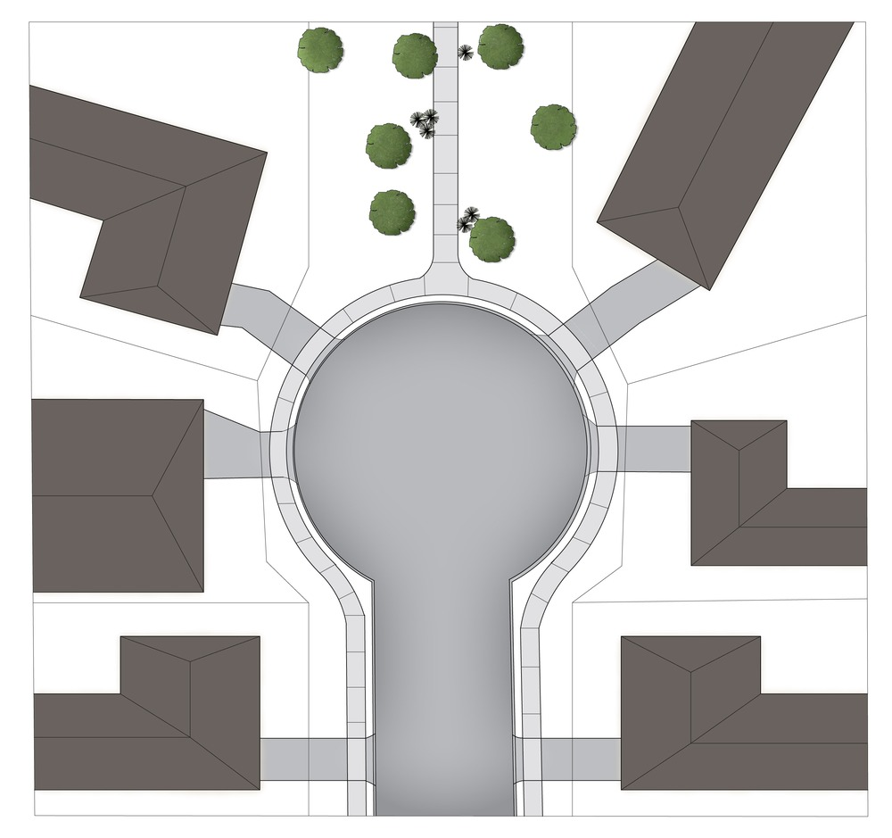  Note - Refer to Planning scheme policy - Neighbourhood design for guidance on how to achieve this outcome. | E23  Development is in accordance with a Neighbourhood development plan.
PO24  Streets are designed and oriented to minimise the impact of cut and fill on the amenity of the streetscape and adjoining development. | E24  - Development is in accordance with a Neighbourhood development plan.  OR  - Street alignment follows ridges or gullies or runs perpendicular to slope.
PO25  Streets are oriented to encourage active transport through a climate responsive and comfortable walking environment whilst also facilitating lots that support subtropical design practices, including:  - controlled solar access & shade provision;  - cross-ventilation.  Note - Refer to Planning scheme policy - Residential design for guidance on how to achieve subtropical design solution. | E25.1  - Development is in accordance with a Neighbourhood development plan.  OR  - Where not unduly constrained by topography or other physical barrier, streets are primarily oriented within 20 or 30 degrees of North-South or East-West in accordance with Figure - Preferred street orientation below.  Figure - Preferred street orientation  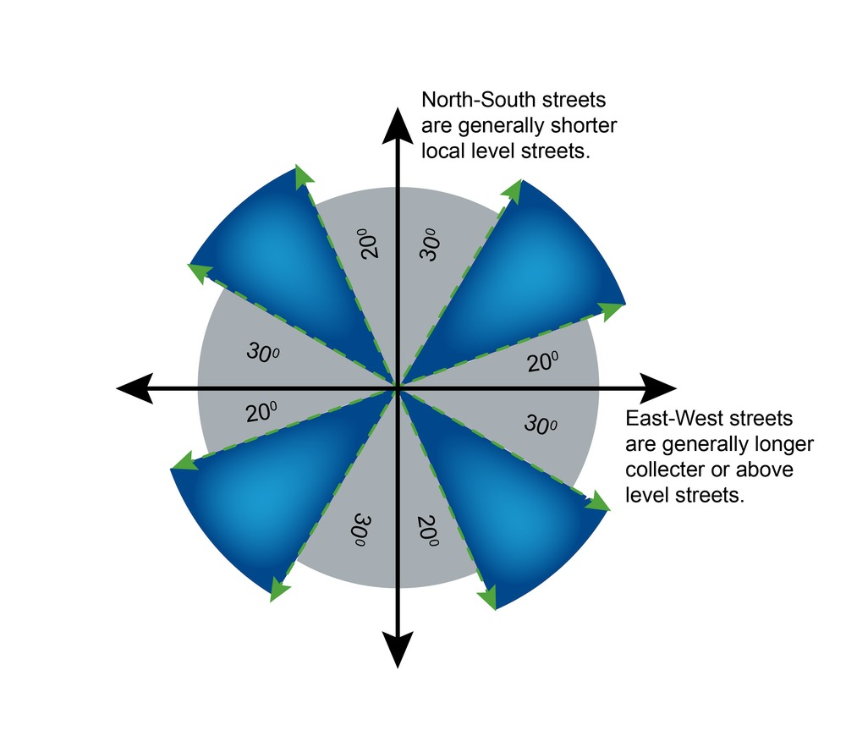
E25.2
- Development is in accordance with a Neighbourhood development plan.
OR
- The long axis of a street block is oriented east-west to facilitate a north-south orientation for a majority of lots as per Figure - Street block design below.

E25.3
- Development is in accordance with a Neighbourhood development plan.
OR
- Where the long axis of lot boundaries are oriented east west, they are 16m or wider so as to allow for alternative dwelling design to achieve solar access and cross-ventilation as per Figure -Street block design below.

Figure - Street block design
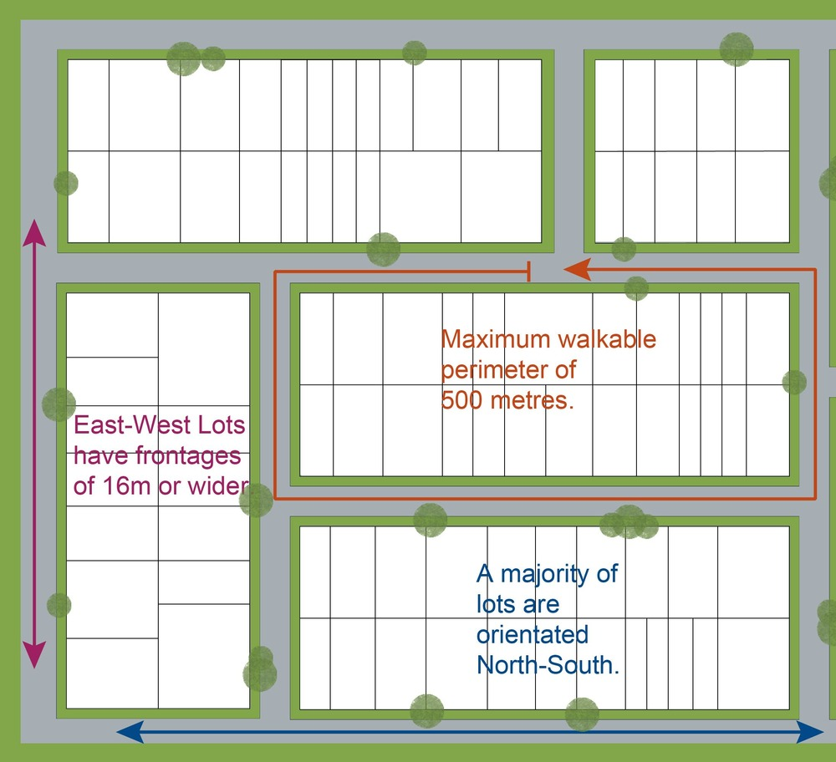
PO26  The street network creates convenient access to major streets roads for heavy vehicles and commercial traffic without introducing through traffic to residential streets. The street network is designed in accordance with a Neighbourhood development plan that reflects the urban structure concept shown indicatively on Figure 7.2.3.2 - Movement, Major streets. | E26  Development is in accordance with a Neighbourhood development plan.
PO27  The road network has sufficient reserve and pavement widths to cater for the current and intended function of the road in accordance with the road type in accordance with Planning scheme policy - Integrated design. | E27  Development is in accordance with a Neighbourhood development plan.
PO28  The street networks encourage walking and cycling and a safe environment for pedestrians and cyclists. The street network is designed in accordance with a Neighbourhood development plan that reflects the urban structure concept shown indicatively on Figure 7.2.3.3 - Movement, walking and cycling. | E28  Development is in accordance with a Neighbourhood development plan.
Laneway design and location
PO29  Laneway location contributes to a high standard of amenity for adjoining lots and the primary streetscape.  Note - Refer to Planning scheme policy - Neighbourhood design for determining locational criteria for laneways. | E29  - Development is in accordance with a Neighbourhood development plan.  OR  - Laneways are primarily used where:  - vehicle access is not permitted from the primary street frontage; or  - limiting vehicle access from the primary street frontage results in a positive streetscape outcome;or  - where lots directly adjoin a local, district or regional Park⁽⁵⁷⁾.
PO30  Laneways service a limited number of allotments, creating a sense of place and enclosed feeling for the pedestrian environment whilst contributing to the high level of connectivity of the street network  Note - Refer to Planning scheme policy - Integrated design and Planning scheme policy - Neighbourhood design for determining design criteria for Laneways. | E30  - Development is in accordance with a Neighbourhood development plan.  OR  - Laneways are limited to 130m in length; and  - Laneways are not designed as dead ends or cul-de-sacs, and are to have vehicle connections to an access street at both ends; and  - Where laneways exceed 100m in length, a 7m wide mid lane pedestrian connection is to be provided between the adjacent access streets and the laneway.
PO31  Laneway lots adjoining a park have a dedicated pathway as road reserve along the park frontage of the lots to contain all services and a concrete path. | E31  Dedicate a minimum 2.5m as road reserve along the park frontage of the lots to contain all services and a 2.0m wide concrete path.  Note - Electrical, water and sewerage services are not to be located in the laneway. Electrical services that are necessary to provide street lighting in accordance with the relevant Australian Standard may be located in the laneway.
PO32  Laneway design ensures the safety of pedestrians, cyclists and motorists by way of site lines, and sufficient road reserve for vehicle movements and the provision of street lighting.  Note - Refer to Planning scheme policy - Integrated design and Planning scheme policy - Neighbourhood design for determining design criteria for Laneways. | E32  - Development is in accordance with a Neighbourhood development plan.  OR  - Laneways are designed with minor meanders only, and maintain direct lines of sight from one end of the laneway to the other; and  - Laneways provide road dedication at strategic locations along the laneway to allow the construction of street lighting and any electrical pillars associated with the street lighting in accordance with current Australian Standards.  Note - The dedication must allow for street lights to be provided on Council’s standard alignment
Park and open space
PO33  A hierarchy of Park⁽⁵⁷⁾ and open space is provided to meet the recreational needs of the community in accordance with a Neighbourhood development plan that reflects the urban structure concept shown indicatively on Figure 7.2.3.4 - Green network and open space.  Note - District level parks or larger may be required in certain locations in accordance with Part 4: Local Government Infrastructure Plan. | E33  Development is in accordance with a Neighbourhood development plan.
PO34  Park⁽⁵⁷⁾ are provided within walking distance of all new residential lots as follows:  - district parks are provided within 15 minutes walking distance time of houses;  - local and neighbourhood parks are provided within 5 minutes walking distance time. | E34  Development is in accordance with a Neighbourhood development plan.
PO35  Park⁽⁵⁷⁾ is of a size and design standard to meet the needs of the expected users. Parks⁽⁵⁷⁾ are provided as per the following table and seek to:  - retain stands of trees in Parks⁽⁵⁷⁾ – for environmental ‘stepping stones’ and for urban relief;  - locate on hilltops, gullies, river banks and between neighbourhoods.  Open space type Minimum area Walking catchment Rate  Small local park⁽⁵⁷⁾ recreation 0.3 ha - 0.5 ha 150-300m 0.5ha/1000 persons  Local park⁽⁵⁷⁾ recreation 0.5 ha - 1ha 400m  District park⁽⁵⁷⁾ recreation 4 ha 1.2km 0.5 ha/1000 persons  District Civic park⁽⁵⁷⁾ (town centre only) 3000m² n/a n/a – only 1 needed in the town centre  Regional/District sports* 4 parks add up to 80ha n/a 4 parks @ 80ha each  * Regional and district parks have been identified on the Figure 7.2.3.4 - Green network and open space. | E35  Development is in accordance with a Neighbourhood development plan.
PO36  The safety and useability of parks is ensured through the careful design of the street network and lot locations which provide high levels of surveillance and access into the park⁽⁵⁷⁾ or open space area. The provision of parks will consider the following:  - local and district parks are bordered by streets and not lots wherever possible;  - where lots do addresses local and district parks⁽⁵⁷⁾, fencing is provided along the park⁽⁵⁷⁾ boundary at a maximum height of 1m prior to the sealing of the plan of subdivision;  - the design of fencing and retaining features allows for safe and direct pedestrian access between the park⁽⁵⁷⁾ and private allotment through the use of private gates and limited retaining features along park⁽⁵⁷⁾ boundaries. | E36  Development is in accordance with a Neighbourhood development plan.
Sloping Land
PO37  Lot layout and design avoids the impacts of cutting, filling and retaining walls on the visual and physical amenity of the streetscape, each lot created and of adjoining lots ensuring, but not limited to, the following:  - the likely location of private open space associated with a Dwelling House on each lot will not be dominated by, or encroached into by built form outcomes such as walls or fences;  - walls and/or fences are kept to a human scale and do not represent barriers to local environmental outcomes and conditions such as good solar access to prevailing breezes; and  - the potential for overlooking from public land into private lots is avoided wherever possible; and  - lot design is integrated with the opportunities available for Dwelling House design to reduce impacts  Note - Refer to Planning scheme policy - Residential design for guidelines on building design on sloped land. | E37.1  Lot layout and design ensures that a lot has a maximum average slope of 1:15 along its long axis and 1:10 along its short axis.
E37.2
Retaining walls and benching and associated cutting, filling and other earthworks associated with reconfiguring a lot are limited to:
- a maximum vertical dimension of 1.5m from natural ground for any single retaining structure; or
- where incorporating a retaining structure greater than 1.5m in height, the retaining wall is stepped, terraced and landscaped as follows:
  - maximum 1m vertical, minimum 0.5m horizontal, maximum 2m vertical (refer figure below);
  - maximum overall structure height of 3m; or

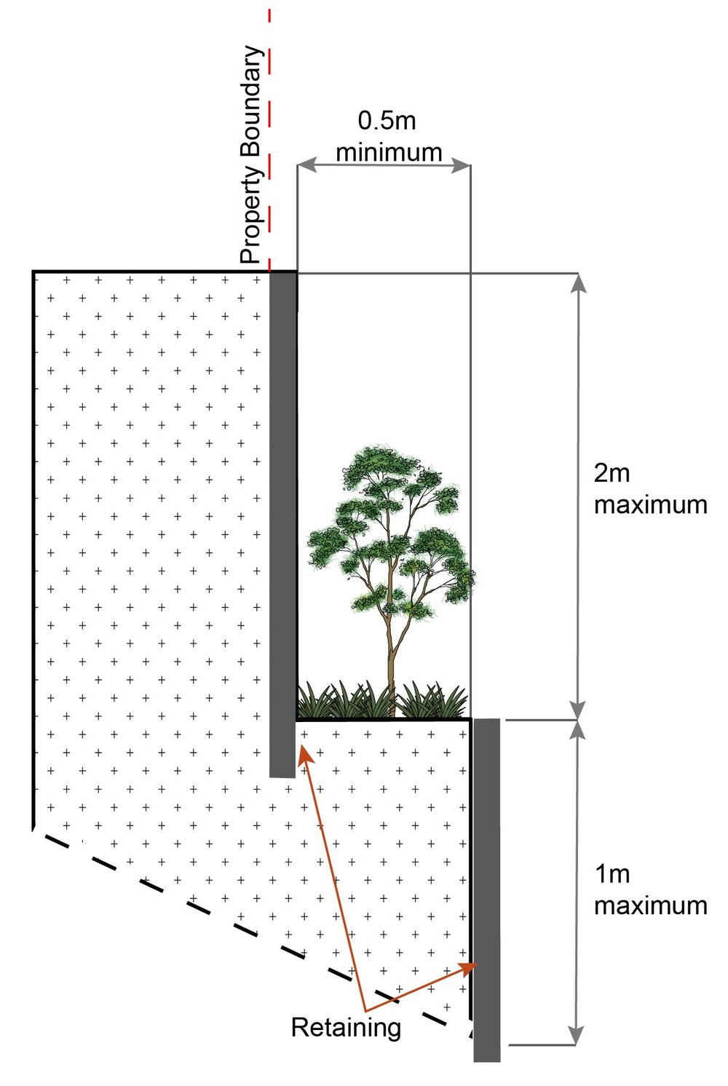
- where incorporating benching along the short axis (from side to side boundary) of a lot:
- the difference between levels at each boundary is no greater than 4m per lot;
- each bench has a maximum height of 2m (refer figure below); or

- where incorporating benching along the long axis (from front to rear boundary):
- each bench has a maximum height of 2m;
- lots orientate up/down the slope.
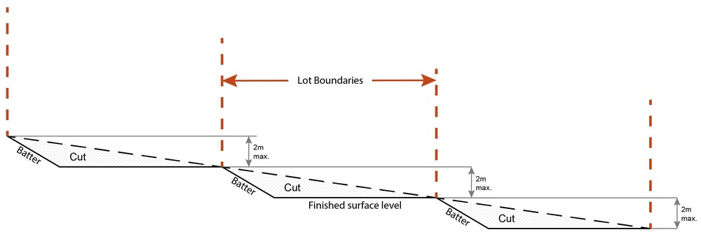
Note - Benching is to incorporate suitable measures to ensure stabilisation and prevent erosion.
Editor's note - Strict cut and fill requirements apply at the (22) stage. Deferral of slope solutions until building stage is not an acceptable outcome.
Figure - Sloped lot design
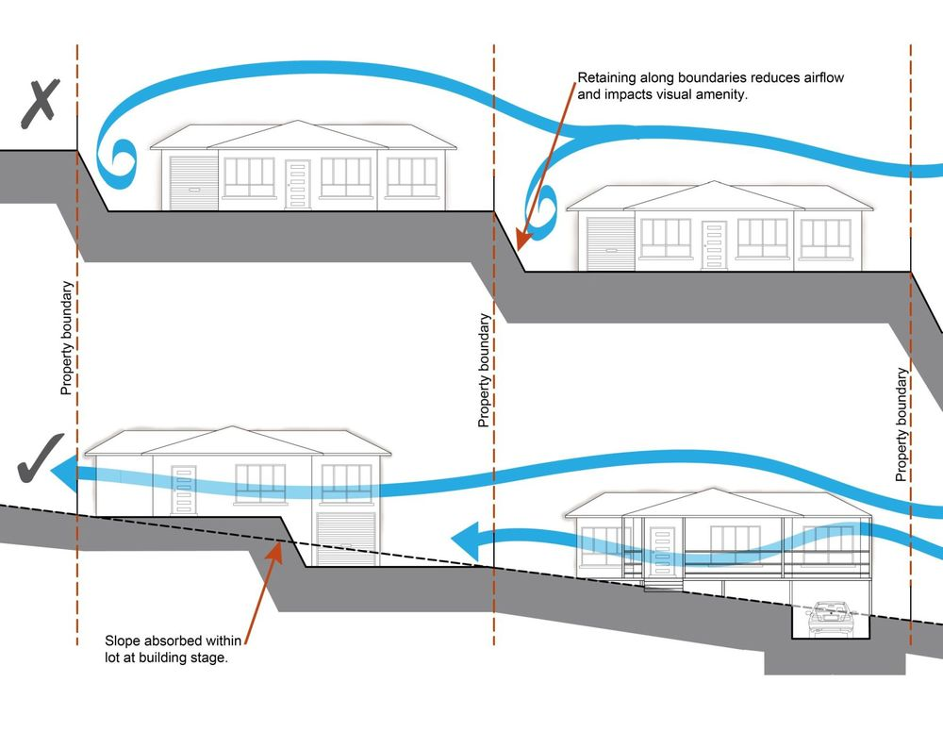
Boundary realignment
PO38  Boundary alignments ensure that infrastructure and services are wholly contained within the lot they serve. | No example provided.
PO39  Boundary realignment does not result in:  - existing land uses on-site becoming non-complying with planning scheme criteria;  - lots being unserviced by infrastructure;  - lots not providing for own private servicing  - adverse impacts on the quality and integrity of the biodiversity and ecological values inherent to a High Value Area identified in Overlay map - Environmental areas . | No example provided.
PO40  Boundary realignment results in lots which have appropriate size, dimensions and access to cater for uses consistent with the precinct, sub-precincts and any relevant other precinct. | E40  Lot sizes and dimensions (excluding any access handles) comply with Lot Types A, B, C, D, E or F in accordance with Table 7.2.3.7.1.3: Lot Types.
Reconfiguring existing development by Community Title
PO41
Reconfiguring a lot which creates or amends a community title scheme as described in the Body Corporate and Community Management Act 1997 is undertaken in a way that does not result in existing uses on the land becoming unlawful or otherwise operating in a manner that is:
- inconsistent with any approvals on which those uses rely; or
- inconsistent with the for accepted development requirements applying to those uses at the time that they were established.

Note - Examples of land uses becoming unlawful include, but are not limited to the following:

- Land on which a Dual occupancy(21)(22) has been established is reconfigured in a way that results in both dwellings no longer being on the one lot. The reconfiguring has the effect of transforming the development from a Dual occupancy(21) to two separate Dwelling houses(22)(23), at least one of which does not satisfy the requirements for accepted development applying to Dwelling houses(22).

- Land on which a Multiple dwelling(49) has been established is reconfigured in a way that precludes lawful access to required communal facilities by either incorporating some of those facilities into private lots or otherwise obstructing the normal access routes to those facilities. Those communal facilities may have been required under the requirements for accepted development for the use or conditions of development approval.
Editor's note - To satisfy this performance outcome, the development application may need to be a combined application for reconfiguring a lot and a material change of use or otherwise be supported by details that confirm that the land use still satisfies all relevant land use requirements.

Reconfiguring by Lease
PO42  Reconfiguring a lot which divides land or buildings by lease in a way that allows separate occupation or use of those facilities is undertaken in a way that does not result in existing uses on the land becoming unlawful or otherwise operating in a manner that is:  - inconsistent with any approvals on which those uses rely; or  - inconsistent with the for accepted development requirements applying to those uses at the time that they were established.  Note - An example of a land use becoming unlawful is a Multiple dwelling⁽⁴⁹⁾ over which one or more leases have been created in a way that precludes lawful access to some of the required communal facilities. Some of the communal car parking facilities have been incorporated into lease areas while other leases are located in a way that obstructs the normal access routes to other communal facilities. Those communal facilities may have been required under the requirements for accepted development for the use or conditions of development approval, but they are no longer freely available to all occupants of the Multiple dwelling⁽⁴⁹⁾.  Editor's note - To satisfy this performance outcome, the development application may need to be supported by details that confirm that the land use still satisfies all relevant land use requirements.  Editor's note - Under the definition in Schedule 2 of the Act, the following do not constitute reconfiguring a lot and are not subject to this performance outcome:  - a lease for a term, including renewal options, not exceeding 10 years; and  - an agreement for the exclusive use of part of the common property for a community titles scheme under the Body Corporate and Community Management Act 1997. | No example provided.
Volumetric subdivision
PO43  The reconfiguring of the space above or below the surface of the land ensures appropriate area, dimensions and access arrangements to cater for uses consistent with the precinct and does not result in existing land uses on-site becoming non-complying with planning scheme criteria.  Note - Examples may include but are not limited to:  - where a dwelling house⁽²²⁾ includes a secondary dwelling or associated outbuildings, they cannot be separately titled as they are dependent on the Dwelling house⁽²²⁾ use. | No example provided.
Access easements
PO44  Access easements contain a driveway constructed to an appropriate standard for the intended use. | No example provided.
PO45  Where the access easement adjoins a constructed road, it has appropriate grade, verge cross section and safe sight distance for accessing vehicles, through traffic, and active transport users. | No example provided.
PO46  The easement covers all works associated with the access. | E46  The easement covers all driveway construction including cut and fill batters, drainage works and utility services.
PO47  Relocation or alteration of existing services are undertaken as a result of the access easement. | No example provided.
Utilities
PO48  All services including water supply, sewage disposal, electricity, street lighting, telecommunications and gas (if available) are provided in accordance with Planning scheme policy - Integrated design (Appendix A). | No example provided.
Stormwater location and design
PO49  Where development is for an urban purpose that involves a land 2500m² or greater in size and results in 6 or more lots, stormwater quality management systems are designed, constructed, established and maintained to minimise the environmental impact of stormwater on surface, groundwater and receiving water environments and meet the design objectives outlined in Schedule 10 - Stormwater management design objectives.  Note - A site based stormwater management plan prepared by a suitably qualified professional will be required in accordance with Planning scheme policy - Stormwater management. Stormwater quality infrastructure is to be designed in accordance with Planning scheme policy - Integrated design (Appendix C). | No example provided.
PO50  Development is designed and constructed to achieve Water Sensitive Urban Design best practice including:  - protection of existing natural features;  - integrating public open space with stormwater corridors or infrastructure;  - maintaining natural hydrologic behaviour of catchments and preserving the natural water cycle;  - protecting water quality environmental values of surface and ground waters;  - minimising capital and maintenance costs of stormwater infrastructure.  Note - Refer to Planning scheme policy - Integrated design (Appendix C) for more information and examples on water sensitive urban design.  Note - A site based stormwater management plan prepared in accordance with Planning scheme policy - Stormwater management may be required to demonstrate compliance with this PO. | No example provided.
PO51  Stormwater drainage infrastructure (including inter-allotment drainage) within private land is protected by easements in favour of Council with sufficient area for practical access for maintenance.  Note - In order to achieve a lawful point of discharge, stormwater easements may also be required over temporary drainage channels/infrastructure where stormwater discharges to a balance lot prior to entering Council's stormwater drainage system. | E51  Stormwater drainage infrastructure (excluding detention and bio-retention systems) through or within private land (including inter-allotment drainage) is protected by easements in favour of Council. Minimum easement widths are as follows:  Pipe Diameter Minimum Easement Width (excluding access requirements)  Stormwater pipe up to 825mm diameter 3.0m  Stormwater pipe up to 825mm diameter with sewer pipe up to 225m diameter 4.0m  Stormwater pipe greater than 825mm diameter Easement boundary to be 1m clear of the outside wall of the stormwater pipe (each side)  Note - Additional easement width may be required in certain circumstances in order to facilitate maintenance access to the stormwater system.  Note - Refer to Planning scheme policy - Integrated design (Appendix C) for easement requirements over open channels.
PO52  Stormwater management facilities are located outside of riparian areas and prevent increased channel bed and bank erosion. | No example provided.
PO53  Natural streams and riparian vegetation are retained and enhanced through revegetation. | No example provided.
PO54  Areas constructed as detention basins:  - are adaptable for passive recreation;  - appear to be a natural land form;  - provide practical access for maintenance purposes;  - do not create safety or security issues by creating potential concealment areas;  - have adequate setbacks to adjoining properties;  - are located within land to be dedicated to Council as public land. | E54  Stormwater detention basins are designed and constructed in accordance with Planning scheme policy - Integrated design (Appendix C) and Planning scheme policy - Operational works inspection, maintenance and bonding procedures.
PO55  Development maintains and improves the environmental values of waterway ecosystems. | No example provided.
PO56  A constructed water body proposed to be dedicated as public asset is to be avoided, unless there is an overriding need in the public interest | No example provided.
PO57  Lots are of a sufficient grade to accommodate effective stormwater drainage to a lawful point of discharge. | E57  The surface level of a lot is at a minimum grade of 1:100 and slopes towards the street frontage, or other lawful point of discharge.
Stormwater management system
PO58  The major drainage system has the capacity to safely convey stormwater flows for the defined flood event. | E58  The roads, drainage pathways, drainage features and waterways safely convey the stormwater flows for the defined flood event without allowing flows to encroach upon private lots.
PO59  Overland flow paths (for any storm event) from newly constructed roads and public open space areas do not pass through private lots and allow safe and convenient access for pedestrians and cyclists. | E59  Drainage pathways are provided to accommodate overland flows from roads and public open space areas. The overland flow paths have a minimum width of 8m and are designed and constructed to allow safe and convenient access for pedestrians and cyclists.
PO60  Provide measures to properly manage surface flows for the 1% AEP event (for the fully developed catchment) draining to and through the land to ensure no actionable nuisance is created to any person or premises as a result of the development. The development must not result in ponding on adjacent land, redirection of surface flows to other premises or blockage of a surface flow relief path for flows exceeding the design flows for any underground system within the development. | E60  The stormwater drainage system is designed and constructed in accordance with Planning scheme policy - Integrated design.
PO61  The stormwater management system is designed to:  - protect the environmental values in downstream waterways;  - maintain ground water recharge areas;  - preserve existing natural wetlands and associated vegetation buffers;  - avoid disturbing soils or sediments;  - avoid altering the natural hydrologic regime in acid sulfate soil and nutrient hazardous areas;  - maintain and improve receiving water quality;  - protect natural waterway configuration;  - protect natural wetlands and vegetation;  - protect downstream and adjacent properties;  - protect and enhance riparian areas. | No example provided.
PO62  Design and construction of the stormwater management system:  - utilise methods and materials to minimise the whole of lifecycle costs of the stormwater management system; and  - are co-ordinated with civil and other landscaping works.  Note - To determine the standards for stormwater management system construction refer to Planning scheme policy - Integrated design. | No example provided.
PO63  Where associated with a minor green corridor identified on Figure 7.2.3.4 - Green network and open space, development will adopt bio-retention systems for stormwater treatment that recognises and promotes Councils Total Water Cycle Management policy and the efficient use of water resources.  Note - To determine the standards for stormwater management system construction refer to Planning scheme policy - Integrated design. | No example provided.
Clearing of native vegetation
PO64  Reconfiguring a lot facilitates the retention of native vegetation by:  - incorporating native vegetation and habitat trees into the overall subdivision design, development layout, on-street amenity and landscaping where practicable;  - ensuring habitat trees are located outside a development footprint. Where habitat trees are to be cleared, replacement fauna nesting boxes are provided at the rate of 1 nest box for every hollow removed. Where hollows have not yet formed in trees > 80cm in diameter at 1.3m height, 3 nest boxes are required for every habitat tree removed.  - providing safe, unimpeded, convenient and ongoing wildlife movement;  - avoiding creating fragmented and isolated patches of native vegetation.  - ensuring that biodiversity quality and integrity of habitats is not adversely impacted upon but are maintained and protected;  - ensuring that soil erosion and land degradation does not occur;  - ensuring that quality of surface water is not adversely impacted upon by providing effective vegetated buffers to water bodies. | E64  Development is in accordance with a Neighbourhood development plan.
Noise
PO65  Noise attenuation structure (e.g. walls, barriers or fences):  - contribute to safe and usable public spaces, through maintaining high levels of surveillance of parks, streets and roads that serve active transport purposes (e.g. existing or future pedestrian paths or cycle lanes etc);  - maintain the amenity of the streetscape.  Note - A noise impact assessment may be required to demonstrate compliance with this PO. Noise impact assessments are to be prepared in accordance with Planning scheme policy - Noise.  Note - Refer to Planning Scheme Policy – Integrated design for details and examples of noise attenuation structures. | E65  Noise attenuation structures (e.g. walls, barriers or fences):  - are not visible from an adjoining road or public area unless;  - adjoining a motorway or rail line; or  - adjoining part of an arterial road that does not serve an existing or future active transport purpose (e.g. pedestrian paths or cycle lanes) or where attenuation through building location and materials is not possible.  - do not remove existing or prevent future active transport routes or connections to the street network;  - are located, constructed and landscaped in accordance with Planning scheme policy - Integrated design.  Note - Refer to Planning Scheme Policy – Integrated design for details and examples of noise attenuation structures.  Note - Refer to Overlay map – Active transport for future active transport routes.
Values and constraints requirements

Note - The relevant values and constraints criteria do not apply where the development is consistent with a current Development permit for Reconfiguring a lot or Material change of use or Operational work, where that approval has considered and addressed (e.g. through a development footprint plan (or similar in the case of Landslide hazard) or conditions of approval) the identified value or constraint under this planning scheme.

Bushfire hazard (refer Overlay map - Bushfire hazard to determine if the following assessment criteria apply) for developable lots only

Note - The preparation of a bushfire management plan in accordance with Planning scheme policy – Bushfire prone areas can assist in demonstrating compliance with the following performance criteria. The identification of a development footprint will assist in demonstrating compliance with the following performance criteria.
PO66  Lots are designed to:  - minimise the risk from bushfire hazard to each lot and provide the safest possible siting for buildings and structures;  - limit the possible spread paths of bushfire within the reconfiguring;  - achieve sufficient separation distance between development and hazardous vegetation to minimise the risk to future buildings and structures during bushfire events;  - maintain the required level of functionality for emergency services and uses during and immediately after a natural hazard event. | E66  Reconfiguring a lot ensures that all new lots are of an appropriate size, shape and layout to allow for the siting of future buildings being located:  - within an appropriate development footprint;  - within the lowest hazard locations on a lot;  - to achieve minimum separation from any source of bushfire hazard of 20m or the distance required to achieve a Bushfire Attack Level (BAL) of more than 29 (as identified under AS3959-2009), whichever is the greater;  - to achieve a minimum separation from any retained vegetation strips or small areas of vegetation of 10m or the distance required to achieve a Bushfire Attack Level (BAL) of more than 29 (as identified under AS3959-2009), whichever is the greater;  - away from ridgelines and hilltops;  - on land with a slope of less than 15%;  - away from north to west facing slopes.
PO67  Lots provide adequate water supply and infrastructure to support fire-fighting. | E67  For water supply purposes, reconfiguring a lot ensures that:  - lots have access to a reticulated water supply provided by a distributer-retailer for the area; or  - where no reticulated water supply is available, on-site fire fighting water storage containing not less than 10,000 litres and located within a development footprint.
PO68  Lots are designed to :  - promote safe site access by avoiding potential entrapment situations;  - promote accessibility and manoeuvring for fire fighting during bushfire. | E68  Reconfiguring a lot ensures a new lot is provided with:  - direct road access and egress to public roads;  - an alternative access where the private driveway is longer than 100m to reach a public road;  - driveway access to a public road that has a gradient no greater than 12.5%;  - minimum width of 3.5m.
PO69  Lots ensure the road layout and design supports:  - safe and efficient emergency services access to sites; and manoeuvring within the subdivision;  - availability and maintenance of access routes for the purpose of safe evacuation. | E69  Reconfiguring a lot provides a road layout which:  - includes a perimeter road that separating the new lots from hazardous vegetation on adjacent lots incorporating by:  - a cleared width of 20m;  - road gradients not exceeding 12.5%;  - pavement and surface treatment capable of being used by emergency vehicles;  - Turning areas for fire fighting appliances in accordance with Qld Fire and Emergency Services' Fire Hydrant and Vehicle Access Guidelines.  - Or if the above is not practicable, a fire maintenance trail separates the lots from hazardous vegetation on adjacent lots incorporating:  - a minimum cleared width of 6m and minimum formed width of 4m;  - gradient not exceeding 12.5%;  - cross slope not exceeding 10%;  - a formed width and erosion control devices to the standards specified in Planning scheme policy - Integrated design;  - a turning circle or turnaround area at the end of the trail to allow fire fighting vehicles to manoeuvre;  - passing bays and turning/reversing bays every 200m;  - an access easement that is granted in favour of the Council and the Queensland Fire and Rescue Service or located on public land.  - excludes cul-de-sacs, except where a perimeter road with a cleared width of 20m isolates the lots from hazardous vegetation on adjacent lots; and  - excludes dead-end roads.
Heritage and landscape character (refer Overlay map - Heritage and landscape character to determine if the following assessment criteria apply)

Note - The identification of a development footprint will assist in demonstrating compliance with the following performance criteria.
PO70  Lots do not:  - reduce public access to a heritage place, building, item or object;  - create the potential to adversely affect views to and from the heritage place, building, item or object;  - obscure or destroy any pattern of historic subdivision, historical context, landscape setting or the scale and consistency of the urban fabric relating to the local heritage place. | No example provided.
High voltage electricity line buffer(refer Overlay map - Infrastructure buffers to determine if the following assessment criteria apply)
Note - The identification of a development footprint will assist in demonstrating compliance with the following performance criteria.

PO71  Lots provide a development footprint outside of the buffer. | No example provided.
PO72  The creation of lots does not compromise or adversely impact upon the efficiency and integrity of supply. | E72  No new lots are created within the buffer area.
PO73  The creation of new lots does not compromise or adversely impact upon access to the supply line for any required maintenance or upgrading work. | E73  No new lots are created within the buffer area.
PO74  Boundary realignments:  - do not result in the creation of additional building development within the buffer;  - result in the reduction of building development opportunities within the buffer. | No example provided.
Bulk water supply infrastructure buffer (refer Overlay map - Infrastructure buffers to determine if the following assessment criteria apply)

Note - The identification of a development footprint will assist in demonstrating compliance with the following performance criteria.
PO75  Lots provide a development footprint outside of the buffer. | No example provided.
PO76  The creation of lots does not compromise or adversely impact upon the efficiency and integrity of supply. | No example provided.
PO77  The creation of lots does not compromise or adversely impact upon access to the supply line for any required maintenance or upgrading work. | No example provided.
PO78  Boundary realignments:  - do not result in the creation of additional building development within the buffer;  - results in the reduction of building development opportunities within the buffer. | No example provided.
Overland flow path (refer Overlay map - Overland flow path to determine if the following assessment criteria apply)
Note - The applicable river and creek flood planning levels associated with defined flood event (DFE) within the inundation area can be obtained by requesting a flood check property report from Council.

PO79  Development:  - minimises the risk to persons from overland flow;  - does not increase the potential for damage from overland flow either on the premises or on a surrounding property, public land, road or infrastructure. | No example provided.
PO80  Development:  - maintains the conveyance of overland flow predominantly unimpeded through the premises for any event up to and including the 1% AEP for the fully developed upstream catchment;  - does not concentrate, intensify or divert overland flow onto an upstream, downstream or surrounding property.  Note - Reporting to be prepared in accordance with Planning scheme policy – Flood hazard, Coastal hazard and Overland flow. | E80  Development ensures that any buildings are not located in an Overland flow path area.  Note: A report from a suitably qualified Registered Professional Engineer Queensland is required certifying that the development does not increase the potential for significant adverse impacts on an upstream, downstream or surrounding property.
PO81  Development does not:  - directly, indirectly or cumulatively cause any increase in overland flow velocity or level;  - increase the potential for flood damage from overland flow either on the premises or on a surrounding property, public land, road or infrastructure.  Note - Open concrete drains greater than 1m in width are not an acceptable outcome, nor are any other design options that may increase scouring.  Note - A report from a suitably qualified Registered Professional Engineer Queensland is required certifying that the development does not increase the potential for significant adverse impacts on an upstream, downstream or surrounding premises.  Note - Reporting to be prepared in accordance with Planning scheme policy – Flood hazard, Coastal hazard and Overland flow | No example provided.
PO82  Development ensures that overland flow is not conveyed from a road or public open space onto a private lot, unless the development is in a Rural zone. | E82  Development ensures that overland flow paths and drainage infrastructure is provided to convey overland flow from a road or public open space area away from a private lot, unless the development is in the Rural zone.
PO83  Development ensures that Council and inter-allotment drainage infrastructure, overland flow paths and open drains through private property cater for overland flows for a fully developed upstream catchment flows and are able to be easily maintained.  Note - A report from a suitably qualified Registered Professional Engineer Queensland is required certifying that the development does not increase the potential for significant adverse impacts on an upstream, downstream or surrounding premises.  Note - Reporting to be prepared in accordance with Planning scheme policy – Flood hazard, Coastal hazard and Overland flow | E83.1  Development ensures that roof and allotment drainage infrastructure is provided in accordance with the following relevant level as identified in QUDM:  - Urban area – Level III;  - Rural area – N/A;  - Industrial area – Level V;  - Commercial area – Level V.
E83.2
Development ensures that all Council and allotment drainage infrastructure is designed to accommodate any event up to and including the 1% AEP for the fully developed upstream catchment.

PO84  Development protects the conveyance of overland flow such that easements for drainage purposes are provided over:  - a stormwater pipe if the nominal pipe diameter exceeds 300mm;  - an overland flow path where it crosses more than one property; and  - inter-allotment drainage infrastructure.  Note - Refer to Planning scheme policy - Integrated design for details and examples.  Note - Stormwater drainage easement dimensions are provided in accordance with Section 3.8.5 of QUDM. | No example provided.
Additional criteria for development for a Park
PO85  Development for a Park⁽⁵⁷⁾ ensures that the design and layout responds to the nature of the overland flow affecting the premises such that:  - public benefit and enjoyment is maximised;  - impacts on the asset life and integrity of park structures is minimised;  - maintenance and replacement costs are minimised. | E85  Development for a Park⁽⁵⁷⁾ ensures works are provided in accordance with the requirements set out in Appendix B of the Planning scheme policy - Integrated Design.
Table 7.2.3.7.1.3 - Lot Types
