Table 9.4.1.3.2.1 Assessable development - Emerging community - Transition precinct
Performance outcomes | Examples that achieve aspects of the Performance Outcomes |  | E Compliance  - Yes  - No See PO or  - NA |  | Justification for compliance
Where on a developable lot or creating developable lots
Lot size and design
PO1  Reconfiguring a lot does not result in additional lots. | No example provided.
Boundary realignment
PO2  Boundary realignments do not result in the:  - fragmentation or alienation of the land or result in the loss of land for future urban purposes;  - delay the use of the land for urban purposes;  - existing land uses on-site becoming non-compliant due to:  - lot size;  - parking requirements;  - servicing;  - dependant elements of an existing or approved land use being separately titled. | No example provided.
  Note - Examples may include but are not limited to:
  - Where a Dwelling house⁽²²⁾ includes a secondary dwelling or associated outbuildings, they cannot be separately titled as they are dependent on the Dwelling house⁽²²⁾ use.
Where on a developed lot or creating developed lots
Density
PO3  Reconfiguring of a lot:  - for land within the Morayfield South urban area identified on ‘Figure 9.4.1.3.2.1 Morayfield South urban area’, development does not compromise future developments ability to achieve a minimum residential density of 45 dwellings per hectare to ensure efficient use of the land and infrastructure which facilitates feasible public transport patronage and creates a diverse medium density neighbourhood character; or  - for all other land, development achieves a minimum net residential density of 10 lots per hectare, whilst not exceeding 25 lots per hectare, creating a diverse low-medium density neighbourhood character. | No example provided.
Lot design, mix and location
PO4  Lots have an area, shape and dimension sufficient to ensure they can accommodate:  - the built form intended within and outside the Walking distance (Centre) and Walking distance (Train Station) overlay areas and the Morayfield South urban area (identified on ‘Figure 9.4.1.3.2.1 Morayfield South urban area’) under the Emerging community zone - Transition precinct overall outcomes in Part 6  - all domestic outbuildings and possible on site servicing requirements (e.g. on-site waste disposal);  - areas for car parking, vehicular access and manoeuvring;  - areas for useable and practical private open space.  Note - Driveway locations for each narrow lot and on-street car parking locations are nominated on a plan of development | E4.1  For land within the Morayfield South urban area identified on ‘Figure 9.4.1.3.2.1 Morayfield South urban area’, lot dimensions comply with Lot Types A, B or F in accordance with ‘Table 9.4.1.3.2.3: Lot Types.’
E4.2
For all other areas, lot dimensions (excluding any access handles) comply with:
- where in the Walking distance (Centre) or Walking distance (Train Station) overlay areas, no example provided;
- where outside the Walking distance (Centre) and Walking distance (Train Station) overlay areas, Lot Types A, B, C, D, E or F in accordance with ‘Table 9.4.1.3.2.3: Lot Types’:
Note - For the purpose of rear lots, frontage is the average width of the lot (excluding any access handle or easement).

E4.3
Lots with a primary frontage of 12.5 metres or less and an average width of 12.5 metres or less incorporate provision for built to boundary walls in accordance with the requirements of Section 9.3.1 - Dwelling house code.
Note - Built to boundary walls for lots subject to E4.3 are shown on a plan of development.
PO5  Reconfiguring a lot creating more than 5 lots provides a diversity of lot sizes and dimensions that will:  - accommodate a diversity of dwelling types, sizes and forms;  - create varied and interesting streetscapes by providing a noticeable variation of frontage widths when observed from the street and avoiding large concentrations of lots with similar dimensions;  - ensure development supports the mix of housing options intended within and outside the Walking distance (Centre) and Walking distance (Train Station) overlay areas and the Morayfield South urban area (identified on ‘Figure 9.4.1.3.2.1 Morayfield South urban area’) under the Emerging community zone - Transition precinct overall outcomes in Part 6.  Note - Refer to the lot diversity figures below providing an example demonstrating compliance with the performance outcome. | E5.1  For land within the Morayfield South urban area identified on ‘Figure 9.4.1.3.2.1 Morayfield South urban area’, lot sizes comply with Lot Types A or E in accordance with ‘Table 9.4.1.3.2.3: Lot Types’
  Editor's note - Lots containing built to boundary walls should also include an appropriate easement to facilitate the maintenance of any wall within 600mm of a boundary. For boundaries with built to boundary walls on adjacent lots a 'High Density Development Easement' is recommended; or for all other built to boundary walls and 'easement for maintenance purposes' is recommended.
 | No example provided for all other locations.
Figure - Lot diversity within Walking distance (Centre) and Walking distance (Train Station) overlay areas
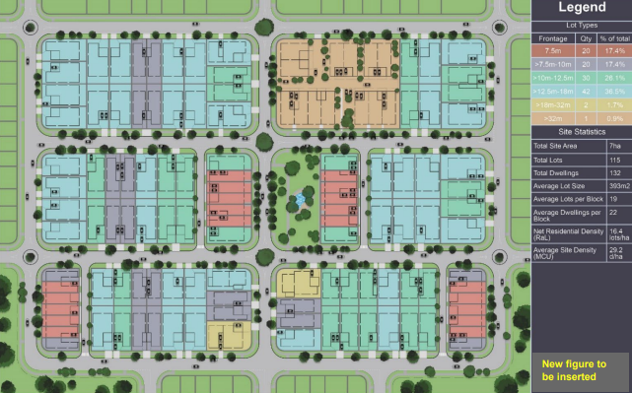

Figure - Lot diversity outside Walking distance (Centre) and Walking distance (Train Station) overlay areas
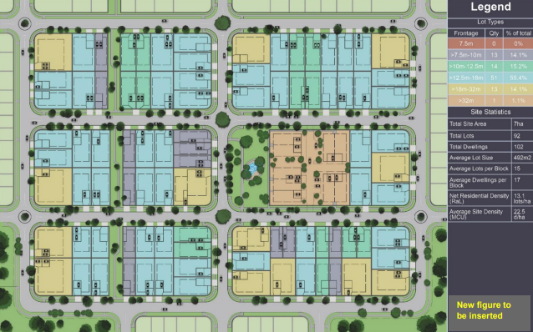
PO6  Narrow lots are not concentrated within a single location, to:  - ensure diversity within the streetscape;  - create visual relief;  - provide opportunities for landscaped open space to be provided between dwellings at frequent intervals along the street;  - minimise conflicts between vehicle access and on-street parking. | E6.1  Lots with a primary frontage width of 7.5 metres or less are only created where they are provided with laneway access.
  Note - Narrow lots are those with a primary frontage width of 12.5 metres or less, or types A, B or C in ‘Table 9.4.1.3.2.3: Lot Types’.
  Note - Driveway locations for each narrow lot and on-street car parking locations are nominated on a plan of development.
E6.2
Groupings of narrow lots are limited to:
- where not accessed via a laneway, no more than four adjoining lots with a primary frontage width of 12.5 metres or less along the same street frontage; or
- where accessed via a laneway, no more than eight adjoining lots with a primary frontage width 12.5 metres or less along the same street frontage.
Note - Nothing in the example prevents more than one group of adjoining lots with primary frontages of 12.5 metres or less sharing the same street frontage.
PO7  Where outside the Walking distance (Centre) and Walking distance (Train Station) overlay areas, lots that facilitate medium to high density residential uses (freehold or community titles) are located in proximity to recreational opportunities, commercial and community facilities and public transport nodes. | E7.1  Where outside the Walking distance (Centre) and Walking distance (Train Station) overlay areas, groupings of four or more adjoining lots with primary frontage widths of 9.5 metres or less are located:  - adjoining a park or directly opposite a park fronting the same street; or  - within 200 metres of a public transport stop or station; or  - within 200 metres of a Centre zone or neighbourhood hub (refer Overlay map - Community activities and neighbourhood hubs).
E7.2
Where outside the Walking distance (Centre) and Walking distance (Train Station) overlay areas, lots with a site area of 800m2 or greater are located:
- adjoining a park or directly opposite a park fronting the same street; or
- within 200 metres of a public transport stop or station; or
- within 200 metres of a Centre zone or neighbourhood hub (refer Overlay map - Community activities and neighbourhood hubs).
Note - E7.2 does not include balance lots pending further subdivision in future stages.
PO8
N/A - This PO has been deleted
PO9  Provision is made for integrated construction and orderly streetscapes where narrow lots suitable for terrace and row housing are co-located.  Note - Narrow lots are those with a primary frontage width of 12.5 metres or less, or types A, B or C in ‘Table 9.4.1.3.2.3: Lot Types’. | E9  Any lot with a primary frontage width of 12.5 metres or less and an average width of 12.5 metres or less (excluding any access handle or easement) sharing a boundary with a lot where built to boundary walls are nominated to both side boundaries provides for a built to boundary wall on the shared boundary.  Note - Built to boundary walls for lots with primary frontages of 12.5 metres or less are to be shown on a plan of development in accordance with the requirements of Section 9.3.1 - Dwelling house code.
PO9A  Crossovers for narrow lots are located to facilitate on-street parking and street trees between driveways. Note - Narrow lots are those with a primary frontage width of 12.5 metres or less, or types A, B or C in ‘Table 9.4.1.3.2.3: Lot Types’.  Note - Driveway locations for each narrow lot, on-street car parking locations and street tree planting zones for each street tree are nominated on a plan of development. | E9A  Crossovers for lots with primary frontages of 10 metres or less are paired up with crossovers of any adjoining lots that have a primary frontage of 10 metres or less in accordance with ‘Figure - Paired crossovers’ below.  Figure - Paired crossovers  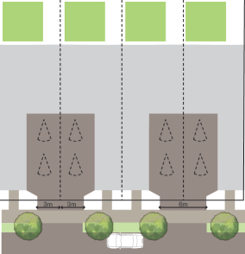
  Note - Driveway locations for lots with primary frontages of 12.5 metres or less are to be shown on a plan of development. Refer to Planning scheme policy - Residential design for additional guidance.
PO9B  Lot layout and design enhances the amenity of neighbourhoods by providing opportunities for larger visual breaks and landscaped open space between lots, buildings and structures at frequent intervals along the street. | E9B.1  The maximum combined frontage of adjoining lots with primary frontages of 15 metres or less does not exceed 100 metres, measured along the street.  Editor’s note - Dwellings on lots with a primary frontage of 15 metres or less have reduced side boundary setback requirements in the Queensland Development Code. Lots with a primary frontage of 12.5 metres or less also support built to boundary wall outcomes under the planning scheme.
E9B.2
Street blocks do not exceed 200 metres in any dimension or provide the following every 150 metres of street block length or part thereof:
- a minimum 10 metre wide mid-block pedestrian connection between two street frontages if forming part of a connection spanning at least three separate street blocks; or
- a laneway between two street frontages if providing access to lots where built to boundary walls to both side boundaries are nominated on a plan of development.
Note - PO15, PO17 and PO31 contain additional connectivity outcomes that apply to mid-block pedestrian connections.
Note - Mid-block pedestrian connections are provided as public road reserve and embellished as public open space. Section 6 of Planning scheme policy - Integrated design (Appendix B) provides design guidance for linear linkages that is relevant for mid-block pedestrian connections (see ‘Figure - Mid-block pedestrian connection’ below providing an example of the expected outcome).
Figure - Mid-block pedestrian connection
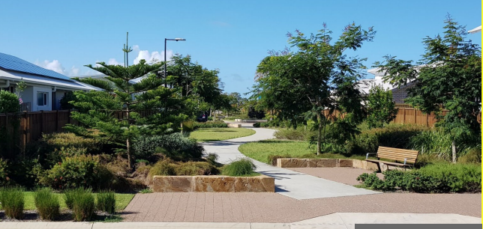
Sloping Land
PO10  Lot layout and design avoids the impacts of cutting, filling and retaining walls on the visual and physical amenity of the streetscape, each lot created and of adjoining lots ensuring, but not limited to, the following:  - The likely location of private open space associated with a Dwelling House on each lot will not be dominated by, or encroached into by built form outcomes such as walls or fences;  - Walls and/or fences are kept to a human scale and do not represent barriers to local environmental outcomes and conditions such as good solar access and access to prevailing breezes; and  - The potential for overlooking from public land into private lots is avoided wherever possible; and  - Lot design is integrated with the opportunities available for Dwelling House design to reduce impacts. |  | E10.1  Lot layout and design ensures that a lot has a maximum average slope of 1:15 along its long axis and 1:10 along its short axis.
  Note - Refer to Planning scheme policy - Residential design for guidelines on building design on sloped land.
E10.2
Retaining walls and benching and associated cutting, filling and other earthworks associated with reconfiguring a lot are limited to:
- a maximum vertical dimension of 1.5m from ground level for any single retaining structure; or
- where incorporating a retaining structure greater than 1.5m in height, the retaining wall is stepped, terraced and landscaped as follows:
  - maximum 1m vertical, minimum 0.5m horizontal, maximum 2m vertical (refer figure below);
  - Maximum overall structure height of 3m; or
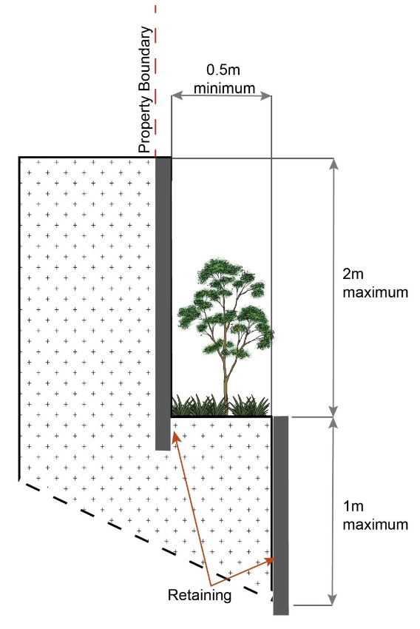

- where incorporating benching along the short axis (from side to side boundary) of a lot:
  - The difference between levels at each boundary is no greater than 4m per lot;
  - each bench has a maximum height of 2m (refer Figure below); or
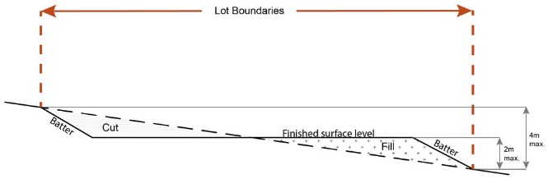

- where incorporating benching along the long axis (from front to rear boundary):
  - each bench has a maximum height of 2m;
  - lots orientate up/down the slope (refer Figure below).
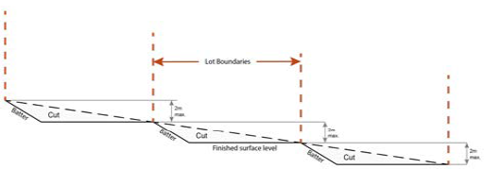
Note - Benching is to incorporate suitable measures to ensure stabilisation and prevent erosion.
Editor's note - Strict cut and fill requirements apply at the Dwelling house stage. Deferral of slope solutions until building stage is not an acceptable outcome.

Figure - Sloped lot design
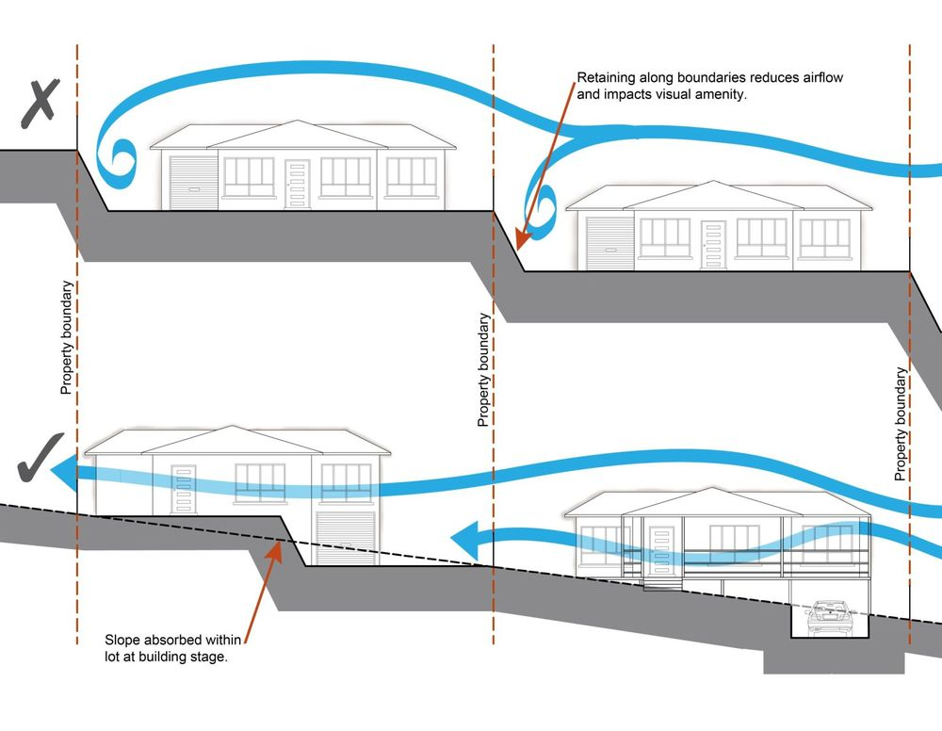

Rear lots
PO11  Rear lots do not establish in the Morayfied South urban area identified on ‘Figure 9.4.1.3.2.1 Morayfield South urban area’. | No example provided.
PO12  For all other areas, rear lots:  - contribute to the mix of lot sizes;  - are limited to 1 behind any full frontage lot (i.e. A lot with a street frontage that is not an access handle);  - provide sufficient area for vehicles to manoeuvre on-site allowing entry and exit to the rear lot in forward gear. | No example provided.
PO13  Access handles for rear lots are:  - a minimum of 5m wide to allow for safe vehicle access and service corridors from the rear lot to the street;  - are located on 1 side of the full frontage lot;  - limited to no more than 2 directly adjoining each other. | No example provided.
Street design and layout
PO14  Development maintains, contributes to or provides for a street layout that facilitates regular and consistent shaped lots through the use of rectilinear grid patterns, or modified grid patterns where constrained by topographical and other physical barriers. | No example provided.
  Note - Refer to Planning scheme policy - Neighbourhood design for guidance on how to achieve compliance with this outcome.
PO15  Development maintains, contributes to or provides for a street layout that is designed to connect to surrounding neighbourhoods, providing an interconnected street, pedestrian and cyclist network that connects nearby centres, neighbourhood hubs, community facilities, public transport nodes and open space to residential areas.  The layout ensures that new development is provided with multiple points of access. The timing of transport works ensures that multiple points of access are provided during early stages of a development. | No example provided.
  Note - Refer to Planning scheme policy - Neighbourhood design for guidance on achieving the above outcome.
PO16  Development provides and maintains the connections shown on:  - ‘Figure 1 - Morayfield South’ - Morayfield South;  - ‘Figure 2 - Narangba East’ - Narangba East. | No example provided.
PO17  Development maintains, contributes to or provides for a street layout that provides an efficient and legible movement network with high levels of connectivity within and external to the to the site by:  - facilitating increased active transport with a focus on safety and amenity for pedestrians and cyclists;  - providing street blocks with a maximum walkable perimeter of 500m (refer Figure - Street block design);  - providing a variety of street block sizes to facilitate a range of intensity and scale in built form;  - reducing street block sizes as they approach an activity focus (e.g centre, neighbourhood hub, train station, community activity, public open space);  - facilitating possible future connections to adjoining sites for roads, green linkages and other essential infrastructure. | No example provided.
  Note - Refer to Planning scheme policy - Neighbourhood design for guidance on how to achieve compliance with this outcome.
PO18  Street layouts create convenient and highly permeable movement networks between lower and higher order roads, whilst not adversely affecting the safety and function of the higher order road. | No example provided.
  Note - Refer to Planning scheme policy - Neighbourhood design for guidance on how to achieve compliance with this outcome.
PO19  Streets are designed and constructed in accordance with Planning scheme policy - Integrated design and Planning scheme policy - Operational works inspection, maintenance and bonding procedures. The street design and construction accommodates the following functions:  - access to premises by providing convenient vehicular movement for residents between their homes and the major road network;  - safe and convenient pedestrian and cycle movement;  - adequate on street parking;  - stormwater drainage paths and treatment facilities;  - efficient public transport routes;  - utility services location;  - emergency access and waste collection;  - setting and approach (streetscape, landscaping and street furniture) for adjoining residences;  - expected traffic speeds and volumes; and  - wildlife movement (where relevant). | No example provided.
  Note - Preliminary road design (including all services, street lighting, stormwater infrastructure, access locations, street trees and pedestrian network) may be required to demonstrate compliance with this PO.
  Note - Refer to Planning scheme policy - Environmental areas and corridors for examples of when and where wildlife movement infrastructure is required.
PO19A  Street trees are provided to create shade and comfort for walking and cycling, reduce urban heat and enhance amenity. | E19A  Street trees are provided in accordance with Planning scheme policy - Integrated design.  Note - Planning scheme policy - Integrated design (Appendix A) identifies the street tree planting rate for different street and road typologies.  Note - Street tree planting zones for each street tree are nominated on the plan of development. Street tree planting zones are located and sized to provide flexibility in their placement and certainty for their viable positioning clear of utilities/services, driveways and other possible infrastructure conflicts.
PO20  Cul-de-sac or dead end streets are not proposed unless:  - topography or other physical barriers exist to the continuance of the street network or vehicle connection to an existing road is not permitted;  - there are no appropriate alternative solutions;  - the cul-de-sac or dead end street will facilitate future connections to adjoining land or development. | No example provided.
  Note - Refer to Planning scheme policy - Neighbourhood design for guidance on how to achieve compliance with this outcome.
PO21  Where cul-de-sacs are proposed due to vehicular connection to existing roads not being permitted, they are to be designed to allow a 10m wide pedestrian connection as public land through to the existing road with no lots proposed at the head of the cul-de-sac generally as shown in figure below.  Figure - Cul-de-sac design  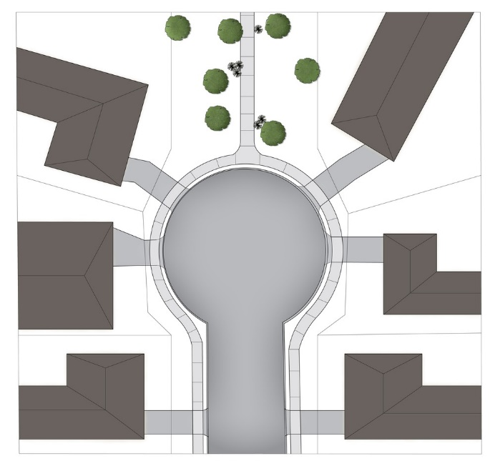 | No example provided.
  Note - Refer to Planning scheme policy - Neighbourhood design for guidance on how to achieve this outcome.
PO22  Streets are designed and oriented to minimise the impact of cut and fill on the amenity of the streetscape and adjoining development. | E22  Street alignment follows ridges or gullies or runs perpendicular to slope.
PO23  Streets are oriented to encourage active transport through a climate responsive and comfortable walking environment whilst also facilitating lots that support subtropical design practices, including:  - controlled solar access & shade provision  - cross-ventilation. | E23.1  Where not unduly constrained by topography or other physical barrier, streets are primarily oriented within 20 or 30 degrees of North-South or East-West in accordance with Figure - Preferred street orientation below.  Figure - Preferred street orientation  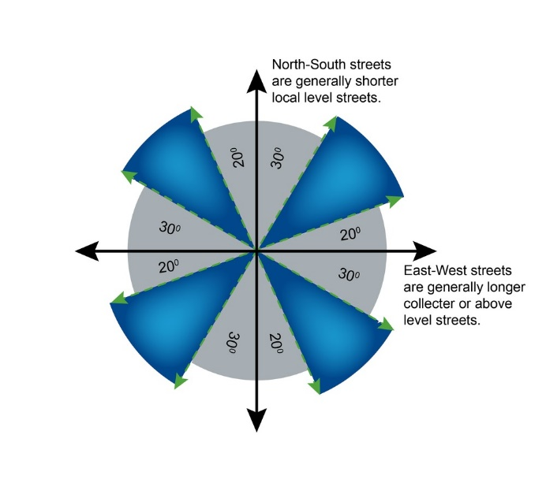
  Note - Refer to Planning scheme policy - Residential design for guidance on how to achieve subtropical design solution.
E23.2
The long axis of a street block is oriented east-west to facilitate a north-south orientation for a majority of lots as per Figure - Street block design below.
E23.3
Where the long axis of lot boundaries are oriented east west, they are 16m or wider so as to allow for alternative dwelling design to achieve solar access and cross-ventilation as per Figure -Street block design below.
Figure - Street block design
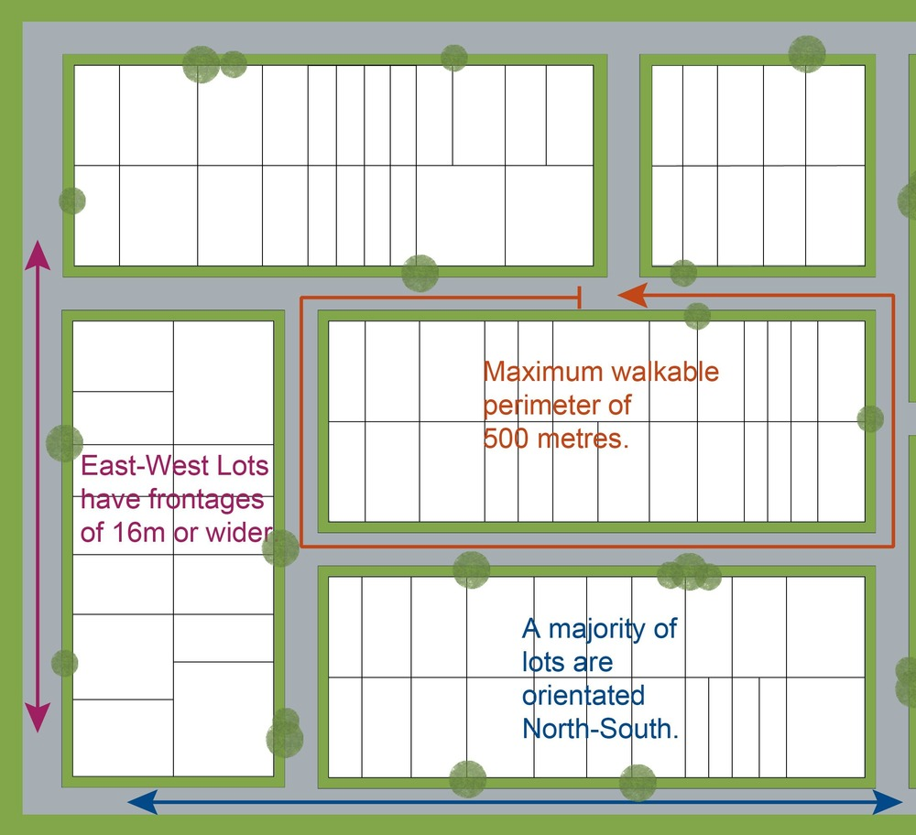

PO24  The street network creates convenient access to arterial and sub-arterial roads for heavy vehicles and commercial traffic without introducing through traffic to residential streets. | No example provided.
PO25  The existing road network (whether trunk or non-trunk) is upgraded where necessary to cater for the impact from the development. | E25.1  New intersections onto existing roads are designed to accommodate traffic volumes and traffic movements taken from a date 10 years from the date of completion of the last stage of the development. Design is to be in accordance with Planning scheme policy - Integrated design.
  Note - An applicant may be required to submit an Integrated Transport Assessment (ITA), prepared in accordance with Planning scheme policy - Integrated transport assessment to demonstrate compliance with this PO, when any of the following occurs:
  - development is within 200m of a transport sensitive location such as a school, shopping centre, bus or train station or a large generator of pedestrian or vehicular traffic;
  - forecast traffic to/from the development exceeds 5% of the two way flow on the adjoining road or intersection in the morning or afternoon transport peak within 10 years of the development completion;
  - development access onto a sub arterial, or arterial road or within 100m of a signalised intersection;
  - residential development greater than 50 lots or dwellings;
  - offices greater than 4,000m² Gross Floor Area (GFA);
  - retail activities including Hardware and trade supplies, Showroom, Shop or Shopping centre greater than 1,000m² GFA;
  - warehouses and Industry greater than 6,000m² GFA;
  - on-site carpark greater than 100 spaces;
  - development has a trip generation rate of 100 vehicles or more within the peak hour;
  - development which dissects or significantly impacts on an environmental area or an environmental corridor.
  The ITA is to review the development’s impact upon the external road network for the period of 10 years from completion of the development. The ITA is to provide sufficient information for determining the impact and the type and extent of any ameliorative works required to cater for the additional traffic. The ITA must include a future structural road layout of adjoining properties that will form part of this catchment and road connecting to these properties. The ITA is to assess the ultimate developed catchment’s impacts and necessary ameliorative works, and the works or contribution required by the applicant as identified in the study.
  Note - The road network is mapped on Overlay map - Road hierarchy.
  Note - The primary and secondary active transport network is mapped on Overlay map - Active transport.
  Note - All turns vehicular access to existing lots is to be retained at new road intersections wherever practicable.
  Note - Existing on-street parking is to be retained at new road intersections and along road frontages wherever practicable.
E25.2
Existing intersections external to the site are upgraded as necessary to accommodate increased traffic from the development. Design is in accordance with Planning scheme policy - Integrated design and Planning scheme policy - Operational works inspection, maintenance and bonding procedures.
Note - All turns vehicular access to existing lots is to be retained at upgraded road intersections wherever practicable.
Note - Existing on-street parking is to be retained at upgraded road intersections and along road frontages wherever practicable.

E25.3
The active transport network is extended in accordance with Planning scheme policy - Integrated design.

PO26  New intersections along all streets and roads are located and designed to provide safe and convenient movements for all users. |  | E26  New intersection spacing (centreline – centreline) along a through road conforms with the following:  - Where the through road provides an access or residential street function:  - intersecting road located on same side = 60 metres; or  - intersecting road located on opposite side = 40 metres.  - Where the through road provides a local collector or district collector function:  - intersecting road located on same side = 100 metres; or  - intersecting road located on opposite side = 60 metres.  - Where the through road provides a sub-arterial function:  - intersecting road located on same side = 250 metres; or  - intersecting road located on opposite side = 100 metres.  - Where the through road provides an arterial function:  - intersecting road located on same side = 350 metres; or  - intersecting road located on opposite side = 150 metres.  - Walkable block perimeter does not exceed 500 metres.
  Note - Refer Planning scheme policy - Integrated design and Planning scheme policy - Operational works inspection, maintenance and bonding procedures for design and construction standards.
  Note - An Integrated Transport Assessment (ITA) including preliminary intersection designs, prepared in accordance with Planning scheme policy - Integrated transport assessment may be required to demonstrate compliance with this PO. Intersection spacing will be determined based on the deceleration and queue storage distances required for the intersection after considering vehicle speed and present/forecast turning and through volumes.
  Note - Based on the absolute minimum intersection spacing identified above, all turns access may not be permitted (ie. left in/left out only) at intersections with sub-arterial roads or arterial roads.
  Note - The road network is mapped on Overlay map - Road hierarchy.
  Note - An Integrated Transport Assessment (ITA) including preliminary intersection designs, prepared in accordance with Planning scheme policy - Integrated transport assessment may be required to demonstrate compliance with this PO.
PO27  All Council controlled frontage roads adjoining the development are designed and constructed in accordance with Planning scheme policy - Integrated design and Planning scheme policy - Operational works inspection, maintenance and bonding procedure. All new works are extended to join any existing works within 20m. |  | E27  Design and construct all Council controlled frontage roads in accordance with Planning scheme policy - Integrated design, Planning scheme policy - Operational works inspection, maintenance and bonding procedures and the following:
  Note - Frontage roads include streets where no direct lot access is provided.
  Note - The road network is mapped on Overlay map - Road hierarchy.
  Note - The Primary and Secondary active transport network is mapped on Overlay map - Active transport.
  Note - Roads are considered to be constructed in accordance with Council’s standards when there is sufficient pavement width, geometry and depth to comply with the requirements of Planning scheme policy - Integrated design and Planning scheme policy - Operational works inspection, maintenance and bonding procedures.
   | Situation | Minimum construction
   | Frontage road unconstructed or gravel road only;  OR  Frontage road sealed but not constructed* to Planning scheme policy - Integrated design standard;  OR  Frontage road partially constructed* to Planning scheme policy - Integrated design standard. | Construct the verge adjoining the development and the carriageway (including development side kerb and channel) to a minimum sealed width containing near side parking lane (if required), cycle lane (if required), 2 travel lanes plus 1.5m wide (full depth pavement) gravel shoulder and table drainage to the opposite side.  The minimum total travel lane width is:  - 6m for minor roads;  - 7m for major roads.
  Note - Major roads are sub-arterial roads and arterial roads. Minor roads are roads that are not major roads.
  Note - Construction includes all associated works (services, street lighting and linemarking).
  Note - Alignment within road reserves is to be agreed with Council.
  Note - *Roads are considered to be constructed in accordance with Council standards when there is sufficient pavement width, geometry and depth to comply with the requirements of Planning scheme policy - Integrated design and Planning scheme policy - Operational works inspection, maintenance and bonding procedures. Testing of the existing pavement may be required to confirm whether the existing works meet the standards in Planning scheme policy - Integrated design and Planning scheme policy - Operational works inspection, maintenance and bonding procedures.
PO28  Sealed and flood free road access during the minor storm event is available to the site from the nearest arterial or sub-arterial road. |  | E28  Roads or streets giving access to the development from the nearest arterial or sub-arterial road are flood free during the minor storm event and are sealed.
  Editor's note - Where associated with a State-controlled road, further requirements may apply, and approvals may be required from the Department of Transport and Main Roads.
  Note - The road network is mapped on Overlay map - Road hierarchy.
PO29  Roads which provide access to the site from an arterial or sub-arterial road remain trafficable during major storm events without flooding or impacting upon residential properties or other premises. |  | E29.1  Access roads to the development have sufficient longitudinal and cross drainage to remain safely trafficable during major storm (1% AEP) events.
  Note - The road network is mapped on Overlay map - Road hierarchy.
  Note - Refer to QUDM for requirements regarding trafficability.
E29.2
Culverts and causeways do not increase inundation levels or increase velocities, for all events up to the defined flood event, to upstream or downstream properties.
Laneway design and location
PO30  Laneway location contributes to a high standard of amenity for adjoining lots and the primary streetscape. |  | E30  Laneways are primarily used where:  - vehicle access is not permitted from the primary street frontage; or  - limiting vehicle access from the primary street frontage results in a positive streetscape outcome;or  - where lots directly adjoin a local, district or regional Park⁽⁵⁷⁾.
  Note - Refer to Planning scheme policy - Neighbourhood design for determining locational criteria for Laneways.
PO31  Laneways service a limited number of allotments, creating a sense of place and enclosed feeling for the pedestrian environment whilst contributing to the high level of connectivity of the street network. |  | E31.1  Laneways are limited to 130m in length.
  Note - Refer to Planning scheme policy - Integrated design and Planning scheme policy - Neighbourhood design for determining design criteria for Laneways.
E31.2
Laneways are not designed as dead ends or cul-de-sacs, and are to have vehicle connections to an access street at both ends.
E31.3
Where laneways exceed 100m in length, a 7m wide mid lane pedestrian connection is to be provided between the adjacent access streets and the laneway.
PO32  Laneway design ensures the safety of pedestrians, cyclists and motorists by way of site lines, and sufficient road reserve for vehicle movements and the provision of street lighting. |  | E32.1  Laneways are designed with minor meanders only, and maintain direct lines of sight from one end of the laneway to the other.
  Note - Refer to Planning scheme policy - Integrated design and Planning scheme policy - Neighbourhood design for determining design criteria for Laneways.
E32.2
Laneways provide road dedication at strategic locations along the laneway to allow the construction of street lighting and any electrical pillars associated with the street lighting in accordance with current Australian Standards.
Note - The dedication must allow for street lights on to be provided on Council’s standard alignment.

PO33  Laneway lots adjoining a park have a dedicated pathway as road reserve along the park frontage of the lots to contain all services and a concrete path. |  | E33  Dedicate a minimum 2.5m as road reserve along the park frontage of the lots to contain all services and a 2m wide concrete path.
  Note - Electrical, water and sewerage services are not to be located in the laneway. Electrical services that are necessary to provide street lighting in accordance with the relevant Australian Standard may be located in the laneway.
Park and open space
PO34  A hierarchy of Park⁽⁵⁷⁾ and open space is provided to meet the recreational needs of the community. |  | No example provided.
  Note - To determine the extent and location of Park⁽⁵⁷⁾ and open space required refer to Planning scheme policy - Integrated design.
  Note - District level Parks⁽⁵⁷⁾ or larger may be required in certain locations in accordance with Part 4: Local Government Infrastructure Plan.
PO35  Park⁽⁵⁷⁾ is to be provided within walking distance of all new residential lots. |  | No example provided.
  Note - To determine maximum walking distances for Park⁽⁵⁷⁾ types refer to Planning scheme policy - Integrated design.
PO36  Park⁽⁵⁷⁾ is of a size and design standard to meet the needs of the expected users. |  | No example provided.
  Note - To determine the size and design standards for Parks⁽⁵⁷⁾ refer to Planning scheme policy - Integrated design.
PO37  The safety and useability of Parks⁽⁵⁷⁾ is ensured through the careful design of the street network and lot locations which provide high levels of surveillance and access into the Park⁽⁵⁷⁾ or open space area. |  | E37.1  Local and district Parks⁽⁵⁷⁾ are bordered by streets and lots orientated to address and front onto Parks and not lots backing onto or not addressing the Park wherever possible.
E37.2
Where lots do adjoin local and district Parks⁽⁵⁷⁾, and fencing is provided along the Park⁽⁵⁷⁾ boundary, it is located within the lot and at a maximum height of 1m.
E37.3
The design of fencing and retaining features allows for safe and direct pedestrian access between the Park⁽⁵⁷⁾ and private allotment through the use of private gates and limited retaining features along Park⁽⁵⁷⁾ boundaries.
Transitions to Rural and Rural residential zoned areas
PO37A  Development that has an interface to the Rural or Rural residential zones provides buffers and a transition in development intensity to preserve the very low density character and amenity of these existing communities, such as by locating the following at the interface:  - parks and open space;  - perimeter roads with tree planting in the road reserve;  - larger lot sizes with primary frontages greater than 15m. |  | No example provided.
Boundary realignment
PO38  Boundary alignments ensure that infrastructure and services are wholly contained within the lot they serve. |  | No example provided.
PO39  Boundary realignment does not result in:  - existing land uses on-site becoming non-complying with planning scheme criteria;  - lots being unserviced by infrastructure;  - lots not providing for own private servicing. |  | No example provided.
  Note - Examples may include but are not limited to:
  - minimum lot size requirements;
  - setbacks;
  - parking and access requirements;
  - servicing and Infrastructure requirements;
  - dependant elements of an existing or approved land use being separately titled, including but not limited to:
    - Where premises is approved as Multiple dwelling with a communal open space area, the communal open space cannot be separately titled as it is required by the Multiple dwelling approval.
    - Where a commercial or industrial land use contains an ancillary office, the office cannot be separately titled as it is considered part of the commercial or industrial use.
    - Where a Dwelling house⁽²²⁾ includes a secondary dwelling or associated outbuildings, they cannot be separately titled as they are dependent on the Dwelling house⁽²²⁾ use.
PO40  Boundary realignment results in lots which have appropriate size, dimensions and access to cater for uses consistent with the precinct. |  | E40  Lot dimensions (excluding access handles) comply with:  - for land within the Morayfield South urban area identified on ‘Figure 9.4.1.3.2.1 Morayfield South urban area’, lot dimensions comply with Lot Types A or E in accordance with ‘Table 9.4.1.3.2.3: Lot Types’; or  - for all other areas, dimensions (excluding any access handles) comply with:  - where in the Walking distance (Centre) or Walking distance (Train Station) overlay areas, no example provided;  - where outside the Walking distance (Centre) and Walking distance (Train Station) overlay areas, Lot Types A, B, C, D, E or F in accordance with ‘Table 9.4.1.3.2.3: Lot Types’.
  Note - Refer to overall outcomes for the General residential zone - Next generation neighbourhood precinct for uses consistent in this precinct.
Reconfiguring existing development by Community Title
PO41  Reconfiguring a lot which creates or amends a community title scheme as described in the Body Corporate and Community Management Act 1997 is undertaken in a way that does not result in existing uses on the land becoming unlawful or otherwise operating in a manner that is:  - inconsistent with any approvals on which those uses rely; or  - inconsistent with the requirements for accepted development applying to those uses at the time that they were established. |  | No example provided.
  Note -Examples of land uses becoming unlawful include, but are not limited to the following:
  - Land on which a Dual occupancy⁽²¹⁾ has been established is reconfigured in a way that results in both dwellings no longer being on the one lot. The reconfiguring has the effect of transforming the development from a Dual occupancy⁽²¹⁾ to two separate Dwelling houses⁽²²⁾, at least one of which does not satisfy the requirements for accepted development applying to Dwelling houses.
  - Land on which a Multiple dwelling⁽⁴⁹⁾ has been established is reconfigured in a way that precludes lawful access to required communal facilities by either incorporating some of those facilities into private lots or otherwise obstructing the normal access routes to those facilities. Those communal facilities may have been required under the requirements for accepted development for the use or conditions of development approval.
  Editor's note - To satisfy this performance outcome, the development application may need to be a combined application for reconfiguring a lot and a material change of use or otherwise be supported by details that confirm that the land use still satisfies all relevant land use requirements.
Reconfiguring by Lease
PO42  Reconfiguring a lot which divides land or buildings by lease in a way that allows separate occupation or use of those facilities is undertaken in a way that does not result in existing uses on the land becoming unlawful or otherwise operating in a manner that is:  - inconsistent with any approvals on which those uses rely; or  - inconsistent with the requirements for accepted development applying to those uses at the time that they were established. |  | No example provided.
  Note - An example of a land use becoming unlawful is a Multiple dwelling⁽⁴⁹⁾ over which one or more leases have been created in a way that precludes lawful access to some of the required communal facilities. Some of the communal car parking facilities have been incorporated into lease areas while other leases are located in a way that obstructs the normal access routes to other communal facilities. Those communal facilities may have been required under the requirements for accepted development for the use or conditions of development approval, but they are no longer freely available to all occupants of the Multiple dwelling⁽⁴⁹⁾.
  Editor's note -To satisfy this performance outcome, the development application may need to be supported by details that confirm that the land use still satisfies all relevant land use requirements.
  Editor’s note – Under the definition in Schedule 2 of the Act, the following do not constitute reconfiguring a lot and are not subject to this performance outcome:
  - a lease for a term, including renewal options, not exceeding 10 years; and
  - an agreement for the exclusive use of part of the common property for a community titles scheme under the Body Corporate and Community Management Act 1997.
Volumetric subdivision
PO43  The reconfiguring of the space above or below the surface of the land ensures appropriate area, dimensions and access arrangements to cater for uses consistent with the precinct and does not result in existing land uses on-site becoming non-complying with planning scheme criteria. |  | No example provided.
  Note - Examples may include but are not limited to:
  - where a Dwelling house⁽²²⁾ includes a secondary dwelling or associated outbuildings, they cannot be separately titled as they are dependent on the Dwelling house⁽²²⁾ use.
Access Easements
PO44  Access easements contain a driveway constructed to an appropriate standard for the intended use. |  | No example provided.
PO45  Where the access easement adjoins a constructed road, it has appropriate grade, verge cross section and safe sight distance for accessing vehicles, through traffic, and active transport users. |  | No example provided.
PO46  The easement covers all works associated with the access. |  | E46  The easement covers all driveway construction including cut and fill batters, drainage works and utility services.
PO47  Relocation or alteration of existing services are undertaken as a result of the access easement. |  | No example provided.
Utilities
PO48  All services including water supply, sewage disposal, electricity, street lighting, telecommunications and gas (if available) are provided in accordance with Planning scheme policy - Integrated design (Appendix A). | No example provided.

Stormwater location and design
PO49  Where development is for an urban purpose that involves a land 2500m² or greater in size and results in 6 or more lots, stormwater quality management systems are designed, constructed, established and maintained to minimise the environmental impact of stormwater on surface, groundwater and receiving water environments and meet the design objectives outlined in Schedule 10 - Stormwater management design objectives. | No example provided.
  Note - A site based stormwater management plan prepared by a suitably qualified professional will be required in accordance with Planning scheme policy - Stormwater management. Stormwater quality infrastructure is to be designed in accordance with Planning scheme policy - Integrated design (Appendix C).
PO50  Development is designed and constructed to achieve Water Sensitive Urban Design best practice including:  - protection of existing natural features;  - integrating public open space with stormwater corridors or infrastructure;  - maintaining natural hydrologic behaviour of catchments and preserving the natural water cycle;  - protecting water quality environmental values of surface and ground waters;  - minimising capital and maintenance costs of stormwater infrastructure. | No example provided.
  Note - Refer to Planning scheme policy - Integrated design (Appendix C) for more information and examples on water sensitive urban design.
  Note - A site based stormwater management plan prepared in accordance with Planning scheme policy - Stormwater management may be required to demonstrate compliance with this PO.
PO51  Stormwater drainage infrastructure (including inter-allotment drainage) within private land is protected by easements in favour of Council with sufficient area for practical access for maintenance. | E51  Stormwater drainage infrastructure (excluding detention and bio-retention systems) through or within private land (including inter-allotment drainage) is protected by easements in favour of Council. Minimum easement widths are as follows:
  Note - In order to achieve a lawful point of discharge, stormwater easements may also be required over temporary drainage channels/infrastructure where stormwater discharges to a balance lot prior to entering Council's stormwater drainage system.
   | Pipe Diameter | Minimum Easement Width (excluding access requirements)
   | Stormwater pipe up to 825mm diameter | 3.0m
   | Stormwater pipe up to 825mm diameter with sewer pipe up to 225m diameter | 4.0m
   | Stormwater pipe greater than 825mm diameter | Easement boundary to be 1m clear of the outside wall of the stormwater pipe (each side).
  Note - Additional easement width may be required in certain circumstances in order to facilitate maintenance access to the stormwater system.
  Note - Refer to Planning scheme policy - Integrated design (Appendix C) for easement requirements over open channels.
PO52  Stormwater management facilities are located outside of riparian areas and prevent increased channel bed and bank erosion. | No example provided.
PO53  Natural streams and riparian vegetation are retained and enhanced through revegetation. | No example provided.
PO54  Areas constructed as detention basins:  - are adaptable for passive recreation;  - appear to be a natural land form;  - provide practical access for maintenance purposes;  - do not create safety or security issues by creating potential concealment areas;  - have adequate setbacks to adjoining properties;  - are located within land to be dedicated to Council as public land. | E54  Stormwater detention basins are designed and constructed in accordance with Planning scheme policy - Integrated design (Appendix C) and Planning scheme policy - Operational works inspection, maintenance and bonding procedures.
PO55  Development maintains the environmental values of waterway ecosystems. | No example provided.
PO56  A constructed water body proposed to be dedicated as public asset is to be avoided, unless there is an overriding need in the public interest. | No example provided.
PO57  Lots are of a sufficient grade to accommodate effective stormwater drainage to a lawful point of discharge. | E57  The surface level of a lot is at a minimum grade of 1:100 and slopes towards the street frontage, or other lawful point of discharge.
Stormwater management system
PO58  The major drainage system has the capacity to safely convey stormwater flows for the defined flood event. | E58  The roads, drainage pathways, drainage features and waterways safely convey the stormwater flows for the defined flood event without allowing flows to encroach upon private lots.
PO59  Overland flow paths (for any storm event) from newly constructed roads and public open space areas do not pass through private lots and allow safe and convenient access for pedestrians and cyclists. | E59  Drainage pathways are provided to accommodate overland flows from roads and public open space areas. The overland flow paths have a minimum width of 8m and are designed and constructed to allow safe and convenient access for pedestrians and cyclists.
PO60  Development achieves the greater pollutant removal of:  - no increase in mean annual pollutant loads (TSS, TP, TN and gross pollutants) from the existing land uses; or  - the stormwater management design objectives for post-construction as outlined in Schedule 10 - Stormwater management design objectives. | No example provided.
  Note - Achievement of this performance outcome may require the development to be in accordance with a stormwater management plan.
PO61  Provide measures to properly manage surface flows for the 1% AEP event (for the fully developed catchment) draining to and through the land to ensure no actionable nuisance is created to any person or premises as a result of the development. The development must not result in ponding on adjacent land, redirection of surface flows to other premises or blockage of a surface flow relief path for flows exceeding the design flows for any underground system within the development. | E61  The stormwater drainage system is designed and constructed in accordance with Planning scheme policy - Integrated design.
PO62  The stormwater management system is designed to:  - protect the environmental values in downstream waterways;  - maintain ground water recharge areas;  - preserve existing natural wetlands and associated buffers;  - avoid disturbing soils or sediments;  - avoid altering the natural hydrologic regime in acid sulfate soil and nutrient hazardous areas;  - maintain and improve receiving water quality;  - protect natural waterway configuration;  - protect natural wetlands and vegetation;  - protect downstream and adjacent properties;  - protect and enhance riparian areas. | No example provided.
PO63  Design and construction of the stormwater management system:  - utilise methods and materials to minimise the whole of lifecycle costs of the stormwater management system; and  - are coordinated with civil and other landscaping works. | No example provided.
  Note - Refer to Planning scheme policy - Integrated design for guidance on how to demonstrate achievement of this performance outcome.

Native vegetation where not located in the Environmental areas overlay
PO64  Reconfiguring a lot facilitates the retention of native vegetation by:  - incorporating native vegetation and habitat trees into the overall subdivision design, development layout, on-street amenity and landscaping where practicable;  - ensuring habitat trees are located outside a development footprint. Where habitat trees are to be cleared, replacement fauna nesting boxes are provided at the rate of 1 nest box for every hollow removed. Where hollows have not yet formed in trees > 80cm in diameter at 1.3m height, 3 nest boxes are required for every habitat tree removed.  - providing safe, unimpeded, convenient and ongoing wildlife movement;  - avoiding creating fragmented and isolated patches of native vegetation.  - ensuring that biodiversity quality and integrity of habitats is not adversely impacted upon but are maintained and protected;  - ensuring that soil erosion and land degradation does not occur;  - ensuring that quality of surface water is not adversely impacted upon by providing effective vegetated buffers to water bodies. | No example provided.
Tree planting
PO64A  Development incorporates new trees throughout the overall subdivision design and development layout in locations that shade, reduce urban heat and enhance amenity, such as in:  - mid-block pedestrian connections;  - laneways;  - road reserves;  - parks and open space areas.  Note - Refer to Planning scheme policy - Neighbourhood design and Planning scheme policy - Integrated design for guidance on tree planting in development design and layout.  Note - Street tree planting zones for each street tree are nominated on the plan of development. Street tree planting zones are located and sized to provide flexibility in their placement and certainty for their viable positioning clear of utilities/services, driveways and other possible infrastructure conflicts | No example provided.
Noise
PO65  Noise attenuation structure (e.g. walls, barriers or fences):  - contribute to safe and usable public spaces, through maintaining high levels of surveillance of parks, streets and roads that serve active transport purposes (e.g. existing or future pedestrian paths or cycle lanes etc);  - maintain the amenity of the streetscape. | E65  Noise attenuation structures (e.g. walls, barriers or fences):  - are not visible from an adjoining road or public area unless;  - adjoining a motorway or rail line; or  - adjoining part of an arterial road that does not serve an existing or future active transport purpose (e.g. pedestrian paths or cycle lanes) or where attenuation through building location and materials is not possible.  - do not remove existing or prevent future active transport routes or connections to the street network;  - are located, constructed and landscaped in accordance with Planning scheme policy - Integrated design.
  Note - A noise impact assessment may be required to demonstrate compliance with this PO. Noise impact assessments are to be prepared in accordance with Planning scheme policy - Noise.
  Note - Refer to Planning Scheme Policy – Integrated design for details and examples of noise attenuation structures.
  Note - Refer to Planning Scheme Policy – Integrated design for details and examples of noise attenuation structures.
  Note - Refer to Overlay map – Active transport for future active transport routes.
PO66  Lots that adjoin land in the Rural residential zone establish mitigation measures to reduce the potential amenity issues on Rural residential lots. | E66  A 1.8m high solid screen fence is provided on any boundary that directly adjoins land within the Rural residential zone.
Values and constraints criteria
Note - The relevant values and constraints criteria do not apply where the development is consistent with a current Development permit for Reconfiguring a lot or Material change of use or Operational work, where that approval has considered and addressed (e.g. through a development footprint plan (or similar in the case of Landslide hazard) or conditions of approval) the identified value or constraint under this planning scheme.

Bushfire hazard (refer Overlay map - Bushfire hazard to determine if the following assessment criteria apply)
Note - The preparation of a bushfire management plan in accordance with Planning scheme policy – Bushfire prone areas can assist in demonstrating compliance with the following performance criteria. The identification of a development footprint will assist in demonstrating compliance with the following performance criteria.

PO67  Lots are designed to:  - minimise the risk from bushfire hazard to each lot and provide the safest possible siting for buildings and structures;  - limit the possible spread paths of bushfire within the reconfiguring;  - achieve sufficient separation distance between development and hazardous vegetation to minimise the risk to future buildings and structures during bushfire events;  - maintain the required level of functionality for emergency services and uses during and immediately after a natural hazard event. | E67  Reconfiguring a lot ensures that all new lots are of an appropriate size, shape and layout to allow for the siting of future buildings being located:  - within an appropriate development footprint;  - within the lowest hazard locations on a lot;  - to achieve minimum separation between development or development footprint and any source of bushfire hazard of 20m or the distance required to achieve a Bushfire Attack Level BAL (as identified under AS3959-2009), whichever is the greater;  - to achieve a minimum separation between development or development footprint and any retained vegetation strips or small areas of vegetation of 10m or the distance required to achieve a Bushfire Attack Level BAL (as identified under AS3959-2009), whichever is the greater;  - away from ridgelines and hilltops;  - on land with a slope of less than 15%;  - away from north to west facing slopes.
PO68  Lots provide adequate water supply and infrastructure to support fire-fighting. | E68  For water supply purposes, reconfiguring a lot ensures that:  - lots have access to a reticulated water supply provided by a distributer retailer for the area; or  - where no reticulated water supply is available, on-site fire fighting water storage containing not less than 10000 litres and located within a development footprint.
PO69  Lots are designed to achieve:  - safe site access by avoiding potential entrapment situations;  - accessibility and manoeuvring for fire-fighting during bushfire. | E69  Reconfiguring a lot ensures a new lot is provided with:  - direct road access and egress to public roads;  - an alternative access where the private driveway is longer than 100m to reach a public road;  - driveway access to a public road that has a gradient no greater than 12.5%;  - minimum width of 3.5m.
PO70  The road layout and design supports:  - safe and efficient emergency services access to all lots; and manoeuvring within the subdivision;  - availability and maintenance of access routes for the purpose of safe evacuation. | E70  Reconfiguring a lot provides a road layout which:  - includes a perimeter road that separating the new lots from hazardous vegetation on adjacent lots incorporating by:  - a cleared width of 20m;  - road gradients not exceeding 12.5%;  - pavement and surface treatment capable of being used by emergency vehicles;  - Turning areas for fire fighting appliances in accordance with Qld Fire and Emergency Services' Fire Hydrant and Vehicle Access Guidelines.  - Or if the above is not practicable, a fire maintenance trail separates the lots from hazardous vegetation on adjacent lots incorporating:  - a minimum cleared width of 6m and minimum formed width of 4m;  - gradient not exceeding 12.5%;  - cross slope not exceeding 10%;  - a formed width and erosion control devices to the standards specified in Planning scheme policy - Integrated design;  - a turning circle or turnaround area at the end of the trail to allow fire fighting vehicles to manoeuvre;  - passing bays and turning/reversing bays every 200m;  - an access easement that is granted in favour of the Council and the Queensland Fire and Rescue Service or located on public land.  - excludes cul-de-sacs, except where a perimeter road with a cleared width of 20m isolates the lots from hazardous vegetation on adjacent lots; and  - excludes dead-end roads.
Environmental areas (refer Overlay map - Environmental areas to determine if the following assessment criteria apply)
Note - The identification of a development footprint will assist in demonstrating compliance with the following performance criteria.
Editors' Note - The accuracy of overlay mapping can be challenged through the development application process (code assessable development) or by way of a planning scheme amendment. See Council's website for details.

PO71  No new boundaries are to be located within 2m of a High Value Area; | No example provided.
PO72  Lots are designed to:  - minimise the extent of encroachment into the MLES waterway buffer or a MLES wetland buffer;  - ensure quality and integrity of biodiversity and ecological values is not adversely impacted upon but are maintained and protected;  - incorporate native vegetation and habitat trees into the overall subdivision design, development layout, on-street amenity and landscaping where practicable;  - provide safe, unimpeded, convenient and ongoing wildlife movement;  - avoid creating fragmented and isolated patches of native vegetation;  - ensuring that soil erosion and land degradation does not occur;  - ensuring that quality of surface water is not adversely impacted upon by providing effective vegetated buffers to water bodies.  AND  Where development results in the unavoidable loss of native vegetation within a MLES waterway buffer or a MLES wetland buffer, an environmental offset is required in accordance with the environmental offset requirements identified in Planning scheme policy - Environmental areas. | E72  Reconfiguring a lot ensures that no additional lots are created within a Value Offset Area.
Extractive resources transport route buffer (refer Overlay map - Extractive resources to determine if the following assessment criteria apply)
Note - The identification of a development footprint will assist in demonstrating compliance with the following performance criteria.

PO73  Lots provide a development footprint outside of the buffer. | No example provided.
PO74  Access to a lot is not from an identified extractive industry transportation route, but to an alternative public road. | No example provided.
Extractive resources separation area(refer Overlay map - Extractive resources to determine if the following assessment criteria apply)
Note - The identification of a development footprint will assist in demonstrating compliance with the following performance criteria.

PO75  Lots provide a development footprint outside of the separation area. | No example provided.
Heritage and landscape character (refer Overlay map - Heritage and landscape character to determine if the following assessment criteria apply)
Note - The identification of a development footprint will assist in demonstrating compliance with the following performance criteria.

PO76  Lots do not:  - reduce public access to a heritage place, building, item or object;  - create the potential to adversely affect views to and from the heritage place, building, item or object;  - obscure or destroy any pattern of historic subdivision, historical context, landscape setting or the scale and consistency of the urban fabric relating to the local heritage place. | No example provided.
PO77  Reconfiguring a lot retains significant trees and incorporates them into the subdivision design, development layout and provision of infrastructure. | No example provided.
Infrastructure buffers (refer Overlay map - Infrastructure buffers to determine if the following assessment criteria apply)
Note - The identification of a development footprint will assist in demonstrating compliance with the following performance criteria.

Bulk water supply infrastructure
PO78  Reconfiguration of lots does not compromise or adversely impact upon the efficiency and integrity of Bulk water supply infrastructure. | No example provided.
PO79  Reconfiguring of lots ensures that access requirements of Bulk water supply infrastructure are maintained. | E79  Bulk water supply infrastructure traversing or within private land are protected by easement in favour of the service provider for access and maintenance.
PO80  Development within a Bulk water supply infrastructure buffer:  - is located, designed and constructed to protect the integrity of the water supply pipeline;  - maintains adequate access for any required maintenance or upgrading work to the water supply pipeline. | E80  New lots provide a development footprint outside the Bulk water supply infrastructure buffer.
PO81  Boundary realignments:  - do not result in the creation of additional building development opportunities within the buffer;  - results in the reduction of building development opportunities within the buffer. | No example provided.
High voltage electricity line buffer
PO82  Lots provide a development footprint outside of the buffer. | No example provided.
PO83  Adequate buffers are provided between utilities and dwellings to protect residential amenity and health. | E83  New lots provide a development footprint for utilities and dwellings outside of the buffer.
PO84  The creation of new lots does not compromise or adversely impact upon the efficiency and integrity of supply. | E84  No new lots are created within the buffer area.
PO85  The creation of new lots does not compromise or adversely impact upon access to the supply line for any required maintenance or upgrading work. | E85  No new lots are created within the buffer area.
PO86  Boundary realignments:  - do not result in the creation of additional building development opportunities within the buffer;  - result in the reduction of building development opportunities within the buffer. | No example provided.
Landslide hazard (refer Overlay map - Landslide hazard to determine if the following assessment criteria apply)
Note - The preparation of a site-specific geotechnical assessment report in accordance with Planning scheme policy - Landslide hazard can assist in demonstrating compliance with the following performance criteria. The identification of a development footprint on will assist in demonstrating compliance with the following performance criteria.

PO87  Lots ensure that:  - future building location is located in part of a site not subject to landslide risk;  - the need for excessive on-site works, change to finished landform, or excessive vegetation clearance to provide for future development is avoided;  - there is minimal disturbance to natural drainage patterns;  - earthworks does not:  - involve cut and filling having a height greater than 1.5m;  - involve any retaining wall having a height greater than 1.5m;  - involve earthworks exceeding 50m³, and  - redirect or alter the existing flows of surface or groundwater. | E87.1  Lots provides development footprint for all lots free from risk of landslide.
E87.2
Development footprints and driveways for lot does not exceed 15% slope.
Overland flow path (refer Overlay map - Overland flow path to determine if the following assessment criteria apply)
Note - The applicable river and creek flood planning levels associated with defined flood event (DFE) within the inundation area can be obtained by requesting a flood check property report from Council.

PO88  Development:  - minimises the risk to persons from overland flow;  - does not increase the potential for damage from overland flow either on the premises or on a surrounding property, public land, road or infrastructure. | No example provided.
PO89  Development:  - maintains the conveyance of overland flow predominantly unimpeded through the premises for any event up to and including the 1% AEP for the fully developed upstream catchment;  - does not concentrate, intensify or divert overland flow onto an upstream, downstream or surrounding property. | E89  Development ensures that any buildings are not located in an Overland flow path area.
  Note - Reporting to be prepared in accordance with Planning scheme policy – Flood hazard, Coastal hazard and Overland flow.
  Note: A report from a suitably qualified Registered Professional Engineer Queensland is required certifying that the development does not increase the potential for significant adverse impacts on an upstream, downstream or surrounding property.
PO90  Development does not:  - directly, indirectly or cumulatively cause any increase in overland flow velocity or level;  - increase the potential for flood damage from overland flow either on the premises or on a surrounding property, public land, road or infrastructure. | No example provided.
  Note - Open concrete drains greater than 1m in width are not an acceptable outcome, nor are any other design options that may increase scouring.
  Note - A report from a suitably qualified Registered Professional Engineer Queensland is required certifying that the development does not increase the potential for significant adverse impacts on an upstream, downstream or surrounding premises.
  Note - Reporting to be prepared in accordance with Planning scheme policy – Flood hazard, Coastal hazard and Overland flow.
PO91  Development ensures that overland flow is not conveyed from a road or public open space onto a private lot, unless the development is in a Rural zone. | E91  Development ensures that overland flow paths and drainage infrastructure is provided to convey overland flow from a road or public open space area away from a private lot, unless the development is in the Rural zone.
PO92  Development ensures that Council and inter-allotment drainage infrastructure, overland flow paths and open drains through private property cater for overland flows for a fully developed upstream catchment flows and are able to be easily maintained. | E92.1  Development ensures that roof and allotment drainage infrastructure is provided in accordance with the following relevant level as identified in QUDM:  - Urban area – Level III;  - Rural area – N/A;  - Industrial area – Level V;  - Commercial area – Level V.
  Note - A report from a suitably qualified Registered Professional Engineer Queensland is required certifying that the development does not increase the potential for significant adverse impacts on an upstream, downstream or surrounding premises.
  Note - Reporting to be prepared in accordance with Planning scheme policy – Flood hazard, Coastal hazard and Overland flow
E92.2
Development ensures that all Council and allotment drainage infrastructure is designed to accommodate any event up to and including the 1% AEP for the fully developed upstream catchment.
PO93  Development protects the conveyance of overland flow such that easements for drainage purposes are provided over:  - a stormwater pipe if the nominal pipe diameter exceeds 300mm;  - an overland flow path where it crosses more than one property; and  - inter-allotment drainage infrastructure. | No example provided.
  Note - Refer to Planning scheme policy - Integrated design for details and examples.
  Note - Stormwater drainage easement dimensions are provided in accordance with Section 3.8.5 of QUDM.
Additional criteria for development for a Park
PO94  Development for a Park⁽⁵⁷⁾ ensures that the design and layout responds to the nature of the overland flow affecting the premises such that:  - public benefit and enjoyment is maximised;  - impacts on the asset life and integrity of park structures is minimised;  - maintenance and replacement costs are minimised. | E94  Development for a Park⁽⁵⁷⁾ ensures works are provided in accordance with the requirements set out in Appendix B of the Planning scheme policy - Integrated Design.
Riparian and wetland setbacks (refer Overlay map - Riparian and wetland setback to determine if the following assessment criteria apply)
Note - - W1, W2 and W3 waterway and drainage lines, and wetlands are mapped on Schedule 2, Section 2.5 Overlay Maps – Riparian and wetland setbacks.

PO95  Lots are designed to:  - minimise the extent of encroachment into the riparian and wetland setback;  - ensure the protection of wildlife corridors and connectivity;  - reduce the impact on fauna habitats;  - minimise edge effects;  - ensure an appropriate extent of public access to waterways and wetlands. | E95  Reconfiguring a lot ensures that:  - no new lots are created within a riparian and wetland setback;  - new public roads are located between the riparian and wetland setback and the proposed new lots.
  Note - Riparian and wetlands are mapped on Schedule 2, Section 2.5 Overlay Maps – Riparian and wetland setbacks.

Table 9.4.1.3.2.3: Lot Types

Figure 1 - Morayfield South

Figure 2 - Narangba East
