Table 6.2.6.2.2 Assessable development - Suburban neighbourhood precinct
Performance outcomes | Examples that achieve aspects of the Performance Outcomes |  | E Compliance  - Yes  - No See PO or  - NA | Justification for compliance
General criteria
Density
PO1  The Suburban neighbourhood precinct has a low residential density of a maximum of 15 dwellings per hectare (site density) except for Dual occupancies⁽²¹⁾.  OR  Maximum site density of 75 dwellings per ha if:  - for Relocatable home park, Residential care facility or Retirement facility, within 800m walking distance of a higher order or district centre; or  - for Multiple dwelling, Rooming accommodation, Short-term accommodation or tourist park within 400m walking distance of a higher order or district centre or a train station. | No example provided.
Building height (Residential uses)
PO2  Buildings and structures have a height that:  - is consistent with the low rise character of the Suburban neighbourhood precinct;  - responds to the topographic features of the site, including slope and orientation;  - is not visually dominant or overbearing with respect to the streetscape, street conditions (e.g. street width) or adjoining properties;  - positively contributes to the existing built form of the surrounding area;  - responds to the height of development on adjoining land where contained within another precinct or zone. | E2  Building height does not exceed:  - that mapped on Overlay map – Building heights; or  - for domestic outbuildings, including free standing carports and garages, 4m and a mean height not exceeding 3.5m.
  Note - To demonstrate compliance with the above a visual impact assessment may be required in accordance with Planning scheme policy - Residential design. Visual impact assessments will require the consideration of all built form matters (e.g. height, setbacks, site cover, building bulk and mass, articulation, roof form and other design aspects) from a variety of perspectives to ascertain if the proposal will result in a positive contribution.
  Note - Refer to Planning scheme policy - Residential design for details and examples.
Building height (Non-residential uses)
PO3  The height of non-residential buildings does not adversely affect amenity of the area or of adjoining properties and positively contributes to the intended built form of the surrounding area. | E3  Building height does not exceed the maximum height identified on Overlay map - Building heights except for architectural features associated with religious expression on Place of worship⁽⁶⁰⁾ and Educational establishment⁽²⁴⁾ buildings.
  Note - To demonstrate compliance with the above a visual impact assessment may be required in accordance with Planning scheme policy - Residential design. Visual impact assessments will require the consideration of all built form matters (e.g. height, setbacks, site cover, building bulk and mass, articulation, roof form and other design aspects) from a variety of perspectives to ascertain if the proposal will result in a positive contribution.
Setbacks (Residential uses)
PO4  Residential buildings and structures are setback to:  - be consistent with the low density suburban character where buildings are positioned further away from footpaths and further apart from each other and maximise private open space at the rear;  - result in development not being visually dominant or overbearing with respect to the streetscape and the adjoining sites;  - maintain private open space areas that are of a size and dimension to be usable and functional;  - maintain the privacy of adjoining properties;  - ensure parked vehicles do not restrict pedestrian and traffic movement and safety;  - limit the length, height and opening of boundary walls to maximise privacy and amenity on adjoining properties;  - provide adequate separation to particular infrastructure and waterbodies to minimise adverse impacts on people, property, water quality and infrastructure;  - built to boundary walls do not create unusable or inaccessible spaces and do not negatively impact the streetscape character, amenity or functionality of adjoining properties. | E4.1  Setbacks (excluding built to boundary walls) comply with Table 6.2.6.3 - Setback (Residential uses).
  Note - Refer to Planning scheme policy - Residential design for details and examples.
  Note - Greater setbacks may be required if the lot adjoins an environmental corridor or area (Refer to values and constraints for details).
E4.2
Buildings (excluding class 10 buildings and structures) ensure that built to boundary walls are:
- only established on lots having a primary frontage of 18m or less and where permitted in Table 6.2.6.2.4;
- of a length and height not exceeding that specified in Table 6.2.6.2.4 ‘Built to boundary walls (Residential uses)’;
- setback from the side boundary:
  - if a plan of development provides for only one built to boundary wall on the one boundary, not more than 200mm; or
  - if a built to boundary wall may be built on each side of the same boundary, not more than 20mm;
- on the low side of a sloping lot.
Editor's note - Lots containing built to boundary walls should also include an appropriate easement to facilitate the maintenance of any wall within 600mm of a boundary. For boundaries with built to boundary walls on adjacent lots a 'High Density Development Easement' is recommended; or for all other built to boundary walls a 'easement for maintenance purposes' is recommended.

Setbacks (Non-residential uses)
PO5  Front setbacks ensure non-residential buildings address and actively interface with streets and public spaces. | E5.1  For the primary street frontage buildings are constructed:  - to the property boundary; or  - setback a maximum of 3m from the property boundary, where for the purpose of outdoor dining.
E5.2
For the secondary street frontage, setbacks are consistent with adjoining buildings.
PO6  Side and rear setbacks cater for driveway(s), services, utilities and buffers requires to protect the amenity of adjoining sensitive land uses and the development will not be visually dominant or overbearing with respect to adjoining properties. | No example provided.
Site cover (Residential uses)
PO7  Residential buildings and structures will ensure that site cover:  - does not result in a site density that is inconsistent with the character of the area;  - does not result in an over development of the site;  - does not result in other elements of the site being compromised (e.g. Setbacks, open space etc);  - reflects the low density character of the area. | E7  Site cover does not exceed 50% (excluding eaves, sun shading devices, patios, balconies and other unenclosed structures).
  Note - Refer to Planning scheme policy - Residential design for details and examples.
Movement network
PO8  Development is designed to connect to and form part of the surrounding neighbourhood by providing interconnected streets, pedestrian and cyclist pathways to adjoining development, nearby centres, neighbourhood hubs, community facilities, public transport nodes and open space. |  | E8.1  Development provides and maintains the connections shown on the following movement figures:  - Figure 1 - Elimbah - Beerburrum Road  - Figure 2 - Bellmere - Guilford Court  - Figure 3 - Narangba - Youngs Road / Oakey Flat Road  - Figure 4 - Dakabin  - Figure 5 - Mango Hill - Johns Road  - Figure 6 - Lawnton - Akers Road / Isis Road  - Figure 7 - Albany Creek - Morgan Road  - Figure 8 - Deception Bay - Bailey Road / Park Road  - Figure 9 - Rothwell - Whitlock Drive
  Note - Refer to Planning scheme policy - Neighbourhood design for guidance on achieving the above outcome.
E8.2
For areas not shown on the above movement figures, no example provided.
Note - Refer to Planning scheme policy - Neighbourhood design for guidance on achieving the Performance outcome.

Built form
PO9  The development has a built form consistent with a low rise detached dwelling house⁽²²⁾ that addresses the street. | No example provided.
  Note - Refer to Planning scheme policy - Residential design for details and examples.
Water sensitive urban design
PO10  Best practice Water Sensitive Urban Design (WSUD) is incorporated within development sites adjoining street frontages to mitigate impacts of stormwater run-off in accordance with Planning scheme policy - Integrated design. | No example provided.
Sensitive land use separation
PO11  Sensitive land uses within 250m of land in the Industry zone - General industry precinct must mitigate any potential exposure to industrial air, noise or odour emissions that impact on human health, amenity and wellbeing. | E11  Development is designed and operated to ensure that:  - it meets the criteria outlined in the Planning Scheme Policy – Noise;  - the air quality objectives in the Environmental Protection (Air) Policy 2008, are met.
  Note - A noise impact assessment may be required to demonstrate compliance with this PO. Noise impact assessments are to be prepared in accordance with Planning scheme policy – Noise.
PO12  Vulnerable land uses within 1,500m of any existing Tier 1, 2 or 3 MHF is compatible with MHF risks. | No example provided.
  Note - To demonstrate compliance with this performance outcome a impact assessment report may be required.
Amenity
PO13  The amenity of the area and adjacent sensitive land uses are protected from the impacts of dust, odour, noise, light, chemicals and other environmental nuisances. | No example provided.
Noise
PO14  Noise generating uses do not adversely affect existing or potential noise sensitive uses. | No example provided.
  Note - The use of walls, barriers or fences that are visible from or adjoin a road or public area are not appropriate noise attenuation measures unless adjoining a motorway, arterial road or rail line.
  Note - A noise impact assessment may be required to demonstrate compliance with this PO. Noise impact assessments are to be prepared in accordance with Planning scheme policy - Noise.
PO15  Sensitive land uses are provided with an appropriate acoustic environment within designated external private outdoor living spaces and internal areas while:  - contributing to safe and usable public spaces, through maintaining high levels of surveillance of parks, streets and roads that serve active transport purposes (e.g. existing or future pedestrian paths or cycle lanes etc);  - maintaining the amenity of the streetscape. | E15.1  Development is designed to meet the criteria outlined in the Planning Scheme Policy – Noise.
  Note - A noise impact assessment may be required to demonstrate compliance with this PO. Noise impact assessments are to be prepared in accordance with Planning scheme policy - Noise.
  Note - Refer to Planning Scheme Policy – Integrated design for details and examples of noise attenuation structures.
E15.2

Noise attenuation structures (e.g. walls, barriers or fences):
- are not visible from an adjoining road or public area unless:
  - adjoining a motorway or rail line; or
  - adjoining part of an arterial road that does not serve an existing or future active transport purpose (e.g. pedestrian paths or cycle lanes) or where attenuation through building location and materials is not possible.
- do not remove existing or prevent future active transport routes or connections to the street network;
- are located, constructed and landscaped in accordance with Planning scheme policy - Integrated design.
Note - Refer to Planning scheme policy – Integrated design for details and examples of noise attenuation structures.

Note - Refer to Overlay map – Active transport for future active transport routes.

Clearing of habitat trees where not located within the Environmental areas overlay map
PO16  - Development ensures that the biodiversity quality and integrity of habitats is not adversely impacted upon but maintained and protected.  - Development does not result in the net loss of fauna habitat. Where development does result in the loss of a habitat tree, development will provide replacement fauna nesting boxes at the following rate of 1 nest box for every hollow removed. Where hollows have not yet formed in trees > 80cm in diameter at 1.3m height, 3 nest boxes are required for every habitat tree removed.  - Development does not result in soil erosion or land degradation or leave land exposed for an unreasonable period of time but is rehabilitated in a timely manner | No example provided.
  Note: Further guidance on habitat trees is provided in Planning scheme policy - Environmental areas

Works criteria
Utilities
PO17  All services including water supply, sewage disposal, electricity, street lighting, telecommunications and gas (if available) are provided in accordance with Planning scheme policy - Integrated design (Appendix A). |  |  |  |  |  |  |  | No example provided.
Access
PO18  Where required, access easements contain a driveway and provision for services appropriate to the use. The easement covers all works associated with the access in accordance with Planning scheme policy - Integrated design. |  |  |  |  |  |  |  | No example provided.
PO19  The layout of the development does not compromise:  - the development of the road network in the area;  - the function or safety of the road network;  - the capacity of the road network. |  |  |  |  |  |  |  | E19.1  Direct vehicle access for residential development does not occur from arterial or sub-arterial roads or a motorway.
  Note - The road hierarchy is mapped on Overlay map - Road hierarchy.
  Editor's note - Residential developments should consider amalgamation with the lot to the rear and gaining access via a laneway.
  Note - The road hierarchy is mapped on Overlay map - Road hierarchy.
E19.2
The development provides for the extension of the road network in the area in accordance with Council’s road network planning.
E19.3
The development does not compromise future road widening of frontage roads in accordance with the relevant standard and Council’s road planning.
E19.4
The development layout allows forward vehicular access to and from the site.
PO20  Safe access is provided for all vehicles required to access the site. |  |  |  |  |  |  |  | E20.1  Site access and driveways are designed and located in accordance with:  - where for a Council-controlled road and associated with a Dwelling house:  - Planning scheme policy - Integrated design;  - where for a Council-controlled road and not associated with a Dwelling house:  - AS/NZS2890.1 Parking facilities Part 1: Off street car parking;  - AS 2890.2 - Parking facilities Part 2: Off-street commercial vehicle facilities;  - Planning scheme policy - Integrated design;  - Schedule 8 - Service vehicle requirements;  - where for a State-Controlled road, the Safe Intersection Sight Distance requirements in Austroads and the appropriate IPWEAQ standard drawings, or a copy of a Transport Infrastructure Act 1994, section 62 approval.
E20.2
Internal driveways, car parks and access ways are designed and constructed with a sealed pavement and in accordance with:
a. AS/NZS 2890.1 Parking Facilities Part 1: Off street car parking;
b. AS 2890.2 Parking Facilities Part 2: Off street commercial vehicle facilities;
c. Planning scheme policy - Integrated design; and
d. Schedule 8 - Service vehicle requirements.
Note - This includes queue lengths (refer to Schedule 8 - Service vehicle requirements), pavement widths and construction.
E20.3
Access driveways, manoeuvring areas and loading facilities are sealed and provide for service vehicles listed in Schedule 8 - Service vehicle requirements for the relevant use. The on-site manoeuvring is to be in accordance with Schedule 8 - Service vehicle requirements.
E20.4
Landscaping (including shade trees) is provided within car parks in accordance with Planning scheme policy Integrated design.

PO21  Sealed and flood free road access during the minor storm event is available to the site from the nearest arterial or sub-arterial road.  Editor's note - Where associated with a State-controlled road, further requirements may apply, and approvals may be required from the Department of Transport and Main Roads. |  |  |  |  |  |  |  | E21  Roads or streets giving access to the development from the nearest arterial or sub-arterial road are flood free during the minor storm event and are sealed.  Note - The road network is mapped on Overlay map - Road hierarchy.
PO22  Roads which provide access to the site from an arterial or sub-arterial road remain trafficable during major storm events without flooding or impacting upon residential properties or other premises. |  |  |  |  |  |  |  | E22.1  Access roads to the development have sufficient longitudinal and cross drainage to remain safely trafficable during major storm (1% AEP) events.  Note - The road network is mapped on Overlay map - Road hierarchy.  Note - Refer to QUDM for requirements regarding trafficability.
E22.2
Culverts and causeways do not increase inundation levels or increase velocities, for all events up to the defined flood event, to upstream or downstream properties.

Street design and layout
PO23  Streets are designed and constructed in accordance with Planning scheme policy - Integrated design and Planning scheme policy - Operational works inspection, maintenance and bonding procedures. The street design and construction accommodates the following functions:  a. access to premises by providing convenient vehicular movement for residents between their homes and the major road network;  b. safe and convenient pedestrian and cycle movement;  c. adequate on street parking;  d. stormwater drainage paths and treatment facilities;  e. efficient public transport routes;  f. utility services location;  g. emergency access and waste collection;  h. setting and approach (streetscape, landscaping and street furniture) for adjoining residences;  i. expected traffic speeds and volumes; and  j. wildlife movement (where relevant).  Note - Preliminary road design (including all services, street lighting, stormwater infrastructure, access locations, street trees and pedestrian network) may be required to demonstrate compliance with this PO.  Note - Refer to Planning scheme policy - Environmental areas and corridors for examples of when and where wildlife movement infrastructure is required. |  |  |  |  |  |  |  | No example provided.
PO24  The existing road network (whether trunk or non-trunk) is upgraded where necessary to cater for the impact from the development.  Note - An applicant may be required to submit an Integrated Transport Assessment (ITA), prepared in accordance with Planning scheme policy - Integrated transport assessment to demonstrate compliance with this PO, when any of the following occurs:  - Development is within 200m of a transport sensitive location such as a school, shopping centre, bus or train station or a  large generator of pedestrian or vehicular traffic;  - Forecast traffic to/from the development exceeds 5% of the two way flow on the adjoining road or intersection in the morning or afternoon transport peak within 10 years of the development completion;  - Development access onto a sub arterial, or arterial road or within 100m of a signalised intersection;  - Residential development greater than 50 lots or dwellings;  - Offices greater than 4,000m2 Gross Floor Area (GFA);  - Retail activities including Hardware and trade supplies, Showroom, Shop or Shopping centre greater than 1,000m2 GFA;  - Warehouses and Industry greater than 6,000m2 GFA;  - On-site carpark greater than 100 spaces;  - Development has a trip generation rate of 100 vehicles or more within the peak hour;  - Development which dissects or significantly impacts on an environmental area or an environmental corridor.  The ITA is to review the development’s impact upon the external road network for the period of 10 years from completion of the development. The ITA is to provide sufficient information for determining the impact and the type and extent of any ameliorative works required to cater for the additional traffic. The ITA must include a future structural road layout of adjoining properties that will form part of this catchment and road connecting to these properties. The ITA is to assess the ultimate developed catchment’s impacts and necessary ameliorative works, and the works or contribution required by the applicant as identified in the study.  Note - The road network is mapped on Overlay map - Road hierarchy.  Note - The primary and secondary active transport network is mapped on Overlay map - Active transport. |  |  |  |  |  |  |  | E24.1  New intersections onto existing roads are designed to accommodate traffic volumes and traffic movements taken from a date 10 years from the date of completion of the last stage of the development. Detailed design is to be in accordance with Planning scheme policy - Integrated design.  Note - All turns vehicular access to existing lots is to be retained at new road intersections wherever practicable.  Note - Existing on-street parking is to be retained at new road intersections and along road frontages wherever practicable.
E24.2
Existing intersections external to the site are upgraded as necessary to accommodate increased traffic from the development. Design is in accordance with Planning scheme policy - Operational works inspection, maintenance and bonding procedures.
Note - All turns vehicular access to existing lots is to be retained at new road intersections wherever practicable.
Note - Existing on-street parking is to be retained at upgraded road intersections and along road frontages wherever practicable.

E24.3
The active transport network is extended in accordance with Planning scheme policy - Integrated design.

PO25  New intersections along all streets and roads are located and designed to provide safe and convenient movements for all users.  Note - Refer Planning scheme policy - Integrated design and Planning scheme policy - Operational works inspection, maintenance and bonding procedures for design and construction standards.  Note - An Integrated Transport Assessment (ITA) including preliminary intersection designs, prepared in accordance with Planning scheme policy - Integrated transport assessment may be required to demonstrate compliance with this PO. Intersection spacing will be determined based on the deceleration and queue storage distances required for the intersection after considering vehicle speed and present/forecast turning and through volumes. |  |  |  |  |  |  |  | E25  New intersection spacing (centreline – centreline) along a through road conforms with the following:  - Where the through road provides an access or residential street function:  - intersecting road located on same side = 60 metres; or  - intersecting road located on opposite side = 40 metres.  b. Where the through road provides a local collector or district collector function:  i. intersecting road located on same side = 100 metres; or  ii. intersecting road located on opposite side = 60 metres.  c. Where the through road provides a sub-arterial function:  i. intersecting road located on same side = 250 metres; or  ii. intersecting road located on opposite side = 100 metres.  d. Where the through road provides an arterial function:  i. intersecting road located on same side = 350 metres; or  ii. intersecting road located on opposite side =150 metres.  e. Walkable block perimeter does not exceed:  i. 600 metres in the Coastal communities precinct and Suburban neighbourhood precinct;  ii. 500 metres in the Next generation neighbourhood precinct;  - 400 metres in the Urban neighbourhood precinct.  Note - Based on the absolute minimum intersection spacing identified above, all turns access may not be permitted (ie. left in/left out only) at intersections with sub-arterial roads or arterial roads.  Note - The road network is mapped on Overlay map - Road hierarchy.  Note - An Integrated Transport Assessment (ITA) including preliminary intersection designs, prepared in accordance with Planning scheme policy - Integrated transport assessment may be required to demonstrate compliance with this PO.
PO26  All Council controlled frontage roads adjoining the development are designed and constructed in accordance with Planning scheme policy - Integrated design and Planning scheme policy - Operational works inspection, maintenance and bonding procedures. All new works are extended to join any existing works within 20m.  Note - Frontage roads include streets where no direct lot access is provided.  Note - The road network is mapped on Overlay map - Road hierarchy  Note - The Primary and Secondary active transport network is mapped on Overlay map - Active transport.  Note - Roads are considered to be constructed in accordance with Council’s standards when there is sufficient pavement width, geometry and depth to comply with the requirements of Planning scheme policy - Integrated design and Planning scheme policy - Operational works inspection, maintenance and bonding procedures. |  |  |  |  |  |  |  | E26  Design and construct all Council controlled frontage roads in accordance with Planning scheme policy - Integrated design, Planning scheme policy - Operational works inspection, maintenance and bonding procedures and the following:  Note - Major roads are sub-arterial roads and arterial roads. Minor roads are roads that are not major roads.  Note - Construction includes all associated works (services, street lighting and linemarking).  Note - Alignment within road reserves is to be agreed with Council.  Note - *Roads are considered to be constructed in accordance with Council standards when there is sufficient pavement width, geometry and depth to comply with the requirements of Planning scheme policy - Integrated design and Planning scheme policy - Operational works inspection, maintenance and bonding procedures. Testing of the existing pavement may be required to confirm whether the existing works meet the standards in Planning scheme policy - Integrated design and Planning scheme policy - Operational works inspection, maintenance and bonding procedures.
  Situation | Minimum construction
  Frontage road unconstructed or gravel road only;  OR  Frontage road sealed but not constructed* to Planning scheme policy - Integrated design standard;  OR  Frontage road partially constructed* to Planning scheme policy - Integrated design standard. | Construct the verge adjoining the development and the carriageway (including development side kerb and channel) to a minimum sealed width containing near side parking lane (if required), cycle lane (if required), 2 travel lanes plus 1.5m wide (full depth pavement) gravel shoulder and table drainage to the opposite side.  The minimum total travel lane width is:  - 6m for minor roads;  - 7m for major roads.
Stormwater
PO27  Minor stormwater drainage systems (internal and external) have the capacity to convey stormwater flows from frequent storm events for the fully developed upstream catchment whilst ensuring pedestrian and vehicular traffic movements are safe and convenient. |  |  |  |  |  | E27.1  The capacity of all minor drainage systems are designed in accordance with Planning scheme policy - Integrated design.
E27.2
Stormwater pipe network capacity is to be calculated in accordance with the Hydraulic Grade Line method as detailed in Australian Rainfall and Runoff or QUDM.

E27.3
Development ensures that inter-allotment drainage infrastructure is provided in accordance with the relevant level as identified in QUDM.
Note - Development provides inter-allotment – QUDM level III drainage, including bunds, to all lots that have a gradient less than 1 in 100 (for the whole of the allotment) to the road. The inter-allotment drainage system (including easements) is provided in accordance with Planning scheme policy - Integrated design (Appendix C).
PO28  Major stormwater drainage system(s) have the capacity to safely convey stormwater flows for the 1% AEP event for the fully developed upstream catchment. |  |  |  |  |  | E28.1  The internal drainage system safely and adequately conveys the stormwater flows for the 1% AEP event for the fully developed upstream catchment through the site.
E28.2
The external (downstream) drainage system safely conveys the stormwater flows for the 1% AEP event for the fully developed upstream catchment without allowing the flows to encroach upon private lots.

E28.3
Overland flow paths from roads and public open space areas do not pass through private lots. Drainage pathways are provided to accommodate overland flows from roads and public open space areas.
E28.4
The flow velocity in all unlined or soft faced open drains is kept within acceptable limits for the type of material or lining and condition of the channel.
Note - Refer to QUDM for recommended average flow velocities.
PO29  Provide measures to properly manage surface flows for the 1% AEP event (for the fully developed catchment) draining to and through the land to ensure no actionable nuisance is created to any person or premises as a result of the development. The development must not result in ponding on adjacent land, redirection of surface flows to other premises or blockage of a surface flow relief path for flows exceeding the design flows for any underground system within the development. |  |  |  |  |  | E29  The stormwater drainage system is designed and constructed in accordance with Planning scheme policy- Integrated design.
PO30  Stormwater run-off from the site is conveyed to a point of lawful discharge without causing actionable nuisance to any person, property or premises.  Note - Refer to Planning scheme policy - Integrated design for details.  Note - A downstream drainage discharge report in accordance with Planning scheme policy - Stormwater management may be required to demonstrate achievement of this performance outcome.  Note - A watercourse as defined in the Water Act may be accepted as a lawful point of discharge providing the drainage discharge from the site does not increase the downstream flood levels during events up to and including the 1% AEP storm. An afflux of +20mm may be accepted on Council controlled land and road infrastructure. No worsening is ensured when stormwater is discharged into a catchment that includes State Transport Infrastructure. |  |  |  |  |  | No example provided.
PO31
Stormwater generated from the development does not compromise the capacity of existing stormwater infrastructure downstream of the site.
Note - A downstream drainage discharge report in accordance with Planning scheme policy - Stormwater management may be required to demonstrate achievement of this performance outcome.

PO32  Where development:  a. is for an urban purpose that involves a land area of 2500m2 or greater; and  b. will result in:  i. 6 or more dwellings; or  ii. an impervious area greater than 25% of the net developable area,  stormwater quality management systems are designed, constructed, established and maintained to minimise the environmental impact of stormwater on surface, groundwater and receiving water environments and meet the design objectives outlined in Schedule 10 - Stormwater management design objectives.  Note - A site based stormwater management plan prepared by a suitably qualified professional will be required in accordance with Planning scheme policy - Stormwater management. Stormwater quality infrastructure is to be designed in accordance with Planning scheme policy - Integrated design (Appendix C). |  |  |  |  |  | No example provided.
PO33  Stormwater drainage pipes and structures through or within private land (including inter-allotment drainage) are protected by easements in favour of Council with sufficient area for practical access for maintenance purposes.  Note - In order to achieve a lawful point of discharge, stormwater easements may also be required over temporary drainage channels/infrastructure where stormwater discharges to a balance lot prior to entering Council’s stormwater drainage system. |  |  |  |  |  | E33  Stormwater drainage infrastructure (excluding detention and bio-retention systems) through or within private land (including inter-allotment drainage) is protected by easements in favour of Council. Minimum easement widths are as follows:  Note - Additional easement width may be required in certain circumstances in order to facilitate maintenance access to the stormwater system.  Note - Refer to Planning scheme policy - Integrated design (Appendix C) for easement requirements over open channels.
  Pipe Diameter | Minimum easement width (excluding access requirements)
  Stormwater pipe up to 825mm diameter | 3.0m
  Stormwater pipe up to 825mm diameter with sewer pipe up to 225m diameter | 4.0m
  Stormwater pipe greater than 825mm diameter | Easement boundary to be 1m clear of the outside wall of the stormwater pipe (each side).
PO34  Stormwater management facilities (excluding outlets) are located outside of riparian areas and prevent increased channel bed and bank erosion. |  |  |  |  |  | No example provided.
PO35  Council is provided with accurate representations of the completed stormwater management works within residential developments. |  |  |  |  |  | E35  “As Built” drawings and specifications of the stormwater management devices certified by an RPEQ is provided.  Note - Documentation is to include:  a. photographic evidence and inspection date of the installation of approved underdrainage;  b. copy of the bioretention filter media delivery dockets/quality certificates confirming the materials comply with specifications in the approved Stormwater Management Plan;  c. date of the final inspection.
Site works and construction management
PO36  The site and any existing structures are maintained in a tidy and safe condition. |  |  |  |  |  | No example provided.
PO37  All works on-site are managed to:  - minimise as far as practicable, impacts on adjoining or adjacent premises and the streetscape in regard to erosion and sedimentation, dust, noise, safety and light;  - minimise as far as possible, impacts on the natural environment  - ensure stormwater discharge is managed in a manner that does not cause actionable nuisance to any person or premises;  - avoid adverse impacts on street trees and their critical root zone. |  |  |  |  |  | E37.1  Works incorporate temporary stormwater runoff, erosion and sediment controls and trash removal devices designed in accordance with the Urban Stormwater Quality Planning Guidelines, State Planning Policy, Schedule 10 - Stormwater management design objectives, Planning scheme policy - Stormwater management and Planning scheme policy - Integrated design, including but not limited to the following:  - stormwater is not discharged to adjacent properties in a manner that differs significantly from pre-existing conditions;  - stormwater discharged to adjoining and downstream properties does not cause scour or erosion of any kind;  - stormwater discharge rates do not exceed pre-existing conditions;  - minimum design storm for all temporary diversion drains and sedimentation basins in accordance with Schedule 10 - Stormwater management design objectives;  - ponding or concentration of stormwater does not occur on adjoining properties.
E37.2
Stormwater runoff, erosion and sediment controls are constructed in accordance with Planning scheme policy- Integrated design (Appendix C) prior to commencement of any clearing or earthworks and are maintained and adjusted as necessary at all times to ensure their ongoing effectiveness.
Note - The measures are adjusted on-site to maximise their effectiveness.
E37.3
The completed earthworks area is stabilised using turf, established grass seeding, mulch or sprayed stabilisation techniques to control erosion and sediment and dust from leaving the property.
E37.4
Existing street trees are protected and not damaged during works.
Note - Where development occurs in the tree protection zone, measures and techniques as detailed in Australian Standard AS4970 Protection of trees on development sites are adopted and implemented.
PO38  Dust suppression measures are implemented during soil disturbances and construction works to protect nearby premises from unreasonable dust impacts. |  |  |  |  |  | E38  No dust emissions extend beyond the boundaries of the site during soil disturbances and construction works.
PO39  All development works including the transportation of material to and from the site are managed to not negatively impact the existing road network, the amenity of the surrounding area or the streetscape.  Note - A Traffic Management Plan may be required to demonstrate compliance with this PO. A Traffic Management Plan is to be prepared in accordance with the Manual of Uniform Traffic Control Devices (MUTCD). |  |  |  |  |  | E39.1  Construction traffic including contractor car parking is controlled in accordance with a traffic management plan, prepared in accordance with the Manual of UniformTraffic Control Devices (MUTCD) to ensure all traffic movements to and from the site are safe.
E39.2
All contractor car parking is either provided on the development site, or on an alternative site in the general locality which has been set aside for car parking. Contractors vehicles are generally not to be parked in existing roads.
E39.3
Any material dropped, deposited or spilled on the road(s) as a result of construction processes associated with the site are to be cleaned at all times.

E39.4
Construction traffic to and from the development site uses the highest classification streets or roads where a choice of access routes is available. Haul routes for the transport of imported or spoil material and gravel pavement material along Council roads below sub-arterial standard must be approved routes.
Note - The road hierarchy is mapped on Overlay map - Road hierarchy.
Note - A dilapidation report may be required to demonstrate compliance with this E.

E39.5
Where works are carried out in existing roads, the works must be undertaken so that the existing roads are maintained in a safe and usable condition. Practical access for residents, visitors and services (including postal deliveries and refuse collection) is retained to existing lots during the construction period and after completion of the works.
Note - A traffic control plan prepared in accordance with the Manual of Uniform Traffic Control Devices (MUTCD) will be required for any works that will affect access, traffic movements or traffic safety in existing roads.
E39.6
Access to the development site is obtained via an existing lawful access point.
PO40  All disturbed areas are to be progressively stabilised during construction and the entire site rehabilitated and substantially stabilised at the completion of construction.  Note - Refer to Planning scheme policy - Integrated design for fifty (50) millimetres; details. |  |  |  |  |  | E40  At completion of construction all disturbed areas of the site are to be:  - topsoiled with a minimum compacted thickness of fifty (50) millimetres;  - stabilised using turf, established grass seeding, mulch or sprayed stabilisation techniques.  Note - These areas are to be maintained during any maintenance period to maximise grass coverage.
PO41  Earthworks are undertaken to ensure that soil disturbances are staged into manageable areas.  Note - A site specific Erosion and Sediment Control Plan (ESCP) will be required to demonstrate compliance with this PO. An ESCP is to be prepared in accordance with Planning scheme policy - Stormwater management and Planning scheme policy - Integrated design (Appendix C). |  |  |  |  |  | E41  Soil disturbances are staged into manageable areas of not greater than 3.5 ha.
PO42  The clearing of vegetation on-site:  - is limited to the area of infrastructure works, building areas and other necessary areas for the works; and  - includes the removal of declared weeds and other materials which are detrimental to the intended use of the land;  - is disposed of in a manner which minimises nuisance and annoyance to existing premises.  Note - No burning of cleared vegetation is permitted. |  |  |  |  |  | E42.1  All native vegetation to be retained on-site is temporarily fenced or protected prior to and during development works.  Note - No parking of vehicles or storage of machinery or goods is to occur in these areas during development works.
E42.2
Disposal of materials is managed in one or more of the following ways:
- all cleared vegetation, declared weeds, stumps, rubbish, car bodies, scrap metal and the like are removed and disposed of in a Council land fill facility; or
- all native vegetation with a diameter below 400mm is to be chipped and stored on-site.
Note - The chipped vegetation must be stored in an approved location.
PO43  All development works are carried out at times which minimise noise impacts to residents. |  |  |  |  |  | E43  All development works are carried out within the following times:  a. Monday to Saturday (other than public holidays) between 6:30am and 6:30pm on the same day;  b. no work is to be carried out on Sundays or public holidays.  Note - Work outside the above hours may be approved (in writing) where it can be demonstrated that the work will not cause significant inconvenience or disruption to the public, or the work is unlikely to cause annoyance or inconvenience to occupants of adjacent properties.
PO44  Any alteration or relocation in connection with or arising from the development to any service, installation, plant, equipment or other item belonging to or under the control of the telecommunications authority, electricity authorities, the Council or other person engaged in the provision of public utility services is to be carried with the development and at no cost to Council. |  |  |  |  |  | No example provided.
Earthworks
PO45  On-site earthworks are designed to consider the visual and amenity impact as they relate to:  - the natural topographical features of the site;  - short and long-term slope stability;  - soft or compressible foundation soils;  - reactive soils;  - low density or potentially collapsing soils;  - existing fill and soil contamination that may exist on-site;  - the stability and maintenance of steep slopes and batters;  - excavation (cut) and fill and impacts on the amenity of adjoining lots (e.g. residential). |  |  |  |  |  | E45.1  All cut and fill batters are provided with appropriate scour, erosion protection and run-off control measures including catch drains at the top of batters and lined batter drains as necessary.
E45.2
Stabilisation measures are provided, as necessary, to ensure long-term stability and low maintenance of steep slopes and batters.
45.3
Inspection and certification of steep slopes and batters is required by a suitably qualified and experienced RPEQ.

45.4
All fill batters steeper than 1 (V) in 6 (H) on residential lots are fully turfed to prevent scour and erosion.

45.5
All filling or excavation is contained on-site and is free draining.
E45.6
All fill placed on-site is:
a. limited to that area necessary for the approved use;
b. clean and uncontaminated (i.e. no building waste, concrete, green waste, actual acid sulfate soils, potential acid sulfate soils or contaminated material etc.).
45.7
The site is prepared and the fill placed on-site in accordance with AS3798.
Note - The fill is to be inspected and tested in accordance with Planning scheme policy - Operational works inspection, maintenance and bonding procedures.
PO46  Embankments are stepped, terraced and landscaped to not adversely impact on the visual amenity of the surrounding area. |  |  |  |  |  | E46  Any embankments more than 1.5 metres in height are stepped, terraced and landscaped.  Figure - Embankment  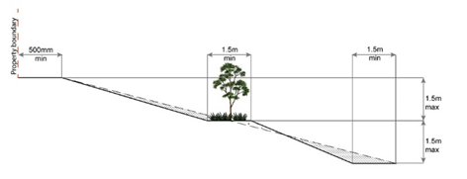
PO47  Filling or excavation is undertaken in a manner that:  - does not adversely impact on a Council or public sector entity maintained infrastructure or any drainage feature on, or adjacent to the land;  - does not preclude reasonable access to a Council or public sector entity maintained infrastructure or any drainage feature on, or adjacent to the land for monitoring, maintenance or replacement purposes. |  |  |  |  |  | E47.1  No filling or excavation is undertaken in an easement issued in favour of Council or a public sector entity.
  Note - Public sector entity as defined in the Act.
  Note - Public sector entity as defined in the Act.
E47.2
Filling or excavation that would result in any of the following is not carried out on-site:
- a reduction in cover over any Council or public sector entity infrastructure service to less than 600mm;
- an increase in finished surface grade over, or within 1.5m on each side of, the Council or public sector entity infrastructure above that which existed prior to the earthworks being undertaken;
- prevent reasonable access to Council or public sector entity maintained infrastructure or any drainage feature on, or adjacent to the site for monitoring, maintenance or replacement purposes.
Note - Public sector entity is defined in Schedule 2 of the Act.
Note - All building work covered by QDC MP1.4 is excluded from this provision.

PO48  Filling or excavation does not result in land instability.  Note - Steep slopes and batters are inspected and certified for long-term stability by a suitably qualified and experienced geotechnical engineer with RPEQ qualifications. Stabilisation measures are provided, as necessary, to ensure long-term stability and low maintenance. |  |  |  |  |  | No example provided.
PO49  Filling or excavation does not result in:  - adverse impacts on the hydrological and hydraulic capacity of the waterway or floodway;  - increased flood inundation outside the site;  - any reduction in the flood storage capacity in the floodway;  - any clearing of native vegetation. |  |  |  |  |  | No example provided.
  Note - To demonstrate compliance with this outcome, Planning Scheme Policy - Stormwater Management provides guidance on the preparation of a site based stormwater management plan by a suitably qualified professional. Refer to Planning scheme policy - Integrated design for guidance on infrastructure design and modelling requirements.
PO50  Filling or excavation on the development site is undertaken in a manner which does not create or accentuate problems associated with stormwater flows and drainage systems on land adjoining the site. |  |  |  |  |  | E50  Filling and excavation undertaken on the development site are shaped in a manner which does not:  - prevent stormwater surface flow which, prior to commencement of the earthworks, passed onto the development site, from entering the land; or  - redirect stormwater surface flow away from existing flow paths; or  - divert stormwater surface flow onto adjacent land, (other than a road), in a manner which:  - concentrates the flow; or  - increases the flow rates of stormwater over the affected section of the adjacent land above the situation which existed prior to the diversion; or  - causes actionable nuisance to any person, property or premises.
PO51  All earth retaining structures provide a positive interface with the streetscape and minimise impacts on the amenity of adjoining residents. |  |  |  |  |  | E51  Earth retaining structures:  - are not constructed of boulder rocks or timber;  - where height is no greater than 900mm, are provided in accordance with Figure - Retaining on a boundary;  Figure - Retaining on boundary  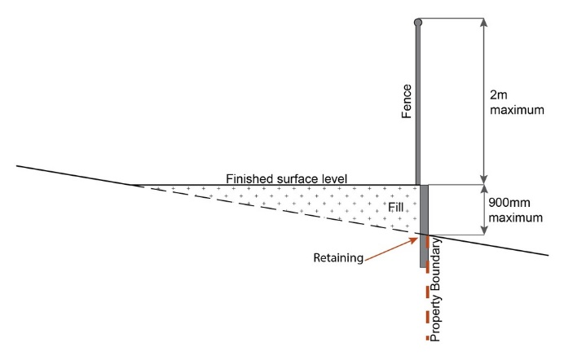  - where height is greater than 900mm but no greater than 1.5m, are to be setback at least the equivalent height of the retaining structure from any property boundary;  - where height is greater than 1.5m, are to be setback and stepped 1.5m vertical: 1.5m horizontal, terraced, landscaped and drained as shown below.  Figure - Cut  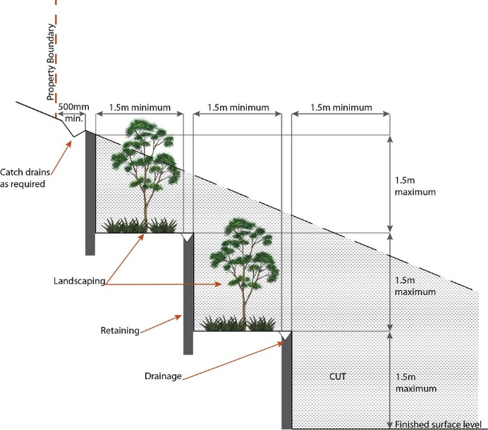  Figure - Fill  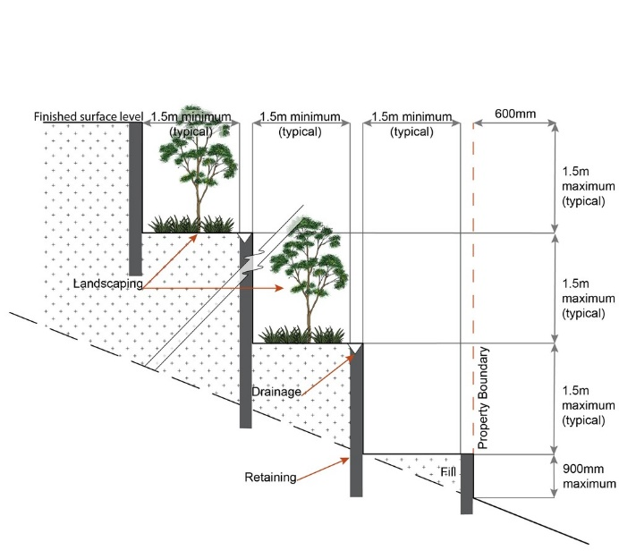
  Note - Refer to Planning scheme policy - Residential design for guidance on how to achieve compliance with this performance outcome.
Fire Services
Note - The provisions under this heading only apply if:
- the development is for, or incorporates:
  - reconfiguring a lot for a community title scheme creating 1 or more vacant lots; or
  - material change of use for 2 or more sole occupancy units on the same lot, or within the same community titles scheme; or
  - material change of use for a Tourist park⁽⁸⁴⁾ with accommodation in the form of caravans or tents; or
  - material change of use for outdoor sales⁽⁵⁴⁾, outdoor processing or outdoor storage where involving combustible materials.
AND
- none of the following exceptions apply:
  - the distributor-retailer for the area has indicated, in its netserv plan, that the premises will not be served by that entity’s reticulated water supply; or
  - every part of the development site is within 60m walking distance of an existing fire hydrant on the distributor-retailer’s reticulated water supply network, measured around all obstructions, either on or adjacent to the site.

Note - The provisions under this heading do not apply to buildings that are required by the Building Code of Australia to have a fire hydrant system complying with Australian Standard AS 2419.1 (2005) – Fire Hydrant Installations or other fire fighting facilities which provide equivalent protection.

PO52  Development incorporates a fire fighting system that:  - satisfies the reasonable needs of the fire fighting entity for the area;  - is appropriate for the size, shape and topography of the development and its surrounds;  - is compatible with the operational equipment available to the fire fighting entity for the area;  - considers the fire hazard inherent in the materials comprising the development and their proximity to one another;  - considers the fire hazard inherent in the surrounds to the development site;  - is maintained in effective operating order. |  |  |  |  |  | E52.1  External fire hydrant facilities are provided on site to the standard prescribed under the relevant parts of Australian Standard AS 2419.1 (2005) – Fire Hydrant Installations.
  Note - The Queensland Fire and Emergency Services is the entity currently providing the fire fighting function for the urban areas of the Moreton Bay Region.
  Note - For this requirement for accepted development, the following are the relevant parts of AS 2419.1 (2005) that may be applicable:
  - in regard to the form of any fire hydrant - Part 8.5 and Part 3.2.2.1, with the exception that for Tourist parks⁽⁸⁴⁾ or development comprised solely of dwellings and their associated outbuildings, single outlet above-ground hydrants or suitably signposted in-ground hydrants would be an acceptable alternative;
  - in regard to the general locational requirements for fire hydrants - Part 3.2.2.2 (a), (e), (f), (g) and (h) as well as Appendix B of AS 2419.1 (2005);
  - in regard to the proximity of hydrants to buildings and other facilities - Part 3.2.2.2 (b), (c) and (d), with the exception that:
    - for dwellings and their associated outbuildings, hydrant coverage need only extend to the roof and external walls of those buildings;
    - for caravans and tents, hydrant coverage need only extend to the roof of those tents and caravans;
    - for outdoor sales⁽⁵⁴⁾, processing or storage facilities, hydrant coverage is required across the entire area of the outdoor sales⁽⁵⁴⁾, outdoor processing and outdoor storage facilities;
  - in regard to fire hydrant accessibility and clearance requirements - Part 3.5 and, where applicable, Part 3.6.
E52.2
A continuous path of travel having the following characteristics is provided between the vehicle access point to the site and each external fire hydrant and hydrant booster point on the land:
- an unobstructed width of no less than 3.5m;
- an unobstructed height of no less than 4.8m;
- constructed to be readily traversed by a 17 tonne HRV fire brigade pumping appliance;
- an area for a fire brigade pumping appliance to stand within 20m of each fire hydrant and 8m of each hydrant booster point.

E52.3
On-site fire hydrant facilities are maintained in effective operating order in a manner prescribed in Australian Standard AS1851 (2012) – Routine service of fire protection systems and equipment.
PO53  On-site fire hydrants that are external to buildings, as well as the available fire fighting appliance access routes to those hydrants, can be readily identified at all times from, or at, the vehicular entry point to the development site. |  |  |  |  |  | E53  For development that contains on-site fire hydrants external to buildings:  - those external hydrants can be seen from the vehicular entry point to the site; or  - a sign identifying the following is provided at the vehicular entry point to the site:  - the overall layout of the development (to scale);  - internal road names (where used);  - all communal facilities (where provided);  - the reception area and on-site manager’s office (where provided);  - external hydrants and hydrant booster points;  - physical constraints within the internal roadway system which would restrict access by fire fighting appliances to external hydrants and hydrant booster points.
  Note - The sign prescribed above, and the graphics used are to be:
  - in a form;
  - of a size;
  - illuminated to a level;
  which allows the information on the sign to be readily understood, at all times, by a person in a fire fighting appliance up to 4.5m from the sign.
PO54  Each on-site fire hydrant that is external to a building is signposted in a way that enables it to be readily identified at all times by the occupants of any firefighting appliance traversing the development site. |  |  |  |  |  | E54  For development that contains on-site fire hydrants external to buildings, those hydrants are identified by way of marker posts and raised reflective pavement markers in the manner prescribed in the technical note Fire hydrant indication system produced by the Queensland Department of Transport and Main Roads.
  Note - Technical note Fire hydrant indication system is available on the website of the Queensland Department of Transport and Main Roads.
Use specific criteria
Dual occupancies⁽²¹⁾
PO55  Dual Occupancies⁽²¹⁾ are infrequent and dispersed within the streetscape and are not located within 200m (measured along the street alignment) of a lot containing an existing, approved or a properly made application for a Dual Occupancy⁽²¹⁾. |  |  |  |  |  | E55  Are located on lots with an area of 1000m² or greater.
  Note - Refer to Planning scheme policy - Residential design for dispersal method and calculation.
Home based business⁽³⁵⁾
PO56  The scale and intensity of the Home Based Business⁽³⁵⁾:  - is compatible with the physical characteristics of the site and the character of the local area;  - is able to accommodate anticipated car parking demand without negatively impacting the streetscape or road safety;  - does not adversely impact on the amenity of adjoining and nearby premises;  - remains ancillary to the residential use of the dwelling;  - does not create conditions which cause hazards or nuisances to neighbours or other persons not associated with the activity;  - ensures employees and visitors to the site do not negatively impact the expected amenity of adjoining properties;  - ensures service and delivery vehicles do not negatively impact the amenity of the area. |  |  |  |  |  | No example provided.
Major electricity infrastructure, Substation and Utility installation
PO57  The development does not have an adverse impact on the visual amenity of a locality and is:  - high quality design and construction;  - visually integrated with the surrounding area;  - not visually dominant or intrusive;  - located behind the main building line;  - below the level of the predominant tree canopy or the level of the surrounding buildings and structures;  - camouflaged through the use of colours and materials which blend into the landscape;  - treated to eliminate glare and reflectivity;  - landscaped;  - otherwise consistent with the amenity and character of the zone and surrounding area. |  |  |  |  |  | E57.1  Development is designed to minimise surrounding land use conflicts by ensuring infrastructure, buildings, structures and other equipment:  - are enclosed within buildings or structures;  - are located behind the main building line;  - have a similar height, bulk and scale to the surrounding fabric;  - have horizontal and vertical articulation applied to all exterior walls.
E57.2
A minimum 3m wide strip of dense planting is provided around the outside of the fenced area, between the development and street frontage, side and rear boundaries.

PO58  Infrastructure does not have an impact on pedestrian health and safety. |  |  |  |  |  | E58  Access control arrangements:  - do not create dead-ends or dark alleyways adjacent to the infrastructure;  - minimise the number and width of crossovers and entry points;  - provide safe vehicular access to the site;  - do not utilise barbed wire or razor wire.
PO59  All activities associated with the development occur within an environment incorporating sufficient controls to ensure the facility:  - generates no audible sound at the site boundaries where in a residential setting; or  - meet the objectives as set out in the Environmental Protection (Noise) Policy 2008. |  |  |  |  |  | E59  All equipment which produces audible or non-audible sound is housed within a fully enclosed building incorporating sound control measures sufficient to ensure noise emissions meet the objectives as set out in the Environmental Protection (Noise) Policy 2008.
Sales office⁽⁷²⁾
PO60  The Sales office⁽⁷²⁾ is:  - designed to provide functional and safe access, manoeuvring areas and car parking spaces for the number and type of vehicles anticipated to access the site;  - temporary in nature;  - not be isolated or separated from land being displayed for sale within the office. |  |  |  |  |  | No example provided.
  Note - Refer to Planning scheme policy - Integrated design for access and crossover requirements.
Telecommunications facility⁽⁸¹⁾
Editor's note - In accordance with the Federal legislation Telecommunications facilities ⁽⁸¹⁾must be constructed and operated in a manner that will not cause human exposure to electromagnetic radiation beyond the limits outlined in the Radiocommunications (Electromagnetic Radiation - Human Exposure) Standard 2003 and Radio Protection Standard for Maximum Exposure Levels to Radiofrequency Fields - 3Khz to 300Ghz.

PO61  Telecommunications facilities⁽⁸¹⁾ are co-located with existing telecommunications facilities⁽⁸¹⁾, Utility installation⁽⁸⁶⁾, Major electricity infrastructure⁽⁴³⁾ or Substation⁽⁸⁰⁾ if there is already a facility in the same coverage area. |  |  |  |  |  | E61.1  New telecommunication facilities⁽⁸¹⁾ are co-located on existing towers with new equipment shelter and associated structures positioned adjacent to the existing shelters and structures.
E61.2
If not co-located with an existing facility, all co-location opportunities have been investigated and fully exhausted within a 2km radius of the site.

PO62  A new Telecommunications facility⁽⁸¹⁾ is designed and constructed to ensure co-masting or co-siting with other carriers both on the tower or pole and at ground level is possible in the future. |  |  |  |  |  | E62  A minimum area of 45m² is available to allow for additional equipment shelters and associated structures for the purpose of co-locating on the proposed facility.
PO63  Telecommunications facilities⁽⁸¹⁾ do not conflict with lawful existing land uses both on and adjoining the site. |  |  |  |  |  | E63  The development results in no net reduction in the minimum quantity and standard of landscaping, private or communal open space or car parking spaces required under the planning scheme or under an existing development approval.
PO64  The Telecommunications facility⁽⁸¹⁾ does not have an adverse impact on the visual amenity of a locality and is:  - high quality design and construction;  - visually integrated with the surrounding area;  - not visually dominant or intrusive;  - located behind the main building line;  - below the level of the predominant tree canopy or the level of the surrounding buildings and structures;  - camouflaged through the use of colours and materials which blend into the landscape;  - treated to eliminate glare and reflectivity;  - landscaped;  - otherwise consistent with the amenity and character of the zone and surrounding area. |  |  |  |  |  | E64.1  Where in an urban area, the development does not protrude more than 5m above the level of the existing treeline, prominent ridgeline or building rooftops in the surrounding townscape.
E64.2
In all other areas towers do not exceed 35m in height.

E64.3
Towers, equipment shelters and associated structures are of a design, colour and material to:
- reduce recognition in the landscape;
- reduce glare and reflectivity.

E64.4
All structures and buildings are setback behind the main building line and a minimum of 10m from side and rear boundaries, except where in the Industry and Extractive industry zones, the minimum side and rear setback is 3m.
Where there is no established building line the facility is located at the rear of the site.

E64.5
The facility is enclosed by security fencing or by other means to ensure public access is prohibited.

E64.6
A minimum 3m wide strip of dense planting is provided around the perimeter of the fenced area, between the facility and street frontage and adjoining uses.
Note - Landscaping is provided in accordance with Planning scheme policy - Integrated design.

Note - Council may require a detailed landscaping plan, prepared by a suitably qualified person, to ensure compliance with Planning scheme policy - Integrated design.

PO65  Lawful access is maintained to the site at all times that does not alter the amenity of the landscape or surrounding uses. |  |  |  |  |  | E65  An Access and Landscape Plan demonstrates how 24 hour vehicular access will be obtained and maintained to the facility in a manner that is appropriate to the site’s context.
PO66  All activities associated with the development occur within an environment incorporating sufficient controls to ensure the facility generates no audible sound at the site boundaries where in a residential setting. |  |  |  |  |  | E66  All equipment comprising the Telecommunications facility⁽⁸¹⁾ which produces audible or non-audible sound is housed within a fully enclosed building incorporating sound control measures sufficient to ensure no noise from this equipment can be heard, or felt at the site boundary.
Retail, commercial and community uses
PO67  Community activities:  - are located to:  - cluster with other non-residential activities to form a neighbourhood hub (this may include being located within or adjacent to an existing neighbourhood hub); or  - if establishing a new neighbourhood hub (as described in the PO below) be on a main street;  - are located on allotments that have appropriate area and dimensions for the siting of:  - buildings and structures;  - vehicle servicing, deliveries, parking, manoeuvring and circulation;  - landscaping and open space including buffering;  - are of a small scale, having regard to the surrounding character;  - are serviced by public transport;  - do not negatively impact adjoining residents or the streetscape. |  |  |  |  |  | No example provided.
PO68  Retail and commercial uses within a neighbourhood hub are of a scale that provide for the convenience needs or localised services of the immediate neighbourhood and do not constitute the scale or function of a Local centre. |  |  |  |  |  | E68  Retail and commercial uses within a neighbourhood hub consist of no more than:  - 1 small format supermarket with a maximum GFA of 1200m²;  - 10 small format retail or commercial tenancies with a maximum GFA of 100m² each.
  Note - For the function and scale of a Local centre refer to Table 6.2.1.1 Moreton Bay centres network.
PO69  The expansion (into adjoining lots) of existing neighbourhood hubs or the establishment of a new neighbourhood hub must:  - adjoin or address a park, public open space or include privately owned civic or forecourt space having a minimum area of 400m²;  - be located on the corner of a sub-arterial or collector road;  - form a ‘Main street’ having a maximum length of 200m;  - be centrally located within an 800m radial catchment;  - be separated from other neighbourhood hubs and centres by 1600m, measured from the centre of each neighbourhood hub or centre. |  |  |  |  |  | No example provided.
PO70  Corner stores may establish as standalone uses where:  - having a maximum GFA of 250m²;  - the building adjoins the street frontage and has its main pedestrian entrance from the street frontage;  - Not within 1600m of another corner store, neighbourhood hub or centre. |  |  |  |  |  | No example provided.
PO71  Service stations are located, designed and orientated to:  - establish on heavily trafficked roads where the amenity of surrounding residential uses is already subject to impacts by road vehicle noise;  - be in proximity of a neighbourhood hub or centre;  - not negatively impact active streets, public spaces or hubs of activity where the pedestrian safety and comfort is of high importance (e.g. in neighbourhood hubs and centres);  - not result in the fragmentation of active streets (e.g. site where active uses are located on adjoining lots);  - ensure the amenity of adjoining properties is protected;  - reduce the visual impact of the Service station from the streetscape while maintaining surveillance from the site to the street;  - minimise impacts on adjoining residential uses, to a level suitable relative to expected residential amenity of the area. (e.g. high order road in urban or next generation neighbourhood, likely to be noisy and not like suburban);  - provide ancillary uses that meet the convenience needs of users. |  |  |  |  |  | E71.1  Service stations are located:  - adjoining or within 400m of:  - a neighbourhood hub identified on Overlay map - Community activities and neighbourhood hubs (not on a neighbourhood hub lot); or  - a centre zone;  - on the corner lot of an arterial or sub-arterial road.
E71.2
Service stations are designed and orientated on site to:
- include a landscaping strip having a minimum depth of 1m adjoining all road frontages;
- building and structures (including fuel pump canopies) are setback a minimum of 3m from the primary and secondary frontage and a minimum of 5m from side and rear boundaries;
- include a screen fence, of a height and standard in accordance with a noise impact assessment (Note - Noise impact assessments are to be prepared in accordance with Planning scheme policy - Noise), on side and rear boundaries where adjoining land is able to contain a residential use;
- not include more than 2 driveway crossovers.

PO72  Non-residential uses (excluding a Service station) address and activate streets and public spaces by:  - ensuring buildings and individual tenancies address street frontage(s), civic space and other areas of pedestrian movement;  - new buildings adjoin or are within 3m of the primary frontage(s), civic space or public open space;  - locating car parking areas and drive-through facilities behind or under buildings to not dominate the street environment;  - establishing and maintaining interaction, pedestrian activity and casual surveillance through appropriate land uses and building design (e.g. The use of windows or glazing and avoiding blank walls with the use of sleeving);  - providing visual interest to the façade (e.g. Windows or glazing, variation in colours, materials, finishes, articulation, recesses or projections);  - establishing and maintaining human scale. |  |  |  |  |  | No example provided.
PO73  All buildings exhibit a high standard of design and construction, which:  - add visual interest to the streetscape (e.g. variation in materials, patterns, textures and colours, cantilevered awning);  - enable differentiation between buildings;  - contribute to a safe environment;  - incorporate architectural features within the building facade at the street level to create human scale (e.g. cantilevered awning);  - include building entrances that are readily identifiable from the road frontage;  - locate and orientate to favour active and public transport usage by connecting to pedestrian footpaths on the street frontage and adjoining sites;  - incorporate appropriate acoustic treatments, having regard to any adjoining residential uses;  - facilitate casual surveillance of all public spaces. |  |  |  |  |  | No example provided.
PO74  Development provides functional and integrated car parking and vehicle access, that:  - prioritises the movement and safety of pedestrians between the street frontage and the entrance to the building;  - provides safety and security of people and property at all times;  - does not impede active frontage and active transport options;  - does not impact on the safe and efficient movement of traffic external to the site;  - is consolidated and shared with adjoining sites wherever possible. |  |  |  |  |  | No example provided.
PO75  The safety and efficiency of pedestrian movement is prioritised in the design of car parking areas through providing pedestrian paths in car parking areas that are:  - located along the most direct route between building entrances, car parks and adjoining uses;  - protected from vehicle intrusion through the use of physical and visual separation (e.g. wheel stops, trees etc);  - are of a width to allow safe and efficient access for prams and wheelchairs. |  |  |  |  |  | No example provided.
PO76  The number of car parking spaces is managed to:  - avoid significant impacts on the safety and efficiency of the road network;  - avoid an oversupply of car parking spaces;  - avoid the visual impact of large areas of open car parking from road frontages and public areas;  - promote active and public transport options;  - promote innovative solutions, including on-street parking and shared parking areas. |  |  |  |  |  | E76.1  Car parking is provided in accordance with Schedule 7 - Car parking.
  Note - Refer to Planning scheme policy - Integrated transport assessment for guidance on how to achieve compliance with this outcome.
  Note - The above rates exclude car parking spaces for people with a disability required by Disability Discrimination Act 1992 or the relevant disability discrimination legislation and standards.
E76.2
All car parking areas are designed and constructed in accordance with Australian Standard AS2890.1 Parking facilities Part 1: Off-street car parking.

PO77  - End of trip facilities are provided for employees or occupants, in the building or on-site within a reasonable walking distance, and include:  - adequate bicycle parking and storage facilities; and  - adequate provision for securing belongings; and  - change rooms that include adequate showers, sanitary compartments, wash basins and mirrors.  - Notwithstanding a. there is no requirement to provide end of trip facilities if it would be unreasonable to provide these facilities having regard to:  - the projected population growth and forward planning for road upgrading and development of cycle paths; or  - whether it would be practical to commute to and from the building on a bicycle, having regard to the likely commute distances and nature of the terrain; or  - the condition of the road and the nature and amount of traffic potentially affecting the safety of commuters. |  |  |  |  |  | E77.1  Minimum bicycle parking facilities are provided in accordance with the table below (rounded up to the nearest whole number).  Editor's note - The examples for end of trip facilities prescribed under the Queensland Development Code permit a local planning instrument to prescribe facility levels higher than the default levels identified in those acceptable solutions. This example is a combination of the default levels set for end of trip facilities in the Queensland Development Code and the additional facilities required by Council.
  Use | Minimum Bicycle Parking
  Residential uses comprised of dwellings | Minimum 1 space per dwelling
  All other residential uses | Minimum 1 space per 2 car parking spaces identified in Schedule 7 – car parking
  Non-residential uses | Minimum 1 space per 200m2 of GFA
E77.2
Bicycle parking is:
- provided in accordance with Austroads (2008), Guide to Traffic Management - Part 11: Parking;
- protected from the weather by its location or a dedicated roof structure;
- located within the building or in a dedicated, secure structure for residents and staff;
- adjacent to building entrances or in public areas for customers and visitors.
Note - Bicycle parking structures are to be constructed to the standards prescribed in AS2890.3.

Note - Bicycle parking and end of trip facilities provided for residential and non-residential activities may be pooled, provided they are within 100 metres of the entrance to the building.

Editor's note - The examples for end of trip facilities prescribed under the Queensland Development Code permit a local planning instrument to prescribe facility levels higher than the default levels identified in those acceptable solutions. This example is an amalgamation of the default levels set for end of trip facilities in the Queensland Development Code and the additional facilities required by Council.

E77.3
For non-residential uses, storage lockers:
- are provide at a rate of 1.6 per bicycle parking space (rounded up to the nearest whole number);
- have minimum dimensions of 900mm (height) x 300mm (width) x 450mm (depth).
Note - Storage lockers may be pooled across multiple sites and activities when within 100 metres of the entrance to the building and within 50 metres of bicycle parking and storage facilities.

Bicycle spaces provided | Male/ Female | Change rooms required | Showers required | Sanitary compartments required | Washbasins required
1-5 | Male and female | 1 unisex change room | 1 | 1 closet pan | 1
6-19 | Female | 1 | 1 | 1 closet pan | 1
20 or more | Male | 1 | 1 | 1 closet pan | 1
20 or more | Female | 1 | 2, plus 1 for every 20 bicycle spaces provided thereafter | 2 closet pans, plus 1 sanitary compartment for every 60 bicycle parking spaces provided thereafter | 1, plus 1 for every 60 bicycle parking spaces provided thereafter
20 or more | Male | 1 | 2, plus 1 for every 20 bicycle spaces provided thereafter | 1 urinal and 1 closet pans, plus 1 sanitary compartment at the rate of 1 closet pan or 1 urinal for every 60 bicycle space provided thereafter | 1, plus 1 for every 60 bicycle parking spaces provided thereafter
Editor's note - The examples for end of trip facilities prescribed under the Queensland Development Code permit a local planning instrument to prescribe facility levels higher than the default levels identified in those acceptable solutions. This example is an amalgamation of the default levels set for end of trip facilities in the Queensland Development Code and the additional facilities required by Council.

E77.4
For non-residential uses, changing rooms:
- are provided at a rate of 1 per 10 bicycle parking spaces;
- are fitted with a lockable door or otherwise screened from public view;
- are provided with shower(s), sanitary compartment(s) and wash basin(s) in accordance with the table below:
Note - All showers have a minimum 3-star Water Efficiency Labelling and Standards (WELS) rating shower head.
Note - All sanitary compartments are constructed in compliance with F2.3 (e) and F2.5 of BCA (Volume 1).
- are provided with:
  - a mirror located above each wash basin;
  - a hook and bench seating within each shower compartment;
  - a socket-outlet located adjacent to each wash basin.
Note - Change rooms may be pooled across multiple sites, residential and non-residential activities when within 100 metres of the entrance to the building and within 50 metres of bicycle parking and storage facilities

Editor's note - The examples for end of trip facilities prescribed under the Queensland Development Code permit a local planning instrument to prescribe facility levels higher than the default levels identified in those acceptable solutions. This example is an amalgamation of the default levels set for end of trip facilities in the Queensland Development Code and the additional facilities required by Council.

PO78  Loading and servicing areas:  - are not visible from the street frontage;  - are integrated into the design of the building;  - include screening and buffers to reduce negative impacts on adjoining sensitive land uses;  - where possible loading and servicing areas are consolidated and shared with adjoining sites. |  |  |  |  |  | No example provided.
PO79  Bins and bin storage area/s are designed, located and managed to prevent amenity impacts on the locality. |  |  |  |  |  | E79  Development is designed to meet the criteria in the Planning scheme policy - Waste and is demonstrated in a waste management program.
PO80  On-site landscaping is provided, that:  - is incorporated into the design of the development;  - reduces the dominance of car parking and servicing areas from the street frontage;  - retains mature trees wherever possible;  - does not create safety or security issues by creating potential concealment areas or interfering with sightlines;  - maintains the achievement of active frontages and sight lines for casual surveillance. |  |  |  |  |  | No example provided.
  Note - All landscaping is to accord with Planning scheme policy - Integrated design.
PO81  Surveillance and overlooking are maintained between the road frontage and the main building line. |  |  |  |  |  | E81  No fencing is provided forward of the building line.
PO82  Lighting is designed to provide adequate levels of illumination to public and communal spaces to maximise safety and minimise adverse impacts on residential and other sensitive land uses. |  |  |  |  |  | No example provided.
PO83  The hours of operation minimise adverse amenity impacts on adjoining sensitive land uses. |  |  |  |  |  | E83  Hours of operation do not exceed 6:00am to 9:00pm Monday to Sunday.
Values and constraints criteria
Note - The relevant values and constraints criteria do not apply where the development is consistent with a current Development permit for Reconfiguring a lot or Material change of use or Operational work, where that approval has considered and addressed (e.g. through a development footprint plan (or similar in the case of Landslide hazard) or conditions of approval) the identified value or constraint under this planning scheme.
Acid sulfate soils - (refer Overlay map - Acid sulfate soils to determine if the following assessment criteria apply)
Note - To demonstrate achievement of the performance outcome, an Acid sulfate soils (ASS) investigation report and soil management plan is prepared by a qualified engineer. Guidance for the preparation an ASS investigation report and soil management plan is provided in Planning scheme policy - Acid sulfate soils.
PO84  Development avoids disturbing acid sulfate soils. Where development disturbs acid sulfate soils, development:  - is managed to avoid or minimise the release of surface or groundwater flows containing acid and metal contaminants into the environment;  - protects the environmental and ecological values and health of receiving waters;  - protects buildings and infrastructure from the effects of acid sulfate soils. |  |  |  |  |  | E84  Development does not involve:  - excavation or otherwise removing of more than 100m³ of soil or sediment where below than 5m Australian Height datum AHD; or  - filling of land of more than 500m³ of material with an average depth of 0.5m or greater where below the 5m Australian Height datum AHD.
Environmental areas (refer Overlay map - Environmental areas to determine if the following assessment criteria apply)
Note – The following are excluded from the native vegetation clearing provisions of this planning scheme:
Clearing of native vegetation located within an approved development footprint;
Clearing of native vegetation within 10m from a lawfully established building reasonably necessary for emergency access or immediately required in response to an accident or emergency;
Clearing of native vegetation reasonably necessary to remove or reduce the risk vegetation poses to serious personal injury or damage to infrastructure;
Clearing of native vegetation reasonably necessary to construct and maintain a property boundary fence and not exceed 4m in width either side of the fence where in the Rural, Rural residential and Environmental Management and Conservation zones. In any other zone, clearing is not to exceed 2m in width either side of the fence;
Clearing of native vegetation reasonably necessary for the purpose of maintenance or works within a registered easement for public infrastructure or drainage purposes;
Clearing of native vegetation in accordance with a bushfire management plan prepared by a suitably qualified person, submitted to and accepted by Council;
Clearing of native vegetation associated with removal of recognised weed species, maintaining existing open pastures and cropping land, windbreaks, lawns or created gardens;
Grazing of native pasture by stock;
Native forest practice where accepted development under Part 1, 1.7.7 Accepted development

Note - Definition for native vegetation is located in Schedule 1 Definitions.
Note - Native vegetation subject to this criteria primarily comprises of matters of national environmental significance (MNES), matters of state environmental significance (MSES). They also comprise some matters of local environmental significance (MLES). A MLES is defined in Schedule 1.2, Administrative definitions. A list of the elements that apply to the mapped MSES and MLES is provided in Appendix 1 of the Planning scheme policy - Environmental areas.
Editors' Note - The accuracy of overlay mapping can be challenged through the development application process (code assessable development) or by way of a planning scheme amendment. See Council's website for details.
Note - To demonstrate achievement of the performance outcome, an ecological assessment, vegetation management plan and fauna management plan, as required, are prepared by a suitably qualified person. Guidance for the preparation of above mentioned reports is provided in Planning scheme policy - Environmental areas.
Vegetation clearing, ecological value and connectivity
PO85  Development avoids locating in a High Value Area or a Value Offset Area. Where it is not practicable or reasonable for development to avoid establishing in these areas, development must ensure that:  - the quality and integrity of the biodiversity and ecological values inherent to a High Value Area and a Value Offset Area is maintained and not lost or degraded;  - on-site mitigation measures, mechanisms or processes are in place demonstrating the quality and integrity of the biodiversity and ecological values inherent to a High Value Area and a Value Offset Area are maintained. For example, this can be achieved through replacement, restoration or rehabilitation planting as part of any proposed covenant, the development of a Vegetation Management Plan, a Fauna Management Plan, and any other on-site mitigation options identified in the Planning scheme policy - Environmental areas*. |  |  |  |  |  | No example provided.
  * Editor's note - This is not a requirement for an environmental offset under the Environmental Offsets Act 2014.
PO86  Development provides for safe, unimpeded, convenient and ongoing wildlife movement and establishes and maintains habitat connectivity by:  - retaining habitat trees;  - providing contiguous patches of habitat;  - provide replacement and rehabilitation planting to improve connectivity;  - avoiding the creation of fragmented and isolated patches of habitat;  - providing wildlife movement infrastructure. |  |  |  |  |  | No example provided.
  Editor's note - Wildlife movement infrastructure may include refuge poles, tree boulevarding, ‘stepping stone’ vegetation plantings, tunnels, appropriate wildlife fencing; culverts with ledges, underpasses, overpasses, land bridges and rope bridges. Further information is provided in Planning scheme policy – Environmental areas.
Vegetation clearing and habitat protection
PO87  Development ensures that the biodiversity quality and integrity of habitats is not adversely impacted upon but maintained and protected. |  |  |  |  |  | No example provided.
PO88  Development does not result in the net loss or degradation of habitat value in a High Value Area or a Value Offset Area. Where development does result in the loss or degradation of habitat value, development will:  - rehabilitate, revegetate, restore and enhance an area to ensure it continues to function as a viable and healthy habitat area;  - provide replacement fauna nesting boxes in the event of habitat tree loss in accordance with Planning scheme policy - Environmental areas;  - undertake rehabilitation, revegetation and restoration in accordance with the South East Queensland Ecological Restoration Framework. |  |  |  |  |  | No example provided.
PO89  Development ensures safe, unimpeded, convenient and ongoing wildlife movement and habitat connectivity by:  - providing contiguous patches of habitat;  - avoiding the creation of fragmented and isolated patches of habitat;  - providing wildlife movement infrastructure;  - providing replacement and rehabilitation planting to improve connectivity. |  |  |  |  |  | No example provided.
Vegetation clearing and soil resource stability
PO90  Development does not:  - result in soil erosion or land degradation;  - leave cleared land exposed for an unreasonable period of time but is rehabilitated in a timely manner. |  |  |  |  |  | No example provided.
Vegetation clearing and water quality
PO91  Development maintains or improves the quality of groundwater and surface water within, and downstream, of a site by:  - ensuring an effective vegetated buffers and setbacks from waterbodies is retained to achieve natural filtration and reduce sediment loads;  - avoiding or minimising changes to landforms to maintain hydrological water flows;  - adopting suitable measures to exclude livestock from entering a waterbody where a site is being used for animal husbandry⁽⁴⁾ and animal keeping⁽⁵⁾ activities. |  |  |  |  |  | No example provided.
PO92  Development minimises adverse impacts of stormwater run-off on water quality by:  - minimising flow velocity to reduce erosion;  - minimising hard surface areas;  - maximising the use of permeable surfaces;  - incorporating sediment retention devices;  - minimising channelled flow. |  |  |  |  |  | No example provided.
Vegetation clearing and access, edge effects and urban heat island effects
PO93  Development retains safe and convenient public access in a manner that does not result in the adverse edge effects or the loss or degradation of biodiversity values within the environment. |  |  |  |  |  | No example provided.
PO94  Development minimises potential adverse ‘edge effects’ on ecological values by:  - providing dense planting buffers of native vegetation between a development and environmental areas;  - retaining patches of native vegetation of greatest possible size where located between a development and environmental areas ;  - restoring, rehabilitating and increasing the size of existing patches of native vegetation;  - ensuring that buildings and access (public and vehicle) are setback as far as possible from environmental areas and corridors;  - landscaping with native plants of local origin. |  |  |  |  |  | No example provided.
  Editor's note - Edge effects are factors of development that go to detrimentally affecting the composition and density of natural populations at the fringe of natural areas. Factors include weed invasion, pets, public and vehicle access, nutrient loads, noise and light pollution, increased fire frequency and changes in the groundwater and surface water flow.
PO95  Development avoids adverse microclimate change and does not result in increased urban heat island effects. Adverse urban heat island effects are minimised by:  - pervious surfaces;  - providing deeply planted vegetation buffers and green linkage opportunities;  - landscaping with local native plant species to achieve well-shaded urban places;  - increasing the service extent of the urban forest canopy. |  |  |  |  |  | No example provided.
Vegetation clearing and Matters of Local Environmental Significance (MLES) environmental offsets
PO96  Where development results in the unavoidable loss of native vegetation within a Value Offset Area MLES waterway buffer or a Value Offset Area MLES wetland buffer, an environmental offset is required in accordance with the environmental offset requirements identified in Planning scheme policy - Environmental areas. |  |  |  |  |  | No example provided.
  Editor's note - For MSES Koala Offsets, the environmental offset provisions in schedule 11 of the Regulation, in combination with the requirements of the Environmental Offset Act 2014, apply.
Extractive resources separation area (refer Overlay map - Extractive resources (separation area) to determine if the following assessment criteria apply)
Note - To demonstrate achievement of the performance outcomes, a noise impact assessment report is prepared by a suitably qualified person. Guidance to preparing noise impact assessment report is provided in Planning scheme policy – Noise.

PO97  Development does not increase the number of people living in the Extractive Resources separation area. |  |  |  |  |  | E97  One dwelling house⁽²²⁾ permitted per lot within separation area.
PO98  Development:  - does not introduce or increase uses that are sensitive to the impacts of an Extractive industry⁽²⁷⁾;  - is compatible with the operation of an Extractive industry⁽²⁷⁾;  - does not comprise or undermine the function and integrity of the separation area in providing a buffer between key extractive and processing activities and sensitive, incompatible uses outside the separation area. |  |  |  |  |  | E98  Development within the separation area does not include the following activities:  - Caretaker's accommodation⁽¹⁰⁾;  - Community residence⁽¹⁶⁾;  - Dual occupancy⁽²¹⁾;  - Dwelling unit⁽²³⁾;  - Hospital⁽³⁶⁾;  - Rooming accommodation⁽⁶⁹⁾;  - Multiple dwelling⁽⁴⁹⁾;  - Non-resident workforce accommodation⁽⁵²⁾;  - Relocatable home park⁽⁶²⁾;  - Residential care facility⁽⁶⁵⁾;  - Resort complex⁽⁶⁶⁾;  - Retirement facility⁽⁶⁷⁾;  - Rural workers’ accommodation⁽⁷¹⁾;  - Short-term accommodation⁽⁷⁷⁾;  - Tourist park⁽⁸⁴⁾.
PO99  Habitable rooms achieve the noise levels listed in Schedule 1 Acoustic Quality Objectives, Environmental Protection (Noise) Policy 2008 and provides a safe, healthy and disturbance free living environment. |  |  |  |  |  | E99  All habitable rooms within the separation area are:  - acoustically insulated to achieve the noise levels listed in Schedule 1 Acoustic Quality Objectives, Environmental Protection (Noise) Policy 2008;  - provided with mechanical ventilation.
Extractive resources transport route (refer Overlay map - Extractive resources (transport route and buffer) to determine if the following assessment criteria apply)
PO100  Development:  - does not increase in the number of people living in close proximity to a transport route and being subject to the adverse effects from the transportation route;  - does not result in the establishment of uses that are incompatible with the operation of Extractive resources transport routes;  - adopts design and location measures to satisfactorily mitigate the potential adverse impacts associated with transportation routes on sensitive land uses. Such measures include, but are not limited to:  - locating the furthest distance possible from the transportation route;  - habitable rooms being located the furthest from the transportation route;  - shielding and screening private outdoor recreation space from the transportation routes. |  |  |  |  |  | E100  The following uses are not located within the 100m wide transport route buffer:  - Caretaker’s accommodation⁽¹⁰⁾, except where located in the Extractive industry zone;  - Community residence⁽¹⁶⁾;  - Dual occupancy⁽²¹⁾;  - Dwelling house⁽²²⁾;  - Dwelling unit⁽²³⁾;  - Hospital⁽³⁶⁾;  - Rooming accommodation⁽⁶⁹⁾;  - Multiple dwelling⁽⁴⁹⁾;  - Non-resident workforce accommodation⁽⁵²⁾;  - Relocatable home park⁽⁶²⁾;  - Residential care facility⁽⁶⁵⁾;  - Resort complex⁽⁶⁶⁾;  - Retirement facility⁽⁶⁷⁾;  - Rural workers’ accommodation⁽⁷¹⁾;  - Short-term accommodation⁽⁷⁷⁾;  - Tourist park⁽⁸⁴⁾.
PO101  Development:  - does not adversely impact upon the efficient and effective transportation of extractive material along a transportation route;  - ensures vehicle access and egress along transportation routes are designed and located to achieve a high degree of safety, having good visibility;  - utilises existing vehicle access points and where existing vehicle access points are sub-standard or poorly formed, they are upgraded to an appropriate standard. |  |  |  |  |  | E101.1  Development does not create a new vehicle access point onto an Extractive resources transport route.
E101.2
A vehicle access point is located, designed and constructed in accordance with Planning scheme policy - Integrated design.

Heritage and landscape character (refer Overlay map - Heritage and landscape character to determine if the following assessment criteria apply)
Note - To assist in demonstrating achievement of heritage performance outcomes, a Cultural heritage impact assessment report is prepared by a suitably qualified person verifying the proposed development is in accordance with The Australia ICOMOS Burra Charter.
Note - To assist in demonstrating achievement of this performance outcome, a Tree assessment report is prepared by a qualified arborist in accordance with Planning scheme policy – Heritage and landscape character. The Tree assessment report will also detail the measures adopted in accordance with AS 4970-2009 Protection of trees on development sites.
Note - Places, including sites, objects and buildings having local cultural heritage significance, are identified on Overlay map - Heritage and landscape character and listed in Schedule 1 of Planning scheme policy - Heritage and landscape character. Places also having cultural heritage significance at a State level and being entered in the Queensland Heritage Register, are also identified in Schedule 1 of Planning scheme policy - Heritage and landscape character.

PO102  Development will:  - not diminish or cause irreversible damage to the cultural heritage values present on the site, and associated with a heritage site, object or building;  - protect the fabric and setting of the heritage site, object or building;  - be consistent with the form, scale and style of the heritage site, object or building;  - utilise similar materials to those existing, or where this is not reasonable or practicable, neutral materials and finishes;  - incorporate complementary elements, detailing and ornamentation to those present on the heritage site, object or building;  - retain public access where this is currently provided. |  |  |  |  |  | E102  Development is for the preservation, maintenance, repair and restoration of a site, object or building of cultural heritage value.
  Note - A cultural heritage conservation management plan for the preservation, maintenance, repair and restoration of a site, object or building of cultural heritage value is prepared in accordance with Planning scheme policy - Heritage and landscape character. The plan is sent to, and approved by Council prior to the commencement of any preservation, maintenance, repair and restoration works.
PO103  Demolition and removal is only considered where:  - a report prepared by a suitably qualified conservation architect or conservation engineer demonstrates that the building is structurally unsound and is not reasonably capable of economic repair; or  - demolition is confined to the removal of outbuildings, extensions and alterations that are not part of the original structure; or  - limited demolition is performed in the course of repairs, maintenance or restoration; or  - demolition is performed following a catastrophic event which substantially destroys the building or object. |  |  |  |  |  | No example provided.
PO104  Where development is occurring on land adjoining a site of cultural heritage value, the development is to be sympathetic to and consistent with the cultural heritage values present on the site and not result in their values being eroded, degraded or unreasonably obscured from public view. |  |  |  |  |  | No example provided.
PO105  Development does not adversely impact upon the health and vitality of significant trees. Where development occurs in proximity to a significant tree, construction measures and techniques as detailed in AS 4970-2009 Protection of trees on development sites are adopted to ensure a significant tree's health, wellbeing and vitality.  Significant trees are only removed where they are in a poor state of health or where they pose a health and safety risk to persons or property. A Tree Assessment report prepared by a suitably qualified arborist confirming a tree's state of health is required to demonstrate achievement of this performance outcome. |  |  |  |  |  | E105  Development does:  - not result in the removal of a significant tree;  - not occur within 20m of a protected tree;  - involve pruning of a tree in accordance with Australian Standard AS 4373-2007 – Pruning of Amenity Trees.
Infrastructure buffers (refer Overlay map - Infrastructure buffers to determine if the following assessment criteria apply)
PO106  Odour sensitive development is separated from Wastewater treatment plants so they are not adversely affected by odour emission or other air pollutant impacts. |  |  |  |  |  | E106  The following uses are not located within a wastewater treatment site buffer:  - Caretaker’s accommodation⁽¹⁰⁾;  - Community residence⁽¹⁶⁾;  - Dual occupancy⁽²¹⁾;  - Dwelling house⁽²²⁾  - Dwelling unit⁽²³⁾;  - Hospital⁽³⁶⁾;  - Rooming accommodation⁽⁶⁹⁾;  - Multiple dwelling⁽⁴⁹⁾;  - Non-resident workforce accommodation⁽⁵²⁾;  - Relocatable home park⁽⁶²⁾;  - Residential care facility⁽⁶⁵⁾;  - Resort complex⁽⁶⁶⁾;  - Retirement facility⁽⁶⁷⁾;  - Rural workers’ accommodation⁽⁷¹⁾;  - Short-term accommodation⁽⁷⁷⁾;  - Tourist park⁽⁸⁴⁾.
PO107  Development within a Water supply buffer captures solid or liquid waste from all land use, development and activities is designed, constructed and managed to prevent the release of contaminants to surface water or groundwater bodies. |  |  |  |  |  | E107.1  Run-off and sediment from roadways and impervious surfaces within a Water supply buffer are intercepted and treated on-site to remove oil, grease, chemicals, silt, trace metals and nutrients such as nitrogen and phosphorous.
E107.2
Incineration or burial of waste within a Water supply buffer is not undertaken onsite.
E107.3
Solid waste within a Water supply buffer is collected and stored in weather proof, sealed waste receptacles, located in roofed and bunded areas, for disposal by a licenced contractor.
E107.4
Holding tanks within a Water supply buffer are used for all liquid waste and provide for the separation of oils/solvents and solids prior to pump-out and collection by a licenced contractor.
E107.5
Management, handling and storage of hazardous chemicals (including fuelling of vehicles) within a Water supply buffer, is undertaken in secured, climate controlled, weather proof, level and bunded enclosures.

PO108  On-site sewerage systems within a Water supply buffer are designed and operated to ensure there is no worsening or adverse impacts to health risks, environmental risks and water quality. |  |  |  |  |  | E108  Secondary treated wastewater treatment systems within a Water supply buffer include:  - emergency storage capable of holding 3-6 hours peak flow of treated effluent in the event of emergencies or overload with provision for de-sludging;  - back up pump installation and backup power;  - MEDLI modelling to determine irrigation rates and sizing of irrigation areas;  - vegetated land application areas are not located in overland flow paths or on areas that perform groundwater recharge or discharge functions; and  - wastewater collection and storage systems have a capacity to accommodate full load at peak times and includes temporary facilities.
  Editor's Note - For guidance refer to the Seq water Development Guidelines: Development Guidelines for Water Quality Management in Drinking Water Catchments 2012.
PO109  Development within a Bulk water supply infrastructure buffer is located, designed and constructed to:  - protect the integrity of the water supply pipeline;  - maintain adequate access for any required maintenance or upgrading work to the water supply pipeline; |  |  |  |  |  | E109  Development:  - does not involve the construction of any buildings or structures within a Bulk water supply infrastructure buffer;  - involving a major hazard facility or environmentally relevant activity (ERA) is setback 30m from a Bulk water supply infrastructure buffer.
PO110  Development is located and designed to maintain required access to Bulk water supply infrastructure. |  |  |  |  |  | E110  Development does not restrict access to Bulk water supply infrastructure of any type or size, having regard to (among other things):  - buildings or structures;  - gates and fences;  - storage of equipment or materials;  - landscaping or earthworks or stormwater or other infrastructure.
PO111  Odour sensitive development is separated from landfill sites so they are not adversely affected by odour emission or other air pollutant impacts. |  |  |  |  |  | E111  The following uses are not located within a Landfill buffer:  - Caretaker’s accommodation⁽¹⁰⁾;  - Community residence⁽¹⁶⁾;  - Dual occupancy⁽²¹⁾;  - Dwelling house⁽²²⁾;  - Dwelling unit⁽²³⁾;  - Hospital⁽³⁶⁾;  - Rooming accommodation⁽⁶⁹⁾;  - Multiple dwelling⁽⁴⁹⁾;  - Non-resident workforce accommodation⁽⁵²⁾;  - Relocatable home park⁽⁶²⁾;  - Residential care facility⁽⁶⁵⁾;  - Resort complex⁽⁶⁶⁾;  - Retirement facility⁽⁶⁷⁾;  - Rural workers’ accommodation⁽⁷¹⁾;  - Short-term accommodation⁽⁷⁷⁾;  - Tourist park⁽⁸⁴⁾.
PO112  Habitable rooms within an Electricity supply substation buffer are located a sufficient distance from substations⁽⁸⁰⁾ to avoid any potential adverse impacts on personal health and wellbeing from electromagnetic fields. |  |  |  |  |  | E112  Habitable rooms:  - are not located within an Electricity supply substation buffer; and  - proposed on a site subject to an Electricity supply supply substation⁽⁸⁰⁾are acoustically insulted to achieve the noise levels listed in Schedule 1, Acoustic Quality Objectives, Environmental Protection (Noise) Policy 2008.
  Note - Habitable room is defined in the Building Code of Australia (Volume 1)
  Note - Habitable room is defined in the Building Code of Australia (Volume 1)
PO113  Habitable rooms within an Electricity supply substation buffer are acoustically insulated from the noise of a substation⁽⁸⁰⁾ to achieve the noise levels listed in Schedule 1 Acoustic Quality Objectives, Environmental Protection (Noise) Policy 2008 and provides a safe, healthy and disturbance free living environment. |  |  |  |  |  | No example provided.
  Note - To demonstrate achievement of the performance outcome, a noise impact assessment report is prepared by a suitably qualified person. Guidance to preparing an noise impact assessment report is provided in Planning scheme policy – Noise.
  Note - Habitable room is defined in the Building Code of Australia (Volume 1)
PO114  Development within a High voltage electricity line buffer provides adequate buffers to high voltage electricity lines to protect amenity and health by ensuring development:  - is located and designed to avoid any potential adverse impacts on personal health and wellbeing from electromagnetic fields in accordance with the principle of prudent avoidance;  - is located and designed in a manner that maintains a high level of security of supply;  - is located and design so not to impede upon the functioning and maintenance of high voltage electrical infrastructure. |  |  |  |  |  | E114  Development does not involve the construction of any buildings or structures within a High voltage electricity line buffer.
PO115  Development within a Pumping station buffer is located, designed and constructed to:  - ensure that odour or other air pollutant impacts on the amenity of the development met the air quality of objectives in the Environmental Protection (Air) Policy 2008;  - ensure that noise impacts on the amenity of the development met the indoor noise objectives set out in the Environmental Protection (Noise) Policy 2008. |  |  |  |  |  | E115  Development does not involve the construction of any buildings or structures within a Pumping station buffer.
Overland flow path (refer Overlay map - Overland flow path to determine if the following assessment criteria apply)
Note - The applicable river and creek flood planning levels associated with defined flood event (DFE) within the inundation area can be obtained by requesting a flood check property report from Council.

PO116  Development:  - minimises the risk to persons from overland flow;  - does not increase the potential for damage from overland flow either on the premises or other premises, public land, watercourses, roads or infrastructure. |  |  |  |  |  | No example provided.
PO117  Development:  - maintains the conveyance of overland flow predominantly unimpeded through the premises for any event up to and including the 1% AEP for the fully developed upstream catchment;  - does not concentrate, intensify or divert overland flow onto an upstream, downstream or surrounding property. |  |  |  |  |  | No example provided.
  Note - A report from a suitably qualified Registered Professional Engineer Queensland is required certifying that the development does not increase the potential for significant adverse impacts on an upstream, downstream or surrounding premises.
  Note - Reporting to be prepared in accordance with Planning scheme policy – Flood hazard, Coastal hazard and Overland flow.
PO118  Development does not:  - directly, indirectly or cumulatively cause any increase in overland flow velocity or level;  - increase the potential for flood damage from overland flow either on the premises or other premises, public lands, watercourses, roads or infrastructure.  Note - Open concrete drains greater than 1m in width are not an acceptable outcome, nor are any other design options that may increase scouring. |  |  |  |  |  | No example provided.
PO119  Development ensures that public safety and the risk to the environment are not adversely affected by a detrimental impact of overland flow on a hazardous chemical located or stored on the premises. |  |  |  |  |  | E119  Development ensures that a hazardous chemical is not located or stored in an Overland flow path area.
  Note - Refer to the Work Health and Safety Act 2011 and associated Regulation and Guidelines, the Environmental Protection Act 1994 and the relevant building assessment provisions under the Building Act 1975 for requirements related to the manufacture and storage of hazardous substances.
PO120  Development which is not in a Rural zone ensures that overland flow is not conveyed from a road or public open space onto a private lot. |  |  |  |  |  | E120  Development which is not in a Rural zone that an overland flow paths and drainage infrastructure is provided to convey overland flow from a road or public open space area away from a private lot.
PO121  Development ensures that inter-allotment drainage infrastructure, overland flow paths and open drains through private property cater for overland flows for a fully developed upstream catchment and are able to be easily maintained. |  |  |  |  |  | E121.1  Development ensures that roof and allotment drainage infrastructure is provided in accordance with the following relevant level as identified in QUDM:  - Urban area – Level III;  - Rural area – N/A;  - Industrial area – Level V;  - Commercial area – Level V.
  Note - A report from a suitably qualified Registered Professional Engineer Queensland is required certifying that the development does not increase the potential for significant adverse impacts on an upstream, downstream or surrounding premises.
  Note - Reporting to be prepared in accordance with Planning scheme policy – Flood hazard, Coastal hazard and Overland flow
E121.2
Development ensures that inter-allotment drainage infrastructure is designed to accommodate any event up to and including the 1% AEP for the fully developed upstream catchment.

PO122  Development protects the conveyance of overland flow such that an easement for drainage purposes is provided over:  - a stormwater pipe if the nominal pipe diameter exceeds 300mm;  - an overland flow path where it crosses more than one premises;  - inter-allotment drainage infrastructure. |  |  |  |  |  | No example provided.
  Note - Refer to Planning scheme policy - Integrated design for details and examples.
  Note - Stormwater Drainage easement dimensions are provided in accordance with Section 3.8.5 of QUDM.
Additional criteria for development for a Park
PO123  Development for a Park⁽⁵⁷⁾ ensures that the design and layout responds to the nature of the overland flow affecting the premises such that:  - public benefit and enjoyment is maximised;  - impacts on the asset life and integrity of park structures is minimised;  - maintenance and replacement costs are minimised. |  |  |  |  |  | E123  Development for a Park⁽⁵⁷⁾ ensures works are provided in accordance with the requirements set out in Appendix B of the Planning scheme policy - Integrated design.
Riparian and wetland setbacks
PO124  Development provides and maintains a suitable setback from waterways and wetlands that protects natural and environmental values. This is achieved by recognising and responding to the following matters:  - impact on fauna habitats;  - impact on wildlife corridors and connectivity;  - impact on stream integrity;  - impact of opportunities for revegetation and rehabilitation planting;  - edge effects. |  |  |  |  |  | E124  Development does not occur within:  - 50m from top of bank for W1 waterway and drainage line  - 30m from top of bank for W2 waterway and drainage line  - 20m from top of bank for W3 waterway and drainage line  - 100m from the edge of a Ramsar wetland, 50m from all other wetlands.
  Note - W1, W2 and W3 waterway and drainage lines, and wetlands are mapped on Schedule 2, Section 2.5 Overlay Maps – Riparian and wetland setbacks.
Scenic amenity - Regionally significant (Hills) and Locally important (Coast) (refer Overlay map - Scenic amenity to determine if the following assessment criteria apply)
PO125  Development:  - avoids being viewed as a visually conspicuous built form on a hill top or ridgeline;  - retain the natural character or bushland settings as the dominant landscape characteristic;  - is viewed as being visually consistent with the natural landscape setting and does not diminish the scenic and visual qualities present in the environment. |  |  |  |  |  | E125  Where located in the Regionally significant (Hills) scenic amenity overlay, buildings and structures are not:  - located on a hill top or ridge line;  - all parts of the building and structure are located below the hill top or ridge line.
PO126  Development:  - does not adversely detract or degrade the quality of views, vista or key landmarks;  - retains the natural character or bushland settings as the dominant landscape characteristic. |  |  |  |  |  | E126  Where located in the Regionally significant (Hills) scenic amenity overlay, driveways and accessways:  - go across land contours, and do not cut straight up slopes;  - follow natural contours, not resulting in batters or retaining walls being greater than 900mm in height.
PO127  Buildings and structures incorporate colours and finishes that:  - are consistent with a natural, open space character and bushland environment;  - do not produce glare or appear visual incompatible with the surrounding natural character and bushland environment;  - are not visually dominant or detract from the natural qualities of the landscape. |  |  |  |  |  | E127.1  Where located in the Regionally significant (hills) scenic amenity overlay, roofs and wall surfaces of buildings and structures adopt the following colours:
  Colours from Australian Standard AS2700s – 1996
  G12 – Holly | G54 – Mist Green | N 44 – Bridge Grey
  G13 – Emerald | G55 – Lichen | N45 – Koala Grey
  G14 – Moss Green | G56 – Sage Green | N52 – Mid Grey
  G15 – Rainforest Green | G62 – Rivergum | N54 – Basalt
  G16 – Traffic Green | G64 – Slate | N55 – Lead Grey
  G17 – Mint Green | G65 – Ti Tree | X54 – Brown
  G21 – Jade | N25 – Birch Grey | X61 – Wombat
  G22 – Serpentine | N32 – Green Grey | X62 – Dark Earth
  G23 – Shamrock | N33 – Lightbox Grey | X63 – Iron Bark
  G24 – Fern Green | N35 – Light Grey | Y51 – Bronze Olive
  G25 – Olive | N41 – Oyster | Y61 – Black Olive
  G34 – Avocado | N42 – Storm Grey | Y63 – Khaki
  G52 – Eucalyptus | N43 – Pipeline Grey | Y66 – Mudstone
  G53 – Banksia
E127.2
Where located in the Regionally significant (hills) scenic amenity overlay, roofs and wall surfaces of buildings and structures are painted or finished such that reflectivity is less than 35%.
PO128  Landscaping  - complements the coastal landscape character and amenity;  - has known resilience and robustness in the coastal environment;  Fences and walls:  - do not appear visually dominant or conspicuous within its setting;  - reduce visual appearance through the use of built form articulation, setbacks, and plant screening;  - use materials and colours that are complementary to the coastal environment.  Building design responds to the bayside location and complements the particular bayside character and amenity by adopting and incorporating a range of architectural character elements.  Vegetation that contributes to bayside character and identity are:  - retained;  - protected from development diminishing their significance. |  |  |  |  |  | E128  Where located in the Locally Important (Coast) scenic amenity overlay:  - landscaping comprises indigenous coastal species;  - fences and walls are no higher than 1m; and  - existing pine trees, palm trees, mature fig and cotton trees are retained.  - where over 12m in height, the building design includes the following architectural character elements:  - curving balcony edges and walls, strong vertical blades and wall planes;  - balcony roofs, wall articulation expressed with different colours, curves in plan and section, and window awnings;  - roof top outlooks, tensile structures as shading devices;  - lightweight structures use white frame elements in steel and timber, bold colour contrast.
Transport noise corridors (refer Overlay map - Transport noise corridors to determine if the following assessment criteria apply)
Note - This is for information purposes only. No requirements for accepted development or criteria for assessable development apply. Development located within a Transport Noise Corridor must satisfy the requirements of the Queensland Development Code

 | Table 6.2.6.2.3 Setbacks
 | Residential uses
 | Height of wall | Frontage  primary |  |  | Frontage  secondary to street |  |  |  |  | Frontage  secondary to lane |  |  | Side  non-built to boundary wall  To OMP and wall |  | Rear  To OMP and wall |  | Trafficable water body  To OMP and wall
 | Height of wall | To wall | To OMP | To covered car parking space* | To wall |  | To OMP |  | To covered car parking space* |  | To OMP, wall and covered car parking space*
 | Less than 4.5m | Min 4.5m | Min 3m | Min 5.4m | Min 3m |  | Min 2m |  | Min 5.4m |  | Min 0.5m |  |  | Min 1.5m |  | Min 1.5m |  | Min 4.5m
 | 4.5m to 8.5m | Min 4.5m | Min 3m | N/A | Min 3m |  | Min 2m |  | N/A |  | Min 0.5m |  |  | Min 2m |  | Min 2m |  | Min 4.5m
 | Greater than 8.5 | Min 4.5m | Min 3m | N/A | Min 3m |  | Min 2m |  | N/A |  | Min 0.5m |  |  | Min 2m up to 8.5m in height; plus 0.5m for every 3m in height (or storey) or part thereof over 8.5m |  | Min 2m up to 8.5m in height; plus 0.5m for every 3m in height (or storey) or part thereof over 8.5m |  | Min 4.5m

Note - * Does not apply to basement car parking areas
Table 6.2.6.2.4 Built to boundary walls (Residential uses)
Lot frontage width | Mandatory / Optional | Length and height of built to boundary wall  Suburban neighbourhood precinct
Less than 7.5m | Mandatory - both sides unless a corner lot | As per QDC
7.5m to 12.5m | Mandatory - one side | As per QDC
Greater than 12.5m to 18m | Optional:  - on 1 boundary only;  - where the built to boundary wall adjoins a lot with a frontage less than 18m | As per QDC
Greater than 18m | Not permitted.

Movement network figures
Figure 1 - Elimbah - Beerburrum Road
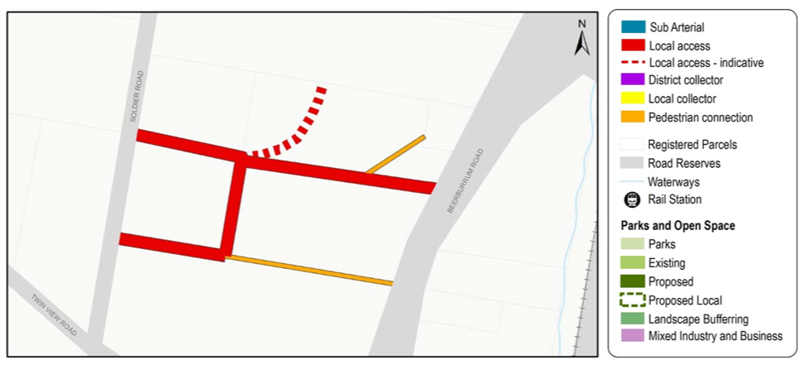

Figure 2 - Bellmere - Guilford Court
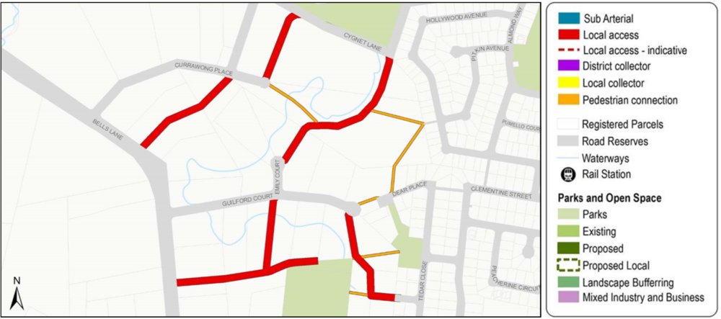

Figure 3 - Narangba - Youngs Road / Oakey Flat Road
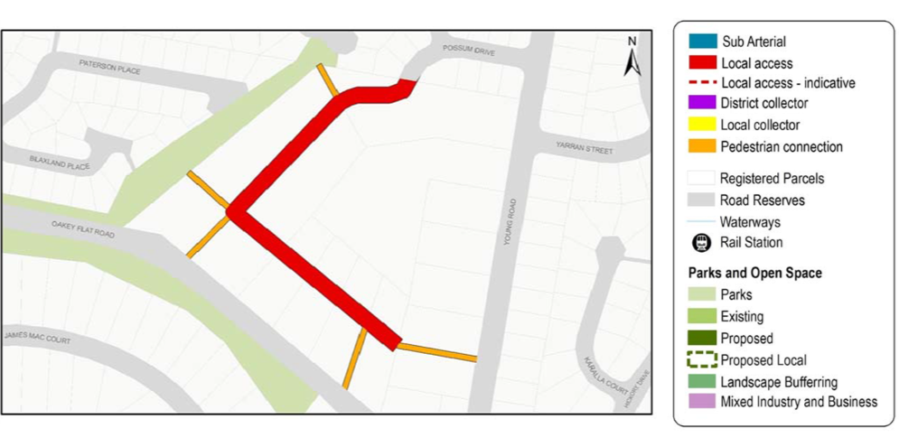

Figure 4 - Dakabin
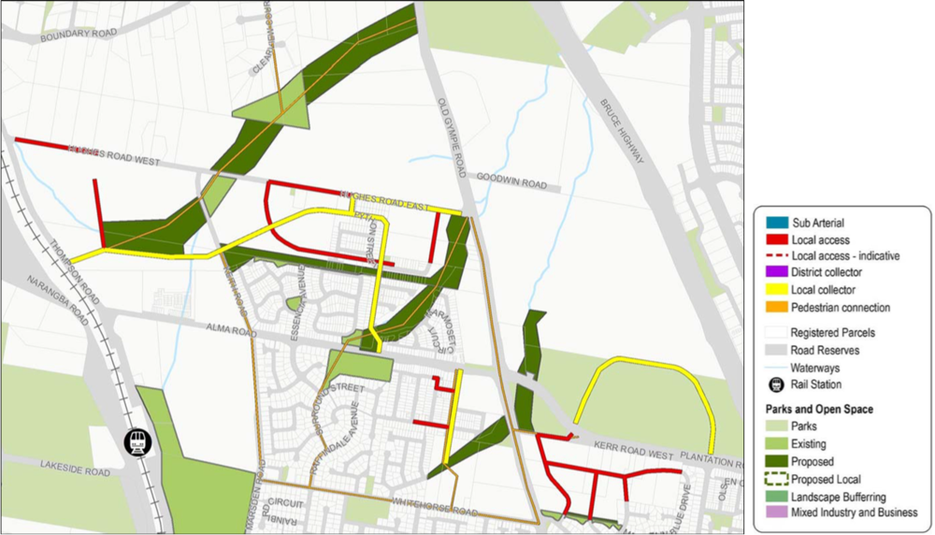

Figure 5 - Mango Hill - Johns Road
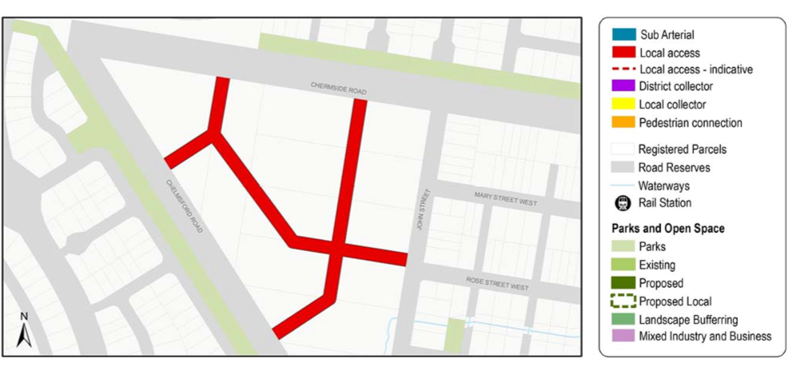

Figure 6 - Lawnton - Akers Road / Isis Road
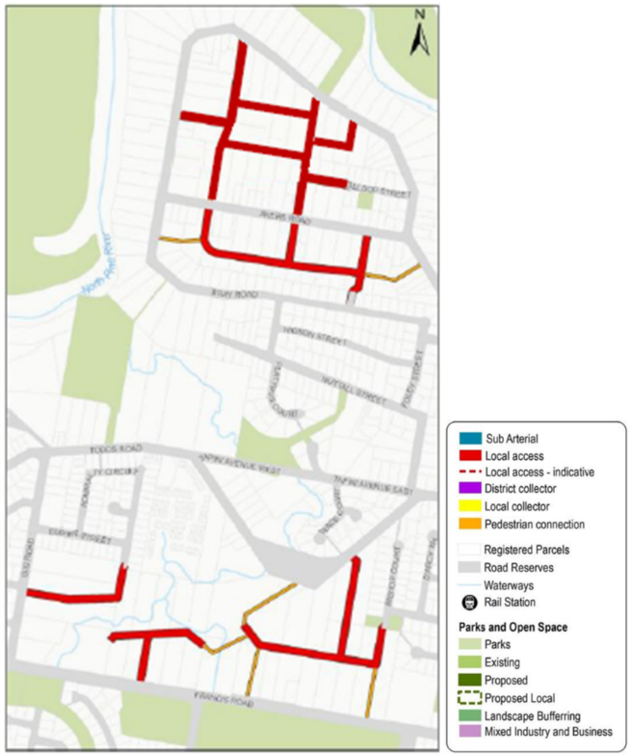
Figure 7 - Albany Creek - Morgan Road
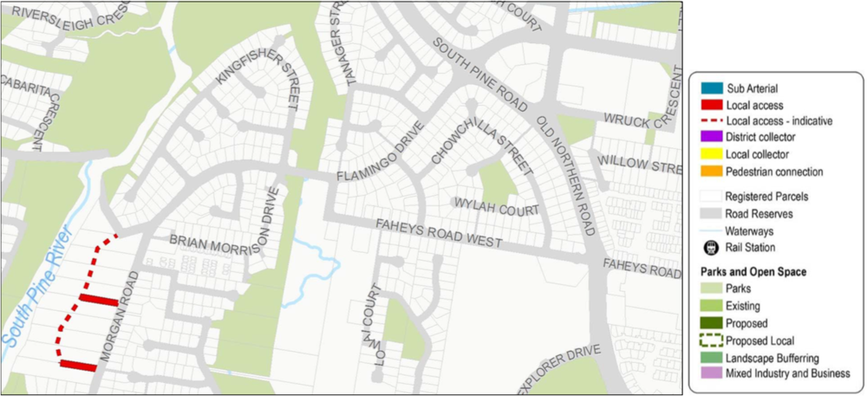

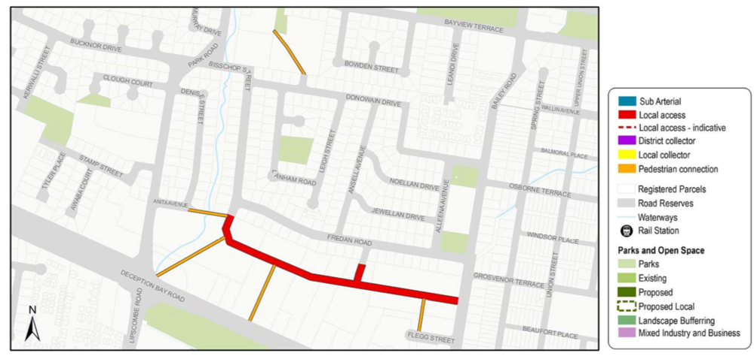
Figure 8 - Deception Bay - Bailey Road / Park Road

Figure 9 - Rothwell - Whitlock Drive
