Requirements for accepted development - Abbey precinct

Requirements for accepted development |  | E Compliance  - Yes  - No | Council confirmation
General requirements
Building height
RAD1 | Building height does not exceed the maximum height identified on Overlay map - Building heights, except for architectural features associated with religious expression on Place of worship⁽⁶⁰⁾ and Educational establishment⁽²⁴⁾ buildings.
Setbacks
RAD2 | Buildings and structures, excluding Multiple dwelling⁽⁴⁹⁾, are setback as follows:  - road frontage - 10m  - side boundary - 10m  - rear boundary - 10m
Specific rural uses setbacks
RAD3 | The following uses, associated buildings and structures are setback from all lot boundaries as follows:  - Animal husbandry⁽⁴⁾ (buildings only) - 10m  - Cropping⁽¹⁹⁾ (buildings only) - 10m  - Intensive horticulture⁽⁴⁰⁾ - 20m
Site cover
RAD4 | Site cover of all buildings and structures does not exceed 20%.
Residential density
RAD5 | Residential density does not exceed 21 dwellings on the site, including 1 Dwelling house⁽²²⁾ and 20 Multiple dwellings⁽⁴⁹⁾.
Car parking
RAD6 | On-site car parking is provided in accordance with Schedule 7 - Car parking.
Waste
RAD7 | Bins and bin storage areas are provided, designed and managed in accordance with Planning scheme policy - Waste.
Lighting
RAD8 | Artificial lighting on-site is directed and shielded in such a manner as not to exceed the recommended maximum values of light technical parameters for the control of obtrusive light given in Table 2.1 of the Australian Standard AS 4282 (1997) Control of Obtrusive Effects of Outdoor Lighting.
  Note - "Curfewed hours" are taken to be those between 10pm and 7am the following day.
Hazardous chemicals
RAD9 | All development that involves the storage or handling of hazardous chemicals listed in Schedule 9, Development involving hazardous chemicals, Table 9.0.1 Quantity thresholds for hazardous chemicals stored as accepted development subject to requirements complies with Table 9.0.3 Hazardous chemicals.
RAD10 | Development does not involve the storage or handling of hazardous chemicals listed in Schedule 9, Development involving hazardous chemicals, Table 9.0.2 Hazardous chemicals assessable thresholds.
Clearing of habitat trees where not located in the Environmental areas overlay map
RAD11 | Development does not result in the damaging, destroyed or clearing of a habitat tree. This does not apply to:  - Clearing of a habitat tree located within an approved development footprint;  - Clearing of a habitat tree within 10m from a lawfully established building reasonably necessary for emergency access or immediately required in response to an accident or emergency;  - Clearing of a habitat tree reasonably necessary to remove or reduce the risk vegetation poses to serious personal injury or damage to infrastructure;  - Clearing of a habitat tree reasonably necessary to construct and maintain a property boundary fence and not exceed 4m in width either side of the fence where in the Rural , Rural residential and Environmental management and conservation zones. In any other zone, clearing is not to exceed 2m in width either side of the fence;  - Clearing of a habitat tree reasonably necessary for the purpose of maintenance or works within a registered easement for public infrastructure or drainage purposes;  - Clearing of a habitat tree in accordance with a bushfire management plan prepared by a suitably qualified person, submitted to and accepted by Council;  - Clearing of a habitat tree associated with removal of recognised weed species, maintaining existing open pastures and cropping land, windbreaks, lawns or created gardens;  - Native forest practice where accepted development under Part 1, 1.7.7 Accepted development.
  Editor's note - A native tree measuring greater than 80cm in diameter when measured at 1.3m from the ground is recognised as a ‘habitat tree’. For further information on habitat trees, refer to Planning scheme policy – Environmental areas and corridors. Information detailing how this measurement is undertaken is provided in Australian Standard AS 4970 2009 Protection of Trees on Development Sites - Appendix A.

Works requirements
Utilities
RAD12 | Development is provided in an appropriate level of service and infrastructure in accordance with Planning scheme policy - Integrated design (Appendix A).
Access
RAD13 | The frontage road is fully constructed to Council’s standards.  Note - Roads are considered to be constructed in accordance with Council standards when there is sufficient pavement width, geometry and depth to comply with the requirements of Planning scheme policy - Integrated design and Planning scheme policy - Operational works inspection, maintenance and bonding procedures. Testing of the existing pavement may be required to confirm whether the existing works meet the standards in Planning scheme policy - Integrated design and Planning scheme policy - Operational works inspection, maintenance and bonding procedures.  Note - Frontage roads include streets where no direct lot access is provided.
RAD14 | Any new or changes to existing crossovers and driveways are designed, located and constructed in accordance with:  - where for a Council-controlled road and associated with a Dwelling house:  i. Planning scheme policy - Integrated design;  - where for a Council-controlled road and not associated with a Dwelling house:  i. AS/NZS2890.1 Parking facilities Part 1: Off street car parking;  ii. AS/NZS 2890.2 - Parking facilities Part 2: Off-street commercial vehicle facilities;  iii. Planning scheme policy - Integrated design;  iv. Schedule 8 - Service vehicle requirements;  - where for a State-Controlled road, the Safe Intersection Sight Distance requirements in Austroads and the appropriate IPWEAQ standard drawings, or a copy of a Transport Infrastructure Act 1994, section 62 approval.
RAD15 | Any new or changes to existing internal driveways and access ways are designed and constructed in accordance with AS/NZS 2890.1 Parking Facilities Part 1: Off street car parking and the relevant standards in Planning scheme policy - Integrated design.
RAD16 | Access driveways, manoeuvring areas and loading facilities are sealed and provide for service vehicles listed in Schedule 8 - Service vehicle requirements for the relevant use. The on-site manoeuvring is to be in accordance with Schedule 8 - Service vehicle requirements.
Stormwater
RAD17 | Any new or changes to existing stormwater run-off from the site is conveyed to a point of lawful discharge without causing actionable nuisance to any person, property or premises in accordance with Planning scheme policy – Integrated design.
  Note - A watercourse as defined in the Water Act may be accepted as a lawful point of discharge providing the drainage discharge from the site does not increase the downstream flood levels during events up to and including the 1% AEP storm. An afflux of +20mm may be accepted on Council controlled land and road infrastructure. No worsening is ensured when stormwater is discharged into a catchment that includes State Transport Infrastructure.
RAD18 | Development incorporates a 'deemed to comply solution' to manage stormwater quality where the development:  a. is for an urban purpose that involves a land area of 2500m² or greater; and  b. will result in:  i. 6 or more dwellings; or  ii. an impervious area greater than 25% of the net developable area.  Note - The deemed to comply solution is to be designed, constructed, established and maintained in accordance with the requirements of Water by Design ‘Deemed to Comply Solutions - Stormwater Quality Management for South East Queensland’ and Planning scheme policy - Integrated design.
RAD19 | Development ensures that surface flows entering the premises from adjacent properties are not blocked, diverted or concentrated.  Note - A report from a suitably qualified Registered Professional Engineer Queensland may be required certifying that the development does not increase the potential for significant adverse impacts on an upstream, downstream or surrounding premises.
RAD20 | Development ensures that works (e.g. fences and walls) do not block, divert or concentrate the flow of stormwater to adjoining properties.  Note - A report from a suitably qualified Registered Professional Engineer Queensland may be required certifying that the development does not increase the potential for significant adverse impacts on an upstream, downstream or surrounding premises.
RAD21 | Stormwater drainage infrastructure (excluding detention and bio-retention systems) through or within private land is protected by easements in favour of Council (at no cost to Council). Minimum easement widths are as follows:  Note - Additional easement width may be required in certain circumstances in order to facilitate maintenance access to the stormwater system.  Note - Refer to Planning scheme policy - Integrated design (Appendix C) for easement requirements over open channels.
  Pipe Diameter | Minimum Easement Width (excluding access requirements)
  Stormwater Pipe up to 825mm diameter | 3.0m
  Stormwater Pipe up to 825mm diameter with Sewer pipe up to 225mm diameter | 4.0m
  Stormwater pipe greater than 825mm diameter | Easement boundary to be 1m clear of the outside wall of the pipe and clear of all pits.
Site works and construction management
RAD22 | The site and any existing structures are to be maintained in a tidy and safe condition.
RAD23 | Development does not cause erosion or allow sediment to leave the site.  Note - The International Erosion Control Association (Australasia) Best Practice Erosion and Sediment Control provides guidance on strategies and techniques for managing erosion and sedimentation.
RAD24 | No dust emissions extend beyond the boundaries of the site during soil disturbances and construction works.
RAD25 | Existing street trees are protected and not damaged during works.  Note - Where development occurs in the tree protection zone, measures and techniques as detailed in Australian Standard AS 4970 Protection of trees on developments sites are adopted and implemented.
RAD26 | Any damage to Council land or infrastructure is repaired or replaced with the same materials, prior to plan sealing, or final building classification.
RAD27 | Construction traffic including contractor car parking is controlled in accordance with a traffic management plan, prepared in accordance with the Manual of Uniform Traffic Control Devices (MUTCD) to ensure all traffic movements to and from the site are safe.
RAD28 | Any material dropped, deposited or spilled on the road(s) as a result of construction processes associated with the site are to be cleaned at all times.
RAD29 | All native vegetation to be retained on-site is temporarily fenced or protected prior to and during development works.
  Note - No parking of vehicles or storage of machinery or goods is to occur in these areas during development works.
RAD30 | Disposal of materials is managed in one or more of the following ways:  a. all cleared vegetation, declared weeds, stumps, rubbish, car bodies, scrap metal and the like are removed and disposed of in a Council land fill facility; or  b. all native vegetation with a diameter below 400mm is to be chipped and stored on-site.  Note - No burning of cleared vegetation is permitted.  Note - The chipped vegetation must be stored in an approved location.
RAD31 | All development works are carried out within the following times:  a. Monday to Saturday (other than public holidays) between 6:30am and 6:30pm on the same day;  b. no work is to be carried out on Sundays or public holidays.
Earthworks
RAD32 | The total of all cut and fill on-site does not exceed 900mm in height.  Figure - Cut and fill  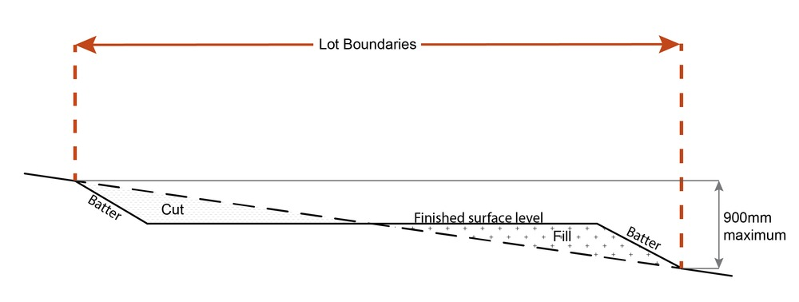
  Note - This is site earthworks not building work.
RAD33 | Cut and fill batters, (other than batters to dams and water impoundments), have a finished slope no steeper than the following:  a. any cut batter is no steeper than 1V in 4H;  b. any fill batter, (other than a compacted fill batter), is no steeper than 1V in 4H;  c. any compacted fill batter is no steeper than 1V in 4H.
RAD34 | All cut and fill batters are provided with appropriate scour, erosion protection and run-off control measures including catch drains at the top of batters and lined batter drains as necessary
RAD35 | Stabilisation measures are provided, as necessary, to ensure long-term stability and low maintenance of steep slopes and batters.  Note - Inspection and certification of steep slopes and batters may be required by a suitably qualified and experienced RPEQ.
RAD36 | All fill and excavation is contained on-site and is free draining.
RAD37 | Earthworks undertaken on the development site are shaped in a manner which does not:  a. prevent stormwater surface flow which, prior to commencement of the earthworks, passed onto the development site, from entering the land; or  b. redirect stormwater surface flow away from existing flow paths; or  c. divert stormwater surface flow onto adjacent land (other than a road) in a manner which:  i. concentrates the flow; or  ii. increases the flow rates of stormwater over the affected section of the adjacent land above the situation which existed prior to the diversion; or  iii. causes actionable nuisance to any person, property or premises.
RAD38 | All fill placed on-site is:  a. limited to that necessary for the approved use;  b. clean and uncontaminated (i.e. no building waste, concrete, green waste, actual acid sulfate soils, potential acid sulfate soils or contaminated material etc.)
RAD39 | The site is prepared and the fill placed on-site in accordance with Australian Standard AS3798.
  Note - The fill is to be inspected and tested in accordance with Planning scheme policy - Operational works inspection, maintenance and bonding procedures
RAD40 | No filling or excavation is undertaken in an easement issued in favour of Council or a public sector entity.  Note - Public sector entity is defined in Schedule 2 of the Act.
RAD41 | Filling or excavation that would result in any of the following is not carried out on site:  - a reduction in cover over any Council or public sector entity infrastructure to less than 600mm;  - an increase in finished surface grade over, or within 1.5m on each side of, the Council or public sector entity infrastructure above that which existed prior to the filling or excavation works being undertaken;  - prevent reasonable access to Council or public sector entity maintained infrastructure or any drainage feature on, or adjacent to the site for monitoring, maintenance or replacement purposes.  Note - Public sector entity is defined in Schedule 2 of the Act.  Note - All building work covered by QDC MP1.4 is excluded from this provision.
Fire services
Note - The provisions under this heading only apply if:
- the development is for, or incorporates:
  - reconfiguring a lot for a community title scheme creating 1 or more vacant lots; or
  - material change of use for 2 or more sole occupancy units on the same lot, or within the same community titles scheme; or
  - material change of use for a Tourist park⁽⁸⁴⁾ with accommodation in the form of caravans or tents; or
  - material change of use for outdoor sales⁽⁵⁴⁾, outdoor processing or outdoor storage where involving combustible materials.
AND
- none of the following exceptions apply:
  - the distributor-retailer for the area has indicated, in its netserv plan, that the premises will not be served by that entity’s reticulated water supply; or
  - every part of the development site is within 60m walking distance of an existing fire hydrant on the distributor-retailer’s reticulated water supply network, measured around all obstructions, either on or adjacent to the site.
Note - The provisions under this heading do not apply to buildings that are required by the Building Code of Australia to have a fire hydrant system complying with Australian Standard AS 2419.1 (2005) – Fire Hydrant Installations or other fire fighting facilities which provide equivalent protection.

RAD42 | External fire hydrant facilities are provided on site to the standard prescribed under the relevant parts of Australian Standard AS 2419.1 (2005) – Fire Hydrant Installations.
  Note - For this requirement for accepted development, the following are the relevant parts of AS 2419.1 (2005):
  - in regard to the form of any fire hydrant - Part 8.5 and Part 3.2.2.1, with the exception that for Tourist parks⁽⁸⁴⁾ or development comprised solely of dwellings and their associated outbuildings, single outlet above-ground hydrants or suitably signposted in-ground hydrants would be an acceptable alternative;
  - in regard to the general locational requirements for fire hydrants - Part 3.2.2.2 (a), (e), (f), (g) and (h) as well as Appendix B of AS 2419.1 (2005);
  - in regard to the proximity of hydrants to buildings and other facilities - Part 3.2.2.2 (b), (c) and (d), with the exception that:
    - - for dwellings and their associated outbuildings, hydrant coverage need only extend to the roof and external walls of those buildings;
    - - for caravans and tents, hydrant coverage need only extend to the roof of those tents and caravans;
    - - for outdoor sales⁽⁵⁴⁾, processing or storage facilities, hydrant coverage is required across the entire area of the outdoor sales⁽⁵⁴⁾, outdoor processing and outdoor storage facilities; and
  - in regard to fire hydrant accessibility and clearance requirements - Part 3.5 and where applicable, Part 3.6.
RAD43 | A continuous path of travel having the following characteristics is provided between the vehicle access point to the site and each external fire hydrant and hydrant booster point on the land:  - an unobstructed width of no less than 3.5m;  - an unobstructed height of no less than 4.8m;  - constructed to be readily traversed by a 17 tonne HRV fire brigade pumping appliance;  - an area for a fire brigade pumping appliance to stand within 20m of each fire hydrant and 8m of each hydrant booster point.
RAD44 | On-site fire hydrant facilities are maintained in effective operating order in a manner prescribed in Australian Standard AS1851 (2012) – Routine service of fire protection systems and equipment.
RAD45 | For development that contains on-site fire hydrants external to buildings:  - those external hydrants can be seen from the vehicular entry point to the site; or  - a sign identifying the following is provided at the vehicular entry point to the site:  - the overall layout of the development (to scale);  - internal road names (where used);  - all communal facilities (where provided);  - the reception area and on-site manager’s office (where provided);  - external hydrants and hydrant booster points;  - physical constraints within the internal roadway system which would restrict access by fire fighting appliances to external hydrants and hydrant booster points.
  Note - The sign prescribed above, and the graphics used are to be:
  - in a form;
  - of a size;
  - illuminated to a level;
  which allows the information on the sign to be readily understood, at all times, by a person in a fire fighting appliance up to 4.5m from the sign.
RAD46 | For development that contains on-site fire hydrants external to buildings, those hydrants are identified by way of marker posts and raised reflective pavements markers in the manner prescribed in the technical note Fire hydrant indication system produced by the Queensland Department of Transport and Main Roads.
  Note - Technical note Fire hydrant indication system is available on the website of the Queensland Department of Transport and Main Roads.

Use specific requirements
Dwelling house⁽²²⁾
RAD47 | The dwelling house⁽²²⁾ is only used to accommodate members of the Confraternity.
RAD48 | Where the dwelling house⁽²²⁾ includes a secondary dwelling, the secondary dwelling:  - has a maximum GFA of 100m²;  - obtains access from the existing driveway giving access to the Dwelling house⁽²²⁾;  - is setback 50m from all property boundaries;  - is located within 20m of the principal Dwelling house⁽²²⁾;  - is separated from other dwellings by a minimum distance of 1.5m;  - is only used to accommodate members of the Confraternity.
Home based business ⁽³⁵⁾
RAD49 | Home based business(s)⁽³⁵⁾ are fully contained within a dwelling or on-site structure, except for a home based child care facility.
RAD50 | The maximum total use area is 100m².
RAD51 | Only 1 additional non-resident, either an employee or customer, is permitted on the site at any one time.
  Note - This provision does not apply to Bed and Breakfast or farmstay business.
RAD52 | Service and delivery vehicles do not exceed one Small Rigid Vehicle (SRV) at any one time.
RAD53 | Vehicle parking for the Home based business⁽³⁵⁾ on-site is limited to 1 car or Small Rigid Vehicle (SRV).
RAD54 | The amenity of the area and adjacent sensitive land uses are protected from the impacts of dust, odour, noise, light, chemicals and other environmental nuisances.
RAD55 | The Home based business⁽³⁵⁾ does not involve vehicle servicing or major repairs, including spray painting or panel beating.
  Note - Vehicle servicing excludes general maintenance of a vehicle such as, but not limited to, changing engine fluids, filters and parts such as batteries and plugs.
RAD56 | The hours of operation do not exceed 8:00am to 6:00pm, Monday to Saturday and are not open to the public on Sunday's, Christmas Day, Good Friday and Anzac Day.
  Note - Office⁽⁵³⁾ or administrative activities that do not generate non-residents visiting the site, such as book-keeping and computer work, may operate outside the hours of operation.
RAD57 | The Home based business⁽³⁵⁾ does not generate noise that is audible from the boundary of the lot.
  Note - Guidance on acceptable noise is provided in the standards listed in the Environmental (Noise) Policy 2008.
  Note - This provision does not apply to the use of motor vehicles.
RAD58 | The Home based business⁽³⁵⁾ does not involve an environmentally relevant activity (ERA) as defined in the Environmental Protection Regulation 2008.
RAD59 | Only goods grown, produced or manufactured on-site are sold from the site.
RAD60 | Display of goods grown, produced or manufactured on-site are contained within a dwelling or on-site structure and the display of goods is not visible from boundary of the site.
RAD61 | For bed and breakfast and farmstays:  - overnight accommodation is provided in the Dwelling house⁽²²⁾ of the accommodation operator.  - maximum 4 bedrooms are provided for a maximum of 10 guests.  - meals are served to paying guests only.  - rooms do not contain food preparation facilities.
Multiple dwelling ⁽⁴⁹⁾
RAD62 | Multiple dwellings⁽⁴⁹⁾ are provided in the form of detached buildings.
RAD63 | The number of Multiple dwellings⁽⁴⁹⁾ located on the site does not exceed 20.
RAD64 | Multiple dwellings⁽⁴⁹⁾ are separated by a minimum distance of 1.5m and a maximum of 10m.
RAD65 | Multiple dwellings⁽⁴⁹⁾ are setback a minimum 50m from all property boundaries.
RAD66 | Multiple dwellings⁽⁴⁹⁾ are only used to accommodate members of the Confraternity.
Rural workers' accommodation ⁽⁷¹⁾
RAD67 | Rural workers' accommodation⁽⁷¹⁾ is located in the Residential Area on Map 1 - Abbey use areas.
RAD68 | No more than 1 Rural workers' accommodation⁽⁷¹⁾ per lot.
RAD69 | Rural workers' accommodation⁽⁷¹⁾ is contained within 1 structure.
RAD70 | No more than 12 rural workers are accommodated.
RAD71 | Access is obtained from the existing driveway giving access to the Dwelling house⁽²²⁾.
Telecommunications facility⁽⁸¹⁾
Editor's note - In accordance with the Federal legislation Telecommunications facilities⁽⁸¹⁾ must be constructed and operated in a manner that will not cause human exposure to electromagnetic radiation beyond the limits outlined in the Radiocommunications (Electromagnetic Radiation - Human Exposure) Standard 2003 and Radio Protection Standard for Maximum Exposure Levels to Radiofrequency Fields - 3Khz to 300Ghz.

RAD72 | A minimum area of 45m² is available to allow for additional equipment shelters and associated structures for the purpose of co-locating on the proposed facility.
RAD73 | The development results in no net reduction in the minimum quantity and standard of landscaping, private or communal open space or car parking spaces required under the planning scheme or under an existing development approval.
RAD74 | Equipment shelters and associated structures are located:  - directly beside the existing equipment shelter and associated structures;  - behind the main building line;  - further away from the frontage than the existing equipment shelter and associated structures;  - a minimum of 10m from side and rear boundaries, except where in the Industry and Extractive industry zones, the minimum side and rear setback is 3m.
RAD75 | Equipment shelters and other associated structures are either the same type of colour or material to match the surrounding locality.
RAD76 | The facility is enclosed by security fencing or by other means to ensure public access is prohibited.
RAD77 | A minimum 3m wide strip of dense planting is provided around the perimeter of the fenced area, between the development and street frontage and adjoining uses.
  Note - Landscaping is provided in accordance with Planning scheme policy - Integrated design.
  Note - Council may require a detailed landscaping plan, prepared by a suitably qualified person to ensure compliance with Planning scheme policy - Integrated design.
RAD78 | All equipment comprising the telecommunications facility⁽⁸¹⁾ which produces audible or non-audible sound is housed within a fully enclosed building incorporating sound control measures sufficient to ensure no noise from this equipment can be heard, or felt at the site boundary.

Values and constraints requirements
Note - The relevant values and constraints requirements do not apply where the development is consistent with a current Development permit for Reconfiguring a lot or Material change of use or Operational work, where that approval has considered and addressed (e.g. through a development footprint plan (or similar in the case of Landslide hazard) or conditions of approval) the identified value or constraint under this planning scheme.

Acid sulfate soils - (refer Overlay map - Acid sulfate soils to determine if the following requirements apply)
Note - Planning scheme policy - Acid sulfate soils provides guidance for requirements for accepted development that has the potential to disturb acid sulfate soils i.e. development involving filling or excavation works below the thresholds of 100m³ and 500m³ respectively.

RAD79 | Development does not involve:  - excavation or otherwise removing of more than 100m³ of soil or sediment where below 5m Australian Height Datum AHD, or  - filling of land of more than 500m³ of material with an average depth of 0.5m or greater where below the 5m AHD.  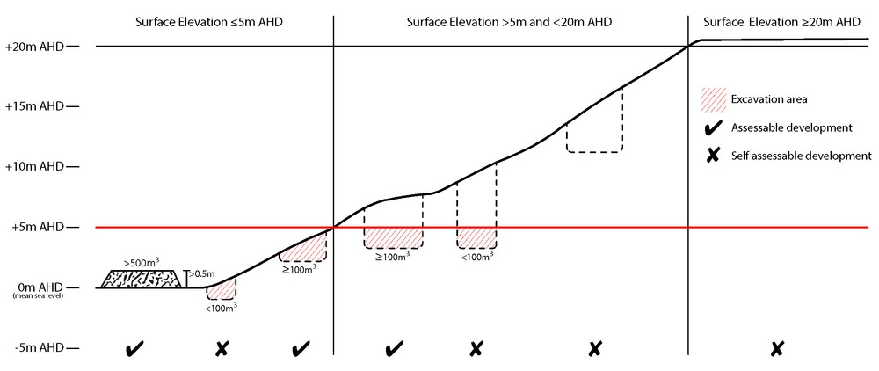
Bushfire hazard (refer Overlay map - Bushfire hazard to determine if the following requirements apply)
Note - For the purposes of section 12 of the Building Regulation 2006, land identified as very high potential bushfire intensity, high potential bushfire intensity, medium potential bushfire intensity or potential impact buffer on the Bushfire hazard overlay map is the 'designated bushfire hazard area'. AS 3959-2009 Construction of buildings in bushfire hazard areas applies within these areas.

RAD80 | - Building and structures are:  - not located on a ridgeline  - not located on land with a slope greater than 15% (see Overlay map – Landslide hazard)  - Dwellings are located on east to south facing slopes.  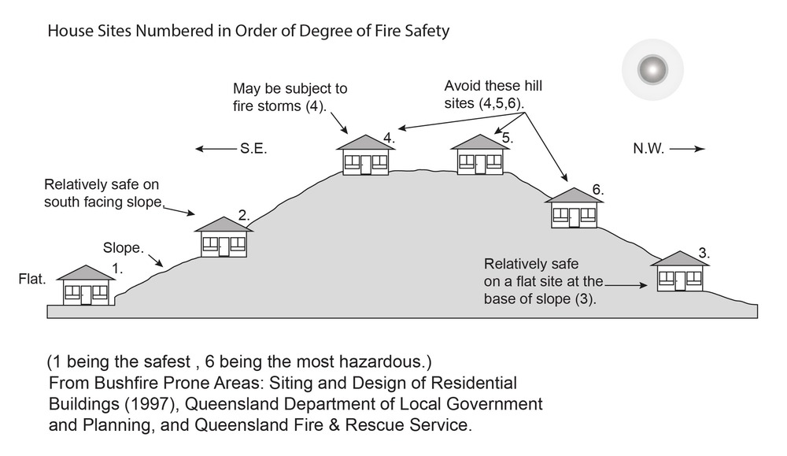
RAD81 | Buildings and structures have contained within the site:  - a separation from classified vegetation of 20m or the distance required to achieve a bushfire attack level (BAL) at the building, roofed structure or fire fighting water supply of no more than 29, whichever is the greater;  - a separation from low threat vegetation of 10m or the distance required to achieve a bushfire attack level (BAL) at the building, roofed structure or fire fighting water supply of no more than 29, whichever is the greater;  - a separation of no less than 10m between a fire fighting water supply extraction point and any classified vegetation, buildings and other roofed structures;  - an area suitable for a standard fire fighting appliance to stand within 3m of a fire fighting water supply extraction point; and  - an access path suitable for use by a standard fire fighting appliance having a formed width of at least 4m, a cross-fall of no greater than 5%, and a longitudinal gradient of no greater than 25%:  - to, and around, each building and other roofed structure; and  - to each fire fighting water supply extraction point.
  Note - The meaning of the terms classified vegetation and low threat vegetation as well as the method of calculating the bushfire attack level are as described in Australian Standard AS 3959.
RAD82 | The length of driveway:  - to a public road does not exceed 100m between the most distant part of a building used for any purpose other than storage and the nearest part of a public road;  - has a maximum gradient no greater than 12.5%;  - have a minimum width of 3.5m;  - accommodate turning areas for fire fighting appliances in accordance with Qld Fire and Emergency Services' Fire Hydrant and Vehicle Access Guideline.
RAD83 | - A reticulated water supply is provided by a distributer retailer for the area or, where not connected to a reticulated water supply, on-site fire fighting water storage containing not less than 10 000 litres (tanks with fire brigade tank fittings, swimming pools) is provided and located within 10m of buildings and structures.  - Where a swimming pool is the nominated on-site fire fighting water storage source, vehicle access to within 3m of that water storage source is provided.  - Where a tank is the nominated on-site fire fighting water storage source, it includes:  - a hardstand area allowing medium rigid vehicle (15 tonne fire appliance) access within 6m of the tank;  - fire brigade tank fittings, comprising 50mm ball valve and male camlock coupling and, if underground, an access hole of 20mm (minimum) to accommodate suction lines.
RAD84 | Development does not involve the manufacture or storage of hazardous chemicals.
Environmental areas (refer Overlay map - Environmental areas to determine if the following requirements apply)
Note - The following are excluded from the native clearing provisions of this planning scheme:
- Clearing of native vegetation located within an approved development footprint;
- Clearing of native vegetation within 10m from a lawfully established building reasonably necessary for emergency access or immediately required in response to an accident or emergency;
- Clearing of native vegetation reasonably necessary to remove or reduce the risk vegetation poses to serious personal injury or damage to infrastructure;
- Clearing of native vegetation reasonably necessary to construct and maintain a property boundary fence and not exceed 4m in width either side of the fence where in the Rural, Rural residential and Environmental Management and Conservation zones. In any other zone, clearing is not to exceed 2m in width either side of the fence;
- Clearing of native vegetation reasonably necessary for the purpose of maintenance or works within a registered easement for public infrastructure or drainage purposes;
- Clearing of native vegetation in accordance with a bushfire management plan prepared by a suitably qualified person, submitted to and accepted by Council;
- Clearing of native vegetation associated with removal of recognised weed species, maintaining existing open pastures and cropping land, windbreaks, lawns or created gardens;
- Grazing of native pasture by stock;
- Native forest practice where accepted development under Part 1, 1.7.7 Accepted development.
Note - Definition for native vegetation is located in Schedule 1 Definitions.

Note - Native vegetation subject to this requirement primarily comprises of matters of national environmental significance (MNES), matters of state environmental significance (MSES). They also comprise some matters of local environmental significance (MLES). A MLES is defined in Schedule 1.2, Administrative definitions. A list of the elements that apply to the mapped MSES and MLES is provided in Appendix 1 of the Planning scheme policy - Environmental areas.
Editors' Note - The accuracy of overlay mapping can be challenged through the development application process (code assessable development) or by way of a planning scheme amendment. See Council's website for details.
Editors' Note - When clearing native vegetation within a MSES area, you may still require approval from the State government.

RAD85 | Where no suitable land cleared of native vegetation exists, clearing of native vegetation in High Value Area or Value Offset Area is for the purpose of a new dwelling house⁽²²⁾ and all associated facilities* or an extension to an existing dwelling house⁽²²⁾ only, and comprises an area no greater than 1500m².
  Note - *All associated facilities includes: on-site wastewater treatment, all areas of disturbance, on-site parking, access and manoeuvring areas.
  Editor's note - See in heading above for other uses excluded from native vegetation clearing requirements.
  Editor's note - Where vegetation clearance is accepted development subject to requirements, care should be undertaken to avoid adverse impacts on koalas, koala habitat values and habitat connectivity and to encourage existing koala usage of the site. Measures to minimise impacts include:
  - co-locating all associated activities, infrastructure and access strips;
  - be the least valued area of koala habitat on the site;
  - minimise the footprint of the development envelope area;
  - minimise edge effects to areas external to the development envelope;
  - location and design consideration to ensure koala safety and movement in accordance with the Koala-sensitive Design Guideline and Planning scheme policy – Environmental areas;
  - sufficient area between the development and koala habitat trees to achieve their long-term viability.
  Editor's note - Where vegetation clearing is accepted development subject to requirements, consideration should be given to avoid clearing habitat trees. Habitat trees may contain structural hollows where animals live, breed and shelter. The provision of nest boxes or salvaging of hollows will provide compensatory roosting and nesting opportunities for local wildlife including sugar gliders, possums and owls. For further information see Planning scheme policy – Environmental areas.
RAD86 | No clearing of native vegetation is to occur within the Value Offset Area MLES - Waterway buffer or Value Offset Area MLES - Wetland buffer.  This does not apply to the following:  - Clearing of native vegetation located within an approved development footprint;  - Clearing of native vegetation within 10m from a lawfully established building reasonably necessary for emergency access or immediately required in response to an accident or emergency;  - Clearing of native vegetation reasonably necessary to remove or reduce the risk vegetation poses to serious personal injury or damage to infrastructure;  - Clearing of native vegetation reasonably necessary to construct and maintain a property boundary fence and not exceed 4m in width either side of the fence where in the Rural, Rural residential and Environmental management and conservation zones. In any other zone, clearing is not to exceed 2m in width either side of the fence;  - Clearing of native vegetation reasonably necessary for the purpose of maintenance or works within a registered easement for public infrastructure or drainage purposes;  - Clearing of native vegetation in accordance with a bushfire management plan prepared by a suitably qualified person, submitted to and accepted by Council;  - Clearing of native vegetation associated with removal of recognised weed species, maintaining existing open pastures and cropping land, windbreaks, lawns or created gardens;  - Grazing of native pasture by stock;  - Native forest practice where accepted development under Part 1, 1.7.7 Accepted development.
Heritage and landscape character (refer Overlay map - Heritage and landscape character to determine if the following requirements apply)
Note - Places, including sites, objects and buildings having local cultural heritage significance, are identified on Overlay map - Heritage and landscape character and listed in Schedule 1 of Planning scheme policy - Heritage and landscape character. Places also having cultural heritage significance at a State level and being entered in the Queensland Heritage Register, are also identified in Schedule 1 of Planning scheme policy - Heritage and landscape character.

RAD87 | Development is for the preservation, maintenance, repair and restoration of the site, object or building.  This does not apply to Listed item 99, in Schedule 1 - List of sites, objects and buildings of significant historical and cultural value of Planning scheme policy - Heritage and landscape character.
  Note - Preservation, maintenance, repair and restoration are defined in Schedule 1 - Definitions
RAD88 | A cultural heritage conservation management plan is prepared in accordance with Planning scheme policy – Heritage and landscape character and submitted to Council prior to the commencement of any preservation, maintenance, repair and restoration works. Any preservation, maintenance, repair and restoration works are in accordance with the Council approved cultural heritage conservation management plan.  This does not apply to Listed item 99 in Schedule 1 - List of sites, objects and buildings of significant historical and cultural value of Planning scheme policy - Heritage and landscape character.
RAD89 | Development does not result in the removal of or damage to any significant tree identified on Overlay map – Heritage and landscape character and listed in Appendix 2 of Planning scheme policy – Heritage and landscape character.
RAD90 | The following development does not occur within 20m of the base of any significant tree, identified on Overlay map – Heritage and landscape character and listed in Appendix 2 of Planning scheme policy – Heritage and landscape character:  - construction of any building;  - laying of overhead or underground services;  - any sealing, paving, soil compaction;  - any alteration of more than 75mm to the ground surface prior to work commencing.
RAD91 | Pruning of a significant tree occurs in accordance with Australian Standard AS 4373-2007 - Pruning of Amenity Trees.
Landslide hazard (refer Overlay map - Landslide hazard to determine if the following requirements apply)
RAD92 | Development does not:  - involve earthworks exceeding 50m³;  - involve cut and fill having a height greater than 600mm;  - involve any retaining wall having a height greater than 600mm;  - redirect or alter the existing flow of surface or groundwater.
RAD93 | Buildings, excluding domestic outbuildings:  - are split-level, multiple-slab, pier or pole construction;  - are not single plane slab on ground.
RAD94 | Development does not involve the manufacture, handling or storage of hazardous chemicals.
Overland flow path (refer Overlay map - Overland flow path to determine if the following requirements apply)
RAD95 | Development for a material change of use or building work does not involve the construction of a building or structure in an Overland flow path area.
RAD96 | Development for a material change of use or operational work does not impede the flow of flood waters through the premises or worsen flood flows to other premises.
  Note - A report from a suitably qualified Registered Professional Engineer Queensland is required certifying that the development does not increase the potential for significant adverse impacts on an upstream, downstream or surrounding premises.
  Note - Reporting to be prepared in accordance with Planning scheme policy – Flood hazard, Coastal hazard and Overland flow
RAD97 | Development for a material change of use or building work ensures that fencing in an overland flow path area is at least 50% permeable.
RAD98 | Development for a material change of use or building work that involves a hazardous chemical ensures the hazardous chemicals is not located within an overland flow path area.
RAD99 | Development for a material change of use or building work for a Park⁽⁵⁷⁾ ensures that work is provided in accordance with the requirements set out in Appendix B of the Planning scheme policy - Integrated design.
Riparian and wetland setbacks (refer Overlay map - Riparian and wetland setback to determine if the following requirements apply)
Note - W1, W2 and W3 waterway and drainage lines, and wetlands are mapped on Schedule 2, Section 2.5 Overlay Maps – Riparian and wetland setbacks.

RAD100 | No development is to occur within:  - 50m from top of bank for W1 waterway and drainage line  - 30m from top of bank for W2 waterway and drainage line  - 20m from top of bank for W3 waterway and drainage line  - 100m from the edge of a Ramsar wetland, 50m from all other wetlands.
  Note - W1, W2 and W3 waterways and drainage lines, and wetlands are mapped on Schedule 2, Section 2.5 Overlay Maps – Riparian and wetland setbacks.
  Note - In some cases, the top of bank may not be easily defined, as such a hydraulic measurement may be applied instead. Moreton Bay Regional Council will provide further direction on how to determine and locate the setback boundary in these locations.
  Note - The minimum setback distance applies to the each side of waterway.
Transport noise corridors (refer Overlay map - Transport noise corridors)
Note - This is for information purposes only. No requirements for accepted development or criteria for assessable development apply. Development located within a Transport Noise Corridor must satisfy the requirements of the Queensland Development Code

Map 1 - Abbey uses area
