Table 6.2.12.4.2 Assessable development - Township industry precinct

Performance outcomes | Examples that achieve aspects of the Performance Outcomes | E Compliance  - Yes  - No See PO or  - NA | Justification for compliance
General criteria
Site cover
PO1  Building site cover allows for adequate on-site provision of:  - car parking;  - vehicle access and manoeuvring;  - setbacks to boundaries;  - landscaped areas. | No example provided.
Building height
PO2  The height of buildings is in keeping with the predominant industrial character of the precinct and does not cause adverse amenity impacts on nearby sensitive land uses and zones. | E2  Development does not exceed the maximum height identified on Overlay map - Building heights.
Setbacks
PO3  Street boundary setbacks:  - minimise building bulk and visual dominance from the street;  - provide areas for landscaping at the front of the site;  - allow for customer parking to be located at the front of the building. | E3  Buildings maintain a minimum setback of :  - 6m to the street frontage;  - 3m to the secondary street frontage;  - 5m to land not included in the Industry zone.
  Note - The following diagram illustrates an acceptable design response to this outcome.
  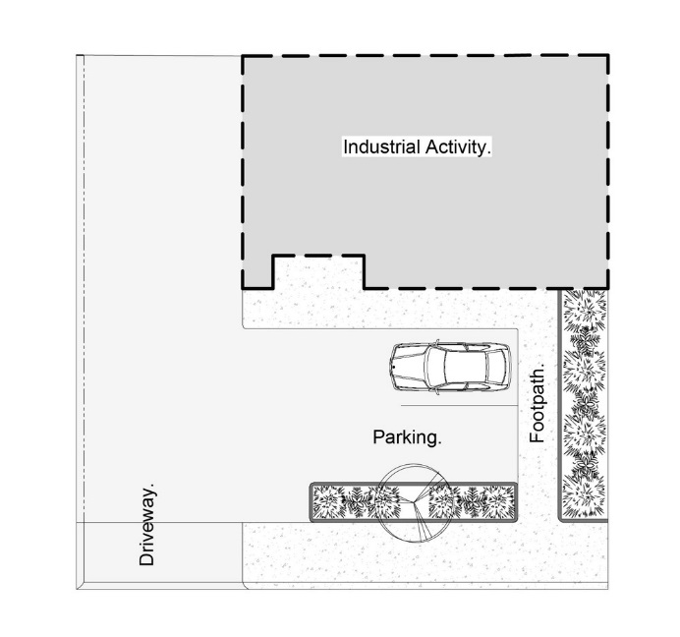
PO4  Side and rear setbacks protect the amenity of adjoining sensitive land uses. | E4  Where development adjoins land in a Township residential precinct, the building is setback a minimum of 5m from the property boundary, and includes landscaping along the boundary appropriate for screening with a mature height of at least 3m.
  Note - Refer to Planning scheme policy - Integrated design for determining acceptable levels of landscaping for screening purposes.
Staff recreation area
PO5  Development provides an on-site recreation area for staff that:  - includes seating, tables and rubbish bins;  - is adequately protected from the weather;  - is safely accessible to all staff;  - is separate and private from public areas;  - is located away from a noisy or odorous activity. | No example provided.
Landscaping
PO6  Landscaping is provided on the site to:  - visually soften the built form, areas of hardstand, storage areas and mechanical plant associated with the on-site activities;  - complement the existing or desired streetscape;  - minimise the impact of industrial development on any adjoining lots not zoned for industrial purposes. | E6  Landscaping is provided and maintained in accordance with Planning scheme policy - Integrated design.
Fencing
PO7  The provision of fencing on street frontages does not dominate the streetscape or create safety issues. | E7  Where fencing is provided on the street frontage, it has a minimum transparency of 70%.
  Note - The following example illustrates an acceptable design response to this outcome.
  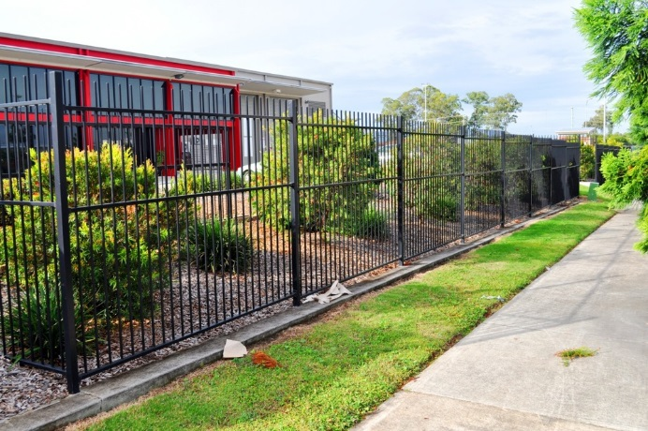
Public access
PO8  The use has a safe, clearly identifiable public access separated from service and parking areas. | E8.1  Pedestrian linkages are provided from the street and customer car parking areas directly to the main entrance of the building.
  Note - The following diagram illustrates an acceptable design response to this outcome.
E8.2
There is no public access to or through industrial service areas.
Car parking
PO9  Car parking is provided on-site to meet the anticipated demand of employees and visitors and avoid adverse impacts on the external road network. | E9  Car parking is provided in accordance with Schedule 7 - Car parking.
  Note - Refer to Planning scheme policy - Integrated transport assessment for guidance on how to achieve compliance with this outcome.
PO10  The design of car parking areas:  - does not impact on the safety of the external road network;  - ensures the safety of pedestrians at all times;  - ensures the safe movement of vehicles within the site. | E10  All car parking areas are designed and constructed in accordance with Australian Standard AS2890.1.
PO11  Vehicle access and car parking areas minimise visual, noise and headlight impacts on adjoining sensitive land uses. | E11  Where car parking or manoeuvring areas are within 5.0 metres of the property boundary of an adjoining sensitive land use, a 1.8 metre solid timber screen fence is provided for the full length of these areas along the property boundary.
Loading and servicing
PO12  Service areas including loading/unloading facilities, plant areas and outdoor storage areas are screened from the direct view from public areas and land not included within the Industry zone. | No example provided.
  Note - If landscaping is proposed for screening purposes, refer to Planning scheme policy - Integrated design for determining acceptable levels.
Waste
PO13  Bins and bin storage area/s are designed, located and managed to prevent amenity impacts on the locality. | E13  Bins and bin storage area/s are provided, designed and managed in accordance with Planning scheme policy – Waste.
Environmental impacts
PO14  Where a use is not an environmentally relevant activity under the Environmental Protection Act, the release of any containment that may cause environmental harm is mitigated to an acceptable level. | E14  Development achieves the standard listed in Schedule 1 Air Quality Objectives, Environmental Protection (Air) Policy 2008.
Lighting
PO15  Lighting is directed and shielded to not cause unreasonable disturbance to any person on adjoining land. | E15  Artificial lighting on-site is directed and shielded in such a manner as not to exceed the recommended maximum values of light technical parameters for the control of obtrusive light given in Table 2.1 of Australian Standard AS 4282 (1997) Control of Obtrusive Effects of Outdoor Lighting.
  Note - “Curfewed hours” are taken to be those hours between 10pm and 7am on the following day
Noise
PO16  Noise generating uses do not adversely affect existing or potential noise sensitive uses. | No example provided.
  Note - The use of walls, barriers or fences that are visible from or adjoin a road or public area are not appropriate noise attenuation measures unless adjoining a motorway, arterial road or rail line.
  Note - A noise impact assessment may be required to demonstrate compliance with this performance outcome. Noise impact assessments are to be prepared in accordance with Planning scheme policy - Noise.
PO17  Sensitive land uses are provided with an appropriate acoustic environment within designated external private outdoor living spaces and internal areas while:  - contributing to safe and usable public spaces, through maintaining high levels of surveillance of parks, streets and roads that serve active transport purposes (e.g. existing or future pedestrian paths or cycle lanes etc);  - maintaining the amenity of the streetscape. | E17.1  Development is designed to meet the criteria outlined in the Planning Scheme Policy – Noise.
  Note - A noise impact assessment may be required to demonstrate compliance with this PO. Noise impact assessments are to be prepared in accordance with Planning scheme policy - Noise.
  Note - Refer to Planning Scheme Policy – Integrated design for details and examples of noise attenuation structures.
E17.2
Noise attenuation structures (e.g. walls, barriers or fences):
- are not visible from an adjoining road or public area unless:
  - adjoining a motorway or rail line; or
  - adjoining part of an arterial road that does not serve an existing or future active transport purpose (e.g. pedestrian paths or cycle lanes) or where attenuation through building location and materials is not possible.
- do not remove existing or prevent future active transport routes or connections to the street network;
- are located, constructed and landscaped in accordance with Planning scheme policy - Integrated design.
Note - Refer to Planning scheme policy – Integrated design for details and examples of noise attenuation structures.
Note - Refer to Overlay map – Active transport for future active transport routes.

Hazardous chemicals
Note - To assist in demonstrating compliance with the following performance outcomes, a Hazard Assessment Report may be required to be prepared and submitted by a suitably qualified person in accordance with 'State Planning Policy Guideline - Guidance on development involving hazardous chemicals'.
Terms used in this section are defined in 'State Planning Policy Guideline - Guidance on development involving hazardous chemicals'.

PO18  Off sites risks from foreseeable hazard scenarios involving hazardous chemicals are commensurate with the sensitivity of the surrounding land use zones. | E18.1  Off site impacts or risks from any foreseeable hazard scenario does not exceed the dangerous dose at the boundary of land zoned for vulnerable or sensitive land uses as described below:  Dangerous Dose  - For any hazard scenario involving the release of gases or vapours:  - AEGL2 (60minutes) or if not available ERPG2;  - An oxygen content in air <19.5% or >23.5% at normal atmospheric pressure.  - For any hazard scenario involving fire or explosion:  - 7kPa overpressure;  - 4.7kW/m2 heat radiation.  If criteria E19.1 (a) or (b) cannot be achieved, then the risk of any foreseeable hazard scenario shall not exceed an individual fatality risk level of 0.5 x 10-6/year.
E18.2
Off site impacts or risks from any foreseeable hazard scenario does not exceed the dangerous dose at the boundary of a commercial or community activity land use zone as described below:
Dangerous Dose
- For any hazard scenario involving the release of gases or vapours:
  - AEGL2 (60minutes) or if not available ERPG2;
  - An oxygen content in air <19.5% or >23.5% at normal atmospheric pressure.
- For any hazard scenario involving fire or explosion:
  - 7kPa overpressure;
  - 4.7kW/m2 heat radiation.
If criteria E19.2 (a) or (b) cannot be achieved, then the risk of any foreseeable hazard scenario shall not exceed an individual fatality risk level of 5 x 10-6/year.
E18.3
Off site impacts or risks from any foreseeable hazard scenario does not exceed the dangerous dose at the boundary of an industrial land use zone as described below:
Dangerous Dose
- For any hazard scenario involving the release of gases or vapours:
  - AEGL2 (60minutes) or if not available ERPG2;
  - An oxygen content in air <19.5% or >23.5% at normal atmospheric pressure.
- For any hazard scenario involving fire or explosion:
  - 14kPa overpressure;
  - 12.6kW/m2 heat radiation.
If criteria E19.3 (a) or (b) cannot be achieved, then the risk of any foreseeable hazard scenario shall not exceed an individual fatality risk level of 50 x 10-6/year.
PO19  Buildings and package stores containing fire-risk hazardous chemicals are designed to detect the early stages of a fire situation and notify a designated person. | E19  Buildings and package stores containing fire-risk hazardous chemicals are provided with 24 hour monitored fire detection system for early detection of a fire event.
PO20  Common storage areas containing packages of flammable and toxic hazardous chemicals are designed with spill containment system(s) that are adequate to contain releases, including fire fighting media. | E20  Storage areas containing packages of flammable and toxic hazardous chemicals are designed with spill containment system(s) capable of containing a minimum of the total aggregate capacity of all packages plus the maximum operating capacity of any fire protection system for the storage area(s) over a minimum of 60 minutes.
PO21  Storage and handling areas, including manufacturing areas, containing hazardous chemicals in quantities greater than 2,500L or kg within a Local Government “flood hazard area” are located and designed in a manner to minimise the likelihood of inundation of flood waters from creeks, rivers, lakes or estuaries. | E21.1  The base of any tank with a WC >2,500L or kg is higher than any relevant flood height level identified in an area’s flood hazard area. Alternatively:  - bulk tanks are anchored so they cannot float if submerged or inundated by water; and  - tank openings not provided with a liquid tight seal, i.e. an atmospheric vent, are extended above the relevant flood height level.
E21.2
The lowest point of any storage area for packages >2,500L or kg is higher than any relevant flood height level identified in an area’s flood hazard area. Alternatively, package stores are provided with impervious bund walls or racking systems higher than the relevant flood height level.
Clearing of habitat trees where not located within the Environmental areas overlay map
PO22  - Development ensures that the biodiversity quality and integrity of habitats is not adversely impacted upon but maintained and protected.  - Development does not result in the net loss of fauna habitat. Where development does result in the loss of a habitat tree, development will provide replacement fauna nesting boxes at the following rate of 1 nest box for every hollow removed. Where hollows have not yet formed in trees > 80cm in diameter at 1.3m height, 3 nest boxes are required for every habitat tree removed.  - Development does not result in soil erosion or land degradation or leave land exposed for an unreasonable period of time but is rehabilitated in a timely manner | No example provided.
  Note: Further guidance on habitat trees is provided in Planning scheme policy - Environmental areas

Works criteria
Utilities
PO23  The development is connected to an existing reticulated electricity supply system approved by the relevant energy regulating authority. | E23  Development is connected to underground electricity.
PO24  The development has access to telecommunications and broadband services in accordance with current standards. | No example provided.
PO25  The development provides for the treatment and disposal of sewage and other waste water in a way that will not cause environmental harm or pose a risk to public health. | E25.1  Where in a sewered area, the development is connected to a reticulated sewerage network.
E25.2
Trade waste is pre-treated on-site prior to discharging into the sewerage network.
PO26  The development is provided with an adequate and sustainable supply of potable (drinking and general use e.g. gardening, washing, fire fighting) water. | E26  Where in an existing connections area or a future connections area as detailed in the Unitywater Connections Policy, the development is connected to the reticulated water supply system in accordance with the South East Queensland Water Supply and Sewerage Design and Construction Code and the relevant Water Service Association of Australia (WSAA) codes and standards.
PO27  The development is provided with constructed and dedicated road access. | No example provided.
Access
PO28  Where required, access easements contain a driveway and provision for services appropriate to the use. The easement covers all works associated with the access in accordance with Planning scheme policy - Integrated design. | No example provided.
PO29  The layout of the development does not compromise:  - the development of the road network in the area;  - the function or safety of the road network;  - the capacity of the road network. | E29.1  The development provides for the extension of the road network in the area in accordance with Council’s road network planning.
  Note - The road hierarchy is mapped on Overlay map - Road hierarchy.
E29.2
The development does not compromise future road widening of frontage roads in accordance with the relevant standard and Council’s road planning.
E29.3
The lot layout allows forward access to and from the site.
PO30  Safe access is provided for all vehicles required to access the site. | E30.1  Site access and driveways are designed and located in accordance with:  - Where for a Council-controlled road, AS/NZS2890.1 section 3; or  - Where for a State-Controlled road, the Safe Intersection Sight Distance requirements in AustRoads and the appropriate IPWEAQ standard drawings, or a copy of a Transport Infrastructure Act 1994, section 62 approval.
E30.2
Internal driveways and access ways are designed and constructed in accordance with AS/NZS2890.1 Parking Facilities – Off street car parking and the relevant standards in Planning scheme policy - Integrated design.
Note - This includes queue lengths (refer to Schedule 8 Service vehicle requirements), pavement widths and construction.

E30.3
Access driveways, manoeuvring areas and loading facilities provide for service vehicles listed in Schedule 8 Service vehicle requirements for the relevant use. The on-site manoeuvring is to be in accordance with Schedule 8 Service vehicle requirements.
PO31  Upgrade works (whether trunk or non-trunk) are provided where necessary to:  - ensure the type or volume of traffic generated by the development does not have a negative impact on the external road network;  - ensure the orderly and efficient continuation of the active transport network;  - ensure the site frontage is constructed to a suitable urban standard generally in accordance with Planning scheme policy - Integrated design. | No example provided.
  Note - An Integrated Transport Assessment (ITA) may be required to demonstrate compliance with this performance outcome refer to Planning scheme policy - Integrated transport assessment for guidance on when an ITA is required. An ITA should be prepared in accordance with Planning scheme policy - Integrated transport assessment.
  Note - The road network is mapped on Overlay map - Road hierarchy.
  Note - The primary and secondary active transport network is mapped on Overlay map - Active transport.
  Note - To demonstrate compliance with c. of this performance outcome, site frontage works where in existing road reserve (non-trunk) are to be designed and constructed as follows:
  - Where the street is partially established to an urban standard, match the alignment of existing kerb and channel and provide carriageway widening and underground drainage where required; or
  - Where the street is not established to an urban standard, prepare a design that demonstrates how the relevant features of the particular road as shown in the Planning scheme policy - Integrated Design can be achieved in the existing reserve.
  Note - Refer to Planning scheme policy - Integrated design for road network and active transport network design standards.
Stormwater
PO32  Stormwater run-off from the site is conveyed to a point of lawful discharge without causing nuisance or annoyance to any person, property or premises. | No example provided.
  Note - Refer to Planning scheme policy - Integrated design for details.
  Note - A downstream drainage discharge report in accordance with Planning scheme policy - Stormwater management may be required to demonstrate achievement of this performance outcome.
  Note - A watercourse as defined in the Water Act may be accepted as a lawful point of discharge providing the drainage discharge from the site does not increase the downstream flood levels during events up to and including the 1% AEP storm. An afflux of +20mm may be accepted on Council controlled land and road infrastructure. No worsening is ensured when stormwater is discharged into a catchment that includes State Transport Infrastructure.
PO33  Stormwater generated from the development does not compromise the capacity of existing stormwater infrastructure downstream of the site. | No example provided.
  Note - A downstream drainage discharge report in accordance with Planning scheme policy - Stormwater management may be required to demonstrate achievement of this performance outcome.
PO34  Stormwater quality management systems are designed and constructed to minimise the environmental impact of stormwater discharge on surface and underground receiving water quality and meet the design objectives in Tables A and B in Appendix 2 of the SPP. | No example provided.
  Note - A stormwater management plan prepared by a suitably qualified professional will be required in accordance with Planning scheme policy - Stormwater management.
PO35  Easements for drainage purposes are provided over:  - stormwater pipes located in freehold land if the pipe diameter exceeds 300mm;  - overland flow paths where they cross more than one property boundary. | No example provided.
  Note - Refer to Planning scheme policy - Integrated design for details.
  Note - Stormwater Drainage easement dimensions are provided in accordance with Section 3.8.5 of QUDM.
Site works and construction management
PO36  The site and any existing structures are maintained in a tidy and safe condition. | No example provided.
PO37  All works on-site are managed to:  - minimise as far as practicable, impacts on adjoining or adjacent premises and the streetscape in regard to erosion and sedimentation, dust, noise, safety and light;  - minimise as far as possible, impacts on the natural environment;  - ensure stormwater discharge is managed in a manner that does not cause nuisance or annoyance to any person or premises;  - avoid adverse impacts on street trees and their critical root zone. | E37.1  Works incorporate temporary stormwater runoff, erosion and sediment controls and trash traps designed in accordance with the Urban Stormwater Quality Planning Guidelines, Planning scheme policy - Stormwater management and Planning scheme policy - Integrated design, including but not limited to the following:  - stormwater is not discharged to adjacent properties in a manner that differs significantly from pre-existing conditions;  - stormwater discharged to adjoining and downstream properties does not cause scour and erosion;  - stormwater discharge rates do not exceed pre-existing conditions;  - the 10% AEP storm event is the minimum design storm for all temporary diversion drains; and  - the 50% AEP storm event is the minimum design storm for all silt barriers and sedimentation basins.
E37.2
Stormwater runoff, erosion and sediment controls are constructed prior to commencement of any clearing or earthworks and are maintained and adjusted as necessary at all times to ensure their ongoing effectiveness.
Note - The measures are adjusted on-site to maximise their effectiveness.

E37.3
The completed earthworks area is stabilised using turf, established grass seeding, mulch or sprayed stabilisation techniques to control erosion and sediment and dust from leaving the property.
E37.4
Where works are proposed in proximity to an existing street tree, an inspection and a root management plan is undertaken by a qualified arborist which demonstrates and ensures that no permanent damage is caused to the tree.
PO38  Dust suppression measures are implemented during soil disturbances and construction works to protect nearby premises from unreasonable dust impacts. | E38  No dust emissions extend beyond the boundaries of the site during soil disturbances and construction works.
PO39  All works on-site and the transportation of material to and from the site are managed to not negatively impact the existing road network, the amenity of the surrounding area or the streetscape. | E39.1  Construction traffic including contractor car parking is controlled in accordance with a traffic management plan, prepared in accordance with the Manual of Uniform Traffic Control Devices (MUTCD) to ensure all traffic movements to and from the site are safe.
  Note - Where the amount of imported or exported material is greater than 50m³, a haulage route must be identified and approved by Council.
E39.2
All contractor car parking is either provided on the development site, or on an alternative site in the general locality which has been set aside for car parking. Contractors vehicles are generally not to be parked in existing roads.
Note - A Traffic Management Plan may be required for the site in accordance with the Manual of Uniform Traffic Control Devices (MUTCD).

E39.3
Any material dropped, deposited or spilled on the road(s) as a result of construction processes associated with the site are to be cleaned at all times.
PO40  All disturbed areas are rehabilitated at the completion of construction. | E40  At completion of construction all disturbed areas of the site are to be:  - topsoiled with a minimum compacted thickness of fifty (50) millimetres;  - grassed.
  Note - Refer to Planning scheme policy - Integrated design for details.
  Note - These areas are to be maintained during any maintenance period to maximise grass coverage from grass seeding of these areas.
PO41  The clearing of vegetation on-site:  - is limited to the area of infrastructure works, building areas and other necessary areas for the works; and  - includes the removal of declared weeds and other materials which are detrimental to the intended use of the land;  - is disposed of in a manner which minimises nuisance and annoyance to existing premises. | E41.1  All native vegetation to be retained on-site is temporarily fenced or protected prior to and during development works.
  Note - No burning of cleared vegetation is permitted.
  Note - No parking of vehicles of storage of machinery or goods is to occur in these areas during development works.
E41.2
Disposal of materials is managed in one or more of the following ways:
- all cleared vegetation, declared weeds, stumps, rubbish, car bodies, scrap metal and the like are removed and disposed of in a Council land fill facility; or
- all native vegetation with a diameter below 400mm is to be chipped and stored on-site.
Note - The chipped vegetation must be stored in an approved location, preferably a park or public land.

PO42  Any alteration or relocation in connection with or arising from the development to any service, installation, plant, equipment or other item belonging to or under the control of the telecommunications authority, electricity authorities, the Council or other person engaged in the provision of public utility services is to be carried with the development and at no cost to Council. | No example provided.
Earthworks
PO43  On-site earthworks are designed to consider the visual and amenity impact as they relate to:  - the natural topographical features of the site;  - short and long-term slope stability;  - soft or compressible foundation soils;  - reactive soils;  - low density or potentially collapsing soils;  - existing fill and soil contamination that may exist on-site;  - the stability and maintenance of steep rock slopes and batters;  - excavation (cut) and fill and impacts on the amenity of adjoining lots (e.g. residential). | E43.1  All cut and fill batters are provided with appropriate scour, erosion protection and run-off control measures including catch drains at the top of batters and lined batter drains as necessary.
  Note - Filling or excavation works are to be completed within six months of the commencement date.
E43.2
Stabilisation measures are provided, as necessary, to ensure long-term stability and low maintenance of steep rock slopes and batters.
E43.3
Inspection and certification of steep rock slopes and batters is required by a suitably qualified and experienced RPEQ.
E43.4
All filling or excavation is contained on-site.
E43.5
All fill placed on-site is:
- limited to that required for the necessary approved use;
- clean and uncontaminated (i.e. no building waste, concrete, green waste or contaminated material etc. is used as fill).
E43.6
The site is prepared and the fill placed on-site in accordance with AS3798.
Note - The fill is to be inspected and tested in accordance with Planning scheme policy - Operational works inspection, maintenance and bonding procedures.

PO44  Embankments are stepped, terraced and landscaped to not adversely impact on the visual amenity of the surrounding area. | E44  Any embankments more than 1.5 metres in height are stepped, terraced and landscaped.  Figure - Embankment  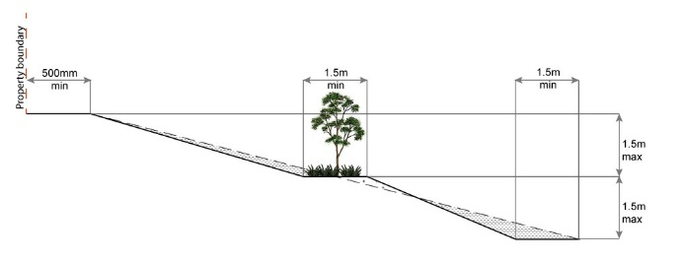
PO45  Filling or excavation is undertaken in a manner that:  - does not adversely impact on a Council or public sector entity maintained infrastructure or any drainage feature on, or adjacent to the land;  - does not preclude reasonable access to a Council or public sector entity maintained infrastructure or any drainage feature on, or adjacent to the land for monitoring, maintenance or replacement purposes. | E45.1  No filling or excavation is undertaken in an easement issued in favour of Council or a public sector entity.
  Note - Public sector entity as defined in the Sustainable Planning Act 2009.
  Note - Public sector entity as defined in the Sustainable Planning Act 2009.
E45.2
Filling or excavation that would result in any of the following is not carried out on-site:
- a reduction in cover over any Council or public sector entity infrastructure service to less than 600mm;
- an increase in finished surface grade over, or within 1.5m on each side of, the Council or public sector entity infrastructure above that which existed prior to the earthworks being undertaken.
Note - Public sector entity as defined in the Sustainable Planning Act 2009.

PO46  Filling or excavation does not result in land instability. | No example provided.
  Note - Steep rock slopes and batters are inspected and certified for long-term stability by a suitably qualified and experienced geotechnical engineer with RPEQ qualifications. Stabilisation measures are provided, as necessary, to ensure long-term stability and low maintenance.
PO47  Development does not result in  - adverse impacts on the hydrological and hydraulic capacity of the waterway or floodway;  - increased flood inundation outside the site;  - any reduction in the flood storage capacity in the floodway;  - and any clearing of native vegetation. | No example provided.
  Note - To demonstrate compliance with this outcome, Planning Scheme Policy - Stormwater Management provides guidance on the preparation of a site based stormwater management plan by a suitably qualified professional. Refer to Planning scheme policy - Integrated design for guidance on infrastructure design and modelling requirements.
Retaining walls and structures
PO48  All earth retaining structures provide a positive interface with the streetscape and minimise impacts on the amenity of adjoining residents. | E48  Earth retaining structures:  - are not constructed of boulder rocks or timber;  - where height is no greater than 900mm, are provided in accordance with Figure - Retaining on a boundary;  Figure - Retaining on boundary  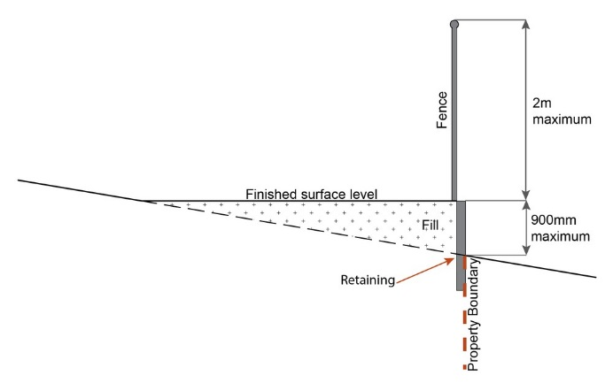  - where height is greater than 900mm but no greater than 1.5m, are to be setback at least the equivalent height of the retaining structure from any property boundary;  - where height is greater than 1.5m, are to be setback and stepped 1.5m vertical: 1.5m horizontal, terraced, landscaped and drained as shown below.  Figure - Cut  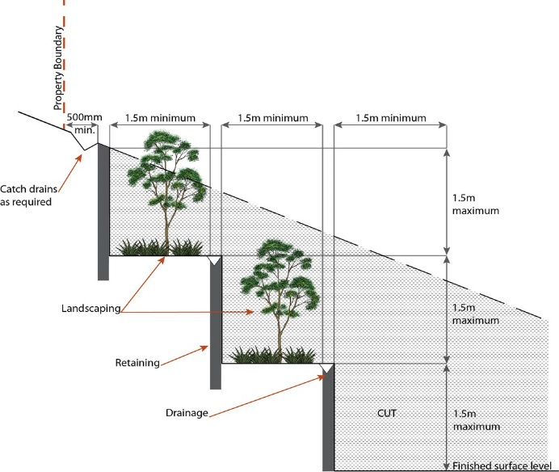  Figure - Fill  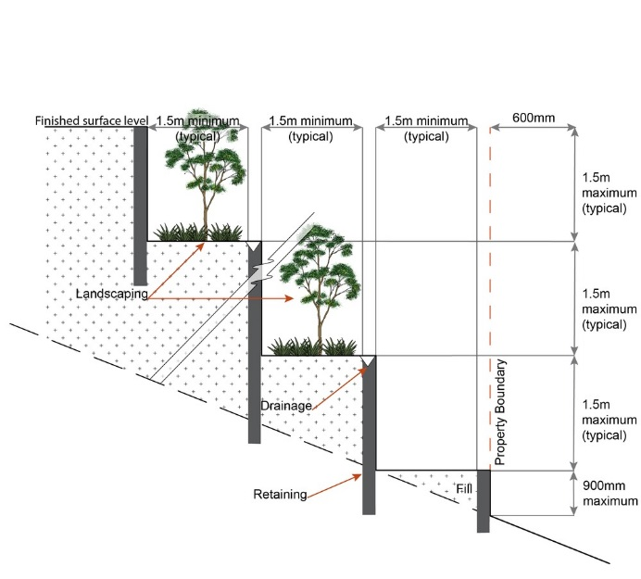
Fire Services
Note - The provisions under this heading only apply if:
- the development is for, or incorporates:
  - reconfiguring a lot for a community title scheme creating 1 or more vacant lots; or
  - material change of use for 2 or more sole occupancy units on the same lot, or within the same community titles scheme; or
  - material change of use for a Tourist park⁽⁸⁴⁾ with accommodation in the form of caravans or tents; or
  - material change of use for outdoor sales⁽⁵⁴⁾, outdoor processing or outdoor storage where involving combustible materials.
AND
- none of the following exceptions apply:
  - the distributor-retailer for the area has indicated, in its netserv plan, that the premises will not be served by that entity’s reticulated water supply; or
  - every part of the development site is within 60m walking distance of an existing fire hydrant on the distributor-retailer’s reticulated water supply network, measured around all obstructions, either on or adjacent to the site.
Note - The provisions under this heading do not apply to buildings that are required by the Building Code of Australia to have a fire hydrant system complying with Australian Standard AS 2419.1 (2005) – Fire Hydrant Installations or other fire fighting facilities which provide equivalent protection.

PO49  Development incorporates a fire fighting system that:  - satisfies the reasonable needs of the fire fighting entity for the area;  - is appropriate for the size, shape and topography of the development and its surrounds;  - is compatible with the operational equipment available to the fire fighting entity for the area;  - considers the fire hazard inherent in the materials comprising the development and their proximity to one another;  - considers the fire hazard inherent in the surrounds to the development site;  - is maintained in effective operating order. | E49.1  External fire hydrant facilities are provided on site to the standard prescribed under the relevant parts of Australian Standard AS 2419.1 (2005) – Fire Hydrant Installations.
  Note - The Queensland Fire and Emergency Services is the entity currently providing the fire fighting function for the urban areas of the Moreton Bay Region.
  Note - For this requirement for accepted development, the following are the relevant parts of AS 2419.1 (2005) that may be applicable:
  - in regard to the form of any fire hydrant - Part 8.5 and Part 3.2.2.1, with the exception that for Tourist parks⁽⁸⁴⁾ or development comprised solely of dwellings and their associated outbuildings, single outlet above-ground hydrants or suitably signposted in-ground hydrants would be an acceptable alternative;
  - in regard to the general locational requirements for fire hydrants - Part 3.2.2.2 (a), (e), (f), (g) and (h) as well as Appendix B of AS 2419.1 (2005);
  - in regard to the proximity of hydrants to buildings and other facilities - Part 3.2.2.2 (b), (c) and (d), with the exception that:
    - for dwellings and their associated outbuildings, hydrant coverage need only extend to the roof and external walls of those buildings;
    - for caravans and tents, hydrant coverage need only extend to the roof of those tents and caravans;
    - for outdoor sales⁽⁵⁴⁾, processing or storage facilities, hydrant coverage is required across the entire area of the outdoor sales⁽⁵⁴⁾, outdoor processing and outdoor storage facilities;
  - in regard to fire hydrant accessibility and clearance requirements - Part 3.5 and, where applicable, Part 3.6.
E49.2
A continuous path of travel having the following characteristics is provided between the vehicle access point to the site and each external fire hydrant and hydrant booster point on the land:
- an unobstructed width of no less than 3.5m;
- an unobstructed height of no less than 4.8m;
- constructed to be readily traversed by a 17 tonne HRV fire brigade pumping appliance;
- an area for a fire brigade pumping appliance to stand within 20m of each fire hydrant and 8m of each hydrant booster point.
E49.3
On-site fire hydrant facilities are maintained in effective operating order in a manner prescribed in Australian Standard AS1851 (2012) – Routine service of fire protection systems and equipment.
PO50  On-site fire hydrants that are external to buildings, as well as the available fire fighting appliance access routes to those hydrants, can be readily identified at all times from, or at, the vehicular entry point to the development site. | E50  For development that contains on-site fire hydrants external to buildings:  - those external hydrants can be seen from the vehicular entry point to the site; or  - a sign identifying the following is provided at the vehicular entry point to the site:  - the overall layout of the development (to scale);  - internal road names (where used);  - all communal facilities (where provided);  - the reception area and on-site manager’s office (where provided);  - external hydrants and hydrant booster points;  - physical constraints within the internal roadway system which would restrict access by fire fighting appliances to external hydrants and hydrant booster points.
  Note - The sign prescribed above, and the graphics used are to be:
  - in a form;
  - of a size;
  - illuminated to a level;
  which allows the information on the sign to be readily understood, at all times, by a person in a fire fighting appliance up to 4.5m from the sign.
PO51  Each on-site fire hydrant that is external to a building is signposted in a way that enables it to be readily identified at all times by the occupants of any firefighting appliance traversing the development site. | E51  For development that contains on-site fire hydrants external to buildings, those hydrants are identified by way of marker posts and raised reflective pavement markers in the manner prescribed in the technical note Fire hydrant indication system produced by the Queensland Department of Transport and Main Roads.
  Note - Technical note Fire hydrant indication system is available on the website of the Queensland Department of Transport and Main Roads.

Use specific criteria
Industrial land uses
PO52  Ancillary office⁽⁵³⁾, administration functions, retail sales and customer service components do not compromise the primary use of the site for industrial purposes or compromise the viability, role or function of the region's centre network. | E52  The combined area of ancillary non-industrial activities, including but not limited to offices⁽⁵³⁾, administration functions, display and retail sale of commodities, articles or goods resulting from the industrial processes on-site, does not exceed 30% of the GFA or 500m², whichever is the lesser.
PO53  Buildings directly adjoining land outside of the industry precinct:  - are compatible with the character of the adjoining area;  - minimise overlooking and overshadowing;  - maintain privacy;  - do not cause significant loss of amenity to neighbouring residents by way of noise, vibration, odour, lighting, traffic generation and hours of operation. | No example provided.
PO54  Medium impact industry⁽⁴⁷⁾ uses only establish in the precinct where:  - buildings and activities are located at least 250m from a sensitive land use or sensitive zone;  - not constraining the function or viability of existing or future uses in the precinct;  - not adversely affecting the amenity, health or safety of employees and visitors of the surrounding uses;  - not adversely affecting the amenity, health or safety of nearby sensitive land uses. | No example provided.
  Note - Separation distances are to be measured in a straight line, in accordance with the State policy.
Caretaker’s accommodation ⁽¹⁰⁾
PO55  Development of Caretaker's accommodation⁽¹⁰⁾:  - does not compromise the productivity of the use occurring on-site and in the surrounding area;  - is domestic in scale;  - provides adequate car parking provisions exclusive on the primary use of the site;  - is safe for the residents;  - has regard to the open space and recreation needs of the residents. | E55  Caretaker's accommodation⁽¹⁰⁾:  - has a maximum GFA is 80m²;  - does not gain access from a separate driveway to that of the industrial use;  - provides a minimum 16m² of private open space directly accessible from a habitable room;  - provides car parking in accordance with Schedule 7 - Car parking.
Sales office ⁽⁷²⁾
PO56  Sales office⁽⁷²⁾ remain temporary in duration and demonstrates a relationship to the land or buildings being displayed or sold. | E56  A Sales office⁽⁷²⁾ is located on the site for no longer than 2 years.
Major electricity infrastructure⁽⁴³⁾, Substation⁽⁸⁰⁾ and Utility installation⁽⁸⁶⁾
PO57  The development does not have an adverse impact on the visual amenity of a locality and is:  - high quality design and construction;  - visually integrated with the surrounding area;  - not visually dominant or intrusive;  - located behind the main building line;  - below the level of the predominant tree canopy or the level of the surrounding buildings and structures;  - camouflaged through the use of colours and materials which blend into the landscape;  - treated to eliminate glare and reflectivity;  - landscaped;  - otherwise consistent with the amenity and character of the zone and surrounding area. | E57.1  Development is designed to minimise surrounding land use conflicts by ensuring infrastructure, buildings, structures and other equipment:  - are enclosed within buildings or structures;  - are located behind the main building line;  - have a similar height, bulk and scale to the surrounding fabric;  - have horizontal and vertical articulation applied to all exterior walls.
E57.2
A minimum 3m wide strip of dense planting is provided around the outside of the fenced area, between the development and street frontage, side and rear boundaries.
PO58  Infrastructure does not have an impact on pedestrian health and safety. | E58  Access control arrangements:  - do not create dead-ends or dark alleyways adjacent to the infrastructure;  - minimise the number and width of crossovers and entry points;  - provide safe vehicular access to the site;  - do not utilise barbed wire or razor wire.
PO59  All activities associated with the development occur within an environment incorporating sufficient controls to ensure the facility:  - generates no audible sound at the site boundaries where in a residential setting; or  - meet the objectives as set out in the Environmental Protection (Noise) Policy 2008. | E59  All equipment which produces audible or non-audible sound is housed within a fully enclosed building incorporating sound control measures sufficient to ensure noise emissions meet the objectives as set out in the Environmental Protection (Noise) Policy 2008.
Telecommunications facility ⁽⁸¹⁾
Editor's note - In accordance with the Federal legislation Telecommunications facilities ⁽⁸¹⁾must be constructed and operated in a manner that will not cause human exposure to electromagnetic radiation beyond the limits outlined in the Radiocommunications (Electromagnetic Radiation - Human Exposure) Standard 2003 and Radio Protection Standard for Maximum Exposure Levels to Radiofrequency Fields - 3Khz to 300Ghz.

PO60  Telecommunications facilities⁽⁸¹⁾ are co-located with existing telecommunications facilities⁽⁸¹⁾, Utility installation⁽⁸⁶⁾, Major electricity infrastructure⁽⁴³⁾ or Substation⁽⁸⁰⁾ if there is already a facility in the same coverage area. | E60.1  New telecommunication facilities⁽⁸¹⁾ are co-located on existing towers with new equipment shelter and associated structures positioned adjacent to the existing shelters and structures.
E60.2
If not co-located with an existing facility, all co-location opportunities have been investigated and fully exhausted within a 2km radius of the site.
PO61  A new Telecommunications facility⁽⁸¹⁾ is designed and constructed to ensure co-masting or co-siting with other carriers both on the tower or pole and at ground level is possible in the future. | E61  A minimum of 45m² is available at ground level to allow for additional equipment shelters and associated structures for the purpose of co-locating on the proposed facility.
PO62  Telecommunications facilities⁽⁸¹⁾ do not conflict with lawful existing land uses both on and adjoining the site. | E62  The development results in no net reduction in the minimum quantity and standard of landscaping, private or communal open space or car parking spaces required under the planning scheme or under an existing development approval.
PO63  The Telecommunications facility⁽⁸¹⁾ does not have an adverse impact on the visual amenity of a locality and is:  - high quality design and construction;  - visually integrated with the surrounding area;  - not visually dominant or intrusive;  - located behind the main building line;  - below the level of the predominant tree canopy or the level of the surrounding buildings and structures;  - camouflaged through the use of colours and materials which blend into the landscape;  - treated to eliminate glare and reflectivity;  - landscaped;  - otherwise consistent with the amenity and character of the zone and surrounding area. | E63.1  Where in an urban area, the development does not protrude more than 5m above the level of the existing treeline, prominent ridgeline or building rooftops in the surrounding townscape.
E63.2
In all other areas towers do not exceed 35m in height.
E63.3
Towers, equipment shelters and associated structures are of a design, colour and material to:
- reduce recognition in the landscape;
- reduce glare and reflectivity.
E63.4
All structures and buildings are setback behind the main building line and a minimum of 10m from side and rear boundaries, except where in the Industry and Extractive industry zones, the minimum side and rear setback is 3m.
Where there is no established building line the facility is located at the rear of the site.
E63.5
The facility is enclosed by security fencing or by other means to ensure public access is prohibited.
E63.6
A minimum 3m wide strip of dense planting is provided around the perimeter of the fenced area, between the facility and street frontage and adjoining uses.
Note - Landscaping is provided in accordance with Planning scheme policy - Integrated design.
Note - Council may require a detailed landscaping plan, prepared by a suitably qualified person, to ensure compliance with Planning scheme policy - Integrated design.

PO64  Lawful access is maintained to the site at all times that does not alter the amenity of the landscape or surrounding uses. | E64  An Access and Landscape Plan demonstrates how 24 hour vehicular access will be obtained and maintained to the facility in a manner that is appropriate to the site’s context.
PO65  All activities associated with the development occur within an environment incorporating sufficient controls to ensure the facility generates no audible sound at the site boundaries where in a residential setting. | E65  All equipment comprising the Telecommunications facility⁽⁸¹⁾ which produces audible or non-audible sound is housed within a fully enclosed building incorporating sound control measures sufficient to ensure no noise from this equipment can be heard, or felt at the site boundary.

Values and constraints criteria
Note - The relevant values and constraints criteria do not apply where the development is consistent with a current Development permit for Reconfiguring a lot or Material change of use or Operational work, where that approval has considered and addressed (e.g. through a development footprint plan (or similar in the case of Landslide hazard) or conditions of approval) the identified value or constraint under this planning scheme.

Environmental areas (refer Overlay map - Environmental areas to determine if the following assessment criteria apply)
Note – The following are excluded from the native vegetation clearing provisions of this planning scheme:
- Clearing of native vegetation located within an approved development footprint;
- Clearing of native vegetation within 10m from a lawfully established building reasonably necessary for emergency access or immediately required in response to an accident or emergency;
- Clearing of native vegetation reasonably necessary to remove or reduce the risk vegetation poses to serious personal injury or damage to infrastructure;
- Clearing of native vegetation reasonably necessary to construct and maintain a property boundary fence and not exceed 4m in width either side of the fence where in the Rural, Rural residential and Environmental Management and Conservation zones. In any other zone, clearing is not to exceed 2m in width either side of the fence;
- Clearing of native vegetation reasonably necessary for the purpose of maintenance or works within a registered easement for public infrastructure or drainage purposes;
- Clearing of native vegetation in accordance with a bushfire management plan prepared by a suitably qualified person, submitted to and accepted by Council;
- Clearing of native vegetation associated with removal of recognised weed species, maintaining existing open pastures and cropping land, windbreaks, lawns or created gardens;
- Grazing of native pasture by stock;
- Native forest practice where accepted development under Part 1, 1.7.7 Accepted development.
Note - Definition for native vegetation is located in Schedule 1 Definitions.
Note - Native vegetation subject to this criteria primarily comprises of matters of national environmental significance (MNES), matters of state environmental significance (MSES). They also comprise some matters of local environmental significance (MLES). A MLES is defined in Schedule 1.2, Administrative definitions. A list of the elements that apply to the mapped MSES and MLES is provided in Appendix 1 of the Planning scheme policy - Environmental areas.
Editors' Note - The accuracy of overlay mapping can be challenged through the development application process (code assessable development) or by way of a planning scheme amendment. See Council's website for details.
Note - To demonstrate achievement of the performance outcome, an ecological assessment, vegetation management plan and fauna management plan, as required, are prepared by a suitably qualified person. Guidance for the preparation of above mentioned reports is provided in Planning scheme policy - Environmental areas.

Vegetation clearing, ecological value and connectivity
PO66  Development avoids locating in a High Value Area or a Value Offset Area. Where it is not practicable or reasonable for development to avoid establishing in these areas, development must ensure that:  - the quality and integrity of the biodiversity and ecological values inherent to a High Value Area and a Value Offset Area is maintained and not lost or degraded;  - on-site mitigation measures, mechanisms or processes are in place demonstrating the quality and integrity of the biodiversity and ecological values inherent to a High Value Area and a Value Offset Area are maintained. For example, this can be achieved through replacement, restoration or rehabilitation planting as part of any proposed covenant, the development of a Vegetation Management Plan, a Fauna Management Plan, and any other on-site mitigation options identified in the Planning scheme policy - Environmental areas*. | No example provided.
  * Editor's note - This is not a requirement for an environmental offset under the Environmental Offsets Act 2014.
PO67  Development provides for safe, unimpeded, convenient and ongoing wildlife movement and establishes and maintains habitat connectivity by:  - retaining habitat trees;  - providing contiguous patches of habitat;  - provide replacement and rehabilitation planting to improve connectivity;  - avoiding the creation of fragmented and isolated patches of habitat;  - providing wildlife movement infrastructure. | No example provided.
  Editor's note - Wildlife movement infrastructure may include refuge poles, tree boulevarding, ‘stepping stone’ vegetation plantings, tunnels, appropriate wildlife fencing; culverts with ledges, underpasses, overpasses, land bridges and rope bridges. Further information is provided in Planning scheme policy – Environmental areas.
Vegetation clearing and habitat protection
PO68  Development ensures that the biodiversity quality and integrity of habitats is not adversely impacted upon but maintained and protected. | No example provided.
PO69  Development does not result in the net loss or degradation of habitat value in a High Value Area or a Value Offset Area. Where development does result in the loss or degradation of habitat value, development will:  - rehabilitate, revegetate, restore and enhance an area to ensure it continues to function as a viable and healthy habitat area;  - provide replacement fauna nesting boxes in the event of habitat tree loss in accordance with Planning scheme policy - Environmental areas;  - undertake rehabilitation, revegetation and restoration in accordance with the South East Queensland Ecological Restoration Framework. | No example provided.
PO70  Development ensures safe, unimpeded, convenient and ongoing wildlife movement and habitat connectivity by:  - providing contiguous patches of habitat;  - avoiding the creation of fragmented and isolated patches of habitat;  - providing wildlife movement infrastructure;  - providing replacement and rehabilitation planting to improve connectivity. | No example provided.
Vegetation clearing and soil resource stability
PO71  Development does not:  - result in soil erosion or land degradation;  - leave cleared land exposed for an unreasonable period of time but is rehabilitated in a timely manner. | No example provided.
Vegetation clearing and water quality
PO72  Development maintains or improves the quality of groundwater and surface water within, and downstream, of a site by:  - ensuring an effective vegetated buffers and setbacks from waterbodies is retained to achieve natural filtration and reduce sediment loads;  - avoiding or minimising changes to landforms to maintain hydrological water flows;  - adopting suitable measures to exclude livestock from entering a waterbody where a site is being used for animal husbandry⁽⁴⁾ and animal keeping⁽⁵⁾ activities. | No example provided.
PO73  Development minimises adverse impacts of stormwater run-off on water quality by:  - minimising flow velocity to reduce erosion;  - minimising hard surface areas;  - maximising the use of permeable surfaces;  - incorporating sediment retention devices;  - minimising channelled flow. | No example provided.
Vegetation clearing and access, edge effects and urban heat island effects
PO74  Development retains safe and convenient public access in a manner that does not result in the adverse edge effects or the loss or degradation of biodiversity values within the environment. | No example provided.
PO75  Development minimises potential adverse ‘edge effects’ on ecological values by:  - providing dense planting buffers of native vegetation between a development and environmental areas;  - retaining patches of native vegetation of greatest possible size where located between a development and environmental areas ;  - restoring, rehabilitating and increasing the size of existing patches of native vegetation;  - ensuring that buildings and access (public and vehicle) are setback as far as possible from environmental areas and corridors;  - landscaping with native plants of local origin. | No example provided.
  Editor's note - Edge effects are factors of development that go to detrimentally affecting the composition and density of natural populations at the fringe of natural areas. Factors include weed invasion, pets, public and vehicle access, nutrient loads, noise and light pollution, increased fire frequency and changes in the groundwater and surface water flow.
PO76  Development avoids adverse microclimate change and does not result in increased urban heat island effects. Adverse urban heat island effects are minimised by:  - pervious surfaces;  - providing deeply planted vegetation buffers and green linkage opportunities;  - landscaping with local native plant species to achieve well-shaded urban places;  - increasing the service extent of the urban forest canopy. | No example provided.
Vegetation clearing and Matters of Local Environmental Significance (MLES) environmental offsets
PO77  Where development results in the unavoidable loss of native vegetation within a Value Offset Area MLES waterway buffer or a Value Offset Area MLES wetland buffer, an environmental offset is required in accordance with the environmental offset requirements identified in Planning scheme policy - Environmental areas. | No example provided.
  Editor's note - For MSES Koala Offsets, the environmental offset provisions in schedule 11 of the Regulation, in combination with the requirements of the Environmental Offset Act 2014, apply.
Heritage and landscape character (refer Overlay map - Heritage and landscape character to determine if the following assessment criteria apply)
Note - To assist in demonstrating achievement of heritage performance outcomes, a Cultural heritage impact assessment report is prepared by a suitably qualified person verifying the proposed development is in accordance with The Australia ICOMOS Burra Charter.
Note - To assist in demonstrating achievement of this performance outcome, a Tree assessment report is prepared by a qualified arborist in accordance with Planning scheme policy – Heritage and landscape character. The Tree assessment report will also detail the measures adopted in accordance with AS 4970-2009 Protection of trees on development sites.
Note - Places, including sites, objects and buildings having local cultural heritage significance, are identified on Overlay map - Heritage and landscape character and listed in Schedule 1 of Planning scheme policy - Heritage and landscape character. Places also having cultural heritage significance at a State level and being entered in the Queensland Heritage Register, are also identified in Schedule 1 of Planning scheme policy - Heritage and landscape character.

PO78  Development will:  - not diminish or cause irreversible damage to the cultural heritage values present on the site, and associated with a heritage site, object or building;  - protect the fabric and setting of the heritage site, object or building;  - be consistent with the form, scale and style of the heritage site, object or building;  - utilise similar materials to those existing, or where this is not reasonable or practicable, neutral materials and finishes;  - incorporate complementary elements, detailing and ornamentation to those present on the heritage site, object or building;  - retain public access where this is currently provided. | E78  Development is for the preservation, maintenance, repair and restoration of a site, object or building of cultural heritage value.
  Note - A cultural heritage conservation management plan for the preservation, maintenance, repair and restoration of a site, object or building of cultural heritage value is prepared in accordance with Planning scheme policy - Heritage and landscape character. The plan is sent to, and approved by Council prior to the commencement of any preservation, maintenance, repair and restoration works.
PO79  Demolition and removal is only considered where:  - a report prepared by a suitably qualified conservation architect or conservation engineer demonstrates that the building is structurally unsound and is not reasonably capable of economic repair; or  - demolition is confined to the removal of outbuildings, extensions and alterations that are not part of the original structure; or  - limited demolition is performed in the course of repairs, maintenance or restoration; or  - demolition is performed following a catastrophic event which substantially destroys the building or object. | No example provided.
PO80  Where development is occurring on land adjoining a site of cultural heritage value, the development is to be sympathetic to and consistent with the cultural heritage values present on the site and not result in their values being eroded, degraded or unreasonably obscured from public view. | No example provided.
PO81  Development does not adversely impact upon the health and vitality of significant trees. Where development occurs in proximity to a significant tree, construction measures and techniques as detailed in AS 4970-2009 Protection of trees on development sites are adopted to ensure a significant tree's health, wellbeing and vitality.  Significant trees are only removed where they are in a poor state of health or where they pose a health and safety risk to persons or property. A Tree Assessment report prepared by a suitably qualified arborist confirming a tree's state of health is required to demonstrate achievement of this performance outcome. | E81  Development does:  - not result in the removal of a significant tree;  - not occur within 20m of a protected tree;  - involve pruning of a tree in accordance with Australian Standard AS 4373-2007 – Pruning of Amenity Trees.
Infrastructure buffers (refer Overlay map - Infrastructure buffers to determine if the following assessment criteria apply)
PO82  Habitable rooms within an Electricity supply substation buffer are located a sufficient distance from substations⁽⁸⁰⁾ to avoid any potential adverse impacts on personal health and wellbeing from electromagnetic fields. | E82  Habitable rooms:  - are not located within an Electricity supply substation buffer; and  - proposed on a site subject to an Electricity supply supply substation⁽⁸⁰⁾are acoustically insulted to achieve the noise levels listed in Schedule 1, Acoustic Quality Objectives, Environmental Protection (Noise) Policy 2008.
  Note - Habitable room is defined in the Building Code of Australia (Volume 1)
  Note - Habitable room is defined in the Building Code of Australia (Volume 1)
PO83  Habitable rooms within an Electricity supply substation buffer are acoustically insulated from the noise of a substation⁽⁸⁰⁾ to achieve the noise levels listed in Schedule 1 Acoustic Quality Objectives, Environmental Protection (Noise) Policy 2008 and provides a safe, healthy and disturbance free living environment. | No example provided.
  Note - To demonstrate achievement of the performance outcome, a noise impact assessment report is prepared by a suitably qualified person. Guidance to preparing an noise impact assessment report is provided in Planning scheme policy – Noise.
  Note - Habitable room is defined in the Building Code of Australia (Volume 1)
PO84  Development within a Pumping station buffer is located, designed and constructed to:  - ensure that odour or other air pollutant impacts on the amenity of the development met the air quality of objectives in the Environmental Protection (Air) Policy 2008;  - ensure that noise impacts on the amenity of the development met the indoor noise objectives set out in the Environmental Protection (Noise) Policy 2008. | E84  Development does not involve the construction of any buildings or structures within a Pumping station buffer.
Overland flow path (refer Overlay map - Overland flow path to determine if the following assessment criteria apply)
Note - The applicable river and creek flood planning levels associated with defined flood event (DFE) within the inundation area can be obtained by requesting a flood check property report from Council.

PO85  Development:  - minimises the risk to persons from overland flow;  - does not increase the potential for damage from overland flow either on the premises or other premises, public land, watercourses, roads or infrastructure. | No example provided.
PO86  Development:  - maintains the conveyance of overland flow predominantly unimpeded through the premises for any event up to and including the 1% AEP for the fully developed upstream catchment;  - does not concentrate, intensify or divert overland flow onto an upstream, downstream or surrounding property. | No example provided.
  Note - A report from a suitably qualified Registered Professional Engineer Queensland is required certifying that the development does not increase the potential for significant adverse impacts on an upstream, downstream or surrounding premises.
  Note - Reporting to be prepared in accordance with Planning scheme policy – Flood hazard, Coastal hazard and Overland flow.
PO87  Development does not:  - directly, indirectly or cumulatively cause any increase in overland flow velocity or level;  - increase the potential for flood damage from overland flow either on the premises or other premises, public lands, watercourses, roads or infrastructure. | No example provided.
  Note - Open concrete drains greater than 1m in width are not an acceptable outcome, nor are any other design options that may increase scouring.
PO88  Development ensures that public safety and the risk to the environment are not adversely affected by a detrimental impact of overland flow on a hazardous chemical located or stored on the premises. | E88  Development ensures that a hazardous chemical is not located or stored in an Overland flow path area.
  Note - Refer to the Work Health and Safety Act 2011 and associated Regulation and Guidelines, the Environmental Protection Act 1994 and the relevant building assessment provisions under the Building Act 1975 for requirements related to the manufacture and storage of hazardous substances.
PO89  Development which is not in a Rural zone ensures that overland flow is not conveyed from a road or public open space onto a private lot. | E89  Development which is not in a Rural zone that an overland flow paths and drainage infrastructure is provided to convey overland flow from a road or public open space area away from a private lot.
PO90  Development ensures that inter-allotment drainage infrastructure, overland flow paths and open drains through private property cater for overland flows for a fully developed upstream catchment and are able to be easily maintained. | E90.1  Development ensures that roof and allotment drainage infrastructure is provided in accordance with the following relevant level as identified in QUDM:  - Urban area – Level III;  - Rural area – N/A;  - Industrial area – Level V;  - Commercial area – Level V.
  Note - A report from a suitably qualified Registered Professional Engineer Queensland is required certifying that the development does not increase the potential for significant adverse impacts on an upstream, downstream or surrounding premises.
  Note - Reporting to be prepared in accordance with Planning scheme policy – Flood hazard, Coastal hazard and Overland flow
E90.2
Development ensures that inter-allotment drainage infrastructure is designed to accommodate any event up to and including the 1% AEP for the fully developed upstream catchment.
PO91  Development protects the conveyance of overland flow such that an easement for drainage purposes is provided over:  - a stormwater pipe if the nominal pipe diameter exceeds 300mm;  - an overland flow path where it crosses more than one premises;  - inter-allotment drainage infrastructure. | No example provided.
  Note - Refer to Planning scheme policy - Integrated design for details and examples.
  Note - Stormwater Drainage easement dimensions are provided in accordance with Section 3.8.5 of QUDM.
Additional criteria for development for a Park⁽⁵⁷⁾
PO92  Development for a Park⁽⁵⁷⁾ ensures that the design and layout responds to the nature of the overland flow affecting the premises such that:  - public benefit and enjoyment is maximised;  - impacts on the asset life and integrity of park structures is minimised;  - maintenance and replacement costs are minimised. | E92  Development for a Park⁽⁵⁷⁾ ensures works are provided in accordance with the requirements set out in Appendix B of the Planning scheme policy - Integrated design.
Riparian and wetland setbacks
PO93  Development provides and maintains a suitable setback from waterways and wetlands that protects natural and environmental values. This is achieved by recognising and responding to the following matters:  - impact on fauna habitats;  - impact on wildlife corridors and connectivity;  - impact on stream integrity;  - impact of opportunities for revegetation and rehabilitation planting;  - edge effects. | E93  Development does not occur within:  - 50m from top of bank for W1 waterway and drainage line  - 30m from top of bank for W2 waterway and drainage line  - 20m from top of bank for W3 waterway and drainage line  - 100m from the edge of a Ramsar wetland, 50m from all other wetlands.
  Note - W1, W2 and W3 waterway and drainage lines, and wetlands are mapped on Schedule 2, Section 2.5 Overlay Maps – Riparian and wetland setbacks.
Scenic amenity - Regionally significant (Hills) and Locally important (Coast) (refer Overlay map - Scenic amenity to determine if the following assessment criteria apply)
PO94  Development:  - avoids being viewed as a visually conspicuous built form on a hill top or ridgeline;  - retain the natural character or bushland settings as the dominant landscape characteristic;  - is viewed as being visually consistent with the natural landscape setting and does not diminish the scenic and visual qualities present in the environment. | E94  Where located in the Regionally significant (Hills) scenic amenity overlay, buildings and structures are not:  - located on a hill top or ridge line;  - all parts of the building and structure are located below the hill top or ridge line.
PO95  Development:  - does not adversely detract or degrade the quality of views, vista or key landmarks;  - retains the natural character or bushland settings as the dominant landscape characteristic. | E95  Where located in the Regionally significant (Hills) scenic amenity overlay, driveways and accessways:  - go across land contours, and do not cut straight up slopes;  - follow natural contours, not resulting in batters or retaining walls being greater than 900mm in height.
PO96  Buildings and structures incorporate colours and finishes that:  - are consistent with a natural, open space character and bushland environment;  - do not produce glare or appear visual incompatible with the surrounding natural character and bushland environment;  - are not visually dominant or detract from the natural qualities of the landscape. | E96.1  Where located in the Regionally significant (hills) scenic amenity overlay, roofs and wall surfaces of buildings and structures adopt the following colours:
  Colours from Australian Standard AS2700s – 1996
  G12 – Holly | G54 – Mist Green | N 44 – Bridge Grey
  G13 – Emerald | G55 – Lichen | N45 – Koala Grey
  G14 – Moss Green | G56 – Sage Green | N52 – Mid Grey
  G15 – Rainforest Green | G62 – Rivergum | N54 – Basalt
  G16 – Traffic Green | G64 – Slate | N55 – Lead Grey
  G17 – Mint Green | G65 – Ti Tree | X54 – Brown
  G21 – Jade | N25 – Birch Grey | X61 – Wombat
  G22 – Serpentine | N32 – Green Grey | X62 – Dark Earth
  G23 – Shamrock | N33 – Lightbox Grey | X63 – Iron Bark
  G24 – Fern Green | N35 – Light Grey | Y51 – Bronze Olive
  G25 – Olive | N41 – Oyster | Y61 – Black Olive
  G34 – Avocado | N42 – Storm Grey | Y63 – Khaki
  G52 – Eucalyptus | N43 – Pipeline Grey | Y66 – Mudstone
  G53 – Banksia
E96.2
Where located in the Regionally significant (hills) scenic amenity overlay, roofs and wall surfaces of buildings and structures are painted or finished such that reflectivity is less than 35%.

