Table 6.2.2.4.1 Requirements for accepted development - Lakeside precinct

Requirements for accepted development |  | E Compliance  - Yes  - No | Council confirmation
General requirements
Building setbacks
RAD1 | Buildings and structures are setback as follows:  - road frontage - 6m  - side boundary - 3m  - rear boundary - 3m.
Site cover
RAD2 | Site cover does not exceed 40%.
Car parking
RAD3 | On-site car parking is provided in accordance with Schedule 7 - Car parking.
RAD4 | Minimum cycle parking spaces are provided at minimum 1 employee space per 200m² of GFA.
Waste
RAD5 | Bins and bin storage areas are provided, designed and managed in accordance with Planning scheme policy – Waste.
Lighting
RAD6 | Artificial lighting on-site is directed and shielded in such a manner as not to exceed the recommended maximum values of light technical parameters for the control of obtrusive light given in Table 2.1 of Australian Standard AS 4282 (1997) Control of Obtrusive Effects of Outdoor Lighting.
  Note - "Curfewed hours” are taken to be those hours between 10pm and 7am on the following day.
Hazardous chemicals
RAD7 | All development that involves the storage or handling of hazardous chemicals listed in Schedule 9, Development involving hazardous chemicals, Table 9.0.1 Quantity thresholds for hazardous chemicals stored as accepted development subject to requirements complies with Table 9.0.3 Hazardous chemicals.
RAD8 | Development does not involve the storage or handling of hazardous chemicals listed in Schedule 9, Development involving hazardous chemicals, Table 9.0.2 Hazardous chemicals assessable thresholds.
Clearing of habitat trees where not located in the Environmental areas overlay map
RAD9 | Development does not result in the damaging, destroyed or clearing of a habitat tree. This does not apply to:  - Clearing of a habitat tree located within an approved development footprint;  - Clearing of a habitat tree within 10m from a lawfully established building reasonably necessary for emergency access or immediately required in response to an accident or emergency;  - Clearing of a habitat tree reasonably necessary to remove or reduce the risk vegetation poses to serious personal injury or damage to infrastructure;  - Clearing of a habitat tree reasonably necessary to construct and maintain a property boundary fence and not exceed 4m in width either side of the fence where in the Rural , Rural residential and Environmental management and conservation zones. In any other zone, clearing is not to exceed 2m in width either side of the fence;  - Clearing of a habitat tree reasonably necessary for the purpose of maintenance or works within a registered easement for public infrastructure or drainage purposes;  - Clearing of a habitat tree in accordance with a bushfire management plan prepared by a suitably qualified person, submitted to and accepted by Council;  - Clearing of a habitat tree associated with removal of recognised weed species, maintaining existing open pastures and cropping land, windbreaks, lawns or created gardens;  - Native forest practice where accepted development under Part 1, 1.7.7 Accepted development.
  Editor's note - A native tree measuring greater than 80cm in diameter when measured at 1.3m from the ground is recognised as a ‘habitat tree’. For further information on habitat trees, refer to Planning scheme policy – Environmental areas and corridors. Information detailing how this measurement is undertaken is provided in Australian Standard AS 4970 2009 Protection of Trees on Development Sites - Appendix A.

Works requirements
Utilities
RAD10 | Where available, the development is connected to:  - an existing reticulated electricity supply;  - telecommunications and broadband;  - reticulated sewerage;  - reticulated water;  - constructed and dedicated road.
RAD11 | Where not in a sewered area, the development is serviced by an appropriate on-site sewerage facility.
  Note - A site and soil evaluation report is generally required to demonstrate compliance with this outcome. Reports are to be prepared in accordance with AS1547 On-site domestic wastewater management and the Queensland Plumbing and Wastewater Code.
RAD12 | Where not in an existing connections area or a future connections area as detailed in the Unitywater Connections Policy, the development is provided with an adequate water supply of 45,000 litres by way of on-site storage which provides equivalent water quality and reliability to support the use requirements of the development.
Access
RAD13 | Any new or changes to existing site access and driveways are designed and located in accordance with:  - Where for a Council-controlled road, AS/NZS2890.1 section 3; or  - Where for a State-Controlled road, the Safe Intersection Sight Distance requirements in AustRoads and the appropriate IPWEAQ standard drawings, or a copy of a Transport Infrastructure Act 1994, section 62 approval.
RAD14 | Any new or changes to existing internal driveways and access ways are designed and constructed in accordance with AS/NZS2890.1 Parking Facilities – Off street car parking and the relevant standards in Planning scheme policy - Integrated design.
Stormwater
RAD15 | Any new or changes to existing stormwater run-off from the site is conveyed to a point of lawful discharge without causing nuisance or annoyance to any person, property or premises in accordance with Planning scheme policy – Integrated design.
  Note - A watercourse as defined in the Water Act may be accepted as a lawful point of discharge providing the drainage discharge from the site does not increase the downstream flood levels during events up to and including the 1% AEP storm. An afflux of +20mm may be accepted on Council controlled land and road infrastructure. No worsening is ensured when stormwater is discharged into a catchment that includes State Transport Infrastructure.
Site works and construction management
RAD16 | The site and any existing structures are to be maintained in a tidy and safe condition.
RAD17 | Site construction works incorporate temporary stormwater run-off, erosion and sediment controls and trash traps designed in accordance with the Urban Stormwater Quality Planning Guidelines, Planning scheme policy - Stormwater management and Planning scheme policy - Integrated design.
RAD18 | Construction traffic including contractor car parking is controlled in accordance with a traffic management plan, prepared in accordance with the Manual of Uniform Traffic Control Devices (MUTCD) to ensure all traffic movements to and from the site are safe.
RAD19 | All native vegetation to be retained on-site is temporarily fenced or protected prior to and during development works.
  Note - No parking of vehicles or storage of machinery or goods is to occur in these areas during development works.
RAD20 | Any damage to Council land or infrastructure is repaired or replaced with the same materials, prior to plan sealing, or final building classification.
RAD21 | Any material dropped, deposited or spilled on the road(s) as a result of construction processes associated with the site are to be cleaned at all times.
Earthworks
RAD22 | The site is prepared and the fill placed on-site in accordance with Australian Standard AS3798.
  Note - The fill is to be inspected and tested in accordance with Planning scheme policy - Operational works inspection, maintenance and bonding procedures
RAD23 | The total of all cut and fill on-site does not exceed 900mm in height.  Figure - Cut and fill  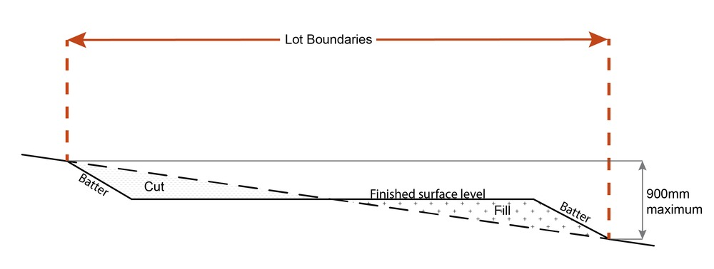
  Note - This is site earthworks not building work.
RAD24 | Filling or excavation does not result in:  - a reduction in cover over any Council or public sector entity infrastructure to less than 600mm;  - an increase in finished surface grade over, or within 1.5m on each side of, the Council or public sector entity infrastructure above that which existed prior to the filling or excavation works being undertaken.
  Note - Public sector entity is defined in Schedule 2 of the Act.
Fire services
Note - The provisions under this heading only apply if:
- the development is for, or incorporates:
  - reconfiguring a lot for a community title scheme creating 1 or more vacant lots; or
  - material change of use for 2 or more sole occupancy units on the same lot, or within the same community titles scheme; or
  - material change of use for a Tourist park⁽⁸⁴⁾ with accommodation in the form of caravans or tents; or
  - material change of use for outdoor sales⁽⁵⁴⁾, outdoor processing or outdoor storage where involving combustible materials.
AND
- none of the following exceptions apply:
  - the distributor-retailer for the area has indicated, in its netserv plan, that the premises will not be served by that entity’s reticulated water supply; or
  - every part of the development site is within 60m walking distance of an existing fire hydrant on the distributor-retailer’s reticulated water supply network, measured around all obstructions, either on or adjacent to the site.
Note - The provisions under this heading do not apply to buildings that are required by the Building Code of Australia to have a fire hydrant system complying with Australian Standard AS 2419.1 (2005) – Fire Hydrant Installations or other fire fighting facilities which provide equivalent protection.

RAD25 | External fire hydrant facilities are provided on site to the standard prescribed under the relevant parts of Australian Standard AS 2419.1 (2005) – Fire Hydrant Installations.
  Note - For this requirement for accepted development, the following are the relevant parts of AS 2419.1 (2005):
  - in regard to the form of any fire hydrant - Part 8.5 and Part 3.2.2.1, with the exception that for Tourist parks⁽⁸⁴⁾ or development comprised solely of dwellings and their associated outbuildings, single outlet above-ground hydrants or suitably signposted in-ground hydrants would be an acceptable alternative;
  - in regard to the general locational requirements for fire hydrants - Part 3.2.2.2 (a), (e), (f), (g) and (h) as well as Appendix B of AS 2419.1 (2005);
  - in regard to the proximity of hydrants to buildings and other facilities - Part 3.2.2.2 (b), (c) and (d), with the exception that:
    - - for dwellings and their associated outbuildings, hydrant coverage need only extend to the roof and external walls of those buildings;
    - - for caravans and tents, hydrant coverage need only extend to the roof of those tents and caravans;
    - - for outdoor sales⁽⁵⁴⁾, processing or storage facilities, hydrant coverage is required across the entire area of the outdoor sales⁽⁵⁴⁾, outdoor processing and outdoor storage facilities; and
  - in regard to fire hydrant accessibility and clearance requirements - Part 3.5 and where applicable, Part 3.6.
RAD26 | A continuous path of travel having the following characteristics is provided between the vehicle access point to the site and each external fire hydrant and hydrant booster point on the land:  - an unobstructed width of no less than 3.5m;  - an unobstructed height of no less than 4.8m;  - constructed to be readily traversed by a 17 tonne HRV fire brigade pumping appliance;  - an area for a fire brigade pumping appliance to stand within 20m of each fire hydrant and 8m of each hydrant booster point.
RAD27 | On-site fire hydrant facilities are maintained in effective operating order in a manner prescribed in Australian Standard AS1851 (2012) – Routine service of fire protection systems and equipment.
RAD28 | For development that contains on-site fire hydrants external to buildings:  - those external hydrants can be seen from the vehicular entry point to the site; or  - a sign identifying the following is provided at the vehicular entry point to the site:  - the overall layout of the development (to scale);  - internal road names (where used);  - all communal facilities (where provided);  - the reception area and on-site manager’s office (where provided);  - external hydrants and hydrant booster points;  - physical constraints within the internal roadway system which would restrict access by fire fighting appliances to external hydrants and hydrant booster points.
  Note - The sign prescribed above, and the graphics used are to be:
  - in a form;
  - of a size;
  - illuminated to a level;
  which allows the information on the sign to be readily understood, at all times, by a person in a fire fighting appliance up to 4.5m from the sign.
RAD29 | For development that contains on-site fire hydrants external to buildings, those hydrants are identified by way of marker posts and raised reflective pavements markers in the manner prescribed in the technical note Fire hydrant indication system produced by the Queensland Department of Transport and Main Roads.
  Note - Technical note Fire hydrant indication system is available on the website of the Queensland Department of Transport and Main Roads.

Use specific requirements
Caretaker's accommodation ⁽¹⁰⁾
RAD30 | A caretaker's accommodation⁽¹⁰⁾ has a maximum GFA of 80m².
RAD31 | No more than 1 caretaker's accommodation⁽¹⁰⁾ is established per site.
RAD32 | Does not gain access from a separate driveway to the main use on the site.
RAD33 | Includes a minimum 16m² of private open space directly accessible from a habitable room.
RAD34 | Provide car parking in accordance with Schedule 7 - Car parking.
Club ⁽¹⁴⁾
RAD35 | Limited to 1 club⁽¹⁴⁾.
RAD36 | Development does not exceed 150m² GFA.
Motor sport facility ⁽⁴⁸⁾
RAD37 | Competitive use of the track by motor vehicles is limited to the hours of 9am to 7pm.
RAD38 | Non-competitive motor vehicle use complying with the vehicle standards in the Transport Operations (Road Use Management—Vehicle Standards and Safety) Regulation 2010 for use of the track is limited to the hours of 7am to 9pm.
  Note - for vehicle standards, see section 4 of the Transport Operations (Road Use Management—Vehicle Standards and Safety) Regulation 2010
RAD39 | Use of the track by motor vehicles is not to occur before 7am or after 9pm.
Telecommunications facility⁽⁸¹⁾
Editor's note - In accordance with the Federal legislation Telecommunications facilities⁽⁸¹⁾ must be constructed and operated in a manner that will not cause human exposure to electromagnetic radiation beyond the limits outlined in the Radiocommunications (Electromagnetic Radiation - Human Exposure) Standard 2003 and Radio Protection Standard for Maximum Exposure Levels to Radiofrequency Fields - 3Khz to 300Ghz.

RAD40 | A minimum of 45m² is available at ground level to allow for additional equipment shelters and associated structures for the purpose of co-locating on the proposed facility.
RAD41 | The development results in no net reduction in the minimum quantity and standard of landscaping, private or communal open space or car parking spaces required under the planning scheme or under an existing development approval.
RAD42 | Equipment shelters and associated structures are located:  - directly beside the existing equipment shelter and associated structures;  - behind the main building line;  - further away from the frontage than the existing equipment shelter and associated structures;  - a minimum of 10m from side and rear boundaries, except where in the Industry and Extractive industry zones, the minimum side and rear setback is 3m.
RAD43 | Equipment shelters and other associated structures are either the same type of colour or material to match the surrounding locality.
RAD44 | The facility is enclosed by security fencing or by other means to ensure public access is prohibited.
RAD45 | A minimum 3m wide strip of dense planting is provided around the perimeter of the fenced area, between the development and street frontage and adjoining uses.
  Note - Landscaping is provided in accordance with Planning scheme policy - Integrated design.
  Note - Council may require a detailed landscaping plan, prepared by a suitably qualified person to ensure compliance with Planning scheme policy - Integrated design.
RAD46 | All equipment comprising the telecommunications facility⁽⁸¹⁾ which produces audible or non-audible sound is housed within a fully enclosed building incorporating sound control measures sufficient to ensure no noise from this equipment can be heard, or felt at the site boundary.

Values and constraints requirements
Note - The relevant values and constraints requirements do not apply where the development is consistent with a current Development permit for Reconfiguring a lot or Material change of use or Operational work, where that approval has considered and addressed (e.g. through a development footprint plan (or similar in the case of Landslide hazard) or conditions of approval) the identified value or constraint under this planning scheme.

Acid sulfate soils - (refer Overlay map - Acid sulfate soils to determine if the following requirements apply)
Note - Planning scheme policy - Acid sulfate soils provides guidance for requirements for accepted development that has the potential to disturb acid sulfate soils i.e. development involving filling or excavation works below the thresholds of 100m³ and 500m³ respectively.

RAD47 | Development does not involve:  - excavation or otherwise removing of more than 100m³ of soil or sediment where below 5m Australian Height Datum AHD, or  - filling of land of more than 500m³ of material with an average depth of 0.5m or greater where below the 5m AHD.  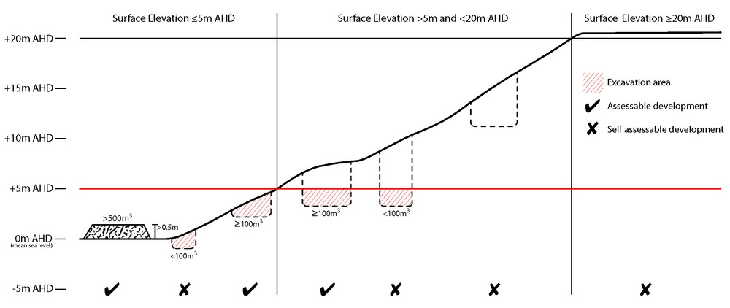
Bushfire hazard (refer Overlay map - Bushfire hazard to determine if the following requirements apply)
Note - For the purposes of section 12 of the Building Regulation 2006, land identified as very high potential bushfire intensity, high potential bushfire intensity, medium potential bushfire intensity or potential impact buffer on the Bushfire hazard overlay map is the 'designated bushfire hazard area'. AS 3959-2009 Construction of buildings in bushfire hazard areas applies within these areas.

RAD48 | - Building and structures are:  - not located on a ridgeline  - not located on land with a slope greater than 15% (see Overlay map – Landslide hazard)  - Dwellings are located on east to south facing slopes.  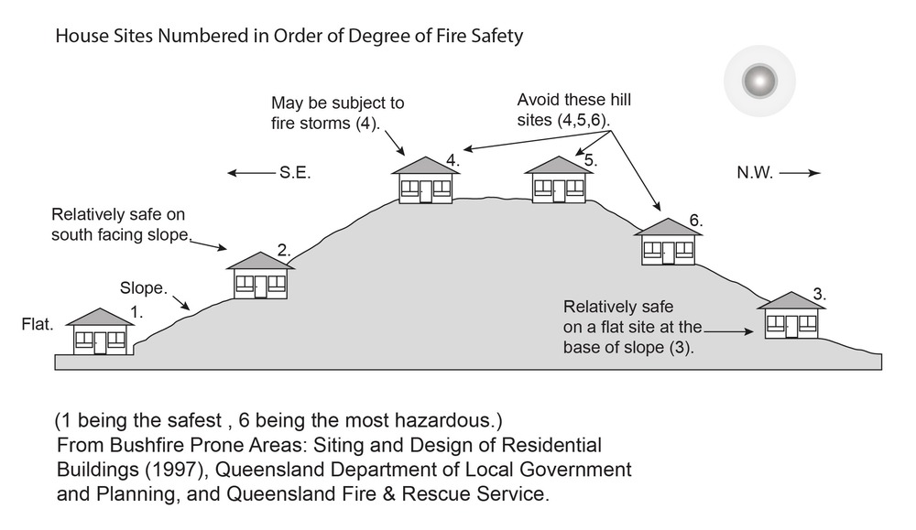
RAD49 | Buildings and structures have contained within the site:  - a separation from classified vegetation of 20m or the distance required to achieve a bushfire attack level (BAL) at the building, roofed structure or fire fighting water supply of no more than 29, whichever is the greater;  - a separation from low threat vegetation of 10m or the distance required to achieve a bushfire attack level (BAL) at the building, roofed structure or fire fighting water supply of no more than 29, whichever is the greater;  - a separation of no less than 10m between a fire fighting water supply extraction point and any classified vegetation, buildings and other roofed structures;  - an area suitable for a standard fire fighting appliance to stand within 3m of a fire fighting water supply extraction point; and  - an access path suitable for use by a standard fire fighting appliance having a formed width of at least 4m, a cross-fall of no greater than 5%, and a longitudinal gradient of no greater than 25%:  - to, and around, each building and other roofed structure; and  - to each fire fighting water supply extraction point.
  Note - The meaning of the terms classified vegetation and low threat vegetation as well as the method of calculating the bushfire attack level are as described in Australian Standard AS 3959.
RAD50 | The length of driveway:  - to a public road does not exceed 100m between the most distant part of a building used for any purpose other than storage and the nearest part of a public road;  - has a maximum gradient no greater than 12.5%;  - have a minimum width of 3.5m;  - accommodate turning areas for fire fighting appliances in accordance with Qld Fire and Emergency Services' Fire Hydrant and Vehicle Access Guideline.
RAD51 | - A reticulated water supply is provided by a distributer retailer for the area or, where not connected to a reticulated water supply, on-site fire fighting water storage containing not less than 10 000 litres (tanks with fire brigade tank fittings, swimming pools) is provided and located within 10m of buildings and structures.  - Where a swimming pool is the nominated on-site fire fighting water storage source, vehicle access to within 3m of that water storage source is provided.  - Where a tank is the nominated on-site fire fighting water storage source, it includes:  - a hardstand area allowing medium rigid vehicle (15 tonne fire appliance) access within 6m of the tank;  - fire brigade tank fittings, comprising 50mm ball valve and male camlock coupling and, if underground, an access hole of 20mm (minimum) to accommodate suction lines.
RAD52 | Development does not involve the manufacture or storage of hazardous chemicals.
Environmental areas (refer Overlay map - Environmental areas to determine if the following requirements apply)
Note - The following are excluded from the native clearing provisions of this planning scheme:
- Clearing of native vegetation located within an approved development footprint;
- Clearing of native vegetation within 10m from a lawfully established building reasonably necessary for emergency access or immediately required in response to an accident or emergency;
- Clearing of native vegetation reasonably necessary to remove or reduce the risk vegetation poses to serious personal injury or damage to infrastructure;
- Clearing of native vegetation reasonably necessary to construct and maintain a property boundary fence and not exceed 4m in width either side of the fence where in the Rural, Rural residential and Environmental Management and Conservation zones. In any other zone, clearing is not to exceed 2m in width either side of the fence;
- Clearing of native vegetation reasonably necessary for the purpose of maintenance or works within a registered easement for public infrastructure or drainage purposes;
- Clearing of native vegetation in accordance with a bushfire management plan prepared by a suitably qualified person, submitted to and accepted by Council;
- Clearing of native vegetation associated with removal of recognised weed species, maintaining existing open pastures and cropping land, windbreaks, lawns or created gardens;
- Grazing of native pasture by stock;
- Native forest practice where accepted development under Part 1, 1.7.7 Accepted development.
Note - Definition for native vegetation is located in Schedule 1 Definitions.

Note - Native vegetation subject to this requirement primarily comprises of matters of national environmental significance (MNES), matters of state environmental significance (MSES). They also comprise some matters of local environmental significance (MLES). A MLES is defined in Schedule 1.2, Administrative definitions. A list of the elements that apply to the mapped MSES and MLES is provided in Appendix 1 of the Planning scheme policy - Environmental areas.
Editors' Note - The accuracy of overlay mapping can be challenged through the development application process (code assessable development) or by way of a planning scheme amendment. See Council's website for details.
Editors' Note - When clearing native vegetation within a MSES area, you may still require approval from the State government.

RAD53 | Where no suitable land cleared of native vegetation exists, clearing of native vegetation in High Value Area or Value Offset Area is for the purpose of a new dwelling house⁽²²⁾ and all associated facilities* or an extension to an existing dwelling house⁽²²⁾ only, and comprises an area no greater than 1500m².
  Note - *All associated facilities includes: on-site wastewater treatment, all areas of disturbance, on-site parking, access and manoeuvring areas.
  Editor's note - See in heading above for other uses excluded from native vegetation clearing requirements.
  Editor's note - Where vegetation clearance is accepted development subject to requirements, care should be undertaken to avoid adverse impacts on koalas, koala habitat values and habitat connectivity and to encourage existing koala usage of the site. Measures to minimise impacts include:
  - co-locating all associated activities, infrastructure and access strips;
  - be the least valued area of koala habitat on the site;
  - minimise the footprint of the development envelope area;
  - minimise edge effects to areas external to the development envelope;
  - location and design consideration to ensure koala safety and movement in accordance with the Koala-sensitive Design Guideline and Planning scheme policy – Environmental areas;
  - sufficient area between the development and koala habitat trees to achieve their long-term viability.
  Editor's note - Where vegetation clearing is accepted development subject to requirements, consideration should be given to avoid clearing habitat trees. Habitat trees may contain structural hollows where animals live, breed and shelter. The provision of nest boxes or salvaging of hollows will provide compensatory roosting and nesting opportunities for local wildlife including sugar gliders, possums and owls. For further information see Planning scheme policy – Environmental areas.
RAD54 | No clearing of native vegetation is to occur within the Value Offset Area MLES - Waterway buffer or Value Offset Area MLES - Wetland buffer.  This does not apply to the following:  - Clearing of native vegetation located within an approved development footprint;  - Clearing of native vegetation within 10m from a lawfully established building reasonably necessary for emergency access or immediately required in response to an accident or emergency;  - Clearing of native vegetation reasonably necessary to remove or reduce the risk vegetation poses to serious personal injury or damage to infrastructure;  - Clearing of native vegetation reasonably necessary to construct and maintain a property boundary fence and not exceed 4m in width either side of the fence where in the Rural, Rural residential and Environmental management and conservation zones. In any other zone, clearing is not to exceed 2m in width either side of the fence;  - Clearing of native vegetation reasonably necessary for the purpose of maintenance or works within a registered easement for public infrastructure or drainage purposes;  - Clearing of native vegetation in accordance with a bushfire management plan prepared by a suitably qualified person, submitted to and accepted by Council;  - Clearing of native vegetation associated with removal of recognised weed species, maintaining existing open pastures and cropping land, windbreaks, lawns or created gardens;  - Grazing of native pasture by stock;  - Native forest practice where accepted development under Part 1, 1.7.7 Accepted development.
Heritage and landscape character (refer Overlay map - Heritage and landscape character to determine if the following requirements apply)
Note - Places, including sites, objects and buildings having local cultural heritage significance, are identified on Overlay map - Heritage and landscape character and listed in Schedule 1 of Planning scheme policy - Heritage and landscape character. Places also having cultural heritage significance at a State level and being entered in the Queensland Heritage Register, are also identified in Schedule 1 of Planning scheme policy - Heritage and landscape character.

RAD55 | Development is for the preservation, maintenance, repair and restoration of the site, object or building.  This does not apply to Listed item 99, in Schedule 1 - List of sites, objects and buildings of significant historical and cultural value of Planning scheme policy - Heritage and landscape character.
  Note - Preservation, maintenance, repair and restoration are defined in Schedule 1 - Definitions
RAD56 | A cultural heritage conservation management plan is prepared in accordance with Planning scheme policy – Heritage and landscape character and submitted to Council prior to the commencement of any preservation, maintenance, repair and restoration works. Any preservation, maintenance, repair and restoration works are in accordance with the Council approved cultural heritage conservation management plan.  This does not apply to Listed item 99 in Schedule 1 - List of sites, objects and buildings of significant historical and cultural value of Planning scheme policy - Heritage and landscape character.
RAD57 | Development does not result in the removal of or damage to any significant tree identified on Overlay map – Heritage and landscape character and listed in Appendix 2 of Planning scheme policy – Heritage and landscape character.
RAD58 | The following development does not occur within 20m of the base of any significant tree, identified on Overlay map – Heritage and landscape character and listed in Appendix 2 of Planning scheme policy – Heritage and landscape character:  - construction of any building;  - laying of overhead or underground services;  - any sealing, paving, soil compaction;  - any alteration of more than 75mm to the ground level prior to work commencing.
RAD59 | Pruning of a significant tree occurs in accordance with Australian Standard AS 4373-2007 - Pruning of Amenity Trees.
Landslide hazard (refer Overlay map - Landslide hazard to determine if the following requirements apply)
RAD60 | Development does not:  - involve earthworks exceeding 50m³;  - involve cut and fill having a height greater than 600mm;  - involve any retaining wall having a height greater than 600mm;  - redirect or alter the existing flow of surface or groundwater.
RAD61 | Buildings, excluding domestic outbuildings:  - are split-level, multiple-slab, pier or pole construction;  - are not single plane slab on ground.
RAD62 | Development does not involve the manufacture, handling or storage of hazardous chemicals.
Infrastructure buffers (refer Overlay map - Infrastructure buffers to determine if the following requirements apply)
RAD63 | Development within a Water supply buffer does not include the incineration or burial of waste and all other waste is collected and stored in weather proof, sealed waste receptacles, located in roofed and bunded areas, for disposal by a licenced contractor.
RAD64 | Management, handling and storage of hazardous chemicals (including fuelling of vehicles) within a Water supply buffer, is undertaken in secured, climate controlled, weather proof, level and bunded enclosures.
RAD65 | Development does not restrict access to Bulk water supply infrastructure of any type or size, having regard to (among other things):  - buildings or structures;  - gates and fences;  - storage of equipment or materials;  - landscaping or earthworks or stormwater or other infrastructure.
RAD66 | On-site sewerage facilities in a Water supply buffer produce a minimum secondary treated effluent (90th percentile) and effluent application to ensure water quality is maintained and protected.
RAD67 | On-site sewerage facilities in a Water supply buffer for a dwelling house⁽²²⁾ include:  - emergency storage capacity of 1,000 litres and adequate buffering for shock loading/down time;  - a reserve land application area of 100% of the effluent irrigation design area;  - land application areas that are vegetated;  - the base of the land application field is at least 2 metres above the seasonal high water table/bedrock (whichever is the closest to the base of the application area);  - wastewater collection and storage systems must have capacity to accommodate full load at peak times.
RAD68 | On-site sewerage facilities in a Water supply buffer for development other than a dwelling house include emergency storage capable of holding 3-6 hours peak flow of treated effluent in the event of emergencies/overload with provision for de-sludging.
RAD69 | Development involving Permanent plantation⁽⁵⁹⁾ within a Water supply buffer maintains a minimum of 30% ground cover at all times.
RAD70 | Development does not involve the construction of any buildings or structures within a Bulk water supply infrastructure buffer.
Overland flow path (refer Overlay map - Overland flow path to determine if the following requirements apply)
RAD71 | Development for a material change of use or building work does not involve the construction of a building or structure in an Overland flow path area.
RAD72 | Development for a material change of use or operational work does not impede the flow of flood waters through the premises or worsen flood flows to other premises.
  Note - A report from a suitably qualified Registered Professional Engineer Queensland is required certifying that the development does not increase the potential for significant adverse impacts on an upstream, downstream or surrounding premises.
  Note - Reporting to be prepared in accordance with Planning scheme policy – Flood hazard, Coastal hazard and Overland flow
RAD73 | Development for a material change of use or building work ensures that fencing in an overland flow path area is at least 50% permeable.
RAD74 | Development for a material change of use or building work that involves a hazardous chemical ensures the hazardous chemicals is not located within an overland flow path area.
RAD75 | Development for a material change of use or building work for a Park⁽⁵⁷⁾ ensures that work is provided in accordance with the requirements set out in Appendix B of the Planning scheme policy - Integrated design.
Riparian and wetland setbacks (refer Overlay map - Riparian and wetland setback to determine if the following requirements apply)
Note - W1, W2 and W3 waterway and drainage lines, and wetlands are mapped on Schedule 2, Section 2.5 Overlay Maps – Riparian and wetland setbacks.

RAD76 | No development is to occur within:  - 50m from top of bank for W1 waterway and drainage line  - 30m from top of bank for W2 waterway and drainage line  - 20m from top of bank for W3 waterway and drainage line  - 100m from the edge of a Ramsar wetland, 50m from all other wetlands.
  Note - W1, W2 and W3 waterways and drainage lines, and wetlands are mapped on Schedule 2, Section 2.5 Overlay Maps – Riparian and wetland setbacks.
  Note - In some cases, the top of bank may not be easily defined, as such a hydraulic measurement may be applied instead. Moreton Bay Regional Council will provide further direction on how to determine and locate the setback boundary in these locations.
  Note - The minimum setback distance applies to the each side of waterway.
Transport noise corridors (refer Overlay map - Transport noise corridors)
Note - This is for information purposes only. No requirements for accepted development or criteria for assessable development apply. Development located within a Transport Noise Corridor must satisfy the requirements of the Queensland Development Code

