Table 9.4.4.3 Assessable development - Advertising devices

Performance outcomes | Examples that achieve aspects of the Performance Outcomes |  |  | E Compliance  - Yes  - No See PO or  - NA |  | Justification for compliance
General
PO1  Advertising devices are of an appropriate number, type, design, scale, height and location to:  - not contribute to visual clutter or be overbearing or visually dominant;  - complement the existing and future planned character and amenity of the area in which it is located;  - maintain a human scale and not detract from or interfere with the form and function of a pedestrian friendly environment;  - be compatible with the surrounding streetscape and landscape. Advertising devices should be considered as another design element, which integrate with the architecture, scale, proportions and style of buildings, landscaping, structures and other Advertising devices located both within and surrounding the site;  - minimise any potential adverse impacts on adjoining sites, such as overshadowing or the loss of key views and view corridors;  - not diminish or cause irreversible damage to any cultural heritage values present on the site or those associated with a heritage site, item or object. | E1.1  The Advertising device is in the form of one or more of the following types:  - awning;  - fence;  - freestanding;  - projecting;  - roof;  - wall/façade.  Note - Refer to Planning scheme policy – Advertising devices (section 2) for guidance on satisfying the above criteria.
E1.2
The Advertising device complies with the criteria specified in Column 2 of Table 9.4.4.4.
E1.3
The total combined signface area of all Advertising devices on the site complies with the following table:
Note - The total combined signface area includes any existing Advertising devices located on the site.
Note - For sign face area calculation purposes:
- Where Advertising devices feature 2 display faces with an internal angle of 45 degrees or less, only one of the display faces forms part of the maximum total sign face area calculation.
- Advertising devices that feature 2 display faces with an internal angle greater than 45 degrees must calculate each display face as a separate sign face area.
- Advertising devices that include more than 2 display faces must calculate the additional display faces as separate signface area.

Note - Refer to Planning scheme policy – Advertising devices (section 3) for signface area calculation.

Zone / Local plan | Total combined signface area
- Centre  - Community facilities  - Emerging community, General residential and Rural residential - if on a lot identified on Overlay map – Community activities and neighbourhood hubs  - Industry  - Caboolture West local plan  - Enterprise and employment precinct – all sub-precincts  - Town centre precinct – all sub-precincts  - Urban living precinct – Local centre sub-precinct  - Urban living precinct – Light industry sub-precinct  - Urban living precinct – Next generation sub-precinct - if on a lot identified for Community activities and Neighbourhood hubs  - Redcliffe Kippa-Ring local plan  - Redcliffe seaside precinct  - Kippa-Ring village precinct  - Kippa-Ring station precinct  - Local services precinct  - Health precinct  - Interim residential precinct - if on a lot identified for Community activities and Neighbourhood hubs  - Woodfordia local plan – all precincts | 1m² for every 1m of primary frontage, or 20m² in total, whichever is the lesser per site.  Note - The figures above exclude awning and wall/facade Advertising device types.
- Emerging community, General residential - if not on a lot identified on Overlay map – Community activities and neighbourhood hubs  - Environmental conservation and management  - Township - Residential precinct  - Caboolture West local plan  - Green network precinct  - Urban living precinct – Next generation sub-precinct - if not identified for Community activities and Neighbourhood hubs  - Redcliffe Kippa-Ring local plan  - Interim residential precinct - if not on a lot identified for Community activities and Neighbourhood hubs | 0.3m² per site
- Extractive industry  - Rural  - Caboolture West local plan – For all Interim uses | 5m² per site
- Rural residential - if not on a lot identified on Overlay map – Community activities and neighbourhood hubs  - Caboolture West local plan  - Rural living precinct | 1m² per site
- Recreation and open space  - Redcliffe Kippa-Ring local plan  - Open space and recreation precinct  - Sport and recreation precinct | 1m² for every 1m of primary frontage, or 20m² in total, whichever is the lesser per site.  Note - The figures above exclude awning and wall/facade Advertising device types.  Note - Advertising devices that meet the following criteria are also excluded from the maximum signface area above.  The Advertising device is located internal to the site and does not directly or immediately face towards:  - a public road;  - a residential property;  - any other public or private place.
- Township - Centre, Convenience and Industry precincts | 1m² for every 1m of primary frontage, or 10m² in total, whichever is the lesser per site.

Safety of pedestrians, cyclists and motorists
PO2  The siting and design of Advertising devices does not pose a hazard or nuisance for pedestrians, cyclists and motorists by ensuring:  - site lines are not obstructed;  - all traffic signs and signals remain visible from all angles;  - the passage of pedestrians, cyclists and motorists is not obstructed. | E2  The Advertising device complies with the criteria specified in Column 2 of Table 9.4.4.4.
Illumination and movement of Advertising devices
PO3  An Advertising device incorporates illumination only where it is appropriate to its setting and does not detract from the amenity and character of the area in which it is located. Illumination must not create a hazard or nuisance for motorists and surrounding uses. | E3.1  The Advertising device is illuminated only where located in the following zones:  - Centre zone;  - Industry zone;  - Caboolture West local plan:  - Town centre precinct - excluding Residential north and Residential south sub-precincts;  - Urban living precinct – Local centre sub-precinct only;  - Enterprise and employment precinct;  - Redcliffe Kippa-Ring local plan:  - Redcliffe seaside precinct;  - Kippa-Ring village precinct;  - Local services precinct;  - Health precinct.
E3.2
Where an Advertising device is illuminated it meets the following criteria:
- illumination is by an internal light source or down light if externally lit;
- illumination is in the form of static lighting;
- lighting is not directed or reflected towards a residential property or public place.
PO4  The Advertising device does not incorporate elements that move, revolve, flash or contain mechanisms that give the impression of movement. | No example provided.
Active frontage and casual surveillance
PO5  The placement of Advertising devices ensures active frontage and casual surveillance of the street is not adversely affected. | E5  Where located in the following zones, the Advertising device is not placed on windows or glazing between a height of 0.8m and 2m above ground level:  - Centre zone - excluding Morayfield and Specialised centre precincts;  - Caboolture West local plan:  - Town centre precinct - Centre core, Mixed business and Civic sub-precincts only;  - Redcliffe Kippa-Ring local plan:  - Redcliffe seaside precinct;  - Kippa-Ring village precinct;  - Kippa-Ring station precinct;  - Local services precinct;  - Health precinct;  - Township zone – Centre precinct.
Advertising devices visible or adjacent to a State-controlled road
PO6  Advertising devices do not adversely impact on the safety and efficiency of the State-controlled road. | E6  Advertising devices visible from a State-controlled road complies with Department of Transport and Main Road's Roadside Advertising Guide (RAG).
Township zone specific provisions
PO7  Where located in the Township zone, Advertising devices reinforce the low key, country town character by being:  - simple in shape and graphics;  - similar in scale to the adjacent approved development;  - integrated into the design and elevation of the building;  - not dominating building facades and streetscapes;  - traditional rather than modern styling. | E7  The Advertising device is provided in accordance with Planning scheme policy – Advertising devices (section 4).
Values and constraints criteria
Note - The relevant values and constraints criteria do not apply where the development is consistent with a current Development permit for Reconfiguring a lot or Material change of use or Operational work, where that approval has considered and addressed (e.g. through a development footprint plan (or similar in the case of Landslide hazard) or conditions of approval) the identified value or constraint under this planning scheme.

Heritage and landscape character (refer Overlay map - Heritage and landscape character to determine if the following assessment criteria apply)
Note - To assist in demonstrating achievement of heritage performance outcomes, a Cultural heritage impact assessment report is prepared by a suitably qualified person verifying the proposed development is in accordance with The Australia ICOMOS Burra Charter.
Note - To assist in demonstrating achievement of this performance outcome, a Tree assessment report is prepared by a qualified arborist in accordance with Planning scheme policy – Heritage and landscape character. The Tree assessment report will also detail the measures adopted in accordance with AS 4970-2009 Protection of trees on development sites.
Note - Places, including sites, objects and buildings having local cultural heritage significance, are identified on Overlay map - Heritage and landscape character and listed in Schedule 1 of Planning scheme policy - Heritage and landscape character. Places also having cultural heritage significance at a State level and being entered in the Queensland Heritage Register, are also identified in Schedule 1 of Planning scheme policy - Heritage and landscape character.

PO8  Development will:  - not diminish or cause irreversible damage to the cultural heritage values present on the site, and associated with a heritage site, object or building;  - protect the fabric and setting of the heritage site, object or building;  - be consistent with the form, scale and style of the heritage site, object or building;  - utilise similar materials to those existing, or where this is not reasonable or practicable, neutral materials and finishes;  - incorporate complementary elements, detailing and ornamentation to those present on the heritage site, object or building;  - retain public access where this is currently provided. |  | E8  Development is for the preservation, maintenance, repair and restoration of a site, object or building of cultural heritage value.  Note - A cultural heritage conservation management plan for the preservation, maintenance, repair and restoration of a site, object or building of cultural heritage value is prepared in accordance with Planning scheme policy - Heritage and landscape character. The plan is sent to, and approved by Council prior to the commencement of any preservation, maintenance, repair and restoration works.
PO9  Demolition and removal is only considered where:  - a report prepared by a suitably qualified conservation architect or conservation engineer demonstrates that the building is structurally unsound and is not reasonably capable of economic repair; or  - demolition is confined to the removal of outbuildings, extensions and alterations that are not part of the original structure; or  - limited demolition is performed in the course of repairs, maintenance or restoration; or  - demolition is performed following a catastrophic event which substantially destroys the building or object. |  | No example provided.
PO10  Where development is occurring on land adjoining a site of cultural heritage value, the development is to be sympathetic to and consistent with the cultural heritage values present on the site and not result in their values being eroded, degraded or unreasonably obscured from public view. |  | No example provided.
PO11  Development does not adversely impact upon the health and vitality of significant trees. Where development occurs in proximity to a significant tree, construction measures and techniques as detailed in AS 4970-2009 Protection of trees on development sites are adopted to ensure a significant tree's health, wellbeing and vitality.  Significant trees are only removed where they are in a poor state of health or where they pose a health and safety risk to persons or property. A Tree Assessment report prepared by a suitably qualified arborist confirming a tree's state of health is required to demonstrate achievement of this performance outcome. |  | E11  Development does:  - not result in the removal of a significant tree;  - not occur within 20m of a protected tree;  - involve pruning of a tree in accordance with Australian Standard AS 4373-2007 – Pruning of Amenity Trees.
Landslide hazard (refer Overlay map - Landslide hazard to determine if the following assessment criteria apply)
Note - To demonstrate achievement of the performance outcomes, a site-specific geotechnical assessment report is prepared by a qualified engineer. Guidance for the preparation of a geotechnical assessment report is provided in Planning scheme policy – Landslide hazard.

PO12  Development:  - maintains the safety of people and property on a site and neighbouring sites from landslides;  - ensures the long-term stability of the site considering the full nature and end use of the development;  - ensures site stability during all phases of construction and development;  - minimises disturbance of natural drainage patterns of the site and does not result in the redirection or alteration of the existing flow if surface or groundwater  - minimises adverse visual impacts on the amenity of adjoining residents and provides a positive interface with the streetscape. |  | E12  Development does not:  - involve earthworks exceeding 50m³;  - involve cut and fill having a height greater than 600mm;  - involve any retaining wall having a height greater than 600mm;  - redirect or alter the existing flow of surface or groundwater.
Overland flow path (refer Overlay map - Overland flow path to determine if the following assessment criteria apply)
Note - The applicable river and creek flood planning levels associated with defined flood event (DFE) within the inundation area can be obtained by requesting a flood check property report from Council.

PO13  Development:  - minimises the risk to persons from overland flow;  - does not increase the potential for damage from overland flow either on the premises or other premises, public land, watercourses, roads or infrastructure. |  | No example provided.
PO14  Development:  - maintains the conveyance of overland flow predominantly unimpeded through the premises for any event up to and including the 1% AEP for the fully developed upstream catchment;  - does not concentrate, intensify or divert overland flow onto an upstream, downstream or surrounding property.  Note - A report from a suitably qualified Registered Professional Engineer Queensland is required certifying that the development does not increase the potential for significant adverse impacts on an upstream, downstream or surrounding premises.  Note - Reporting to be prepared in accordance with Planning scheme policy – Flood hazard, Coastal hazard and Overland flow. |  | E14  No example provided.
PO15  Development does not:  - directly, indirectly or cumulatively cause any increase in overland flow velocity or level;  - increase the potential for flood damage from overland flow either on the premises or other premises, public lands, watercourses, roads or infrastructure.  Note - Open concrete drains greater than 1m in width are not an acceptable outcome, nor are any other design options that may increase scouring. |  | No example provided.
PO16  Development which is not in a Rural zone ensures that overland flow is not conveyed from a road or public open space onto a private lot. |  | E16  Development which is not in a Rural zone that an overland flow paths and drainage infrastructure is provided to convey overland flow from a road or public open space area away from a private lot.
PO17  Development protects the conveyance of overland flow such that an easement for drainage purposes is provided over:  - a stormwater pipe if the nominal pipe diameter exceeds 300mm;  - an overland flow path where it crosses more than one premises;  - inter-allotment drainage infrastructure.  Note - Refer to Planning scheme policy - Integrated design for details and examples.  Note - Stormwater Drainage easement dimensions are provided in accordance with Section 3.8.5 of QUDM. |  | No example provided.

Table 9.4.4.4
Column 1  Advertising device type | Column 2  Advertising device requirements
Awning | An awning Advertising device:  - is not located above the awning;  - is limited to 1 under awning sign per tenancy;  - has a minimum clearance of 2.4m between the lowest point of the advertising device and the footpath/ground level (Refer to Figure – Awning advertising device (a));  - where attached to the awning fascia, has a maximum thickness of 100mm;  - does not extend beyond the awning edges shown on Figure - Awning advertising device (a) and Figure – Awning advertising device (b).  Figure - Awning advertising device (a)  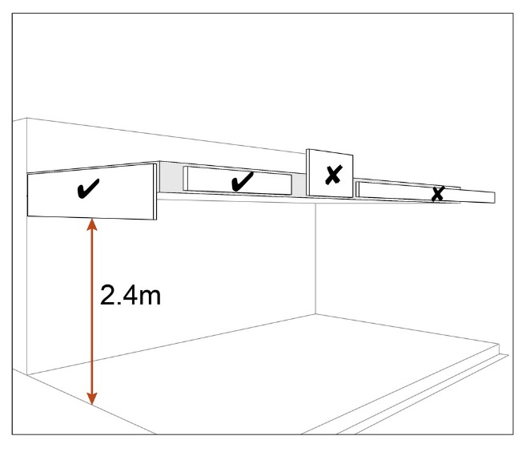  Figure - Awning advertising device (b)  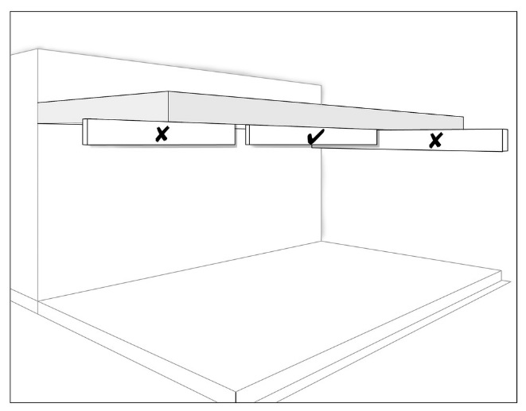
Fence | A fence Advertising device:  - has a maximum thickness of 100mm;  - does not extend beyond any edge of the fence to which it is attached (Refer to Figure – Fence advertising device).  Figure - Fence advertising device  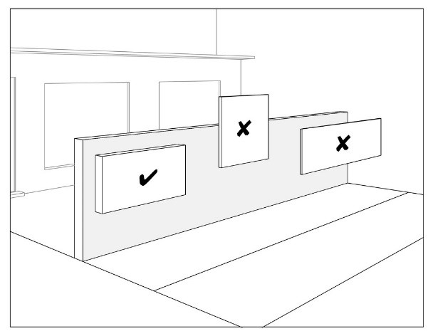
Freestanding | A freestanding Advertising device:  - is limited to 1 per site entrance, with a maximum of 2 per frontage;  - is setback a minimum 1m from the front boundary and 3m from the side and rear boundaries of the site;  - does not exceed the maximum height for the zone in which it is located as specified below:  Zone / Local plan Height in metres (m)  - Centre - Community facilities - Emerging community, General residential - if on a lot identified on Overlay map – Community activities and neighbourhood hubs - Extractive industry - Industry - Recreation and open space - Rural - Rural residential – if on a lot identifies for Community activities and Neighbourhood hubs - Caboolture West local plan – For all Interim uses - Caboolture West local plan - Enterprise and employment precinct – all sub-precincts - Town centre precinct – all sub-precincts - Urban living precinct – Local centre sub-precinct - Urban living precinct – Light industry sub-precinct - Urban living precinct – Next generation sub-precinct - if on a lot identified for Community activities and Neighbourhood hubs - Redcliffe Kippa-Ring local plan - Redcliffe seaside precinct - Kippa-Ring village precinct - Kippa-Ring station precinct - Local services precinct - Health precinct - Interim residential precinct - if on a lot identified for Community activities and Neighbourhood hubs - Open space and recreation precinct - Sport and recreation precinct - Woodfordia local plan 6m Note - Height is to be measured from ground level.  - Emerging community, General residential - if not on a lot identified on Overlay map – Community activities and neighbourhood hubs - Environmental conservation and management - Rural residential – if not on a lot identified for Community activities and Neighbourhood hubs - Township - Caboolture West local plan - Green network precinct - Rural living precinct - Urban living precinct – Next generation sub-precinct - if not identified for Community activities and Neighbourhood hubs - Redcliffe Kippa-Ring local plan - Interim residential precinct - if not on a lot identified for Community activities and Neighbourhood hubs 1.5m Note - Height is to be measured from ground level.
Projecting | A projecting Advertising device:  - if under 2.4m high clearance to any footpath, has a maximum projection of 300mm (Refer to Figure – Projecting advertising device (a));  - if 2.4m or greater high clearance to any footpath, has a maximum projection setback a minimum of 1.5m from the kerb line (Refer to Figure – Projecting advertising device), except where located in the Township zone – Centre precinct, the maximum projection setback is a minimum 600mm from the kerb line (Refer to Figure – Township zone projecting advertising device).  Figure - Projecting advertising device (a)  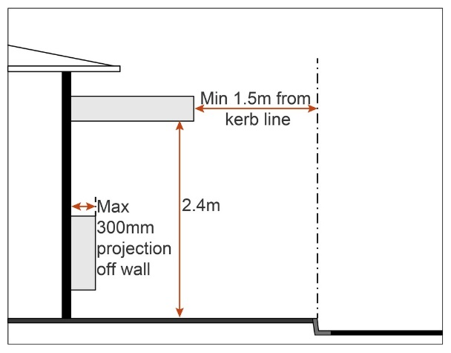  Figure - Township zone projecting advertising device  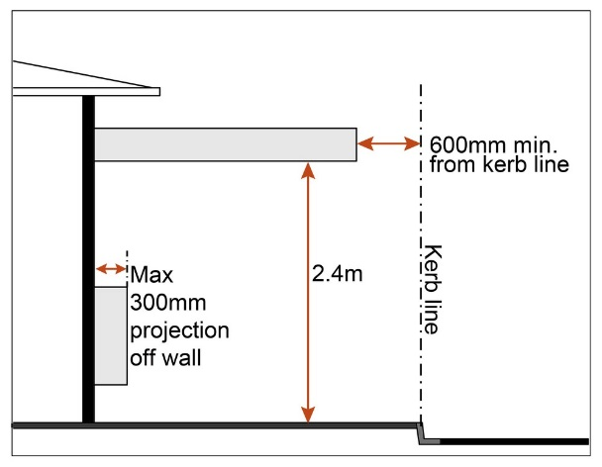  - does not extend beyond the edges of the wall/façade to which it is attached as shown on Figure - Projecting advertising device (b).  Figure - Projecting advertising device (b)  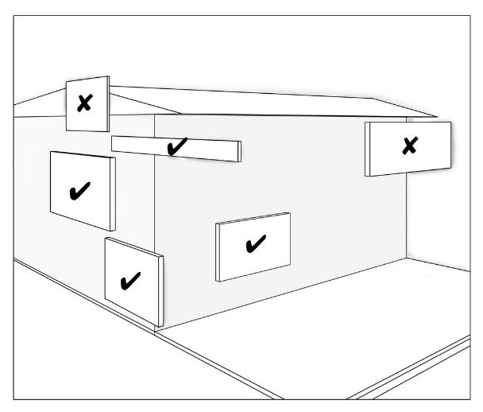
Roof | A roof Advertising device:  - is limited to 1 per site;  - does not protrude from the surface of the roof or parapet to which it is attached by more than 100mm;  - does not extend beyond any edge of the roof or parapet to which it is attached (Refer to Figure – Roof advertising device).  Figure - Roof advertising device  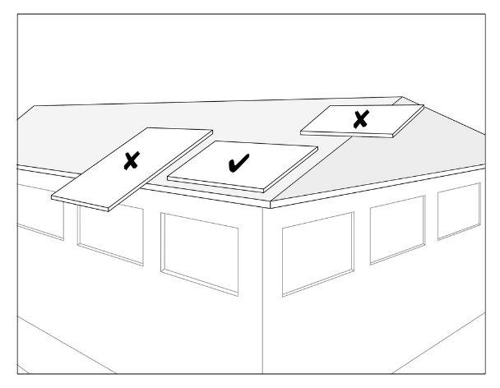
Wall/Facade | A wall/façade Advertising device:  - has a maximum thickness of 100mm;  - does not extend beyond the edges of the wall/façade shown on Figure – Wall/façade advertising device.  Figure - Wall/Facade advertising device  