 |  |  | Table 9.4.1.6.4.1 Assessable development - General residential zone - Urban neighbourhood precinct
 |  |  | Performance outcomes | Examples that achieve aspects of the Performance Outcomes |  |  |  |  |  |  | E Compliance  - Yes  - No See PO or  - NA |  |  |  | Justification for compliance
 |  |  | Density
 |  |  | PO1  Reconfiguring a lot does not compromise future developments ability to achieve a minimum residential site density of 45 dwellings per hectare to ensure efficient use of the land and infrastructure which facilitates feasible public transport patronage and creates a diverse medium density neighbourhood character. | E1  Residential uses have a minimum site density of:  - 75 dwellings per ha for sites shown on:  - ‘Figure 1 - Kallangur’ - Kallangur;  - ‘Figure 2 - Mango Hill’ - Mango Hill;  - ‘Figure 3 - Mango Hill East’ - Mango Hill East;  - ‘Figure 4 - Murrumba Downs’ - Murrumba Downs; or  - ‘Figure 5 Kippa-Ring ’ - Kippa-Ring  - 45 dwellings per hectare for all other areas.
 |  |  | Lot design, mix and location
 |  |  | PO2  Reconfiguring a lot facilitates the provision of varied housing options, a mix of lot sizes and encourages diversity within the streetscape whilst maintaining the medium to high density character of the precinct. | E2  Lot sizes comply with Lot Types A, B or F in accordance with ‘Table 9.4.1.6.4.3: Lot Types’ - Lot Types.  Editor's note - Lots containing built to boundary walls should also include an appropriate easement to facilitate the maintenance of any wall within 600mm of a boundary. For boundaries with built to boundary walls on adjacent lots a 'High Density Development Easement' is recommended; or for all other built to boundary walls and 'easement for maintenance purposes' is recommended.
 |  |  | PO3  Narrow lots do not adversely affect the character and amenity of the precinct. Residential uses establish in a manner which facilitates an integrated streetscape, maximises the efficient use of land and achieves a safe and efficient street network.  Note - Built to boundary walls and driveway locations for lots with frontages of 12.5 metres or less are to be shown on a plan of development in accordance with the requirements of section 9.3.1 - Dwelling house code | No example provided.
 |  |  | PO4  Group construction and integrated streetscape solutions are facilitated through the location and grouping of lots suitable for terrace and row housing. | E4.1  Any lot sharing a boundary with a Lot Type A must contain a mandatory built to boundary wall on the shared boundary.  Note - Built to boundary walls for lots with frontages of 12.5 metres or less are to be shown on a plan of development in accordance with the requirements of section 9.3.1 - Dwelling house code.
E4.2
Driveway crossovers for lots with frontages of less than 10m are paired up to facilitate on-street parking.
Note - Driveway locations for lots with frontages of less than 10 metres are to be shown on a plan of development in accordance with Planning Scheme Policy - Residential Design.

 |  |  | PO5  A range of different lots are distributed throughout the development with no one lot type concentrated within a single location, to create diversity within the streetscape and minimise conflicts between vehicle access and on street parking. | E5.1  Where not accessed via a laneway, a maximum of 4 adjoining lots of the same type in accordance with ‘Table 9.4.1.6.4.3: Lot Types’ - Lot Types are proposed where fronting the same street.
E5.2
Where accessed via a laneway, a maximum of 8 adjoining lots of the same type in accordance with ‘Table 9.4.1.6.4.3: Lot Types’ are proposed where fronting the same street.
 |  |  | PO6  Rear lots do not establish in the Urban neighbourhood precinct. | No example provided.
 |  |  | Sloping land
 |  |  | PO7  Lot layout and design minimises the impacts of cutting, filling and retaining walls on the visual and physical amenity of the streetscape and of adjoining lots.  Note - Refer to Planning scheme policy - Residential design for guidelines on building design on sloped land. | E7.1  Lot layout and design ensures that a lot has a maximum average slope of 1:15 along its long axis and 1:10 along its short axis.
E7.2
Retaining walls and benching and associated cutting, filling and other earthworks associated with reconfiguring a lot are limited to:
- a maximum vertical dimension of 1.5m from ground level for any single retaining structure; or
- where incorporating a retaining structure greater than 1.5m in height, the retaining wall is stepped, terraced and landscaped as follows:
  - maximum 1m vertical, minimum 0.5m horizontal, maximum 2m vertical (refer figure below); or
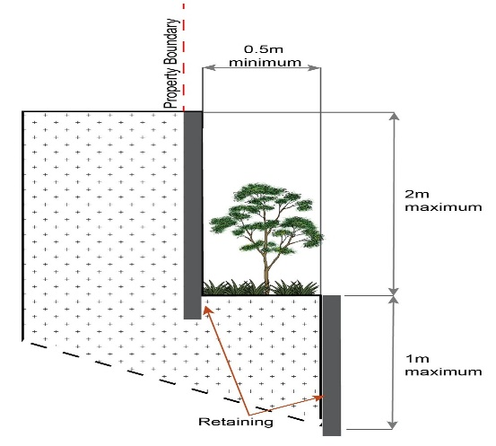
- where incorporating benching along the short axis (from side to side boundary) of a lot:
  - benching has a maximum total height of 4m per lot
  - each bench has a maximum height of 2m (refer Figure below); or
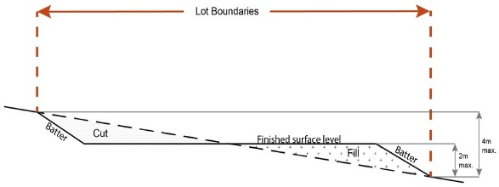
- where incorporating benching along the long axis (from front to rear boundary):
  - benching does not exceed 2m in height;
  - lots include mandatory built to boundary walls
  - lots consist of lot type A (7.5m – 8.5m frontage) only;
  - lots orientate up/down the slope.
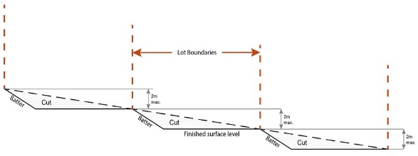
Note - Benching is to incorporate suitable measures to ensure stabilisation and prevent erosion.
Editor's note - Strict cut and fill requirements apply at the Dwelling house⁽²²⁾ stage. Deferral of slope solutions until building stage is not an acceptable outcome.

Figure - Sloped lot design

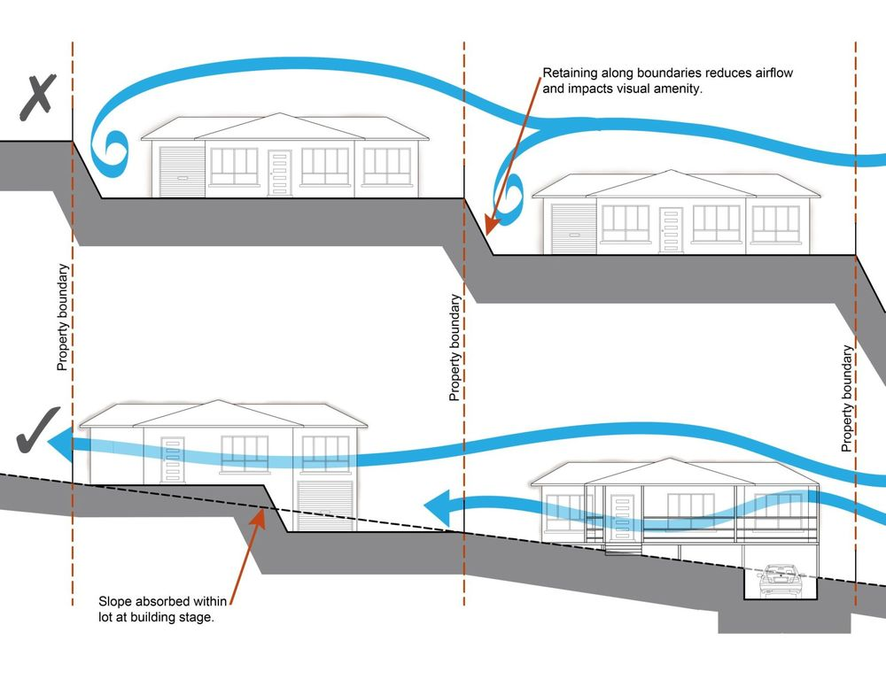
Street design and layout
PO8  Development maintains, contributes to or provides for a street layout that facilitate regular and consistent shaped lots through the use of rectilinear grid patterns, or modified grid patterns where constrained by topographical and other physical barriers.  Note - Refer to Planning scheme policy - Neighbourhood design for guidance on how to achieve compliance with this outcome. |  |  |  |  |  |  |  |  | No example provided.
PO9  Development maintains, contributes to or provides for a street layout that is designed to connect to surrounding neighbourhoods, providing an interconnected street, pedestrian and cyclist network that connects nearby centres, neighbourhood hubs, community facilities, public transport nodes and open space to residential areas.  The layout ensures that new development is provided with multiple points of access. The timing of transport works ensures that multiple points of access are provided during early stages of a development.  Note - Refer to Planning Scheme Policy - Neighbourhood design for guidance on achieving the above outcome. |  |  |  |  |  |  |  |  | E9.1  Development provides and maintains the connections shown on the following movement figures:  - Figure 6 - Dakabin;  - Figure 7 - Kallangur;  - Figure 8 - Mango Hill;  - Figure 9 - Mango Hill East;  - Figure 10 - Narangba - Main Street;  - Figure 11 - Petrie.
E9.2
For areas not shown on the above movement figures, no example provided.
Note - Refer to Planning Scheme Policy - Neighbourhood design for guidance on achieving the performance outcome.

PO10  Development maintains, contributes to or provides for a street layout that provides an efficient and legible movement network with high levels of connectivity within and external to the site by:  - facilitating increased active transport with a focus on safety and amenity for pedestrians and cyclists;  - providing street blocks with a maximum walkable perimeter of 400m (refer to Figure - Street block design);  - providing a variety of street block sizes to facilitate a range of intensity and scale in built form;  - reducing street block sizes as they approach an activity focus (e.g. centre, neighbourhood hub, train station, community activity, public open space);  - facilitating possible future connections to adjoining sites for roads, green linkages and other essential infrastructure.  Note - Refer to Planning scheme policy - Neighbourhood design for guidance on how to achieve compliance with this outcome. |  |  |  |  |  |  |  |  | No example provided.
PO11  Street layouts create convenient and highly permeable movement networks between lower and higher order roads, whilst not adversely affecting the safety and function of the higher order road. |  |  |  |  |  |  |  |  | No example provided.
PO12  Streets are designed and constructed in accordance with Planning scheme policy - Integrated design and Planning scheme policy - Operational works inspection, maintenance and bonding procedures. The street design and construction accommodates the following functions:  - access to premises by providing convenient vehicular movement for residents between their homes and the major road network.  - safe and convenient pedestrian and cycle movement;  - adequate on street parking;  - stormwater drainage paths and treatment facilities;  - efficient public transport routes;  - utility services location;  - emergency access and waste collection;  - setting and approach (streetscape, landscaping and street furniture) for adjoining residences;  - expected traffic speeds and volumes; and  - wildlife movement (where relevant).  Note - Preliminary road design (including all services, street lighting, stormwater infrastructure, access locations, street trees and pedestrian network) may be required to demonstrate compliance with this PO.  Note - Refer to Planning scheme policy - Environmental areas and corridors for examples of when and where wildlife movement infrastructure is required. |  |  |  |  |  |  |  |  | No example provided.
PO13  Cul-de-sacs or dead end streets are not proposed unless:  - topography or other physical barriers exist to the continuance of the street network or vehicle connection to an existing road is not permitted; and  - there are no appropriate alternative solutions; or  - the cul-de-sac or dead end street will facilitate future connections to adjoining land or development.  Note - Refer to Planning scheme policy - Neighbourhood design for guidance on achieving this outcome. |  |  |  |  |  |  |  |  | No example provided.
PO14  Where cul-de-sacs are proposed:  - head must be visible from the entry point;  - are to be no longer than 50 metres in length;  - emergency access can be achieved under circumstances where entry via the carriageway may be compromised. |  |  |  |  |  |  |  |  | No example provided.
PO15  Where cul-de-sacs are proposed due to connection to existing roads not being permitted, they are to be designed to allow a 10m wide pedestrian connection as public land through to the existing road with no lots proposed at the head of the cul-de-sac generally as shown in the figure below.  Figure - Cul-de-sac design  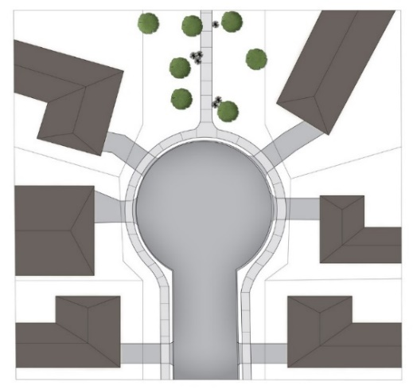  Note - Refer to Planning scheme policy - Neighbourhood design for guidance on how to achieve this outcome. |  |  |  |  |  |  |  |  | No example provided.
PO16  Streets are designed and oriented to minimise the impact of cut and fill on the amenity of the streetscape and adjoining development. |  |  |  |  |  |  |  |  | E16  Street alignment follows ridges or gullies or runs perpendicular to slope.
PO17  Streets are oriented to encourage active transport through a climate responsive and comfortable walking environment whilst also facilitating lots that support subtropical design practices, including:  - controlled solar access & shade provision  - cross-ventilation.  Note - Refer to Planning scheme policy - Residential design for guidance on how to achieve subtropical design outcomes through dwelling design. |  |  |  |  |  |  |  |  | E17.1  Where not unduly constrained by topography or other physical barrier, streets are primarily oriented within 20 or 30 degrees of North-South or East-West.  Figure - Preferred street orientation  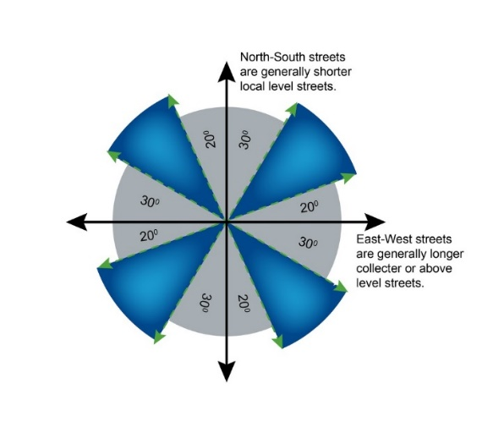
E17.2
The long axis of a street block is oriented east-west to facilitate a north-south orientation for a majority of lots as per Figure - Street block design.
Figure - Street block design
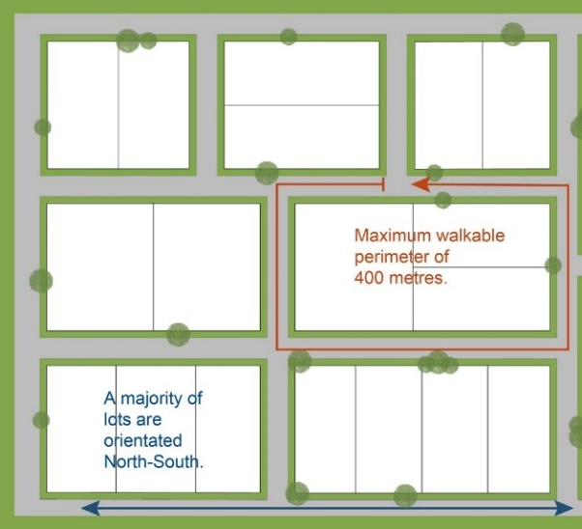
PO18  The street network creates convenient access to arterial and sub-arterial roads for heavy vehicles and commercial traffic without introducing through traffic to residential streets. |  |  |  |  |  |  |  |  |  | No example provided.
PO19  The existing road network (whether trunk or non-trunk) is upgraded where necessary to cater for the impact from the development.  Note - An applicant may be required to submit an Integrated Transport Assessment (ITA), prepared in accordance with Planning scheme policy - Integrated transport assessment to demonstrate compliance with this PO, when any of the following occurs:  - development is within 200m of a transport sensitive location such as a school, shopping centre, bus or train station or a large generator of pedestrian or vehicular traffic;  - forecast traffic to/from the development exceeds 5% of the two way flow on the adjoining road or intersection in the morning or afternoon transport peak within 10 years of the development completion;  - development access onto a sub arterial, or arterial road or within 100m of a signalised intersection;  - residential development greater than 50 lots or dwellings;  - offices greater than 4,000m² Gross Floor Area (GFA);  - retail activities including Hardware and trade supplies, Showroom, Shop or Shopping centre greater than 1,000m² GFA;  - warehouses and Industry greater than 6,000m² GFA;  - on-site carpark greater than 100 spaces;  - development has a trip generation rate of 100 vehicles or more within the peak hour;  - development which dissects or significantly impacts on an environmental area or an environmental corridor.  The ITA is to review the development’s impact upon the external road network for the period of 10 years from completion of the development. The ITA is to provide sufficient information for determining the impact and the type and extent of any ameliorative works required to cater for the additional traffic. The ITA must include a future structural road layout of adjoining properties that will form part of this catchment and road connecting to these properties. The ITA is to assess the ultimate developed catchment’s impacts and necessary ameliorative works, and the works or contribution required by the applicant as identified in the study.  Note - The road network is mapped on Overlay map - Road hierarchy.  Note - The primary and secondary active transport network is mapped on Overlay map - Active transport. |  |  |  |  |  |  |  |  |  | E19.1  New intersections onto existing roads are designed to accommodate traffic volumes and traffic movements taken from a date 10 years from the date of completion of the last stage of the development. Design is to be in accordance with Planning scheme policy - Integrated design.  Note - All turns vehicular access to existing lots is to be retained at new road intersections wherever practicable.  Note - Existing on-street parking is to be retained at new road intersections and along road frontages wherever practicable.
E19.2
Existing intersections external to the site are upgraded as necessary to accommodate increased traffic from the development. Design is in accordance with Planning scheme policy - Integrated design and Planning scheme policy - Operational works inspection, maintenance and bonding procedures.
Note - All turns vehicular access to existing lots is to be retained at upgraded road intersections wherever practicable.
Note - Existing on-street parking is to be retained at upgraded road intersections and along road frontages wherever practicable.

E19.3
The active transport network is extended in accordance with Planning scheme policy - Integrated design.
PO20  New intersections along all streets and roads are located and designed to provide safe and convenient movements for all users.  Note - Refer Planning scheme policy - Integrated design and Planning scheme policy - Operational works inspection, maintenance and bonding procedures for design and construction standards.  Note - An Integrated Transport Assessment (ITA) including preliminary intersection designs, prepared in accordance with Planning scheme policy - Integrated transport assessment may be required to demonstrate compliance with this PO. Intersection spacing will be determined based on the deceleration and queue storage distances required for the intersection after considering vehicle speed and present/forecast turning and through volumes. |  |  |  | E20  New intersection spacing (centreline – centreline) along a through road conforms with the following:  - Where the through road provides an access or residential street function:  - intersecting road located on same side = 60 metres; or  - intersecting road located on opposite side = 40 metres.  - Where the through road provides a local collector or district collector function:  - intersecting road located on same side = 100 metres; or  - intersecting road located on opposite side = 60 metres.  - Where the through road provides a sub-arterial function:  - intersecting road located on same side = 250 metres; or  - intersecting road located on opposite side = 100 metres.  - Where the through road provides an arterial function:  - intersecting road located on same side = 350 metres; or  - intersecting road located on opposite side = 150 metres.  - Walkable block perimeter does not exceed:  - 600 metres in the Coastal communities precinct and Suburban neighbourhood precicint;  - 500 metres in the Next generation neighbourhood precinct;  - 400 metres in the Urban neighbourhood precinct.  Note - Based on the absolute minimum intersection spacing identified above, all turns access may not be permitted (ie. left in/left out only) at intersections with sub-arterial roads or arterial roads.  Note - The road network is mapped on Overlay map - Road hierarchy.  Note - An Integrated Transport Assessment (ITA) including preliminary intersection designs, prepared in accordance with Planning scheme policy - Integrated transport assessment may be required to demonstrate compliance with this example.
PO21  All Council controlled frontage roads adjoining the development are designed and constructed in accordance with Planning scheme policy - Integrated design and Planning scheme policy - Operational works inspection, maintenance and boding procedure. All new works are extended to join any existing works within 20m.  Note - Frontage roads include streets where no direct lot access is provided.  Note - The road network is mapped on Overlay map - Road hierarchy.  Note - The Primary and Secondary active transport network is mapped on Overlay map - Active transport.  Note - Roads are considered to be constructed in accordance with Council’s standards when there is sufficient pavement width, geometry and depth to comply with the requirements of Planning scheme policy - Integrated design and Planning scheme policy - Operational works inspection, maintenance and bonding procedures. |  |  |  |  |  |  | E21  Design and construct all Council controlled frontage roads in accordance with Planning scheme policy - Integrated design, Planning scheme policy - Operational works inspection, maintenance and bonding procedures and the following:  Situation Minimum construction  Frontage road unconstructed or gravel road only; OR Frontage road sealed but not constructed* to Planning scheme policy - Integrated design standard; OR Frontage road partially constructed* to Planning scheme policy - Integrated design standard. Construct the verge adjoining the development and the carriageway (including development side kerb and channel) to a minimum sealed width containing near side parking lane (if required), cycle land (if required), 2 travel lanes plus 1.5m wide (full depth pavement) gravel shoulder and table drainage to the opposite side. The minimum total travel lane width is: - 6m for minor roads; - 7m for major roads.  Note - Major roads are sub-arterial roads and arterial roads. Minor roads are roads that are not major roads.  Note - Construction includes all associated works (services, street lighting and linemarking)  Note - Alignment within road reserves is to be agreed with Council.  Note - *Roads are considered to be constructed in accordance with Council standards when there is sufficient pavement width, geometry and depth to comply with the requirements of Planning scheme policy - Integrated design and Planning scheme policy - Operational works inspection, maintenance and bonding procedures. Testing of the existing pavement may be required to confirm whether the existing works meet the standards in Planning scheme policy - Integrated design and Planning scheme policy - Operational works inspection, maintenance and bonding procedures.
PO22  Sealed and flood free road access during the minor storm event is available to the site from the nearest arterial or sub-arterial road.  Editor's note - Where associated with a State-controlled road, further requirements may apply, and approvals may be required from the Department of Transport and Main Roads. |  |  |  |  |  |  |  | E22  Roads or streets giving access to the development from the nearest arterial or sub-arterial road are flood free during the minor storm event and are sealed.  Note - The road network is mapped on Overlay map - Road hierarchy.
PO23  Roads which provide access to the site from an arterial or sub-arterial road remain trafficable during major storm events without flooding or impacting upon residential properties or other premises. |  |  |  |  |  | E23.1  Access roads to the development have sufficient longitudinal and cross drainage to remain safely trafficable during major storm (1% AEP) events.  Note - The road network is mapped on Overlay map - Road hierarchy.  Note - Refer to QUDM for requirements regarding trafficability.
E23.2
Culverts and causeways do not increase inundation levels or increase velocities, for all events up to the defined flood event, to upstream or downstream properties.
 |  | Laneway design and location
 |  | PO24  Laneway location contributes to a high standard of amenity for adjoining lots and the primary streetscape.  Note - Refer to Planning scheme policy - Neighbourhood design for determining locational criteria for Laneways. |  | E24  Laneways are primarily used where:  - vehicle access is not permitted from the primary street frontage; or  - limiting vehicle access from the primary street frontage results in a positive streetscape outcome;or  - where lots directly adjoin a local, district or regional Park⁽⁵⁷⁾.
 |  | PO25  Laneways service a limited number of allotments, creating a sense of place and enclosed feeling for the pedestrian environment at the non-laneway frontage of the lots whilst contributing to a high level of connectivity of the street network.  Note - Refer to Planning scheme policy - Integrated design and Planning scheme policy - Neighbourhood design for determining design criteria for Laneways. |  | E25.1  Laneways are limited to 130m in length.
E25.2
Laneways are not designed as dead ends or cul-de-sacs, and are to have vehicle connections to an access street at both ends.
E25.3
Where laneways exceed 100m in length, a 7m wide mid lane pedestrian connection is to be provided between the adjacent access streets and the laneway.
 |  | PO26  Laneway design ensures the safety of pedestrians, cyclists and motorists by way of site lines, and sufficient road reserve for vehicle movements and the provision of street lighting.  Note - Refer to Planning scheme policy - Integrated design and Planning scheme policy - Neighbourhood design for determining design criteria for Laneways. |  | E26.1  Laneways are designed with minor meanders only, and maintain direct lines of sight from one end of the laneway to the other.
E26.2
Laneways provide road dedication at strategic locations along the laneway to allow the construction of street lighting and any electrical pillars associated with the street lighting in accordance with current Australian Standards.
Note - The dedication must allow for street lights on to be provided on Council’s standard alignment.

 |  | PO27  Laneway lots adjoining a park have a dedicated pathway as road reserve along the park frontage of the lots to contain all services and a concrete path. |  | E27  Dedicate a minimum 2.5m as road reserve along the park frontage of the lots to contain all services and a 2.0m wide concrete path.  Note - Electrical, water and sewerage services are not to be located in the laneway. Electrical services that are necessary to provide street lighting in accordance with the relevant Australian Standard may be located in the laneway.
 |  | Park and open space
 |  | PO28  A hierarchy of Park⁽⁵⁷⁾ and open space is provided to meet the recreational needs of the community.  Note - To determine the extent and location of Park⁽⁵⁷⁾ and open space required refer to Planning scheme policy - Integrated design.  Note - District level Parks⁽⁵⁷⁾ or larger may also be required in certain locations in accordance with Part 4: Local Government Infrastructure Plan. |  | No example provided.
 |  | PO29  Park⁽⁵⁷⁾ is to be provided within walking distance of all new residential lots.  Note - To determine maximum walking distances for Park⁽⁵⁷⁾ types refer to Planning scheme policy - Integrated design. |  | No example provided.
 |  | PO30  Park⁽⁵⁷⁾ is of a size and design standard to meet the needs of the expected users.  Note - To determine the size and design standards for Parks⁽⁵⁷⁾ refer to Planning scheme policy - Integrated design. |  | No example provided.
 |  | PO31  Parks⁽⁵⁷⁾ are designed and located to be safe and useable for all members of the community with high levels of surveillance, based on Crime Prevention Through Environmental Design principles, and access. |  | E31.1  Local and district Parks⁽⁵⁷⁾ are bordered by streets and lots orientated to address and front onto Parks and not lots backing onto or not addressing the Park wherever possible.
E31.2
Where lots do adjoin local and district Parks⁽⁵⁷⁾, and fencing is provided along the Park⁽⁵⁷⁾ boundary, it is located within the lot and at a maximum height of 1m.
E31.3
The design of fencing and retaining features allows for safe and direct pedestrian access between the Park⁽⁵⁷⁾ and private allotment through the use of private gates and limited retaining features along Park⁽⁵⁷⁾ boundaries.
 |  | Boundary realignment
 |  | PO32  Boundary alignments ensure that infrastructure and services are wholly contained within the lot they serve. |  | No example provided.
 |  | PO33  Boundary realignment does not result in  - existing land uses on-site becoming non-complying with planning scheme criteria;  - lots being unserviced by infrastructure.  Note - Examples may include but are not limited to:  - minimum lot size requirements;  - setbacks;  - parking and access requirements;s  - servicing and Infrastructure requirements;  - dependant elements of an existing or approved land use being separately titled, including but not limited to:  - Where premises are approved as Multiple Dwelling⁽⁴⁹⁾ Units with a communal open space area, the communal open space cannot be separately titled as it is required by the Multiple Dwelling⁽⁴⁹⁾ approval.  - Where a commercial or industrial land use contains an ancillary office⁽⁵³⁾, the office⁽⁵³⁾ cannot be separately titled as it is considered part of the commercial or industrial use.  - Where a Dwelling house⁽²²⁾ includes a secondary dwelling or associated outbuildings, they cannot be separately titled as they are dependent on the Dwelling house⁽²²⁾ use. |  | No example provided.
 |  | PO34  Boundary realignment results in lots which have appropriate size, dimensions and access to cater for uses consistent with the precinct.  Note - Refer to overall outcomes for the General residential zone - Urban neighbourhood precinct for uses consistent in this precinct. |  | E34  Lot sizes and dimensions (excluding an access handles) comply with Lot Types A, B or F in accordance with ‘Table 9.4.1.6.4.3: Lot Types’ - Lot Types.
 |  | Reconfiguring existing development by Community Title
 |  | PO35  Reconfiguring a lot which creates or amends a community title scheme as described in the Body Corporate and Community Management Act 1997 is undertaken in a way that does not result in existing uses on the land becoming unlawful or otherwise operating in a manner that is:  - inconsistent with any approvals on which those uses rely; or  - inconsistent with the requirements for accepted development applying to those uses at the time that they were established.  Note -Examples of land uses becoming unlawful include, but are not limited to the following:  - Land on which a Dual occupancy⁽²¹⁾ has been established is reconfigured in a way that results in both dwellings no longer being on the one lot. The reconfiguring has the effect of transforming the development from a Dual occupancy⁽²¹⁾ to two separate Dwelling⁽²²⁾ houses, at least one of which does not satisfy the requirements for accepted development applying to Dwelling houses.  - Land on which a Multiple dwelling⁽⁴⁹⁾ has been established is reconfigured in a way that precludes lawful access to required communal facilities by either incorporating some of those facilities into private lots or otherwise obstructing the normal access routes to those facilities. Those communal facilities may have been required under the requirements for accepted development for the use or conditions of development approval.  Editor's note - To satisfy this performance outcome, the development application may need to be a combined application for reconfiguring a lot and a material change of use or otherwise be supported by details that confirm that the land use still satisfies all relevant land use requirements. |  | No example provided.
 |  | Reconfiguring by Lease
 |  | PO36  Reconfiguring a lot which divides land or buildings by lease in a way that allows separate occupation or use of those facilities is undertaken in a way that does not result in existing uses on the land becoming unlawful or otherwise operating in a manner that is:  - inconsistent with any approvals on which those uses rely; or  - inconsistent with the requirements for accepted development applying to those uses at the time that they were established.  Note - An example of a land use becoming unlawful is a Multiple dwelling⁽⁴⁹⁾ over which one or more leases have been created in a way that precludes lawful access to some of the required communal facilities. Some of the communal car parking facilities have been incorporated into lease areas while other leases are located in a way that obstructs the normal access routes to other communal facilities. Those communal facilities may have been required under the requirements for accepted development for the use or conditions of development approval, but they are no longer freely available to all occupants of the Multiple dwelling⁽⁴⁹⁾.  Editor's note -To satisfy this performance outcome, the development application may need to be supported by details that confirm that the land use still satisfies all relevant land use requirements.  Editor’s note – Under the definition in Schedule 2 of the Act, the following do not constitute reconfiguring a lot and are not subject to this performance outcome:  - a lease for a term, including renewal options, not exceeding 10 years; and  - an agreement for the exclusive use of part of the common property for a community titles scheme under the Body Corporate and Community Management Act 1997. |  | No example provided.
 |  | Volumetric subdivision
 |  | PO37  The reconfiguring of the space above or below the surface of the land ensures appropriate area, dimensions and access arrangements to cater for uses consistent with the precinct and does not result in existing land uses on-site becoming non-complying with planning scheme criteria.  Note - Examples may include but are not limited to:  - Where a Dwelling house⁽²²⁾ includes a secondary dwelling or associated outbuildings, they cannot be separately titled as they are dependent on the Dwelling house⁽²²⁾ use. |  | No example provided.
 |  | Access Easements
 |  | PO38  Access easements contain a driveway constructed to an appropriate standard for the intended use. |  | No example provided.
 |  | PO39  Where the access easement adjoins a constructed road, it has appropriate grade, verge cross section and safe sight distance for accessing vehicles, through traffic, and active transport users. |  | No example provided.
 |  | PO40  The easement covers all works associated with the access. |  | E40  The easement covers all driveway construction including cut and fill batters, drainage works and utility services.
 |  | PO41  Relocation or alteration of existing services are undertaken as a result of the access easement. |  | No example provided.
 |  | Utilities
 |  | PO42  All services including water supply, sewage disposal, electricity, street lighting, telecommunications and gas (if available) are provided in accordance with Planning scheme policy - Integrated design (Appendix A). |  | No example provided.
 |  | Stormwater location and design
 |  | PO43  Where development is for an urban purpose that involves a land 2500m2 or greater in size and results in 6 or more lots, stormwater quality management systems are designed, constructed, established and maintained to minimise the environmental impact of stormwater on surface, groundwater and receiving water environments and meet the design objectives outlined in Schedule 10 - Stormwater management design objectives.  Note - A site based stormwater management plan prepared by a suitably qualified professional will be required in accordance with Planning scheme policy - Stormwater management. Stormwater quality infrastructure is to be designed in accordance with Planning scheme policy - Integrated design (Appendix C). |  | No example provided.
 |  | PO44  Development is designed and constructed to achieve Water Sensitive Urban Design best practice including:  - protection of existing natural features;  - integrating public open space with stormwater corridors or infrastructure;  - maintaining natural hydrologic behaviour of catchments and preserving the natural water cycle;  - protecting water quality environmental values of surface and ground waters;  - minimising capital and maintenance costs of stormwater infrastructure.  Note - Refer to Planning scheme policy - Integrated design (Appendix C) for more information and examples on water sensitive urban design.  Note - A site based stormwater management plan prepared in accordance with Planning scheme policy - Stormwater management may be required to demonstrate compliance with this PO. |  | No example provided.
 |  | PO45  Stormwater drainage infrastructure (including inter-allotment drainage) within private land is protected by easements in favour of Council with sufficient area for practical access for maintenance.  Note - In order to achieve a lawful point of discharge, stormwater easements may also be required over temporary drainage channels/infrastructure where stormwater discharges to a balance lot prior to entering Council's stormwater drainage system. |  | E45  Stormwater drainage infrastructure (excluding detention and bio-retention systems) through or within private land (including inter-allotment drainage) is protected by easements in favour of Council. Minimum easement widths are as follows:  Pipe Diameter Minimum Easement Width (excluding access requirements)  Stormwater pipe up to 825mm diameter 3.0m  Stormwater pipe up to 825mm diameter with sewer pipe up to 225m diameter 4.0m  Stormwater pipe greater than 825mm diameter Easement boundary to be 1m clear of the outside wall of the stormwater pipe (each side).  Note - Additional easement width may be required in certain circumstances in order to facilitate maintenance access to the stormwater system.  Note - Refer to Planning scheme policy - Integrated design (Appendix C) for easement requirements over open channels.
 |  | PO46  All inter-allotment stormwater drainage infrastructure located within private land and burdening another lot is protected by easements in favour of Council with sufficient area for practical access for maintenance.  Note - Refer to Planning scheme policy - Integrated design for guidance on how to demonstrate achievement of this performance outcome. |  | No example provided.
 |  | PO47  Stormwater management facilities are located outside of riparian areas and prevent increased channel bed and bank erosion. |  | No example provided.
 |  | PO48  Natural streams and riparian vegetation are retained and enhanced through revegetation. |  | No example provided.
 |  | PO49  Areas constructed as detention basins:  - are adaptable for passive recreation;  - appear to be a natural land form;  - provide practical access for maintenance purposes;  - do not create safety or security issues by creating potential concealment areas;  - have adequate setbacks to adjoining properties;  - are located within land to be dedicated to Council as public land. |  | E49  Stormwater detention basins are designed and constructed in accordance with Planning scheme policy - Integrated design (Appendix C) and Planning scheme policy - Operational works inspection, maintenance and bonding procedures.
 |  | PO50  Development maintains the environmental values of waterway ecosystems. |  | No example provided.
 |  | PO51  A constructed water body proposed to be dedicated as public asset is to be avoided, unless there is an overriding need in the public interest. |  | No example provided.
 |  | PO52  Lots are of a sufficient grade to accommodate effective stormwater drainage to a lawful point of discharge. |  | E52  The surface level of a lot is at a minimum grade of 1:100 and slopes towards the street frontage, or other lawful point of discharge.
 |  | Stormwater management system
 |  | PO53  The major drainage system has the capacity to safely convey stormwater flows for the defined flood event. |  | E53  The roads, drainage pathways, drainage features and waterways safely convey the stormwater flows for the defined flood event without allowing flows to encroach upon private lots.
 |  | PO54  Overland flow paths (for any storm event) from newly constructed roads and public open space areas do not pass through private lots and allow safe and convenient access for pedestrians and cyclists. |  | E54  Drainage pathways are provided to accommodate overland flows from roads and public open space areas. The overland flow paths have a minimum width of 8m and are designed and constructed to allow safe and convenient access for pedestrians and cyclists.
 |  | PO55  Provide measures to properly manage surface flows for the 1% AEP event (for the fully developed catchment) draining to and through the land to ensure no actionable nuisance is created to any person or premises as a result of the development. The development must not result in ponding on adjacent land, redirection of surface flows to other premises or blockage of a surface flow relief path for flows exceeding the design flows for any underground system within the development. |  | E55  The stormwater drainage system is designed and constructed in accordance with Planning scheme policy - Integrated design.
 |  | PO56  The stormwater management system is designed to:  - protect the environmental values in downstream waterways;  - maintain ground water recharge areas;  - preserve existing natural wetlands and associated buffers;  - avoid disturbing soils or sediments;  - avoid altering the natural hydrologic regime in acid sulfate soil and nutrient hazardous areas;  - maintain and improve receiving water quality;  - protect natural waterway configuration;  - protect natural wetlands and vegetation;  - protect downstream and adjacent properties;  - protect and enhance riparian areas. |  | No example provided.
 |  | PO57  Design and construction of the stormwater management system:  - utilise methods and materials to minimise the whole of lifecycle costs of the stormwater management system; and  - are coordinated with civil and other landscaping works.  Note - Refer to Planning scheme policy - Integrated design for guidance on how to demonstrate achievement of this performance outcome. |  | No example provided.
 |  | Native vegetation where not located in the Environmental areas overlay
 |  | PO58  Reconfiguring a lot facilitates the retention of native vegetation by:  - incorporating native vegetation and habitat trees into the overall subdivision design, development layout, on-street amenity and landscaping where practicable;  - ensuring habitat trees are located outside a development footprint. Where habitat trees are to be cleared, replacement fauna nesting boxes are provided at the rate of 1 nest box for every hollow removed. Where hollows have not yet formed in trees > 80cm in diameter at 1.3m height, 3 nest boxes are required for every habitat tree removed.  - providing safe, unimpeded, convenient and ongoing wildlife movement;  - avoiding creating fragmented and isolated patches of native vegetation.  - ensuring that biodiversity quality and integrity of habitats is not adversely impacted upon but are maintained and protected;  - ensuring that soil erosion and land degradation does not occur;  - ensuring that quality of surface water is not adversely impacted upon by providing effective vegetated buffers to water bodies. |  | No example provided
 | Noise
 | PO59  Noise attenuation structure (e.g. walls, barriers or fences):  - contribute to safe and usable public spaces, through maintaining high levels of surveillance of parks, streets and roads that serve active transport purposes (e.g. existing or future pedestrian paths or cycle lanes etc);  - maintain the amenity of the streetscape.  Note - A noise impact assessment may be required to demonstrate compliance with this PO. Noise impact assessments are to be prepared in accordance with Planning scheme policy - Noise.  Note - Refer to Planning Scheme Policy – Integrated design for details and examples of noise attenuation structures. |  |  |  | E59  Noise attenuation structures (e.g. walls, barriers or fences):  - are not visible from an adjoining road or public area unless;  - adjoining a motorway or rail line; or  - adjoining part of an arterial road that does not serve an existing or future active transport purpose (e.g. pedestrian paths or cycle lanes) or where attenuation through building location and materials is not possible.  - do not remove existing or prevent future active transport routes or connections to the street network;  - are located, constructed and landscaped in accordance with Planning scheme policy - Integrated design.  Note - Refer to Planning Scheme Policy – Integrated design for details and examples of noise attenuation structures.  Note - Refer to Overlay map – Active transport for future active transport routes.
Values and constraints criteria
Note - The relevant values and constraints criteria do not apply where the development is consistent with a current Development permit for Reconfiguring a lot or Material change of use or Operational work, where that approval has considered and addressed (e.g. through a development footprint plan (or similar in the case of Landslide hazard) or conditions of approval) the identified value or constraint under this planning scheme.

Bushfire hazard (refer Overlay map - Bushfire hazard to determine if the following assessment criteria apply)
Note - The preparation of a bushfire management plan in accordance with Planning scheme policy - Bushfire prone areas can assist in demonstrating compliance with the following performance criteria. The identification of a development footprint will assist in demonstrating compliance with the following performance criteria.

 | PO60  Lots are designed to:  - minimise the risk from bushfire hazard to each lot and provide the safest possible siting for buildings and structures;  - limit the possible spread paths of bushfire within the reconfiguring;  - achieve sufficient separation distance between development and hazardous vegetation to minimise the risk to future buildings and structures during bushfire events;  - maintain the required level of functionality for emergency services and uses during and immediately after a natural hazard event. |  |  |  | E60  Reconfiguring a lot ensures that all new lots are of an appropriate size, shape and layout to allow for the siting of future buildings being located:  - within an appropriate development footprint;  - within the lowest hazard locations on a lot;  - to achieve minimum separation between development or development footprint and any source of bushfire hazard of 20m or the distance required to achieve a Bushfire Attack Level BAL (as identified under AS3959-2009), whichever is the greater;  - to achieve a minimum separation between development or development footprint and any retained vegetation strips or small areas of vegetation of 10m or the distance required to achieve a Bushfire Attack Level BAL (as identified under AS3959-2009), whichever is the greater;  - away from ridgelines and hilltops;  - on land with a slope of less than 15%;  - away from north to west facing slopes.
 | PO61  Lots provide adequate water supply and infrastructure to support fire-fighting. |  |  |  | E61  For water supply purposes, reconfiguring a lot ensures that:  - lots have access to a reticulated water supply provided by a distributer retailer for the area; or  - where no reticulated water supply is available, on-site fire fighting water storage containing not less than 10000 litres and located within a development footprint.
 | PO62  Lots are designed to achieve:  - safe site access by avoiding potential entrapment situations;  - accessibility and manoeuvring for fire-fighting during bushfire. |  |  |  | E62  Reconfiguring a lot ensures a new lot is provided with:  - direct road access and egress to public roads;  - an alternative access where the private driveway is longer than 100m to reach a public road;  - driveway access to a public road that has a gradient no greater than 12.5%;  - minimum width of 3.5m.
 | PO63  The road layout and design supports:  - safe and efficient emergency services access to all lots; and manoeuvring within the subdivision;  - availability and maintenance of access routes for the purpose of safe evacuation. |  |  |  | E63  Reconfiguring a lot provides a road layout which:  - includes a perimeter road that separating the new lots from hazardous vegetation on adjacent lots incorporating by:  - a cleared width of 20m;  - road gradients not exceeding 12.5%;  - pavement and surface treatment capable of being used by emergency vehicles;  - Turning areas for fire fighting appliances in accordance with Qld Fire and Emergency Services' Fire Hydrant and Vehicle Access Guidelines.  - Or if the above is not practicable, a fire maintenance trail separates the lots from hazardous vegetation on adjacent lots incorporating:  - a minimum cleared width of 6m and minimum formed width of 4m;  - gradient not exceeding 12.5%;  - cross slope not exceeding 10%;  - a formed width and erosion control devices to the standards specified in Planning scheme policy - Integrated design;  - a turning circle or turnaround area at the end of the trail to allow fire fighting vehicles to manoeuvre;  - passing bays and turning/reversing bays every 200m;  - an access easement that is granted in favour of the Council and the Queensland Fire and Rescue Service or located on public land.  - excludes cul-de-sacs, except where a perimeter road with a cleared width of 20m isolates the lots from hazardous vegetation on adjacent lots; and  - excludes dead-end roads.
Environmental areas (refer Overlay map - Environmental areas to determine if the following assessment criteria apply)
Note - The identification of a development footprint will assist in demonstrating compliance with the following performance criteria.

Editors' Note - The accuracy of overlay mapping can be challenged through the development application process (code assessable development) or by way of a planning scheme amendment. See Council's website for details.

 | PO64  No new boundaries are located within 2m of High Value Areas. |  |  |  | No example provided.
 | PO65  Lots are designed to:  - minimise the extent of encroachment into the MLES waterway buffer or a MLES wetland buffer;  - ensure quality and integrity of biodiversity and ecological values is not adversely impacted upon but are maintained and protected;  - incorporate native vegetation and habitat trees into the overall subdivision design, development layout, on-street amenity and landscaping where practicable;  - provide safe, unimpeded, convenient and ongoing wildlife movement;  - avoid creating fragmented and isolated patches of native vegetation;  - ensuring that soil erosion and land degradation does not occur;  - ensuring that quality of surface water is not adversely impacted upon by providing effective vegetated buffers to water bodies.  AND  Where development results in the unavoidable loss of native vegetation within a MLES waterway buffer or a MLES wetland buffer, an environmental offset is required in accordance with the environmental offset requirements identified in Planning scheme policy - Environmental areas. |  |  |  | E65  Reconfiguring a lot ensures that no additional lots are created within a Value Offset Area.
Extractive resources transport route buffer (refer Overlay map - Extractive resources to determine if the following assessment criteria apply)
Note - The identification of a development footprint will assist in demonstrating compliance with the following performance criteria.

 | PO66  Lots provide a development footprint outside of the buffer. |  |  |  | No example provided.
 | PO67  Access to a new lot is not from an identified extractive industry transportation route, but to an alternative public road. |  |  |  | No example provided.
Heritage and landscape character (refer Overlay map - Heritage and landscape character to determine if the following assessment criteria apply)
Note - The identification of a development footprint will assist in demonstrating compliance with the following performance criteria.

 | PO68  Lots do not:  - reduce public access to a heritage place, building, item or object;  - create the potential to adversely affect views to and from the heritage place, building, item or object;  - obscure or destroy any pattern of historic subdivision, historical context, landscape setting or the scale and consistency of the urban fabric relating to the local heritage place. |  |  |  | No example provided.
 | PO69  Reconfiguring a lot retains significant trees and incorporates them into the subdivision design, development layout and provision of infrastructure. |  |  |  | No example provided.
Infrastructure buffers (refer Overlay map - Infrastructure buffers to determine if the following assessment criteria apply)
Note - The identification of a development footprint will assist in demonstrating compliance with the following performance criteria.

 | Bulk water supply infrastructure
 | PO70  Reconfiguration of lots does not compromise or adversely impact upon the efficiency and integrity of Bulk water supply infrastructure. |  |  |  | No example provided.
 | PO71  Reconfiguring of lots ensures that access requirements of Bulk water supply infrastructure are maintained. |  |  |  | E71  Bulk water supply infrastructure traversing or within private land are protected by easement in favour of the service provider for access and maintenance.
 | PO72  Development within a Bulk water supply infrastructure buffer:  - is located, designed and constructed to protect the integrity of the water supply pipeline;  - maintains adequate access for any required maintenance or upgrading work to the water supply pipeline. |  |  |  | E72  New lots provide a development footprint outside the Bulk water supply infrastructure buffer.
 | PO73  Boundary realignments:  - do not result in the creation of additional building development opportunities within the buffer;  - results in the reduction of building development opportunities within the buffer. |  |  |  | No example provided.
Landslide hazard (refer Overlay map - Landslide hazard to determine if the following assessment criteria apply)
Note - The preparation of a site-specific geotechnical assessment report in accordance with Planning scheme policy - Landslide hazard can assist in demonstrating compliance with the following performance criteria. The identification of a development footprint will assist in demonstrating compliance with the following performance criteria.

 | PO74  Lots ensure that:  - future development is located in part of a site not subject to landslide risk;  - the need for excessive on-site works, change to finished landform, or excessive vegetation clearance to provide for future development is avoided;  - there is minimal disturbance to natural drainage patterns;  - earthworks does not:  - involve cut and filling having a height greater than 1.5m;  - involve any retaining wall having a height greater than 1.5m;  - involve earthworks exceeding 50m³;  - redirect or alter the existing flows of surface or groundwater. |  |  |  | E74.1  Lot provides development footprint for all lots free from risk of landslide.
E74.2
Development footprints for lots does not exceed 15% slope.
Overland flow path (refer Overlay map - Overland flow path to determine if the following assessment criteria apply)
Note - The applicable river and creek flood planning levels associated with defined flood event (DFE) within the inundation area can be obtained by requesting a flood check property report from Council.

 | PO75  Development:  - minimises the risk to persons from overland flow;  - does not increase the potential for damage from overland flow either on the premises or on a surrounding property, public land, road or infrastructure. |  |  |  | No example provided.
 | PO76  Development:  - maintains the conveyance of overland flow predominantly unimpeded through the premises for any event up to and including the 1% AEP for the fully developed upstream catchment;  - does not concentrate, intensify or divert overland flow onto an upstream, downstream or surrounding property.  Note - Reporting to be prepared in accordance with Planning scheme policy – Flood hazard, Coastal hazard and Overland flow. |  |  |  | E76  Development ensures that any buildings are not located in an Overland flow path area.  Note: A report from a suitably qualified Registered Professional Engineer Queensland is required certifying that the development does not increase the potential for significant adverse impacts on an upstream, downstream or surrounding property.
 | PO77  Development does not:  - directly, indirectly or cumulatively cause any increase in overland flow velocity or level;  - increase the potential for flood damage from overland flow either on the premises or on a surrounding property, public land, road or infrastructure.  Note - Open concrete drains greater than 1m in width are not an acceptable outcome, nor are any other design options that may increase scouring.  Note - A report from a suitably qualified Registered Professional Engineer Queensland is required certifying that the development does not increase the potential for significant adverse impacts on an upstream, downstream or surrounding premises.  Note - Reporting to be prepared in accordance with Planning scheme policy – Flood hazard, Coastal hazard and Overland flow |  |  |  | No example provided.
 | PO78  Development ensures that overland flow is not conveyed from a road or public open space onto a private lot, unless the development is in a Rural zone. |  |  |  | E78  Development ensures that overland flow paths and drainage infrastructure is provided to convey overland flow from a road or public open space area away from a private lot, unless the development is in the Rural zone.
 | PO79  Development ensures that Council and inter-allotment drainage infrastructure, overland flow paths and open drains through private property cater for overland flows for a fully developed upstream catchment flows and are able to be easily maintained.  Note - A report from a suitably qualified Registered Professional Engineer Queensland is required certifying that the development does not increase the potential for significant adverse impacts on an upstream, downstream or surrounding premises.  Note - Reporting to be prepared in accordance with Planning scheme policy – Flood hazard, Coastal hazard and Overland flow |  |  |  | E79.1  Development ensures that roof and allotment drainage infrastructure is provided in accordance with the following relevant level as identified in QUDM:  - Urban area – Level III;  - Rural area – N/A;  - Industrial area – Level V;  - Commercial area – Level V.
E79.2
Development ensures that all Council and allotment drainage infrastructure is designed to accommodate any event up to and including the 1% AEP for the fully developed upstream catchment.
 | PO80  Development protects the conveyance of overland flow such that easements for drainage purposes are provided over:  - a stormwater pipe if the nominal pipe diameter exceeds 300mm;  - an overland flow path where it crosses more than one property; and  - inter-allotment drainage infrastructure.  Note - Refer to Planning scheme policy - Integrated design for details and examples.  Note - Stormwater drainage easement dimensions are provided in accordance with Section 3.8.5 of QUDM. |  |  |  | No example provided.
 | Additional criteria for development for a Park
 | PO81  Development for a Park⁽⁵⁷⁾ ensures that the design and layout responds to the nature of the overland flow affecting the premises such that:  - public benefit and enjoyment is maximised;  - impacts on the asset life and integrity of park structures is minimised;  - maintenance and replacement costs are minimised. |  |  |  | E81  Development for a Park⁽⁵⁷⁾ ensures works are provided in accordance with the requirements set out in Appendix B of the Planning scheme policy - Integrated Design.
Riparian and wetland setbacks (refer Overlay map - Riparian and wetland setback to determine if the following assessment criteria apply)
Note - - W1, W2 and W3 waterway and drainage lines, and wetlands are mapped on Schedule 2, Section 2.5 Overlay Maps – Riparian and wetland setbacks.

 | PO82  Lots are designed to:  - minimise the extent of encroachment into the riparian and wetland setback;  - ensure the protection of wildlife corridors and connectivity;  - reduce the impact on fauna habitats;  - minimise edge effects;  - ensure an appropriate extent of public access to waterways and wetlands. |  |  |  | E82  Reconfiguring a lot ensures that:  - no new lots are created within a riparian and wetland setback;  - new public roads are located between the riparian and wetland setback and the proposed new lots.  Note - Riparian and wetlands are mapped on Schedule 2, Section 2.5 Overlay Maps – Riparian and wetland setbacks.
Scenic amenity (refer Overlay map - Scenic amenity to determine if the following assessment criteria apply)
Note - The identification of a development footprint will assist in demonstrating compliance with the following performance criteria.

 | PO83  New lots are sited, designed and oriented to:  - maximise the retention of existing trees and land cover including the preservation of coastal trees;  - maximise the retention of highly natural and vegetated areas and natural landforms by minimising the use of cut and fill. |  |  |  | No example provided.

Table 9.4.1.6.4.3: Lot Types
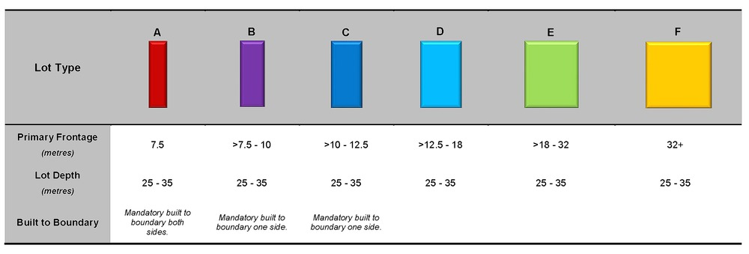

Density Figures
Figure 1 - Kallangur
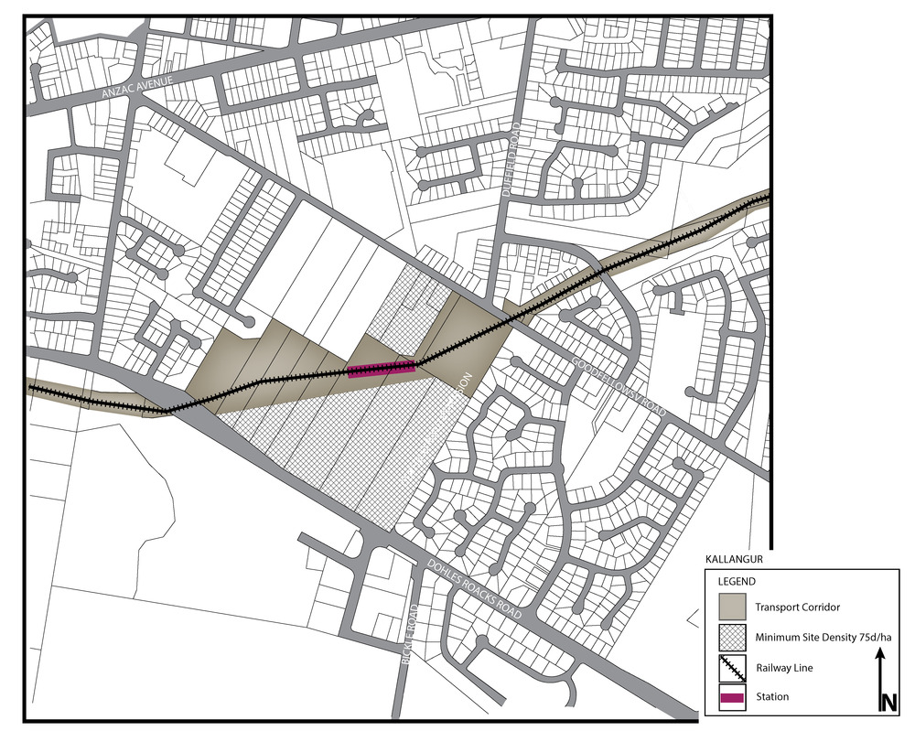

Figure 2 - Mango Hill
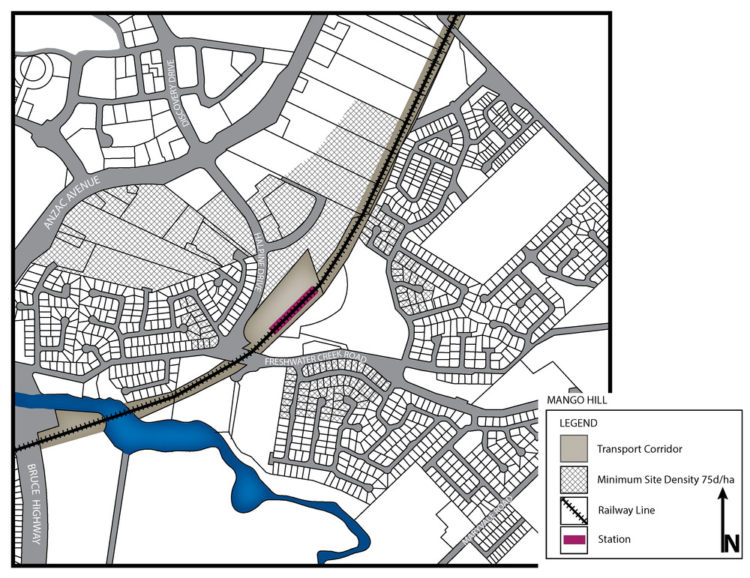

Figure 3 - Mango Hill East
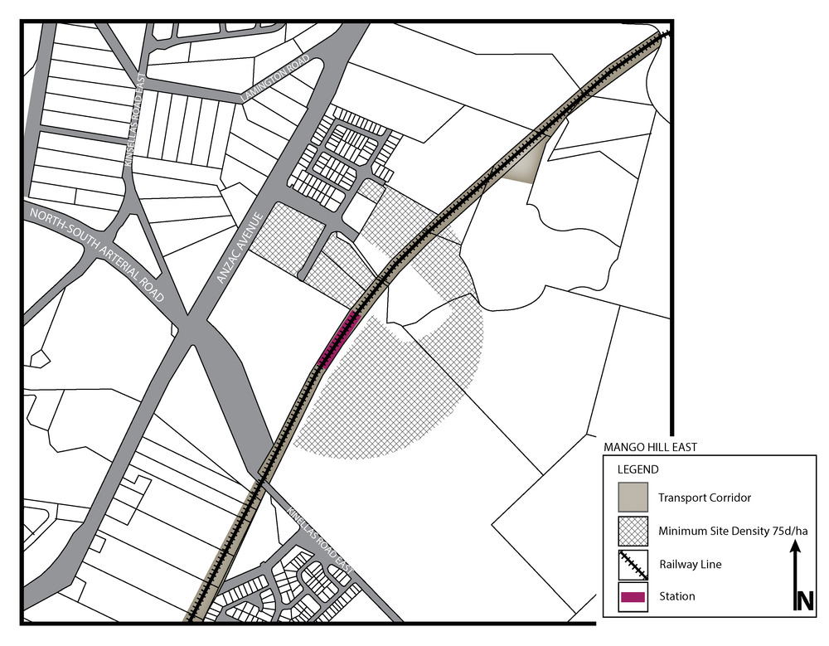

Figure 4 - Murrumba Downs
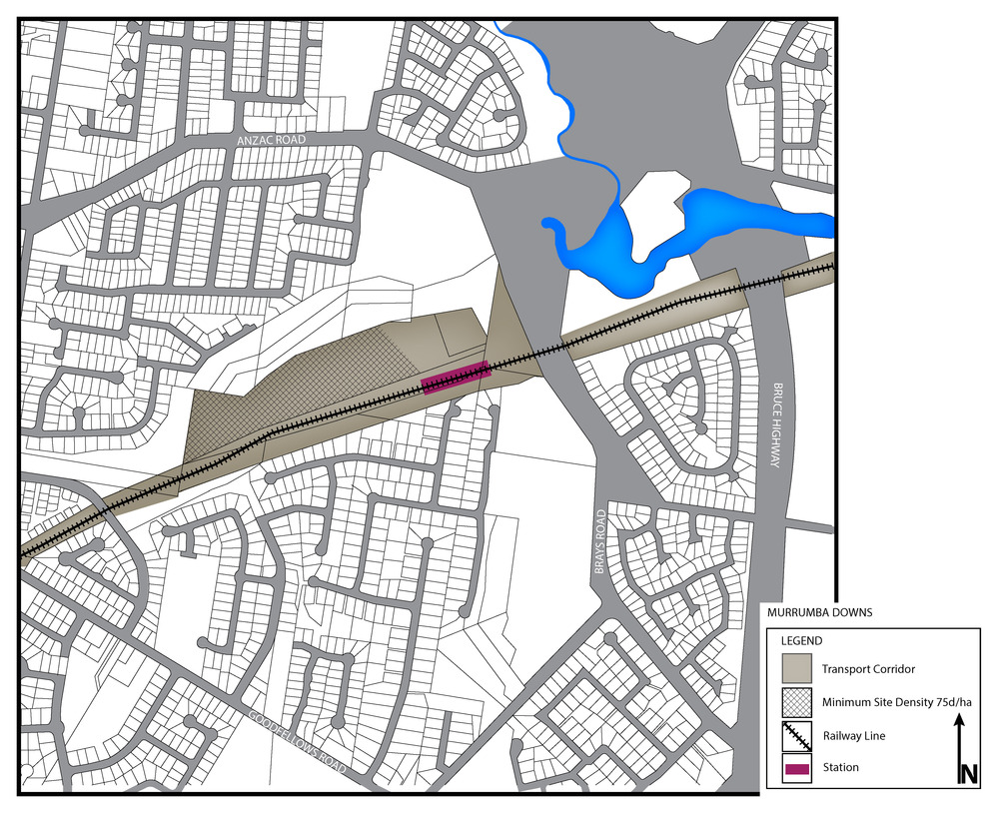

Figure 5 Kippa-Ring
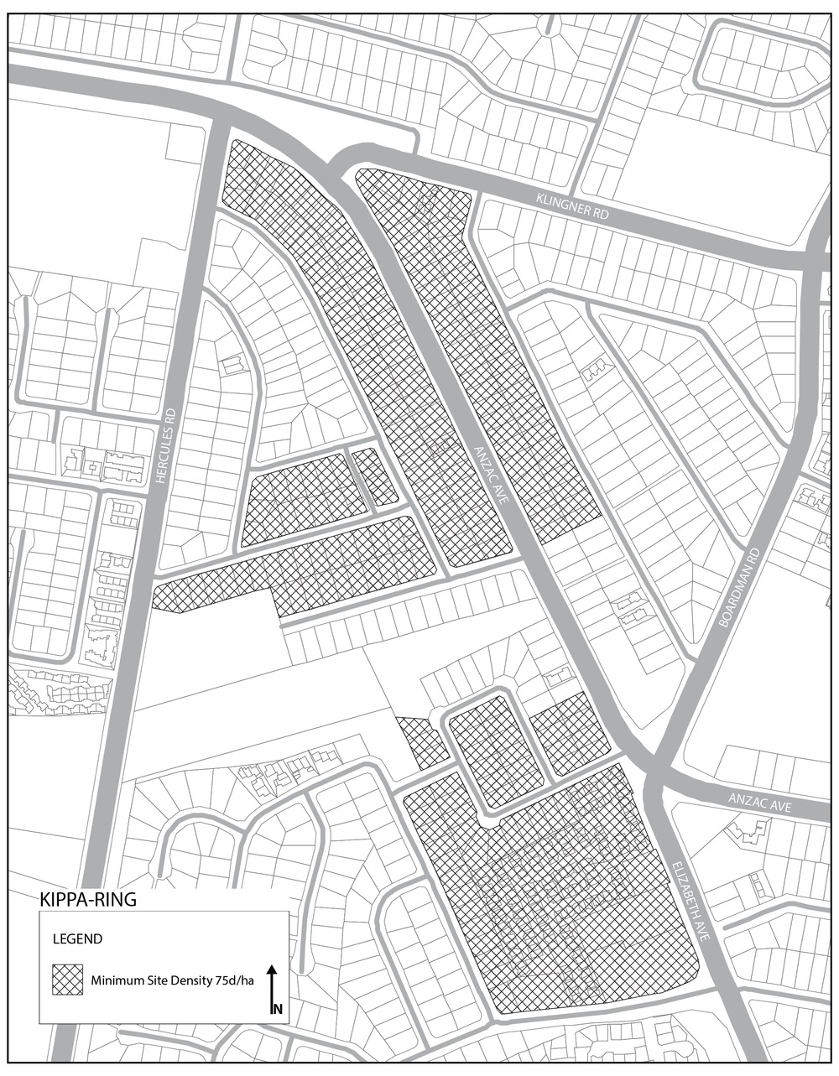

Movement network figures
Figure 6 - Dakabin
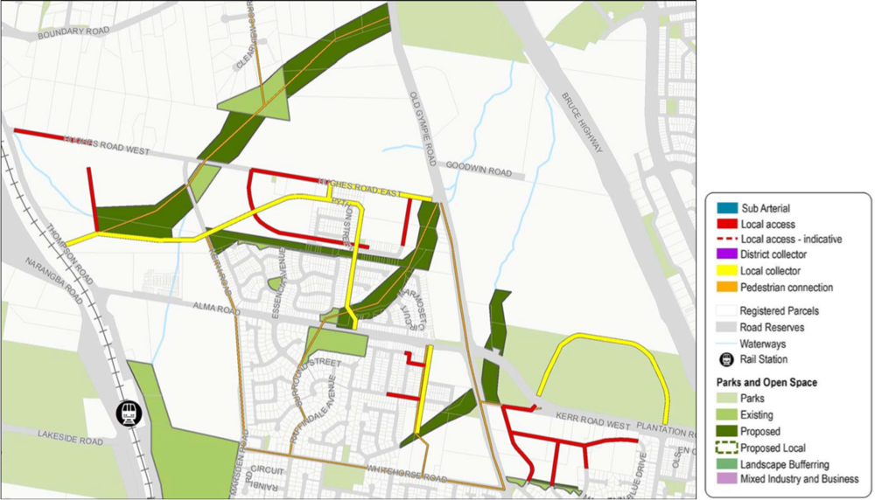

Figure 7 - Kallangur
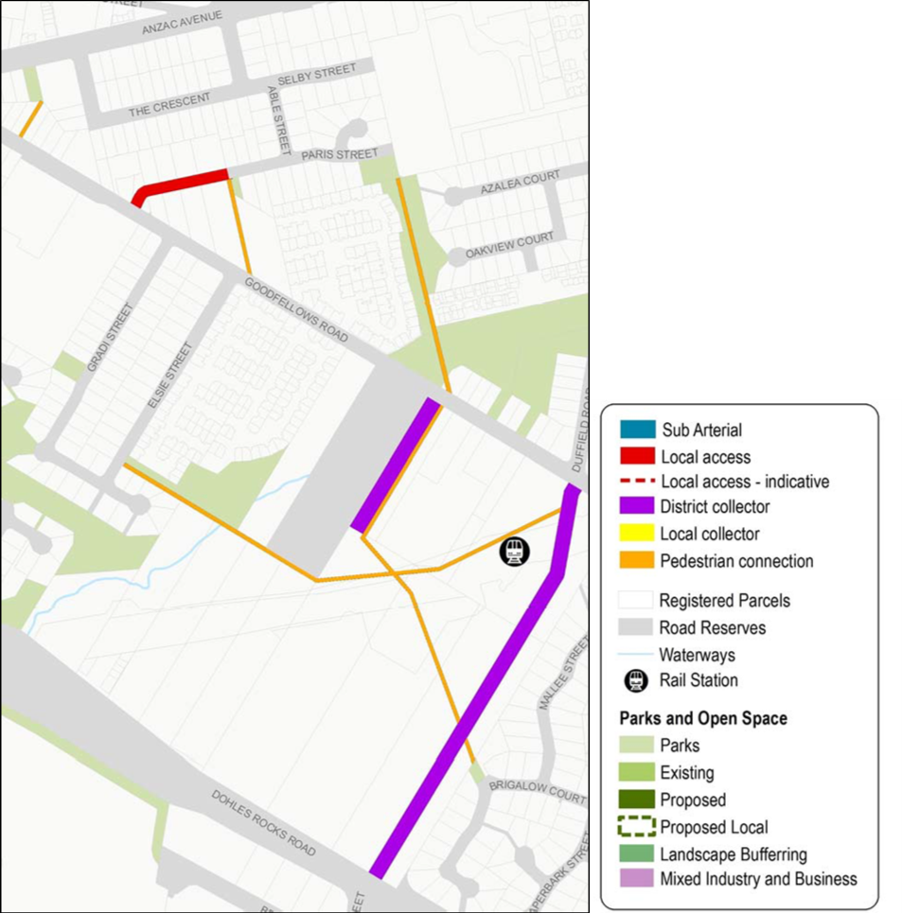

Figure 8 - Mango Hill
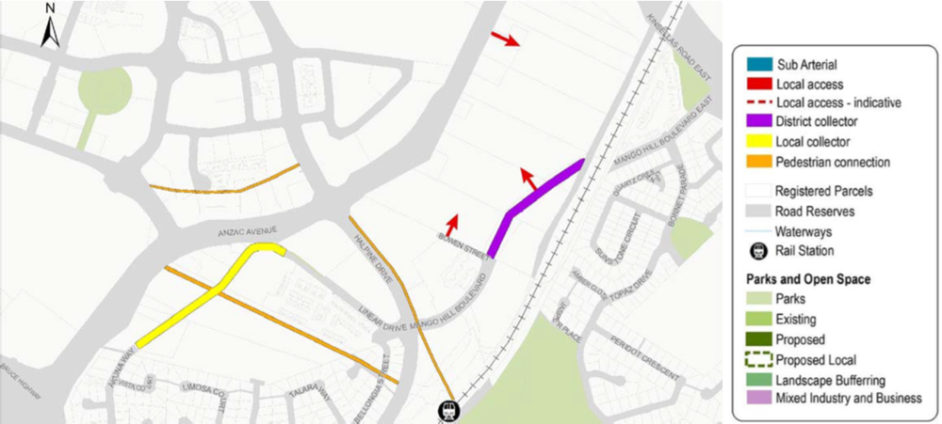

Figure 9 - Mango Hill East
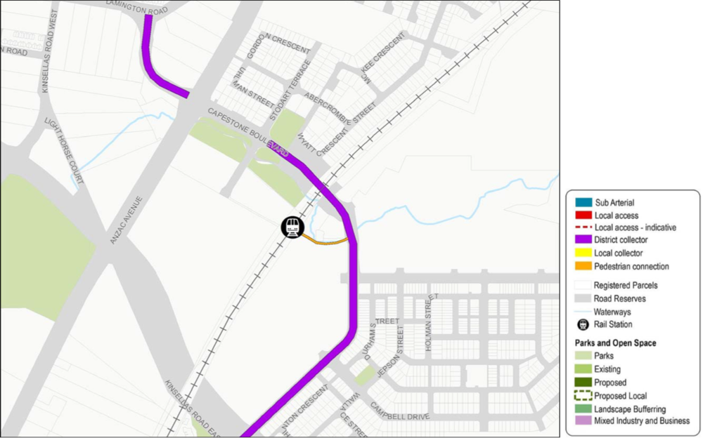

Figure 10 - Narangba - Main Street
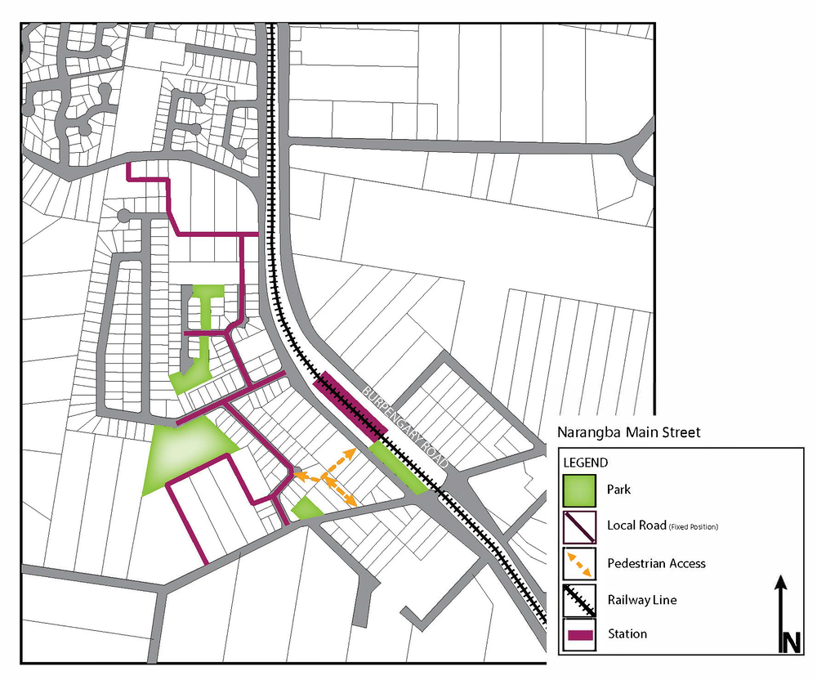

Figure 11 - Petrie
