Table 6.2.10.2 Assessable development - Rural zone

Performance outcomes | Examples that achieve aspects of the Performance Outcomes | E Compliance  - Yes  - No See PO or  - NA | Justification for compliance
General criteria
General performance outcome for all development
PO1  Development:  - adds value to an existing rural activity, the natural environment, or a tourism attraction;  - does not prejudice the ongoing operation of an existing or approved rural activity;  - is adequately serviced with necessary infrastructure to meet on-site needs and requirements;  - ensures adequate on-site stormwater and waste disposal is provided to avoid adverse impacts on water quality;  - is a size and scale that maintains the low density, low intensity and open area landscape character anticipated in the Rural zone;  - is designed, located and operated in a manner that avoids nuisance impacts on sensitive land uses;  - requires minimal filling or excavation. Where this occurs, visual impacts are reduced through screening;  - avoids being obtrusive or visually dominant by achieving low-set built form;  - uses natural and non-reflective materials and colours consistent with existing and surrounding rural buildings and rural environment, except where materials such as netting, shade cloth and similar coverings are necessary for agricultural operations;  - is not subject to a development constraint such as, but not limited to, flood, steep slope, waterway setback and significant vegetation; and  - does not result in any instability, erosion or degradation of land, water, soil resource or loss of natural, ecological or biological values. | No example provided.
Development footprint
PO2  All buildings, structures, associated facilities and infrastructure are contained within an approved development footprint. Development outside of an approved development footprint must:  - not be subject to a development constraint such as, but not limited to, flood, steep slope, waterway setbacks and significant vegetation;  - development does not result in any instability, erosion or degradation of land, water, soil resource or loss of natural, ecological or biological values. | E2  Where a development footprint has been identified as part of a development approval for reconfiguring a lot, all development occurs within the development footprint.
Building height
PO3  Height of buildings and structures:  - is consistent with the existing low rise, open area and low density character and amenity of the Rural zone and its precincts;  - does not unduly impact on access to daylight, sunlight, overshadowing or privacy experienced by adjoining premises;  - for buildings in the Hamlet precinct, the height of buildings reflect the individual character of the area;  - does not adversely affect the operation of aviation facility at Mt Glorious by adopting design or on-site management measures that:  - ensures a physical line-of-sight between transmitting or receiving devices.  - ensure electromagnetic fields do not interfere with the functioning of the aviation facility. | E3  Building height and all structures do not exceed the maximum height identified on Overlay map - Building heights; except in the Hamlet precinct, where outbuildings, free standing car ports or garages do not exceed 3.5m.
Setbacks
PO4  Setbacks are:  - sufficient to minimise overlooking and maintain privacy of adjoining properties; and  - sufficient to ensure development is not visually dominant or overbearing on adjoining properties. | E4.1  Unless specified elsewhere in the zone code, the minimum setback from a boundary is as follows:  - road boundary – 6m  - side boundary – 4.5m  - rear boundary – 4.5m.
E4.2
For lots located in the Hamlet precinct, the minimum setback from a boundary is as follows:
- road boundary - 6m
- side boundary - 1.5m for lots having 1000m² or less; 3m for lots greater than 1000m²
- rear boundary - 4m.
PO5  For those properties within the catchments of Lake Samsonvale or Lake Kurwongbah, dwelling houses⁽²²⁾, outbuildings and their associated waste/effluent disposal areas are positioned in a manner which avoids adverse impacts on the water quality of those lakes. | E5.1  For sites within the catchment of Lake Samsonvale or Lake Kurwongbah a setback of no less than 400m is maintained between the following nominated full supply levels to those lakes and any dwelling house⁽²²⁾ or outbuilding on the land:-  - RL 39.63m AHD being the full supply level to Lake Samsonvale; and  - RL 21m AHD being the full supply level to Lake Kurwongbah.  OR  No part of any dwelling house⁽²²⁾ or outbuilding on Lot 5 RP111651 or Lot 10 RP111653 or Lot 8 RP111268 is any closer than 80m to the full supply level of RL 21m AHD to Lake Kurwongbah.
E5.2
Waste/effluent disposal systems are located at least:
- 80m from the full supply level of RL 21m AHD to Lake Kurwongbah on Lot 5 RP111651 or Lot 10 RP111653 or Lot 8 RP111268; and
- 400m from RL 39.63m AHD being the full supply level to Lake Samsonvale and RL 21m AHD being the full supply level to Lake Kurwongbah.
Amenity
PO6  The amenity of the area and adjacent sensitive land uses are protected from the impacts of dust, odour, light, chemicals and other environmental nuisance. | No example provided.
Waste treatment
PO7  Stormwater generated on-site is treated and disposed of in an acceptable manner to mitigate any impacts on soil, surface water or ground water quality. Development resulting in the degradation of soil, surface water or ground water quality is avoided. | E7  All concentrated animal use areas (e.g. sheds, pens, holding yards, stables, kennels and other animal enclosures) are provided with site drainage to ensure all run-off is directed to suitable detention basins, filtration or other treatment areas.
Rural uses setbacks
PO8  Development ensures:  - sufficient separation from existing sensitive land uses to avoid adverse impacts from chemical spray, fumes, odour and dust;  - environmental nuisance or annoyance resulting from-but not limited to-noise, storage of materials and waste does not adversely impact on sensitive land uses; and  - buildings and other structures are consistent with the open area, low density, low built form character and amenity associated with the rural environment. | E8  The following uses and associated buildings are setback from all property boundaries as follows:  - Animal husbandry (buildings only) – 10m  - Animal keeping⁽⁵⁾, excluding catteries and kennels - 20m  - Aquaculture⁽⁶⁾ involving ponds or water behind dams – 100m  - Aquaculture⁽⁶⁾ involving the housing of tanks and associated equipment - 20m  - Cropping⁽¹⁹⁾ (building only) – 10m  - Intensive horticulture⁽⁴⁰⁾ – 20m  - Nature-based tourism⁽⁵⁰⁾, Short-term accommodation and Tourist park⁽⁸⁴⁾ - 40m  - Permanent plantations⁽⁵⁹⁾ – 25m  - Rural Industry⁽⁷⁰⁾ - 20m  - Rural workers' accommodation⁽⁷¹⁾ - 40m  - Transport depot⁽⁸⁵⁾, including all vehicle parking, storage and driveway areas – 30m  - Wholesale nursery⁽⁸⁹⁾ – 10m  - Winery⁽⁹⁰⁾ (buildings only) - 10m.
Car parking
PO9  On-site car parking associated with an activity provides safe and convenient on-site parking and manoeuvring to meet anticipated parking demand.  Note - Refer to Planning scheme policy - Integrated transport assessment for guidance on how to achieve compliance with this outcome. | E9  On-site car parking is provided in accordance Schedule 7 - Car parking.
Noise
PO10  Noise generating uses do not adversely affect existing noise sensitive uses.  Note - The use of walls, barriers or fences that are visible from or adjoin a road or public area are not appropriate noise attenuation measures unless adjoining a motorway, arterial road or rail line.  Note - A noise impact assessment may be required to demonstrate compliance with this PO. Noise impact assessments are to be prepared in accordance with Planning scheme policy - Noise. | No example provided.
PO11  Sensitive land uses are provided with an appropriate acoustic environment within designated external private outdoor living spaces and internal areas while:  - contributing to safe and usable public spaces, through maintaining high levels of surveillance of parks, streets and roads that serve active transport purposes (e.g. existing or future pedestrian paths or cycle lanes etc);  - maintaining the amenity of the streetscape.  Note - A noise impact assessment may be required to demonstrate compliance with this PO. Noise impact assessments are to be prepared in accordance with Planning scheme policy - Noise.  Note - Refer to Planning Scheme Policy – Integrated design for details and examples of noise attenuation structures. | E11.1  Development is designed to meet the criteria outlined in the Planning Scheme Policy – Noise.
E11.2
Noise attenuation structures (e.g. walls, barriers or fences):
- are not visible from an adjoining road or public area unless:
  - adjoining a motorway or rail line; or
  - adjoining part of an arterial road that does not serve an existing or future active transport purpose (e.g. pedestrian paths or cycle lanes) or where attenuation through building location and materials is not possible.
- do not remove existing or prevent future active transport routes or connections to the street network;
- are located, constructed and landscaped in accordance with Planning scheme policy - Integrated design.
Note - Refer to Planning scheme policy – Integrated design for details and examples of noise attenuation structures.
Note - Refer to Overlay map – Active transport for future active transport routes.

Hazardous Chemicals
Note - To assist in demonstrating compliance with the following performance outcomes, a Hazard Assessment Report may be required to be prepared and submitted by a suitably qualified person in accordance with 'State Planning Policy Guideline - Guidance on development involving hazardous chemicals'.

Terms used in this section are defined in State 'State Planning Policy Guideline - Guidance on development involving hazardous chemicals'.

PO12  Off sites risks from foreseeable hazard scenarios involving hazardous chemicals are commensurate with the sensitivity of the surrounding land use zones. | E12.1  Off site impacts or risks from any foreseeable hazard scenario does not exceed the dangerous dose at the boundary of land zoned for vulnerable or sensitive land uses as described below:  Dangerous Dose  - For any hazard scenario involving the release of gases or vapours:  - AEGL2 (60minutes) or if not available ERPG2;  - An oxygen content in air <19.5% or >23.5% at normal atmospheric pressure.  - For any hazard scenario involving fire or explosion:  - 7kPa overpressure;  - 4.7kW/m2 heat radiation.  If criteria E1.1 (a) or (b) cannot be achieved, then the risk of any foreseeable hazard scenario shall not exceed an individual fatality risk level of 0.5 x 10-6/year.
E12.2
Off site impacts or risks from any foreseeable hazard scenario does not exceed the dangerous dose at the boundary of a commercial or community activity land use zone as described below:

Dangerous Dose
- For any hazard scenario involving the release of gases or vapours:
  - AEGL2 (60minutes) or if not available ERPG2;
  - An oxygen content in air <19.5% or >23.5% at normal atmospheric pressure.
- For any hazard scenario involving fire or explosion:
  - 7kPa overpressure;
  - 4.7kW/m2 heat radiation.
If criteria E1.2 (a) or (b) cannot be achieved, then the risk of any foreseeable hazard scenario shall not exceed an individual fatality risk level of 5 x 10-6/year.
E12.3
Off site impacts or risks from any foreseeable hazard scenario does not exceed the dangerous dose at the boundary of an industrial land use zone as described below:

Dangerous Dose
- For any hazard scenario involving the release of gases or vapours:
  - AEGL2 (60minutes) or if not available ERPG2;
  - An oxygen content in air <19.5% or >23.5% at normal atmospheric pressure.
- For any hazard scenario involving fire or explosion:
  - 14kPa overpressure;
  - 12.6kW/m2 heat radiation.
If criteria E1.3 (a) or (b) cannot be achieved, then the risk of any foreseeable hazard scenario shall not exceed an individual fatality risk level of 50 x 10-6/year.
PO13  Buildings and package stores containing fire-risk hazardous chemicals are designed to detect the early stages of a fire situation and notify a designated person. | E13  Buildings and package stores containing fire-risk hazardous chemicals are provided with 24 hour monitored fire detection system for early detection of a fire event.
PO14  Common storage areas containing packages of flammable and toxic hazardous chemicals are designed with spill containment system(s) that are adequate to contain releases, including fire fighting media. | E14  Storage areas containing packages of flammable and toxic hazardous chemicals are designed with spill containment system(s) capable of containing a minimum of the total aggregate capacity of all packages plus the maximum operating capacity of any fire protection system for the storage area(s) over a minimum of 60 minutes.
PO15  Storage and handling areas, including manufacturing areas, containing hazardous chemicals in quantities greater than 2,500L or kg within a Local Government “flood hazard area” are located and designed in a manner to minimise the likelihood of inundation of flood waters from creeks, rivers, lakes or estuaries. | E15.1  The base of any tank with a WC >2,500L or kg is higher than any relevant flood height level identified in an area’s flood hazard area. Alternatively:  - bulk tanks are anchored so they cannot float if submerged or inundated by water; and  - tank openings not provided with a liquid tight seal, i.e. an atmospheric vent, are extended above the relevant flood height level.
E15.2
The lowest point of any storage area for packages >2,500L or kg is higher than any relevant flood height level identified in an area’s flood hazard area. Alternatively, package stores are provided with impervious bund walls or racking systems higher than the relevant flood height level.
Clearing of habitat trees where not located within the Environmental areas overlay map
PO16  - Development ensures that the biodiversity quality and integrity of habitats is not adversely impacted upon but maintained and protected.  - Development does not result in the net loss of fauna habitat. Where development does result in the loss of a habitat tree, development will provide replacement fauna nesting boxes at the following rate of 1 nest box for every hollow removed. Where hollows have not yet formed in trees > 80cm in diameter at 1.3m height, 3 nest boxes are required for every habitat tree removed.  - Development does not result in soil erosion or land degradation or leave land exposed for an unreasonable period of time but is rehabilitated in a timely manner  Note: Further guidance on habitat trees is provided in Planning scheme policy - Environmental areas | No example provided.

Works criteria
Utilities
PO17  All services including water supply, sewage disposal, electricity, street lighting, telecommunications and gas (if available) are provided in a manner that:  - is effective in delivery of service and meets reasonable community expectations;  - has capacity to service the maximum lot yield envisaged for the zone and the service provider’s design assumptions;  - ensures a logical, sequential, efficient and integrated roll out of the service network;  - is conveniently accessible in the event of maintenance or repair;  - minimises whole of life cycle costs for that infrastructure;  - minimises risk of potential adverse impacts on the natural and built environment;  - minimises risk of potential adverse impact on amenity and character values;  - recognises and promotes Councils Total Water Cycle Management policy and the efficient use of water resources. | E17  Development is provided with an appropriate level of service and infrastructure in accordance with Planning scheme policy - Integrated design (Appendix A).
Access
PO18  Where required, access easements contain a driveway and provision for services appropriate to the use. The easement covers all works associated with the access in accordance with Planning scheme policy - Integrated design. | No example provided.
PO19  The layout of the development does not compromise:  - the development of the road network in the area;  - the function or safety of the road network;  - the capacity of the road network.  Note - The road hierarchy is mapped on Overlay map - Road hierarchy. | E19.1  The development provides for the extension of the road network in the area in accordance with Council’s road network planning.
E19.2
The development does not compromise future road widening of frontage roads in accordance with the relevant standard and Council’s road planning.
E19.3
The development layout allows forward vehicular access to and from the site.
PO20  Safe access is provided for all vehicles required to access the site. | E20.1  Site access and driveways are designed, located and constructed in accordance with:  - where for a Council-controlled road and associated with a Dwelling house:  - Planning scheme policy - Integrated design;  - where for a Council-controlled road and not associated with a Dwelling house:  - AS/NZS2890.1 Parking facilities Part 1: Off street car parking;  - AS 2890.2 - Parking facilities Part 2: Off-street commercial vehicle facilities;  - Planning scheme policy - Integrated design;  - Schedule 8 - Service vehicle requirements;  - where for a State-Controlled road, the Safe Intersection Sight Distance requirements in Austroads and the appropriate IPWEAQ standard drawings, or a copy of a Transport Infrastructure Act 1994, section 62 approval.
E20.2
Internal driveways, car parks and access ways are designed and constructed with a sealed pavement and in accordance with:
- AS/NZS 2890.1 Parking Facilities Part 1: Off street car parking;
- AS 2890.2 Parking Facilities Part 2: Off street commercial vehicle facilities;
- Planning scheme policy - Integrated design; and
- Schedule 8 - Service vehicle requirements.
Note - This includes queue lengths (refer to Schedule 8 - Service vehicle requirements), pavement widths and construction.

E20.3
Crossovers and driveways associated with a Dwelling house are designed, located and constructed in accordance with Planning scheme policy - Integrated design.
E20.4
Access driveways, manoeuvring areas and loading facilities are sealed and provide for service vehicles listed in Schedule 8 - Service vehicle requirements for the relevant use. The on-site manoeuvring is to be in accordance with Schedule 8 - Service vehicle requirements.
E20.5
Landscaping (including shade trees) is provided within car parks in accordance with Planning scheme policy - Integrated design.
PO21  Sealed and flood free road access during the minor storm event is available to the site from the nearest arterial or sub-arterial road.  Editor's note - Where associated with a State-controlled road, further requirements may apply, and approvals may be required from the Department of Transport and Main Roads. | E21  Roads or streets giving access to the development from the nearest arterial or sub-arterial road are flood free during the minor storm event and are sealed.  Note - The road network is mapped on Overlay map - Road hierarchy.
Street design and layout
PO22  Streets are designed and constructed in accordance with Planning scheme policy - Integrated design and Planning scheme policy - Operational works inspection, maintenance and bonding procedures. The street design and construction accommodates the following functions:  - access to premises by providing convenient vehicular movement for residents between their homes and the major road network;  - safe and convenient pedestrian and cycle movement;  - adequate on street parking;  - stormwater drainage paths and treatment facilities;  - efficient public transport routes;  - utility services location;  - emergency access and waste collection;  - setting and approach (streetscape, landscaping and street furniture) for adjoining residences;  - expected traffic speeds and volumes; and  - wildlife movement (where relevant).  Note - Preliminary road design (including all services, street lighting, stormwater infrastructure, access locations, street trees and pedestrian network) may be required to demonstrate compliance with this PO.  Note - Refer to Planning scheme policy - Environmental areas and corridors for examples of when and where wildlife movement infrastructure is required. | No example provided.
PO23  The existing road network (whether trunk or non-trunk) is upgraded where necessary to cater for the impact from the development.  Note - An applicant may be required to submit an Integrated Transport Assessment (ITA), prepared in accordance with Planning scheme policy - Integrated transport assessment to demonstrate compliance with this PO, when any of the following occurs:  - Development is within 200m of a transport sensitive location such as a school, shopping centre, bus or train station or a large generator of pedestrian or vehicular traffic;  - Forecast traffic to/from the development exceeds 5% of the two way flow on the adjoining road or intersection in the morning or afternoon transport peak within 10 years of the development completion;  - Development access onto a sub arterial, or arterial road or within 100m of a signalised intersection;  - Residential development greater than 50 lots or dwellings;  - Offices greater than 4,000m² Gross Floor Area (GFA);  - Retail activities including Hardware and trade supplies, Showroom, Shop or Shopping centre greater than 1,000m² GFA;  - Warehouses and Industry greater than 6,000m² GFA;  - On-site carpark greater than 100 spaces;  - Development has a trip generation rate of 100 vehicles or more within the peak hour;  - Development which dissects or significantly impacts on an environmental area or an environmental corridor.  The ITA is to review the development’s impact upon the external road network for the period of 10 years from completion of the development. The ITA is to provide sufficient information for determining the impact and the type and extent of any ameliorative works required to cater for the additional traffic. The ITA must include a future structural road layout of adjoining properties that will form part of this catchment and road connecting to these properties. The ITA is to assess the ultimate developed catchment’s impacts and necessary ameliorative works, and the works or contribution required by the applicant as identified in the study.  Note - The road network is mapped on Overlay map - Road hierarchy.  Note - The primary and secondary active transport network is mapped on Overlay map - Active transport. | E23.1  New intersections onto existing roads are designed to accommodate traffic volumes and traffic movements taken from a date 10 years from the date of completion of the last stage of the development. Detailed design is to be in accordance with Planning scheme policy - Integrated design.  Note - All turns vehicular access to existing lots is to be retained at new road intersections wherever practicable.  Note - Existing on-street parking is to be retained at new road intersections and along road frontages wherever practicable.
E23.2
Existing intersections external to the site are upgraded as necessary to accommodate increased traffic from the development. Design is in accordance with Planning scheme policy - Operational works inspection, maintenance and bonding procedures.
Note - All turns vehicular access to existing lots is to be retained at new road intersections wherever practicable.
Note - Existing on-street parking is to be retained at upgraded road intersections and along road frontages wherever practicable.

E23.3
The active transport network is extended in accordance with Planning scheme policy - Integrated design.
PO24  New intersections along all streets and roads are located and designed to provide safe and convenient movements for all users.  Note - Refer Planning scheme policy - Integrated design and Planning scheme policy - Operational works inspection, maintenance and bonding procedures for design and construction standards.  Note - An Integrated Transport Assessment (ITA) including preliminary intersection designs, prepared in accordance with Planning scheme policy - Integrated transport assessment may be required to demonstrate compliance with this PO. Intersection spacing will be determined based on the deceleration and queue storage distances required for the intersection after considering vehicle speed and present/forecast turning and through volumes. | E24  New intersection spacing (centreline – centreline) along a through road conforms with the following:  - Where the through road provides an access or collector function:  - intersecting road located on same side = 100 metres;  - intersecting road located on opposite side = 50 metres.  - Where the through road provides a sub-arterial function:  - intersecting road located on same side = 300 metres;  - intersecting road located on opposite side = 150 metres.  - When the through road provides an arterial function:  - intersecting road located on the same side = 500 metres;  - intersecting road located on opposite side = 250 metres.  Note - Based on the absolute minimum intersection spacing identified above, all turns access may not be permitted (ie. left in/left out only) at intersections with sub-arterial roads or arterial roads.  Note - The road network is mapped on Overlay map - Road hierarchy.  Note - An Integrated Transport Assessment (ITA) including preliminary intersection designs, prepared in accordance with Planning scheme policy - Integrated transport assessment may be required to demonstrate compliance with this PO
Stormwater
PO25  Minor stormwater drainage systems (internal and external) have the capacity to convey stormwater flows from frequent storm events for the fully developed upstream catchment whilst ensuring pedestrian and vehicular traffic movements are safe and convenient. | E25.1  The capacity of all minor drainage systems are designed in accordance with Planning scheme policy - Integrated design.
E25.2
Stormwater pipe network capacity is to be calculated in accordance with the Hydraulic Grade Line method as detailed in Australian Rainfall and Runoff or QUDM.
PO26  Major stormwater drainage system(s) have the capacity to safely convey stormwater flows for the 1% AEP event for the fully developed upstream catchment. | E26.1  The internal drainage system safely and adequately conveys the stormwater flows for the 1% AEP event for the fully developed upstream catchment through the site.
E26.2
The external (downstream) drainage system safely conveys the stormwater flows for the 1% AEP event for the fully developed upstream catchment without allowing the flows to encroach upon private lots.
E26.3
Overland flow paths (for any storm event) from newly constructed roads and public open space areas do not pass through the development footprint.
E26.4
The flow velocity in all unlined or soft faced open drains is kept within acceptable limits for the type of material or lining and condition of the channel.
Note - Refer to QUDM for recommended average flow velocities.

PO27  Provide measures to properly manage surface flows for the 1% AEP event (for the fully developed catchment) draining to and through the land to ensure no actionable nuisance is created to any person or premises as a result of the development. The development must not result in ponding on adjacent land, redirection of surface flows to other premises or blockage of a surface flow relief path for flows exceeding the design flows for any underground system within the development. | E27  The stormwater drainage system is designed and constructed in accordance with Planning scheme policy - Integrated design.
PO28  Stormwater run-off from the site is conveyed to a point of lawful discharge without causing actionable nuisance to any person, property or premises.  Note - Refer to Planning scheme policy - Integrated design for details.  Note - A downstream drainage discharge report in accordance with Planning scheme policy - Stormwater management may be required to demonstrate achievement of this performance outcome.  Note - A watercourse as defined in the Water Act may be accepted as a lawful point of discharge providing the drainage discharge from the site does not increase the downstream flood levels during events up to and including the 1% AEP storm. An afflux of +20mm may be accepted on Council controlled land and road infrastructure. No worsening is ensured when stormwater is discharged into a catchment that includes State Transport Infrastructure. | No example provided.
PO29  Stormwater generated from the development does not compromise the capacity of existing stormwater infrastructure downstream of the site.  Note - A downstream drainage discharge report in accordance with Planning scheme policy - Stormwater management may be required to demonstrate achievement of this performance outcome. | No example provided.
PO30  Stormwater drainage pipes and structures through or within private land (including inter-allotment drainage) are protected by easements in favour of Council with sufficient area for practical access for maintenance purposes.  Note - In order to achieve a lawful point of discharge, stormwater easements may also be required over temporary drainage channels/infrastructure where stormwater dams to a balance lot prior to entering Council’s stormwater drainage system. | E30.1  Stormwater drainage infrastructure (excluding detention and bio-retention systems) through or within private land (including inter-allotment drainage) is protected by easements in favour of Council. Minimum easement widths are as follows:  Pipe Diameter Minimum easement width (excluding access requirements)  Stormwater pipe up to 825mm diameter 3.0m  Stormwater pipe up to 825mm diameter with sewer pipe up to 225m diameter 4.0m  Stormwater pipe greater than 825mm diameter Easement boundary to be 1m clear of the outside wall of the stormwater pipe (each side).  Note - Additional easement width may be required in certain circumstances in order to facilitate maintenance access to the stormwater system.  Note - Refer to Planning scheme policy - Integrated design (Appendix C) for easement requirements over open channels.
E30.2
Easements are provided over all headwalls and outlet structures within private land. The easement is to cover all drainage works and extend to the point where the stormwater flows return to natural flow conditions.
PO31  Stormwater management facilities (excluding outlets) are located outside of riparian areas and prevent increased channel bed and bank erosion. | No example provided.
PO32  Council is provided with accurate representations of the completed stormwater management works within residential developments. | E32  “As Built” drawings and specifications of the stormwater management devices certified by an RPEQ is provided.  Note - Documentation is to include:  - photographic evidence and inspection date of the installation of approved underdrainage;  - copy of the bioretention filter media delivery dockets/quality certificates confirming the materials comply with specifications in the approved Stormwater Management Plan;  - date of the final inspection.
Site works and construction management
PO33  The site and any existing structures are maintained in a tidy and safe condition. | No example provided.
PO34  All works on-site are managed to:  - minimise as far as practicable, impacts on adjoining or adjacent premises and the streetscape in regard to erosion and sedimentation, dust, noise, safety and light;  - minimise as far as possible, impacts on the natural environment;  - ensure stormwater discharge is managed in a manner that does not cause actionable nuisance to any person or premises;  - avoid adverse impacts on street trees and their critical root zone. | E34.1  Works incorporate temporary stormwater runoff, erosion and sediment controls and trash removal devices designed in accordance with the Urban Stormwater Quality Planning Guidelines, State Planning Policy, Schedule 10 - Stormwater management design objectives, Planning scheme policy - Stormwater management and Planning scheme policy - Integrated design, including but not limited to the following:  - stormwater is not discharged to adjacent properties in a manner that differs significantly from pre-existing conditions;  - stormwater discharged to adjoining and downstream properties does not cause scour or erosion of any kind;  - stormwater discharge rates do not exceed pre-existing conditions;  - minimum design storm for all temporary diversion drains and sedimentation basins in accordance with Schedule 10 - Stormwater management design objectives;  - ponding or concentration of stormwater does not occur on adjoining properties.
E34.2
Stormwater runoff, erosion and sediment controls are constructed in accordance with Planning scheme policy - Integrated design (Appendix C) prior to commencement of any clearing or earthworks and are maintained and adjusted as necessary at all times to ensure their ongoing effectiveness.
Note - The measures are adjusted on-site to maximise their effectiveness.

E32.3
The completed earthworks area is stabilised using turf, established grass seeding, mulch or sprayed stabilisation techniques to control erosion and sediment and dust from leaving the property.
E34.4
Existing street trees are protected and not damaged during works.
Note - Where development occurs in the tree protection zone, measures and techniques as detailed in Australian Standard AS 4970 Protection of trees on development sites are adopted and implemented.

PO35  Dust suppression measures are implemented during soil disturbances and construction works to protect nearby premises from unreasonable dust impacts. | E35  No dust emissions extend beyond the boundaries of the site during soil disturbances and construction works.
PO36  All development works including the transportation of material to and from the site are managed to not negatively impact the existing road network, the amenity of the surrounding area or the streetscape.  Note - A Traffic Management Plan may be required to demonstrate compliance with this PO. A Traffic Management Plan is to be prepared in accordance with the Manual of Uniform Traffic Control Devices (MUTCD).  Note - A haulage route must be identified and approved by Council where imported or exported material is transported to the site via a road of Local Collector standard or less, and:  - the aggregate volume of imported or exported material is greater than 1000m³; or  - the aggregate volume of imported or exported material is greater than 200m³ per day; or  - the proposed haulage route involves a vulnerable land use or shopping centre.  Note - A dilapidation report (including photographs) may be required for the haulage route to demonstrate compliance with this PO.  Editor's note - Where associated with a State-controlled road, further requirements may apply, and approval may be required from the Department of Transport and Main Roads. | E36.1  Construction traffic including contractor car parking is controlled in accordance with a traffic management plan, prepared in accordance with the Manual of Uniform Traffic Control Devices (MUTCD) to ensure all traffic movements to and from the site are safe.
E36.2
All contractor car parking is either provided on the development site, or on an alternative site in the general locality which has been set aside for car parking. Contractors vehicles are generally not to be parked in existing roads.

E36.3
Any material dropped, deposited or spilled on the road(s) as a result of construction processes associated with the site are to be cleaned at all times.
E36.4
Construction traffic to and from the development site uses the highest classification streets or roads where a choice of access routes is available. Haul routes for the transport of imported or spoil material and gravel pavement material along Council roads below sub-arterial standard must be approved routes.
Note - The road hierarchy is mapped on Overlay map - Road hierarchy.
Note - A dilapidation report may be required to demonstrate compliance with this E.

E36.5
Where works are carried out in existing roads, the works must be undertaken so that the existing roads are maintained in a safe and usable condition. Practical access for residents, visitors and services (including postal deliveries and refuse collection) is retained to existing lots during the construction period and after completion of the works.
Note - A traffic control plan prepared in accordance with the Manual of Uniform Traffic Control Devices (MUTCD) will be required for any works that will affect access, traffic movements or traffic safety in existing roads.

E36.6
Access to the development site is obtained via an existing lawful access point.
PO37  All disturbed areas are to be progressively stabilised during construction and the entire site rehabilitated and substantially stabilised at the completion of construction.  Note - Refer to Planning scheme policy - Integrated design for details. | E37  At completion of construction all disturbed areas of the site are to be:  - topsoiled with a minimum compacted thickness of fifty (50) millimetres;  - stabilised using turf, established grass seeding, mulch or sprayed stabilisation techniques.  Note - These areas are to be maintained during any maintenance period to maximise grass coverage.
PO38  Earthworks are undertaken to ensure that soil disturbances are staged into manageable areas.  Note - A site specific Erosion and Sediment Control Plan (ESCP) will be required to demonstrate compliance with this PO. An ESCP is to be prepared in accordance with Planning scheme policy - Stormwater management and Planning scheme policy - Integrated design (Appendix C). | E38  Soil disturbances are staged into manageable areas of not greater than 3.5 ha.
PO39  The clearing of vegetation on-site:  - is limited to the area of infrastructure works, building areas and other necessary areas for the works; and  - includes the removal of declared weeds and other materials which are detrimental to the intended use of the land;  - is disposed of in a manner which minimises nuisance and annoyance to existing premises.  Note - No burning of cleared vegetation is permitted. | E39.1  All native vegetation to be retained on-site is temporarily fenced or protected prior to and during development works.  Note - No parking of vehicles or storage of machinery or goods is to occur in these areas during development works.
E39.2
Disposal of materials is managed in one or more of the following ways:
- all cleared vegetation, declared weeds, stumps, rubbish, car bodies, scrap metal and the like are removed and disposed of in a Council land fill facility; or
- all native vegetation with a diameter below 400mm is to be chipped and stored on-site.
Note - The chipped vegetation must be stored in an approved location.

PO40  All development works are carried out at times which minimise noise impacts to residents. | E40  All development works are carried out within the following times:  - Monday to Saturday (other than public holidays) between 6:30am and 6:30pm on the same day;  - no work is to be carried out on Sundays or public holidays.  Note - Work outside the above hours may be approved (in writing) where it can be demonstrated that the work will not cause significant inconvenience or disruption to the public, or the work is unlikely to cause annoyance or inconvenience to occupants of adjacent properties.
PO41  Any alteration or relocation in connection with or arising from the development to any service, installation, plant, equipment or other item belonging to or under the control of the telecommunications authority, electricity authorities, the Council or other person engaged in the provision of public utility services is to be carried with the development and at no cost to Council. | No example provided.
Earthworks
PO42  On-site earthworks are designed to consider the visual and amenity impact as they relate to:  - the natural topographical features of the site;  - short and long-term slope stability;  - soft or compressible foundation soils;  - reactive soils;  - low density or potentially collapsing soils;  - existing fill and soil contamination that may exist on-site;  - the stability and maintenance of steep slopes and batters;  - excavation (cut) and fill and impacts on the amenity of adjoining lots (e.g. residential). | E42.1  All cut and fill batters are provided with appropriate scour, erosion protection and run-off control measures including catch drains at the top of batters and lined batter drains as necessary.
E42.2
Stabilisation measures are provided, as necessary, to ensure long-term stability and low maintenance of steep slopes and batters.
E42.3
Inspection and certification of steep slopes and batters is required by a suitably qualified and experienced RPEQ.
E42.4
All fill batters steeper than 1 (V) in 6 (H) on residential lots are fully turfed to prevent scour and erosion.
E42.5
All filling or excavation is contained on-site and is free draining.
E42.6
All fill placed on-site is:
- limited to that area necessary for the approved use;
- clean and uncontaminated (i.e. no building waste, concrete, green waste, actual acid sulfate soils, potential acid sulfate soils or contaminated material etc.).
E42.7
The site is prepared and the fill placed on-site in accordance with AS3798.
Note - The fill is to be inspected and tested in accordance with Planning scheme policy - Operational works inspection, maintenance and bonding procedures.

PO43  Embankments are stepped, terraced and landscaped to not adversely impact on the visual amenity of the surrounding area. | E43  Any embankments more than 1.5 metres in height are stepped, terraced and landscaped.  Figure - Embankment  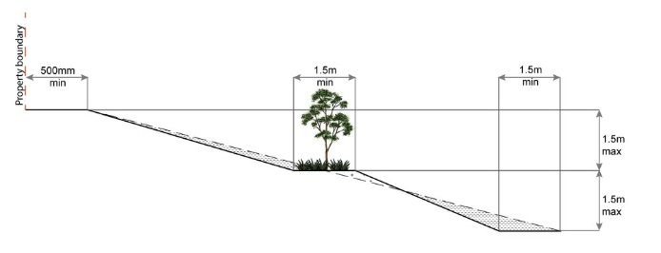
PO44  Filling or excavation is undertaken in a manner that:  - does not adversely impact on a Council or public sector entity maintained infrastructure or any drainage feature on, or adjacent to the land;  - does not preclude reasonable access to a Council or public sector entity maintained infrastructure or any drainage feature on, or adjacent to the land for monitoring, maintenance or replacement purposes.  Note - Public sector entity is defined in Schedule 2 of the Act. | E44.1  No filling or excavation is undertaken in an easement issued in favour of Council or a public sector entity.  Note - Public sector entity is defined in Schedule 2 of the Act.
E44.2
Filling or excavation that would result in any of the following is not carried out on-site:
- a reduction in cover over any Council or public sector entity infrastructure service to less than 600mm;
- an increase in finished surface grade over, or within 1.5m on each side of, the Council or public sector entity infrastructure above that which existed prior to the earthworks being undertaken;
- prevent reasonable access to Council or public sector entity maintained infrastructure or any drainage feature on, or adjacent to the site for monitoring, maintenance or replacement purposes.
Note - Public sector entity is defined in Schedule 2 of the Act.
Note - All building work covered by QDC MP1.4 is excluded from this provision.

PO45  Filling or excavation does not cause any adverse impacts on utility services or on-site effluent disposal areas. | E45.1  The area subject to filling or excavation does not contain any utility services.
E45.2
The distance between the top water level of a private dam and the irrigation area of a household sewage treatment plant (secondary treatment) is 30.0 metres.
E45.3
The distance between the top water level of a private dam and the irrigation area of a septic trench (primary treatment) is 50.0 metres.
Note - Refer to the Water Quality Vision and Objectives contained in the Seqwater Development Guidelines: Development Guidelines for Water Quality Management in Drinking Water Catchments 2017 where contained within water resource area and water supply buffer area.

PO46  Filling or excavation does not result in land instability.  Note - Steep slopes and batters are inspected and certified for long-term stability by a suitably qualified and experienced geotechnical engineer with RPEQ qualifications. Stabilisation measures are provided, as necessary, to ensure long-term stability and low maintenance. | No example provided.
PO47  Filling or excavation does not result in  - adverse impacts on the hydrological and hydraulic capacity of the waterway or floodway;  - increased flood inundation outside the site;  - any reduction in the flood storage capacity in the floodway;  - any clearing of native vegetation.  Note - To demonstrate compliance with this outcome, Planning Scheme Policy - Stormwater Management provides guidance on the preparation of a site based stormwater management plan by a suitably qualified professional. Refer to Planning scheme policy - Integrated design for guidance on infrastructure design and modelling requirements. | No example provided.
PO48  Filling or excavation on the development site is undertaken in a manner which does not create or accentuate problems associated with stormwater flows and drainage systems on land adjoining the site. | E48  Filling and excavation undertaken on the development site are shaped in a manner which does not:  - prevent stormwater surface flow which, prior to commencement of the earthworks, passed onto the development site, from entering the land; or  - redirect stormwater surface flow away from existing flow paths; or  - divert stormwater surface flow onto adjacent land, (other than a road), in a manner which:  - concentrates the flow; or  - increases the flow rates of stormwater over the affected section of the adjacent land above the situation which existed prior to the diversion; or  - causes actionable nuisance to any person, property or premises.
PO49  All earth retaining structures provide a positive interface with the streetscape and minimise impacts on the amenity of adjoining residents.  Note - Refer to Planning scheme policy - Residential design for guidance on how to achieve compliance with this performance outcome. | E49  Earth retaining structures:  - are not constructed of boulder rocks or timber;  - where height is no greater than 900mm, are provided in accordance with Figure - Retaining on a boundary;  Figure - Retaining on boundary  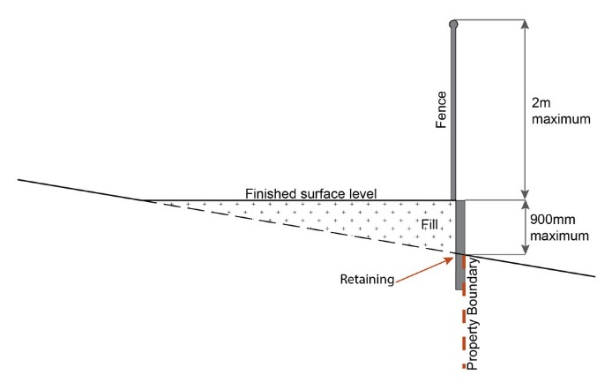  - where height is greater than 900mm but no greater than 1.5m, are to be setback at least the equivalent height of the retaining structure from any property boundary;  - where height is greater than 1.5m, are to be setback and stepped 1.5m vertical: 1.5m horizontal, terraced, landscaped and drained as shown below.  Figure - Cut  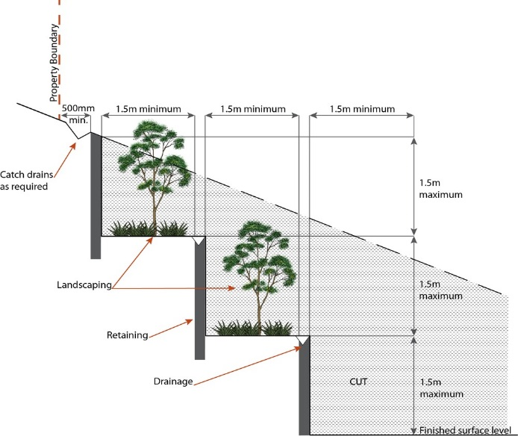  Figure - Fill  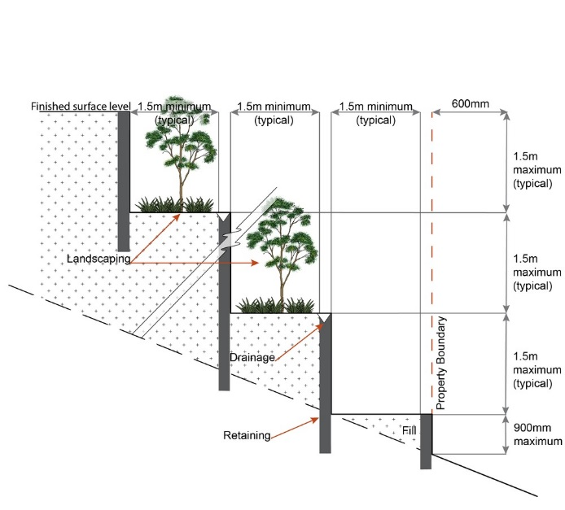

Use specific criteria
Animal keeping⁽⁵⁾ for catteries and kennels
PO50  Development for a cattery and kennel ensures that:  - it is a size, scale and design not visually dominant, overbearing or inconsistent with detached, low density, low built form character anticipated in the Rural zone;  - it is sufficiently landscaped, fenced and screened to reduce the visual appearance of buildings, structures, storage and parking areas;  - design, siting and construction prevents animal noise from being clearly audible beyond the development site and does not create a disturbance to residents on adjoining and surrounding properties;  - all building, including runs, are located a minimum 400m from all property boundaries;  - fencing of sufficient height and depth, being a minimum height of 1.8m and minimum depth of 0.2m, is provided to prevent animals escaping. |  | No example provided.
Dwelling house ⁽²²⁾
PO51  Development does not result in residential density exceeding more than one dwelling house ⁽²²⁾per lot. |  | E51  Residential density does not exceed one dwelling house⁽²²⁾ per lot.
PO52  Height of buildings and structures:  - is consistent with the existing low rise, open area and low density character and amenity of the Rural zone and its precincts;  - does not unduly impact on access to daylight, sunlight, overshadowing or privacy experienced by adjoining premises;  - for buildings in the Hamlet precinct, the height of buildings reflect the individual character of the area;  - does not adversely affect the operation of aviation facility at Mt Glorious (refer Overlay map - Infrastructure buffers) by adopting design or on-site management measures that:  - ensures a physical line-of-sight between transmitting or receiving devices.  - ensure electromagnetic fields do not interfere with the functioning of the aviation facility. |  | E52  Building height and all structures do not exceed the maximum height identified on Overlay map - Building heights; except in the Hamlet precinct, where outbuildings, free standing car ports or garages do not exceed 3.5m.
PO53  For those properties within the catchments of Lake Samsonvale or Lake Kurwongbah, dwelling houses⁽²²⁾, outbuildings and their associated waste/effluent disposal areas are positioned in a manner which avoids adverse impacts on the water quality of those lakes. |  | E53.1  For Lake Samsonvale or Lake Kurwongbah, a setback of no less than 400m is maintained between the following nominated full supply levels to those lakes and any dwelling house⁽²²⁾ or outbuilding on the land:-  - RL 39.63m AHD being the full supply level to Lake Samsonvale; and  - RL 21m AHD being the full supply level to Lake Kurwongbah.  OR  No part of any dwelling house⁽²²⁾ or outbuilding on Lot 5 RP111651 or Lot 10 RP111653 or Lot 8 RP111268 is any closer than 80m to the full supply level of RL 21m AHD to Lake Kurwongbah.
E53.2
Waste/effluent disposal systems are located at least:-
- 80m from the full supply level of RL 21m AHD to Lake Kurwongbah on Lot 5 RP111651 or Lot 10 RP111653 or Lot 8 RP111268; and
- 400m from RL 39.63m AHD being the full supply level to Lake Samsonvale and RL 21m AHD being the full supply level to Lake Kurwongbah.
PO54  All buildings, structures, associated facilities and infrastructure are contained within an approved development footprint. Development outside of an approved development footprint must:  - not be subject to a development constraint such as, but not limited to, flood, steep slope, waterway setbacks and significant vegetation;  - development does not result in any instability, erosion or degradation of land, water, soil resource or loss of natural, ecological or biological values. |  | E54  Where a development footprint has been identified as part of a development approval for reconfiguring a lot, all development occurs within the development footprint.
PO55  Development is designed to respond to sloping topography in the siting, design and form of buildings and structures by:  - minimising overuse of cut and fill to avoid single-plane slabs and benching;  - avoiding expanses of retaining walls, loss of trees and vegetation and interference with natural drainage systems;  - minimising any impact on the landscape character of the Rural zone;  - protecting the amenity of adjoining properties. |  | E55  Building and site design on slopes between 10% and 15% must:  - use split-level, multiple-slab, pier or pole construction;  - avoid single-plane slabs and benching;  - ensure the height of any cut or fill, whether retained or not, does not exceed 900mm.
Dwelling house⁽²²⁾ - secondary dwelling
PO56  Dwelling house⁽²²⁾ where including a secondary dwelling, the secondary dwelling:  - remains subordinate to the principal dwelling;  - a size, scale and design that is not visually dominant, overbearing and inconsistent with the low density, open area character and form anticipated in a relevant precinct of the Rural zone. |  | E56  The secondary dwelling:  - The maximum GFA for a second dwelling is as follows:  - in the Rural zone - 100m²;  - in the Hamlet precinct - 45m² for a lot with a primary frontage less than 15m;  - in the Hamlet precinct - 55m² for a lot with a primary frontage of 15m or more;  - in the Agriculture precinct - 100m²;  - in the Rural living investigation precinct - 100m².  - obtains access from the existing driveway giving access to the dwelling house⁽²²⁾.  Note - In the Cedarton Foresters Cooperative and Mt Nebo plant nursery precinct, no secondary dwellings are permitted as part of the Land Management Plan.
Education establishment for agricultural education or agricultural training facilities
PO57  An education establishment:  - is for the purpose of agricultural education or agricultural training training only;  - does not cause nuisance, detract or conflict with the primary role and associated Event Management Plans on land in the nearby Community facility zone, when occurring at the same time as an event occurring on that land. Such issues include, but are not limited to, noise, waste generation and disposal, traffic generation, location of and to sensitive land uses;  - is limited in size and scale and do not have adverse impacts on the low-set built form, low density, open area character and amenity of the Rural zone, including considerations to the impact of noise, traffic, and on-site waste disposal;  - avoids locating in area of high quality cropping⁽¹⁹⁾ land as identified in the Agriculture precinct;  - avoids establishing on land subject to a flooding risk, or where avoidance is not possible, identify measures to be taken mitigate any potential risk to property and life;  - ensures vehicle parking and storage areas are to be screened from public view to minimise adverse visual impacts on rural character;  - does not degrade or compromise the visual, natural, biological and ecological values associated with vegetated areas or adversely impact upon water quality;  - does not adversely impact on the safe and efficient operation of the external road network. |  | No example provided.
Food and drink outlet ⁽²⁸⁾
PO58  Food and drink outlets⁽²⁸⁾:  - are of a size, scale and type that is not visually dominant, overbearing or inconsistent with the low density, open area character and built form anticipated in a Rural zone;  - do not comprise a drive-through facility;  - incorporate materials, colours and finishes that allow buildings and structures to be viewed as a consistent and compatible component of the rural landscape. |  | No example provided.
Home based business ⁽³⁵⁾
PO59  Development :  - is subordinate in size and function of the primary use of the dwelling as a permanent residence;  - does not adversely impact upon the low density, low intensity built form and open area character and amenity for the locality;  - ensures the nature, scale and intensity of the home based business does not result in adverse visual or nuisance impacts on the residents in adjoining or nearby dwellings;  - results in a vehicular and pedestrian traffic generation consistent with that reasonably expected in the surrounding low density, low intensity built form and open area character and amenity for the Rural zone;  - store no more heavy vehicles, trailer and motor vehicles on-site, as follows:  - 1 heavy vehicle  - 1 trailer  - 3 motor vehicles.  - in the Hamlet precinct, no heavy vehicles, trailers and motor vehicles are stored or parked on-site. Only 1 Small rigid vehicle (SRV) is permitted to be parked or stored on-site. |  | E59.1  Home based business⁽³⁵⁾(s) are fully contained within a dwelling or on-site structure, except for a home based child care facility.
E59.2
Except in the Hamlet precinct, the maximum total use area is 100m².

In the Hamlet precinct, the maximum total use area is 40m².
E59.3
Up to 2 additional non-resident , either employees or customers, are permitted on the site at any one time, except where involving the use of heavy vehicles, where no employees are permitted.
E59.4
Except in the Hamlet precinct, the maximum number of heavy vehicles, trailers and motor vehicles stored on-site is as follows:
- 1 heavy vehicle
- 1 trailer
- Up to 3 motor vehicles.
In the Hamlet Precinct, no heavy vehicles, trailers and motor vehicles are stored or parked on-site. Only 1 small rigid vehicle is permitted to be parked or stored on-site.
PO60  The hours of operation do not cause a nuisance or have a significant adverse impact on the amenity of residents on adjoining and surrounding properties. |  | E60  Hours of operation to be restricted to 8.00am to 6.00pm Monday to Saturdays and are not open to the public on Sunday's, Christmas Day, Good Friday and Anzac Day, except for:  - bed and breakfast or farm stay business which may operate on a 24 hour basis;  - office or administrative activities that do not generate non-residents visiting the site, such as book keeping and computer work;  - starting and warming up of heavy vehicles, which can commence at 7.00am.
PO61  Home based business⁽³⁵⁾ does not result in:  - an adverse visual, odour, particle drift or noise nuisance impact on the residents in adjoining or nearby dwellings;  - an adverse impact upon the low intensity and open area character and amenity anticipated in the locality;  - the establishment of vehicle servicing or major repairs, spray painting, panel beating or any environmentally relevant activity (ERA). |  | E61.1  Home based business⁽³⁵⁾(es) do not comprise of vehicle servicing or major repairs, including spray painting or panel beating is carried out on-site.
E62.2
Home based business⁽³⁵⁾(es) do not comprise an environmentally relevant activity (ERA) as defined in the Environmental Protection Regulation 2008.
E62.3
Activities associated with the use do not cause a nuisance by way of aerosols, fumes, light, noise, odour, particles or smoke.
PO63  On-site display and sale component is limited to the activities undertaken on the site and does not result in:  - the display and sale of goods being viewed from beyond the site;  - the overall development on the site having a predominantly commercial appearance. |  | E63.1  Only goods grown, produced or manufactured on-site are sold from the site.
E63.2
Display of goods grown, produced or manufactured on-site are contained within a dwelling or on-site structure and the display of goods is not visible from the boundary of the site.
PO64  Bed and breakfast and farmstays are of a size and scale that:  - are consistent with the low intensity and open area character and amenity of the Rural zone;  - ensures acceptable levels of privacy and amenity for the residents in adjoining or nearby dwellings. |  | E64  For bed and breakfast and farmstays:  - overnight accommodation is provided in the dwelling house⁽²²⁾ of the accommodation operator.  - maximum 4 bedrooms are provided for a maximum of 10 guests.  - meals are served to paying guests only.  - rooms do not contain food preparation facilities.
Intensive animal industry ⁽³⁹⁾
PO65  To manage potential adverse noise, dust, odour, water quality and visual amenity impacts on sensitive land uses, intensive animal industry⁽³⁹⁾, including stockpiles and compost piles are setback as per the applicable guideline:  - Queensland Guidelines for Meat Chicken Farms 2012  - Reference Manual for the Establishment and Operation of Beef Cattle Feedlots in Queensland  - Interim Guideline - Sheep Feedlot Assessment in Queensland May 2010  - National Environmental Guidelines for Piggeries 2nd Edition (revised) 2010. |  | E65  To manage potential adverse noise, dust, odour, water quality and visual amenity impacts on adjoining and surrounding sites and sensitive land uses, intensive animal industry⁽³⁹⁾, including temporary litter stockpiles and compost piles are setback a minimum distance as follows:  - all site boundaries - 300m;  - where a site boundary adjoins a Residential or Rural-residential zone boundary - 500m;  - from a waterway - 100m.  Figure - Intensive animal industry separation distances  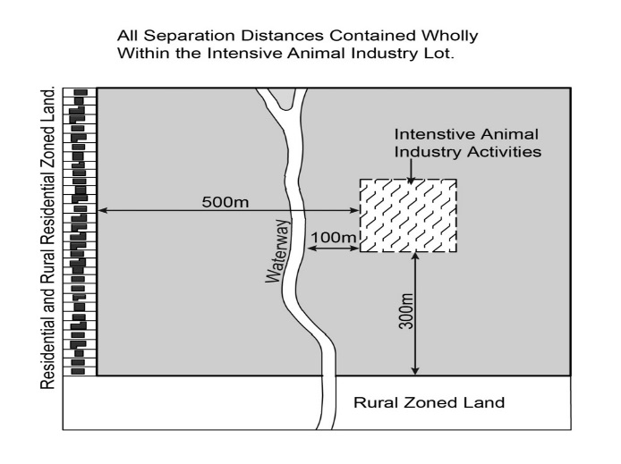  Note - Where a road reserve adjoins an intensive animal industry⁽³⁹⁾, the road reserve shall not form part of the separation distance as identified in diagram above.
Major electricity infrastructure⁽⁴³⁾, Substation⁽⁸⁰⁾ and Utility installation⁽⁸⁶⁾
PO66  The development does not have an adverse impact on the visual amenity of a locality and is:  - high quality design and construction;  - visually integrated with the surrounding area;  - not visually dominant or intrusive;  - located behind the main building line;  - below the level of the predominant tree canopy or the level of the surrounding buildings and structures;  - camouflaged through the use of colours and materials which blend into the landscape;  - treated to eliminate glare and reflectivity;  - landscaped;  - otherwise consistent with the amenity and character of the zone and surrounding area. |  | E66.1  Development is designed to minimise surrounding land use conflicts by ensuring infrastructure, buildings, structures and other equipment:  - are enclosed within buildings or structures;  - are located behind the main building line;  - have a similar height, bulk and scale to the surrounding fabric;  - have horizontal and vertical articulation applied to all exterior walls.
E66.2
A minimum 3m wide strip of dense planting is provided around the outside of the fenced area, between the development and street frontage, side and rear boundaries.
PO67  Infrastructure does not have an impact on pedestrian health and safety. |  | E67  Access control arrangements:  - do not create dead-ends or dark alleyways adjacent to the infrastructure;  - minimise the number and width of crossovers and entry points;  - provide safe vehicular access to the site;  - do not utilise barbed wire or razor wire.
PO68  All activities associated with the development occur within an environment incorporating sufficient controls to ensure the facility generates no audible sound at the site boundaries where in a residential setting. |  | E68  All equipment which produces audible or non-audible sound is housed within a fully enclosed building incorporating sound control measures sufficient to ensure no noise from this equipment can be heard, or felt at the site boundary of a sensitive land use.
Markets ⁽⁴⁶⁾
PO69  Markets⁽⁴⁶⁾ are located and laid out in a manner that provides for:  - convenient pedestrian access and movement between proposed stalls;  - view corridors and legibility between stalls to adjacent roads, directional and information signage and surrounding uses;  - pedestrian comfort and safety, including the provision of public toilet facilities;  - waste and rubbish disposal facilities appropriate to the type and scale of the proposed market⁽⁴⁶⁾;  - emergency vehicle access to and within the market⁽⁴⁶⁾;  - safe, convenient and accessible car parking is provided to meet demand. |  | No example provided.
Nature-based tourism
PO70  Development associated with nature-based tourism⁽⁵⁰⁾:  - is not, or does not act, as a permanent place of residence for persons where a typical period of time does not exceed 3 consecutive months;  - is of a size, scale, intensity and design that minimises the potential for adverse noise, visual, privacy and traffic impacts on adjoining or nearby residents;  - is of a size, scale, intensity and design that is consistent with the low intensity, low -set built form and open area character and amenity anticipated for the Rural zone;  - provides suitable open space, buildings and facilities that meet the recreational, social and amenity needs of people staying on-site;  - provides landscape buffer along adjoining property boundaries to fully screen activities occurring on the site;  - where located within the catchments of Lake Samsonvale or Lake Kurwongbah, nature-based tourism buildings and their associated waste/effluent disposal areas are positioned in a manner which avoids adverse impacts on the water quality of those lakes. |  | No example provided.
Non-resident workforce accommodation ⁽⁵²⁾
PO71  Development associated with non-resident workforce accommodation⁽⁵²⁾:  - provides accommodation for rural workers only and is not advertised or used for the purpose of accommodating general travellers or tourists.  - is not, or does not act, as a permanent place of residence for persons where a typical period of time does not exceed 3 consecutive months;  - is of a size, scale, intensity and design that minimises the potential for adverse noise, visual, privacy and traffic impacts on adjoining or nearby residents;  - is of a size, scale, intensity and design that is consistent with the low intensity, low-set built form and open area character and amenity anticipated for the Rural zone;  - provides suitable open space, buildings and facilities that meet the recreational, social and amenity needs of people staying on-site;  - provides landscape buffer along adjoining property boundaries to fully screen activities occurring on the site;  - where located within the catchments of Lake Samsonvale or Lake Kurwongbah, Non-resident workforce accommodation buildings and their associated waste/effluent disposal areas are positioned in a manner which avoids adverse impacts on the water quality of those lakes. |  | No example provided.
Parking station ⁽⁵⁸⁾
PO72  Parking station⁽⁵⁸⁾:  - is limited to supporting an event occurring on nearby Community facility zoned land;  - achieves a high level of connectivity for pedestrians to the Community facilities zone;  - does not cause nuisance, detract or conflict with the primary role and associated Event Management Plans on land in the nearby Community facility zone, when occurring at the same time as an event occurring on that land;  - limited in size and scale and do not have adverse impacts on the low-set built form, low density, open area character and amenity of the Rural zone;  - vehicle parking and storage areas are to be screened from public view to minimise adverse visual impacts on rural character;  - avoids establishing on land subject to a flooding risk, or where avoidance is not possible, identify measures to be taken mitigate any potential risk to property and life; and  - does not adversely impact on the safe and efficient operation of the external road network. |  | No example provided.
Permanent plantation ⁽⁵⁹⁾
PO73  Planting for permanent plantation⁽⁵⁹⁾ purposes:  - only comprises native species endemic to the area;  - is sufficiently set back from property boundaries to avoid adverse impacts on adjoining properties such as shading, fire risk, health and safety. |  | No example provided.
Roadside stall ⁽⁶⁸⁾
PO74  A roadside stall⁽⁶⁸⁾:  - comprises only one roadside stall⁽⁶⁸⁾ per property;  - only offers goods grown, produced or manufactured on the site;  - is of a size and in a location that will not result in nuisance, or have a significant adverse impact on the amenity, for residents on adjoining and surrounding properties. |  | E74  For a roadside stall⁽⁶⁸⁾:  - no more than one roadside stall⁽⁶⁸⁾ per property;  - goods offered for sale are only goods grown, produced or manufactured on the site;  - the maximum area associated with a roadside stall⁽⁶⁸⁾, including any larger separate items displayed for sale, does not exceed 20m².
PO75  A roadside stall⁽⁶⁸⁾ is designed and located to:  - ensure safe and accessible access, egress and on-site parking;  - ensure safe and efficient functioning of roads. |  | E75  Roadside stall⁽⁶⁸⁾:  - obtains vehicle access from a road classified as an Arterial or Sub-Arterial (see Overlay Map - Road hierarchy);  - provide car parking for 2 vehicles off the road carriage and located on the property;  - is located no closer than 100m from an intersection.
Rural workers' accommodation
PO76  Rural workers accommodation⁽⁷¹⁾:  - provide quarters only for staff employed to work the land for rural purposes;  - is of a size, scale and design not visually dominant, overbearing and inconsistent with detached, low density, open area character and low intensity built form anticipated in the Rural zone;  - is screened and landscaped in a manner so it is not visible from a road;  - is of a size, scale, intensity and design that minimises the potential for adverse noise, visual, privacy and traffic impacts on adjoining or nearby residents  - where located within the catchments of Lake Samsonvale or Lake Kurwongbah, Rural worker's accommodation buildings and their associated waste/effluent disposal areas are positioned in a manner which avoids adverse impacts on the water quality of those lakes. |  | No example provided.
Sales office ⁽⁷²⁾
PO77  Sales office⁽⁷²⁾ remain temporary in duration and demonstrates a relationship to the land or buildings being displayed or sold. |  | E71  A sales office is located on the site for no longer than 2 years.
Short-term accommodation ⁽⁷⁷⁾
PO78  Development associated short-term accommodation⁽⁷⁷⁾:  - is not, or does not act, as a permanent place of residence for persons where a typical period of time does not exceed 3 consecutive months;  - is of a size, scale, intensity and design that minimises the potential for adverse noise, visual, privacy and traffic impacts on adjoining or nearby residents;  - is of a size, scale, intensity and design that is consistent with the low intensity, low -set built form and open area character and amenity anticipated for the Rural zone;  - provides suitable open space, buildings and facilities that meet the recreational, social and amenity needs of people staying on-site;  - provides landscape buffer along adjoining property boundaries to fully screen activities occurring on the site;  - where located within the catchments of Lake Samsonvale or Lake Kurwongbah, short-term accommodation buildings and their associated waste/effluent disposal areas are positioned in a manner which avoids adverse impacts on the water quality of those lakes. |  | No example provided.
Telecommunications facility ⁽⁸¹⁾
Editor's note - In accordance with the Federal legislation Telecommunications facilities⁽⁸¹⁾ must be constructed and operated in a manner that will not cause human exposure to electromagnetic radiation beyond the limits outlined in the Radiocommunications (Electromagnetic Radiation - Human Exposure) Standard 2003 and Radio Protection Standard for Maximum Exposure Levels to Radiofrequency Fields - 3Khz to 300Ghz.

PO79  Telecommunications facilities⁽⁸¹⁾ are co-located with existing telecommunications facilities⁽⁸¹⁾, Utility installation⁽⁸⁶⁾, Major electricity infrastructure⁽⁴³⁾ or Substation⁽⁸⁰⁾ if there is already a facility in the same coverage area. |  | E79.1  New telecommunication facilities are co-located on existing towers with new equipment shelter and associated structures positioned adjacent to the existing shelters and structures.
E79.2
If not co-located with an existing facility, all co-location opportunities have been investigated and fully exhausted within a 2km radius of the site.
PO80  A new Telecommunications facility⁽⁸¹⁾ is designed and constructed to ensure co-masting or co-siting with other carriers both on the tower or pole and at ground level is possible in the future. |  | E80  A minimum area of 45m² is available to allow for additional equipment shelters and associated structures for the purpose of co-locating on the proposed facility.
PO81  Telecommunications facilities⁽⁸¹⁾ do not conflict with lawful existing land uses both on and adjoining the site. |  | E81  The development results in no net reduction in the minimum quantity and standard of landscaping, private or communal open space or car parking spaces required under the planning scheme or under an existing development approval.
PO82  The Telecommunications facility⁽⁸¹⁾ does not have an adverse impact on the visual amenity of a locality and is:  - high quality design and construction;  - visually integrated with the surrounding area;  - not visually dominant or intrusive;  - located behind the main building line;  - below the level of the predominant tree canopy or the level of the surrounding buildings and structures;  - camouflaged through the use of colours and materials which blend into the landscape;  - treated to eliminate glare and reflectivity;  - landscaped;  - otherwise consistent with the amenity and character of the zone and surrounding area. |  | E82.1  Where in an urban area, the development does not protrude more than 5m above the level of the existing treeline, prominent ridgeline or building rooftops in the surrounding townscape.
E82.2
In all other areas towers do not exceed 35m in height.
E82.3
Towers, equipment shelters and associated structures are of a design, colour and material to:
- reduce recognition in the landscape;
- reduce glare and reflectivity.
E82.4
All structures and buildings are setback behind the main building line and a minimum of 10m from side and rear boundaries, except where in the Industry and Extractive industry zones, the minimum side and rear setback is 3m.
Where there is no established building line the facility is located at the rear of the site.
E82.5
The facility is enclosed by security fencing or by other means to ensure public access is prohibited.
E82.6
A minimum 3m wide strip of dense planting is provided around the perimeter of the fenced area, between the facility and street frontage and adjoining uses.
Note - Landscaping is provided in accordance with Planning scheme policy - Integrated design.
Note - Council may require a detailed landscaping plan, prepared by a suitably qualified person, to ensure compliance with Planning scheme policy - Integrated design.

PO83  Lawful access is maintained to the site at all times that does not alter the amenity of the landscape or surrounding uses. |  | E83  An Access and Landscape Plan demonstrates how 24 hour vehicular access will be obtained and maintained to the facility in a manner that is appropriate to the site’s context.
PO84  All activities associated with the development occur within an environment incorporating sufficient controls to ensure the facility generates no audible sound at the site boundaries where in a residential setting. |  | E84  All equipment comprising the Telecommunications facility⁽⁸¹⁾ which produces audible or non-audible sound is housed within a fully enclosed building incorporating sound control measures sufficient to ensure no noise from this equipment can be heard, or felt at the site boundary.
Tourist park ⁽⁸⁴⁾
PO85  Development associated with a tourist park⁽⁸⁴⁾:  - is not, or does not act, as a permanent place of residence for persons where a typical period of time does not exceed 3 consecutive months;  - is of a size, scale, intensity and design that minimises the potential for adverse noise, visual, privacy and traffic impacts on adjoining or nearby residents;  - is of a size, scale, intensity and design that is consistent with the low intensity, low -set built form and open area character and amenity anticipated for the Rural zone;  - provides suitable open space, buildings and facilities that meet the recreational, social and amenity needs of people staying on-site;  - provides landscape buffer along adjoining property boundaries to fully screen activities occurring on the site. |  | No example provided.
Transport depot ⁽⁸⁵⁾
PO86  Development ensures that:  - it does not adversely impact upon the low density, low intensity built form and open area character and amenity for the locality;  - the scale and intensity of the development does not result in adverse visual or nuisance impacts on the residents in adjoining or nearby dwellings, and when viewed from the road;  - vehicular movements are consistent with that reasonably expected in the surrounding low density, low intensity built form and open area character and amenity for the Rural zone. |  | E86.1  Development, including all vehicle parking, drive way areas and storage areas, is set back 30m from all property boundaries.
E86.2
The maximum number of heavy vehicles, trailers and motor vehicles stored on-site is as follows:
- 4 heavy vehicles;
- 4 trailers;
- Up to 6 motor vehicles.
PO87  Development does not include the establishment of vehicle servicing, major repairs, spray painting, panel beating on a site. |  | E87  No vehicle servicing or major repairs, including spray painting or panel beating, is undertaken on the site.
PO88  Development is suitably screened to ensure adverse visual impacts on the residents in adjoining or nearby dwellings are minimised. |  | E88  Vehicle parking areas, vehicle standing areas and outdoor storage areas of plant and equipment are screened from adjoining sites by either planting, wall(s), fence(s) or a combination to at least 1.8m in height along the length of those areas.  Planting for screening is to have a minimum depth of 3m.
PO89  Development gains access to a State Arterial, Arterial or Sub-Arterial road as they are roads of a suitable construction standard to accommodate heavy vehicles. Access to roads of a lesser classification are avoided. |  | E89  The site obtains vehicle access from a road classified as a State Arterial, Arterial or Sub-Arterial (see Overlay Map - Road hierarchy).
Veterinary service ⁽⁸⁷⁾
PO90  Development for veterinary services⁽⁸⁷⁾:  - are for veterinary care, surgery, treatment and overnight stay of animals only;  - are of a size, scale and design not visually dominant, overbearing and inconsistent with detached, low density, open area character and low intensity built form anticipated in the Rural zone;  - are landscaped, fenced and screened in a manner to reduce the visual appearance of buildings, structures, storage and parking areas;  - has vehicle access from a road classified as a State Arterial, Arterial or Sub-Arterial (see Overlay map - Road hierarchy). |  | No example provided.
Winery ⁽⁹⁰⁾
PO91  Development associated with a winery⁽⁹⁰⁾:  - is for winery⁽⁹⁰⁾ and ancillary activities only;  - is of a size, scale and design not visually dominant, overbearing and inconsistent with detached, low density, open area character and low intensity built form anticipated in the Rural zone  - is landscaped, fenced and screened in a manner to minimise the visual appearance of buildings, structures, storage and parking areas;  - has vehicle access from a road classified as a State Arterial, Arterial or Sub-Arterial (see Overlay map - Road hierarchy). |  | No example provided.
Precinct specific criteria
Woodfordia and abbey surrounds precinct
PO92  When occurring during events occurring on nearby Community facility zoned land, development:  - is limited to activities that have a nexus with, and support an event occurring on nearby Community facility zoned land. Activities include, but not limited to: temporary camping facilities, accommodation facilities, walking tracks and trails, recreational activities, eco-tourism and agri-tourism;  - achieves a high level of connectivity for pedestrians to the Community facility zone to minimise the need for private vehicle trips and reduce demand on local transport infrastructure;  - does not cause nuisance, detract or conflict with the primary role and associated Event Management Plans on land in the nearby Community facility zone, when occurring at the same time as an event occurring on that land. Such issues include, but are not limited to, noise, waste generation and disposal, traffic generation, location of and to sensitive land uses;  - activities are limited in size and scale and do not have adverse impacts on the low-set built form, low density, open area character and amenity of the Rural zone, including considerations to the impact of noise, traffic, and on-site waste disposal;  - avoids establishing on land subject to a flooding risk, or where avoidance is not possible, identify measures to be taken mitigate any potential risk to property and life;  - does not adversely impact on the safe and efficient operation of the external road network. | No example provided.
PO93  When occurring outside of events occurring on nearby Community facility zoned land, development:  - is to be used for rural primary production purposes;  OR  - is for small scale tourism activities only comprising eco-based tourism, agricultural based education and recreation activities that:  - do not cause nuisance, detract or conflict with the primary role and associated Event Management Plans on land in the nearby Community facility zone, when occurring at the same time as an event occurring on that land. Such issues include, but are not limited to, noise, waste generation and disposal, traffic generation, location of and to sensitive land uses;  - are limited in size and scale and do not have adverse impacts on the low-set built form, low density, open area character and amenity of the Rural zone, including considerations to the impact of noise, traffic, and on-site waste disposal;  - avoids locating in area of high quality cropping⁽¹⁹⁾ land as identified in the Agriculture Precinct;  - avoids establishing on land subject to a flooding risk, or where avoidance is not possible, identify measures to be taken mitigate any potential risk to property and life;  - do degrade or compromise the visual, natural, biological and ecological values associated with vegetated areas or adversely impact upon water quality;  - does not adversely impact on the safe and efficient operation of the external road network. | No example provided.
Agriculture precinct
PO94  Development does not compromise the future primary productive capacity and characteristics of the highly productive land resource. | No example provided.
PO95  Development that does not require access to, or rely on the use of, fertile soils is not located in the Agricultural precinct. | No example provided.
PO96  Development ensures that buildings, driveways, hardstand, storage and vehicle parking areas are located in a manner or position to minimise the loss of the land resource and maximise the availability of the land resource for primary production. | No example provided.
PO97  Development does not result in the cessation or closure of primary production activities occurring on the same site. | No example provided.
Cedarton Foresters Cooperative and Mt Nebo plant nursery precinct
PO98  Development in accordance with the Land Management Plan and supporting documentation located in Table A - Cedarton Forester's Cooperative - Land Management Plan or Table B - Mt Nebo Plant Nursery - Land Management Plan. | No example provided.
Rural living investigation precinct
PO99  Development does not:  - result in the cessation or closure of primary production activities occurring on the same site;  - result in the fragmentation and isolation of land thereby affecting its potential long term viability or ability for future rural living development;  - result in the disorderly and piecemeal provision of services and infrastructure;  - hinder the long term viability and technical ability of the land to be developed and serviced for future rural living development. | No example provided

Values and constraints criteria
Note - The relevant values and constraints criteria do not apply where the development is consistent with a current Development permit for Reconfiguring a lot or Material change of use or Operational work, where that approval has considered and addressed (e.g. through a development footprint plan (or similar in the case of Landslide hazard) or conditions of approval) the identified value or constraint under this planning scheme.

Acid sulfate soils - (refer Overlay map - Acid sulfate soils to determine if the following assessment criteria apply)
Note - To demonstrate achievement of the performance outcome, an Acid sulfate soils (ASS) investigation report and soil management plan is prepared by a qualified engineer. Guidance for the preparation an ASS investigation report and soil management plan is provided in Planning scheme policy - Acid sulfate soils.

PO100  Development avoids disturbing acid sulfate soils. Where development disturbs acid sulfate soils, development:  - is managed to avoid or minimise the release of surface or groundwater flows containing acid and metal contaminants into the environment;  - protects the environmental and ecological values and health of receiving waters;  - protects buildings and infrastructure from the effects of acid sulfate soils. | E100  Development does not involve:  - excavation or otherwise removing of more than 100m³ of soil or sediment where below than 5m Australian Height datum AHD; or  - filling of land of more than 500m³ of material with an average depth of 0.5m or greater where below the 5m Australian Height datum AHD.
Bushfire hazard (refer Overlay map - Bushfire hazard to determine if the following assessment criteria apply)
Note - To demonstrate achievement of the performance outcomes, a bushfire management plan is prepared by a suitably qualified person. Guidance for the preparation of a bushfire management plan is provided in Planning scheme policy – Bushfire prone areas.
Note - Unacceptable risk is defined as a situation where people or property are exposed to a predictable hazard event that may result in serious injury, loss of life, failure of community infrastructure, or property damage.

PO101  Development:  - minimises the number of buildings and people working and living on a site exposed to bushfire risk;  - ensures the protection of life during the passage of a fire front;  - is located and designed to increase the chance of survival of buildings and structures during a bushfire;  - minimises bushfire risk from build up of fuels around buildings and structures;  - ensure safe and effective access for emergency services during a bushfire. | E101.1  Buildings and structures are:  - not located on a ridgeline;  - not located on land with a slope greater than 15% (see Overlay map - Landslide hazard);  - dwellings are located on east to south facing slopes.
E101.2
Buildings and structures have contained within the site:
- a separation from classified vegetation of 20m or the distance required to achieve a bushfire attack level (BAL) at the building, roofed structure or fire fighting water supply of no more than 29, whichever is the greater;
- a separation from low threat vegetation of 10m or the distance required to achieve a bushfire attack level (BAL) at the building, roofed structure or fire fighting water supply of no more than 29, whichever is the greater;
- a separation of no less than 10m between a fire fighting water supply extraction point and any classified vegetation, buildings and other roofed structures;
- an area suitable for a standard fire fighting appliance to stand within 3m of a fire fighting water supply extraction point; and
- an access path suitable for use by a standard fire fighting appliance having a formed width of at least 4m, a cross-fall of no greater than 5%, and a longitudinal gradient of no greater than 25%:
  - to, and around, each building and other roofed structure; and
  - to each fire fighting water supply extraction point.
Note - The meaning of the terms classified vegetation and low threat vegetation as well as the method of calculating the bushfire attack level are as described in Australian Standard AS 3959

PO102  Development and associated driveways and access ways:  - avoid potential for entrapment during a bushfire;  - ensure safe and effective access for emergency services during a bushfire;  - enable safe evacuation for occupants of a site during a bushfire. | E102  A length of driveway:  - to a road does not exceed 100m between the most distant part of a building used for any purpose other than storage and the nearest part of a public road;  - has a maximum gradient no greater than 12.5%;  - have a minimum width of 3.5m;  - accommodate turning areas for fire fighting appliances in accordance with Qld Fire and Emergency Services' Fire Hydrant and Vehicle Access Guideline.
PO103  Development provides an adequate water supply for fire-fighting purposes. | E103  - a reticulated water supply is provided by a distributer retailer for the area or;  - where not connected to a reticulated water supply, on-site fire fighting water storage containing not less than 10 000 litres (tanks with fire brigade tank fittings, swimming pools) is located within 10m of buildings and structures.  - Where a swimming pool is the nominated on-site fire fighting water storage source, vehicle access is provided to within 3m of that water storage source.  - Where a tank is the nominated on-site fire fighting water storage source, it includes:  - a hardstand area allowing medium rigid vehicles (15 tonne fire appliance) access within 6m of the tank;  - fire brigade tank fittings, comprising 50mm ball valve and male camlock coupling and, if underground, an access hole of 200mm (minimum) to accommodate suction lines.
PO104  Development:  - does not present unacceptable risk to people or environment due to the impact of bushfire on dangerous goods or combustible liquids;  - does not present danger or difficulty to emergency services for emergency response or evacuation.  Editor's note - Unacceptable risk is defined as a situation where people or property are exposed to a predictable hazard event that may result in serious injury, loss of life, failure of community infrastructure, or property damage. | E104  Development does not involve the manufacture or storage of hazardous chemicals.
Environmental areas (refer Overlay map - Environmental areas to determine if the following assessment criteria apply)
Note – The following are excluded from the native vegetation clearing provisions of this planning scheme:
- Clearing of native vegetation located within an approved development footprint;
- Clearing of native vegetation within 10m from a lawfully established building reasonably necessary for emergency access or immediately required in response to an accident or emergency;
- Clearing of native vegetation reasonably necessary to remove or reduce the risk vegetation poses to serious personal injury or damage to infrastructure;
- Clearing of native vegetation reasonably necessary to construct and maintain a property boundary fence and not exceed 4m in width either side of the fence where in the Rural, Rural residential and Environmental Management and Conservation zones. In any other zone, clearing is not to exceed 2m in width either side of the fence;
- Clearing of native vegetation reasonably necessary for the purpose of maintenance or works within a registered easement for public infrastructure or drainage purposes;
- Clearing of native vegetation in accordance with a bushfire management plan prepared by a suitably qualified person, submitted to and accepted by Council;
- Clearing of native vegetation associated with removal of recognised weed species, maintaining existing open pastures and cropping land, windbreaks, lawns or created gardens;
- Grazing of native pasture by stock;
- Native forest practice where accepted development under Part 1, 1.7.7 Accepted development
Note - Definition for native vegetation is located in Schedule 1 Definitions.

Note - Native vegetation subject to this criteria primarily comprises of matters of national environmental significance (MNES), matters of state environmental significance (MSES). They also comprise some matters of local environmental significance (MLES). A MLES is defined in Schedule 1.2, Administrative definitions. A list of the elements that apply to the mapped MSES and MLES is provided in Appendix 1 of the Planning scheme policy - Environmental areas.
Editors' Note - The accuracy of overlay mapping can be challenged through the development application process (code assessable development) or by way of a planning scheme amendment. See Council's website for details.

Note - To demonstrate achievement of the performance outcome, an ecological assessment, vegetation management plan and fauna management plan, as required, are prepared by a suitably qualified person. Guidance for the preparation of above mentioned reports is provided in Planning scheme policy - Environmental areas.

Vegetation clearing, ecological value and connectivity
PO105  Development avoids locating in a High Value Area or a Value Offset Area. Where it is not practicable or reasonable for development to avoid establishing in these areas, development must ensure that:  - the quality and integrity of the biodiversity and ecological values inherent to a High Value Area and a Value Offset Area is maintained and not lost or degraded;  - on-site mitigation measures, mechanisms or processes are in place demonstrating the quality and integrity of the biodiversity and ecological values inherent to a High Value Area and a Value Offset Area are maintained. For example, this can be achieved through replacement, restoration or rehabilitation planting as part of any proposed covenant, the development of a Vegetation Management Plan, a Fauna Management Plan, and any other on-site mitigation options identified in the Planning scheme policy - Environmental areas*.  * Editor's note - This is not a requirement for an environmental offset under the Environmental Offsets Act 2014. | No example provided.
PO106  Development provides for safe, unimpeded, convenient and ongoing wildlife movement and establishes and maintains habitat connectivity by:  - retaining habitat trees;  - providing contiguous patches of habitat;  - provide replacement and rehabilitation planting to improve connectivity;  - avoiding the creation of fragmented and isolated patches of habitat;  - providing wildlife movement infrastructure.  Editor's note - Wildlife movement infrastructure may include refuge poles, tree boulevarding, ‘stepping stone’ vegetation plantings, tunnels, appropriate wildlife fencing; culverts with ledges, underpasses, overpasses, land bridges and rope bridges. Further information is provided in Planning scheme policy – Environmental areas. | No example provided.
Vegetation clearing and habitat protection
PO107  Development ensures that the biodiversity quality and integrity of habitats is not adversely impacted upon but maintained and protected. | No example provided.
PO108  Development does not result in the net loss or degradation of habitat value in a High Value Area or a Value Offset Area. Where development does result in the loss or degradation of habitat value, development will:  - rehabilitate, revegetate, restore and enhance an area to ensure it continues to function as a viable and healthy habitat area;  - provide replacement fauna nesting boxes in the event of habitat tree loss in accordance with Planning scheme policy - Environmental areas;  - undertake rehabilitation, revegetation and restoration in accordance with the South East Queensland Ecological Restoration Framework. | No example provided.
PO109  Development ensures safe, unimpeded, convenient and ongoing wildlife movement and habitat connectivity by:  - providing contiguous patches of habitat;  - avoiding the creation of fragmented and isolated patches of habitat;  - providing wildlife movement infrastructure;  - providing replacement and rehabilitation planting to improve connectivity. | No example provided.
Vegetation clearing and soil resource stability
PO110  Development does not:  - result in soil erosion or land degradation;  - leave cleared land exposed for an unreasonable period of time but is rehabilitated in a timely manner. | No example provided.
Vegetation clearing and water quality
PO111  Development maintains or improves the quality of groundwater and surface water within, and downstream, of a site by:  - ensuring an effective vegetated buffers and setbacks from waterbodies is retained to achieve natural filtration and reduce sediment loads;  - avoiding or minimising changes to landforms to maintain hydrological water flows;  - adopting suitable measures to exclude livestock from entering a waterbody where a site is being used for animal husbandry⁽⁴⁾ and animal keeping⁽⁵⁾ activities. | No example provided.
PO112  Development minimises adverse impacts of stormwater run-off on water quality by:  - minimising flow velocity to reduce erosion;  - minimising hard surface areas;  - maximising the use of permeable surfaces;  - incorporating sediment retention devices;  - minimising channelled flow. | No example provided.
Vegetation clearing and access, edge effects and urban heat island effects
PO113  Development retains safe and convenient public access in a manner that does not result in the adverse edge effects or the loss or degradation of biodiversity values within the environment. | No example provided.
PO114  Development minimises potential adverse ‘edge effects’ on ecological values by:  - providing dense planting buffers of native vegetation between a development and environmental areas;  - retaining patches of native vegetation of greatest possible size where located between a development and environmental areas ;  - restoring, rehabilitating and increasing the size of existing patches of native vegetation;  - ensuring that buildings and access (public and vehicle) are setback as far as possible from environmental areas and corridors;  - landscaping with native plants of local origin.  Editor's note - Edge effects are factors of development that go to detrimentally affecting the composition and density of natural populations at the fringe of natural areas. Factors include weed invasion, pets, public and vehicle access, nutrient loads, noise and light pollution, increased fire frequency and changes in the groundwater and surface water flow. | No example provided.
PO115  Development avoids adverse microclimate change and does not result in increased urban heat island effects. Adverse urban heat island effects are minimised by:  - pervious surfaces;  - providing deeply planted vegetation buffers and green linkage opportunities;  - landscaping with local native plant species to achieve well-shaded urban places;  - increasing the service extent of the urban forest canopy. | No example provided.
Vegetation clearing and Matters of Local Environmental Significance (MLES) environmental offsets
PO116  Where development results in the unavoidable loss of native vegetation within a Value Offset Area MLES waterway buffer or a Value Offset Area MLES wetland buffer, an environmental offset is required in accordance with the environmental offset requirements identified in Planning scheme policy - Environmental areas.  Editor's note - For MSES Koala Offsets, the environmental offset provisions in schedule 11 of the Regulation, in combination with the requirements of the Environmental Offset Act 2014, apply. | No example provided.
Extractive resources separation area (refer Overlay map - Extractive resources (separation area) to determine if the following assessment criteria apply)
Note - To demonstrate achievement of the performance outcomes, a noise impact assessment report is prepared by a suitably qualified person. Guidance to preparing noise impact assessment report is provided in Planning scheme policy – Noise.

PO117  Development does not increase the number of people living in the Extractive Resources separation area. | E117  One dwelling house⁽²²⁾ permitted per lot within separation area.
PO118  Development:  - does not introduce or increase uses that are sensitive to the impacts of an Extractive industry⁽²⁷⁾;  - is compatible with the operation of an Extractive industry⁽²⁷⁾;  - does not comprise or undermine the function and integrity of the separation area in providing a buffer between key extractive and processing activities and sensitive, incompatible uses outside the separation area. | E118  Development within the separation area does not include the following activities:  - Caretaker's accommodation⁽¹⁰⁾;  - Community residence⁽¹⁶⁾;  - Dual occupancy⁽²¹⁾;  - Dwelling unit⁽²³⁾;  - Hospital⁽³⁶⁾;  - Rooming accommodation⁽⁶⁹⁾;  - Multiple dwelling⁽⁴⁹⁾;  - Non-resident workforce accommodation⁽⁵²⁾;  - Relocatable home park⁽⁶²⁾;  - Residential care facility⁽⁶⁵⁾;  - Resort complex⁽⁶⁶⁾;  - Retirement facility⁽⁶⁷⁾;  - Rural workers’ accommodation⁽⁷¹⁾;  - Short-term accommodation⁽⁷⁷⁾;  - Tourist park⁽⁸⁴⁾.
PO119  Habitable rooms achieve the noise levels listed in Schedule 1 Acoustic Quality Objectives, Environmental Protection (Noise) Policy 2008 and provides a safe, healthy and disturbance free living environment. | E119  All habitable rooms within the separation area are:  - acoustically insulated to achieve the noise levels listed in Schedule 1 Acoustic Quality Objectives, Environmental Protection (Noise) Policy 2008;  - provided with mechanical ventilation.
PO120  Development provides open space areas for passive recreation in a manner where impacts from key extractive/processing activities, particularly noise, is minimised. | E120  Private open space areas are separated from the resource processing area by buildings or a 1.8m high solid structure.
Extractive resources transport routes (refer Overlay map - Extractive resources (transport route and buffer) to determine if the following assessment criteria apply)
PO121  Development:  - does not increase in the number of people living in close proximity to a transport route and being subject to the adverse effects from the transportation route;  - does not result in the establishment of uses that are incompatible with the operation of Extractive resources transport routes;  - adopts design and location measures to satisfactorily mitigate the potential adverse impacts associated with transportation routes on sensitive land uses. Such measures include, but are not limited to:  - locating the furthest distance possible from the transportation route;  - habitable rooms being located the furthest from the transportation route;  - shielding and screening private outdoor recreation space from the transportation routes. | E121  The following uses are not located within the 100m wide transport route buffer:  - Caretaker’s accommodation⁽¹⁰⁾, except where located in the Extractive industry zone;  - Community residence⁽¹⁶⁾;  - Dual occupancy⁽²¹⁾;  - Dwelling house⁽²²⁾;  - Dwelling unit⁽²³⁾;  - Hospital⁽³⁶⁾;  - Rooming accommodation⁽⁶⁹⁾;  - Multiple dwelling⁽⁴⁹⁾;  - Non-resident workforce accommodation⁽⁵²⁾;  - Relocatable home park⁽⁶²⁾;  - Residential care facility⁽⁶⁵⁾;  - Resort complex⁽⁶⁶⁾;  - Retirement facility⁽⁶⁷⁾;  - Rural workers’ accommodation⁽⁷¹⁾;  - Short-term accommodation⁽⁷⁷⁾;  - Tourist park⁽⁸⁴⁾.
PO122  Development:  - does not adversely impact upon the efficient and effective transportation of extractive material along a transportation route;  - ensures vehicle access and egress along transportation routes are designed and located to achieve a high degree of safety, having good visibility;  - utilises existing vehicle access points and where existing vehicle access points are sub-standard or poorly formed, they are upgraded to an appropriate standard. | E122.1  Development does not create a new vehicle access point onto an Extractive resources transport route.
E122.2
A vehicle access point is located, designed and constructed in accordance with Planning scheme policy - Integrated design.
Heritage and landscape character (refer Overlay map - Heritage and landscape character to determine if the following assessment criteria apply)
Note - Places, including sites, objects and buildings having local cultural heritage significance, are identified on Overlay map - Heritage and landscape character and listed in Schedule 1 of Planning scheme policy - Heritage and landscape character. Places also having cultural heritage significance at a State level and being entered in the Queensland Heritage Register, are also identified in Schedule 1 of Planning scheme policy - Heritage and landscape character.

PO123  Development will:  - not diminish or cause irreversible damage to the cultural heritage values present on the site, and associated with a heritage site, object or building;  - protect the fabric and setting of the heritage site, object or building;  - be consistent with the form, scale and style of the heritage site, object or building;  - utilise similar materials to those existing, or where this is not reasonable or practicable, neutral materials and finishes;  - incorporate complementary elements, detailing and ornamentation to those present on the heritage site, object or building;  - retain public access where this is currently provided. | E123  Development is for the preservation, maintenance, repair and restoration of a site, object or building of cultural heritage value.  Note - A cultural heritage conservation management plan for the preservation, maintenance, repair and restoration of a site, object or building of cultural heritage value is prepared in accordance with Planning scheme policy - Heritage and landscape character. The plan is sent to, and approved by Council prior to the commencement of any preservation, maintenance, repair and restoration works.
PO124  Demolition and removal is only considered where:  - a report prepared by a suitably qualified conservation architect or conservation engineer demonstrates that the building is structurally unsound and is not reasonably capable of economic repair; or  - demolition is confined to the removal of outbuildings, extensions and alterations that are not part of the original structure; or  - limited demolition is performed in the course of repairs, maintenance or restoration; or  - demolition is performed following a catastrophic event which substantially destroys the building or object. | No example provided.
PO125  Where development is occurring on land adjoining a site of cultural heritage value, the development is to be sympathetic to and consistent with the cultural heritage values present on the site and not result in their values being eroded, degraded or unreasonably obscured from public view. | No example provided.
PO126  Development does not adversely impact upon the health and vitality of significant trees. Where development occurs in proximity to a significant tree, construction measures and techniques as detailed in AS 4970-2009 Protection of trees on development sites are adopted to ensure a significant tree's health, wellbeing and vitality.  Significant trees are only removed where they are in a poor state of health or where they pose a health and safety risk to persons or property. A Tree Assessment report prepared by a suitably qualified arborist confirming a tree's state of health is required to demonstrate achievement of this performance outcome. | E126  Development does:  - not result in the removal of a significant tree;  - not occur within 20m of a protected tree;  - involve pruning of a tree in accordance with Australian Standard AS 4373-2007 – Pruning of Amenity Trees.

Landslide hazard (refer Overlay map - Landslide hazard to determine if the following assessment criteria apply)
Note - To demonstrate achievement of the performance outcomes, a site-specific geotechnical assessment report is prepared by a qualified engineer. Guidance for the preparation of a geotechnical assessment report is provided in Planning scheme policy – Landslide hazard.

PO127  Development:  - maintains the safety of people and property on a site and neighbouring sites from landslides;  - ensures the long-term stability of the site considering the full nature and end use of the development;  - ensures site stability during all phases of construction and development;  - minimises disturbance of natural drainage patterns of the site and does not result in the redirection or alteration of the existing flow if surface or groundwater  - minimises adverse visual impacts on the amenity of adjoining residents and provides a positive interface with the streetscape. | E127  Development does not:  - involve earthworks exceeding 50m³;  - involve cut and fill having a height greater than 600mm;  - involve any retaining wall having a height greater than 600mm;  - redirect or alter the existing flow of surface or groundwater.
PO128  Buildings are designed to respond to sloping topography in the siting, design and form of buildings and structures by:  - minimising overuse of cut and fill to create single flat pads and benching;  - avoiding expanses of retaining walls, loss of trees and vegetation and interference with natural drainage systems;  - minimising any adverse visual impact on the landscape character ;  - Protect the amenity of adjoining properties. | E128  Buildings, excluding domestic outbuildings:  - are split-level, multiple-slab, pier or pole construction;  - are not single plane slab on ground.
PO129  Development protects the safety of people, property and the environment from the impacts of landslide on hazardous chemicals manufactured, handled or stored by incorporating design measures to ensure:  - the long-term stability of the development site considering the full nature and end use of the development;  - site stability during all phases of construction and development;  - the development is not adversely affected by landslide activity originating on sloping land above the site;  - emergency access and access from the site for the public and emergency vehicles is available and is not at risk from landslide. | E129  Development does not involve the manufacture, handling or storage of hazardous chemicals.
Infrastructure buffers (refer Overlay map - Infrastructure buffers to determine if the following assessment criteria apply)
PO130  Odour sensitive development is separated from Wastewater treatment plants so they are not adversely affected by odour emission or other air pollutant impacts. | E130  The following uses are not located within a wastewater treatment site buffer:  - Caretaker’s accommodation⁽¹⁰⁾;  - Community residence⁽¹⁶⁾;  - Dual occupancy⁽²¹⁾;  - Dwelling house⁽²²⁾  - Dwelling unit⁽²³⁾;  - Hospital⁽³⁶⁾;  - Rooming accommodation⁽⁶⁹⁾;  - Multiple dwelling⁽⁴⁹⁾;  - Non-resident workforce accommodation⁽⁵²⁾;  - Relocatable home park⁽⁶²⁾;  - Residential care facility⁽⁶⁵⁾;  - Resort complex⁽⁶⁶⁾;  - Retirement facility⁽⁶⁷⁾;  - Rural workers’ accommodation⁽⁷¹⁾;  - Short-term accommodation⁽⁷⁷⁾;  - Tourist park⁽⁸⁴⁾.
PO131  Development within a Water supply buffer captures solid or liquid waste from all land use, development and activities is designed, constructed and managed to prevent the release of contaminants to surface water or groundwater bodies. | E131.1  Run-off and sediment from roadways and impervious surfaces within a Water supply buffer are intercepted and treated on-site to remove oil, grease, chemicals, silt, trace metals and nutrients such as nitrogen and phosphorous.
E131.2
Incineration or burial of waste within a Water supply buffer is not undertaken onsite.
E131.3
Solid waste within a Water supply buffer is collected and stored in weather proof, sealed waste receptacles, located in roofed and bunded areas, for disposal by a licenced contractor.
E131.4
Holding tanks within a Water supply buffer are used for all liquid waste and provide for the separation of oils/solvents and solids prior to pump-out and collection by a licenced contractor.
E131.5
Management, handling and storage of hazardous chemicals (including fuelling of vehicles) within a Water supply buffer, is undertaken in secured, climate controlled, weather proof, level and bunded enclosures.
PO132  On-site sewerage systems within a Water supply buffer are designed and operated to ensure there is no worsening or adverse impacts to health risks, environmental risks and water quality.  Editor's Note - For guidance refer to the Seq water Development Guidelines: Development Guidelines for Water Quality Management in Drinking Water Catchments 2012. | E132  Secondary treated wastewater treatment systems within a Water supply buffer include:  - emergency storage capable of holding 3-6 hours peak flow of treated effluent in the event of emergencies or overload with provision for de-sludging;  - back up pump installation and backup power;  - MEDLI modelling to determine irrigation rates and sizing of irrigation areas;  - vegetated land application areas are not located in overland flow paths or on areas that perform groundwater recharge or discharge functions; and  - wastewater collection and storage systems have a capacity to accommodate full load at peak times and includes temporary facilities.
PO133  Development within a Bulk water supply infrastructure buffer is located, designed and constructed to:  - protect the integrity of the water supply pipeline;  - maintain adequate access for any required maintenance or upgrading work to the water supply pipeline; | E133  Development:  - does not involve the construction of any buildings or structures within a Bulk water supply infrastructure buffer;  - involving a major hazard facility or environmentally relevant activity (ERA) is setback 30m from a Bulk water supply infrastructure buffer.
PO134  Development is located and designed to maintain required access to Bulk water supply infrastructure. | E134  Development does not restrict access to Bulk water supply infrastructure of any type or size, having regard to (among other things):  - buildings or structures;  - gates and fences;  - storage of equipment or materials;  - landscaping or earthworks or stormwater or other infrastructure.
PO135  Development within the Gas pipeline buffer:  - avoids attracting people in large numbers to live, work or congregate;  - avoids the storage of hazardous chemicals;  - maintains adequate access for any required maintenance or upgrading work;  - minimises risk of harm to people and property.  Editor's note - The Petroleum and Gas (Production and Safety) Act 2004 (sections 807 and 808) requires that building or changes in surface level on pipeline land must not occur unless all the pipeline licence holders consent. | E135  Development does not involve the construction of any buildings or structures within the Gas pipeline buffer.  Editor's note - The Petroleum and Gas (Production and Safety) Act 2004 (sections 807 and 808) requires that building or changes in surface level on pipeline land must not occur unless all the pipeline licence holders consent.
PO136  Habitable rooms within an Electricity supply substation buffer are located a sufficient distance from substations⁽⁸⁰⁾ to avoid any potential adverse impacts on personal health and wellbeing from electromagnetic fields.  Note - Habitable room is defined in the Building Code of Australia (Volume 1) | E136  Habitable rooms:  - are not located within an Electricity supply substation buffer; and  - proposed on a site subject to an Electricity supply supply substation⁽⁸⁰⁾are acoustically insulted to achieve the noise levels listed in Schedule 1, Acoustic Quality Objectives, Environmental Protection (Noise) Policy 2008.  Note - Habitable room is defined in the Building Code of Australia (Volume 1)
PO137  Habitable rooms within an Electricity supply substation buffer are acoustically insulated from the noise of a substation⁽⁸⁰⁾ to achieve the noise levels listed in Schedule 1 Acoustic Quality Objectives, Environmental Protection (Noise) Policy 2008 and provides a safe, healthy and disturbance free living environment.  Note - To demonstrate achievement of the performance outcome, a noise impact assessment report is prepared by a suitably qualified person. Guidance to preparing an noise impact assessment report is provided in Planning scheme policy – Noise.  Note - Habitable room is defined in the Building Code of Australia (Volume 1) | No example provided.
PO138  Development within a High voltage electricity line buffer provides adequate buffers to high voltage electricity lines to protect amenity and health by ensuring development:  - is located and designed to avoid any potential adverse impacts on personal health and wellbeing from electromagnetic fields in accordance with the principle of prudent avoidance;  - is located and designed in a manner that maintains a high level of security of supply;  - is located and design so not to impede upon the functioning and maintenance of high voltage electrical infrastructure. | E138  Development does not involve the construction of any buildings or structures within a High voltage electricity line buffer.
PO139  Development within a Pumping station buffer is located, designed and constructed to:  - ensure that odour or other air pollutant impacts on the amenity of the development met the air quality of objectives in the Environmental Protection (Air) Policy 2008;  - ensure that noise impacts on the amenity of the development met the indoor noise objectives set out in the Environmental Protection (Noise) Policy 2008. | E139  Development does not involve the construction of any buildings or structures within a Pumping station buffer.
Overland flow path (refer Overlay map - Overland flow path to determine if the following assessment criteria apply)
Note - The applicable river and creek flood planning levels associated with defined flood event (DFE) within the inundation area can be obtained by requesting a flood check property report from Council.

PO140  Development:  - minimises the risk to persons from overland flow;  - does not increase the potential for damage from overland flow either on the premises or other premises, public land, watercourses, roads or infrastructure. | No example provided.
PO141  Development:  - maintains the conveyance of overland flow predominantly unimpeded through the premises for any event up to and including the 1% AEP for the fully developed upstream catchment;  - does not concentrate, intensify or divert overland flow onto an upstream, downstream or surrounding property.  Note - A report from a suitably qualified Registered Professional Engineer Queensland is required certifying that the development does not increase the potential for significant adverse impacts on an upstream, downstream or surrounding premises.  Note - Reporting to be prepared in accordance with Planning scheme policy – Flood hazard, Coastal hazard and Overland flow. | No example provided.
PO142  Development does not:  - directly, indirectly or cumulatively cause any increase in overland flow velocity or level;  - increase the potential for flood damage from overland flow either on the premises or other premises, public lands, watercourses, roads or infrastructure.  Note - Open concrete drains greater than 1m in width are not an acceptable outcome, nor are any other design options that may increase scouring. | No example provided.
PO143  Development ensures that public safety and the risk to the environment are not adversely affected by a detrimental impact of overland flow on a hazardous chemical located or stored on the premises. | E143  Development ensures that a hazardous chemical is not located or stored in an Overland flow path area.  Note - Refer to the Work Health and Safety Act 2011 and associated Regulation and Guidelines, the Environmental Protection Act 1994 and the relevant building assessment provisions under the Building Act 1975 for requirements related to the manufacture and storage of hazardous substances.
PO144  Development which is not in a Rural zone ensures that overland flow is not conveyed from a road or public open space onto a private lot. | E144  Development which is not in a Rural zone that an overland flow paths and drainage infrastructure is provided to convey overland flow from a road or public open space area away from a private lot.
PO145  Development ensures that inter-allotment drainage infrastructure, overland flow paths and open drains through private property cater for overland flows for a fully developed upstream catchment and are able to be easily maintained.  Note - A report from a suitably qualified Registered Professional Engineer Queensland is required certifying that the development does not increase the potential for significant adverse impacts on an upstream, downstream or surrounding premises.  Note - Reporting to be prepared in accordance with Planning scheme policy – Flood hazard, Coastal hazard and Overland flow | E145.1  Development ensures that roof and allotment drainage infrastructure is provided in accordance with the following relevant level as identified in QUDM:  - Urban area – Level III;  - Rural area – N/A;  - Industrial area – Level V;  - Commercial area – Level V.
PO145.2
Development ensures that inter-allotment drainage infrastructure is designed to accommodate any event up to and including the 1% AEP for the fully developed upstream catchment.
PO146  Development protects the conveyance of overland flow such that an easement for drainage purposes is provided over:  - a stormwater pipe if the nominal pipe diameter exceeds 300mm;  - an overland flow path where it crosses more than one premises;  - inter-allotment drainage infrastructure.  Note - Refer to Planning scheme policy - Integrated design for details and examples.  Note - Stormwater Drainage easement dimensions are provided in accordance with Section 3.8.5 of QUDM. | No example provided.
Additional criteria for development for a Park⁽⁵⁷⁾
PO147  Development for a Park⁽⁵⁷⁾ ensures that the design and layout responds to the nature of the overland flow affecting the premises such that:  - public benefit and enjoyment is maximised;  - impacts on the asset life and integrity of park structures is minimised;  - maintenance and replacement costs are minimised. | PO147  Development for a Park⁽⁵⁷⁾ ensures works are provided in accordance with the requirements set out in Appendix B of the Planning scheme policy - Integrated design.
Riparian and wetland setbacks
PO148  Development provides and maintains a suitable setback from waterways and wetlands that protects natural and environmental values. This is achieved by recognising and responding to the following matters:  - impact on fauna habitats;  - impact on wildlife corridors and connectivity;  - impact on stream integrity;  - impact of opportunities for revegetation and rehabilitation planting;  - edge effects. | E148  Development does not occur within:  - 50m from top of bank for W1 waterway and drainage line  - 30m from top of bank for W2 waterway and drainage line  - 20m from top of bank for W3 waterway and drainage line  - 100m from the edge of a Ramsar wetland, 50m from all other wetlands.  Note - W1, W2 and W3 waterway and drainage lines, and wetlands are mapped on Schedule 2, Section 2.5 Overlay Maps – Riparian and wetland setbacks.
Scenic amenity - Regionally significant (Hills) and Locally important (Coast) (refer Overlay map - Scenic amenity to determine if the following assessment criteria apply)
Note - In the Rural zone, netting, shade cloth and similar coverings associated with agricultural operations are exempt.

PO149  Development:  - avoids being viewed as a visually conspicuous built form on a hill top or ridgeline;  - retain the natural character or bushland settings as the dominant landscape characteristic;  - is viewed as being visually consistent with the natural landscape setting and does not diminish the scenic and visual qualities present in the environment. | E149  Where located in the Regionally significant (Hills) scenic amenity overlay, buildings and structures are not:  - located on a hill top or ridge line;  - all parts of the building and structure are located below the hill top or ridge line.
PO150  Development:  - does not adversely detract or degrade the quality of views, vista or key landmarks;  - retains the natural character or bushland settings as the dominant landscape characteristic. | E150  Where located in the Regionally significant (Hills) scenic amenity overlay, driveways and accessways:  - go across land contours, and do not cut straight up slopes;  - follow natural contours, not resulting in batters or retaining walls being greater than 900mm in height.
PO151  Buildings and structures incorporate colours and finishes that:  - are consistent with a natural, open space character and bushland environment;  - do not produce glare or appear visual incompatible with the surrounding natural character and bushland environment;  - are not visually dominant or detract from the natural qualities of the landscape.  Note - Netting, shade cloth and similar coverings associated with agricultural operations are excluded from this performance outcome. | E151.1  Where located in the Regionally significant (hills) scenic amenity overlay, roofs and wall surfaces of buildings and structures adopt the following colours:  Colours from Australian Standard AS2700s – 1996  G12 – Holly G54 – Mist Green N 44 – Bridge Grey  G13 – Emerald G55 – Lichen N45 – Koala Grey  G14 – Moss Green G56 – Sage Green N52 – Mid Grey  G15 – Rainforest Green G62 – Rivergum N54 – Basalt  G16 – Traffic Green G64 – Slate N55 – Lead Grey  G17 – Mint Green G65 – Ti Tree X54 – Brown  G21 – Jade N25 – Birch Grey X61 – Wombat  G22 – Serpentine N32 – Green Grey X62 – Dark Earth  G23 – Shamrock N33 – Lightbox Grey X63 – Iron Bark  G24 – Fern Green N35 – Light Grey Y51 – Bronze Olive  G25 – Olive N41 – Oyster Y61 – Black Olive  G34 – Avocado N42 – Storm Grey Y63 – Khaki  G52 – Eucalyptus N43 – Pipeline Grey Y66 – Mudstone  G53 – Banksia
E151.2
Where located in the Regionally significant (hills) scenic amenity overlay, roofs and wall surfaces of buildings and structures are painted or finished such that reflectivity is less than 35%.
Transport noise corridors (refer Overlay map - Transport noise corridors to determine if the following assessment criteria apply)
This is for information purposes only. No requirements for accepted development or criteria for assessable development apply. Development located within a Transport Noise Corridor must satisfy the requirements of the Queensland Development Code.

TABLE A – CEDARTON FORESTER’S COOPERATIVE – LAND MANAGEMENT PLAN

Development in the Cedarton Forester’s Cooperative site subject to a land management plan (see Figures 1 – 6)

1.1 Purpose of the land management plan
The site is situated at 1965 Maleny Stanley River Road, Booroobin on land described as Lot 357 SP119036.
The purpose of the land management plan is to achieve the following identification of:
- The nature and extent of development permitted to occur on the site, subject to a land management plan process, namely:
  - A maximum of 22 dwelling sites, associated dwellings and driveways;
  - outbuildings associated with dwellings;
  - 1 community hall for the exclusive use of Cedarton Forester’s Cooperative members only and is not available to members of the public for public use or hire;
  - 1 plant nursery for the exclusive use of Cedarton Forester’s Cooperative members only and the propagation of plants for use on the land management plan site only. The plant nursery is not to be available to the public or sell to the public;
  - 1recycling centre exclusive use of Cedarton Forester’s Cooperative members only;
  - Accessways and associated passing bays throughout the land management plan site.
- The location of development, except for outbuildings listed in (a)(ii) above.
- Any additional works required to facilitate and support the development listed in (a) above.

1.2 Outcomes sought
The outcomes sought by the land management plan are as follows:
- To acknowledge the presence of a multiple dwelling of 22 units associated with the Cedarton Forester’s Cooperative site;
- To limit development to that which existed on the day the planning scheme is adopted. Expansion or addition of land use and building is avoided;
- To ensure that any recognised development occurs in accordance with a land management plan.
Note - Development permitted to occur on the site - This is based on unlawful development currently existing on the site.

Note - The exact location and number of outbuildings to remain on site is unknown at time of preparing the land management plan. At this stage the Cedarton Forester’s Cooperative members have yet to determine which outbuildings are to be retained and upgrade to the necessary standard to obtain building consent. Any outbuilding that has not applied for a building consent to upgrade the building or structure to the necessary standard under the Building Act within the timeframes specified in the land management plan is to be demolished and removed from the site. Failing this, enforcement action will be taken by Council.

Note - Figures 1 – 6 form the Land management plan for the site
Table 1 - Land management plan outcomes to be achieved
No | Subject | Applicability | Outcome to be achieved
1. | Development subject to land management plan | The land management plan site | - Development comprises the following:  - A maximum of 22 dwelling sites, associated dwellings, and driveways.  - Outbuildings associated with dwellings.  - 1 community hall for the exclusive use of Cedarton Forester’s Cooperative members only and is not available to members of the public for public use or hire.  - 1 plant nursery for the exclusive use of Cedarton Forester’s Cooperative members only and the propagation of plants for use on the land management plan site only. The plant nursery is not to be available to the public or sell to the public.  - 1 recycling centre exclusive use of Cedarton Forester’s Cooperative members only.  - Accessways and associated passing bays throughout the land management site.  - Development is to occur in accordance with Figure 1 Cedarton Forester’s Cooperative land management plan – Dwelling and building location.
2. | Accessways | The land management plan site | - Within 2 years of the adoption of the Moreton Bay Planning scheme, the Cedarton Forester’s Cooperative will:  - Undertake all necessary remedial work to the accessway.  - Construct the passing bays PB1 – PB8 as identified on Figure 3 Cedarton Forester’s Cooperative land management plan – Accessway and driveway improvement areas. Passing bays have a minimum length of 20m and a 6m minimum trafficable width measured at the passing bay;  - Seal accessway sections as identified on Figure 3 Cedarton Forester’s Cooperative land management plan – Accessway and driveway improvement areas. Accessways are to be sealed in accordance with Council’s access standards.
3. | Energy | The land management plan site | Electricity is provided by means of solar power.
4. | Water course separation | The land management plan site | No development is located closer than 40m from the top of the bank of a water course identified on Figure 4 – Cedarton Forester’s Cooperative land management plan – Contours, accessway and water courses.
5. | Northern vinculum-connected | The land management plan site | - Residential development is limited to that part of the site lying south of the Maleny-Stanley River Road.  - 2. The area lying north of the Maleny-Stanley River Road is to be retained in its natural state or re-vegetated with local native species.
6. | Dwellings and dwelling sites | 22 Dwelling and dwelling sites | - Dwellings are to be located on sites in accordance with Figure 1 Cedarton Forester’s Cooperative land management plan – Dwelling and building location.  - Dwellings are to be designed and constructed to comply with the Building Act 1975 and the Building Code of Australia.  - Dwellings do not exceed their current building height at time of adopting the scheme and any new dwellings do not exceed a height of 8m.  - The gross floor area of a dwelling is to remain as it is at time of adopting the scheme, or at a maximum of 100m2, whichever is the greater.  - Development applications are to be accompanied by the reports and study requirements identified in Table 2.
7. | Driveways | 22 Dwelling and dwelling sites | Driveways are located on longitudinal gradients not exceeding 1:6 with short sections of no more than 20m length up to 1:4 and constructed driveway cross fall of not more than 1:20.
8. | Out buildings, including nursery and recycling station | All existing out buildings, nursery and recycling station | - All outbuildings, including nursery and recycling station are to be designed and constructed to comply with the Building Act 1975 and the Building Code of Australia.  - Buildings do not exceed a height of 8m.
9. | Community Hall | Community hall | - Community hall is located in accordance with Figure 1 Cedarton Forester’s Cooperative land management plan – Dwelling and building location.  - Community hall is designed and constructed to comply with the Building Act 1975 and the Building Code of Australia.  - Community hall does not exceed a height of 8m.  - The gross floor area of the Community hall is to remain as existing at the time of adopting the scheme.  - Development applications are to be accompanied by the reports and study requirements identified in table 2.
10. | Vegetation Clearing | The land management plan site | No clearing of vegetation, except for the following:  - Clearing associated with establishing a building site for a dwelling;  - Clearing necessary to maintain a driveway to a dwelling or accessway serving the site;  - Clearing required for bushfire management purposes.
11. | Bushfire |  | - All bushfire assessment reports as identified in Table 2, are provided in support of building work.  - A fire maintenance trail is constructed in accordance with Figure 6 Cedarton Forester’s Cooperative land management plan – Accessway and fire maintenance trail:  - For fire fighting purposes, each dwelling is to have an on-site water storage of not less than 5000 litres (e.g accessible dam or tank with fire brigade tank fittings).
12. | Effluent and wastewater treatment and disposal | All dwelling sites, Community hall | All development is to comply with the Plumbing and Drainage Act 2002 and the Queensland Plumbing and Wastewater Code.
13. | Hazardous substance storage | The land management plan site | - All development that involves the storage or handling of hazardous chemicals listed in Schedule 9, Development involving hazardous chemicals, Table 9.0.1 Quantity thresholds for hazardous chemicals stored as accepted development subject to requirements complies with Table 9.0.3 Hazardous chemicals.  - Development does not involve the storage or handling of hazardous chemicals listed in Schedule 9, Development involving hazardous chemicals, Table 9.0.2 Hazardous chemicals assessable thresholds.

Note - Figures 1 – 6 form the land management plan for the site
Table 2 – Existing and Proposed building location and site attributes
Dwelling Site Number  (Dwelling site) | Name of Cedarton Forester’s Cooperative member | Gross Floor area of existing dwelling less than 100m2 | Dwelling remain in existing location | Dwelling to relocate to new location  (Proposed Dwelling site) | Reports and study requirements to support Development Application to legalise and establish dwelling at location.
D1 | M Clark | No | No | PD1 | - Bushfire assessment for dwelling
D2 | K Manning | Yes | Yes | - | - Bushfire assessment for dwelling
D3 | G Fitton | Yes | No | PD3 | - Bushfire assessment for dwelling
D4 | T Bright | No | No | PD4 | - Bushfire assessment for dwelling
D5 | K Avery | Yes | No | PD5 | - Bushfire assessment for dwelling
D6 | Haining & Goodreid | Yes | Yes  (Note – may possibly relocate to PD6 on basis of bushfire assessment) | PD6  (If required to be relocated) | - Bushfire assessment for dwelling in either location
D7 | Burnett & Nolan | No | No | PD7 | - Bushfire assessment for dwelling  - Bushfire assessment for site
D8 | C Adams | Yes | Yes | - | - Bushfire assessment for dwelling  - Bushfire assessment for site.
D9 | M Parks | No | Yes | - | - Bushfire assessment for house
D10 | R Lyndon | No | Yes | - | - Bushfire assessment for house
D11 | Hands & Liddington | Yes | Yes | - | - Bushfire assessment for house
D12 | T Woodhouse | No | Yes | - | - Bushfire assessment for dwelling  - Bushfire assessment for site
D13 | B Kommer | No | No | PD13 | - Bushfire assessment for dwelling
D14 | P May | Yes | Yes | - | - Bushfire assessment for dwelling  - Geotechnical stability for dwelling  - Geotechnical stability and slope for driveway
D15 | R Knight | Yes | Yes | - | - Bushfire assessment for dwelling  - Bushfire assessment for site
D16 | Willoughby & Conrad | Yes | Yes | - | - Bushfire assessment for dwelling  - Bushfire assessment for site
D17 | R Davis | Yes | No | PD17 | - Bushfire assessment for dwelling  - Bushfire assessment for site
D18 | J Turner | Yes | No | PD18 | - Bushfire assessment for dwelling  - Bushfire assessment for site  - Geotechnical stability and slope for driveway
D19 | S Lyne | No | No | PD19 | - Bushfire assessment for dwelling  - Bushfire assessment for site  - Geotechnical stability and slope for driveway
D20 | P McCudden | Yes | No | PD20 | - Bushfire assessment for dwelling
D21 | Jones & Bruzova | Yes | Yes | - | - Bushfire assessment for dwelling  - Bushfire assessment for site  - Bushfire vegetation land management plan  - Geotechnical stability for dwelling  - Geotechnical stability for site  - Geotechnical stability and slope for driveway
D22 | P Hawker | Yes | Yes | - | - Bushfire assessment for dwelling  - Bushfire assessment for site  - Bushfire vegetation land management plan  - Geotechnical stability for dwelling  - Geotechnical stability for site  - Geotechnical stability and slope for driveway
CH | Community hall | Yes | Yes | - | - Bushfire assessment for community hall
RS | Recycling station | No | Yes | - | -
N | Nursery | Yes | Yes | - | -
FFP | Fire fighting pump | - | - | - | -
PB | Access improvements: - Passing bay 1 - 8 | - | - | - | -
____ | Access improvements: Sealing (CFC to undertake) | - | - | - | -
_____ | Accessway (CFC maintain) | - | - | - | -
------- | Driveway (Member maintain) | - | - | - | -
_____ | Watercourse | - | - | - | -

The following table details the outcomes anticipated for the required studies and reports. These are not exhaustive but provide guidance as to the minimum information requirements each report is to contain. It is anticipated that actual content of any of the below stated reports will be more extensive and go beyond the minimum report requirements listed below given the complicated physical and topographical characteristics associated with the site.
Table 3 – Guidance to Information requirements
Reports and study requirements to support Development Application | Minimum Report Requirements
Bushfire assessment report for dwelling and for site | - Report is prepared by a suitably qualified person.  - Report to consider, and be consistent with:  - State Planning Policy Guideline, State interest – natural hazards, Guidance on flood, bushfire and landslide;  - The Moreton Bay Regional Council Planning Scheme Policy – Bushfire hazard;  - The bushfire related matters identified in Table 1 land management plan outcomes to be achieved;  - The recommendations identified in the Bushfire Risk Assessment and Bushfire Risk Land Management plan for Cedarton Forester’s Cooperative prepared by Ecological Natural Area Management, Revision 6, July 2013.
Bushfire vegetation land management plan | - Report is prepared by a suitably qualified person.  - The report is to detail:  - Confirm all vegetation clearance is for bushfire management purposes only;  - The extent of vegetation to be removed;  - The type of vegetation to be removed;  - Why it is necessary for the vegetation to be removed and why it cannot be avoided.
Geotechnical stability report | - Report is prepared by a suitably qualified person.  - Report is to identify and demonstrate any cut to fill pad, roads, retaining structures, outbuilding and dwelling construction has a minimal risk to the safety of people, property by landslide.  - Report to confirm all buildings are appropriately located to minimise erosion and risk of landslide.
Effluent and wastewater disposal report | - Report is prepared by a suitably qualified person.  - Report is to be prepared in accordance with Plumbing and Drainage Act 2002 and the Queensland Plumbing and Wastewater Code and associated guidelines to confirm the suitability of each site to accommodate an on-site sewerage facility; or where a centrally located group collection treatment system is proposed, confirmation as to the suitability of the designated site to accommodate the on-site sewerage facility.  - Detail the preventative measures to limit impact on environmentally sensitive areas such as, but not limited to, watercourses, natural habitat and vegetation.  - Address the cumulative effects of 23 on-site domestic and community hall treatment plants over the whole site. Alternatively, where a centrally located group collection treatment system is proposed, the cumulative effects of that system and any other on-site treatment plants over the whole site.

Figure 1 – Cedarton Forester’s Cooperative land management plan – Dwelling and building location
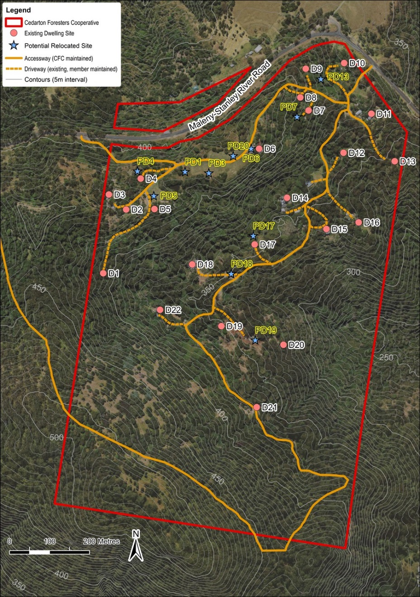

Figure 2 – Cedarton Forester’s Cooperative land management plan – Building development areas
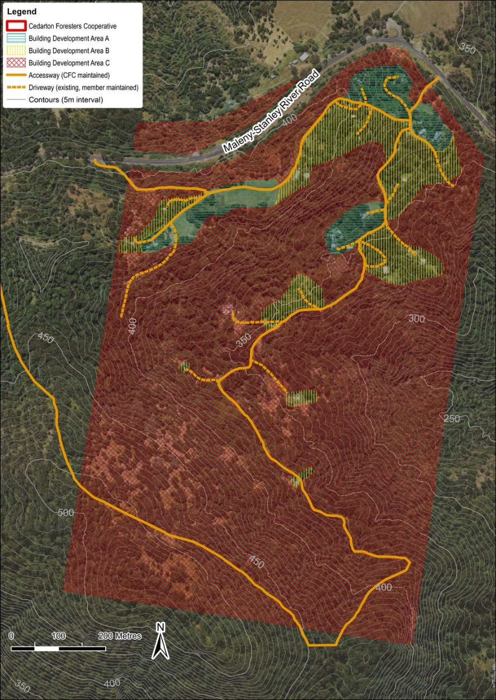

Figure 3 – Cedarton Forester’s Cooperative land management plan – Accessway and driveway improvement areas
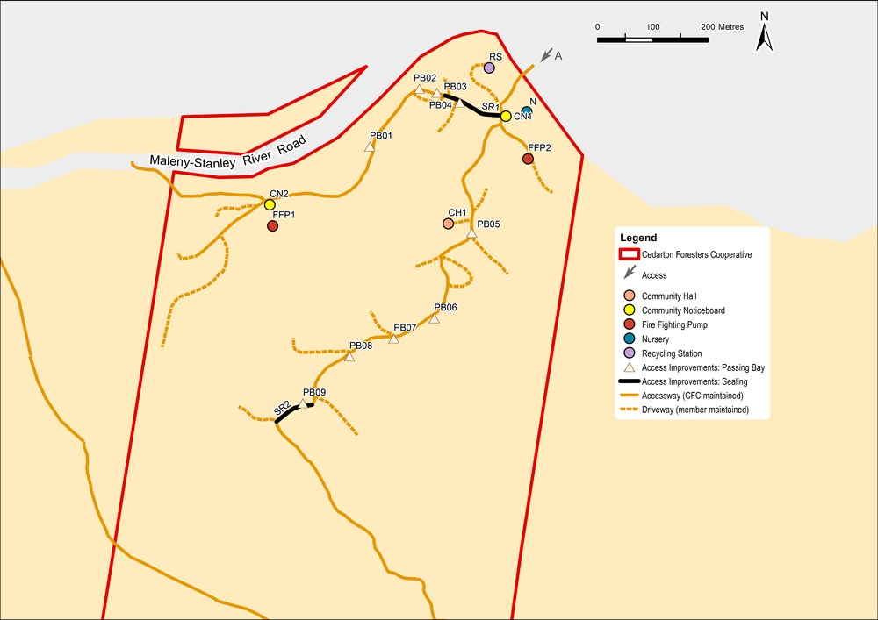

Figure 4 – Cedarton Forester’s Cooperative land management plan – Contours, accessway and water courses
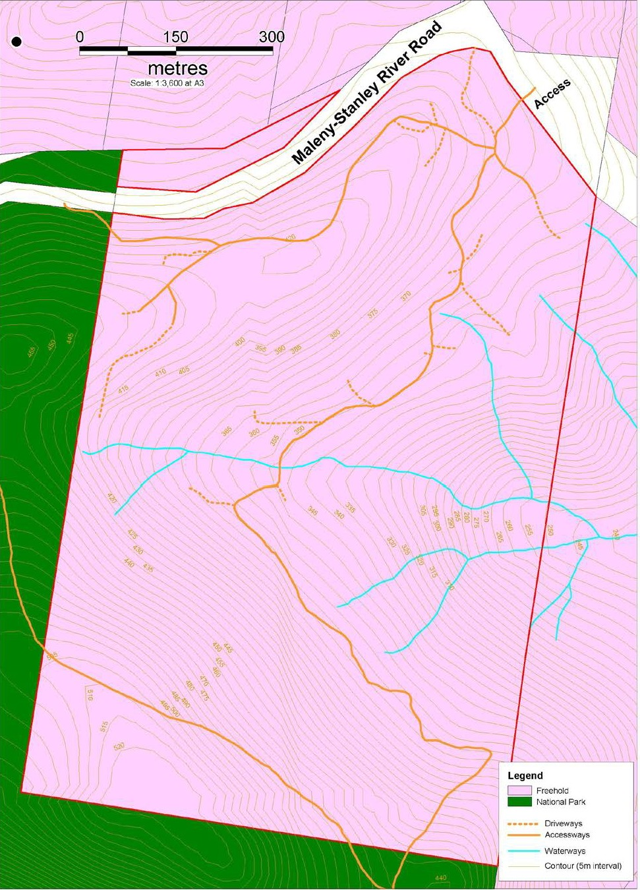
Figure 5 – Cedarton Forester’s Cooperative land management plan – Vegetation clearing areas for dwellings
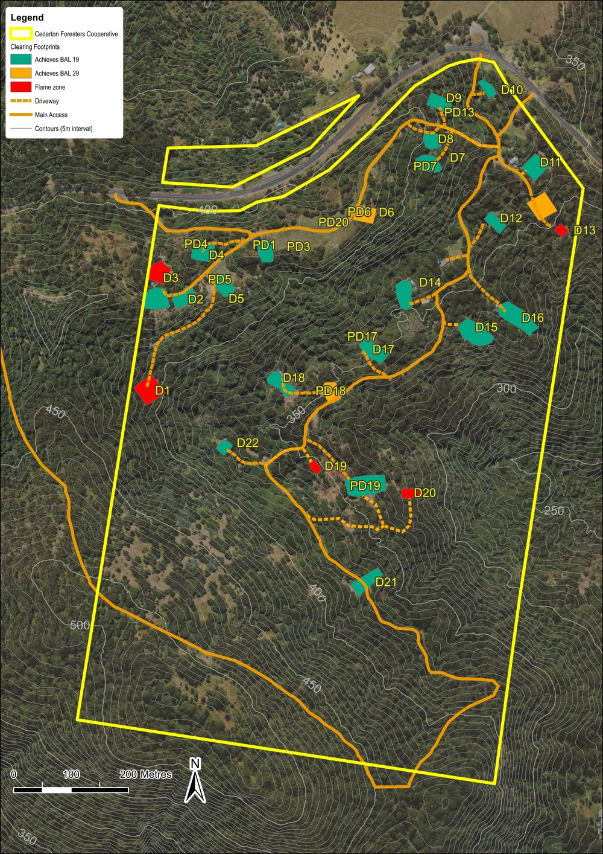
Figure 6 – Cedarton Forester’s Cooperative land management plan – Fire management information and fire maintenance trail
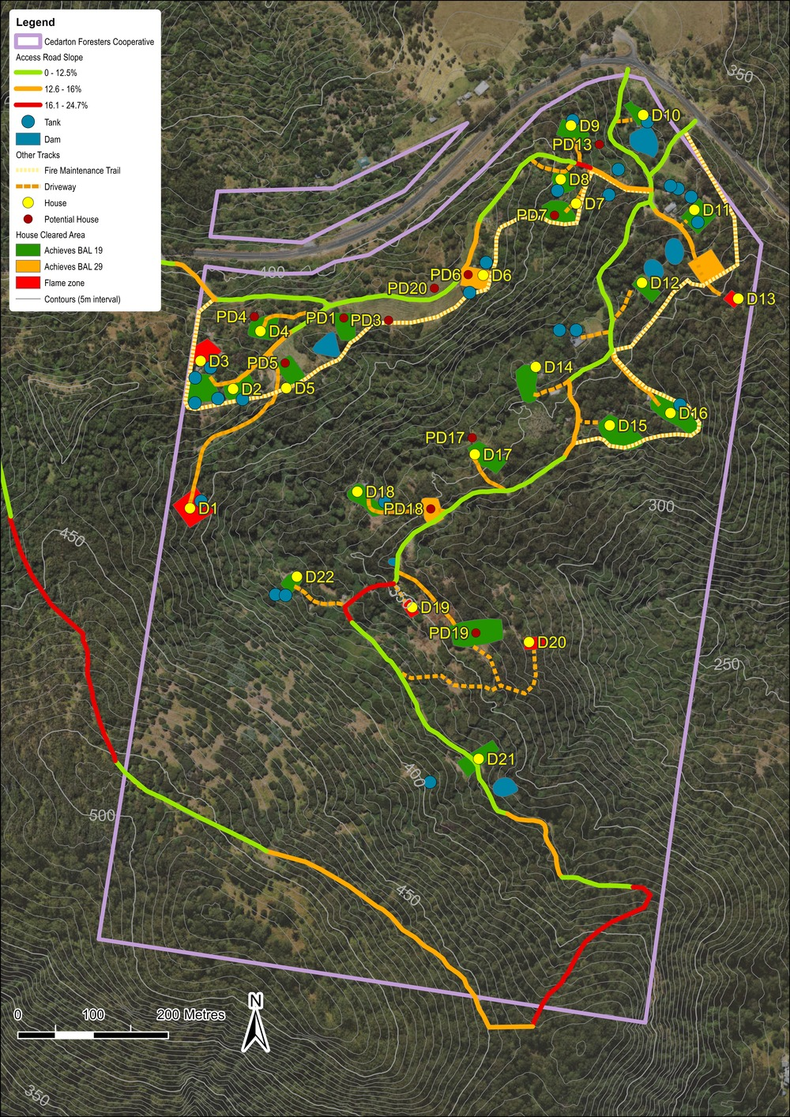
Background information
The following documents assisted to inform the detail and content of the land management plan:
- Cedarton Forester’s Cooperative Land Management Plan August 2013, prepared by Planning Strategies, printed 2 August 2013.
- Bushfire Risk Assessment and Bushfire Risk Land Management plan for Cedarton Forester’s Cooperative (Lot 357 on SP119036) – Revision 6, prepared by Ecological Natural Area Management July 2013.
A copy of these documents can be obtained from Council.

TABLE B – MT NEBO PLANT NURSERY – LAND MANAGEMENT PLAN

Development in the Mt Nebo Plant Nursery site subject to a land management plan (see Figure 1)

1.2 Purpose of the land management plan
The site is situated at 1871 Mt Nebo Road, Mt Nebo, on land described as Lot 2 RP139965.
The purpose of the land management plan is to achieve the following identification of:
- The nature and extent of development permitted to occur on the site, subject to a land management plan process, namely:
  - A maximum of 16 dwelling sites, associated dwellings and driveways;
  - Outbuildings associated with dwellings;
  - Community building comprising the following:
    - 1 community hall for the exclusive use of shareholders only and is not available to members of the public for public use or hire;
    - 1 plant nursery for the exclusive use of shareholders only and the propagation of plants for use on the land management plan site only. The plant nursery is not to be available to the public or sell to the public;
    - 1 administration/office building for the exclusive use of shareholders only;
    - 1 water tank.
  - Accessway throughout the land management plan site.
- The location of development identified in (I) – (IV) above;
- Any additional works required to facilitate and support the development listed in (a) above;

1.2 Outcomes sought
The outcomes sought by the land management plan are as follows:
- To acknowledge the presence of a multiple dwelling of 16 units associated with the Mt Nebo Plant Nursery site;
- To limit development to that which existed on the day the planning scheme is adopted. Expansion or addition of land use and building is avoided;
- To ensure that any recognised development occurs in accordance with a land management plan.

Note - Figure 1 forms the land management plan for the site
Table 1 - Land management plan outcomes to be achieved
No | Subject | Applicability | Outcome to be achieved
1. | Development subject to land management plan | The land management plan site | - Development comprises the following:  - A maximum of 16 dwellings and associated dwelling sites.  - Out buildings associated with dwellings.  - Community building comprising the following:  - 1 community hall for the exclusive use of shareholders only and is not available to members of the public for public use or hire;  - 1 plant nursery for the exclusive use of shareholders only and the propagation of plants for use on the land management plan site only. The plant nursery is not to be available to the public or sell to the public;  - 1 administration/office building for the exclusive use of shareholders only;  - 1 water tank.  - Accessway throughout the land management plan site.  - Development is to occur in accordance with Figure 1 Mt Nebo plant nursery land management plan – Dwelling and building location.
2. | Dwellings and dwelling sites D1 – D13 and D15 | 14 Dwellings and dwelling sites | - Dwellings D1 – D13, D15 are to be located on sites in accordance with Figure 1 Mt Nebo Plant Nursery land management plan – Dwelling and building location.  - Dwellings are to be designed and constructed to comply with the Building Act 1975 and the Building Code of Australia.  - Dwellings do not exceed their current building height at time of planning scheme adoption and any new structures not exceed a height of 8m.  - Dwellings retain their existing gross floor area, or a maximum of 100m2, whichever the greater (see Table 2).
3. | Alternate location for dwellings and dwelling site for D14 and D16 | D14 and D16 | - Dwelling D14 is located to a cleared position downslope or to the north of its current position.  - Dwelling D16 may locate in any position along the existing platform already create by a cut in that location.  - Dwellings are to be designed and constructed to comply with the Building Act 1975 and the Building Code of Australia.  - Dwellings do not exceed their current building height at time of planning scheme adoption and any new structures not exceed a height of 8m.  - Geotechnical and bush fire reports, as identified in Table 5, are required to confirm suitability of dwelling and dwelling site.
4. | All out buildings | All out buildings on-site, being listed or unlisted. | - All outbuildings are to be designed and constructed to comply with the Building Act 1975 and the Building Code of Australia.  - Buildings do not exceed a height of 8m.
5. | Identified Community Buildings CB1-4 | CB1. - Community hall (known as the Galaxy).  CB2 – Nursery (known as the Shadehouse).  CB3 – Administration /office (known as the Octagon).  CB4 – Water tank (known as Top Tank). | - CB1 – CB4 are located on the site in accordance with Figure 7 Mt Nebo Plant Nursery land management plan – Dwelling and building location.  - All buildings and structures are designed and constructed to comply with the Building Act 1975 and the Building Code of Australia.  - All buildings and structures do not exceed a height of 8m.  - The gross floor area associated with CB1 – 4 to be retained.
6. | Bushfire | The land management plan site | The installed pumps and associated reticulation system with around 50 hosecocks is maintained and available for fire fighting purposes.
 |  | Where D14 is to remain in current location | - D14 is to be built to a BAL 19 standard with an 8m separation from any fire source hazard.  - D14 is to be provided with a 3m wide driveway to the accessway identified in Figure 1 Mt Nebo Plant Nursery land management plan – Dwelling and building location.
7. | Effluent and wastewater treatment and disposal | All dwelling sites, Community hall, outbuildings where applicable. | All development is to comply with the Plumbing and Drainage Act 2002 and the Queensland Plumbing and Wastewater Code.
8. | Hazardous substance storage | The land management plan site | - Any development that involves the storage or handling of hazardous chemicals listed in Schedule 9, Development involving hazardous chemicals, Table 9.0.1 Quantity thresholds for hazardous chemicals stored as accepted development subject to requirements complies with Table 9.0.3 Hazardous chemicals assessment thresholds.  - Development does not involve the storage or handling of hazardous chemicals listed in Schedule 9, Development involving hazardous chemicals, Table 9.0.2 Hazardous chemicals assessment thresholds.

Table 2 – Existing building location and site attributes
Dwelling Site Number (Dwelling site) | Name of Mt Nebo Plant Nursery shareholder | Approximate Gross floor area of existing dwelling  (m2) | Identified large outbuildings and area (m2) | Reports and study requirements to establish dwelling at location
D1 | Millard | 105 | OB01  98
D2 | McKavangh & Layton | 94 | -
D3 | Carrigan | 17 | -
D4 | Colbert | 94 | -
D5 | Burkett | 72 | -
D6 | Lachowicz | 124 | OB6  65
D7 | Rice & Borchers | 101 | OB7  86
D8 | Scattini | 108 | OB8  50
D9 | Scattini | 272 | -
D10 | Boaler | 136 | -
D11 | Wills | 88 | -
D12 | Wills | 58 | -
D13 | Albinger & Sanders | 118 | -
D14 | Young | 15 | - | Where for current location:  - Bushfire assessment for dwelling  - Geotechnical stability and slope for driveway
Where for new location:
- Bushfire assessment for dwelling
- Bushfire assessment for site
- Geotechnical stability for dwelling
- Geotechnical stability for site
- Geotechnical stability and slope for driveway
D15 | Scattini | 45 | -
D16 | Wills | 11 | - | - Bushfire assessment for dwelling  - Bushfire assessment for site  - Geotechnical stability for dwelling  - Geotechnical stability for site
Community Buildings and notable outbuildings | Name of Mt Nebo Plant Nursery shareholder | Area of existing community building  (m2) | Identifier
Community hall  (Galaxy) | Scattini | 206 | CB1
Nursery  (Shadehouse) | Scattini | 221 | CB2
Administration office  (Octagon) | Scattini | 14 | CB3
Water Tank  (Top Tank) | Community | 9 | CB4

The following table details the outcomes anticipated for the required studies and reports. These are not exhaustive but provide guidance as to the minimum information requirements each report is to contain. It is anticipated that actual content of any of the below stated reports will be more extensive and go beyond the minimum report requirements listed below given the complicated physical and topographical characteristics associated with the site.
Table 3 – Guidance to Information requirements
Reports and study requirements to support Development Application | Minimum Report Requirements
Bushfire assessment report for dwelling and for site | - Report is prepared by a suitably qualified person.  - Report to consider, and be consistent with:  - State Planning Policy Guideline, State interest – natural hazards, Guidance on flood, bushfire and landslide,  - The Moreton Bay Regional Council Planning Scheme Policy – Bushfire hazard,  - The bushfire related matters identified in Table 1 land management plan outcomes to be achieved,  - The recommendations identified in the Bushfire Risk Assessment and Bushfire Risk Land Management Plan for Mount Nebo Plant Nursery prepared by Ecological Natural Area Management, Revision 4, March 2014.
Geotechnical stability report | - Report is prepared by a suitably qualified person.  - Report is to identify and demonstrate any cut and fill associated with driveways and accessway, cut to fill pad, retaining structures, outbuilding and dwelling construction has a minimal risk to the safety of people, property by landslide.  - Report to confirm buildings are appropriately located to minimise erosion and risk of landslide.
Effluent and wastewater disposal report | - Report is prepared by a suitably qualified person.  - Report is to be prepared in accordance with Plumbing and Drainage Act 2002 and the Queensland Plumbing and Wastewater Code and associated guidelines to confirm the suitability of each site to accommodate an on-site sewerage facility; or where a centrally located group collection treatment system is proposed, confirmation as to the suitability of the designated site to accommodate the on-site sewerage facility.  - Detail the preventative measures to limit impact on environmentally sensitive areas such as, but not limited to, watercourses, natural habitat and vegetation.  - Address the cumulative effects of 16 on-site domestic and community buildings treatment plants over the whole site. Alternatively, where a centrally located group collection treatment system is proposed, the cumulative effects of that system and any other on-site treatment plants over the whole site.

Figure 1 – Mt Nebo Plant Nursery Land Management Plan
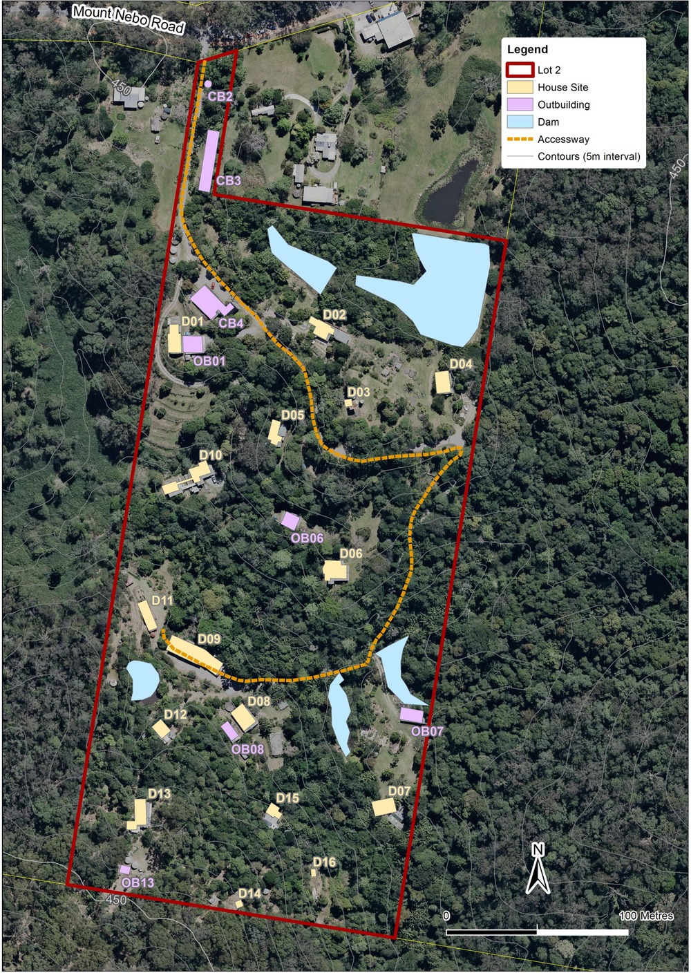
Background information
The following documents assisted to inform the detail and content of the land management plan:
- Mt Nebo Plant Nursery Management Plan March 2014, prepared by Paul Summers Planning Strategies, printed 4 March 2014.
- Mt Nebo Plant Nursery Report on Site Background and Current Circumstances February 2014, prepared by Paul Summers Planning Strategies, printed 20 March 2014.
- Bushfire Risk Assessment and Bushfire Risk Land Management Plan for Mt Nebo Plant Nursery (Lot 2 on RP139965) – Revision 4, prepared by Ecological Natural Area Management March 2014.
A copy of these documents can be obtained from Council.

