Table 9.3.1.1 Requirements for accepted development
Requirements for accepted development |  | E Compliance  - Yes  - No See PO or  - NA | Justification for compliance
General requirements (All lots - Traditional lot, Narrow lot, Row lot and Laneway lot)
Building height
RAD1 | Building height does not exceed that mapped on Overlay map – Building heights.  Note - Minimum's mapped on Overlay map - Building heights, do not apply to Dwelling houses.  Note - The above does not apply to domestic outbuildings. Refer to requirements for Domestic outbuildings in this code.  Note - This is a quantifiable standard that is an alternative provision to the QDC, part MP1.1, A4 and part MP1.2, A4. Non-compliance with this provision for a Dwelling house⁽²²⁾ requires a concurrence agency response from Council.
RAD2 | The height of tall structures (e.g. antenna, aerial, chimney, flagpole or the like) projects no more than 8.5m above ground level and transmission and receiving dishes are no larger than 1.2m diameter.  Note - This is a quantifiable standard that relates to matters identified in Schedule 9, Part 3, Division 2, Table of Regulation. Non-compliance with this provision for a Dwelling house requires a concurrence agency response from council.
Setbacks
RAD3 | Setbacks (excluding built to boundary walls) comply with:  - Emerging community zone:  - Transition precinct (developed lot) Morayfield South urban area identified in ‘Figure 9.3.1.1 Morayfield South - Urban area ’ - Table 9.3.1.6 ‘Setbacks’  - Transition precinct (developed lot) all other areas - Table 9.3.1.5 ‘Setbacks’  - General residential zone:  - Coastal communities precinct - Table 9.3.1.3 ‘Setbacks’  - Suburban neighbourhood precinct - Table 9.3.1.4 ‘Setbacks’  - Next generation neighbourhood precinct - Table 9.3.1.5 ‘Setbacks’  - Urban neighbourhood precinct - Table 9.3.1.6  - Caboolture West local plan:  - Urban living precinct - Next generation sub-precinct - Table 9.3.1.5 ‘Setbacks’  - Redcliffe Kippa-Ring local plan:  - Interim residential precinct - Table 9.3.1.3 ‘Setbacks’  Except for carports in the primary and secondary frontage where they:  - are setback a minimum of:  - 5.4m; or  - if the dwelling was built before 2005:  - not less than the setback to an existing lawfully constructed carport or garage on an adjoining lot having the same road frontage (where a lawfully constructed carport or garage is located on both sides, the lesser of the two is applicable); or  - 0.5m, whichever is the greater; and  - remain open and are not enclosed by walls, screens, doors or the like.  Note - This is a quantifiable standard that is an alternative provision to the QDC, part MP1.1, A1 (a), (b) and (c), A2 (a), (b) and (d) and part MP1.2, A1 (a), (b) and (c), A2 (a), (b) and (d). Non-compliance with this provision for a Dwelling house⁽²²⁾ requires a concurrence agency response from Council. Note - Greater setbacks may be required if the lot adjoins an environmental corridor or area (Refer to values and constraints for details).  Note - The above setbacks apply only to Class 1a and Class 10a buildings/structures.  Editor's note - The location and design of the Dwelling house, specifically garages and covered car parking spaces are to ensure the design and location of any resultant driveways and crossovers are able to comply with relevant criteria of Planning scheme policy - Integrated design (Appendix A) for Driveways, Vehicle and Pedestrian Crossover.
RAD4 | Built to boundary walls are:  - provided on lots if required by an existing approval issued by Council,and are established in accordance with the plan of development under that existing approval (including any subsequent amendments to that plan of development that are approved by council in writing)  OR  if no approved plan of development applies to the land, are only established on lots having a primary frontage of 18m or less and where permitted in Table 9.3.1.7 ‘Built to boundary walls’;  - of a length and height not exceeding that specified in Table 9.3.1.7 ‘Built to boundary walls’;  - setback from the side boundary:  - if a plan of development provides for only one built to boundary wall on the one boundary, not more than 200mm; or  - if a built to boundary wall may be built on each side of the same boundary, not more than 20mm;  - on the low side of a sloping lot.  Editor's note - Lots containing built to boundary walls should also include an appropriate easement to facilitate the maintenance of any wall within 600mm of a boundary. For boundaries with built to boundary walls on adjacent lots a 'High Density Development Easement' is recommended; or for all other built to boundary walls a 'easement for maintenance purposes' is recommended.  Note - The above setbacks apply only to Class 1a and Class 10a buildings/structures.  Note - This is a quantifiable standard that is an alternative provision to the QDC, part MP1.1, A1 (a), (b) and (c), A2 (a), (b) and (d) and part MP1.2, A1 (a), (b) and (c), A2 (a), (b) and (d). Non-compliance with this provision for a Dwelling house⁽²²⁾ requires a concurrence agency response from Council.  Editor's note - A wall is not to be built to the boundary if it has a window or if a wall of a building on an adjoining lot:  - is within 900mm of that boundary;  - is within 1.5m of that boundary and has an opening/window to a habitable room;  - is not constructed from masonry or other material fire rated in accordance with the Building Code of Australia.
Site cover
RAD5 | Site cover (excluding eaves, sun shading devices, patios, balconies and other unenclosed structures) does not exceed:  - Emerging community zone:  - Transition precinct (developed lot) - in accordance with the table below  - General residential zone:  - Coastal communities precinct – 50%  - Suburban neighbourhood precinct – 50%  - Next generation neighbourhood precinct – in accordance with the table below  - Urban neighbourhood precinct – in accordance with the table below  - Caboolture west local plan:  - Urban living precinct - Next generation sub-precinct - in accordance with the table below  - Redcliffe Kippa-Ring local plan:  - Interim residential precinct - 50%  Building height Lot Size  300m² or less 301-400m² 401-500m² 501-1000m² Greater than 1000m²  8.5m or less 75% 70% 60% 60% 60%  >8.5m – 12.0m 50% 50% 60% 50% 50%  >12.0m N/A N/A N/A 50% 40%  Note - This is a quantifiable standard that is an alternative provision to the QDC, part MP1.1, A3 and part MP1.2, A3. Non-compliance with this provision for a Dwelling house⁽²²⁾ requires a concurrence agency response from Council.
Car parking
RAD6 | Car parking spaces are provided in accordance with the table below.  Location Minimum number of carspaces to be provided  General residential zone: - Coastal communities precinct - Suburban neighbourhood precinct Redcliffe Kippa-Ring local plan: - Interim residential precinct 3 per Dwelling house⁽²²⁾  Emerging community zone: - Transition precinct (developed lot) General residential zone: - Next generation neighbourhood precinct - Urban neighbourhood precinct Caboolture west local plan code: - Urban living precinct - Next generation sub-precinct 1 per Dwelling house⁽²²⁾  Note - Does not include the parking of Heavy Vehicles or Heavy Machinery.  Note - This is a quantifiable standard that is an alternative provision to the QDC, part MP1.1, A8 and par MP1.2, A8. Non-compliance with this provision for a Dwelling house⁽²²⁾ requires a concurrence agency response from Council.  Note - The provision of the third parking space may be provided in tandem on site.
RAD7 | Garage and carport openings, where located within 20m of the site frontage, are in accordance with the table below:  Primary or Secondary frontage Covered car space opening(s) per street frontage  Greater than 18m Not specified  12.5m to 18m 6m wide maximum  Less than 12.5m* Single storey dwelling: - maximum 50% of the frontage width (being the frontage vehicle access is from); - recessed: - at least 1.0m behind the main building line; or - at least 1.0m behind a front portico and no more than 2.0m in front of the main building line. Two storey dwelling: - 6.0m wide maximum; - recessed 1.0m behind the front wall or balcony of upper level. Editor's note - Front wall is to have a minimum length of 40% of the adjoining frontage. OR For a laneway lot (Single or two storey): no maximum  Note - *For a laneway lot, vehicle access and parking must be provided via the laneway.  Note - Refer to Planning scheme policy - Residential design for details and examples.  Note - This is a quantifiable standard that is an alternative provision to the QDC, part MP1.1, A1 (b). Non-compliance with this provision for a Dwelling house⁽²²⁾ on a lot under 450m² requires a concurrence agency response from Council.  Note - This is a quantifiable standard that relates to the amenity and aesthetic impacts of the building or structure. Non-compliance with this provision for a Dwelling house⁽²²⁾ on a lot over 450m² requires a concurrence agency response from Council.
Access and driveways
RAD8 | Any new crossovers and driveways or changes to existing crossovers and driveways:  - if there is an approved plan of development, are located in accordance with the plan of development approved by council as part of a development approval or as otherwise amended by council in writing; or  - if no approved plan of development applies to the land, are located in accordance with Planning scheme policy - Integrated design.  Note - This is a quantifiable standard that relates to matters identified in Schedule 9, Part 3, Division 2, Table of Regulation. Non-compliance with this provision for a Dwelling house requires a concurrence agency response from council.
RAD9 | Driveways do not include a reversing bay, manoeuvring area or visitor parking spaces (other than tandem spaces) in the front setback.  Note -This is a quantifiable standard that relates to matters identified in Schedule 9, Part 3, Division 2, Table of Regulation. Non-compliance with this provision for a Dwelling house⁽²²⁾ requires a concurrence agency response from Council.
RAD10 | Crossovers and driveways are designed and constructed in accordance with:  - where for a Council-controlled road, Planning scheme policy - Integrated design;  - where for a State-controlled road, the Safe Intersection Sight Distance requirements in AustRoads and the appropriate IPWEAQ standard drawings, or a copy of a Transport Infrastructure Act, section 62 approval.  Note - This is a quantifiable standard that relates to matters identified in Schedule 9, Part 3, Division 2, Table of Regulation. Non-compliance with this provision for a Dwelling house⁽²²⁾ requires a concurrence agency response from council.
Casual surveillance
RAD11 | The Dwelling house (or the primary dwelling if including a secondary dwelling) must address primary frontages (excluding motorway and arterial roads) with a minimum of a front door, window(s) and pedestrian entrance.  Note - If an acoustic fence has been conditioned as part of a reconfiguring a lot approval this provision does not apply to that frontage.  Note - Refer to Overlay map - Road hierarchy for road classification.  Note - This is a quantifiable standard that relates to matters identified in Schedule 9, Part 3, Division 2, Table of Regulation. Non-compliance with this provision for a Dwelling house⁽²²⁾ requires a concurrence agency response from council.
RAD12 | Each dwelling (primary and secondary), excluding domestic outbuildings and garages, that overlooks an adjoining public space (street, public open space or laneway) provides one habitable room window with an area of at least 1m² or multiple habitable room windows having a combined area of at least 2.5m² overlooking each adjoining public space (street, public open space or laneway).  Note - Secondary dwellings are not required to provide a habitable room window where only the secondary dwelling garage overlooks the adjoining public space and all habitable rooms do not adjoin a public space.  Note - This is a quantifiable standard that relates to matters identified in Schedule 9, Part 3, Division 2, Table of Regulation. Non-compliance with this provision for a Dwelling house⁽²²⁾ requires a concurrence agency response from council.
Waste
RAD13 | Each dwelling (primary and secondary) includes a bin storage area that:  - is not visible from public areas or screened from public areas;  - is not located in the primary frontage setback, unless the dwelling is built to boundary on both sides of the lot with only one frontage;  - is not located in an enclosed garage;  - has a minimum area of 1m x 2m;  - has access to the collection point without going through a dwelling (excluding a garage).  Note - Refer to Planning scheme policy - Residential design for details and examples.  Note - This is a quantifiable standard that relates to matters identified in Schedule 9, Part 3, Division 2, Table of Regulation. Non-compliance with this provision for a Dwelling house⁽²²⁾ requires a concurrence agency response from council.
Utilities
RAD14 | The dwelling is connected to:  - an existing reticulated electricity supply;  - reticulated sewerage where in a reticulated area;  - reticulated water;  - dedicated and constructed road.  Note - This is a quantifiable standard that relates to matters identified in Schedule 9, Part 3, Division 2, Table of Regulation. Non-compliance with this provision for a Dwelling house⁽²²⁾ requires a concurrence agency response from council.
Earthworks
RAD15 | Filling and excavation that is outside of the external walls of any on-site building does not:  - involve a change in level of more than 1.0m relative to natural ground level  or  result in a batter greater than 1V:6H relative to natural ground level;  - necessitate the construction of a freestanding retaining wall exceeding 1.0m in height relative to natural ground level;  - result in the top of any cut batter, or the exposed face of any freestanding retaining wall supporting that cut, being closer than 500mm to a property boundary;  - result in the toe of any fill batter, or exposed face of any freestanding retaining wall supporting that fill, being closer than 1.0m to a property boundary unless:  - the depth of fill within that 1.0m strip does not exceed 200mm relative to natural ground level; or  - the batter slope within that 1.0m strip is no steeper than 1V:2H.  Figure - Filling or Excavation  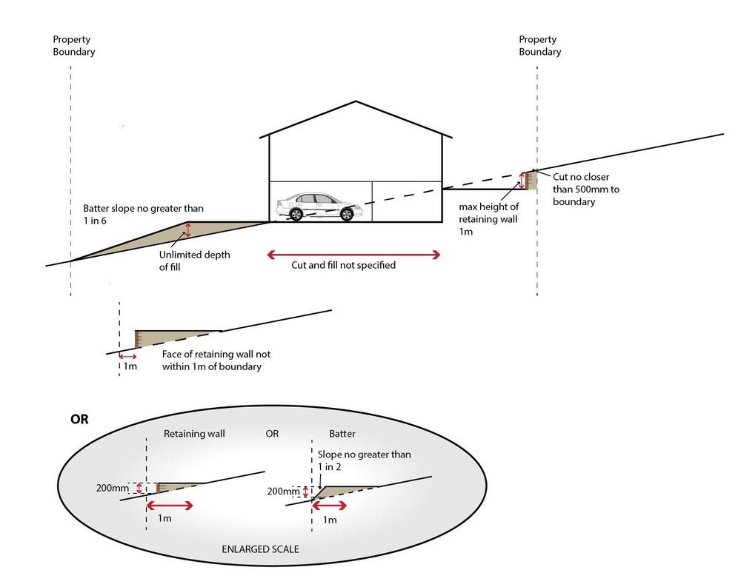  Note - This is a quantifiable standard that relates to the amenity and aesthetic impacts of the building or structure. Non-compliance with this provision for a Dwelling house⁽²²⁾ requires a concurrence agency response from council
Development on a laneway
RAD16 | The Dwelling house⁽²²⁾ (or the primary dwelling where including a secondary dwelling)  - faces the non-laneway frontage;  - has its main pedestrian entrance (front door) from the non-laneway frontage.  Note - This is a quantifiable standard that relates to matters identified in Schedule 9, Part 3, Division 2, Table of Regulation. Non-compliance with this provision for a Dwelling house⁽²²⁾ requires a concurrence agency response from Council.
RAD17 | All vehicle access must be via the laneway.  Note - This is a quantifiable standard that relates to matters identified in Schedule 9, Part 3, Division 2, Table of Regulation. Non-compliance with this provision for a Dwelling house⁽²²⁾ requires a concurrence agency response from Council.
Secondary dwelling
RAD18 | The siting and design of dwellings ensures that the secondary dwelling is:  - not located in front of the primary dwelling;  - annexed to (adjoining, below or above) or located within 10.0m of the primary dwelling (excluding domestic outbuildings).  Note - The requirements to locate a Secondary dwelling within 10m of the primary dwelling is measured from the outermost projection of the primary dwelling (being the main house, excluding domestic outbuildings) to the outermost projection of the Secondary dwelling. The entire Secondary dwelling does not need to be contained within the specified distance.  Note - Refer to Planning scheme policy - Residential design for details and examples.  Note - This is a quantifiable standard that relates to matters identified in Schedule 9, Part 3, Division 2, Table of Regulation. Non-compliance with this provision for a Dwelling house⁽²²⁾ requires a concurrence agency response from council.
RAD19 | No more than 1 secondary dwelling is located on an allotment.  Note - This is a quantifiable standard that relates to matters identified in Schedule 9, Part 3, Division 2, Table of Regulation. Non-compliance with this provision for a Dwelling house⁽²²⁾ requires a concurrence agency response from Council.
RAD20 | The GFA of the secondary dwelling does not exceed:  - 45m² GFA for a lot with a primary frontage less than 15m; or  - 55m² GFA for a lot with a primary frontage of 15m or more.  Note - This is a quantifiable standard that relates to matters identified in Schedule 9, Part 3, Division 2, Table of Regulation. Non-compliance with this provision for a Dwelling house⁽²²⁾ requires a concurrence agency response from Council.
RAD21 | Provide a minimum of one designated car parking space for the Secondary dwelling (in addition to those required for the dwelling house). This car parking space(s) is to be co-located with the parking spaces for the primary dwelling to appear as a single dwelling from the street.  Note - The requirement for co-locating secondary dwelling parking space(s) with the car parking space(s) for the primary dwelling does not apply to corner lots where the primary and secondary dwellings address different street frontages and are accessed via separate driveways.  Note - This is a quantifiable standard that relates to matters identified in Schedule 9, Part 3, Division 2, Table of Regulation. Non-compliance with this provision for a Dwelling house⁽²²⁾ requires a concurrence agency response from Council.  Note - Refer to Planning scheme policy- Residential design for details and examples.
Domestic outbuildings
RAD22 | Domestic outbuildings:  - have a total combined maximum roofed area as outlined in the table below:  Size of lot Maximum roofed area  Less than 600m² 50m²  600m² - 1000m² 70m²  >1000m² – 2000m² 80m²  Greater than 2000m² 150m²  - have a maximum and mean building height as follows:  - where in front of the main building line for a carport - have a maximum building height of 3.3m and a mean height not exceeding 2.7m; or  - for all other instances - have a maximum building height of 4m and a mean height not exceeding 3.5m;  - are located behind the main building line and not within the primary frontage, secondary frontage or trafficable water body setbacks except where for a carport and complying with the front setback for carports specified in this code.  Note - for c. above to determine the main building line a trafficable water body boundary is to be treated the same as a secondary frontage.  Note - This is a quantifiable standard that relates to matters identified in Schedule 9, Part 3, Division 2, Table of Regulation. Non-compliance with this provision for a Dwelling house⁽²²⁾ requires a concurrence agency response from Council.  Note - This is a quantifiable standard that is an alternative provision to the QDC, part MP1.1, A4 and part MP1.2, A4. Non-compliance with this provision for a Dwelling house (22) requires a concurrence agency response from Council.  Note - This is a quantifiable standard that is an alternative provision to the QDC, part MP1.1, A1 (a), (b) and (c), A2 (a), (b) and (d) and part MP1.2, A1 (a), (b) and (c), A2 (a), (b) and (d). Non-compliance with this provision for a Dwelling house(22) requires a concurrence agency response from Council. Note - Greater setbacks may be required if the lot adjoins an environmental corridor or area (Refer to values and constraints for details).  Editor's note - The calculation for mean height is defined in the QDC.
Values and constraints requirements
Note - The relevant values and constraints criteria do not apply where the development is consistent with a current Development permit for Reconfiguring a lot or Material change of use or Operational work, where that approval has considered and addressed (e.g. through a development footprint plan (or similar in the case of Landslide hazard) or conditions of approval) the identified value or constraint under this planning scheme.

Acid sulfate soils - (refer Overlay map - Acid sulfate soils to determine if the following requirements apply)
Note - Planning scheme policy - Acid sulfate soils provides guidance for requirements for accepted development that has the potential to disturb acid sulfate soils i.e. development involving filling or excavation works below the thresholds of 100m³ and 500m³ respectively.

RAD23 | Development does not involve:  - excavation or otherwise removing of more than 100m³ of soil or sediment where below 5m Australian Height Datum AHD, or  - filling of land of more than 500m³ of material with an average depth of 0.5m or greater where below the 5m AHD.  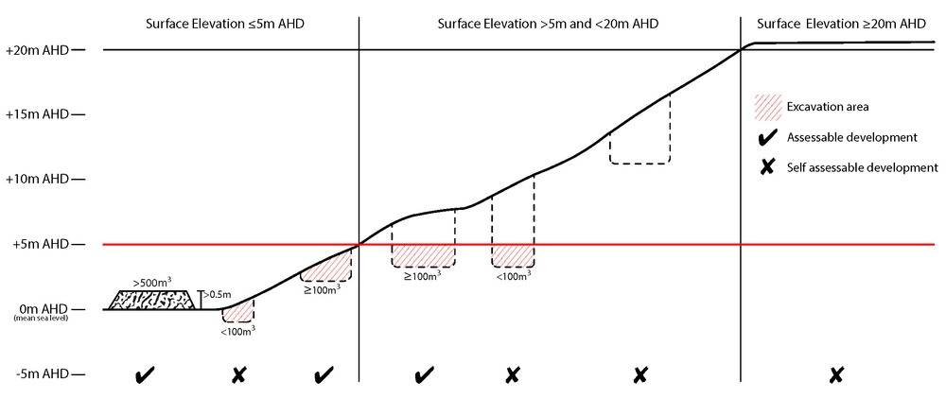
Environmental areas (refer Overlay map - Environmental areas to determine if the following requirements apply)
Note - The following are excluded from the native clearing provisions of this planning scheme:
- Clearing of native vegetation located within an approved development footprint;
- Clearing of native vegetation within 10m from a lawfully established building reasonably necessary for emergency access or immediately required in response to an accident or emergency;
- Clearing of native vegetation reasonably necessary to remove or reduce the risk vegetation poses to serious personal injury or damage to infrastructure;
- Clearing of native vegetation reasonably necessary to construct and maintain a property boundary fence and not exceed 4m in width either side of the fence where in the Rural, Rural residential and Environmental Management and Conservation zones. In any other zone, clearing is not to exceed 2m in width either side of the fence;
- Clearing of native vegetation reasonably necessary for the purpose of maintenance or works within a registered easement for public infrastructure or drainage purposes;
- Clearing of native vegetation in accordance with a bushfire management plan prepared by a suitably qualified person, submitted to and accepted by Council;
- Clearing of native vegetation associated with removal of recognised weed species, maintaining existing open pastures and cropping land, windbreaks, lawns or created gardens;
- Grazing of native pasture by stock;
- Native forest practice where accepted development under Part 1, 1.7.7 Accepted development.
Note - Definition for native vegetation is located in Schedule 1 Definitions.

Note - Native vegetation subject to this criteria primarily comprises of matters of national environmental significance (MNES), matters of state environmental significance (MSES). They also comprise some matters of local environmental significance (MLES). A MLES is defined in Schedule 1.2, Administrative definitions. A list of the elements that apply to the mapped MSES and MLES is provided in Appendix 1 of the Planning scheme policy - Environmental areas.
Editors' Note - The accuracy of overlay mapping can be challenged through the development application process (code assessable development) or by way of a planning scheme amendment. See Council's website for details.
Editors' Note - When clearing native vegetation within a MSES area, you may still require approval from the State government.

RAD24 | Where no suitable land cleared of native vegetation exists, clearing of native vegetation in a High Value Area or Value Area is for the purpose of a new dwelling house⁽²²⁾ or extension to an existing dwelling house⁽²²⁾ only on lots less than 750m².  Editor's note - See in heading above for other uses excluded from native vegetation clearing requirements.  Editor's note - Where vegetation clearance is accepted development subject to requirements, care should be undertaken to avoid adverse impacts on koalas, koala habitat values and habitat connectivity and to encourage existing koala usage of the site. Measures to minimise impacts include:  - co-locating all associated activities, infrastructure and access strips;  - be the least valued area of koala habitat on the site;  - minimise the footprint of the development envelope area;  - minimise edge effects to areas external to the development envelope;  - location and design consideration to ensure koala safety and movement in accordance with the Koala-sensitive Design Guideline and Planning scheme policy – Environmental areas;  - sufficient area between the development and koala habitat trees to achieve their long-term viability.  Editor's note - Where vegetation clearing is accepted development subject to requirements, consideration should be given to avoid clearing habitat trees. Habitat trees may contain structural hollows where animals live, breed and shelter. The provision of nest boxes or salvaging of hollows will provide compensatory roosting and nesting opportunities for local wildlife including sugar gliders, possums and owls. For further information see Planning scheme policy – Environmental areas.
RAD25 | No clearing of native vegetation is to occur within the Value Offset Area MLES - Waterway buffer or Value Offset Area MLES - Wetland buffer.  This does not apply to the following:  - Clearing of native vegetation located within an approved development footprint;  - Clearing of native vegetation within 10m from a lawfully established building reasonably necessary for emergency access or immediately required in response to an accident or emergency;  - Clearing of native vegetation reasonably necessary to remove or reduce the risk vegetation poses to serious personal injury or damage to infrastructure;  - Clearing of native vegetation reasonably necessary to construct and maintain a property boundary fence and not exceed 4m in width either side of the fence where in the Rural, Rural residential and Environmental management and conservation zones. In any other zone, clearing is not to exceed 2m in width either side of the fence;  - Clearing of native vegetation reasonably necessary for the purpose of maintenance or works within a registered easement for public infrastructure or drainage purposes;  - Clearing of native vegetation in accordance with a bushfire management plan prepared by a suitably qualified person, submitted to and accepted by Council;  - Clearing of native vegetation associated with removal of recognised weed species, maintaining existing open pastures and cropping land, windbreaks, lawns or created gardens;  - Grazing of native pasture by stock;  - Native forest practice where accepted development under Part 1, 1.7.7 Accepted development.
Extractive resources separation area (refer Overlay map - Extractive resources (separation area) to determine if the following requirements apply)

RAD26 | Development does not result in more than one dwelling house⁽²²⁾ per lot within separation areas.
RAD27 | Development within the separation area does not include the following uses:  - caretaker's accommodation⁽¹⁰⁾;  - community residence⁽¹⁶⁾;  - dual occupancy⁽²¹⁾;  - dwelling unit⁽²³⁾;  - hospital⁽³⁶⁾;  - rooming accommodation⁽⁶⁹⁾;  - multiple dwelling⁽⁴⁹⁾;  - non-resident workforce accommodation⁽⁵²⁾;  - relocatable home park⁽⁶²⁾;  - residential care facility⁽⁶⁵⁾;  - resort complex⁽⁶⁶⁾;  - retirement facility⁽⁶⁷⁾;  - rural workers’ accommodation⁽⁷¹⁾;  - short-term accommodation⁽⁷⁷⁾;  - tourist park⁽⁸⁴⁾.
RAD28 | All habitable rooms within the separation area are:  - acoustically insulated to achieve the noise levels listed in Schedule 1 Acoustic Quality Objectives, Environmental Protection (Noise) Policy 2008;  - provided with mechanical ventilation.
RAD29 | Private open space areas are separated from the resource processing area by buildings or a 1.8m high solid structure.
Extractive resources transport routes (refer Overlay map - Extractive resources (transport route and buffer) to determine if the following requirements apply)

RAD30 | The following uses are not located within the 100m wide transport route buffer:  - Caretaker’s accommodation⁽¹⁰⁾, except where located in the Extractive industry zone;  - Community residence⁽¹⁶⁾;  - Dual occupancy⁽²¹⁾;  - Dwelling house;⁽²²⁾  - Dwelling unit⁽²³⁾;  - Hospital⁽³⁶⁾;  - Rooming accommodation⁽⁶⁹⁾;  - Multiple dwelling⁽⁴⁹⁾;  - Non-resident workforce accommodation⁽⁵²⁾;  - Relocatable home park⁽⁶²⁾;  - Residential care facility⁽⁶⁵⁾;  - Resort complex⁽⁶⁶⁾;  - Retirement facility⁽⁶⁷⁾;  - Rural workers’ accommodation⁽⁷¹⁾;  - Short-term accommodation⁽⁷⁷⁾;  - Tourist park⁽⁸⁴⁾.
RAD31 | Except for an existing vacant lot, development does not create a new vehicle access point onto an Extractive resources transport route.
RAD32 | A vehicle access point is located, designed and constructed in accordance with Planning scheme policy - Integrated design.
Overland flow path (refer Overlay map - Overland flow path to determine if the following requirements apply)

RAD33 | Development for a material change of use or building work does not involve the construction of a building or structure in an Overland flow path area.
RAD34 | Development for a material change of use or operational work does not impede the flow of flood waters through the premises or worsen flood flows to other premises.  Note - A report from a suitably qualified Registered Professional Engineer Queensland is required certifying that the development does not increase the potential for significant adverse impacts on an upstream, downstream or surrounding premises.  Note - Reporting to be prepared in accordance with Planning scheme policy – Flood hazard, Coastal hazard and Overland flow
RAD35 | Development for a material change of use or building work ensures that fencing in an overland flow path area is at least 50% permeable.
RAD36 | Development for a material change of use or building work that involves a hazardous chemical ensures the hazardous chemicals is not located within an overland flow path area.
RAD37 | Development for a material change of use or building work for a Park⁽⁵⁷⁾ ensures that work is provided in accordance with the requirements set out in Appendix B of the Planning scheme policy - Integrated design.
Heritage and landscape character (refer Overlay map - Heritage and landscape character to determine if the following requirements apply)
Note - Places, including sites, objects and buildings having local cultural heritage significance, are identified on Overlay map - Heritage and landscape character and listed in Schedule 1 of Planning scheme policy - Heritage and landscape character. Places also having cultural heritage significance at a State level and being entered in the Queensland Heritage Register, are also identified in Schedule 1 of Planning scheme policy - Heritage and landscape character.

RAD38 | Development is for the preservation, maintenance, repair and restoration of the site, object or building.  This does not apply to Listed item 99, in Schedule 1 - List of sites, objects and buildings of significant historical and cultural value of Planning scheme policy - Heritage and landscape character.  Note - Preservation, maintenance, repair and restoration are defined in Schedule 1 - Definitions
RAD39 | A cultural heritage conservation management plan is prepared in accordance with Planning scheme policy – Heritage and landscape character and submitted to Council prior to the commencement of any preservation, maintenance, repair and restoration works. Any preservation, maintenance, repair and restoration works are in accordance with the Council approved cultural heritage conservation management plan.  This does not apply to Listed item 99 in Schedule 1 - List of sites, objects and buildings of significant historical and cultural value of Planning scheme policy - Heritage and landscape character.
RAD40 | Development does not result in the removal of or damage to any significant tree identified on Overlay map – Heritage and landscape character and listed in Appendix 2 of Planning scheme policy – Heritage and landscape character.
RAD41 | The following development does not occur within 20m of the base of any significant tree, identified on Overlay map – Heritage and landscape character and listed in Appendix 2 of Planning scheme policy – Heritage and landscape character:  - construction of any building;  - laying of overhead or underground services;  - any sealing, paving, soil compaction;  - any alteration of more than 75mm to the ground surface prior to work commencing.
RAD42 | Pruning of a significant tree occurs in accordance with Australian Standard AS 4373- Pruning of amenity trees.
Infrastructure buffers (refer Overlay map - Infrastructure buffers to determine if the following requirements apply)

RAD43 | Development does not include the following uses within a Wastewater treatment site buffer:  - Caretaker’s accommodation⁽¹⁰⁾;  - Community residence⁽¹⁶⁾;  - Dual occupancy⁽²¹⁾;  - Dwelling house;⁽²²⁾  - Dwelling unit⁽²³⁾;  - Hospital⁽³⁶⁾;  - Rooming accommodation⁽⁶⁹⁾;  - Multiple dwelling⁽⁴⁹⁾;  - Non-resident workforce accommodation⁽⁵²⁾;  - Relocatable home park⁽⁶²⁾;  - Residential care facility⁽⁶⁵⁾;  - Resort complex⁽⁶⁶⁾;  - Retirement facility⁽⁶⁷⁾;  - Rural workers’ accommodation⁽⁷¹⁾;  - Short-term accommodation⁽⁷⁷⁾;  - Tourist park⁽⁸⁴⁾.
RAD44 | Development does not involve the construction of any buildings or structures within a Bulk water supply infrastructure buffer.
RAD45 | Development involving a major hazard facility or an Environmentally Relevant Activity (ERA) is setback 30m from a Bulk water supply infrastructure buffer.
RAD46 | Development does not involve the construction of any buildings or structures within the Gas pipeline buffer.
RAD47 | Development does not include the following uses located within a landfill site buffer:  - caretaker’s accommodation⁽¹⁰⁾;  - community residence⁽¹⁶⁾;  - dual occupancy⁽²¹⁾;  - dwelling house;⁽²²⁾  - dwelling unit⁽²³⁾;  - hospital⁽³⁶⁾;  - rooming accommodation⁽⁶⁹⁾;  - multiple dwelling⁽⁴⁹⁾;  - non-resident workforce accommodation⁽⁵²⁾;  - relocatable home park⁽⁶²⁾;  - residential care facility⁽⁶⁵⁾;  - resort complex⁽⁶⁶⁾;  - retirement facility⁽⁶⁷⁾;  - rural workers’ accommodation⁽⁷¹⁾;  - short term accommodation⁽⁷⁷⁾;  - tourist park⁽⁸⁴⁾.
RAD48 | All habitable rooms located within an Electricity supply substation buffer are:  - located a minimum of 10m from an electricity supply substation⁽⁸⁰⁾ ; and  - acoustically insulated to achieve the noise levels listed in Schedule 1, Acoustic Quality Objectives, Environmental Protection (Noise) Policy 2008.
RAD49 | Development does not involve the construction of any buildings or structures containing habitable rooms or sensitive land uses within a High voltage electricity line buffer.
Riparian and wetland setbacks (refer Overlay map - Riparian and wetland setback to determine if the following requirements apply)
Note - W1, W2 and W3 waterway and drainage lines, and wetlands are mapped on Schedule 2, Section 2.5 Overlay Maps – Riparian and wetland setbacks.

RAD50 | No development is to occur within:  - 50m from top of bank for W1 waterway and drainage line  - 30m from top of bank for W2 waterway and drainage line  - 20m from top of bank for W3 waterway and drainage line  - 100m from the edge of a Ramsar wetland, 50m from all other wetlands.  Note - W1, W2 and W3 waterways and drainage lines, and wetlands are mapped on Schedule 2, Section 2.5 Overlay Maps – Riparian and wetland setbacks.  Note - In some cases, the top of bank may not be easily defined, as such a hydraulic measurement may be applied instead. Moreton Bay Regional Council will provide further direction on how to determine and locate the setback boundary in these locations.  Note - The minimum setback distance applies to the each side of waterway.
Scenic amenity - Regionally significant (Hills) and Locally important (Coast) - (refer Overlay map - Scenic amenity to determine if the following requirements apply)

RAD51 | Where located in the Regionally significant (Hills) scenic amenity overlay, buildings and structures are not:  - located on a hill top or ridge line; and  - all parts of the building and structure are located below the hill top or ridge line.  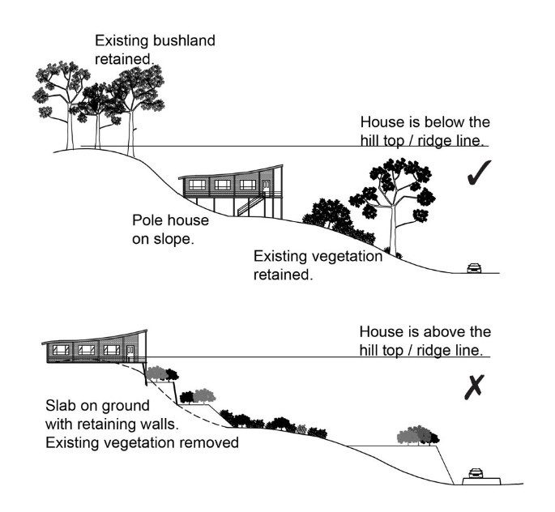
RAD52 | Where located in the Regionally significant (Hills) scenic amenity overlay, driveways and accessways:  - go across land contours and do not cut straight up slopes;  - follow natural contours, not resulting in batters or retaining walls being greater than 1m in height.  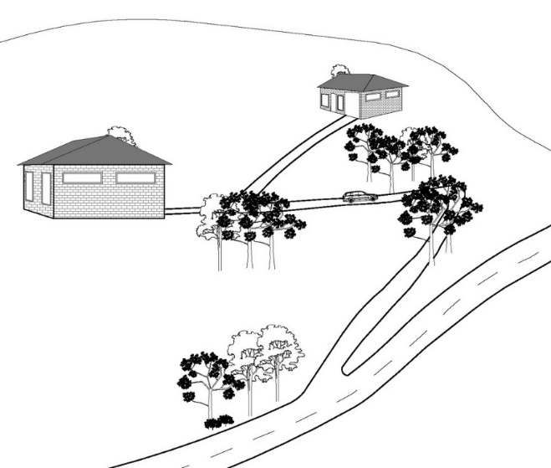
RAD53 | Where located in the Regionally significant (Hills) scenic amenity overlay, roofs and wall surfaces of buildings and structures adopt the following colours:  Colours from Australian Standard AS2700s – 1996  G12 – Holly G53 – Banksia N44 – Bridge Grey  G13 – Emerald G54 – Mist Green N45 – Koala Grey  G14 – Moss Green G55 – Lichen N52 – Mid Grey  G15 – Rainforest Green G56 – Sage Green N54 – Basalt  G16 – Traffic Green G62 – Rivergum N55 – Lead Grey  G17 – Mint Green G64 – Slate X54 – Brown  G21 – Jade G65 – Ti Tree X61 – Wombat  G22 – Serpentine N25 – Birch Grey X62 – Dark Earth  G23 – Shamrock N32 – Green Grey X63 – Iron Bark  G24 – Fern Green N33 – Lightbox Grey Y51 – Bronze Olive  G25 – Olive N35 – Light Grey Y61 – Black Olive  G34 – Avocado N41 – Oyster Y63 – Khaki  G52 – Eucalyptus N42 – Storm Grey Y66 – Mudstone  N43 – Pipeline Grey
RAD54 | Where located in the Regionally significant (Hills) scenic amenity overlay, roofs and wall surfaces of buildings and structures are painted or finished such that reflectivity is less than 35%.
RAD55 | Where located in the Locally important (Coast) scenic amenity overlay;  - landscaping comprises indigenous coastal species;  - fences and walls facing the coast are no higher than 1m. Where fences and walls are higher than 1m, they have 50% transparency. This does not apply to a fence or wall at an angle of 90o to the coast;  - where over 12m in height, the building design includes the following architectural character elements:  - curving balcony edges and walls, strong vertical blades and wall planes;  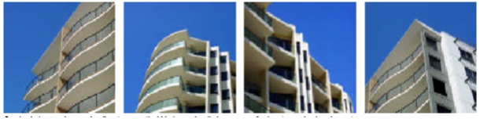  - balcony roofs, wall articulation expressed with different colours, curves in plan and section, and window awnings;  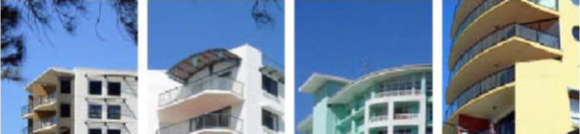  - Roof top outlooks, tensile structure as shading devices; and  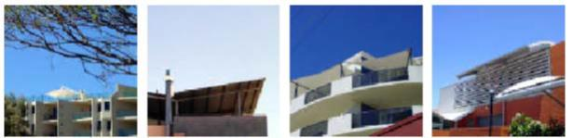  - lightweight structures use white frame elements in steel and timber, bold colour contrast.  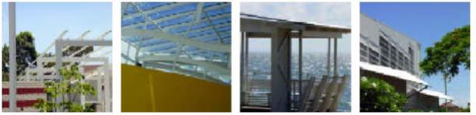  - existing pine trees, palm trees, mature fig and cotton trees are retained.  Note - A list of appropriate indigenous coastal species is identified in Planning scheme policy - Integrated design.
Transport noise corridors (refer Overlay map - Transport noise corridors)
Note - This is for information purposes only. No requirements for accepted development or assessable criteria apply. Development located within a Transport Noise Corridor must satisfy the requirements of the Queensland Development Code

Setback Tables

Table 9.3.1.3 Setbacks
Coastal communities precinct and Redcliffe Kippa-Ring local plan - Interim residential precinct
Height of wall | Frontage  Primary |  |  | Frontage  Secondary to street |  |  | Frontage  Secondary to lane | Side To OMP and wall | Rear To OMP and wall | Trafficable water body  To OMP and wall
 | To wall | To OMP | To covered car parking space and domestic outbuildings | To wall | To OMP | To covered car parking space and domestic outbuildings | To OMP, wall and covered car parking space
Less than 4.5m | Min 6m | Min 4.5m | Min 5.4 | Min 3m | Min 2m | Min 5.4 | Min 0.5 | Refer to standard as in QDC | Refer to standard as in QDC | Min 4.5m
4.5m to 8.5m | Min 6m | Min 4.5m | N/A | Min 3m | Min 2m | N/A | Min 0.5 | Refer to standard as in QDC | Refer to standard as in QDC | Min 4.5m
Greater than 8.5m | Min 6m | Min 4.5m | N/A | Min 3m | Min 2m | N/A | Min 0.5 | Refer to standard as in QDC | Refer to standard as in QDC | Min 4.5m

Table 9.3.1.4 Setbacks
General residential zone - Suburban neighbourhood precinct and Township zone - Residential precinct
Height of wall | Frontage  Primary |  |  | Frontage  Secondary to street |  |  | Frontage  Secondary to lane | Side  Non-built to boundary wall To OMP and wall | Rear To OMP and wall | Trafficable water body To OMP and wall
 | To wall | To OMP | To covered car parking space and domestic outbuildings | To wall | To OMP | To covered car parking space and domestic outbuildings | To OMP, wall and covered car parking space
Less than 4.5m | Min 4.5m | Min 3m | Min 5.4 | Min 3m | Min 2m | Min 5.4 | Min 0.5 | Refer to standard as in QDC | Refer to standard as in QDC | Min 4.5m
4.5m to 8.5m | Min 4.5m | Min 3m | N/A | Min 3m | Min 2m | N/A | Min 0.5 | Refer to standard as in QDC | Refer to standard as in QDC | Min 4.5m
Greater than 8.5. | Min 4.5m | Min 3m | N/A | Min 3m | Min 2m | N/A | Min 0.5 | Refer to standard as in QDC | Refer to standard as in QDC | Min 4.5m

Table 9.3.1.5 Setbacks
Emerging community zone - Transition precinct (developed lot), General residential zone - Next generation neighbourhood precinct and Caboolture West local plan - Urban living precinct (Next generation neighbourhood sub-precinct)
Height of wall | Frontage Primary |  |  | Frontage Secondary to street |  |  | Frontage Secondary to lane | Side  Non-built to boundary wall To OMP and wall | Rear To OMP and wall | Trafficable water body To OMP and wall
 | To wall | To OMP | To covered car parking space and domestic outbuildings | To wall | To OMP | To covered car parking space and domestic outbuildings | To OMP, wall and covered car parking space
Less than 4.5m | Min 3m | Min 2m | Min 5.4m* | Min 2m | Min 1m | Min 5.4m* | Min 0.5 | Refer to standard as in QDC | Refer to standard as in QDC | Min 4.5m
4.5m to 8.5m | Min 3m | Min 2m | N/A | Min 2m | Min 1m | N/A | Min 0.5 | Refer to standard as in QDC | Refer to standard as in QDC | Min 4.5m
Greater than 8.5m | Min 6m | Min 5m | N/A | Min 3m | Min 2m | N/A | Min 0.5 | Refer to standard as in QDC | Refer to standard as in QDC | Min 4.5m

*Note - The minimum setback to covered car parking spaces may be reduced to 4.5m where:
- the primary or secondary frontage of the lot adjoins a road reserve with a minimum rear verge width of 1m or greater and includes a footpath with a width of 2m or greater;
- the lot has a primary frontage greater than 7.5m and no greater than 10m (Lot type B).

Table 9.3.1.6 Setbacks
General residential zone - Urban neighbourhood precinct, and Emerging community zone - Transition precinct (developed lot) and identified in the Morayfield South urban area on Figure 9.3.1.1
Height of wall | Frontage Primary |  |  | Frontage Secondary to street |  |  | Frontage  Secondary to lane | Side  Non-built to boundary wall To OMP and wall | Rear To OMP and wall | Trafficable water body To OMP and wall
 | To wall | To OMP | To covered car parking space and domestic outbuildings | To wall | To OMP | To covered car parking space and domestic outbuildings | To OMP, wall and covered car parking spaces
Less than4.5m | Min 1m | Min 1m | Min 5.4m | Min 1m | Min 1m | Min 5.4m | Min 0.5 | Refer to standard as in QDC | Refer to standard as in QDC | Min 4.5m
4.5 to 8.5m | Min 1m | Min 1m | N/A | Min 1m | Min 1m | N/A | Min 0.5 | Refer to standard as in QDC | Refer to standard as in QDC | Min 4.5m
Greater than 8.5m | Min 5m | Min 3m | N/A | Min 2m | Min 1m | N/A | Min 0.5 | Refer to standard as in QDC | Refer to standard as in QDC | Min 4.5m

Table 9.3.1.7 Built to boundary walls
Lot frontage width | Mandatory / Optional | Length and height of built to boundary wall
 |  | General residential zone:  - Coastal communities precinct  - Suburban neighbourhood precinct  Redcliffe Kippa-Ring local plan:  - Interim residential precinct | Emerging community zone:  - Transition precinct (Developed lot)  General residential zone:  - Next generation neighbourhood precinct  Caboolture West local plan:  - Urban living precinct (Next generation sub-precinct) | Emerging community zone:  - Transition precinct (Developed lot) if within the Morayfield South urban area on Figure 9.3.1.1  General residential zone:  - Urban neighbourhood precinct
7.5m or less | Mandatory - both sides unless a corner lot | Not permitted* | Max Length: 80% of the length of the boundary  Max Height: 7.5m | Max Length: 80% of the length of the boundary  Max Height: 8.5m
More than 7.5m to 12.5m | Mandatory - one side | Not permitted* | Max Length: 60% of the length of the boundary OR 80% if the lot adjoining that boundary has a frontage of 7.5m or less.  Max Height: 7.5m | Max Length: 70% of the length of the boundary  Max Height: 10.5m
More than 12.5m to 18m | Optional:  - on 1 boundary only;  - where the built to boundary wall adjoins a lot with a frontage less than 18m.  Not permitted - Otherwise | Not permitted* | Max Length: the lesser of 15m or 60% of the length of the boundary  Max Height: 7.5m | Max Length: the lesser of 15m or 60% of the length of the boundary  Max Height: 10.5m
Greater than 18m | Not permitted* | Not permitted* | Not permitted* | Not permitted*

Note -The above setbacks apply only to Class 1a and Class 10a buildings/structures.
Note - Max Length includes the length of walls of any other buildings on the same boundary. e.g. detached garage, carport or shed.
Note - For the maximum height of domestic outbuildings refer to the examples that achieve aspects of the performance outcomes for building height and domestic outbuildings.

*Note - Built to boundary walls are not permitted, however, reduced side and rear boundary clearances may be permitted as prescribed (e.g. QDC).

Figure 9.3.1.1 Morayfield South - Urban area
