Table 8.2.2.1 Requirements for accepted development - Flood hazard overlay

Requirements for accepted development |  | E Compliance  - Yes  - No | Council confirmation
Section A – If for accepted development subject to requirements for material change of use in an existing building
RAD1 | Development ensures that new building materials utilised as a consequence of the change of use for habitable and non-habitable rooms below the flood planning level in Table 8.2.2.3 have a high water resistance.  Note - The Queensland Government Fact Sheet 'Rebuilding after a flood' provides information about water resilient products and building techniques. Available at http://www.hpw.qld.gov.au/SiteCollectionDocuments/WaterResilient ProductsAndBuildingTechniquesForRebuildingAfterAFlood.pdf
Section B – If for accepted development subject to requirements other than a material change of use in an existing building
RAD2 | Development ensures that a habitable floor level that is the subject of the development is located, designed and constructed to the flood planning level in Table 8.2.2.3.
RAD3 | Development ensures that a finished floor level the subject of the development is located, designed and constructed to the flood planning level in Table 8.2.2.3.
RAD4 | Development ensures that building materials for non-habitable rooms below the flood planning level in Table 8.2.2.3 have a high water resistance.  Note - The Queensland Government Fact Sheet 'Rebuilding after a flood' provides information about water resilient products and building techniques. Available at http://www.hpw.qld.gov.au/SiteCollectionDocuments/WaterResilient ProductsAndBuildingTechniquesForRebuildingAfterAFlood.pdf
RAD5 | Development on land below the level of the Defined Flood Event involving earthworks complies with the requirements of Table 8.2.2.4 ‘Fill Requirements’ and does not increase the potential for erosion, scour or flood damage either on the premises or on other premises, public land, watercourses, roads or infrastructure or elsewhere in the floodplain.  Note - Prior to development occurring, an investigation into the potential impacts of earthworks should be undertaken by a suitably qualified person so that a prospective developer can satisfy themselves the development meets this RAD. Guidance on the matters to be addressed is provided in Planning scheme policy - Flood hazard, Coastal hazard and Overland flow.
RAD6 | Development that involves a hazardous chemical ensures the hazardous chemical is located and stored at or above the flood planning level in Table 8.2.2.3.
RAD7 | Development for a Park ensures works are provided in accordance with the requirements set out in Appendix B of the Planning scheme policy - Integrated design.
RAD8 | Development for an Advertising device is located, designed and constructed to resist the hydrostatic and hydrodynamic forces as a result of inundation by the Defined Flood Event.

 | Table 8.2.2.3 Flood planning level for a habitable floor (residential development) and a non-habitable floor (non-residential development) and levels for hazardous chemicals
 | Flood planning area | Defined freeboard | Flood planning level
 | Flood planning area (east of the Bruce Highway and inside the Erosion Prone Area in the Coastal hazard overlay) | 500mm | Defined Flood Event + 500mm
 | Flood planning area (east of the Bruce Highway and outside the Erosion Prone Area in the Coastal hazard overlay) | 300mm | Defined Flood Event + 300mm
 | Flood planning area (west of the Bruce Highway) | 750mm | Defined Flood Event + 750mm
Note - If the premise is subject to another overlay which states a flood planning level, the flood planning level that provides the highest level of immunity applies.

Table 8.2.2.4 Fill Requirements
Flood planning area | Fill level
Land in the High risk area included in the Limited development zone. | No filling permitted.
Land in the High risk area not included in the Limited development zone. | No filling permitted.
Land in the Medium risk area and not located in a Drainage investigation area. | No filling permitted.
Land located in a Drainage investigation area identified on Figures 8.2.2.1 to 8.2.2.10. | Filling in accordance with the relevant adopted Drainage master plan.
Land in the Balance flood planning area. | Filling permitted - Development Footprint as a minimum to the Defined Flood Event.

Figure 8.2.2.1 - Albany Creek
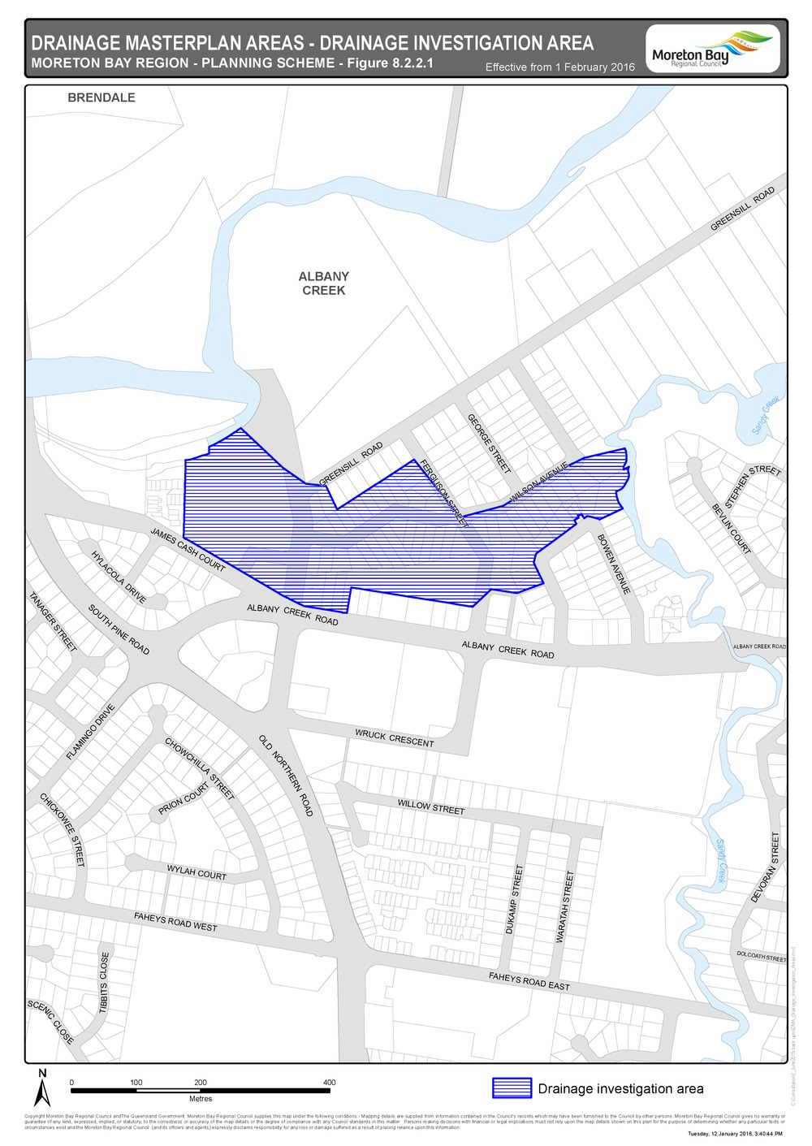

Figure 8.2.2.2 - Clontarf
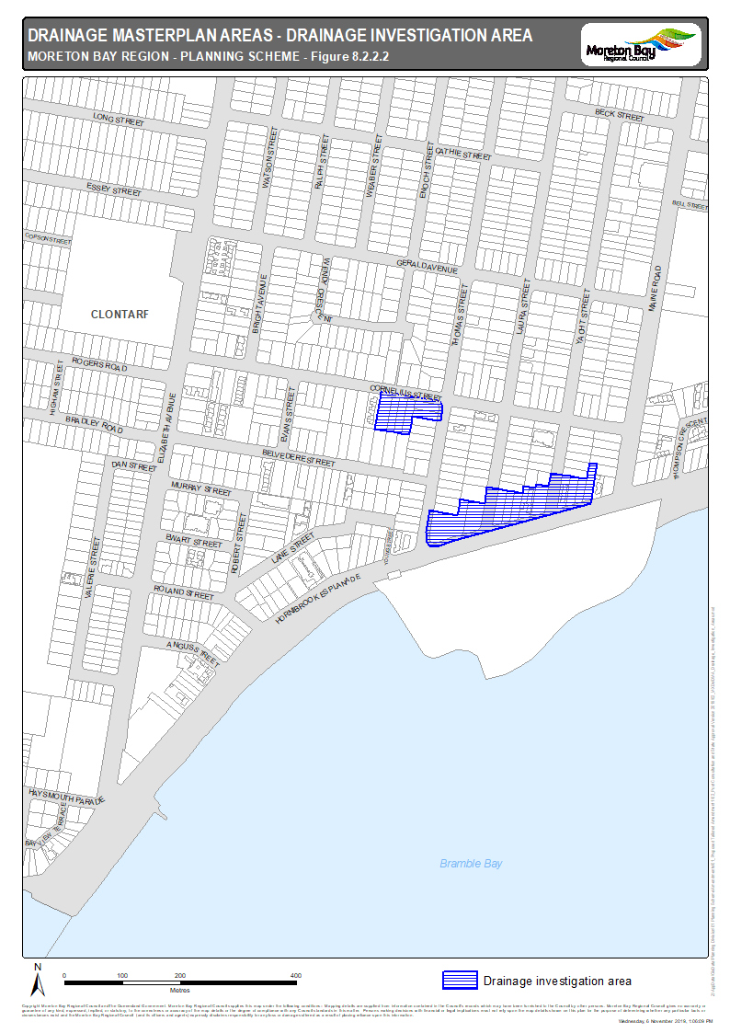
Figure 8.2.2.3 - Woody Point
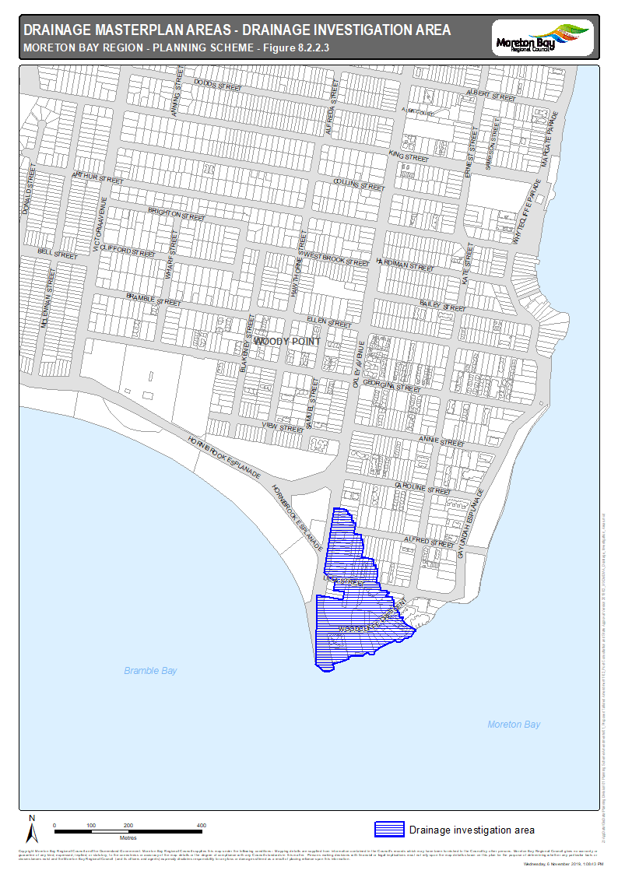
Figure 8.2.2.4 - Margate
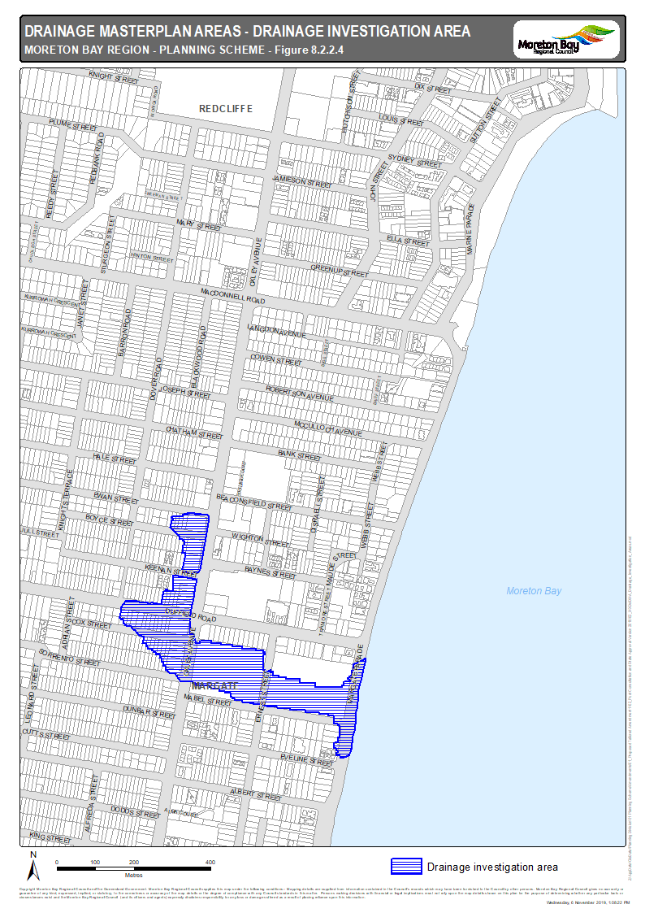
Figure 8.2.2.5 - Redcliffe - Scarborough
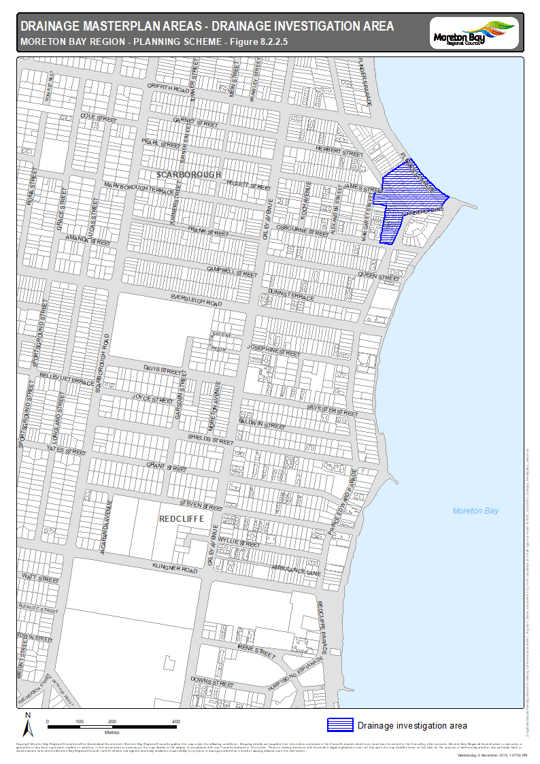
Figure 8.2.2.6 - Scarborough
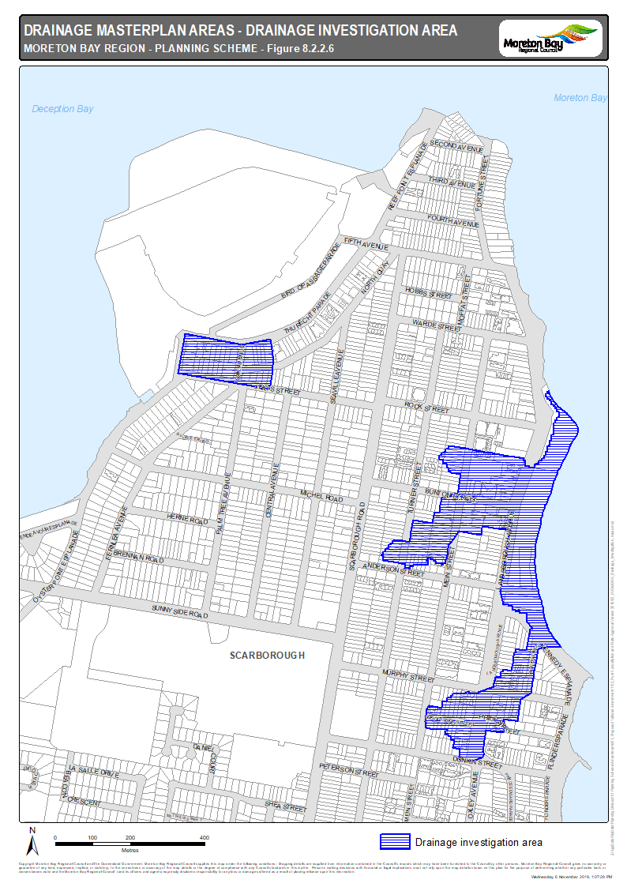
Figure 8.2.2.7 - Rothwell
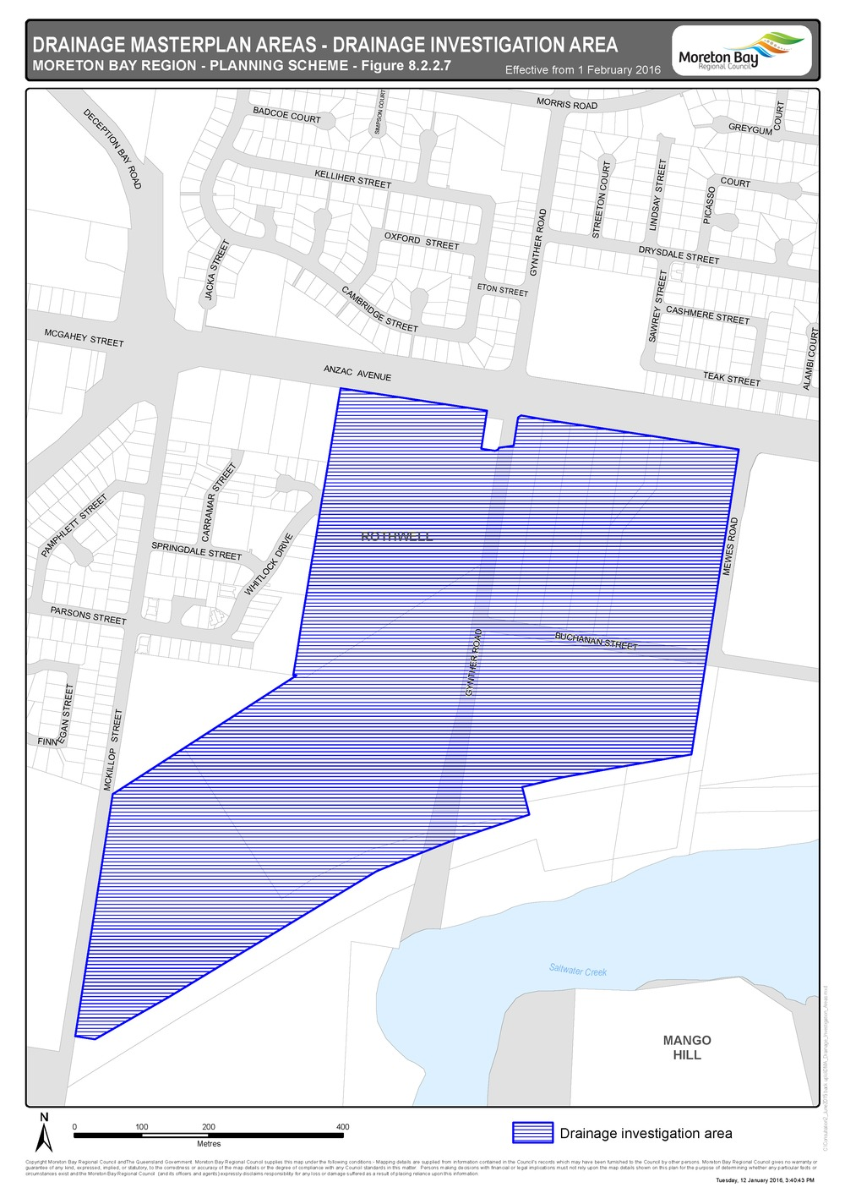

Figure 8.2.2.8 - Deception Bay
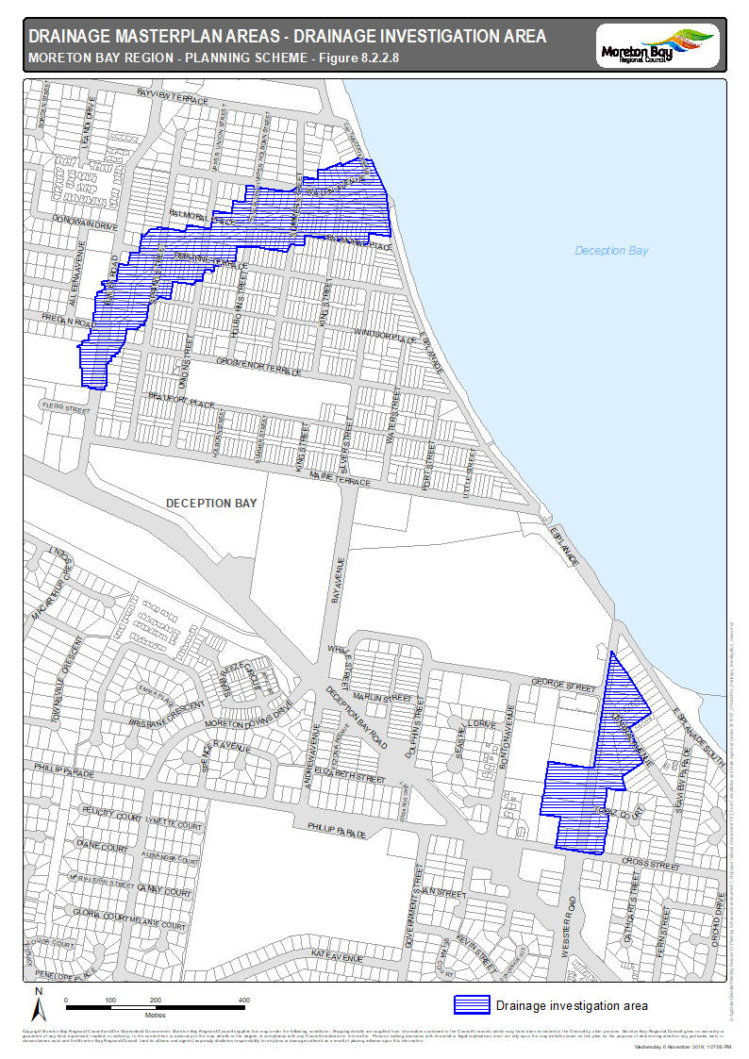
Figure 8.2.2.9 - Burpengary
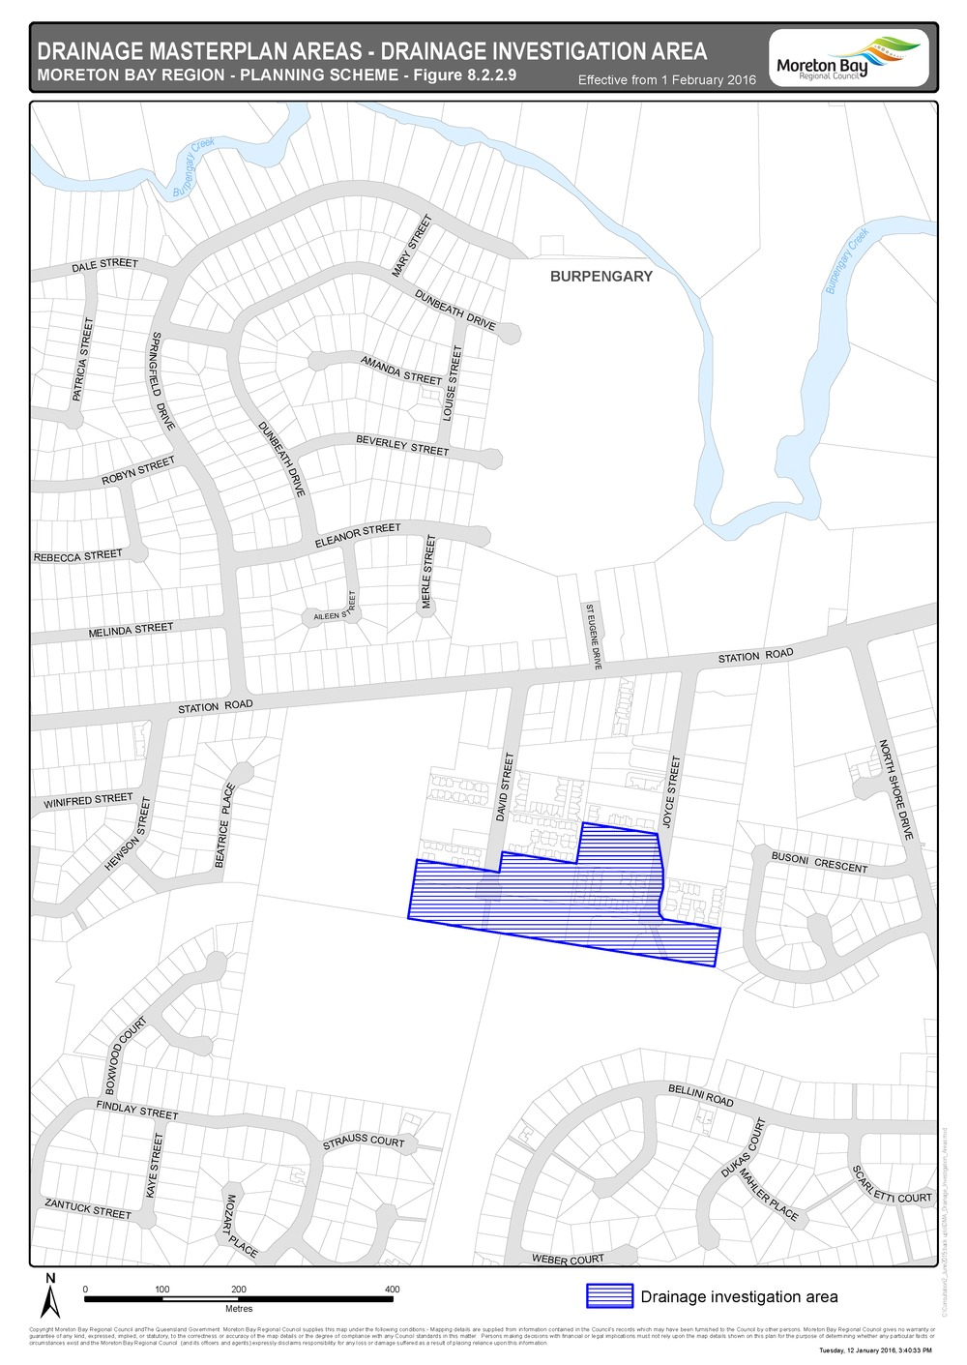

Figure 8.2.2.10 - Caboolture
