Table 7.2.3.4.1 Requirements for accepted development - Green network precinct

Requirements for accepted development |  | E Compliance  - Yes  - No | Council confirmation
General requirements
Structure plan and Neighbourhood development plan
RAD1 | Development occurs in accordance with a Neighbourhood development plan that reflects the urban structure concept shown indicatively on Figure 7.2.3.1 - Caboolture West structure plan and Figure 7.2.3.4 - Green network and open space:  - the provision of infrastructure and services associated with reconfiguring a lot and land development;  - utilities;  - parks⁽⁵⁷⁾ and open space;  - environmental and recreational facilities.
Lighting
RAD2 | Artificial lighting on-site is directed and shielded in such a manner as not to exceed the recommended maximum values of light technical parameters for the control of obtrusive light given in Table 2.1 of Australian Standard AS 4282 (1997) Control of Obtrusive Effects of Outdoor Lighting.  Note - "Curfewed hours” are taken to be those hours between 10pm and 7am on the following day.
Car parking
RAD3 | On-site car parking is provided in accordance with Schedule 7 - Car parking.
Vegetation clearing and environmental offset
RAD4 | No vegetation clearing is permitted except for:  - the provision of infrastructure and services associated with reconfiguring a lot and land development;  - utilities;  - Parks⁽⁵⁷⁾ and open space;  - environmental and recreational facilities.
RAD5 | Vegetation clearance in accordance with a Neighbourhood development plan that reflects the urban structure concept shown indicatively on Figure 7.2.3.1 - Caboolture West structure plan and Figure 7.2.3.4 - Green network and open space.
RAD6 | Any vegetation clearing is to be offset and that offset is located within the Green network precinct.

Works requirements
Utilities
RAD7 | Development is provided with an appropriate level of service and infrastructure in accordance with Planning scheme policy - Integrated design (Appendix A).
Access
RAD8 | Any new or changes to existing crossovers and driveways are designed, located and constructed in accordance with:  - where for a Council-controlled road and associated with a Dwelling house:  - Planning scheme policy - Integrated design;  - where for a Council-controlled road and not associated with a Dwelling house:  - AS/NZS2890.1 Parking facilities - Off street car parking;  - AS/NZS2890.2 - Parking facilities - Off-street commercial vehicle facilities;  - Planning scheme policy - Integrated design;  - Schedule 8 - Service vehicle requirements;  - where for a State-controlled road, the Safe Intersection Sight Distance requirements in AustRoads and the appropriate IPWEAQ standard drawings, or a copy of a Transport Infrastructure Act 1994, section 62 approval.
RAD9 | Any new or changes to existing internal driveways and access ways are designed and constructed in accordance with AS/NZS2890.1 Parking Facilities – Off street car parking and the relevant standards in Planning scheme policy - Integrated design.
RAD10 | Access driveways, manoeuvring areas and loading facilities are sealed and provide for service vehicles listed in Schedule 8 - Service vehicle requirements for the relevant use. The on-site manoeuvring is to be in accordance with Schedule 8 - Service vehicle requirements.
Stormwater
RAD11 | Stormwater run-off from the site is conveyed to a point of lawful discharge without causing actionable nuisance to any person, property or premises in accordance with Planning scheme policy - Integrated design.
Site works and construction management
RAD12 | The site and any existing structures are maintained in a tidy and safe condition.
RAD13 | Site construction works incorporate temporary stormwater run-off, erosion and sediment controls and trash traps designed in accordance with the Urban Stormwater Quality Planning Guidelines and Planning scheme policy - Integrated design.
RAD14 | Construction traffic, including contractor car parking, is controlled in accordance with a traffic management plan prepared in accordance with the Manual of Uniform Traffic Control Devices (MUTCD).
RAD15 | All vegetation to be retained on-site is clearly identified and fenced or protected prior to development works commencing.  Note - Refer to value and constraint requirements for accepted development in this table for classes of vegetation to be retained for accepted development subject to requirements.
RAD16 | Any damage to council land or infrastructure is to be repaired or replaced, with the same materials prior to plan sealing or final building classification.
RAD17 | Any material dropped, deposited or spilled on the road(s) as a result of construction processes associated with the site are to be cleaned at all times.
Earthworks
RAD18 | The site is prepared and the fill placed on-site in accordance with AS3798.  Note - The fill is to be inspected and tested in accordance with Planning scheme policy - Operational works inspection, maintenance and bonding procedures.
RAD19 | The total of all cut and fill on-site does not exceed 900mm in height.  Figure - Cut and fill  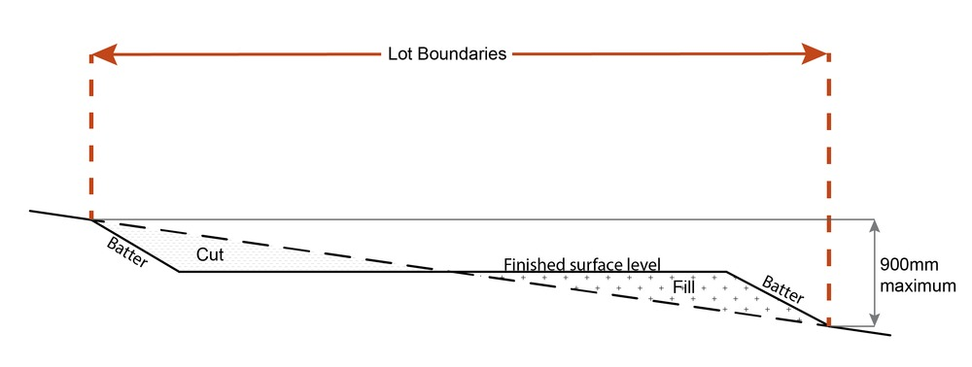  Note - This is site earthworks not building work.
RAD20 | Cut and fill batters, (other than batters to dams and water impoundments), have a finished slope no steeper than the following:  - any cut batter is no steeper than 1V in 4H;  - any fill batter, (other than a compacted fill batter), is no steeper than 1V in 4H;  - any compacted fill batter is no steeper than 1V in 4H.
RAD21 | All cut and fill batters are provided with appropriate scour, erosion protection and run-off control measures including catch drains at the top of batters and lined batter drains as necessary.
RAD22 | Stabilisation measures are provided, as necessary, to ensure long-term stability and low maintenance of steep slopes and batters.  Note - Inspection and certification of steep slopes and batters may be required by a suitably qualified and experienced RPEQ.
RAD23 | All fill and excavation is contained on-site and is free draining.
RAD24 | Earthworks undertaken on the development site are shaped in a manner which does not:  - prevent stormwater surface flow which, prior to commencement of the earthworks, passed onto the development site, from entering the land; or  - redirect stormwater surface flow away from existing flow paths; or  - divert stormwater surface flow onto adjacent land (other than a road) in a manner which:  - concentrates the flow; or  - increases the flow rates of stormwater over the affected section of the adjacent land above the situation which existed prior to the diversion; or  - causes actionable nuisance to any person, property or premises.
RAD25 | All fill placed on-site is:  - limited to that necessary for the approved use;  - clean and uncontaminated (i.e. no building waste, concrete, green waste, actual acid sulfate soils, potential acid sulfate soils or contaminated material etc.).
RAD26 | Filling or excavation that would result in any of the following is not carried out on-site:  - a reduction in cover over any Council or public sector entity infrastructure to less than 600mm;  - an increase in finished surface grade over, or within 1.5m on each side of, the Council or public sector entity infrastructure above that which existed prior to the filling or excavation works being undertaken;  - prevent reasonable access to Council or public sector entity maintained infrastructure or any drainage feature on, or adjacent to the site for monitoring, maintenance or replacement purposes.  Note - Public sector entity is defined in Schedule 2 of the Act.  Note - All building work covered by QDC MP1.4 is excluded from this provision.
Fire services
Note - The provisions under this heading only apply if:
- the development is for, or incorporates:
  - reconfiguring a lot for a community title scheme creating 1 or more vacant lots; or
  - material change of use for 2 or more sole occupancy units on the same lot, or within the same community titles scheme; or
  - material change of use for a Tourist park⁽⁸⁴⁾ with accommodation in the form of caravans or tents; or
  - material change of use for outdoor sales⁽⁵⁴⁾, outdoor processing or outdoor storage where involving combustible materials.
AND
- none of the following exceptions apply:
  - the distributor-retailer for the area has indicated, in its netserv plan, that the premises will not be served by that entity’s reticulated water supply; or
  - every part of the development site is within 60m walking distance of an existing fire hydrant on the distributor-retailer’s reticulated water supply network, measured around all obstructions, either on or adjacent to the site.

Note - The provisions under this heading do not apply to buildings that are required by the Building Code of Australia to have a fire hydrant system complying with Australian Standard AS 2419.1 (2005) – Fire Hydrant Installations or other fire fighting facilities which provide equivalent protection.

RAD27 | External fire hydrant facilities are provided on site to the standard prescribed under the relevant parts of Australian Standard AS 2419.1 (2005) – Fire Hydrant Installations.  Note - For this requirement for accepted development, the following are the relevant parts of AS 2419.1 (2005):  - in regard to the form of any fire hydrant - Part 8.5 and Part 3.2.2.1, with the exception that for Tourist parks⁽⁸⁴⁾ or development comprised solely of dwellings and their associated outbuildings, single outlet above-ground hydrants or suitably signposted in-ground hydrants would be an acceptable alternative;  - in regard to the general locational requirements for fire hydrants - Part 3.2.2.2 (a), (e), (f), (g) and (h) as well as Appendix B of AS 2419.1 (2005);  - in regard to the proximity of hydrants to buildings and other facilities - Part 3.2.2.2 (b), (c) and (d), with the exception that:  - - for dwellings and their associated outbuildings, hydrant coverage need only extend to the roof and external walls of those buildings;  - - for caravans and tents, hydrant coverage need only extend to the roof of those tents and caravans;  - - for outdoor sales⁽⁵⁴⁾, processing or storage facilities, hydrant coverage is required across the entire area of the outdoor sales⁽⁵⁴⁾, outdoor processing and outdoor storage facilities; and  - in regard to fire hydrant accessibility and clearance requirements - Part 3.5 and where applicable, Part 3.6.
RAD28 | A continuous path of travel having the following characteristics is provided between the vehicle access point to the site and each external fire hydrant and hydrant booster point on the land:  - an unobstructed width of no less than 3.5m;  - an unobstructed height of no less than 4.8m;  - constructed to be readily traversed by a 17 tonne HRV fire brigade pumping appliance;  - an area for a fire brigade pumping appliance to stand within 20m of each fire hydrant and 8m of each hydrant booster point.
RAD29 | On-site fire hydrant facilities are maintained in effective operating order in a manner prescribed in Australian Standard AS1851 (2012) – Routine service of fire protection systems and equipment.
RAD30 | For development that contains on-site fire hydrants external to buildings:  - those external hydrants can be seen from the vehicular entry point to the site; or  - a sign identifying the following is provided at the vehicular entry point to the site:  - the overall layout of the development (to scale);  - internal road names (where used);  - all communal facilities (where provided);  - the reception area and on-site manager’s office (where provided);  - external hydrants and hydrant booster points;  - physical constraints within the internal roadway system which would restrict access by fire fighting appliances to external hydrants and hydrant booster points.  Note - The sign prescribed above, and the graphics used are to be:  - in a form;  - of a size;  - illuminated to a level;  which allows the information on the sign to be readily understood, at all times, by a person in a fire fighting appliance up to 4.5m from the sign.
RAD31 | For development that contains on-site fire hydrants external to buildings, those hydrants are identified by way of marker posts and raised reflective pavements markers in the manner prescribed in the technical note Fire hydrant indication system produced by the Queensland Department of Transport and Main Roads.  Note - Technical note Fire hydrant indication system is available on the website of the Queensland Department of Transport and Main Roads.

Use specific requirements
Environment facility ⁽²⁶⁾
RAD32 |  | All buildings and structures associated with an Environment facility⁽²⁶⁾ are setback 10m from all property boundaries.
RAD33 |  | The maximum height of any building and structure associated with an Environment facility⁽²⁶⁾ is 5m.
Outdoor sport and recreation ⁽⁵⁵⁾
RAD34 |  | Site cover of all buildings and structures does not exceed 10%.
RAD35 |  | All buildings and structures are setback a minimum of 10m from all property boundaries.
RAD36 |  | The maximum height of all buildings and structures is 8.5m.
RAD37 |  | Bins and bin storage areas are provided, designed and managed in accordance with Planning scheme policy – Waste.
RAD38 |  | Outdoor storage areas are screened from adjoining sites and roads by either planting, wall(s), fence(s) or a combination thereof at least 1.8m in height along the length of the storage area.
Permanent plantation ⁽⁵⁹⁾
RAD39 |  | Planting only comprises native species endemic to the area.
Telecommunications facility ⁽⁸¹⁾
Editor's note - In accordance with the Federal legislation Telecommunications facilities⁽⁸¹⁾ must be constructed and operated in a manner that will not cause human exposure to electromagnetic radiation beyond the limits outlined in the Radiocommunications (Electromagnetic Radiation - Human Exposure) Standard 2003 and Radio Protection Standard for Maximum Exposure Levels to Radiofrequency Fields - 3Khz to 300Ghz.

RAD40 |  | A minimum area of 45m² is available to allow for additional equipment shelters and associated structures for the purpose of co-locating on the proposed facility.
RAD41 |  | The development results in no net reduction in the minimum quantity and standard of landscaping, private or communal open space or car parking spaces required under the planning scheme or under an existing development approval.
RAD42 |  | Equipment shelters and associated structures are located:  - directly beside the existing equipment shelter and associated structures;  - behind the main building line;  - further away from the frontage than the existing equipment shelter and associated structures;  - a minimum of 10m from side and rear boundaries.
RAD43 |  | Equipment shelters and other associated structures are either the same type of colour or material to match the surrounding locality.
RAD44 |  | The facility is enclosed by security fencing or by other means to ensure public access is prohibited.
RAD45 |  | A minimum 3m wide strip of dense planting is provided around the perimeter of the fenced area, between the development and street frontage and adjoining uses.  Note - Landscaping is provided in accordance with Planning scheme policy - Integrated design.  Note - Council may require a detailed landscaping plan, prepared by a suitably qualified person to ensure compliance with Planning scheme policy - Integrated design.
RAD46 |  | All equipment comprising the telecommunications facility⁽⁸¹⁾ which produces audible or non-audible sound is housed within a fully enclosed building incorporating sound control measures sufficient to ensure no noise from this equipment can be heard, or felt at the site boundary.
Values and constraints requirements

Note - The relevant values and constraints requirements do not apply where the development is consistent with a current Development permit for Reconfiguring a lot or Material change of use or Operational work, where that approval has considered and addressed (e.g. through a development footprint plan (or similar in the case of Landslide hazard) or conditions of approval) the identified value or constraint under this planning scheme.

Acid sulfate soils - (refer Overlay map - Acid sulfate soils to determine if the following requirements apply)
Note - Planning scheme policy - Acid sulfate soils provides guidance for requirements for accepted development that has the potential to disturb acid sulfate soils i.e. development involving filling or excavation works below the thresholds of 100m³ and 500m³ respectively.

RAD47 | Development does not involve:  - excavation or otherwise removing of more than 100m³ of soil or sediment where below 5m Australian Height Datum AHD, or  - filling of land of more than 500m³ of material with an average depth of 0.5m or greater where below the 5m AHD.  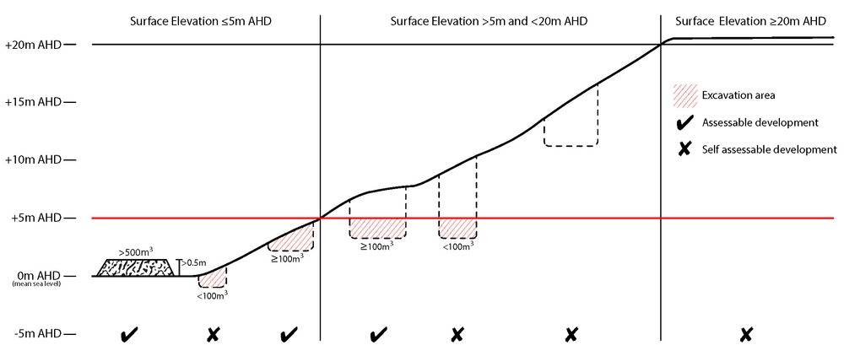
Bushfire hazard (refer Overlay map - Bushfire hazard to determine if the following requirements apply)
Note - For the purposes of section 12 of the Building Regulation 2006, land identified as very high potential bushfire intensity, high potential bushfire intensity, medium potential bushfire intensity or potential impact buffer on the Bushfire hazard area overlay map is the 'designated bushfire hazard area'. AS 3959-2009 Construction of buildings in bushfire hazard area applies within these areas.

Note - The bushfire hazard area provisions do not apply where a development envelope recognising and responding to this constraint has been identified and approved by Council as part of a reconfiguration of lot, development approval or approved Bush Fire Management Plan in this and previous planning schemes.

RAD48 | Building and structures have contained within the site:  - a separation from classified vegetation of 20m or the distance required to achieve a bushfire attack level (BAL) at the building, roofed structure or fire fighting water supply of no more than 29, whichever is the greater;  - a separation from low threat vegetation of 10m or the distance required to achieve a bushfire attack level (BAL) at the building, roof structure or fire fighting water supply of no more than 29, whichever is the greater;  - a separation of no less than 10m between a fire fighting water supply extraction point and any classified vegetation, buildings and other roofed structures;  - an area suitable for a standard fire fighting appliance to stand within 3m of a fire fighting water supply extraction point; and  - an access path suitable for use by a standard fire fighting appliance having a formed width of at least 4m, a cross-fall of no greater than 5%, and a longitudinal gradient of no greater than 25%;  - to, and around, each building and other roofed structures; and  - to each fire fighting water supply extraction point.  Note - The meaning of the terms classified vegetation and low threat vegetation as well as the method of calculating the bushfire attack level are as described in Australian Standard AS3959.
RAD49 | The length of driveway:  - to a public road does not exceed 100m between the most distant part of a building used for any purpose other than storage and the nearest part of a public road;  - has a maximum gradient no greater than 12.5%;  - have a minimum width of 3.5m;  - accommodate turning areas for fire fighting appliances in accordance with Qld Fire and Emergency Services' Fire Hydrant and Vehicle Access Guideline.
RAD50 | - A reticulated water supply is provided by a distributer retailer for the area or, where not connected to a reticulated water supply, on-site fire fighting water storage containing not less than 10,000 litres (tanks with fire brigade tank fittings, swimming pools) is provided and located within 10m of buildings and structures.  - Where a swimming pool is the nominated on-site fire fighting water storage source, vehicle access to within 3m of that water storage source is provided.  - Where a tank is the nominated on-site fire fighting water storage source, it includes:  - a hardstand area allowing medium rigid vehicle (15 tonne fire appliance) access within 6m of the tank;  - fire brigade tank fittings, comprising 50mm ball valve and male camlock coupling and, if underground, an access hole of 20mm (minimum) to accommodate suction lines.
RAD51 | Development does not involve the manufacture or storage of hazardous chemicals.
Heritage and landscape character (refer Overlay map - Heritage and landscape character to determine if the following requirements apply)
RAD52 | Development is for the preservation, maintenance, repair and restoration of the building, item or object of cultural heritage value.
RAD53 | Any maintenance, repair and restoration works are in accordance with Council approval. A cultural heritage construction management plan for maintenance, repair and restoration is prepared in accordance with Planning scheme policy - Heritage and landscape character.
Infrastructure buffer areas (refer Overlay map – Infrastructure buffers to determine if the following requirements apply)
RAD54 | Except where located on Figure 7.2.3.1 - Caboolture West structure plan or an approved Neighbourhood development plan, development does not involve the construction of any buildings or structures within a high voltage electricity line buffer.
RAD55 | Except where located on an approved Neighbourhood development plan, development does not involve the construction of any buildings or structures within a water supply pipeline buffer.
Overland flow path (refer Overlay map - Overland flow path to determine if the following requirements apply)
RAD56 | Development for a material change of use or building work does not involve the construction of a building or structure in an Overland flow path area.
RAD57 | Development for a material change of use or operational work does not impede the flow of flood waters through the premises or worsen flood flows to other premises.  Note - A report from a suitably qualified Registered Professional Engineer Queensland is required certifying that the development does not increase the potential for significant adverse impacts on an upstream, downstream or surrounding premises.  Note - Reporting to be prepared in accordance with Planning scheme policy – Flood hazard, Coastal hazard and Overland flow
RAD58 | Development for a material change of use or building work ensures that fencing in an overland flow path area is at least 50% permeable.
RAD59 | Development for a material change of use or building work that involves a hazardous chemical ensures the hazardous chemicals is not located within an overland flow path area.
RAD60 | Development for a material change of use or building work for a Park⁽⁵⁷⁾ ensures that work is provided in accordance with the requirements set out in Appendix B of the Planning scheme policy - Integrated design.

