Table 7.2.2.2 Assessable development - All precincts
Performance outcomes | Examples that achieve aspects of the Performance Outcomes | E Compliance  -Yes  -No See PO or  -NA | Justification for compliance
General criteria
Events
PO1  The frequency of Woodfordia events⁽¹⁰²⁾ held at Woodfordia⁽¹⁰¹⁾ each year is consistent with site capacity and surrounding infrastructure and does not adversely impact on the amenity of surrounding properties. | E1  The maximum number of event days⁽⁹²⁾ held at Woodfordia⁽¹⁰¹⁾ during a calendar year does not exceed:  - fourteen (14) event days⁽⁹²⁾ for grand events⁽⁹⁶⁾;  - eighteen (18) event days⁽⁹²⁾ for major events⁽⁹⁷⁾;  - twenty-four (24) event days⁽⁹²⁾ for moderate events⁽⁹⁹⁾.  Note - There is no maximum number of event days⁽⁹²⁾ for minor events⁽⁹⁸⁾ or smaller Woodfordia events⁽¹⁰²⁾ held at Woodfordia⁽¹⁰¹⁾ per calendar year.
PO2  During an Woodfordia event⁽¹⁰²⁾, entertainment, facilities, parking and camping:  - are restricted to appropriate areas of Woodfordia⁽¹⁰¹⁾ to maintain the amenity of surrounding residents;  - are adequate to meet the needs of Woodfordia event⁽¹⁰²⁾ participants and meet all relevant regulations and standards;  - are designed and located so as to minimise impacts on rural character;  - provide for safe internal traffic circulation and access to the external road network. | E2.1  Event entertainment:  - occurs only in the Festival valley precinct or in a building designed to mitigate the impact of noise; and  - does not impact on the amenity of surrounding sensitive land uses.
E2.2
Event facilities⁽⁹⁴⁾:
- occur only within the Festival valley precinct or Event facilities precinct; and
- are adequately provided to meet the needs of Woodfordia event⁽¹⁰²⁾ participants.
E2.3
Event camping⁽⁹¹⁾ is screened from view from outside Woodfordia⁽¹⁰¹⁾ through the placement of temporary screening for the duration of the Woodfordia event⁽¹⁰²⁾.
E2.4
Event parking⁽⁹⁵⁾:
- during a grand event⁽⁹⁶⁾ or a major event⁽⁹⁷⁾, occurs only within the Eastern, Event support or Festival valley precincts or within the Camping precinct (part of Lot 7 on RP840560 only);
- during a moderate event⁽⁹⁹⁾ or minor event⁽⁹⁸⁾, occurs only within the Event facilities or Festival valley precincts.
PO3  Site preparation activities ancillary to and necessarily associated with Woodfordia events⁽¹⁰²⁾ occur for a reasonable period of time before and after events. | E3  All persons not directly associated with the setting up or dismantling of a Woodfordia event⁽¹⁰²⁾ must:  - not enter the site more than three (3) days prior to a grand event⁽⁹⁶⁾ or major event⁽⁹⁷⁾ commencing or one (1) day prior to a moderate event⁽⁹⁹⁾ or minor event⁽⁹⁸⁾ commencing;  - vacate the site within three (3) days of completion of a grand event⁽⁹⁶⁾ or major event⁽⁹⁷⁾ and one (1) day of completion of a moderate event⁽⁹⁹⁾ or minor event⁽⁹⁸⁾.
PO4  Woodfordia events⁽¹⁰²⁾ are operated so as to ensure the safety and comfort of participants and the minimisation of adverse impacts on environmental values and the wider community at all times. | E4.1  Woodfordia events⁽¹⁰²⁾ are conducted in accordance with an event management plan, submitted for approval by Council prior to the public promotion and ticket sales of the Woodfordia event⁽¹⁰²⁾.
E4.2
An event management plan is to:
- be submitted to Council at least eight (8) weeks prior to the public promotion and ticket sales of the Woodfordia event⁽¹⁰²⁾;
- identify how the various aspects and potential adverse impacts of the Woodfordia event⁽¹⁰²⁾ will be managed;
- demonstrate how all necessary services and facilities will be provided, including potable water and solid waste and waste water management;
- address acoustic management and bushfire management where dedicated management plans have not been previously prepared and approved by the relevant authorities;
- address transport and access issues by a plan approved by Council, Department of Transport and Main Roads and Queensland Police Service, for a
  - Minor event⁽⁹⁸⁾, a traffic management plan
  - Grand event⁽⁹⁶⁾, Major event⁽⁹⁷⁾ or Moderate event⁽⁹⁹⁾, a Transport and access management plan;
- address water quality management in accordance with the requirements of the Environmental Protection (Water) Policy 2009 – Stanley River environmental values and water quality objectives (July 2010);
- incorporate an emergency management plan, which outlines suitable communication and evacuation procedures, including traffic management, during an emergency on the site (including bushfire, flood and landslide);
- include provisions to avoid potential harm to koalas on the site during a Woodfordia event⁽¹⁰²⁾, including restricting domestic animals being brought to the site and restricting vehicle speeds at Woodfordia⁽¹⁰¹⁾ during a Woodfordia event⁽¹⁰²⁾;
- establish a priority contact phone number for local residents during events to report security issues, noise complaints, traffic issues or other event-related issues;
- be consistent with the requirements of the Woodfordia local plan code and the relevant provisions of any past approvals;
- include new and improved practices that have been developed as a result of the experiences that have occurred in the conduct of Woodfordia events⁽¹⁰²⁾;
- be prepared in consultation with relevant authorities including the Queensland Police Service, Moreton Bay Regional Council and where necessary and the Queensland Fire and Rescue Service;
- in the case of a grand event⁽⁹⁶⁾ or major event⁽⁹⁷⁾, include provision for consultation with the neighbouring properties at least 30 days prior to the Woodfordia event⁽¹⁰²⁾;
- be implemented as approved including any variations or conditions imposed.
E4.3
Where an event management plan is applicable to more than one Woodfordia event⁽¹⁰²⁾, an opportunity for the review of the event management plan after each Woodfordia event⁽¹⁰²⁾ is to be provided, having regard to the operation of and any complaints received during the previous Woodfordia event⁽¹⁰²⁾.
Note - To remove any doubt, nothing in this requirement prevents the submission and Council approval of an event management plan that is applicable to more than one Woodfordia event⁽¹⁰²⁾.

PO5  Surrounding property owners and the wider community are provided with adequate notice and information about Woodfordia events⁽¹⁰²⁾ planned to be held and the likely impacts arising from the Woodfordia events⁽¹⁰²⁾. Adequate processes for feedback and complaints are established, which allow for the continual improvement of Woodfordia event⁽¹⁰²⁾ management. | E5.1  The controller of Woodfordia⁽¹⁰¹⁾ is to prepare, maintain and make publicly available, a three (3) year program of upcoming minor events⁽⁹⁸⁾, moderate events⁽⁹⁹⁾, major events⁽⁹⁷⁾ and grand events⁽⁹⁶⁾, to the best of the controller of the site’s knowledge:  - days/dates of the operation of the Woodfordia event⁽¹⁰²⁾;  - the type/scale of the Woodfordia event⁽¹⁰²⁾;  - a brief description and schedule of the main activities for the Woodfordia event⁽¹⁰²⁾;  - the size of individual Woodfordia events⁽¹⁰²⁾ and estimated attendance;  - anticipated transport arrival and departure profile of individual Woodfordia events⁽¹⁰²⁾.  Note - To remove any doubt, nothing in this requirement prevents the preparation of a single document containing the program of upcoming Woodfordia events⁽¹⁰²⁾ (E5.1) and the register of events held (E5.2).
E5.2
The controller of Woodfordia⁽¹⁰¹⁾ is to prepare and maintain a register of minor events⁽⁹⁸⁾, moderate events⁽⁹⁹⁾, major events⁽⁹⁷⁾ and grand events⁽⁹⁶⁾ held at Woodfordia⁽¹⁰¹⁾, available to Council and the Department of Transport and Main Roads on request and detailing:
- the dates and hours of operation of individual Woodfordia events⁽¹⁰²⁾;
- a brief description of the activities that occurred during individual Woodfordia events⁽¹⁰²⁾;
- the size of individual Woodfordia events⁽¹⁰²⁾, and estimated actual attendance
- arrival and departure transport profile of the Woodfordia events⁽¹⁰²⁾;
- the nature and quantity of complaints received by the Woodfordia event operator during the Woodfordia event⁽¹⁰²⁾;
- the details of any action taken by the Woodfordia event operator in response to the complaint.
E5.3
The controller of Woodfordia⁽¹⁰¹⁾ is to prepare a consultation management plan, available to Council on request and detailing:
- the objectives of community consultation;
- the nature and forms of consultation that will be carried out;
- when consultation with be carried out;
- who is responsible for undertaking consultation.
PO6  Noise associated with a Woodfordia event⁽¹⁰²⁾ or event preparation activities ancillary to and necessarily associated with an Woodfordia event⁽¹⁰²⁾ does not cause environmental harm or nuisance to surrounding sensitive land uses. | E6.1  Woodfordia events⁽¹⁰²⁾ are conducted in accordance with an acoustic management plan, prepared by a suitably qualified person and approved by Council prior to the public promotion and ticket sales of the Woodfordia event⁽¹⁰²⁾.
E6.2
Acoustic management plans prepared for Woodfordia events⁽¹⁰²⁾ are to:
- address all potential noise impacts in accordance with ‘SC 6.16 Planning scheme policy - Noise’;
- identify how the potential impacts of noise from the event will be managed to satisfy the requirements of the Environmental Protection (Noise) Policy 2008;
- identify any special arrangements that may need to be put in place to achieve compliance with the requirements of the Environmental Protection (Noise) Policy 2008;
- be submitted to Council and approved at least eight (8) weeks prior to the public promotion and ticket sales of the Woodfordia event⁽¹⁰²⁾;
- be implemented as approved, including any variations or conditions imposed;
- provide opportunities for feedback from the community.
Note - To remove any doubt, nothing in this requirement prevents the submission of an acoustic management plan that is applicable to more than one Woodfordia event⁽¹⁰²⁾.

E6.3
Where an acoustic management plan is applicable to more than one Woodfordia event⁽¹⁰²⁾, an opportunity for the review of the acoustic management plan after each Woodfordia event⁽¹⁰²⁾ is to be provided, having regard to the operation of the previous Woodfordia event⁽¹⁰²⁾ and receipt of any relevant complaints received during the previous Woodfordia event⁽¹⁰²⁾.
E6.4
Activities not associated with a Woodfordia event⁽¹⁰²⁾ achieve compliance with the requirements of the Environmental Protection (Noise) Policy 2008.
PO7  Woodfordia events⁽¹⁰²⁾:  - minimise the people on a site exposed to bushfire risk;  - ensures the protection of life during the passage of a fire front;  are located and designed to increase the chance of survival of buildings, structures and people during a bushfire; | E7.1  Woodfordia events⁽¹⁰²⁾ are conducted in accordance with a Bushfire management plan, prepared by a suitably qualified person in accordance with Planning scheme policy – Bushfire prone areas and approved by Council prior to the Woodfordia event⁽¹⁰²⁾.  Note - To remove any doubt, nothing in this requirement prevents the submission of a bushfire management plan that is applicable to more than one Woodfordia event⁽¹⁰²⁾.
E7.2
Where a bushfire management plan is applicable to more than one Woodfordia event⁽¹⁰²⁾, an opportunity for the review of the bushfire management plan after each Woodfordia event⁽¹⁰²⁾ is to be provided, having regard to the operation of the previous Woodfordia event⁽¹⁰²⁾ and any relevant complaints received during the previous Woodfordia event⁽¹⁰²⁾.
PO8  Woodfordia events⁽¹⁰²⁾ minimise adverse impacts on the safe and efficient operation of the external road network. | E8.1  The controller of Woodfordia⁽¹⁰¹⁾ is to ensure Woodfordia events⁽¹⁰²⁾, greater than 350 people, are operated in accordance with a Traffic management plan or a Transport and access management plan approved by Council, the Department of Transport and Main Roads and the Queensland Police Service prior to the Woodfordia event⁽¹⁰²⁾.
E8.2
For every Woodfordia event⁽¹⁰²⁾ where no more than 350 persons are in attendance at any point in time:
- upgrading works have been undertaken to the intersection of Kilcoy – Beerwah Road and Woodrow Road to achieve the geometry, sightlines and construction generally in accordance with the standard shown in Figure 7.2.2.3 and event guide/directional signs complying with Figure 7.2.2.4 have been permanently installed along the southern and northern approaches to the intersection;
OR
- traffic management is undertaken in the manner prescribed in an traffic management plan that has been prepared, submitted and subsequently approved.
Note - To remove any doubt, nothing in this requirement prevents the submission of an traffic management plan that is applicable to more than one Woodfordia event⁽¹⁰²⁾. Such a traffic management plan must fully address the specific characteristics associated with each Woodfordia event⁽¹⁰²⁾ and any approval of the plan will be subject to a condition that the entity having overall responsibility for its implementation must keep detailed records of traffic related complaints received during the course of the Woodfordia event⁽¹⁰²⁾.
Note - The approved traffic management plan is to be implemented as varied or conditioned in response to complaints by the assessing authorities.

Editor's note - Guidance on how to prepare Transport access and management plans and a Traffic management plans is provided in ‘SC 6.22 Planning scheme policy - Woodfordia transport and access management’

E8.3
A minor event⁽⁹⁸⁾ is operated in accordance with a traffic management plan prepared by a suitably qualified person and approved by Council, the Department of Transport and Main Roads and the Queensland Police Service prior to the Woodfordia event⁽¹⁰²⁾.
Note - To remove any doubt, nothing in this requirement prevents the submission of a traffic management plan that is applicable to more than one Woodfordia event⁽¹⁰²⁾.
Editor's note - Guidance on how to prepare Transport access and management plans and a Traffic management plans is provided in ‘SC 6.22 Planning scheme policy - Woodfordia transport and access management’.

E8.4
For every Grand event⁽⁹⁶⁾, Major event⁽⁹⁷⁾ or Moderate event⁽⁹⁹⁾, traffic management is undertaken in the manner prescribed in a transport and access management plan that has been prepared, submitted and subsequently approved in accordance with the following:
- the plan has been prepared by a person with suitable qualifications in traffic management and engineering;
- the plan has been prepared in consultation with Council, the Department of Transport and Main Roads and the Queensland Police Service;
- the plan addresses all matters contained in Planning scheme policy – Integrated transport assessment that are relevant to the context;
- the plan addresses all matters contained in section 1.43.5 within volume 1 of the Traffic and Road Use Management Manual – Special Events Affecting Roads in Queensland (Department of Transport and Main Roads);
- the plan conforms with the Manual of Uniform Traffic Control Devices Part 3 Works on Roads (Department of Transport and Main Roads);
- the plan is submitted to the Department of Transport and Main Roads and the Queensland Police Service with sufficient lead time to allow a minimum of four (4) weeks for assessment, review and approval prior to lodgement with Council;
- the plan is submitted to Council a minimum of 8 weeks prior to Grand events and Major events and 4 weeks prior for Moderate events to allow for assessment, review and approval, and includes evidence of approval by the Department of Transport and Main Roads and the Queensland Police Service;
- the plan provides priority access during Woodfordia events⁽¹⁰²⁾ to emergency vehicles and local residents accessing their properties;
- the plan incorporates emergency traffic management procedures that cater for the emergency exit of all patrons of the site in the event the intersection of Woodrow Road and Kilcoy-Beerwah Road is closed;
- the plan identifies where the location of parking for the particular Woodfordia event⁽¹⁰²⁾ is to be located and if there is more than one parking location, how the use of those parking areas will be managed;
- the plan identifies measures for maintaining safe pedestrian connectivity between the Eastern precinct and the balance of Woodfordia⁽¹⁰¹⁾.
Note - To remove any doubt, nothing in this requirement prevents the submission of a transport and access management plan that is applicable to more than one Woodfordia event⁽¹⁰²⁾. Such a transport and access management plan must fully address the specific characteristics associated with each Woodfordia event⁽¹⁰²⁾ and any approval of the plan will be subject to a condition that the entity having overall responsibility for its implementation keeping detailed records of traffic related complaints received during the course of the Woodfordia event⁽¹⁰²⁾.
Note - The approved transport and access management plan is to be implemented as varied or conditioned by the assessing authorities.

Editor's note - Guidance on how to prepare Transport access and management plans and a Traffic management plans is provided in ‘SC 6.22 Planning scheme policy - Woodfordia transport and access management’.

E8.5
Where a transport and access management plan or a traffic management plan is applicable to more than one Woodfordia event⁽¹⁰²⁾, the plan is reviewed, revised as necessary and resubmitted for approval by Council and the Department of Transport and Main Roads between the events covered by the plan. The controller of Woodfordia⁽¹⁰¹⁾ must ensure the revised plan and detailed records of all traffic related complaints are submitted 4 weeks prior to the next Woodfordia event⁽¹⁰²⁾. The revised plan must specifically address:
- observed adverse impacts on the operation of the transport network that can reasonably be attributed to previous Woodfordia events⁽¹⁰²⁾ covered by that management plan;
- any transport related complaints received during the previous Woodfordia events⁽¹⁰²⁾ covered by that management plan; and
- any other changes aimed at further reducing adverse impacts and minimising likely traffic induced complaints.
Note - It is recommended that a lead time of at least 4 weeks be allowed between resubmission of the revised plan and any promotion of the next Woodfordia event⁽¹⁰²⁾.

Access and parking
PO9  Vehicle access points to Woodfordia⁽¹⁰¹⁾ minimise queuing on, and ensure the safe and efficient operation of the external road network. | E9  Vehicle access to Woodfordia⁽¹⁰¹⁾ is provided only through the access points shown in an approved traffic management plan or a transport and access management plan for the Woodfordia event⁽¹⁰²⁾.
PO10  Adequate parking areas are provided to accommodate all employees, volunteers and participants' vehicles within Woodfordia⁽¹⁰¹⁾. | E10  Car parking is provided wholly within Woodfordia⁽¹⁰¹⁾ and in accordance with:  - an approved traffic management plan or a transport and access management plan for the Woodfordia event⁽¹⁰²⁾; OR  - SC 7 ‘Car parking’.
PO11  Parking areas do not detract from the scenic values of the area and are constructed to a sufficient standard to enable access during inclement weather and emergencies. | E11  Car parking areas are screened from view from outside of Woodfordia⁽¹⁰¹⁾ by vegetation.
All development requirements
PO12  Development respects and maintains the cultural, environmental and scenic values of the area. Development in elevated locations:  - retains important skyline elements and significant views into and out of Woodfordia⁽¹⁰¹⁾;  - Is responsive to the natural topography of Woodfordia⁽¹⁰¹⁾ and minimises cutting and filling on hillsides. | E12.1  Buildings:  - are not located within Open space areas shown on Figure 7.2.2.2;  - are a maximum height of:  - 20 metres for single stage structure in the Festival valley precinct;  - 15m in the Festival valley and Event support precinct;  - 8.5m in all other precincts;  - service structures and mechanical plant are screened or designed as part of the building.
E12.2
Buildings:
- retain native vegetation on hillsides and ridgelines where possible;
- are not taller than the natural height of the ridgeline formed by the surrounding topography;
- are constructed in accordance with the requirements and recommendations outlined in any slope stability management plan prepared for Woodfordia⁽¹⁰¹⁾;
- are responsive to the natural topography of Woodfordia⁽¹⁰¹⁾, minimising cutting and filling on hillsides.
PO13  Development has no adverse impacts on the environmental values of Woodfordia⁽¹⁰¹⁾ or the adjoining Bellthorpe National Park. | E13  Buildings and earthworks:  - are not located within the Open space areas;  - Incorporate water sensitive design features to protect the downstream water quality of the Stanley River catchment.
PO14  Development protects and enhances waterway corridors and resources, their hydrologic, waterway quality and ecological functions. | E14.1  Woodfordia⁽¹⁰¹⁾ is managed to protect and enhance the natural values present in the Open space area shown on Figure 7.2.2.2.
E14.2
Outside of the Open space area shown on Figure 7.2.2.2, Woodfordia⁽¹⁰¹⁾ is managed to:
- retain vegetation along waterways;
- provide habitat connectivity between waterways;
- minimise land degradation and disturbance to dispersive soils;
- minimise the release of sediment and nutrient into waterways;
- retain ground cover and vegetation adjoining waterways;
- incorporate appropriate sediment control devices which maintain the quality of water discharged into waterways.
Short term accommodation and Caretaker's accommodation⁽¹⁰⁾
PO15  The scale and location of short-term accommodation⁽⁷⁷⁾ and caretaker's accommodation⁽¹⁰⁾:  - is consistent with the rural character of the area;  - minimises impacts on visual amenity;  - minimises impacts on adjoining property owners;  - avoids areas of open space or environmental value. | E15.1  Short-term accommodation⁽⁷⁷⁾:  - is located outside of the Open space areas shown on Figure 7.2.2.2;  - is not located in the Camping precinct or Eastern precinct;  - does not exceed accommodation for 300 persons at Woodfordia⁽¹⁰¹⁾.  Note - For clarification, event camping⁽⁹¹⁾ forms part of an event and may occur in all precincts during and around event days⁽⁹²⁾. Short-term accommodation⁽⁷⁷⁾ is a separately defined use, not associated with an event and is restricted to the Event facilities and Festival valley precinct.
E15.2
Short-term accommodation⁽⁷⁷⁾ units have a maximum gross floor area of 60m², exclusive of balconies, verandas and decks.
E15.3
Caretaker's accommodation⁽¹⁰⁾:
- does not exceed a total of 5 dwellings;
- is not located in the Camping precinct;
- is provided with 1 car parking space per unit of accommodation.
PO16  Adequate services and facilities, including but not limited to shower and toilet facilities are provided for all short-term accommodation⁽⁷⁷⁾. | E16.1  Short-term accommodation⁽⁷⁷⁾ units are:  - self-contained with respect to shower and toilet facilities; or  - located within reasonable proximity of an amenities building with shower and toilet facilities.
E16.2
When self-contained, short-term accommodation⁽⁷⁷⁾ units are connected to:
- a potable water supply;
- the on-site sewerage treatment plant.
Educational establishment⁽²⁴⁾
PO17  The educational establishment⁽²⁴⁾ is subordinate to and directly associated with the primary use of Woodfordia⁽¹⁰¹⁾ as an events venue, is consistent with the rural character of the locality and provided with adequate services and facilities. | E17.1  Training or instruction is provided only in the fields associated with the maintenance of Woodfordia⁽¹⁰¹⁾ or conduct of events and remains subordinate to the primary use intended for Woodfordia⁽¹⁰¹⁾.
E17.2
1 car parking space per 10 students is provided.
E17.3
On-site student accommodation:
- comprises a maximum gross floor area of 1,000m²;
- is self-contained with respect to shower and toilet facilities, or located adjacent to an amenities building with shower and toilet facilities;
- when self-contained, on-site student accommodation is connected to:
  - a potable water supply;
  - the on-site sewerage treatment plant.
Office⁽⁵³⁾
PO18  Offices⁽⁵³⁾ at Woodfordia⁽¹⁰¹⁾ are used for carrying out administrative functions associated with the management of Woodfordia⁽¹⁰¹⁾ and events held at Woodfordia⁽¹⁰¹⁾. | No example provided.
Rural use setbacks
PO19  Development ensures:  - sufficient separation from existing sensitive land uses to avoid adverse impacts from chemical spray, fumes, odour and dust;  - environmental nuisance or annoyance resulting from-but not limited to-noise, storage of materials and waste does not adversely impact on sensitive land uses; and  - buildings and other structures are consistent with the open area, low density, low built form character and amenity associated with the rural environment. | E19  The following uses, associated buildings and structures are setback from the Woodfordia⁽¹⁰¹⁾ boundary as follows:  - Cropping⁽¹⁹⁾ (building only) – 10m  - Permanent plantations⁽⁵⁹⁾ – 25m  - Short-term accommodation⁽⁷⁷⁾ - 40m  - Wholesale nursery⁽⁸⁹⁾ – 10m.
Permanent plantation⁽⁵⁹⁾
PO20  Planting for permanent plantation⁽⁵⁹⁾ purposes:  - only comprises native species endemic to the area;  - is sufficiently set back from property boundaries to avoid adverse impacts on adjoining properties such as shading, fire risk, health and safety. | No example provided.
Development in the Eastern precinct
PO21  The scale of commercial and retail development within the Eastern precinct does not compete with Woodford township, as the primary local centre and service provider in the area. | E21  In the Eastern precinct, the combined maximum gross floor area of food and drink outlets⁽²⁸⁾, administrative offices⁽⁵³⁾ and shops⁽⁷⁵⁾ does not exceed 500m².
PO22  The scale and design of development in the Eastern precinct:  - is in keeping with the rural character of the surrounding area;  - does not have any adverse impacts on nearby sensitive land uses. | E22  Buildings in the Eastern precinct:  - are a maximum height of 8.5m;  - are setback a minimum of 6.0m from Woodrow Road with dense screen planting provided in the setback.
PO23  Development in the Eastern precinct does not adversely affect the safe and efficient movement of traffic on Kilcoy-Beerwah Road. | E23.1  Vehicle access is only obtained from Woodrow Road.
E23.2
Car parking is wholly contained within the Eastern precinct.
PO24  Buildings in the Eastern precinct is connected to a suitable potable water supply and effluent disposal system. Effluent disposal avoids any adverse impacts on the water quality of waterways. | E24  Buildings are supplied with an adequate potable water supply and connected to an on-site effluent disposal system of a suitable design capacity to meet the needs of the buildings being established in the precinct.
Clearing of habitat trees where not located within Woodfordia Open Space Areas identified within Figure 7.2.2.2
PO25  - Development ensures that the biodiversity quality and integrity of habitats is not adversely impacted upon but maintained and protected.  - Development does not result in the net loss of fauna habitat. Where development does result in the loss of a habitat tree, development will provide replacement fauna nesting boxes at the following rate of 1 nest box for every hollow removed. Where hollows have not yet formed in trees > 80cm in diameter at 1.3m height, 3 nest boxes are required for every habitat tree removed.  - Development does not result in soil erosion or land degradation or leave land exposed for an unreasonable period of time but is rehabilitated in a timely manner  Note: Further guidance on habitat trees is provided in Planning scheme policy - Environmental areas | No example provided.
Values and constraints criteria
Note - The relevant values and constraints criteria do not apply where the development is consistent with a current Development permit for Reconfiguring a lot or Material change of use or Operational work, where that approval has considered and addressed (e.g. through a development footprint plan (or similar in the case of Landslide hazard) or conditions of approval) the identified value or constraint under this planning scheme.

Bushfire hazard (refer Overlay map - Bushfire hazard to determine if the following assessment criteria apply)
Note - To demonstrate achievement of the performance outcomes, a bushfire management plan is prepared by a suitably qualified person. Guidance for the preparation of a bushfire management plan is provided in Planning scheme policy – Bushfire prone areas.
Note - Unacceptable risk is defined as a situation where people or property are exposed to a predictable hazard event that may result in serious injury, loss of life, failure of community infrastructure, or property damage.

PO26  Development:  - minimises the number of buildings and people working and living on a site exposed to bushfire risk;  - ensures the protection of life during the passage of a fire front;  - is located and designed to increase the chance of survival of buildings and structures during a bushfire;  - minimises bushfire risk from build up of fuels around buildings and structures;  - ensure safe and effective access for emergency services during a bushfire. | E26  A bushfire management plan is prepared by a suitably qualified person in accordance with Planning scheme policy – Bushfire prone areas and approved by Council for the site. The management plan will include, but is not limited to, recommendations regarding fire breaks to and setbacks from adjoining vegetation, access for fire fighting appliances, water supply for fire fighting purposes, emergency evacuation procedures, landscaping treatments and construction of buildings. The plan is to be submitted to Council and the relevant fire authorities, including the Queensland Fire and Rescue Service for approval. Queensland Parks and Wildlife Service, as the agency responsible for the management of the adjacent Bellthorpe National Park are to be consulted in the preparation of this management plan.
PO27  Development provides an adequate water supply for fire-fighting purposes. | E27  - a reticulated water supply is provided by a distributer retailer for the area or;  - where not connected to a reticulated water supply, on-site fire fighting water storage containing not less than 10 000 litres (tanks with fire brigade tank fittings, swimming pools) is located within 10m of buildings and structures.  - Where a swimming pool is the nominated on-site fire fighting water storage source, vehicle access is provided to within 3m of that water storage source.  - Where a tank is the nominated on-site fire fighting water storage source, it includes:  - a hardstand area allowing medium rigid vehicles (15 tonne fire appliance) access within 6m of the tank;  - fire brigade tank fittings, comprising 50mm ball valve and male camlock coupling and, if underground, an access hole of 200mm (minimum) to accommodate suction lines.
PO28  Development:  - does not present unacceptable risk to people or environment due to the impact of bushfire on dangerous goods or combustible liquids;  - does not present danger or difficulty to emergency services for emergency response or evacuation.  Editor's note - Unacceptable risk is defined as a situation where people or property are exposed to a predictable hazard event that may result in serious injury, loss of life, failure of community infrastructure, or property damage. | E28  Development does not involve the manufacture or storage of hazardous chemicals.
Woodfordia Open Space Areas identified within Figure 7.2.2.2

Note – The following are excluded from the native vegetation clearing provisions of this planning scheme:
- Clearing of native vegetation located within an approved development footprint;
- Clearing of native vegetation within 10m from a lawfully established building reasonably necessary for emergency access or immediately required in response to an accident or emergency;
- Clearing of native vegetation identified within the annual assessment of trees and reasonably necessary to remove or reduce the risk vegetation poses to serious personal injury or damage to infrastructure;
- Clearing of native vegetation reasonably necessary to construct and maintain a property boundary fence and not exceed 4m in width from the boundary fence where within the Woodfordia Local Plan area;
- Clearing of native vegetation reasonably necessary for the purpose of maintenance or works within a registered easement for public infrastructure or drainage purposes;
- Clearing of native vegetation in accordance with a bushfire management plan prepared by a suitably qualified person, submitted to and accepted by Council;
- Clearing of native vegetation associated with removal of recognised weed species, maintaining existing open pastures and cropping land, windbreaks, lawns or created gardens;
- Grazing of native pasture by stock;
- Native forest practise where under Part 1, 1.7.7 Accepted development.
Note - Definition for native vegetation is located in Schedule 1 Definitions.

Note - Native vegetation subject to this criteria primarily comprises of matters of national environmental significance (MNES), matters of state environmental significance (MSES). They also comprise some matters of local environmental significance (MLES). A MLES is defined in Schedule 1.2, Administrative definitions.
Note - The native vegetation clearing provisions do not apply where a development footprint and development recognising and responding to this constraint has been identified and approved by Council as part of a reconfiguring a lot or development approval in this and previous planning schemes.

Note - To demonstrate achievement of the performance outcome, an ecological assessment, vegetation management plan and fauna management plan, as required, are prepared by a suitably qualified person. Guidance for the preparation of above mentioned reports is provided in Planning scheme policy - Environmental areas.

Vegetation clearing, ecological value and connectivity
PO29  Development avoids locating in Woodfordia Open space areas identified within Map 7.2.2.2. Where it is not practicable or reasonable for development to avoid establishing in these areas, development must ensure that:  - the quality and integrity of the biodiversity and ecological values inherent to a Open space areas areas identified within Map 7.2.2.2 is maintained and not lost or degraded;  - mechanisms or processes are in place demonstrating that any detrimental impacts on biodiversity and ecological values is replaced, restored or rehabilitated, for example through the development of a Vegetation Management Plan and a Fauna Management Plan. | No example provided.
PO30  Development provides for safe, unimpeded, convenient and ongoing wildlife movement and establishes and maintains habitat connectivity by:  - retaining habitat trees;  - providing contiguous patches of habitat;  - provide replacement and rehabilitation planting to improve connectivity;  - avoiding the creation of fragmented and isolated patches of habitat;  - providing wildlife movement infrastructure.  Editor's note - Wildlife movement infrastructure may include refuge poles, tree boulevarding, ‘stepping stone’ vegetation plantings, tunnels, appropriate wildlife fencing; culverts with ledges, underpasses, overpasses, land bridges and rope bridges. Further information is provided in Planning scheme policy – Environmental areas. | No example provided.
Vegetation clearing and habitat protection
PO31  Development ensures that the biodiversity quality and integrity of habitats is not adversely impacted upon but maintained and protected. | No example provided.
PO32  Development does not result in the net loss or degradation of habitat value in Woodfordia Open space areas identified within Map 7.2.2.2. Where development does result in the loss or degradation of habitat value, development will:  - rehabilitate, revegetate, restore and enhance an area to ensure it continues to function as a viable and healthy habitat area;  - provide replacement fauna nesting boxes in the event of habitat tree loss in accordance with Planning scheme policy - Environmental areas;  - undertake rehabilitation, revegetation and restoration in accordance with the South East Queensland Ecological Restoration Framework. | No example provided.
PO33  Development ensures safe, unimpeded, convenient and ongoing wildlife movement and habitat connectivity by:  - providing contiguous patches of habitat;  - avoiding the creation of fragmented and isolated patches of habitat;  - providing wildlife movement infrastructure;  - providing replacement and rehabilitation planting to improve connectivity. | No example provided.
Vegetation clearing and soil resource stability
PO34  Development does not:  - result in soil erosion or land degradation;  - leave cleared land exposed for an unreasonable period of time but is rehabilitated in a timely manner. | No example provided.
Vegetation clearing and water quality
PO35  Development maintains or improves the quality of groundwater and surface water within, and downstream, of a site by:  - ensuring an effective vegetated buffers and setbacks from waterbodies is retained to achieve natural filtration and reduce sediment loads;  - avoiding or minimising changes to landforms to maintain hydrological water flows;  - adopting suitable measures to exclude livestock from entering a waterbody where a site is being used for animal husbandry⁽⁴⁾ and animal keeping⁽⁵⁾ activities. | No example provided.
PO36  Development minimises adverse impacts of stormwater run-off on water quality by:  - minimising flow velocity to reduce erosion;  - minimising hard surface areas;  - maximising the use of permeable surfaces;  - incorporating sediment retention devices;  - minimising channelled flow. | No example provided.
Vegetation clearing, access and edge effects
PO37  Development retains safe and convenient public access in a manner that does not result in the adverse edge effects or the loss or degradation of biodiversity values within the environment. | No example provided.
PO38  Development minimises potential adverse ‘edge effects’ on ecological values by:  - providing dense planting buffers of native vegetation between a development and environmental areas;  - retaining patches of native vegetation of greatest possible size where located between a development and environmental areas ;  - restoring, rehabilitating and increasing the size of existing patches of native vegetation;  - ensuring that buildings and access (public and vehicle) are setback as far as possible from environmental areas and corridors;  - landscaping with native plants of local origin.  Editor's note - Edge effects are factors of development that go to detrimentally affecting the composition and density of natural populations at the fringe of natural areas. Factors include weed invasion, pets, public and vehicle access, nutrient loads, noise and light pollution, increased fire frequency and changes in the groundwater and surface water flow. | No example provided.
Landslide hazard (refer Overlay map - Landslide hazard to determine if the following assessment criteria apply)
Note - To demonstrate achievement of the performance outcomes, a site-specific geotechnical assessment report is prepared by a qualified engineer. Guidance for the preparation of a geotechnical assessment report is provided in Planning scheme policy – Landslide hazard.

PO39  Development:  - maintains the safety of people and property on a site and neighbouring sites from landslides;  - ensures the long-term stability of the site considering the full nature and end use of the development;  - ensures site stability during all phases of construction and development;  - minimises disturbance of natural drainage patterns of the site and does not result in the redirection or alteration of the existing flow if surface or groundwater  - minimises adverse visual impacts on the amenity of adjoining residents and provides a positive interface with the streetscape. | No example provided.
PO40  Buildings are designed to respond to sloping topography in the siting, design and form of buildings and structures by:  - minimising overuse of cut and fill to create single flat pads and benching;  - avoiding expanses of retaining walls, loss of trees and vegetation and interference with natural drainage systems;  - minimising any adverse visual impact on the landscape character ;  - Protect the amenity of adjoining properties. | No example provided.
PO41  Development protects the safety of people, property and the environment from the impacts of landslide on hazardous chemicals manufactured, handled or stored by incorporating design measures to ensure:  - the long-term stability of the development site considering the full nature and end use of the development;  - site stability during all phases of construction and development;  - the development is not adversely affected by landslide activity originating on sloping land above the site;  - emergency access and access from the site for the public and emergency vehicles is available and is not at risk from landslide. | No example provided.
Infrastructure buffers (refer Overlay map - Infrastructure buffers to determine if the following assessment criteria apply)
PO42  Development within the Gas pipeline buffer:  - avoids attracting people in large numbers to live, work or congregate;  - avoids the storage of hazardous chemicals;  - maintains adequate access for any required maintenance or upgrading work;  - minimises risk of harm to people and property.  Editor's note - The Petroleum and Gas (Production and Safety) Act 2004 (sections 807 and 808) requires that building or changes in surface level on pipeline land must not occur unless all the pipeline licence holders consent. | E42  Development does not involve the construction of any buildings or structures within the Gas pipeline buffer.  Editor's note - The Petroleum and Gas (Production and Safety) Act 2004 (sections 807 and 808) requires that building or changes in surface level on pipeline land must not occur unless all the pipeline licence holders consent.
Overland flow path (refer Overlay map - Overland flow path to determine if the following assessment criteria apply)
Note - The applicable river and creek flood planning levels associated with defined flood event (DFE) within the inundation area can be obtained by requesting a flood check property report from Council.

PO43  Development:  - minimises the risk to persons from overland flow;  - does not increase the potential for damage from overland flow either on the premises or other premises, public land, watercourses, roads or infrastructure. | No example provided.
PO44  Development:  - maintains the conveyance of overland flow predominantly unimpeded through the premises for any event up to and including the 1% AEP for the fully developed upstream catchment;  - does not concentrate, intensify or divert overland flow onto an upstream, downstream or surrounding property.  Note - A report from a suitably qualified Registered Professional Engineer Queensland is required certifying that the development does not increase the potential for significant adverse impacts on an upstream, downstream or surrounding premises.  Note - Reporting to be prepared in accordance with Planning scheme policy – Flood hazard, Coastal hazard and Overland flow. | No example provided.
PO45  Development does not:  - directly, indirectly or cumulatively cause any increase in overland flow velocity or level;  - increase the potential for flood damage from overland flow either on the premises or other premises, public lands, watercourses, roads or infrastructure.  Note - Open concrete drains greater than 1m in width are not an acceptable outcome, nor are any other design options that may increase scouring. | No example provided.
PO46  Development ensures that public safety and the risk to the environment are not adversely affected by a detrimental impact of overland flow on a hazardous chemical located or stored on the premises. | E46  Development ensures that a hazardous chemical is not located or stored in an Overland flow path area.  Note - Refer to the Work Health and Safety Act 2011 and associated Regulation and Guidelines, the Environmental Protection Act 1994 and the relevant building assessment provisions under the Building Act 1975 for requirements related to the manufacture and storage of hazardous substances.
PO47  Development which is not in a Rural zone ensures that overland flow is not conveyed from a road or public open space onto a private lot. | E47  Development which is not in a Rural zone that an overland flow paths and drainage infrastructure is provided to convey overland flow from a road or public open space area away from a private lot.
PO48  Development ensures that inter-allotment drainage infrastructure, overland flow paths and open drains through private property cater for overland flows for a fully developed upstream catchment and are able to be easily maintained.  Note - A report from a suitably qualified Registered Professional Engineer Queensland is required certifying that the development does not increase the potential for significant adverse impacts on an upstream, downstream or surrounding premises.  Note - Reporting to be prepared in accordance with Planning scheme policy – Flood hazard, Coastal hazard and Overland flow | E48.1  Development ensures that roof and allotment drainage infrastructure is provided in accordance with the following relevant level as identified in QUDM:  - Urban area – Level III;  - Rural area – N/A;  - Industrial area – Level V;  - Commercial area – Level V.
E48.2
Development ensures that inter-allotment drainage infrastructure is designed to accommodate any event up to and including the 1% AEP for the fully developed upstream catchment.
PO49  Development protects the conveyance of overland flow such that an easement for drainage purposes is provided over:  - a stormwater pipe if the nominal pipe diameter exceeds 300mm;  - an overland flow path where it crosses more than one premises;  - inter-allotment drainage infrastructure.  Note - Refer to Planning scheme policy - Integrated design for details and examples.  Note - Stormwater Drainage easement dimensions are provided in accordance with Section 3.8.5 of QUDM. | No example provided.
Additional criteria for development for a Park
PO50  Development for a Park⁽⁵⁷⁾ ensures that the design and layout responds to the nature of the overland flow affecting the premises such that:  - public benefit and enjoyment is maximised;  - impacts on the asset life and integrity of park structures is minimised;  - maintenance and replacement costs are minimised. | E50  Development for a Park⁽⁵⁷⁾ ensures works are provided in accordance with the requirements set out in Appendix B of the Planning scheme policy - Integrated design.
Scenic amenity - Regionally significant (Hills) and Locally important (Coast) (refer Overlay map - Scenic amenity to determine if the following assessment criteria apply)
PO51  Development:  - avoids being viewed as a visually conspicuous built form on a hill top or ridgeline;  - retain the natural character or bushland settings as the dominant landscape characteristic;  - is viewed as being visually consistent with the natural landscape setting and does not diminish the scenic and visual qualities present in the environment. | E51  Where located in the Regionally significant (Hills) scenic amenity overlay, buildings and structures are not:  - located on a hill top or ridge line;  - all parts of the building and structure are located below the hill top or ridge line.
PO52  Development:  - does not adversely detract or degrade the quality of views, vista or key landmarks;  - retains the natural character or bushland settings as the dominant landscape characteristic. | E52  Where located in the Regionally significant (Hills) scenic amenity overlay, driveways and accessways:  - go across land contours, and do not cut straight up slopes;  - follow natural contours, not resulting in batters or retaining walls being greater than 900mm in height.
PO53  Buildings and structures incorporate colours and finishes that:  - are consistent with a natural, open space character and bushland environment;  - do not produce glare or appear visual incompatible with the surrounding natural character and bushland environment;  - are not visually dominant or detract from the natural qualities of the landscape. | E53.1  Where located in the Regionally significant (hills) scenic amenity overlay, roofs and wall surfaces of buildings and structures adopt the following colours:  Colours from Australian Standard AS2700s – 1996  G12 – Holly G54 – Mist Green N 44 – Bridge Grey  G13 – Emerald G55 – Lichen N45 – Koala Grey  G14 – Moss Green G56 – Sage Green N52 – Mid Grey  G15 – Rainforest Green G62 – Rivergum N54 – Basalt  G16 – Traffic Green G64 – Slate N55 – Lead Grey  G17 – Mint Green G65 – Ti Tree X54 – Brown  G21 – Jade N25 – Birch Grey X61 – Wombat  G22 – Serpentine N32 – Green Grey X62 – Dark Earth  G23 – Shamrock N33 – Lightbox Grey X63 – Iron Bark  G24 – Fern Green N35 – Light Grey Y51 – Bronze Olive  G25 – Olive N41 – Oyster Y61 – Black Olive  G34 – Avocado N42 – Storm Grey Y63 – Khaki  G52 – Eucalyptus N43 – Pipeline Grey Y66 – Mudstone  G53 – Banksia
E53.2
Where located in the Regionally significant (hills) scenic amenity overlay, roofs and wall surfaces of buildings and structures are painted or finished such that reflectivity is less than 35%.

Figure 7.2.2.1: Woodfordia precincts
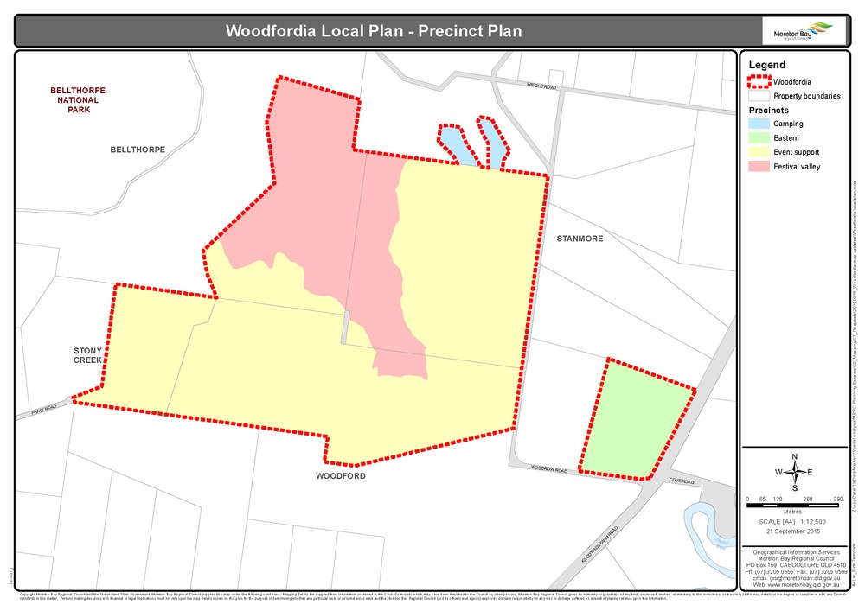
Figure 7.2.2.2: Woodfordia Open Space Areas

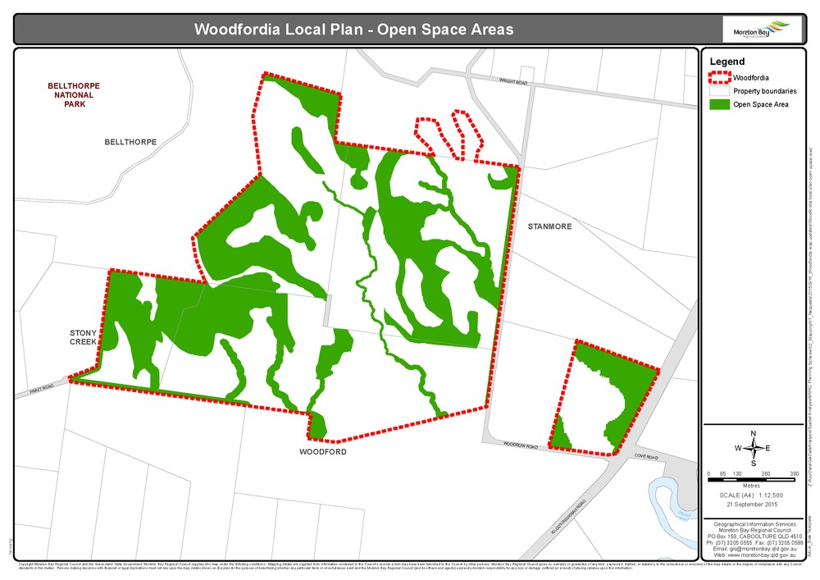
7.2.2.3 Woodfordia – Kilcoy-Beerwah / Woodrow Road Intersection upgrade
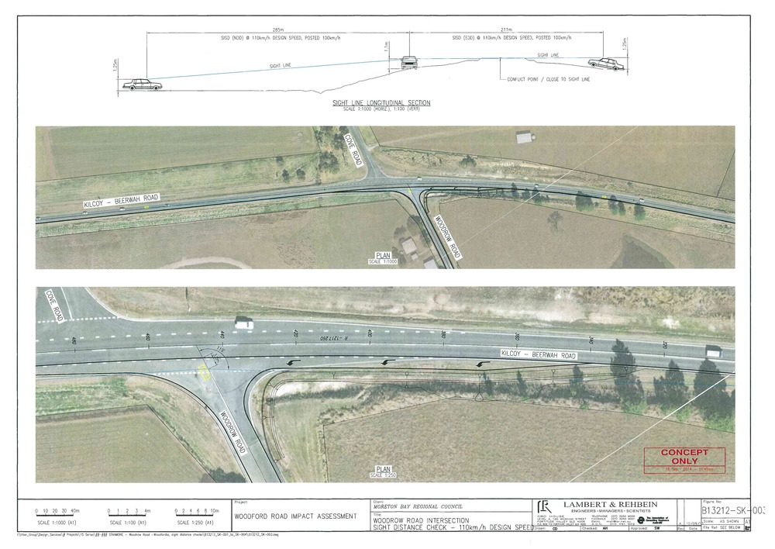
Figure 7.2.2.4 Woodfordia Directional signage
