Table 6.2.12.4.1 Requirements for accepted development - Township industry precinct

Requirements for accepted development |  | E Compliance  - Yes  - No | Council confirmation
General requirements
Extensions to existing buildings
RAD1 | Extensions to an existing building do not exceed 20% of the existing GFA on-site.  Note - The 20% increase in GFA includes all previous instances of GFA increase under this outcome, or as part of Building Work.
RAD2 | Where involving an extension (building work) development retains elements which have cultural heritage, character or streetscape significance.
Building height
RAD3 | Development does not exceed the maximum height identified on Overlay map - Building heights.
Setbacks
RAD4 | Extensions to buildings maintain a minimum setback of:  - 3m to the street frontage/s;  - 5m to land not included in the Industry zone.
Landscaping
RAD5 | Development does not result in a net reduction in established landscaping on the site.
Lighting
RAD6 | Artificial lighting on-site is directed and shielded in such a manner as not to exceed the recommended maximum values of light technical parameters for the control of obtrusive light given in Table 2.1 of the Australian Standard AS 4282 (1997) Control of Obtrusive Effects of Outdoor Lighting.  Note - "Curfewed hours" are taken to be those between 10pm and 7am the following day.
Car parking
RAD7 | On-site car parking is provided at a rate identified in Schedule 7 - Car parking.
Waste
RAD8 | Bins and bin storage area/s are provided, designed and managed in accordance with Planning scheme policy – Waste.
Hazardous Chemicals
RAD9 | All development that involves the storage or handling of hazardous chemicals listed in Schedule 9, Development involving hazardous chemicals, Table 9.0.1 Quantity thresholds for hazardous chemicals stored as accepted development subject to requirements complies with Table 9.0.3 Hazardous chemicals.
RAD10 | Development does not involve the storage or handling of hazardous chemicals listed in Schedule 9, Development involving hazardous chemicals, Table 9.0.2 Hazardous chemicals assessable thresholds.
Clearing of habitat trees where not located in the Environmental areas overlay map
RAD11 | Development does not result in the damaging, destroyed or clearing of a habitat tree. This does not apply to:  - Clearing of a habitat tree located within an approved development footprint;  - Clearing of a habitat tree within 10m from a lawfully established building reasonably necessary for emergency access or immediately required in response to an accident or emergency;  - Clearing of a habitat tree reasonably necessary to remove or reduce the risk vegetation poses to serious personal injury or damage to infrastructure;  - Clearing of a habitat tree reasonably necessary to construct and maintain a property boundary fence and not exceed 4m in width either side of the fence where in the Rural , Rural residential and Environmental management and conservation zones. In any other zone, clearing is not to exceed 2m in width either side of the fence;  - Clearing of a habitat tree reasonably necessary for the purpose of maintenance or works within a registered easement for public infrastructure or drainage purposes;  - Clearing of a habitat tree in accordance with a bushfire management plan prepared by a suitably qualified person, submitted to and accepted by Council;  - Clearing of a habitat tree associated with removal of recognised weed species, maintaining existing open pastures and cropping land, windbreaks, lawns or created gardens;  - Native forest practice where accepted development under Part 1, 1.7.7 Accepted development.  Editor's note - A native tree measuring greater than 80cm in diameter when measured at 1.3m from the ground is recognised as a ‘habitat tree’. For further information on habitat trees, refer to Planning scheme policy – Environmental areas and corridors. Information detailing how this measurement is undertaken is provided in Australian Standard AS 4970 2009 Protection of Trees on Development Sites - Appendix A.

Works requirements
Utilities
RAD12 | Development is provided with an appropriate level of service and infrastructure in accordance with Planning scheme policy - Integrated design (Appendix A).
Access
RAD13 | The frontage road is fully constructed to Council’s standards.  Note - Roads are considered to be constructed in accordance with Council standards when there is sufficient pavement width, geometry and depth to comply with the requirements of Planning scheme policy - Integrated design and Planning scheme policy - Operational works inspection, maintenance and bonding procedures. Testing of the existing pavement may be required to confirm whether the existing works meet the standards in Planning scheme policy - Integrated design and Planning scheme policy - Operational works inspection, maintenance and bonding procedures.  Note - Frontage roads include streets where no direct lot access is provided.
RAD14 | Any new or changes to existing crossovers and driveways are designed, located and constructed in accordance with:  - where for a Council-controlled road and associated with a Dwelling house:  - Planning scheme policy - Integrated design;  - where for a Council-controlled road and not associated with a Dwelling house:  - AS/NZS2890.1 Parking facilities Part 1: Off street car parking;  - AS/NZS 2890.2 - Parking facilities Part 2: Off-street commercial vehicle facilities;  - Planning scheme policy - Integrated design;  - Schedule 8 - Service vehicle requirements;  - where for a State-Controlled road, the Safe Intersection Sight Distance requirements in Austroads and the appropriate IPWEAQ standard drawings, or a copy of a Transport Infrastructure Act 1994, section 62 approval.
RAD15 | Any new or changes to existing internal driveways and access ways are designed and constructed in accordance with AS/NZS 2890.1 Parking Facilities Part 1: Off street car parking and the relevant standards in Planning scheme policy - Integrated design.
RAD16 | Access driveways, manoeuvring areas and loading facilities are sealed and provide for service vehicles listed in Schedule 8 - Service vehicle requirements for the relevant use. The on-site manoeuvring is to be in accordance with Schedule 8 - Service vehicle requirements.
RAD17 | Access driveways, manoeuvring areas and loading facilities are constructed with reinforced concrete road pavements. Concrete is to be designed in accordance with rigid road pavement design principles.  Note - Pavements are to be designed by a RPEQ.
Stormwater
RAD18 | Any new or changes to existing stormwater run-off from the site is conveyed to a point of lawful discharge without causing actionable nuisance to any person, property or premises in accordance with Planning scheme policy – Integrated design.  Note - A watercourse as defined in the Water Act may be accepted as a lawful point of discharge providing the drainage discharge from the site does not increase the downstream flood levels during events up to and including the 1% AEP storm. An afflux of +20mm may be accepted on Council controlled land and road infrastructure. No worsening is ensured when stormwater is discharged into a catchment that includes State Transport Infrastructure.
RAD19 | Development incorporates a 'deemed to comply solution' to manage stormwater quality where the development:  - is for an urban purpose that involves a land area of 2500m² or greater; and  - will result in:  - 6 or more dwellings; or  - an impervious area greater than 25% of the net developable area.  Note - The deemed to comply solution is to be designed, constructed, established and maintained in accordance with the requirements of Water by Design ‘Deemed to Comply Solutions - Stormwater Quality Management for South East Queensland’ and Planning scheme policy - Integrated design.
RAD20 | Development ensures that surface flows entering the premises from adjacent properties are not blocked, diverted or concentrated.  Note - A report from a suitably qualified Registered Professional Engineer Queensland may be required certifying that the development does not increase the potential for significant adverse impacts on an upstream, downstream or surrounding premises.
RAD21 | Development ensures that works (e.g. fences and walls) do not block, divert or concentrate the flow of stormwater to adjoining properties.  Note - A report from a suitably qualified Registered Professional Engineer Queensland may be required certifying that the development does not increase the potential for significant adverse impacts on an upstream, downstream or surrounding premises.
RAD22 | Stormwater drainage infrastructure (excluding detention and bio-retention systems) through or within private land is protected by easements in favour of Council (at no cost to Council). Minimum easement widths are as follows:  Pipe Diameter Minimum Easement Width (excluding access requirements)  Stormwater Pipe up to 825mm diameter 3.0m  Stormwater Pipe up to 825mm diameter with Sewer pipe up to 225m diameter 4.0m  Stormwater pipe greater than 825mm diameter Easement boundary to be 1m clear of the outside wall of the pipe and clear of all pits.  Note - Additional easement width may be required in certain circumstances in order to facilitate maintenance access to the stormwater system.  Note - Refer to Planning scheme policy - Integrated design (Appendix C) for easement requirements over open channels.
Site works and construction management
RAD23 | The site and any existing structures are to be maintained in a tidy and safe condition.
RAD24 | Development does not cause erosion or allow sediment to leave the site.  Note - The International Erosion Control Association (Australasia) Best Practice Erosion and Sediment Control provides guidance on strategies and techniques for managing erosion and sedimentation.
RAD25 | No dust emissions extend beyond the boundaries of the site during soil disturbances and construction works.
RAD26 | Existing street trees are protected and not damaged during works.  Note - Where development occurs in the tree protection zone, measures and techniques as detailed in Australian Standard AS 4970 Protection of trees on developments sites are adopted and implemented.
RAD27 | Any damage to Council land or infrastructure is repaired or replaced with the same materials, prior to plan sealing, or final building classification.
RAD28 | Construction traffic including contractor car parking is controlled in accordance with a traffic management plan, prepared in accordance with the Manual of Uniform Traffic Control Devices (MUTCD) to ensure all traffic movements to and from the site are safe.
RAD29 | Any material dropped, deposited or spilled on the road(s) as a result of construction processes associated with the site are to be cleaned at all times.
RAD30 | All native vegetation to be retained on-site is temporarily fenced or protected prior to and during development works.  Note - No parking of vehicles or storage of machinery or goods is to occur in these areas during development works
RAD31 | Disposal of materials is managed in one or more of the following ways:  - all cleared vegetation, declared weeds, stumps, rubbish, car bodies, scrap metal and the like are removed and disposed of in a Council land fill facility; or  - all native vegetation with a diameter below 400mm is to be chipped and stored on-site.  Note - No burning of cleared vegetation is permitted.  Note - The chipped vegetation must be stored in an approved location.
RAD32 | All development works are carried out within the following times:  - Monday to Saturday (other than public holidays) between 6:30am and 6:30pm on the same day;  - no work is to be carried out on Sundays or public holidays.
Earthworks
RAD33 | The total of all cut and fill on-site does not exceed 900mm in height.  Figure - Cut and fill  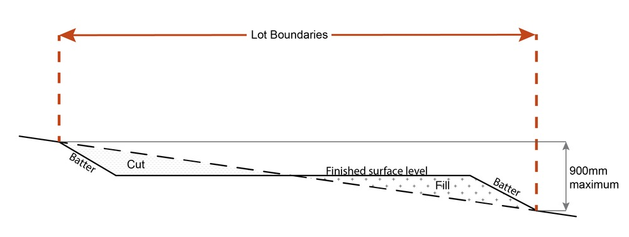  Note - This is site earthworks not building work.
RAD34 | Cut and fill batters, (other than batters to dams and water impoundments), have a finished slope no steeper than the following:  - any cut batter is no steeper than 1V in 4H;  - any fill batter, (other than a compacted fill batter), is no steeper than 1V in 4H;  - any compacted fill batter is no steeper than 1V in 4H.
RAD35 | All cut and fill batters are provided with appropriate scour, erosion protection and run-off control measures including catch drains at the top of batters and lined batter drains as necessary.
RAD36 | Stabilisation measures are provided, as necessary, to ensure long-term stability and low maintenance of steep slopes and batters.  Note - Inspection and certification of steep slopes and batters may be required by a suitably qualified and experienced RPEQ.
RAD37 | All fill and excavation is contained on-site and is free draining.
RAD38 | Earthworks undertaken on the development site are shaped in a manner which does not:  - prevent stormwater surface flow which, prior to commencement of the earthworks, passed onto the development site, from entering the land; or  - redirect stormwater surface flow away from existing flow paths; or  - divert stormwater surface flow onto adjacent land (other than a road) in a manner which:  - concentrates the flow; or  - increases the flow rates of stormwater over the affected section of the adjacent land above the situation which existed prior to the diversion; or  - causes actionable nuisance to any person, property or premises.
RAD39 | All fill placed on-site is:  - limited to that necessary for the approved use;  - clean and uncontaminated (i.e. no building waste, concrete, green waste, actual acid sulfate soils, potential acid sulfate soils or contaminated material etc.).
RAD40 | The site is prepared and the fill placed on-site in accordance with Australian Standard AS3798.  Note - The fill is to be inspected and tested in accordance with Planning scheme policy - Operational works inspection, maintenance and bonding procedures
RAD41 | No filling or excavation is undertaken in an easement issued in favour of Council or a public sector entity.  Note - Public sector entity is defined in Schedule 2 of the Act.
RAD42 | Filling or excavation that would result in any of the following is not carried out on site:  - a reduction in cover over any Council or public sector entity infrastructure to less than 600mm;  - an increase in finished surface grade over, or within 1.5m on each side of, the Council or public sector entity infrastructure above that which existed prior to the filling or excavation works being undertaken;  - prevent reasonable access to Council or public sector entity maintained infrastructure or any drainage feature on, or adjacent to the site for monitoring, maintenance or replacement purposes.  Note - Public sector entity is defined in Schedule 2 of the Act.  Note - All building work covered by QDC MP1.4 is excluded from this provision.
Fire services
Note - The provisions under this heading only apply if:
- the development is for, or incorporates:
  - reconfiguring a lot for a community title scheme creating 1 or more vacant lots; or
  - material change of use for 2 or more sole occupancy units on the same lot, or within the same community titles scheme; or
  - material change of use for a Tourist park⁽⁸⁴⁾ with accommodation in the form of caravans or tents; or
  - material change of use for outdoor sales⁽⁵⁴⁾, outdoor processing or outdoor storage where involving combustible materials.
AND
- none of the following exceptions apply:
  - the distributor-retailer for the area has indicated, in its netserv plan, that the premises will not be served by that entity’s reticulated water supply; or
  - every part of the development site is within 60m walking distance of an existing fire hydrant on the distributor-retailer’s reticulated water supply network, measured around all obstructions, either on or adjacent to the site.
Note - The provisions under this heading do not apply to buildings that are required by the Building Code of Australia to have a fire hydrant system complying with Australian Standard AS 2419.1 (2005) – Fire Hydrant Installations or other fire fighting facilities which provide equivalent protection.

RAD43 | External fire hydrant facilities are provided on site to the standard prescribed under the relevant parts of Australian Standard AS 2419.1 (2005) – Fire Hydrant Installations.  Note - For this requirement for accepted development, the following are the relevant parts of AS 2419.1 (2005):  - in regard to the form of any fire hydrant - Part 8.5 and Part 3.2.2.1, with the exception that for Tourist parks⁽⁸⁴⁾ or development comprised solely of dwellings and their associated outbuildings, single outlet above-ground hydrants or suitably signposted in-ground hydrants would be an acceptable alternative;  - in regard to the general locational requirements for fire hydrants - Part 3.2.2.2 (a), (e), (f), (g) and (h) as well as Appendix B of AS 2419.1 (2005);  - in regard to the proximity of hydrants to buildings and other facilities - Part 3.2.2.2 (b), (c) and (d), with the exception that:  - - for dwellings and their associated outbuildings, hydrant coverage need only extend to the roof and external walls of those buildings;  - - for caravans and tents, hydrant coverage need only extend to the roof of those tents and caravans;  - - for outdoor sales⁽⁵⁴⁾, processing or storage facilities, hydrant coverage is required across the entire area of the outdoor sales⁽⁵⁴⁾, outdoor processing and outdoor storage facilities; and  - in regard to fire hydrant accessibility and clearance requirements - Part 3.5 and where applicable, Part 3.6.
RAD44 | A continuous path of travel having the following characteristics is provided between the vehicle access point to the site and each external fire hydrant and hydrant booster point on the land:  - an unobstructed width of no less than 3.5m;  - an unobstructed height of no less than 4.8m;  - constructed to be readily traversed by a 17 tonne HRV fire brigade pumping appliance;  - an area for a fire brigade pumping appliance to stand within 20m of each fire hydrant and 8m of each hydrant booster point.
RAD45 | On-site fire hydrant facilities are maintained in effective operating order in a manner prescribed in Australian Standard AS1851 (2012) – Routine service of fire protection systems and equipment.
RAD46 | For development that contains on-site fire hydrants external to buildings:  - those external hydrants can be seen from the vehicular entry point to the site; or  - a sign identifying the following is provided at the vehicular entry point to the site:  - the overall layout of the development (to scale);  - internal road names (where used);  - all communal facilities (where provided);  - the reception area and on-site manager’s office (where provided);  - external hydrants and hydrant booster points;  - physical constraints within the internal roadway system which would restrict access by fire fighting appliances to external hydrants and hydrant booster points.  Note - The sign prescribed above, and the graphics used are to be:  - in a form;  - of a size;  - illuminated to a level;  which allows the information on the sign to be readily understood, at all times, by a person in a fire fighting appliance up to 4.5m from the sign.
RAD47 | For development that contains on-site fire hydrants external to buildings, those hydrants are identified by way of marker posts and raised reflective pavements markers in the manner prescribed in the technical note Fire hydrant indication system produced by the Queensland Department of Transport and Main Roads.  Note - Technical note Fire hydrant indication system is available on the website of the Queensland Department of Transport and Main Roads.
Use specific requirements
Land use
RAD48 |  | Where within 100m of a sensitive zone:  - development is undertaken fully indoors;  - uses do not create audible noise measured at the boundary of the site between the hours of 7:00 pm and 6:00 am;  - any new plant or air conditioning equipment is not located along adjoining boundaries with sensitive land uses and screened from view of the street;  - landscaping and noise attenuating fencing are used to buffer visual and audible impacts generated from the use.
RAD49 |  | The combined area for ancillary office⁽⁵³⁾ and administration functions does not exceed 10% of the GFA or 200m² whichever is the lesser.
RAD50 |  | The display of items for sale to the public is limited to commodities, articles or goods resulting from the industrial processes undertaken on-site and limited to 5% of the GFA or 100m² of the use, whichever is the lesser.
Caretaker's accommodation ⁽¹⁰⁾
RAD51 |  | Caretaker's accommodation⁽¹⁰⁾:  - has a maximum GFA of 80m²;  - does not gain access from a separate driveway to the principal use of the site;  - Includes a minimum 16m² of private open space directly accessible from a habitable room.
Sales office ⁽⁷²⁾
RAD52 |  | The use is not carried out for longer than 2 years from the date of commencement.
Telecommunications facility⁽⁸¹⁾
Editor's note - In accordance with the Federal legislation Telecommunications facilities⁽⁸¹⁾ must be constructed and operated in a manner that will not cause human exposure to electromagnetic radiation beyond the limits outlined in the Radiocommunications (Electromagnetic Radiation - Human Exposure) Standard 2003 and Radio Protection Standard for Maximum Exposure Levels to Radiofrequency Fields - 3Khz to 300Ghz.

RAD53 |  | A minimum area of 45m² is available to allow for additional equipment shelters and associated structures for the purpose of co-locating on the proposed facility.
RAD54 |  | The development results in no net reduction in the minimum quantity and standard of landscaping, private or communal open space or car parking spaces required under the planning scheme or under an existing development approval.
RAD55 |  | Equipment shelters and associated structures are located:  - directly beside the existing equipment shelter and associated structures;  - behind the main building line;  - further away from the frontage than the existing equipment shelter and associated structures;  - a minimum of 10m from side and rear boundaries, except where in the Industry and Extractive industry zones, the minimum side and rear setback is 3m.
RAD56 |  | Equipment shelters and other associated structures are either the same type of colour or material to match the surrounding locality.
RAD57 |  | The facility is enclosed by security fencing or by other means to ensure public access is prohibited.
RAD58 |  | A minimum 3m wide strip of dense planting is provided around the perimeter of the fenced area, between the development and street frontage and adjoining uses.  Note - Landscaping is provided in accordance with Planning scheme policy - Integrated design.  Note - Council may require a detailed landscaping plan, prepared by a suitably qualified person to ensure compliance with Planning scheme policy - Integrated design.
RAD59 |  | All equipment comprising the telecommunications facility⁽⁸¹⁾ which produces audible or non-audible sound is housed within a fully enclosed building incorporating sound control measures sufficient to ensure no noise from this equipment can be heard, or felt at the site boundary.

Values and constraints requirements
Note - The relevant values and constraints requirements do not apply where the development is consistent with a current Development permit for Reconfiguring a lot or Material change of use or Operational work, where that approval has considered and addressed (e.g. through a development footprint plan (or similar in the case of Landslide hazard) or conditions of approval) the identified value or constraint under this planning scheme.

Environmental areas (refer Overlay map - Environmental areas to determine if the following requirements apply)
Note - The following are excluded from the native clearing provisions of this planning scheme:
- Clearing of native vegetation located within an approved development footprint;
- Clearing of native vegetation within 10m from a lawfully established building reasonably necessary for emergency access or immediately required in response to an accident or emergency;
- Clearing of native vegetation reasonably necessary to remove or reduce the risk vegetation poses to serious personal injury or damage to infrastructure;
- Clearing of native vegetation reasonably necessary to construct and maintain a property boundary fence and not exceed 4m in width either side of the fence where in the Rural, Rural residential and Environmental Management and Conservation zones. In any other zone, clearing is not to exceed 2m in width either side of the fence;
- Clearing of native vegetation reasonably necessary for the purpose of maintenance or works within a registered easement for public infrastructure or drainage purposes;
- Clearing of native vegetation in accordance with a bushfire management plan prepared by a suitably qualified person, submitted to and accepted by Council;
- Clearing of native vegetation associated with removal of recognised weed species, maintaining existing open pastures and cropping land, windbreaks, lawns or created gardens;
- Grazing of native pasture by stock;
- Native forest practice where accepted development under Part 1, 1.7.7 Accepted development.
Note - Definition for native vegetation is located in Schedule 1 Definitions.
Note - Native vegetation subject to this requirement primarily comprises of matters of national environmental significance (MNES), matters of state environmental significance (MSES). They also comprise some matters of local environmental significance (MLES). A MLES is defined in Schedule 1.2, Administrative definitions. A list of the elements that apply to the mapped MSES and MLES is provided in Appendix 1 of the Planning scheme policy - Environmental areas.
Editors' Note - The accuracy of overlay mapping can be challenged through the development application process (code assessable development) or by way of a planning scheme amendment. See Council's website for details.
Editors' Note - When clearing native vegetation within a MSES area, you may still require approval from the State government.

RAD60 | Where no suitable land cleared of native vegetation exists, clearing of native vegetation in a High Value Area or Value Area is for the purpose of a new dwelling house⁽²²⁾ or extension to an existing dwelling house⁽²²⁾ only on lots less than 750m².  Editor's note - See in heading above for other uses excluded from native vegetation clearing requirements.  Editor's note - Where vegetation clearance is accepted development subject to requirements, care should be undertaken to avoid adverse impacts on koalas, koala habitat values and habitat connectivity and to encourage existing koala usage of the site. Measures to minimise impacts include:  - co-locating all associated activities, infrastructure and access strips;  - be the least valued area of koala habitat on the site;  - minimise the footprint of the development envelope area;  - minimise edge effects to areas external to the development envelope;  - location and design consideration to ensure koala safety and movement in accordance with the Koala-sensitive Design Guideline and Planning scheme policy – Environmental areas;  - sufficient area between the development and koala habitat trees to achieve their long-term viability.  Editor's note - Where vegetation clearing is accepted development subject to requirements, consideration should be given to avoid clearing habitat trees. Habitat trees may contain structural hollows where animals live, breed and shelter. The provision of nest boxes or salvaging of hollows will provide compensatory roosting and nesting opportunities for local wildlife including sugar gliders, possums and owls. For further information see Planning scheme policy – Environmental areas.
RAD61 | No clearing of native vegetation is to occur within the Value Offset Area MLES - Waterway buffer or Value Offset Area MLES - Wetland buffer.  This does not apply to the following:  - Clearing of native vegetation located within an approved development footprint;  - Clearing of native vegetation within 10m from a lawfully established building reasonably necessary for emergency access or immediately required in response to an accident or emergency;  - Clearing of native vegetation reasonably necessary to remove or reduce the risk vegetation poses to serious personal injury or damage to infrastructure;  - Clearing of native vegetation reasonably necessary to construct and maintain a property boundary fence and not exceed 4m in width either side of the fence where in the Rural, Rural residential and Environmental management and conservation zones. In any other zone, clearing is not to exceed 2m in width either side of the fence;  - Clearing of native vegetation reasonably necessary for the purpose of maintenance or works within a registered easement for public infrastructure or drainage purposes;  - Clearing of native vegetation in accordance with a bushfire management plan prepared by a suitably qualified person, submitted to and accepted by Council;  - Clearing of native vegetation associated with removal of recognised weed species, maintaining existing open pastures and cropping land, windbreaks, lawns or created gardens;  - Grazing of native pasture by stock;  - Native forest practice where accepted development under Part 1, 1.7.7 Accepted development.
Heritage and landscape character (refer Overlay map - Heritage and landscape character to determine if the following requirements apply)
Note - Places, including sites, objects and buildings having local cultural heritage significance, are identified on Overlay map - Heritage and landscape character and listed in Schedule 1 of Planning scheme policy - Heritage and landscape character. Places also having cultural heritage significance at a State level and being entered in the Queensland Heritage Register, are also identified in Schedule 1 of Planning scheme policy - Heritage and landscape character.

RAD62 | Development is for the preservation, maintenance, repair and restoration of the site, object or building.  This does not apply to Listed item 99, in Schedule 1 - List of sites, objects and buildings of significant historical and cultural value of Planning scheme policy - Heritage and landscape character.  Note - Preservation, maintenance, repair and restoration are defined in Schedule 1 - Definitions
RAD63 | A cultural heritage conservation management plan is prepared in accordance with Planning scheme policy – Heritage and landscape character and submitted to Council prior to the commencement of any preservation, maintenance, repair and restoration works. Any preservation, maintenance, repair and restoration works are in accordance with the Council approved cultural heritage conservation management plan.  This does not apply to Listed item 99 in Schedule 1 - List of sites, objects and buildings of significant historical and cultural value of Planning scheme policy - Heritage and landscape character.
RAD64 | Development does not result in the removal of or damage to any significant tree identified on Overlay map – Heritage and landscape character and listed in Appendix 2 of Planning scheme policy – Heritage and landscape character.
RAD65 | The following development does not occur within 20m of the base of any significant tree, identified on Overlay map – Heritage and landscape character and listed in Appendix 2 of Planning scheme policy – Heritage and landscape character:  - construction of any building;  - laying of overhead or underground services;  - any sealing, paving, soil compaction;  - any alteration of more than 75mm to the ground surface prior to work commencing.
RAD66 | Pruning of a significant tree occurs in accordance with Australian Standard AS 4373-2007 - Pruning of Amenity Trees.
Infrastructure buffers (refer Overlay map - Infrastructure buffers to determine if the following requirements apply)
RAD67 | All habitable rooms located within an Electricity supply substation buffer are:  - located a minimum of 10m from an electricity supply substation⁽⁸⁰⁾ ; and  - acoustically insulated to achieve the noise levels listed in Schedule 1, Acoustic Quality Objectives, Environmental Protection (Noise) Policy 2008.
Overland flow path (refer Overlay map - Overland flow path to determine if the following requirements apply)
RAD68 | Development for a material change of use or building work does not involve the construction of a building or structure in an Overland flow path area.
RAD69 | Development for a material change of use or operational work does not impede the flow of flood waters through the premises or worsen flood flows to other premises.  Note - A report from a suitably qualified Registered Professional Engineer Queensland is required certifying that the development does not increase the potential for significant adverse impacts on an upstream, downstream or surrounding premises.  Note - Reporting to be prepared in accordance with Planning scheme policy – Flood hazard, Coastal hazard and Overland flow
RAD70 | Development for a material change of use or building work ensures that fencing in an overland flow path area is at least 50% permeable.
RAD71 | Development for a material change of use or building work that involves a hazardous chemical ensures the hazardous chemicals is not located within an overland flow path area.
RAD72 | Development for a material change of use or building work for a Park⁽⁵⁷⁾ ensures that work is provided in accordance with the requirements set out in Appendix B of the Planning scheme policy - Integrated design.
Riparian and wetland setbacks (refer Overlay map - Riparian and wetland setback to determine if the following requirements apply)
Note - W1, W2 and W3 waterway and drainage lines, and wetlands are mapped on Schedule 2, Section 2.5 Overlay Maps – Riparian and wetland setbacks.

RAD73 | No development is to occur within:  - 50m from top of bank for W1 waterway and drainage line  - 30m from top of bank for W2 waterway and drainage line  - 20m from top of bank for W3 waterway and drainage line  - 100m from the edge of a Ramsar wetland, 50m from all other wetlands.  Note - W1, W2 and W3 waterways and drainage lines, and wetlands are mapped on Schedule 2, Section 2.5 Overlay Maps – Riparian and wetland setbacks.  Note - In some cases, the top of bank may not be easily defined, as such a hydraulic measurement may be applied instead. Moreton Bay Regional Council will provide further direction on how to determine and locate the setback boundary in these locations.  Note - The minimum setback distance applies to the each side of waterway.
Scenic amenity - Regionally significant (Hills) and Locally important (Coast) - (refer Overlay map - Scenic amenity to determine if the following requirements apply)
RAD74 | Where located in the Regionally significant (Hills) scenic amenity overlay, buildings and structures are not:  - located on a hill top or ridge line; and  - all parts of the building and structure are located below the hill top or ridge line.  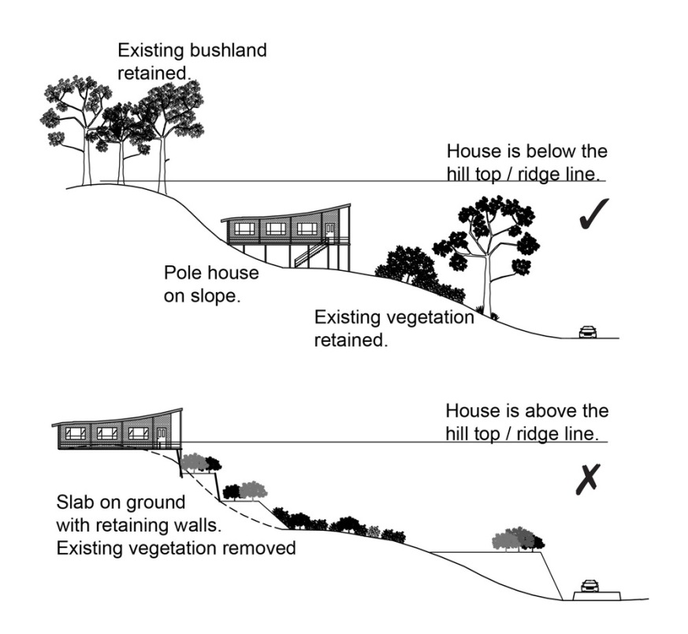
RAD75 | Where located in the Regionally significant (Hills) scenic amenity overlay, driveways and accessways:  - go across land contours and do not cut straight up slopes;  - follow natural contours, not resulting in batters or retaining walls being greater than 1m in height.  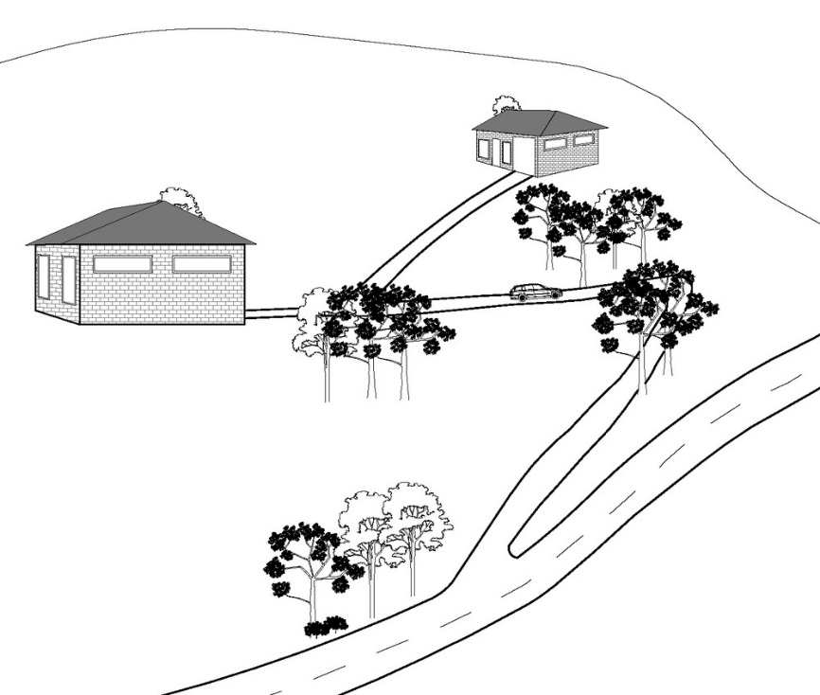
RAD76 | Where located in the Regionally significant (Hills) scenic amenity overlay, roofs and wall surfaces of buildings and structures adopt the following colours:  Colours from Australian Standard AS2700s – 1996  G12 – Holly G53 – Banksia N44 – Bridge Grey  G13 – Emerald G54 – Mist Green N45 – Koala Grey  G14 – Moss Green G55 – Lichen N52 – Mid Grey  G15 – Rainforest Green G56 – Sage Green N54 – Basalt  G16 – Traffic Green G62 – Rivergum N55 – Lead Grey  G17 – Mint Green G64 – Slate X54 – Brown  G21 – Jade G65 – Ti Tree X61 – Wombat  G22 – Serpentine N25 – Birch Grey X62 – Dark Earth  G23 – Shamrock N32 – Green Grey X63 – Iron Bark  G24 – Fern Green N33 – Lightbox Grey Y51 – Bronze Olive  G25 – Olive N35 – Light Grey Y61 – Black Olive  G34 – Avocado N41 – Oyster Y63 – Khaki  G52 – Eucalyptus N42 – Storm Grey Y66 – Mudstone  N43 – Pipeline Grey
RAD77 | Where located in the Regionally significant (Hills) scenic amenity overlay, roofs and wall surfaces of buildings and structures are painted or finished such that reflectivity is less than 35%.
Transport noise corridors (refer Overlay map - Transport noise corridors)
This is for information purposes only. No requirements for accepted development or criteria for assessable development apply. Development located within a Transport Noise Corridor must satisfy the requirements of the Queensland Development Code

