Table 9.3.2.1 Requirements for accepted development - Dual occupancies

Requirements for accepted development |  | E Compliance  - Yes  - No | Council confirmation
General requirements
Dual occupancy ⁽²¹⁾
Private open space
RAD1 | Each dwelling has a clearly defined, private outdoor living space that:  - is as per the table below;  Use Minimum Area in 1 location Minimum Dimension in all directions  Ground level dwellings  All dwelling types 12m² 2.4m  Above ground level dwellings  1 bedroom, studio, rooming unit 8m² 1.5m  2 bedrooms or more bedrooms 12m² 2.4m  - is accessed from a living area;  - for ground floor open space:  - it is screened for privacy from adjoining dwellings;  - located behind the main building line and not within the primary frontage setback;  - for above ground dwellings that adjoin the street, balconies orientate to the street;  - is clear of any utility and non-recreational areas or structures (including but not limited to driveways, air-conditioning units, water tanks, storage structures, refuse storage areas and retaining structures).  Note - Areas for clothes drying are not to be visible from the street.  Note - Utility areas (e.g. driveways, air-conditioning units, water tanks, clothes drying facilities, storage structures and refuse storage areas) are to be notated on a site plan.  Note - Private open space minimum areas may be included within an unenclosed living structure (e.g. patio). Refer to Planning scheme policy - Residential design for details and examples.
Car parking
RAD2 | Car parking spaces are provided in accordance with:  - Emerging community zone:  - Transition precinct (developed lot) - Table 9.3.2.4  - General residential zone  - Next generation neighbourhood - Table 9.3.2.4  - Urban neighbourhood precincts - Table 9.3.2.4
RAD3 | Garages and car ports have a combined opening no greater than 6m wide per street frontage.  Note - Refer to Planning scheme policy - Residential design for details and examples.
Access and driveways
RAD4 | Development provides:  - a maximum crossover width of 4m or for a shared driveway a maximum crossover width of 5m;  - a maximum of one driveway per street frontage; or  where more than 1 driveway per street frontage, driveways are to be at least 12m apart to allow for on-street parking and street trees.  Note - Refer to Planning scheme policy - Integrated design or Planning scheme policy - Residential design for details and examples.  Note - Laneway development provides access from the lane only in accordance with laneway development provisions RAD17-RAD18.
RAD5 | Development provides vehicular crossovers complying with Planning scheme policy - Integrated design.
RAD6 | Driveways do not include a reversing bay, manoeuvring area or visitor parking spaces (other than tandem spaces) in the front setback.
Screening – fences
RAD7 | Where provided, fencing within a setback to a primary or secondary frontage (excluding a laneway) is:  - no less than 0% transparent and does not exceed 1.2 metres in height; or  - no less than 50% transparent and does not exceed 1.5 metres in height; or  - no less than 85% transparent and does not exceed 1.8 metres in height  Note - Refer to Planning scheme policy - Residential design for details and examples.
Building appearance
RAD8 | Where adjoining a street frontage all garages or car ports are setback a minimum of 1.0m behind the main face of the dwelling.  Note - Refer to Planning scheme policy - Residential design for details and examples.
RAD9 | Private open spaces are screened from the other dwelling with an opaque 1.8m high fence.
RAD10 | Domestic outbuildings are located behind the main building line.
Privacy
RAD11 | Habitable room windows that look directly into another habitable room window or private open space of another unit on the same lot are screened or have a sill height of 1.5m or greater or opaque glazing is used.
Casual surveillance
RAD12 | A minimum of one habitable room window having an area of at least 1m² on each level overlooks each adjoining public space (street, public open space or laneway).
RAD13 | Where the lot is a corner lot, each dwelling is oriented to address a separate street frontage.  Note - Refer to Planning scheme policy - Residential design for details and examples.
Waste
RAD14 | Each dwelling includes a garbage bin utility area that:  - is not visible from public areas or is screened from public areas;  - is not located in primary frontage setback;  - is not located in an enclosed garage;  - has a minimum area of 1m x 2m;  - has easy and direct access to the collection point without going through a dwelling (excluding garages).  Note - Refer to Planning scheme policy - Residential design and Planning scheme policy - Waste for details and examples.
Sloping land
RAD15 | Building and lot design on slopes between 10% and 15% must:  - use split-level, multiple-slab, pier or pole construction;  - avoid single-plane slabs and benching;  - have built to boundary walls on the low side of the lot to avoid drainage issues; and  - follow the contour and ensure the height of cut and fill, whether retained or not, does not exceed 900mm.  Figure - Cut and fill  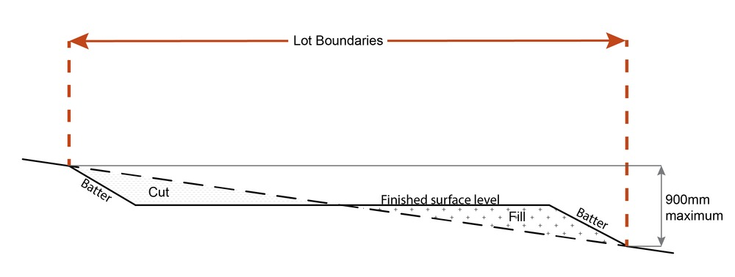
RAD16 | Building and lot design on slopes greater than15% do not include slab on ground.
Development on a laneway
RAD17 | At least one dwelling of the Dual occupancy⁽²¹⁾:  - faces the non-laneway frontage;  - has its main pedestrian entrance (front door) from the non-laneway frontage.
RAD18 | All vehicle access must be via the laneway.

Part B - Requirements for accepted development - Multiple Dwelling⁽⁴⁹⁾

Table 9.3.2.2 Requirements for accepted development - Multiple Dwellings

Requirements for accepted development |  | E Compliance  - Yes  - No | Council confirmation
General requirements
Multiple Dwelling⁽⁴⁹⁾ (Terrace or Row housing, Low rise apartment or Plex)
Private open space
RAD1 | Each dwelling has a clearly defined, private outdoor living space that:  - is as per the table below:  Use Minimum area in 1 location Minimum dimension in all directions  Ground level dwellings  All dwelling types 12m² 2.4m  Above ground level dwellings  1 bedroom, studio, rooming unit 8m² 1.5m  2 bedrooms or more 12m² 2.4m  - is accessed from a living area;  - for ground floor open space:  - it is screened for privacy from adjoining dwellings;  - located behind the main building line and not within the primary frontage setback;  - for above ground dwellings that adjoin the street, balconies orientate to the street;  - is clear of any utility and non-recreational areas or structures (including but not limited to driveways, air-conditioning units, water tanks, storage structures, refuse storage areas and retaining structures).  Note - Areas for clothes drying are not to be visible from the street.  Note - Utility areas (e.g. driveways, air-conditioning units, water tanks, clothes drying facilities, storage structures and refuse storage areas) are to be notated on a site plan.  Note - Private open space minimum areas may be included within an unenclosed living structure (e.g. Patios).
Car parking
RAD2 | Car parking spaces are provided in accordance with:  - General residential zone - Next generation neighbourhood and Urban neighbourhood precincts - Table 9.3.2.4  - General residential zone - Coastal communities and Suburban neighbourhood precincts - Table 9.3.2.4  - Emerging community zone - Transition precinct (developed lot) - Table 9.3.2.4  - Township zone - Table 9.3.2.4  - Centre zone - Caboolture, Morayfield and Strathpine precincts - Table 9.3.2.4  - Redcliffe local plan - Redcliffe seaside village and Kippa-Ring village precincts - Table 9.3.2.4  - Caboolture west local plan - Table 9.3.2.4  - Centre zone - District and Local centre precincts - Table 9.3.2.4
RAD3 | Where fronting a street (not an internal driveway) garage and carport openings are no greater than:  - 3m wide for every 7.5m of primary road frontage; or  - every 6m wide garage or carport opening is separated by at least 6m.  Note - For a laneway lot, vehicle access and parking must be provided via the laneway.  Note - Refer to Planning scheme policy - Residential design for details and examples.
RAD4 | Development does not include basement car parking.
Access and driveways
RAD5 | Development provides a minimum crossover width of 5.5m for a shared driveway;  OR  a maximum of 1, 3m wide crossover for every 7.5m of primary road frontage.  Note - Refer to Planning scheme policy - Integrated design for details and examples.
RAD6 | Where dwellings have access via a shared driveway the driveway is not to be located within 3m of a side boundary containing a residential use.
RAD7 | Development gains access from a laneway, access street or collector, whichever is the lowest order road.
Landscaping
RAD8 | Development incorporates a landscaping strip along the full width of all street frontages (other than laneway frontages), excluding any pedestrian or vehicular access points, with an average depth of:  Zone, precinct, sub-precinct Average depth  General residential zone: - Next generation neighbourhood precinct, Emerging community zone: - Transition precinct (developed lot) 2.0 metres  General residential zone: - Urban neighbourhood precinct 1.0 metre  Note - Refer to Planning scheme policy - Integrated design for details and examples.
Screening – fences
RAD9 | Where provided, fencing within a setback to a primary or secondary frontage (excluding a laneway) is:  - no less than 0% transparent and does not exceed 1.2 metres in height; or  - no less than 50% transparent and does not exceed 1.5 metres in height; or  - no less than 85% transparent and does not exceed 1.8 metres in height  Note - Refer to Planning scheme policy - Residential design for details and examples.
Building appearance
RAD10 | Where adjoining a street frontage, all garages or carports are setback a minimum of 1.0m behind the main face of the dwelling.  Note - Refer to Planning scheme policy - Residential design for details and examples.
RAD11 | Domestic outbuildings are located behind the main building line.
Privacy
RAD12 | Habitable room windows that look directly into another habitable room window or private open space of another unit on the same lot or an adjoining lot are screened or have a sill height of 1.5m or greater or obscure glazing is used.
Casual surveillance
RAD13 | A minimum of one habitable room window having an area of at least 1m² on each level overlooks each adjoining public space (street, public open space or laneway).
RAD14 | All dwellings adjoining or adjacent to a street frontage or public open space (e.g. park) are orientated to address that street frontage or public open space as follows:  - for ground floor dwellings - a clearly identifiable pedestrian entry (front door) from that street frontage or public open space, pedestrian gate in fencing and window(s); or  - for above ground dwellings - a balcony and window(s).
Waste
RAD15 | Each dwelling includes a garbage bin utility area that:  - is not visible from public areas or is screened from public areas;  - is not located in the primary frontage setback;  - is not locate in an enclosed garage;  - has a minimum area of 1m x 2m;  - has easy and direct access to the collection point without going through a dwelling (excluding garages).  Note - Refer to Planning scheme policy - Residential design for details and examples.
Sloping land
RAD16 | Building and lot design on slopes between 10% and 15% must:  - use split-level, multiple-slab, pier or pole construction;  - avoid single-plane slabs and benching;  - have built to boundary walls on the low side of the lot to avoid drainage issues; and  - follow the contour and ensure the height of cut and fill, whether retained or not, does not exceed 900mm.  Figure - Cut and fill
RAD17 | Building and lot design on slopes greater than 15% do not include slab on ground.

