Table 9.4.1.6.1.2 Assessable development - General residential zone - Coastal communities precinct

Performance outcomes | Examples that achieve aspects of the Performance Outcomes | E Compliance  - Yes  - No See PO or  - NA | Justification for compliance
Density
PO1  Reconfiguring a lot does not exceed a net residential density of 11 lots per hectare unless the resultant lot/s are consistent with the low density and established character of the surrounding neighbourhood. | E1  Lots have a minimum site area of 600m² and a minimum primary frontage of 12.5m.
Lot design, mix and location
PO2  Lots have an area, shape and dimension sufficient to ensure they can accommodate:  - a Dwelling house⁽²²⁾ including all domestic outbuildings and possible on site servicing requirements (e.g. on-site waste disposal);  - areas for car parking, vehicular access and manoeuvring;  - areas for useable and practical private open space. | No example provided.
PO3  Reconfiguring a lot does not create medium or high density development being lots with a frontage of less than 10.0 metres. | No example provided.
Sloping land
PO4  Lot layout and design avoids the impacts of cutting, filling and retaining walls on the visual and physical amenity of the streetscape, each lot created and of adjoining lots ensuring, but not limited to, the following:  - The likely location of private open space associated with a Dwelling House on each lot will not be dominated by, or encroached into by built form outcomes such as walls or fences;  - Walls and/or fences are kept to a human scale and do not represent barriers to local environmental outcomes and conditions such as good solar access and access to prevailing breezes; and  - The potential for overlooking from public land into private lots is avoided wherever possible; and  - Lot design is integrated with the opportunities available for Dwelling House design to reduce impacts.  Note - Refer to Planning scheme policy - Residential design for guidelines on building design on sloped land. | E4.1  Lot layout and design ensures that a lot has a maximum average slope of 1:15 along its long axis and 1:10 along its short axis.
E4.2
Retaining walls and benching and associated cutting, filling and other earthworks associated with reconfiguring a lot are limited to:
- a maximum vertical dimension of 1.5m from natural ground for any single retaining structure; or
- where incorporating a retaining structure greater than 1.5m in height, the retaining wall is stepped, terraced and landscaped as follows:
  - maximum 1m vertical, minimum 0.5m horizontal, maximum 2m vertical (refer figure below);
  - Maximum overall structure height of 3m; or
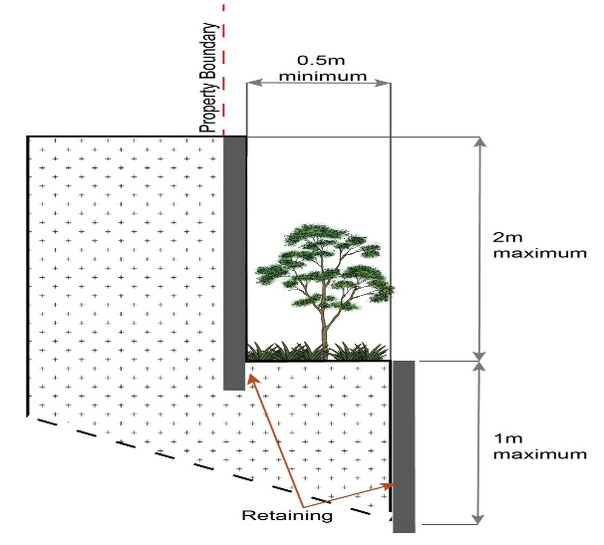
- where incorporating benching along the short axis (from side to side boundary) of a lot:
  - The difference between levels at each boundary is no greater than 4m per lot;
  - each bench has a maximum height of 2m (refer Figure below); or
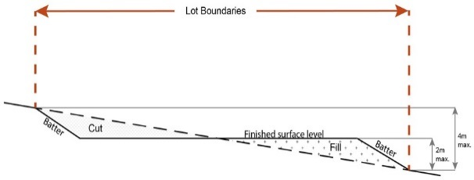
- Where incorporating benching along the long axis (from front to rear boundary):
  - each bench has a maximum height of 2m;
  - lots orientate up/down the slope (refer Figure below).
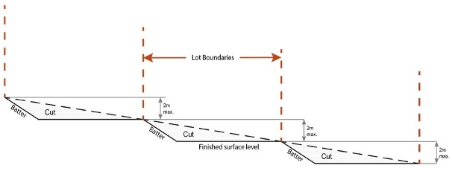
Note - Benching is to incorporate suitable measures to ensure stabilisation and prevent erosion.
Editor's note - Strict cut and fill requirements apply at the Dwelling house⁽²²⁾ stage. Deferral of slope solutions until building stage is not an acceptable outcome.

Figure - Sloped lot design
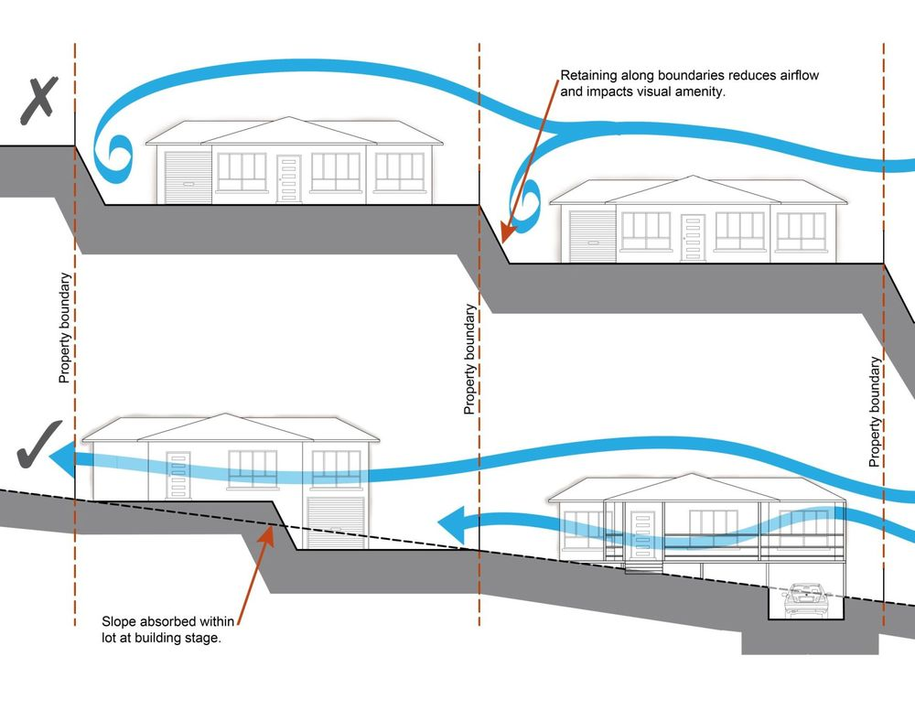
PO5  Lots are of a sufficient grade to accommodate effective stormwater drainage to a lawful point of discharge. | E5  The surface level of a lot is at a minimum grade of 1:100 and slopes towards the street frontage, or other lawful point of discharge
Rear lots
PO6  Rear lots:  - contribute to the mix of lot sizes;  - are limited to 1 behind any full frontage lot (i.e. A lot with a street frontage that is not an access handle);  - Provide sufficient area for vehicles to manoeuvre on-site allowing entry and exit to the rear lot in forward gear. | No example provided.
PO7  Access handles for rear lots are:  - a minimum of 5m wide to allow for safe vehicle access and service corridors from the rear lot to the street;  - are located on 1 side of the full frontage lot;  - limited to no more than 2 directly adjoining each other. | No example provided.
Street design and layout
PO8  Street layouts facilitate regular and consistent shaped lots through the use of rectilinear grid patterns, or modified grid patterns where constrained by topographical and other physical barriers.  Note - Refer to Planning scheme policy - Neighbourhood design for guidance on how to achieve compliance with this outcome. | No example provided.
PO9  Street layouts provide an efficient and legible movement network with high levels of connectivity within and external to the site by:  - facilitating increased active transport with a focus on safety and amenity for pedestrians and cyclists;  - providing street blocks with a maximum walkable perimeter of 600m;  - providing a variety of street block sizes to facilitate a range of intensity and scale in built form;  - reducing street block sizes as they approach an activity focus (e.g centre, neighbourhood hub, community activity, public open space);  - facilitating possible future connections to adjoining sites for roads, green linkages and other essential infrastructure.  Note - Refer to Planning scheme policy - Neighbourhood design for guidance on how to achieve compliance with this outcome. | No example provided.
PO10  Street layouts create convenient and highly permeable movement networks between lower and higher order roads, whilst not adversely affecting the safety and function of the higher order road. | No example provided.
PO11  Streets are designed and constructed to cater for:  - safe and convenient pedestrian and cycle movement;  - on street parking adequate to meet the needs of future residents;  - efficient public transport routes;  - expected traffic speeds and volumes;  - utilities and stormwater drainage;  - lot access, sight lines and public safety;  - emergency access and waste collection;  - waste service vehicles;  - street trees, landscaping and street furniture.  Note - Refer to Planning scheme policy - Integrated design for determining design criteria to achieve this outcome. | No example provided.
PO12  Intersections are designed and constructed to provide for the safe and efficient movement of pedestrians, cyclists, and all forms of light and heavy traffic.  Note - Refer to Planning scheme policy - Integrated design for guidance on how to achieve compliance with this outcome. | No example provided.
PO13  Upgrade works (whether trunk or non-trunk) are provided where necessary to:  - ensure the type or volume of traffic generated by the development does not have a negative impact on the external road network;  - ensure the orderly and efficient continuation of the active transport network;  - ensure the site frontage is constructed to a suitable urban standard generally in accordance with Planning scheme policy - Integrated design.  Note - An Integrated Transport Assessment (ITA) may be required to demonstrate compliance with this performance outcome refer to Planning scheme policy - Integrated transport assessment for guidance on when an ITA is required. An ITA should be prepared in accordance with Planning scheme policy - Integrated transport assessment.  Note - The road network is mapped on Overlay map - Road hierarchy.  Note - The primary and secondary active transport network is mapped on Overlay map - Active transport.  Note - To demonstrate compliance with c. of this performance outcome, site frontage works where in existing road reserve (non-trunk) are to be designed and constructed as follows:  - Where the street is partially established to an urban standard, match the alignment of existing kerb and channel and provide carriageway widening and underground drainage where required; or  - Where the street is not established to an urban standard, prepare a design that demonstrates how the relevant features of the particular road as shown in the Planning scheme policy - Integrated Design can be achieved in the existing reserve.  Note - Refer to Planning scheme policy - Integrated design for road network and active transport network design standards. | No example provided.
PO14  Cul-de-sac or dead end streets are not proposed unless:  - topography or other physical barriers exist to the continuance of the street network or vehicle connection to an existing road is not permitted; and  - there are no appropriate alternative solutions, or  - the cul-de-sac or dead end street will facilitate future connections to adjoining land or development.  Note - Refer to Planning scheme policy - Neighbourhood design for guidance on how to achieve compliance with this outcome. | No example provided.
PO15  Where cul-de-sacs are proposed:  - head must be visible from the entry point;  - are to be no longer than 50 metres in length;  - emergency access can be achieved under circumstances where entry via the carriageway may be compromised. | No example provided.
PO16  Where cul-de-sacs are proposed due to vehicular connection to existing roads not being permitted, they are to be designed to allow a 10m wide pedestrian connection as public land through to the existing road with no lots proposed at the head of the cul-de-sac generally as shown in the figure below.  Figure - Cul-de-sac design  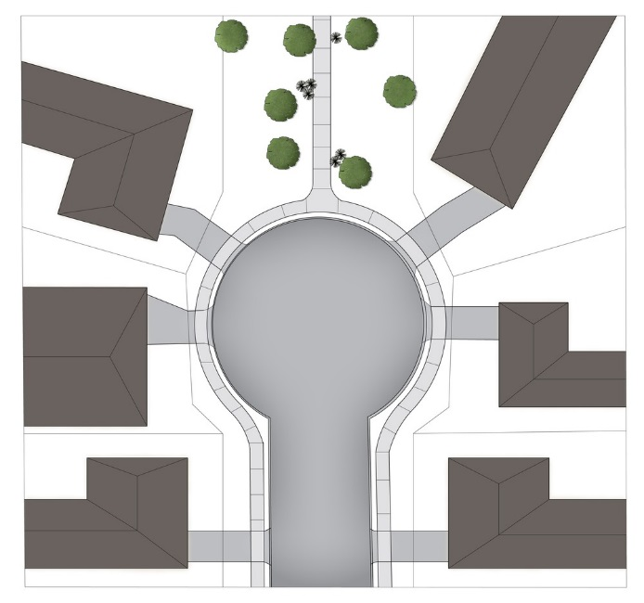  Note - Refer to Planning scheme policy - Neighbourhood design for guidance on how to achieve this outcome. | No example provided.
PO17  Streets are designed and oriented to minimise the impact of cut and fill on the amenity of the streetscape and adjoining development. | E17  Street alignment follows ridges or gullies or runs perpendicular to slope.
PO18  Streets are oriented to encourage active transport through a climate responsive and comfortable walking environment whilst also facilitating lots that support subtropical design practices, including:  - controlled solar access and shade provision;  - cross-ventilation  Note - Refer to Planning scheme policy - Residential design for guidance on how to achieve subtropical design solutions. | E18.1  Where not unduly constrained by topography or other physical barrier, streets are primarily oriented within 20 or 30 degrees of North-South or East-West in accordance with Figure - Preferred street orientation below.  Figure - Preferred street orientation  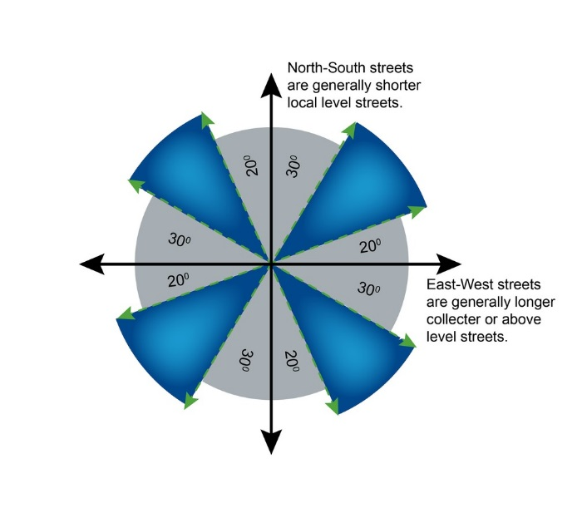
E18.2
The long axis of a street block is oriented east-west to facilitate a north-south orientation for a majority of lots as per Figure - Street block design below.
E18.3
Where lots are oriented east west, they are to have a frontage of 16 metres or wider so as to allow for alternative dwelling design to achieve solar access and cross-ventilation as per Figure - Street block design below.

Figure - Street block design
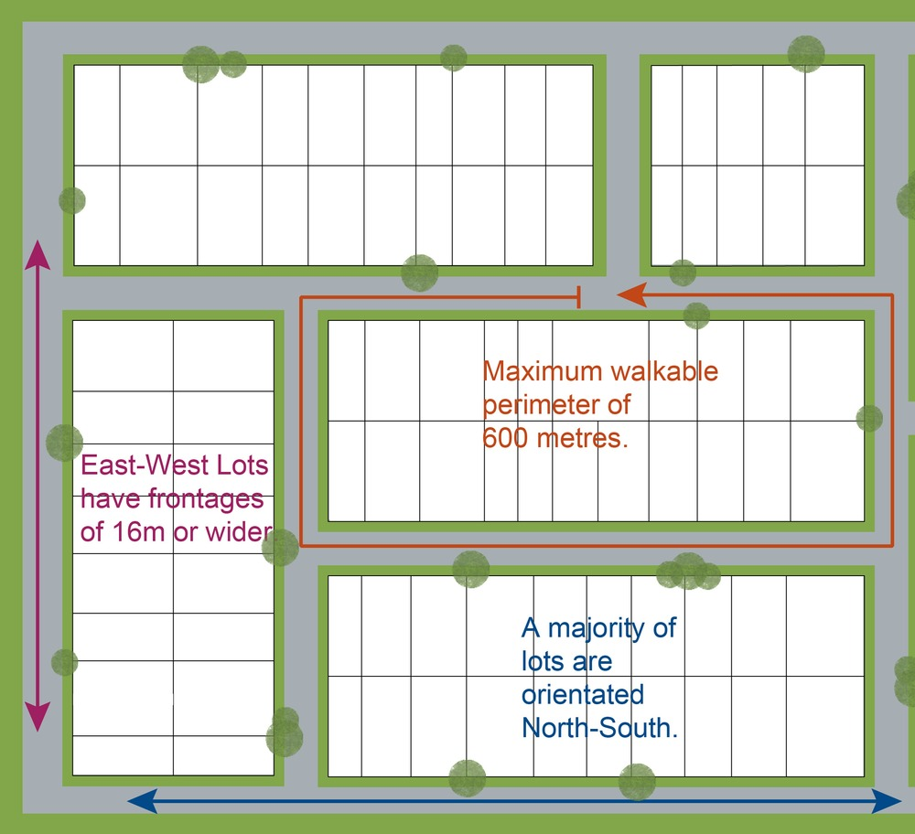

Park⁽⁵⁷⁾ and open space
PO19  A hierarchy of Parks⁽⁵⁷⁾ and open space is provided to meet the recreational needs of the community.  Note - To determine the extent of Park⁽⁵⁷⁾ and open space required refer to Planning scheme policy - Integrated design.  Note - District level Parks⁽⁵⁷⁾ or larger may be required in certain locations in accordance with Part 4: Local Government Infrastructure Plan. | No example provided.
PO20  Park⁽⁵⁷⁾ is to be provided within walking distance of all new residential lots.  Note - To determine maximum walking distances for Park⁽⁵⁷⁾ types refer to Planning scheme policy - Integrated design. | No example provided.
PO21  Park⁽⁵⁷⁾ is of a size and design standard to meet the needs of the expected users.  Note - To determine the size and design standards for Parks⁽⁵⁷⁾ refer to Planning scheme policy - Integrated design. | No example provided.
PO22  Parks⁽⁵⁷⁾ are designed and located to be safe and useable for all members of the community with high levels of surveillance, based on Crime Prevention Through Environmental Design (CPTED) principles, and access. | E22.1  Local and district Parks⁽⁵⁷⁾ are bordered by streets and lots orientated to address and front onto Parks and not lots backing onto or not addressing the Park.
E22.2
Where lots do adjoin local and district Parks⁽⁵⁷⁾, and fencing is provided along the Park⁽⁵⁷⁾ boundary, it is located within the lot and at a maximum height of 1m.
E22.3
The design of fencing and retaining features allows for safe and direct pedestrian access between the Park⁽⁵⁷⁾ and private allotments through the use of gates and limited retaining features along Park⁽⁵⁷⁾ boundaries.
Boundary realignment
PO23  Boundary alignments ensure that infrastructure and services are wholly contained within the lot they serve. | No example provided.
PO24  Boundary realignment does not result in:  - existing land uses on site becoming non-complying with planning scheme criteria;  - lots being unserviced by infrastructure;  - lots not providing for own private servicing.  Note - Examples may include but are not limited to:  - minimum lot size requirements;  - setbacks  - parking and access requirements;  - servicing and Infrastructure requirements;  - dependant elements of an existing or approved land use being separately titled, including but not limited to:  - Where premises is approved as Multiple dwelling⁽⁴⁹⁾ with a communal open space area, the communal open space cannot be separately titled as it is required by the Multiple dwelling⁽⁴⁹⁾ approval.  - Where a commercial or industrial land use contains an ancillary office⁽⁵³⁾, the office⁽⁵³⁾ cannot be separately titled as it is considered part of the commercial or industrial use.  - Where a Dwelling house⁽²²⁾ includes a secondary dwelling or associated outbuildings, they cannot be separately titled as they are dependent on the Dwelling house⁽²²⁾ use. | No example provided.
PO25  Boundary realignment results in lots which have appropriate size, dimensions and access to cater for uses consistent with the precinct.  Note - Refer to overall outcomes for the General residential zone - Coastal communities precinct for uses consistent in this precinct. | E25  Lot sizes and dimensions (excluding any access handles) comply with Lot Types D, E or F in accordance with ‘Table 9.4.1.6.1.3 - Lot Types’ - Lot Types.
Reconfiguring existing development by Community Title
PO26  Reconfiguring a lot which creates or amends a community title scheme as described in the Body Corporate and Community Management Act 1997 is undertaken in a way that does not result in existing uses on the land becoming unlawful or otherwise operating in a manner that is:  - inconsistent with any approvals on which those uses rely; or  - inconsistent with the requirements for accepted development applying to those uses at the time that they were established.  Note -Examples of land uses becoming unlawful include, but are not limited to the following:  - Land on which a Dual occupancy⁽²¹⁾ has been established is reconfigured in a way that results in both dwellings no longer being on the one lot. The reconfiguring has the effect of transforming the development from a Dual occupancy⁽²¹⁾ to two separate Dwelling⁽²²⁾ houses, at least one of which does not satisfy the requirements for accepted development applying to Dwelling houses.  - Land on which a Multiple dwelling⁽⁴⁹⁾ has been established is reconfigured in a way that precludes lawful access to required communal facilities by either incorporating some of those facilities into private lots or otherwise obstructing the normal access routes to those facilities. Those communal facilities may have been required under the requirements for accepted development for the use or conditions of development approval.  Editor's note - To satisfy this performance outcome, the development application may need to be a combined application for reconfiguring a lot and a material change of use or otherwise be supported by details that confirm that the land use still satisfies all relevant land use requirements. | No example provided.
Reconfiguring by Lease
PO27  Reconfiguring a lot which divides land or buildings by lease in a way that allows separate occupation or use of those facilities is undertaken in a way that does not result in existing uses on the land becoming unlawful or otherwise operating in a manner that is:  - inconsistent with any approvals on which those uses rely; or  - inconsistent with the requirements for accepted development applying to those uses at the time that they were established.  Note - An example of a land use becoming unlawful is a Multiple dwelling⁽⁴⁹⁾ over which one or more leases have been created in a way that precludes lawful access to some of the required communal facilities. Some of the communal car parking facilities have been incorporated into lease areas while other leases are located in a way that obstructs the normal access routes to other communal facilities. Those communal facilities may have been required under the requirements for accepted development for the use or conditions of development approval, but they are no longer freely available to all occupants of the Multiple dwelling⁽⁴⁹⁾.  Editor's note -To satisfy this performance outcome, the development application may need to be supported by details that confirm that the land use still satisfies all relevant land use requirements.  Editor’s note – Under the definition in Schedule 2 of the Act, the following do not constitute reconfiguring a lot and are not subject to this performance outcome:  - a lease for a term, including renewal options, not exceeding 10 years; and  - an agreement for the exclusive use of part of the common property for a community titles scheme under the Body Corporate and Community Management Act 1997. | No example provided.
Volumetric subdivision
PO28  The reconfiguring of the space above or below the surface of the land ensures appropriate area, dimensions and access arrangements to cater for uses consistent with the precinct and does not result in existing land uses on site becoming non-complying with the planning scheme criteria.  Note - Examples may include but are not limited to:  - Where a Dwelling house⁽²²⁾ includes a secondary dwelling or associated outbuildings, they cannot be separately titled as they are dependent on the Dwelling house⁽²²⁾ use. | No example provided.
Reticulated supply
PO29  Each lot is provided with an appropriate level of service and infrastructure, including water supply, stormwater management, sewage disposal, stormwater drainage, electricity,telecommunications and gas (if available) in a manner that:  - is efficient in delivery of service;  - is effective in delivery of service;  - is conveniently accessible in the event of maintenance or repair;  - minimises whole of life cycle costs for that infrastructure;  - minimises risk of potential adverse impacts on the natural and built environment;  - minimises risk of potential adverse impact on amenity and character values;  - recognises and promotes Councils Total Water Cycle Management policy and the efficient use of water resources. | E29  Lots are provided with:  - a connection to the reticulated water supply infrastructure network;  - a connection to the sewerage infrastructure network;  - a connection to the reticulated electricity infrastructure network; and  - a physical connection to the telecommunication network, that where available to the land is part of the high speed broadband network.
Stormwater location and design
PO30  The development is planned and designed considering the land use constraints of the site and incorporates water sensitive urban design principles. | No example provided.
PO31  Stormwater drainage pipes and structures through or within private land are protected by easements in favour of Council with sufficient area for practical access for maintenance.  Note - To determine sufficient areas for easements refer to Planning scheme policy - Integrated design. | No example provided.
PO32  Stormwater management facilities are located outside of riparian areas and prevent increased channel bed and bank erosion. | No example provided.
PO33  Natural streams and riparian vegetation are retained and enhanced through revegetation. | No example provided.
PO34  Areas constructed as detention basins are adaptable for passive recreation. | No example provided.
PO35  Development maintains the environmental values of waterway ecosystems. | No example provided.
PO36  Constructed water bodies are not dedicated as public assets. | No example provided.
Stormwater management system
PO37  The major drainage system has the capacity to safely convey stormwater flows for the defined flood event. | E37  The roads, drainage pathways, drainage features and waterways safely convey the stormwater flows for the defined flood event without allowing flows to encroach upon private lots.
PO38  Overland flow paths (for any storm event) from roads and public open space areas do not pass through private lots. | E38  Drainage pathways are provided to accommodate overland flows from roads and public open space areas.
PO39  Where located within the Upper Pine, Hays Inlet and Burpengary Creek catchments, development achieves the greater pollutant removal of:  - 100% reductions in mean annual loads from unmitigated development for total suspended solids, total phosphorus, total nitrogen and gross pollutants >5mm;  - the stormwater management design objectives relevant for Moreton Bay Regional Council identified in Table A and B in Appendix 3 of the SPP.  Note - To demonstrate compliance with this PO a stormwater quality management plan is to be prepared by a suitable qualified person demonstrating compliance with the Urban Stormwater Planning Guideline 2010, Planning scheme policy – Stormwater management, planning scheme policy - Integrated Design and considering any local area stormwater management planning prepared by Council.  Note - Refer to Overlay map - Stormwater catchments for catchment boundaries. | No example provided.
PO40  Where located outside the Upper Pine, Hays Inlet and Burpengary Creek catchments, development achieves the stormwater management design objectives relevant for Moreton Bay Regional Council identified in Tables A and B in Appendix 2 of the SPP.  Note - To demonstrate compliance with this PO a stormwater quality management plan is to be prepared by a suitable qualified person demonstrating compliance with the Urban Stormwater Planning Guideline 2010, Planning Scheme Policy – Stormwater Management, Planning Scheme Policy - Integrated Design and considering any local area stormwater management planning prepared by Council.  Note - Refer to Overlay map - Stormwater catchments for catchment boundaries. | No example provided.
PO41  The stormwater management system is designed to:  - protect the environmental values in downstream waterways;  - maintain ground water recharge areas;  - preserve existing natural wetlands and associated vegetation buffers;  - avoid disturbing soils or sediments;  - avoid altering the natural hydrologic regime in acid sulphate soil and nutrient hazardous areas;  - maintain and improve receiving water quality;  - protect natural waterway configuration;  - protect natural wetlands and vegetation;  - protect downstream and adjacent properties;  - protect and enhance riparian areas. | No example provided.
PO42  Design and construction of the stormwater management system:  - utilise methods and materials to minimise the whole of lifecycle costs of the stormwater management system; and  - are coordinated with civil and other landscaping works.  Note - To determine the standards for stormwater management system construction refer to Planning scheme policy - Integrated design. | No example provided.
Native vegetation where not located in the Environmental areas overlay
PO43  Reconfiguring a lot facilitates the retention of native vegetation by:  - incorporating native vegetation and habitat trees into the overall subdivision design, development layout, on-street amenity and landscaping where practicable;  - ensuring habitat trees are located outside a development footprint. Where habitat trees are to be cleared, replacement fauna nesting boxes are provided at the rate of 1 nest box for every hollow removed. Where hollows have not yet formed in trees > 80cm in diameter at 1.3m height, 3 nest boxes are required for every habitat tree removed.  - providing safe, unimpeded, convenient and ongoing wildlife movement;  - avoiding creating fragmented and isolated patches of native vegetation.  - ensuring that biodiversity quality and integrity of habitats is not adversely impacted upon but are maintained and protected;  - ensuring that soil erosion and land degradation does not occur;  - ensuring that quality of surface water is not adversely impacted upon by providing effective vegetated buffers to water bodies. | No example provided
Noise
PO44  Noise attenuation structure (e.g. walls, barriers or fences):  - contribute to safe and usable public spaces, through maintaining high levels of surveillance of parks, streets and roads that serve active transport purposes (e.g. existing or future pedestrian paths or cycle lanes etc);  - maintain the amenity of the streetscape.  Note - A noise impact assessment may be required to demonstrate compliance with this PO. Noise impact assessments are to be prepared in accordance with Planning scheme policy - Noise.  Note - Refer to Planning Scheme Policy – Integrated design for details and examples of noise attenuation structures. | E44  Noise attenuation structures (e.g. walls, barriers or fences):  - are not visible from an adjoining road or public area unless;  - adjoining a motorway or rail line; or  - adjoining part of an arterial road that does not serve an existing or future active transport purpose (e.g. pedestrian paths or cycle lanes) or where attenuation through building location and materials is not possible.  - do not remove existing or prevent future active transport routes or connections to the street network;  - are located, constructed and landscaped in accordance with Planning scheme policy - Integrated design.  Note - Refer to Planning Scheme Policy – Integrated design for details and examples of noise attenuation structures.  Note - Refer to Overlay map – Active transport for future active transport routes.

Values and constraints criteria
Note - The relevant values and constraints criteria do not apply where the development is consistent with a current Development permit for Reconfiguring a lot or Material change of use or Operational work, where that approval has considered and addressed (e.g. through a development footprint plan (or similar in the case of Landslide hazard) or conditions of approval) the identified value or constraint under this planning scheme.

Bushfire hazard (refer Overlay map - Bushfire hazard to determine if the following assessment criteria apply)
Note -The preparation of a bushfire management plan in accordance with Planning scheme policy – Bushfire prone areas can assist in demonstrating compliance with the following performance criteria. The identification of a development footprint will assist in demonstrating compliance with the following performance criteria.

PO45  Lots are designed to:  - minimise the risk from bushfire hazard to each lot and provide the safest possible siting for buildings and structures;  - limit the possible spread paths of bushfire within the reconfiguring;  - achieve sufficient separation distance between development and hazardous vegetation to minimise the risk to future buildings and structures during bushfire events;  - maintain the required level of functionality for emergency services and uses during and immediately after a natural hazard event. | E45  Reconfiguring a lot ensures that all new lots are of an appropriate size, shape and layout to allow for the siting of future buildings being located:  - within an appropriate development footprint;  - within the lowest hazard locations on a lot;  - to achieve minimum separation between development or development footprint and any source of bushfire hazard of 20m or the distance required to achieve a Bushfire Attack Level BAL (as identified under AS3959-2009), whichever is the greater;  - to achieve a minimum separation between development or development footprint and any retained vegetation strips or small areas of vegetation of 10m or the distance required to achieve a Bushfire Attack Level BAL (as identified under AS3959-2009), whichever is the greater;  - away from ridgelines and hilltops;  - on land with a slope of less than 15%;  - away from north to west facing slopes.
PO46  Lots provide adequate water supply and infrastructure to support fire-fighting. | E46  For water supply purposes, reconfiguring a lot ensures that:  - lots have access to a reticulated water supply provided by a distributer retailer for the area; or  - where no reticulated water supply is available, on-site fire fighting water storage containing not less than 10000 litres and located within a development footprint.
PO47  Lots are designed to achieve:  - safe site access by avoiding potential entrapment situations;  - accessibility and manoeuvring for fire-fighting during bushfire. | E47  Reconfiguring a lot ensures a new lot is provided with:  - direct road access and egress to public roads;  - an alternative access where the private driveway is longer than 100m to reach a public road;  - driveway access to a public road that has a gradient no greater than 12.5%;  - minimum width of 3.5m.
PO48  The road layout and design supports:  - safe and efficient emergency services access to all lots; and manoeuvring within the subdivision;  - availability and maintenance of access routes for the purpose of safe evacuation. | E48  Reconfiguring a lot provides a road layout which:  - includes a perimeter road that separating the new lots from hazardous vegetation on adjacent lots incorporating by:  - a cleared width of 20m;  - road gradients not exceeding 12.5%;  - pavement and surface treatment capable of being used by emergency vehicles;  - Turning areas for fire fighting appliances in accordance with Qld Fire and Emergency Services' Fire Hydrant and Vehicle Access Guidelines.  - Or if the above is not practicable, a fire maintenance trail separates the lots from hazardous vegetation on adjacent lots incorporating:  - a minimum cleared width of 6m and minimum formed width of 4m;  - gradient not exceeding 12.5%;  - cross slope not exceeding 10%;  - a formed width and erosion control devices to the standards specified in Planning scheme policy - Integrated design;  - a turning circle or turnaround area at the end of the trail to allow fire fighting vehicles to manoeuvre;  - passing bays and turning/reversing bays every 200m;  - an access easement that is granted in favour of the Council and the Queensland Fire and Rescue Service or located on public land.  - excludes cul-de-sacs, except where a perimeter road with a cleared width of 20m isolates the lots from hazardous vegetation on adjacent lots; and  - excludes dead-end roads.
Environmental areas (refer Overlay map - Environmental areas to determine if the following assessment criteria apply)
Note - The identification of a development footprint will assist in demonstrating compliance with the following performance criteria.

Editors' Note - The accuracy of overlay mapping can be challenged through the development application process (code assessable development) or by way of a planning scheme amendment. See Council's website for details.

PO49  No new boundaries are located within 2m of High Value Areas. | No example provided.
PO50  Lots are designed to:  - minimise the extent of encroachment into the MLES waterway buffer or a MLES wetland buffer;  - ensure quality and integrity of biodiversity and ecological values is not adversely impacted upon but are maintained and protected;  - incorporate native vegetation and habitat trees into the overall subdivision design, development layout, on-street amenity and landscaping where practicable;  - provide safe, unimpeded, convenient and ongoing wildlife movement;  - avoid creating fragmented and isolated patches of native vegetation;  - ensuring that soil erosion and land degradation does not occur;  - ensuring that quality of surface water is not adversely impacted upon by providing effective vegetated buffers to water bodies.  AND  Where development results in the unavoidable loss of native vegetation within a MLES waterway buffer or a MLES wetland buffer, an environmental offset is required in accordance with the environmental offset requirements identified in Planning scheme policy - Environmental areas. | E50  Reconfiguring a lot ensures that no additional lots are created within a Value Offset Area.
Heritage and landscape character (refer Overlay map - Heritage and landscape character to determine if the following assessment criteria apply)
Note - The identification of a development footprint will assist in demonstrating compliance with the following performance criteria.

PO51  Lots do not:  - reduce public access to a heritage place, building, item or object;  - create the potential to adversely affect views to and from the heritage place, building, item or object;  - obscure or destroy any pattern of historic subdivision, historical context, landscape setting or the scale and consistency of the urban fabric relating to the local heritage place. | No example provided.
PO52  Reconfiguring a lot retains significant trees and incorporates them into the subdivision design, development layout and provision of infrastructure. | No example provided.
Overland flow path (refer Overlay map - Overland flow path to determine if the following assessment criteria apply)
Note - The applicable river and creek flood planning levels associated with defined flood event (DFE) within the inundation area can be obtained by requesting a flood check property report from Council.

PO53  Development:  - minimises the risk to persons from overland flow;  - does not increase the potential for damage from overland flow either on the premises or on a surrounding property, public land, road or infrastructure. | No example provided.
PO54  Development:  - maintains the conveyance of overland flow predominantly unimpeded through the premises for any event up to and including the 1% AEP for the fully developed upstream catchment;  - does not concentrate, intensify or divert overland flow onto an upstream, downstream or surrounding property.  Note - Reporting to be prepared in accordance with Planning scheme policy – Flood hazard, Coastal hazard and Overland flow.. | E54  Development ensures that any buildings are not located in an Overland flow path area.  Note: A report from a suitably qualified Registered Professional Engineer Queensland is required certifying that the development does not increase the potential for significant adverse impacts on an upstream, downstream or surrounding property.
PO55  Development does not:  - directly, indirectly or cumulatively cause any increase in overland flow velocity or level;  - increase the potential for flood damage from overland flow either on the premises or on a surrounding property, public land, road or infrastructure.  Note - Open concrete drains greater than 1m in width are not an acceptable outcome, nor are any other design options that may increase scouring.  Note - A report from a suitably qualified Registered Professional Engineer Queensland is required certifying that the development does not increase the potential for significant adverse impacts on an upstream, downstream or surrounding premises.  Note - Reporting to be prepared in accordance with Planning scheme policy – Flood hazard, Coastal hazard and Overland flow | No example provided.
PO56  Development ensures that overland flow is not conveyed from a road or public open space onto a private lot, unless the development is in a Rural zone. | E56  Development ensures that overland flow paths and drainage infrastructure is provided to convey overland flow from a road or public open space area away from a private lot, unless the development is in the Rural zone.
PO57  Development ensures that Council and inter-allotment drainage infrastructure, overland flow paths and open drains through private property cater for overland flows for a fully developed upstream catchment flows and are able to be easily maintained.  Note - A report from a suitably qualified Registered Professional Engineer Queensland is required certifying that the development does not increase the potential for significant adverse impacts on an upstream, downstream or surrounding premises.  Note - Reporting to be prepared in accordance with Planning scheme policy – Flood hazard, Coastal hazard and Overland flow | E57.1  Development ensures that roof and allotment drainage infrastructure is provided in accordance with the following relevant level as identified in QUDM:  - Urban area – Level III;  - Rural area – N/A;  - Industrial area – Level V;  - Commercial area – Level V.
E57.2
Development ensures that all Council and allotment drainage infrastructure is designed to accommodate any event up to and including the 1% AEP for the fully developed upstream catchment.
PO58  Development protects the conveyance of overland flow such that easements for drainage purposes are provided over:  - a stormwater pipe if the nominal pipe diameter exceeds 300mm;  - an overland flow path where it crosses more than one property; and  - inter-allotment drainage infrastructure.  Note - Refer to Planning scheme policy - Integrated design for details and examples.  Note - Stormwater drainage easement dimensions are provided in accordance with Section 3.8.5 of QUDM. | No example provided.
Additional criteria for development for a Park⁽⁵⁷⁾
PO59  Development for a Park⁽⁵⁷⁾ ensures that the design and layout responds to the nature of the overland flow affecting the premises such that:  - public benefit and enjoyment is maximised;  - impacts on the asset life and integrity of park structures is minimised;  - maintenance and replacement costs are minimised. | E59  Development for a Park⁽⁵⁷⁾ ensures works are provided in accordance with the requirements set out in Appendix B of the Planning scheme policy - Integrated Design.
Riparian and wetland setbacks (refer Overlay map - Riparian and wetland setback to determine if the following assessment criteria apply)
Note - - W1, W2 and W3 waterway and drainage lines, and wetlands are mapped on Schedule 2, Section 2.5 Overlay Maps – Riparian and wetland setbacks.

PO60  Lots are designed to:  - minimise the extent of encroachment into the riparian and wetland setback;  - ensure the protection of wildlife corridors and connectivity;  - reduce the impact on fauna habitats;  - minimise edge effects;  - ensure an appropriate extent of public access to waterways and wetlands. | E60  Reconfiguring a lot ensures that:  - no new lots are created within a riparian and wetland setback;  - new public roads are located between the riparian and wetland setback and the proposed new lots.  Note - Riparian and wetlands are mapped on Schedule 2, Section 2.5 Overlay Maps – Riparian and wetland setbacks.

Table 9.4.1.6.1.3 - Lot Types
