Table 9.4.1.3.2.2 Assessable development - Emerging community - Transition precinct

Performance outcomes | Examples that achieve aspects of the Performance Outcomes | E Compliance  - Yes  - No See PO or  - NA | Justification for compliance
Where on a developable lot or creating developable lots
Lot size and design
PO1  Reconfiguring a lot does not result in additional lots. | No example provided.
Boundary realignment
PO2  Boundary realignments do not result in the:  - fragmentation or alienation of the land or result in the loss of land for future urban purposes;  - delay the use of the land for urban purposes;  - existing land uses on-site becoming non-compliant due to:  - lot size;  - parking requirements;  - servicing;  - dependant elements of an existing or approved land use being separately titled.  Note - Examples may include but are not limited to:  - Where a Dwelling house⁽²²⁾ includes a secondary dwelling or associated outbuildings, they cannot be separately titled as they are dependent on the Dwelling house⁽²²⁾ use. | No example provided.
Where on a developed lot or creating developed lots
Site density
PO3  Reconfiguring of a lot:  - for land within the Morayfield South urban area identified on ‘Figure 9.4.1.3.2.1 Morayfield South urban area’, development does not compromise future developments ability to achieve a minimum residential density of 45 dwellings per hectare to ensure efficient use of the land and infrastructure which facilitates feasible public transport patronage and creates a diverse medium density neighbourhood character; or  - for all other land, development achieves a minimum net residential density of 11 lots per hectare, whilst not exceeding 25 lots per hectare, maintaining a diverse medium density neighbourhood character. | No example provided.
Lot design, mix and location
PO4  Lots have an area, shape and dimension sufficient to ensure they can accommodate:  - a Dwelling house including all domestic outbuildings and possible on site servicing requirements (e.g. on-site waste disposal);  - areas for car parking, vehicular access and manoeuvring;  - areas for useable and practical private open space. | E4.1  For land within the Morayfield South urban area identified on ‘Figure 9.4.1.3.2.1 Morayfield South urban area’, lot sizes comply with Lot Types A, B or F in accordance with Table 9.4.1.6.4.3: Lot Types.
E4.2
For all other areas, lot sizes and dimensions (excluding any access handles) comply with Lot Types A, B, C, D, E or F in accordance with ‘Table 9.4.1.3.2.3: Lot Types’: Lot Types.
Note - For the purpose of rear lots, frontage is the average width of the lot (excluding any access handle or easement)

PO5  Reconfiguring a lot provides for a variety of housing options, by way of a mix of lot sizes and dimensions consistent with the density and character of the precinct, whilst facilitating delivery of diversity within the streetscape. | E5.1  For land within the Morayfield South urban area identified on ‘Figure 9.4.1.3.2.1 Morayfield South urban area’, lot sizes comply with Lot Types A or E in accordance with ‘Table 9.4.1.3.2.3: Lot Types’ - Lot Types.  Editor's note - Lots containing built to boundary walls should also include an appropriate easement to facilitate the maintenance of any wall within 600mm of a boundary. For boundaries with built to boundary walls on adjacent lots a 'High Density Development Easement' is recommended; or for all other built to boundary walls and 'easement for maintenance purposes' is recommended.
E5.2
For reconfiguring a lot which creates in excess of 5 new lots, a mix of lot types in accordance with ‘Table 9.4.1.3.2.3: Lot Types’ are to be incorporated into the development as follows:
- 5 - 10 lots - 2 lot types
- 11 - 20 lots - 3 lot types
- 21 - 50 lots - 4 lot types (must include lot type A)
- >50 lots - 5 lot types (must include lot type A)
Editor's note - Lots containing built to boundary walls should also include an appropriate easement to facilitate the maintenance of any wall within 600mm of a boundary. For boundaries with built to boundary walls on adjacent lots a 'High Density Development Easement' is recommended; or for all other built to boundary walls and 'easement for maintenance purposes' is recommended.

E5.3
For reconfiguring a lot which creates in excess of 20 new lots, the following minimum percentages of lot types in accordance with ‘Table 9.4.1.3.2.3: Lot Types’ apply:
- Lot Type A - 10% of new lots and Lot Type F - 5% of new lots; or
- Lot Type A - 15% of new lots and Lot Type F - 2% of new lots; or
- Lot Type A - 15% of new lots and Lot Type B - 15% of new lots.
Editor's note - Lots containing built to boundary walls should also include an appropriate easement to facilitate the maintenance of any wall within 600mm of a boundary. For boundaries with built to boundary walls on adjacent lots a 'High Density Development Easement' is recommended; or for all other built to boundary walls and 'easement for maintenance purposes' is recommended.

PO6  A range of different lots are distributed throughout the development with no one lot type concentrated within a single location, to create diversity within the streetscape and minimise conflicts between vehicle access and on street parking.  Note - Built to boundary walls and driveway locations for lots with frontages of 12.5 metres or less are to be shown on a plan of development in accordance with the requirements of section 9.3.1 - Dwelling house code. | E6 .1  Where not accessed via a laneway, a maximum of 4 adjoining lots of the same type in accordance with ‘Table 9.4.1.3.2.3: Lot Types’ are proposed where fronting the same street.
E6.2
Where accessed via a laneway, a maximum of 8 adjoining lots of the same type in accordance with ‘Table 9.4.1.3.2.3: Lot Types’ are proposed where fronting the same street.
PO7  Lots that facilitate medium to high density residential uses (freehold or community titles) are located in proximity to recreational opportunities, commercial and community facilities and public transport nodes. | E7.1  Lots with frontages of 7.5 metres or less are located within 200 metres of:  - a park; or  - a public transport stop or station; or  - a higher order centre, district centre, local centre or neighbourhood hub (refer Overlay map - Community activities and neighbourhood hubs).
E7.2
Lots with frontages of 32 metres or greater are predominately located on corner lots or lots with dual road frontages, and within 200 metres of:
- a park; or
- a public transport stop or station; or
- a higher order centre, district centre, local centre or neighbourhood hub (refer Overlay map - Community activities and neighbourhood hubs).
PO8  Narrow lots do not adversely affect the character and amenity of the precinct and ensure that residential uses establish in a manner which facilitates an integrated streetscape, maximises the efficient use of land and achieves a safe and efficient street network.  Note - Built to boundary walls and driveway locations for lots with frontages of 12.5 metres or less are to be shown on a plan of development in accordance with the requirements of section 9.3.1 - Dwelling house code. | No example provided.
PO9  Group construction and integrated streetscape solutions are encouraged through the location and grouping of lots suitable for terrace and row housing. | E9 .1  Any lot sharing a boundary with a Lot Type A must contain a mandatory built to boundary wall on the shared boundary.
E9.2
Driveway crossovers for lots with frontages of less than 10m are paired up to facilitate on-street parking.
Note - Driveway locations for lots with frontages of 8.5 metres or less are to be shown on a plan of development in accordance with Planning Scheme Policy - Residential Design.

Sloping land
PO10  Lot layout and design avoids the impacts of cutting, filling and retaining walls on the visual and physical amenity of the streetscape, each lot created and of adjoining lots ensuring, but not limited to, the following:  - The likely location of private open space associated with a Dwelling House on each lot will not be dominated by, or encroached into by built form outcomes such as walls or fences;  - Walls and/or fences are kept to a human scale and do not represent barriers to local environmental outcomes and conditions such as good solar access and access to prevailing breezes; and  - The potential for overlooking from public land into private lots is avoided wherever possible; and  - Lot design is integrated with the opportunities available for Dwelling House design to reduce impacts.  Note - Refer to Planning scheme policy - Residential design for guidelines on building design on sloped land. | E10.1  Lot layout and design ensures that a lot has a maximum average slope of 1:15 along its long axis and 1:10 along its short axis.
E10.2
Retaining walls and benching and associated cutting, filling and other earthworks associated with reconfiguring a lot are limited to:
- a maximum vertical dimension of 1.5m from natural ground for any single retaining structure; or
- where incorporating a retaining structure greater than 1.5m in height, the retaining wall is stepped, terraced and landscaped as follows:
  - maximum 1m vertical, minimum 0.5m horizontal, maximum 2m vertical (refer figure below);
  - Maximum overall structure height of 3m; or
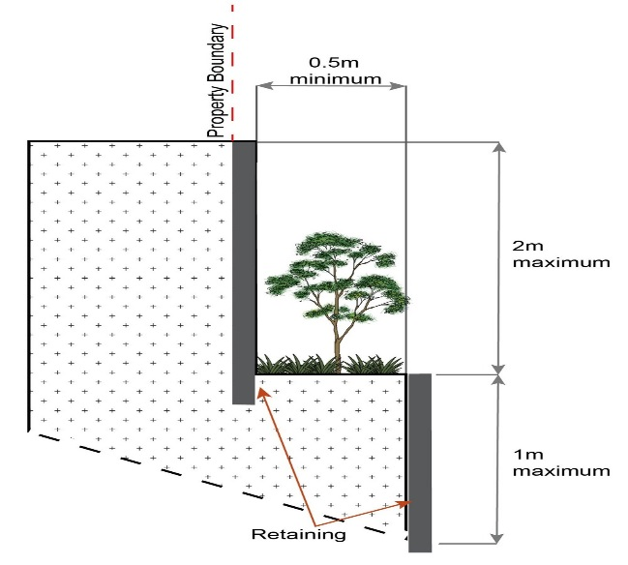
- where incorporating benching along the short axis (from side to side boundary) of a lot:
  - The difference between levels at each boundary is no greater than 4m per lot;
  - each bench has a maximum height of 2m (refer Figure below); or
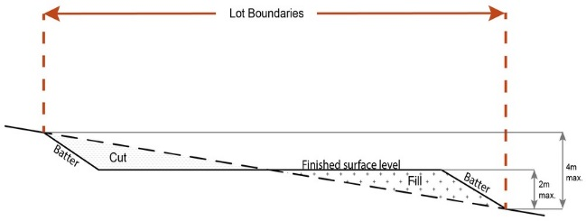
- Where incorporating benching along the long axis (from front to rear boundary):
  - each bench has a maximum height of 2m;
  - lots orientate up/down the slope (refer Figure below).

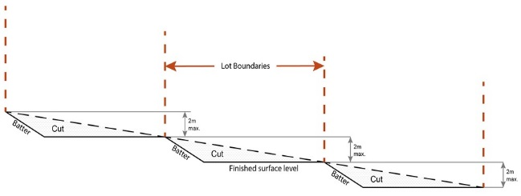
Note - Benching is to incorporate suitable measures to ensure stabilisation and prevent erosion.
Editor's note - Strict cut and fill requirements apply at the Dwelling house stage. Deferral of slope solutions until building stage is not an acceptable outcome.

Figure - Sloped lot design
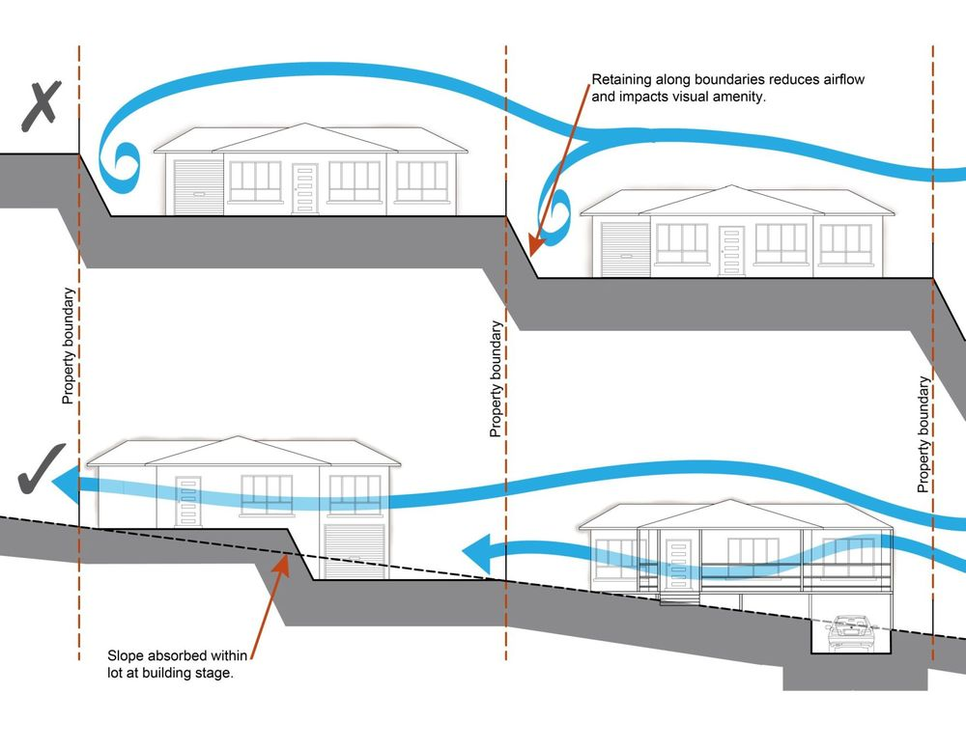
PO11  Lots are of a sufficient grade to accommodate effective stormwater drainage to a lawful point of discharge. | E11  The surface level of a lot is at a minimum grade of 1:100 and slopes towards the street frontage, or other lawful point of discharge.
Rear lots
PO12  Rear lots do not establish in the Morayfield South urban area identified on ‘Figure 9.4.1.3.2.1 Morayfield South urban area’. | No example provided.
PO13  For all other areas, rear lots:  - contribute to the mix of lot sizes;  - are limited to 1 behind any full frontage lot (i.e. A lot with a street frontage that is not an access handle);  - Provide sufficient area for vehicles to manoeuvre on-site allowing entry and exit to the rear lot in forward gear. | No example provided.
PO14  Access handles for rear lots are:  - a minimum of 5m wide to allow for safe vehicle access and service corridors from the rear lot to the street;  - are located on 1 side of the full frontage lot;  - limited to no more than 2 directly adjoining each other. | No example provided.
Street design and layout
PO15  Street layouts facilitate regular and consistent shaped lots through the use of rectilinear grid patterns, or modified grid patterns where constrained by topographical and other physical barriers.  Note - Refer to Planning scheme policy - Neighbourhood design for guidance on how to achieve compliance with this outcome. | No example provided.
PO16  Street layouts are designed to connect to surrounding neighbourhoods by providing an interconnected street, pedestrian and cyclist networks that connects nearby centres, neighbourhood hubs, community facilities, public transport nodes and open space to residential areas for access and emergency management purposes. The layout ensures that new development is provided with multiple points of access. The timing of transport works ensures that multiple points of access are provided during early stages of a development.  Note - Refer to Planning scheme policy - Neighbourhood design for guidance on when alternative access points should be provided for emergency management purposes. | No example provided.
PO17  Development maintains the connections shown on:  - ‘Figure 1 - Morayfield South’ - Morayfield South;  - ‘Figure 2 - Narangba East’ - Narangba East. | No example provided.
PO18  Street layouts provide an efficient and legible movement network with high levels of connectivity within and external to the to the site by:  - facilitating increased active transport with a focus on safety and amenity for pedestrians and cyclists;  - providing street blocks with a maximum walkable perimeter of 500m (refer Figure - Street block design);  - providing a variety of street block sizes;  - reducing street block sizes as they approach an activity focus;  - facilitating possible future connections to adjoining sites for roads, green linkages and other essential infrastructure.  Note - Refer to Planning scheme policy - Neighbourhood design for guidance on how to achieve compliance with this outcome. | No example provided.
PO19  Street layouts create convenient and highly permeable movement networks between lower and higher order roads, whilst not adversely affecting the safety and function of the higher order road.  Note - Refer to Planning scheme policy - Neighbourhood design for guidance on how to achieve compliance with this outcome. | No example provided.
PO20  Streets are designed and constructed to cater for:  - safe and convenient pedestrian and cycle movement;  - on street parking adequate to meet the needs of future resident;  - efficient public transport routes;  - expected traffic speeds and volumes;  - utilities and stormwater drainage;  - lot access, sight lines and public safety;  - emergency access and waste collection;  - waste service vehicles;  - required street trees, landscaping and street furniture.  Note - Refer to Planning scheme policy - Integrated design for determining design criteria to achieve this outcome. | No example provided.
PO21  Intersections are designed and constructed to provide for the safe and efficient movement of pedestrians, cyclists, and all forms of light and heavy vehicles.  Note - Refer to Planning scheme policy - Integrated design for guidance on how to achieve compliance with this outcome. | No example provided.
PO22  Cul-de-sac or dead end streets are not proposed unless:  - topography or other physical barriers exist to the continuance of the street network or vehicle connection to an existing road is not permitted;  - there are no appropriate alternative solutions;  - the cul-de-sac or dead end street will facilitate future connections to adjoining land or development.  Note - Refer to Planning scheme policy - Neighbourhood design for guidance on how to achieve compliance with this outcome. | No example provided.
PO23  Where cul-de-sacs are proposed due to vehicular connection to existing roads not being permitted, they are to be designed to allow a 10m wide pedestrian connection as public land through to the existing road with no lots proposed at the head of the cul-de-sac generally as shown in figure below.  Figure - Cul-de-sac design  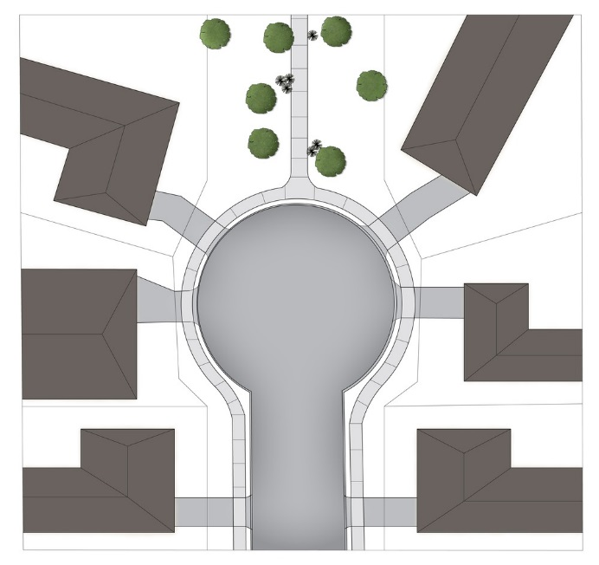  Note - Refer to Planning scheme policy - Neighbourhood design for guidance on how to achieve this outcome. | No example provided.
PO24  Streets are designed and oriented to minimise the impact of cut and fill on the amenity of the streetscape and adjoining development. | E24  Street alignment follows ridges or gullies or runs perpendicular to slope.
PO25  Streets are oriented to encourage active transport through a climate responsive and comfortable walking environment whilst also facilitating lots that support subtropical design practices, including:  - controlled solar access & shade provision  - cross-ventilation.  Note - Refer to Planning scheme policy - Residential design for guidance on how to achieve subtropical design solution. | E25.1  Where not unduly constrained by topography or other physical barrier, streets are primarily oriented within 20 or 30 degrees of North-South or East-West in accordance with Figure - Preferred street orientation below.  Figure - Preferred street orientation  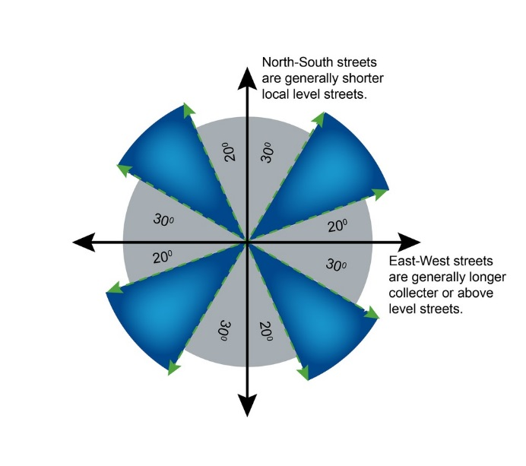
E25.2
The long axis of a street block is oriented east-west to facilitate a north-south orientation for a majority of lots as per Figure - Street block design below.
E25.3
Where lots are oriented east west, they are 16m or wider so as to allow for alternative dwelling design to achieve solar access and cross-ventilation as per Figure -Street block design below.

Figure - Street block design
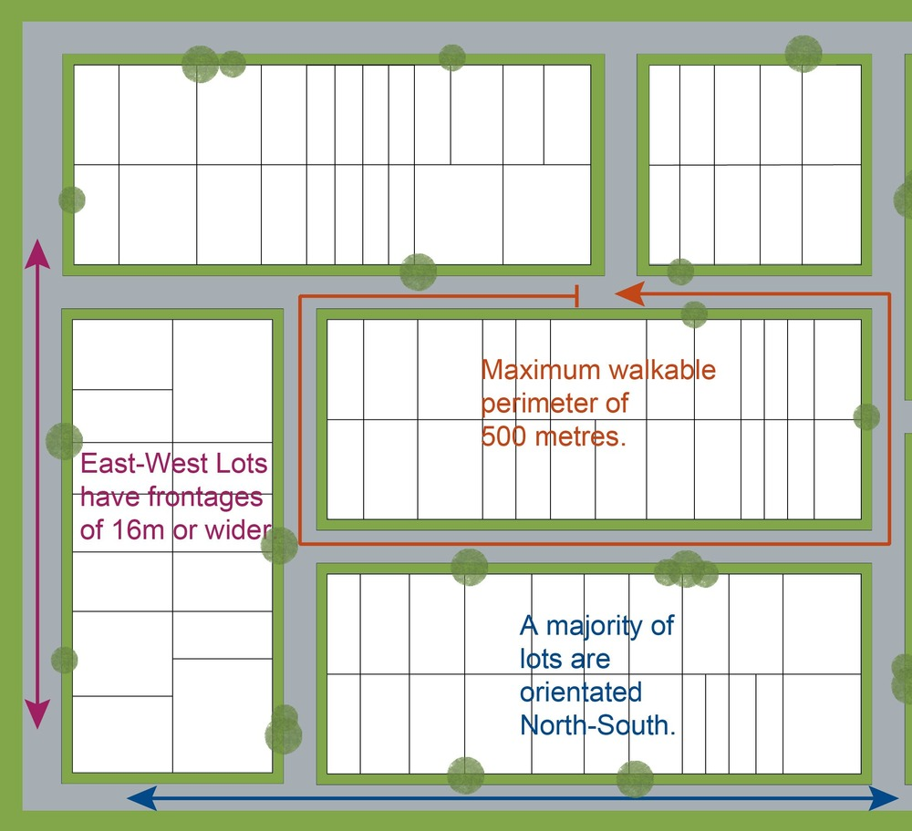

Movement network
PO26  The street network creates convenient access to arterial and sub-arterial roads for heavy vehicles and commercial traffic without introducing through traffic to residential streets. | No example provided.
PO27  The road network has sufficient reserve and pavement widths to cater for the current and intended function of the road in accordance with the road type in accordance with Planning scheme policy - Integrated design. | No example provided.
PO28  Movement networks encourage walking and cycling and a safe environment for pedestrians and cyclists. | E28  Pedestrian paths, bikeways and on-road bicycle facilities are provided for the street type in accordance with Planning scheme policy - Integrated design.
PO29  Upgrade works (whether trunk or non-trunk) are provided where necessary to:  - ensure the type or volume of traffic generated by the development does not have a negative impact on the external road network;  - ensure the orderly and efficient continuation of the active transport network;  - ensure the site frontage is constructed to a suitable urban standard generally in accordance with Planning scheme policy - Integrated design.  Note - An Integrated Transport Assessment (ITA) may be required to demonstrate compliance with this performance outcome refer to Planning scheme policy - Integrated transport assessment for guidance on when an ITA is required. An ITA should be prepared in accordance with Planning scheme policy - Integrated transport assessment.  Note - The road network is mapped on Overlay map - Road hierarchy.  Note - The primary and secondary active transport network is mapped on Overlay map - Active transport.  Note - To demonstrate compliance with c. of this performance outcome, site frontage works where in existing road reserve (non-trunk) are to be designed and constructed as follows:  - Where the street is partially established to an urban standard, match the alignment of existing kerb and channel and provide carriageway widening and underground drainage where required; or  - Where the street is not established to an urban standard, prepare a design that demonstrates how the relevant features of the particular road as shown in the Planning scheme policy - Integrated Design can be achieved in the existing reserve.  Note - Refer to Planning scheme policy - Integrated design for road network and active transport network design standards. | No example provided.
Laneway design and location
PO30  Laneway location contributes to a high standard of amenity for adjoining lots and the primary streetscape.  Note - Refer to Planning scheme policy - Neighbourhood design for determining locational criteria for Laneways. | E30  Laneways are primarily used where:  - vehicle access is not permitted from the primary street frontage; or  - limiting vehicle access from the primary street frontage results in a positive streetscape outcome; or  - where lots directly adjoin a local, district or regional Park⁽⁵⁷⁾.
PO31  Laneways service a limited number of allotments, creating a sense of place and enclosed feeling for the pedestrian environment whilst contributing to the high level of connectivity of the street network.  Note - Refer to Planning scheme policy - Integrated design and Planning scheme policy - Neighbourhood design for determining design criteria for Laneways. | E31.1  Laneways are limited to 130m in length.
E31.2
Laneways are not designed as dead ends or cul-de-sacs, and are to have vehicle connections to an access street at both ends.
E31.3
Where laneways exceed 100m in length, a mid lane pedestrian connection is to be provided between the adjacent access streets and the laneway.
PO32  Laneway design ensures the safety of pedestrians, cyclists and motorists by way of site lines, and sufficient road reserve for vehicle movements and the provision of street lighting.  Note - Refer to Planning scheme policy - Integrated design and Planning scheme policy - Neighbourhood design for determining design criteria for Laneways. | E32.1  Laneways are designed with minor meanders only, and maintain direct lines of sight from one end of the laneway to the other.
E32.2
Laneways provide road dedication at strategic locations along the laneway to allow the construction of street lighting and any electrical pillars associated with the street lighting in accordance with current Australian Standards.
Note - The dedication must allow for street lights on to be provided on Council’s standard alignment

Park⁽⁵⁷⁾ and open space
PO33  A hierarchy of Park⁽⁵⁷⁾ and open space is provided to meet the recreational needs of the community.  Note - To determine the extent and location of Park⁽⁵⁷⁾ and open space required refer to Planning scheme policy - Integrated design.  Note - District level Parks⁽⁵⁷⁾ or larger may be required in certain locations in accordance with Part 4: Local Government Infrastructure Plan. | No example provided.
PO34  Park⁽⁵⁷⁾ is to be provided within walking distance of all new residential lots.  Note - To determine maximum walking distances for Park⁽⁵⁷⁾ types refer to Planning scheme policy - Integrated design. | No example provided.
PO35  Park⁽⁵⁷⁾ is of a size and design standard to meet the needs of the expected users.  Note - To determine the size and design standards for Parks⁽⁵⁷⁾ refer to Planning scheme policy - Integrated design. | No example provided.
PO36  The safety and useability of Parks⁽⁵⁷⁾ is ensured through the careful design of the street network and lot locations which provide high levels of surveillance and access into the Park⁽⁵⁷⁾ or open space area. | E36.1  Local and district Parks⁽⁵⁷⁾ are bordered by streets and lots orientated to address and front onto Parks and not lots backing onto or not addressing the Park wherever possible.
E36.2
Where lots do adjoin local and district Parks⁽⁵⁷⁾, and fencing is provided along the Park⁽⁵⁷⁾ boundary, it is located within the lot and at a maximum height of 1m.
E36.3
The design of fencing and retaining features allows for safe and direct pedestrian access between the Park⁽⁵⁷⁾ and private allotment through the use of private gates and limited retaining features along Park⁽⁵⁷⁾ boundaries.
Boundary realignment
PO37  Boundary alignments ensure that infrastructure and services are wholly contained within the lot they serve. | No example provided.
PO38  Boundary realignment does not result in:  - existing land uses on-site becoming non-complying with planning scheme criteria;  - lots being unserviced by infrastructure;  - lots not providing for own private servicing.  Note - Examples may include but are not limited to:  - minimum lot size requirements;  - setbacks;  - parking and access requirements;  - servicing and Infrastructure requirements;  - dependant elements of an existing or approved land use being separately titled, including but not limited to:  - Where premises is approved as Multiple dwelling with a communal open space area, the communal open space cannot be separately titled as it is required by the Multiple dwelling approval.  - Where a commercial or industrial land use contains an ancillary office, the office cannot be separately titled as it is considered part of the commercial or industrial use.  - Where a Dwelling house⁽²²⁾ includes a secondary dwelling or associated outbuildings, they cannot be separately titled as they are dependent on the Dwelling house⁽²²⁾ use. | No example provided.
PO39  Boundary realignment results in lots which have appropriate size, dimensions and access to cater for uses consistent with the precinct.  Note - Refer to overall outcomes for the General residential zone - Next generation neighbourhood precinct for uses consistent in this precinct. | E39  Lot sizes and dimensions (excluding an access handles) comply with:  - for land within the Morayfield South urban area identified on ‘Figure 9.4.1.3.2.1 Morayfield South urban area’, lot sizes comply with Lot Types A or E in accordance with ‘Table 9.4.1.3.2.3: Lot Types’: Lot Types; or  - for all other areas, lot sizes and dimensions (excluding any access handles) comply with Lot Types A, B, C, D, E or F in accordance with ‘Table 9.4.1.3.2.3: Lot Types’: Lot Types..
Reconfiguring existing development by Community Title
PO40  Reconfiguring a lot which creates or amends a community title scheme as described in the Body Corporate and Community Management Act 1997 is undertaken in a way that does not result in existing uses on the land becoming unlawful or otherwise operating in a manner that is:  - inconsistent with any approvals on which those uses rely; or  - inconsistent with the requirements for accepted development applying to those uses at the time that they were established.  Note -Examples of land uses becoming unlawful include, but are not limited to the following:  - Land on which a Dual occupancy⁽²¹⁾ has been established is reconfigured in a way that results in both dwellings no longer being on the one lot. The reconfiguring has the effect of transforming the development from a Dual occupancy⁽²¹⁾ to two separate Dwelling houses⁽²²⁾, at least one of which does not satisfy the requirements for accepted development applying to Dwelling houses.  - Land on which a Multiple dwelling⁽⁴⁹⁾ has been established is reconfigured in a way that precludes lawful access to required communal facilities by either incorporating some of those facilities into private lots or otherwise obstructing the normal access routes to those facilities. Those communal facilities may have been required under the requirements for accepted development for the use or conditions of development approval.  Editor's note - To satisfy this performance outcome, the development application may need to be a combined application for reconfiguring a lot and a material change of use or otherwise be supported by details that confirm that the land use still satisfies all relevant land use requirements. | No example provided.
Reconfiguring by Lease
PO41  Reconfiguring a lot which divides land or buildings by lease in a way that allows separate occupation or use of those facilities is undertaken in a way that does not result in existing uses on the land becoming unlawful or otherwise operating in a manner that is:  - inconsistent with any approvals on which those uses rely; or  - inconsistent with the requirements for accepted development applying to those uses at the time that they were established.  Note - An example of a land use becoming unlawful is a Multiple dwelling⁽⁴⁹⁾ over which one or more leases have been created in a way that precludes lawful access to some of the required communal facilities. Some of the communal car parking facilities have been incorporated into lease areas while other leases are located in a way that obstructs the normal access routes to other communal facilities. Those communal facilities may have been required under the requirements for accepted development for the use or conditions of development approval, but they are no longer freely available to all occupants of the Multiple dwelling⁽⁴⁹⁾.  Editor's note -To satisfy this performance outcome, the development application may need to be supported by details that confirm that the land use still satisfies all relevant land use requirements.  Editor’s note – Under the definition in Schedule 2 of the Act, the following do not constitute reconfiguring a lot and are not subject to this performance outcome:  - a lease for a term, including renewal options, not exceeding 10 years; and  - an agreement for the exclusive use of part of the common property for a community titles scheme under the Body Corporate and Community Management Act 1997. | No example provided.
Volumetric subdivision
PO42  The reconfiguring of the space above or below the surface of the land ensures appropriate area, dimensions and access arrangements to cater for uses consistent with the precinct and does not result in existing land uses on-site becoming non-complying with planning scheme criteria.  Note - Examples may include but are not limited to:  - where a Dwelling house⁽²²⁾ includes a secondary dwelling or associated outbuildings, they cannot be separately titled as they are dependent on the Dwelling house⁽²²⁾ use. | No example provided.
Reticulated supply
PO43  Each lot is provided with an appropriate level of service and infrastructure commensurate with the precinct. All services, including water supply, stormwater management, sewage disposal, stormwater disposal, drainage, electricity, telecommunications and gas (if available) are provided in a manner that:  - is efficient in delivery of service;  - is effective in delivery of service;  - is conveniently accessible in the event of maintenance or repair;  - minimises whole of life cycle costs for that infrastructure;  - minimises risk of potential adverse impacts on the natural and built environment;  - minimises risk of potential adverse impact on amenity and character values;  - recognises and promotes Councils Total Water Cycle Management policy and the efficient use of water resources. | E43  Lots are provided with:  - a connection to the reticulated water supply infrastructure network;  - a connection to the sewerage infrastructure network;  - a connection to the reticulated electricity infrastructure network; and  - a physical connection to the telecommunication network, that where available to the land is part of the high speed broadband network.
Stormwater location and design
PO44  The development is planned and designed considering the land use constraints of the site and incorporates water sensitive urban design principles. | No example provided.
PO45  Stormwater drainage pipes and structures through or within private land are protected by easements in favour of Council with sufficient area for practical access for maintenance.  Note - Refer to Planning scheme policy - Integrated design for guidance on how to demonstrate achievement of this performance outcome. | No example provided.
PO46  Stormwater management facilities are located outside of riparian areas and prevent increased channel bed and bank erosion. | No example provided.
PO47  Natural streams and riparian vegetation are retained and enhanced through revegetation. | No example provided.
PO48  Areas constructed as detention basins are adaptable for passive recreation. | No example provided.
PO49  Development maintains the environmental values of waterway ecosystems. | No example provided.
PO50  Constructed water bodies are not dedicated as public assets. | No example provided.
Stormwater management system
PO51  The major drainage system has the capacity to safely convey stormwater flows for the defined flood event. | E51  The roads, drainage pathways, drainage features and waterways safely convey the stormwater flows for the defined flood event without allowing flows to encroach upon private lots.
PO52  Overland flow paths (for any storm event) from newly constructed roads and public open space areas do not pass through private lots. | E52  Drainage pathways are provided to accommodate overland flows from roads and public open space areas.
PO53  Where located within the Upper Pine, Hays Inlet and Burpengary Creek catchments, development achieves the greater pollutant removal of:  - 100% reductions in mean annual loads from unmitigated development for total suspended solids, total phosphorus, total nitrogen and gross pollutants >5mm;  - the stormwater management design objectives relevant for Moreton Bay Regional Council identified in Table A and B in Appendix 3 of the SPP.  Note - To demonstrate compliance with this PO a stormwater quality management plan is to be prepared by a suitable qualified person demonstrating compliance with the Urban Stormwater Planning Guideline 2010, Planning Scheme Policy – Stormwater Management, Planning Scheme Policy - Integrated Design and considering any local area stormwater management planning prepared by Council.  Note - Refer to Overlay map - Stormwater catchments for catchment boundaries. | No example provided.
PO54  Where located outside the Upper Pine, Hays Inlet and Burpengary Creek catchments, development achieves the stormwater management design objectives relevant for Moreton Bay Regional Council identified in Tables A and B in Appendix 2 of the SPP.  Note - To demonstrate compliance with this PO a stormwater quality management plan is to be prepared by a suitable qualified person demonstrating compliance with the Urban Stormwater Planning Guideline 2010 and considering any local area stormwater management planning prepared by Council.  Note - Refer to Overlay map - Stormwater catchments for catchment boundaries. | No example provided.
PO55  The stormwater management system is designed to:  - protect the environmental values in downstream waterways;  - maintain ground water recharge areas;  - preserve existing natural wetlands and associated vegetation buffers;  - avoid disturbing soils or sediments;  - avoid altering the natural hydrologic regime in acid sulphate soil and nutrient hazardous areas;  - maintain and improve receiving water quality;  - protect natural waterway configuration;  - protect downstream and adjacent properties;  - protect and enhance riparian areas. | No example provided.
PO56  Design and construction of the stormwater management system:  - utilise methods and materials to minimise the whole of lifecycle costs of the stormwater management system;  - are coordinated with civil and other landscaping works.  Note - Refer to Planning scheme policy - Integrated design for guidance on how to demonstrate achievement of this performance outcome. | No example provided.

Native vegetation where not located in the Environmental areas overlay
PO57  Reconfiguring a lot facilitates the retention of native vegetation by:  - incorporating native vegetation and habitat trees into the overall subdivision design, development layout, on-street amenity and landscaping where practicable;  - ensuring habitat trees are located outside a development footprint. Where habitat trees are to be cleared, replacement fauna nesting boxes are provided at the rate of 1 nest box for every hollow removed. Where hollows have not yet formed in trees > 80cm in diameter at 1.3m height, 3 nest boxes are required for every habitat tree removed.  - providing safe, unimpeded, convenient and ongoing wildlife movement;  - avoiding creating fragmented and isolated patches of native vegetation.  - ensuring that biodiversity quality and integrity of habitats is not adversely impacted upon but are maintained and protected;  - ensuring that soil erosion and land degradation does not occur;  - ensuring that quality of surface water is not adversely impacted upon by providing effective vegetated buffers to water bodies. | No example provided
Noise
PO58  Noise attenuation structure (e.g. walls, barriers or fences):  - contribute to safe and usable public spaces, through maintaining high levels of surveillance of parks, streets and roads that serve active transport purposes (e.g. existing or future pedestrian paths or cycle lanes etc);  - maintain the amenity of the streetscape.  Note - A noise impact assessment may be required to demonstrate compliance with this PO. Noise impact assessments are to be prepared in accordance with Planning scheme policy - Noise.  Note - Refer to Planning Scheme Policy – Integrated design for details and examples of noise attenuation structures. | E58  Noise attenuation structures (e.g. walls, barriers or fences):  - are not visible from an adjoining road or public area unless;  - adjoining a motorway or rail line; or  - adjoining part of an arterial road that does not serve an existing or future active transport purpose (e.g. pedestrian paths or cycle lanes) or where attenuation through building location and materials is not possible.  - do not remove existing or prevent future active transport routes or connections to the street network;  - are located, constructed and landscaped in accordance with Planning scheme policy - Integrated design.  Note - Refer to Planning Scheme Policy – Integrated design for details and examples of noise attenuation structures.  Note - Refer to Overlay map – Active transport for future active transport routes.

Values and constraints criteria
Note - The relevant values and constraints criteria do not apply where the development is consistent with a current Development permit for Reconfiguring a lot or Material change of use or Operational work, where that approval has considered and addressed (e.g. through a development footprint plan (or similar in the case of Landslide hazard) or conditions of approval) the identified value or constraint under this planning scheme.

Bushfire hazard (refer Overlay map - Bushfire hazard to determine if the following assessment criteria apply)
Note - The preparation of a bushfire management plan in accordance with Planning scheme policy – Bushfire prone areas can assist in demonstrating compliance with the following performance criteria. The identification of a development footprint will assist in demonstrating compliance with the following performance criteria.

PO59  Lots are designed to:  - minimise the risk from bushfire hazard to each lot and provide the safest possible siting for buildings and structures;  - limit the possible spread paths of bushfire within the reconfiguring;  - achieve sufficient separation distance between development and hazardous vegetation to minimise the risk to future buildings and structures during bushfire events;  - maintain the required level of functionality for emergency services and uses during and immediately after a natural hazard event. | E59  Reconfiguring a lot ensures that all new lots are of an appropriate size, shape and layout to allow for the siting of future buildings being located:  - within an appropriate development footprint;  - within the lowest hazard locations on a lot;  - to achieve minimum separation between development or development footprint and any source of bushfire hazard of 20m or the distance required to achieve a Bushfire Attack Level BAL (as identified under AS3959-2009), whichever is the greater;  - to achieve a minimum separation between development or development footprint and any retained vegetation strips or small areas of vegetation of 10m or the distance required to achieve a Bushfire Attack Level BAL (as identified under AS3959-2009), whichever is the greater;  - away from ridgelines and hilltops;  - on land with a slope of less than 15%;  - away from north to west facing slopes.
PO60  Lots provide adequate water supply and infrastructure to support fire-fighting. | E60  For water supply purposes, reconfiguring a lot ensures that:  - lots have access to a reticulated water supply provided by a distributer retailer for the area; or  - where no reticulated water supply is available, on-site fire fighting water storage containing not less than 10000 litres and located within a development footprint.
PO61  Lots are designed to achieve:  - safe site access by avoiding potential entrapment situations;  - accessibility and manoeuvring for fire-fighting during bushfire. | E61  Reconfiguring a lot ensures a new lot is provided with:  - direct road access and egress to public roads;  - an alternative access where the private driveway is longer than 100m to reach a public road;  - driveway access to a public road that has a gradient no greater than 12.5%;  - minimum width of 3.5m.
PO62  The road layout and design supports:  - safe and efficient emergency services access to all lots; and manoeuvring within the subdivision;  - availability and maintenance of access routes for the purpose of safe evacuation. | E62  Reconfiguring a lot provides a road layout which:  - includes a perimeter road that separating the new lots from hazardous vegetation on adjacent lots incorporating by:  - a cleared width of 20m;  - road gradients not exceeding 12.5%;  - pavement and surface treatment capable of being used by emergency vehicles;  - Turning areas for fire fighting appliances in accordance with Qld Fire and Emergency Services' Fire Hydrant and Vehicle Access Guidelines.  - Or if the above is not practicable, a fire maintenance trail separates the lots from hazardous vegetation on adjacent lots incorporating:  - a minimum cleared width of 6m and minimum formed width of 4m;  - gradient not exceeding 12.5%;  - cross slope not exceeding 10%;  - a formed width and erosion control devices to the standards specified in Planning scheme policy - Integrated design;  - a turning circle or turnaround area at the end of the trail to allow fire fighting vehicles to manoeuvre;  - passing bays and turning/reversing bays every 200m;  - an access easement that is granted in favour of the Council and the Queensland Fire and Rescue Service or located on public land.  - excludes cul-de-sacs, except where a perimeter road with a cleared width of 20m isolates the lots from hazardous vegetation on adjacent lots; and  - excludes dead-end roads.
Environmental areas (refer Overlay map - Environmental areas to determine if the following assessment criteria apply)
Note - The identification of a development footprint will assist in demonstrating compliance with the following performance criteria.
Editors' Note - The accuracy of overlay mapping can be challenged through the development application process (code assessable development) or by way of a planning scheme amendment. See Council's website for details.

PO63  No new boundaries are to be located within 2m of a High Value Area; | No example provided.
PO64  Lots are designed to:  - minimise the extent of encroachment into the MLES waterway buffer or a MLES wetland buffer;  - ensure quality and integrity of biodiversity and ecological values is not adversely impacted upon but are maintained and protected;  - incorporate native vegetation and habitat trees into the overall subdivision design, development layout, on-street amenity and landscaping where practicable;  - provide safe, unimpeded, convenient and ongoing wildlife movement;  - avoid creating fragmented and isolated patches of native vegetation;  - ensuring that soil erosion and land degradation does not occur;  - ensuring that quality of surface water is not adversely impacted upon by providing effective vegetated buffers to water bodies.  AND  Where development results in the unavoidable loss of native vegetation within a MLES waterway buffer or a MLES wetland buffer, an environmental offset is required in accordance with the environmental offset requirements identified in Planning scheme policy - Environmental areas. | E64  Reconfiguring a lot ensures that no additional lots are created within a Value Offset Area.
Extractive resources transport route buffer (refer Overlay map - Extractive resources to determine if the following assessment criteria apply)
Note - The identification of a development footprint will assist in demonstrating compliance with the following performance criteria.

PO65  Lots provide a development footprint outside of the buffer. | No example provided.
PO66  Access to a lot is not from an identified extractive industry transportation route, but to an alternative public road. | No example provided.
Extractive resources separation area (refer Overlay map - Extractive resources to determine if the following assessment criteria apply)
Note - The identification of a development footprint will assist in demonstrating compliance with the following performance criteria.

PO67  Lots provide a development footprint outside of the separation area. | No example provided.
Heritage and landscape character (refer Overlay map - Heritage and landscape character to determine if the following assessment criteria apply)
Note - The identification of a development footprint will assist in demonstrating compliance with the following performance criteria.

PO68  Lots do not:  - reduce public access to a heritage place, building, item or object;  - create the potential to adversely affect views to and from the heritage place, building, item or object;  - obscure or destroy any pattern of historic subdivision, historical context, landscape setting or the scale and consistency of the urban fabric relating to the local heritage place. | No example provided.
PO69  Reconfiguring a lot retains significant trees and incorporates them into the subdivision design, development layout and provision of infrastructure. | No example provided.
Infrastructure buffers (refer Overlay map - Infrastructure buffers to determine if the following assessment criteria apply)
Note - The identification of a development footprint will assist in demonstrating compliance with the following performance criteria.

Bulk water supply infrastructure
PO70  Reconfiguration of lots does not compromise or adversely impact upon the efficiency and integrity of Bulk water supply infrastructure. | No example provided.
PO71  Reconfiguring of lots ensures that access requirements of Bulk water supply infrastructure are maintained. | E71  Bulk water supply infrastructure traversing or within private land are protected by easement in favour of the service provider for access and maintenance.
PO72  Development within a Bulk water supply infrastructure buffer:  - is located, designed and constructed to protect the integrity of the water supply pipeline;  - maintains adequate access for any required maintenance or upgrading work to the water supply pipeline. | E72  New lots provide a development footprint outside the Bulk water supply infrastructure buffer.
PO73  Boundary realignments:  - do not result in the creation of additional building development opportunities within the buffer;  - results in the reduction of building development opportunities within the buffer. | No example provided.
High voltage electricity line buffer
PO74  Lots provide a development footprint outside of the buffer. | No example provided.
PO75  Adequate buffers are provided between utilities and dwellings to protect residential amenity and health. | E75  New lots provide a development footprint for utilities and dwellings outside of the buffer.
PO76  The creation of new lots does not compromise or adversely impact upon the efficiency and integrity of supply. | E76  No new lots are created within the buffer area.
PO77  The creation of new lots does not compromise or adversely impact upon access to the supply line for any required maintenance or upgrading work. | E77  No new lots are created within the buffer area.
PO78  Boundary realignments:  - do not result in the creation of additional building development opportunities within the buffer;  - result in the reduction of building development opportunities within the buffer. | No example provided.
Landslide hazard (refer Overlay map - Landslide hazard to determine if the following assessment criteria apply)
Note - The preparation of a site-specific geotechnical assessment report in accordance with Planning scheme policy - Landslide hazard can assist in demonstrating compliance with the following performance criteria. The identification of a development footprint on will assist in demonstrating compliance with the following performance criteria.

PO79  Lots ensure that:  - future building location is located in part of a site not subject to landslide risk;  - the need for excessive on-site works, change to finished landform, or excessive vegetation clearance to provide for future development is avoided;  - there is minimal disturbance to natural drainage patterns;  - earthworks does not:  - involve cut and filling having a height greater than 1.5m;  - involve any retaining wall having a height greater than 1.5m;  - involve earthworks exceeding 50m³, and  - redirect or alter the existing flows of surface or groundwater. | E79.1  Lots provides development footprint for all lots free from risk of landslide.
E79.2
Development footprints and driveways for lot does not exceed 15% slope.
Overland flow path (refer Overlay map - Overland flow path to determine if the following assessment criteria apply)
Note - The applicable river and creek flood planning levels associated with defined flood event (DFE) within the inundation area can be obtained by requesting a flood check property report from Council.

PO80  Development:  - minimises the risk to persons from overland flow;  - does not increase the potential for damage from overland flow either on the premises or on a surrounding property, public land, road or infrastructure. | No example provided.
PO81  Development:  - maintains the conveyance of overland flow predominantly unimpeded through the premises for any event up to and including the 1% AEP for the fully developed upstream catchment;  - does not concentrate, intensify or divert overland flow onto an upstream, downstream or surrounding property.  Note - Reporting to be prepared in accordance with Planning scheme policy – Flood hazard, Coastal hazard and Overland flow. | E81  Development ensures that any buildings are not located in an Overland flow path area.  Note: A report from a suitably qualified Registered Professional Engineer Queensland is required certifying that the development does not increase the potential for significant adverse impacts on an upstream, downstream or surrounding property.
PO82  Development does not:  - directly, indirectly or cumulatively cause any increase in overland flow velocity or level;  - increase the potential for flood damage from overland flow either on the premises or on a surrounding property, public land, road or infrastructure.  Note - Open concrete drains greater than 1m in width are not an acceptable outcome, nor are any other design options that may increase scouring.  Note - A report from a suitably qualified Registered Professional Engineer Queensland is required certifying that the development does not increase the potential for significant adverse impacts on an upstream, downstream or surrounding premises.  Note - Reporting to be prepared in accordance with Planning scheme policy – Flood hazard, Coastal hazard and Overland flow | No example provided.
PO83  Development ensures that overland flow is not conveyed from a road or public open space onto a private lot, unless the development is in a Rural zone. | E83  Development ensures that overland flow paths and drainage infrastructure is provided to convey overland flow from a road or public open space area away from a private lot, unless the development is in the Rural zone.
PO84  Development ensures that Council and inter-allotment drainage infrastructure, overland flow paths and open drains through private property cater for overland flows for a fully developed upstream catchment flows and are able to be easily maintained.  Note - A report from a suitably qualified Registered Professional Engineer Queensland is required certifying that the development does not increase the potential for significant adverse impacts on an upstream, downstream or surrounding premises.  Note - Reporting to be prepared in accordance with Planning scheme policy – Flood hazard, Coastal hazard and Overland flow | E84.1  Development ensures that roof and allotment drainage infrastructure is provided in accordance with the following relevant level as identified in QUDM:  - Urban area – Level III;  - Rural area – N/A;  - Industrial area – Level V;  - Commercial area – Level V.
E84.2
Development ensures that all Council and allotment drainage infrastructure is designed to accommodate any event up to and including the 1% AEP for the fully developed upstream catchment.
PO85  Development protects the conveyance of overland flow such that easements for drainage purposes are provided over:  - a stormwater pipe if the nominal pipe diameter exceeds 300mm;  - an overland flow path where it crosses more than one property; and  - inter-allotment drainage infrastructure.  Note - Refer to Planning scheme policy - Integrated design for details and examples.  Note - Stormwater drainage easement dimensions are provided in accordance with Section 3.8.5 of QUDM. | No example provided
Additional criteria for development for a Park⁽⁵⁷⁾
PO86  Development for a Park⁽⁵⁷⁾ ensures that the design and layout responds to the nature of the overland flow affecting the premises such that:  - public benefit and enjoyment is maximised;  - impacts on the asset life and integrity of park structures is minimised;  - maintenance and replacement costs are minimised. | E86  Development for a Park⁽⁵⁷⁾ ensures works are provided in accordance with the requirements set out in Appendix B of the Planning scheme policy - Integrated Design.
Riparian and wetland setbacks (refer Overlay map - Riparian and wetland setback to determine if the following assessment criteria apply)
Note - - W1, W2 and W3 waterway and drainage lines, and wetlands are mapped on Schedule 2, Section 2.5 Overlay Maps – Riparian and wetland setbacks.

PO87  Lots are designed to:  - minimise the extent of encroachment into the riparian and wetland setback;  - ensure the protection of wildlife corridors and connectivity;  - reduce the impact on fauna habitats;  - minimise edge effects;  - ensure an appropriate extent of public access to waterways and wetlands. | E87  Reconfiguring a lot ensures that:  - no new lots are created within a riparian and wetland setback;  - new public roads are located between the riparian and wetland setback and the proposed new lots.  Note - Riparian and wetlands are mapped on Schedule 2, Section 2.5 Overlay Maps – Riparian and wetland setbacks.

Table 9.4.1.3.2.3: Lot Types
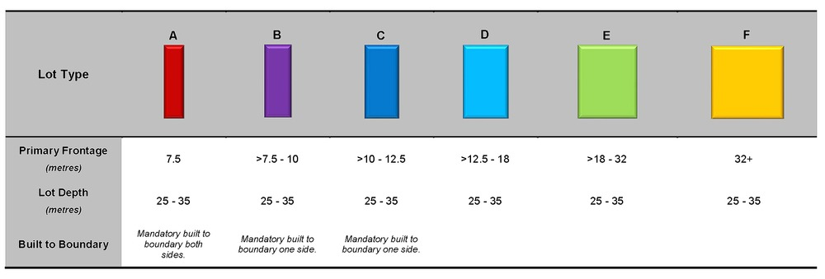

Figure 1 - Morayfield South
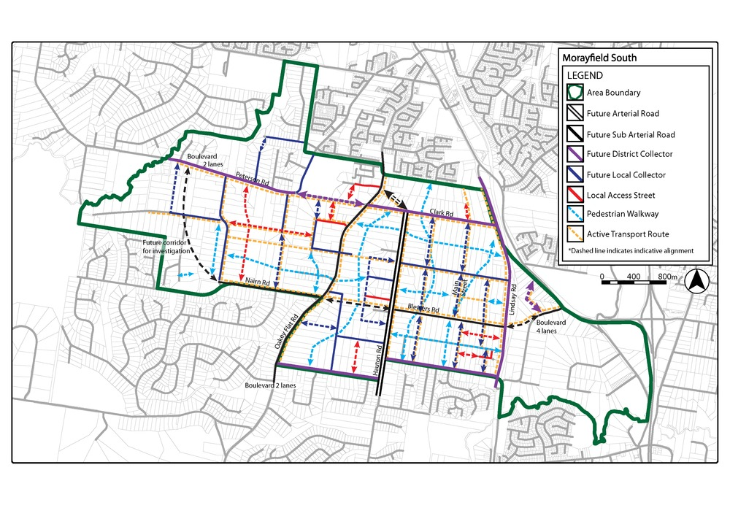

Figure 2 - Narangba East
