Table 9.4.1.12.3.1 Requirements for accepted development - Township zone - Township industry precinct

Requirements for accepted development |  | E Compliance  - Yes  - No | Council confirmation
General requirements
Boundary realignment
RAD1 | Lots created by boundary realignment:  - have a service connection for each lot to the reticulated water supply, sewerage, electricity and telecommunications networks where the networks are available at any location along the frontage of the created lot to a road confirmed by certification from the service provider;  - contain all existing service connections to water, sewer, electricity, telecommunication and other infrastructure or utility services wholly within the lot they serve confirmed by certification from a licensed surveyor  - have a minimum 4 metre wide point of vehicular access into the lot from a sealed road having a minimum clearance of 1 metre to any pole, stormwater gully pit, traffic island, item of street furniture, street tree, or the like in the road;  - do not require additional infrastructure connections or modification to existing connections.  - do not result in the creation of any additional lots;  - have easements connected to existing lots extended to the corresponding created lot(s) when not proposed to be extinguished as a result of the boundary realignment
RAD2 | Boundary realignment does not result in existing land uses on-site becoming non-compliant with planning scheme requirements:  Note - Examples may include but are not limited to:  - minimum lot size requirements;  - minimum or maximum required setbacks  - parking and access requirements;  - servicing and Infrastructure requirements;  - dependant elements of an existing or approved land use being separately titled, including but not limited to:  - Where a commercial or industrial land use contains an ancillary office⁽⁵³⁾, the office⁽⁵³⁾ cannot be separately titled as it is considered part of the commercial or industrial use.
RAD3 | Resulting lots comply with the following minimum lot sizes and dimensions:  Zone (Precinct) Area Frontage Depth  Township zone - Township industry precinct 2,500 m² - -
RAD4 | Resulting lots comply with a minimum frontage to depth ratio of 1:2 or 2:1.  Figure - Frontage to Depth Ratio  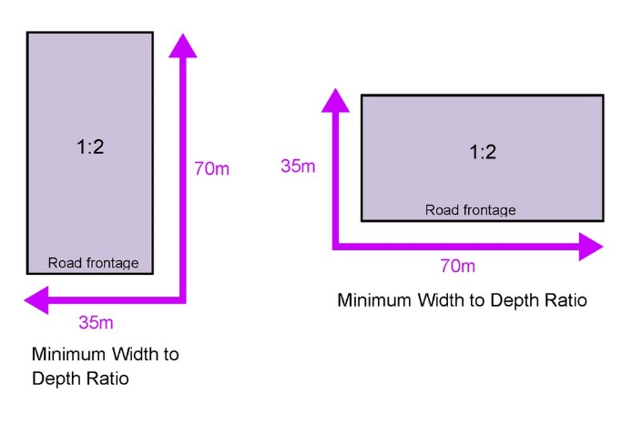
RAD5 | Boundary realignment does not result in the creation of additional building development opportunity within an area subject to an overlay map.
RAD6 | No new boundaries are located within 2m of High Value Areas as identified in Overlay map - Environmental areas.
RAD7 | Boundary realignment does not result in the clearing of any Habitat trees.

