Table 9.4.1.7.1 Requirements for accepted development - Industry zone

Requirements for accepted development |  | E Compliance  - Yes  - No | Council confirmation
General requirements
Boundary realignment
RAD1 | Lots created by boundary realignment:  - contain all service connections to water, sewer, electricity and other infrastructure wholly within the lot they serve;  - have constructed road access;  - do not require additional infrastructure connections or modification to existing connections.  - do not result in the creation of any additional lots;
RAD2 | Boundary realignment does not result in existing land uses on site becoming non-compliant.  Note - Examples may include but are not limited to:  - minimum lot size requirements;  - minimum or maximum required setbacks  - parking and access requirements;  - servicing and Infrastructure requirements;  - dependant elements of an existing or approved land use being separately titled, including but not limited to:  - Where a commercial or industrial land use contains an ancillary office⁽⁵³⁾, the office⁽⁵³⁾ cannot be separately titled as it is considered part of the commercial or industrial use.
RAD3 | Resulting lots comply with the following minimum lot sizes:  Zone (Precinct) Area  Industry Zone  Mixed industry and business precinct 1,000 m²  Light industry precinct 2,500 m²  General industry precinct 4,000 m²  Restricted industry precinct 6,000 m²  Marine industry precinct 4,000 m²
RAD4 | Resulting lots comply with a minimum frontage to depth ratio of 1:2 or 2:1.  Figure - Frontage to Depth Ratio  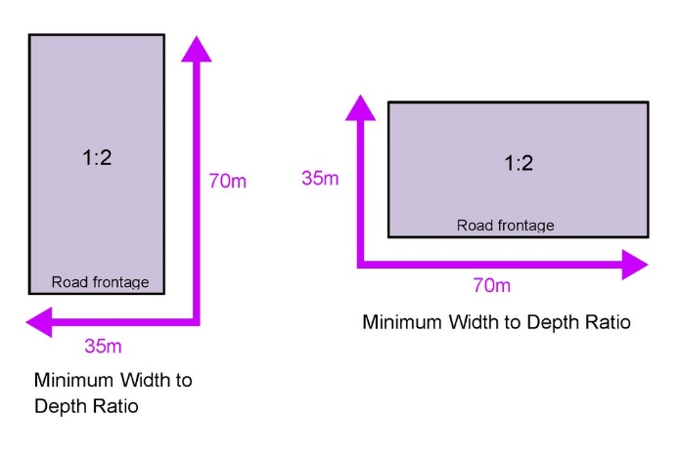
RAD5 | Boundary realignment does not result in the creation of additional building development opportunity within an area subject to an Overlay map.
RAD6 | No new boundaries are located within 2m of High Value Areas as identified in Overlay map - Environmental areas.
RAD7 | Boundary realignment does not result in the clearing of any Habitat trees.

Figure 1 - Dakabin
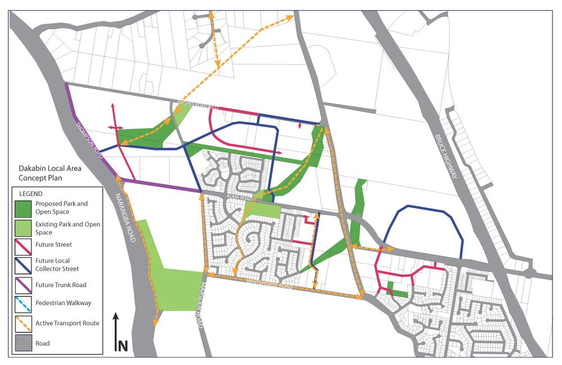

Figure 2 - Deception Bay Road Mixed Industry and Business
