Table 6.2.10.1 Requirements for accepted development - Rural zone

Requirements for accepted development |  | E Compliance  - Yes  - No | Council confirmation
General requirements
Development footprint
RAD1 | Where a development footprint has been identified as part of a development approval for reconfiguring a lot, all development occurs within the development footprint.
Building height
RAD2 | Building height and all structures do not exceed the height identified on Overlay map - Building heights; except in the Hamlet precinct, where outbuildings, free standing car ports or garages do not exceed 3.5m.  Note - This provision does not apply to telecommunication facilities.
Building on sloping land
RAD3 | Building and site design on slopes between 10% and 15% :  - use split-level, multiple-slab, pier or pole construction;  - avoid single-plane slabs and benching; and  - ensure the height of any cut or fill, whether retained or not, does not exceed 900mm.  Note - This provision does not apply to outbuildings or any building work.  Note - This provision does not apply where a development footprint exists for a lot.
Setbacks
RAD4 | Unless specified elsewhere in the zone code and where not located in a bushfire prone area, the minimum setbacks from a lot boundary are as follows:  - road boundary - 6m  - side boundary - 4.5m  - rear boundary - 4.5m.  Note - Where located in a bushfire hazard area (see Overlay map - Bushfire hazard) a greater setback may be required. See values and constraints requirements Bushfire hazard.  Note - This provision does not apply where a development footprint exists for a lot.
RAD5 | For lots located in the Hamlet precinct, the minimum setback from a boundary are as follows:  - road boundary - 6m  - side boundary - 1.5m for lots having 1000m² or less; 3m for lots greater than 1000m²  - rear boundary - 4m.
Lighting
RAD6 | Artificial lighting on-site is directed and shielded in such a manner as not to exceed the recommended maximum values of light technical parameters for the control of obtrusive light given in Table 2.1 of Australian Standard AS 4282 (1997) Control of Obtrusive Effects of Outdoor Lighting.  Note - “Curfewed hours” are taken to be those hours between 10pm and 7am on the following day
Waste treatment
RAD7 | All concentrated animal use areas (e.g. sheds, pens, holding yards, stables) are provided with site drainage to ensure all run-off is directed to suitable detention basins, filtration or other treatment areas.
Rural uses setbacks
RAD8 | The following uses, associated buildings and structures are setback from all lot boundaries as follows:  - Animal husbandry⁽⁴⁾ (buildings only) – 10m  - Animal keeping⁽⁵⁾, excluding catteries and kennels - 20m  - Aquaculture⁽⁶⁾ involving ponds or water behind dams – 100m  - Aquaculture⁽⁶⁾ involving the housing within an enclosed building of tanks and associated equipment - 20m  - Cropping⁽¹⁹⁾ (building only) – 10m  - Intensive horticulture⁽⁴⁰⁾ – 20m  - Nature-based tourism⁽⁵⁰⁾ - 40m  - Non-resident workforce accommodation⁽⁵²⁾ - 40m  - Permanent plantations⁽⁵⁹⁾ – 25m  - Rural Industry⁽⁷⁰⁾ - 20m  - Rural workers' accommodation⁽⁷¹⁾ - 40m  - Short-term accommodation⁽⁷⁷⁾ - 40m  - Tourist park⁽⁸⁴⁾ - 40m  - Transport depot⁽⁸⁵⁾, including all vehicle parking, storage and driveway areas – 30m  - Wholesale nursery⁽⁸⁹⁾ – 10m  - Winery⁽⁹⁰⁾ (buildings only) - 10m.
Car parking (for other than Non-resident workforce accommodation and Rural workers' accommodation)
RAD9 | On-site car parking is provided in accordance with Schedule 7 - Car parking.
Hazardous Chemicals
RAD10 | All development that involves the storage or handling of hazardous chemicals listed in Schedule 9, Development involving hazardous chemicals, Table 9.0.1 Quantity thresholds for hazardous chemicals stored as accepted development subject to requirements complies with Table 9.0.3 Hazardous chemicals.
RAD11 | Development does not involve the storage or handling of hazardous chemicals listed in Schedule 9, Development involving hazardous chemicals, Table 9.0.2 Hazardous chemicals assessable thresholds.
Clearing of habitat trees where not located in the Environmental areas overlay map
RAD12 | Development does not result in the damaging, destroyed or clearing of a habitat tree. This does not apply to:  - Clearing of a habitat tree located within an approved development footprint;  - Clearing of a habitat tree within 10m from a lawfully established building reasonably necessary for emergency access or immediately required in response to an accident or emergency;  - Clearing of a habitat tree reasonably necessary to remove or reduce the risk vegetation poses to serious personal injury or damage to infrastructure;  - Clearing of a habitat tree reasonably necessary to construct and maintain a property boundary fence and not exceed 4m in width either side of the fence where in the Rural , Rural residential and Environmental management and conservation zones. In any other zone, clearing is not to exceed 2m in width either side of the fence;  - Clearing of a habitat tree reasonably necessary for the purpose of maintenance or works within a registered easement for public infrastructure or drainage purposes;  - Clearing of a habitat tree in accordance with a bushfire management plan prepared by a suitably qualified person, submitted to and accepted by Council;  - Clearing of a habitat tree associated with removal of recognised weed species, maintaining existing open pastures and cropping land, windbreaks, lawns or created gardens;  - Native forest practice where accepted development under Part 1, 1.7.7 Accepted development.  Editor's note - A native tree measuring greater than 80cm in diameter when measured at 1.3m from the ground is recognised as a ‘habitat tree’. For further information on habitat trees, refer to Planning scheme policy – Environmental areas and corridors. Information detailing how this measurement is undertaken is provided in Australian Standard AS 4970 2009 Protection of Trees on Development Sites - Appendix A.

Works requirements
Utilities
RAD13 | Where available, the development is connected to:  - an existing reticulated electricity supply;  - telecommunications and broadband;  - reticulated sewerage;  - reticulated water;  - constructed and dedicated road.
RAD14 | Where not in a sewered area, the development is serviced by an appropriate on-site sewerage facility.  Note - A site and soil evaluation report is generally required to demonstrate compliance with this outcome. Reports are to be prepared in accordance with AS1547 On-site domestic wastewater management and the Queensland Plumbing and Wastewater Code.
RAD15 | Where not in an existing connections area or future connections area as detailed in the Unitywater Connections Policy (Water), development is provided with an adequate water supply of 45,000 litres by way of on-site storage.
Access
RAD16 | Any new or changes to existing site access and driveways are designed and located in accordance with:  - Where for a Council-controlled road, AS/NZS2890.1 section 3; or  - Where for a State-Controlled road, the Safe Intersection Sight Distance requirements in AustRoads and the appropriate IPWEAQ standard drawings, or a copy of a Transport Infrastructure Act 1994, section 62 approval.
RAD17 | Any new or changes to existing internal driveways and access ways are designed and constructed in accordance with AS/NZS2890.1 Parking Facilities – Off street car parking and the relevant standards in Planning scheme policy - Integrated design.
Stormwater
RAD18 | Any new or changes to existing stormwater run-off from the site is conveyed to a point of lawful discharge without causing nuisance or annoyance to any person, property or premises in accordance with Planning scheme policy – Integrated design.  Note - A watercourse as defined in the Water Act may be accepted as a lawful point of discharge providing the drainage discharge from the site does not increase the downstream flood levels during events up to and including the 1% AEP storm. An afflux of +20mm may be accepted on Council controlled land and road infrastructure. No worsening is ensured when stormwater is discharged into a catchment that includes State Transport Infrastructure.
Site works and construction management
RAD19 | The site and any existing structures are to be maintained in a tidy and safe condition.
RAD20 | Site construction works incorporate temporary stormwater run-off, erosion and sediment controls and trash traps designed in accordance with the Urban Stormwater Quality Planning Guidelines, Planning scheme policy - Stormwater management and Planning scheme policy - Integrated design.
RAD21 | Construction traffic including contractor car parking is controlled in accordance with a traffic management plan, prepared in accordance with the Manual of Uniform Traffic Control Devices (MUTCD) to ensure all traffic movements to and from the site are safe.
RAD22 | All native vegetation to be retained on-site is temporarily fenced or protected prior to and during development works.  Note - No parking of vehicles or storage of machinery or goods is to occur in these areas during development works.
RAD23 | Any damage to Council land or infrastructure is repaired or replaced with the same materials, prior to plan sealing, or final building classification.
RAD24 | Any material dropped, deposited or spilled on the road(s) as a result of construction processes associated with the site are to be cleaned at all times.
Earthworks
RAD25 | The site is prepared and the fill placed on-site in accordance with Australian Standard AS3798.  Note - The fill is to be inspected and tested in accordance with Planning scheme policy - Operational works inspection, maintenance and bonding procedures
RAD26 | The total of all cut and fill on-site does not exceed 900mm in height.  Figure - Cut and fill  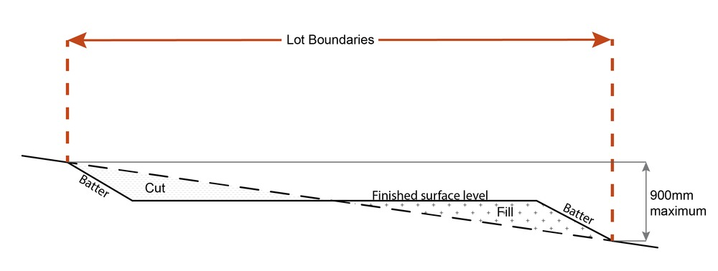  Note - This is site earthworks not building work.
RAD27 | Filling or excavation does not result in:  - a reduction in cover over any Council or public sector entity infrastructure to less than 600mm;  - an increase in finished surface grade over, or within 1.5m on each side of, the Council or public sector entity infrastructure above that which existed prior to the filling or excavation works being undertaken.  Note - Public sector entity is defined in Schedule 2 of the Act.

Use specific requirements
Dwelling house ⁽²²⁾
RAD28 | Residential density does not exceed one dwelling house⁽²²⁾ per lot.
RAD29 | The minimum setbacks from a lot boundary are as follows:  - road boundary - 6m  - side boundary - 4.5m  - rear boundary - 4.5m.  Note - Where located in a bushfire hazard area (see Overlay map - Bushfire hazard) a greater setback may be required. See values and constraints requirements Bushfire hazard.  Note - This is a quantifiable standard that is an alternative provision to the QDC, part MP1.2, A1 (a), (b) and (c), A2 (a), (b) and (d). Non-compliance with this provision for a Dwelling house requires a concurrence agency response from Council.  Note - This provision does not apply where a development footprint exists for a lot.
RAD30 | Where located in the Hamlet precinct, the minimum setbacks from a lot boundary are as follows:  - road boundary - 6m  - side boundary - 1.5m for lots having 1000m² or less  - 3m for lots greater than 1000m²  - rear boundary - 4m.  Note -This is a quantifiable standard that is an alternative provision to the QDC, part MP1.1, A1 (a), (b) and (c), A2 (a), (b) and (d) and part MP1.2, A1 (a), (b) and (c), A2 (a), (b) and (d). Non-compliance with this provision for a Dwelling house requires a concurrence agency response from Council.  Note - This provision does not apply where a development footprint exists for a lot.
RAD31 | Building height for a dwelling house⁽²²⁾ does not exceed the maximum height identified on Overlay map - Building heights.
RAD32 | Where located in the Hamlet precinct, building height does not exceed:  - that on Overlay map - Building heights; or  - 3.5m for outbuildings, free standing car ports or garages.
RAD33 | For Lake Samsonvale or Lake Kurwongbah, a setback of no less than 400m is maintained between the following nominated full supply levels to those lakes and any dwelling house⁽²²⁾ or outbuilding on the land:-  - RL 39.63m AHD being the full supply level to Lake Samsonvale; and  - RL 21m AHD being the full supply level to Lake Kurwongbah.  OR  No part of any dwelling house⁽²²⁾ or outbuilding on Lot 5 RP111651 or Lot 10 RP111653 or Lot 8 RP111268 is any closer than 80m to the full supply level of RL 21m AHD to Lake Kurwongbah.  Editor's note - The 400m buffer around Lake Samsonvale and Lake Kurwongbah is shown on Overlay map - Infrastructure buffers
RAD34 | Waste/effluent disposal systems are located at least:-  - 80m from the full supply level of RL 21m AHD to Lake Kurwongbah on Lot 5 RP111651 or Lot 10 RP 111653 or Lot RP 8 111268; and  - 400m from RL 39.63m AHD being the full supply level to Lake Samsonvale and RL 21m AHD being the full supply level to Lake Kurwongbah.  Editor's note - The 400m buffer around Lake Samsonvale and Lake Kurwongbah is shown on Overlay map - Infrastructure buffers
RAD35 | Where a development footprint has been identified as part of a development approval for reconfiguring a lot, all development occurs within that development footprint.
RAD36 | Building and site design on slopes between 10% and 15% must:  - use split-level, multiple-slab, pier or pole construction;  - avoid single-plane slabs and benching;  - ensure the height of any cut or fill, whether retained or not, does not exceed 900mm.  Note - This provision does not apply to outbuildings or any building work.  Note - This provision does not apply where a development footprint exists for a lot.
Dwelling house⁽²²⁾ - secondary dwelling
RAD37 | The maximum GFA for a secondary dwelling is as follows:  - in the Rural zone - 100m²;  - in the Hamlet precinct - 45m² for a lot with a primary frontage less than 15m;  - In the Hamlet precinct - 55m² for a lot with a primary frontage of 15m or more;  - in the Agriculture precinct - 100m²  - in the Rural living investigation precinct - 100m².  Note - In the Cedarton Foresters Cooperative and Mt Nebo plant nursery precinct, no secondary dwellings are permitted as part of the Land Management Plan.
RAD38 | The secondary dwelling obtains access from the existing driveway giving access to the dwelling house⁽²²⁾.
Home based business ⁽³⁵⁾
RAD39 | Home based business⁽³⁵⁾(s) are fully contained within a dwelling or on-site structure, except for a home based child care facility.
RAD40 | The maximum total use area is 100m², except where in the Hamlet precinct, the maximum total use area is 40m².
RAD41 | Up to 2 additional non-resident , either employees or customers, are permitted on the site at any one time, except where involving the use of heavy vehicles, where no employees are permitted.  Note - This provision does not apply to Bed and Breakfast or farmstay business.
RAD42 | Hours of operation are restricted to 8.00am to 6.00pm Monday to Saturdays and are not open to the public on Sunday's, Christmas Day, Good Friday and Anzac Day, except for:  - bed and breakfast or farm stay business which may operate on a 24 hour basis;  - office or administrative activities that do not generate non-residents visiting the site, such as book keeping and computer work;  - starting and warming up of heavy vehicles, which can commence at 7.00am.
RAD43 | The maximum number of heavy vehicles, trailer and motor vehicles stored on-site is as follows:  - 1 heavy vehicle;  - 1 trailer;  - Up to 3 motor vehicles.  EXCEPT  In the Hamlet precinct, no heavy vehicles, trailers and motor vehicles are stored or parked on-site. Only 1 small rigid vehicle (SRV) is permitted to be parked or stored on-site.  Note - The car parking provision associated with the dwelling house⁽²²⁾ is in addition to this requirement.  Note - The number of motor vehicles stated is in addition to motor vehicles associated with a dwelling house⁽²²⁾.
RAD44 | The home based business does not involve vehicle servicing or major repairs, including spray painting or panel beating.  Note - Vehicle servicing excludes general maintenance of a vehicle such as, but not limited to, changing of tyres, engine fluids, filters and parts such as batteries and plugs.
RAD45 | The home based business⁽³⁵⁾ does not generate noise that is audible from the boundary of the lot.  Note - Guidance as acceptable noise is provided in the standards listed in the Environmental Protection (Noise) Policy 2008.  Note - This provision does not apply to the use of heavy vehicle or motor vehicles.
RAD46 | Activities associated with the use do not cause a nuisance by way of aerosols, fumes, light, noise, odour, particles or smoke.  Note - Nuisance is defined in the Environmental Protection Act 1994
RAD47 | The home based business⁽³⁵⁾ does not involve an environmentally relevant activity (ERA) as defined in the Environmental Protection Regulation 2008.
RAD48 | Only goods grown, produced or manufactured on-site are sold from the site.
RAD49 | Display of goods grown, produced or manufactured on-site are contained within a dwelling or on-site structure and the display of goods is not visible from the boundary of the site.
RAD50 | For bed and breakfast and farmstays:  - overnight accommodation is provided in the dwelling house⁽²²⁾ of the accommodation operator;  - maximum 4 bedrooms are provided for a maximum of 10 guests;  - meals are served to paying guests only;  - rooms do not contain food preparation facilities.
Nature-based tourism ⁽⁵⁰⁾
RAD51 | For Lake Samsonvale or Lake Kurwongbah, a setback of no less than 400m is maintained between the following nominated full supply levels to those lakes and any Nature-based tourism⁽⁵⁰⁾ on the land:-  - RL 39.63m AHD being the full supply level to Lake Samsonvale; and  - RL 21m AHD being the full supply level to Lake Kurwongbah.  OR  No part of any Nature-based tourism⁽⁵⁰⁾ on Lot 5 RP111651 or Lot 10 RP111653 or Lot 8 RP111268 is any closer than 80m to the full supply level of RL 21m AHD to Lake Kurwongbah.  Editor's note - The 400m buffer around Lake Samsonvale and Lake Kurwongbah is shown on Overlay map - Infrastructure buffers
RAD52 | Waste/effluent disposal systems are located at least:-  - 80m from the full supply level of RL 21m AHD to Lake Kurwongbah on Lot 5 RP111651 or Lot 10 RP111653 or Lot 8 RP111268 ; and  - 400m from RL 39.63m AHD being the full supply level to Lake Samsonvale and RL 21m AHD being the full supply level to Lake Kurwongbah.  Editor's note - The 400m buffer around Lake Samsonvale and Lake Kurwongbah is shown on Overlay map - Infrastructure buffers
Non-residential workforce accommodation⁽⁵²⁾
RAD53 | No more than 1 Non-residential workforce accommodation⁽⁵²⁾ use per site.
RAD54 | Non-residential workforce accommodation⁽⁵²⁾ is contained within 1 structure.
RAD55 | Non-residential workforce accommodation⁽⁵²⁾ obtains access from the existing driveway giving access to the Dwelling house.
RAD56 | For Lake Samsonvale or Lake Kurwongbah, a setback of no less than 400m is maintained between the following nominated full supply levels to those lakes and any Non-resident workforce accommodation⁽⁵²⁾ on the land:-  - RL 39.63m AHD being the full supply level to Lake Samsonvale; and  - RL 21m AHD being the full supply level to Lake Kurwongbah.  OR  No part of any Non-resident workforce accommodation⁽⁵²⁾ on Lot 5 RP111651 or Lot 10 RP111653 or Lot 8 RP111268 is any closer than 80m to the full supply level of RL 21m AHD to Lake Kurwongbah.  Editor's note - The 400m buffer around Lake Samsonvale and Lake Kurwongbah is shown on Overlay map - Infrastructure buffers
RAD57 | Waste/effluent disposal systems are located at least:-  - 80m from the full supply level of RL 21m AHD to Lake Kurwongbah on Lot 5 RP111651 or Lot 10 RP111653 or Lot 8 RP111268; and  - 400m from RL 39.63m AHD being the full supply level to Lake Samsonvale and RL 21m AHD being the full supply level to Lake Kurwongbah.  Editor's note - The 400m buffer around Lake Samsonvale and Lake Kurwongbah is shown on Overlay map - Infrastructure buffers
Permanent plantation ⁽⁵⁹⁾
RAD58 | Planting only comprises native species naturally occurring in the area.
Roadside stall ⁽⁶⁸⁾
Note - These provisions do not apply to a home based business⁽³⁵⁾

RAD59 | No more than one roadside stall per property.
RAD60 | Goods offered for sale are only goods grown, produced or manufactured on the site.
RAD61 | The maximum area associated with a roadside stall⁽⁶⁸⁾, including any larger separate items displayed for sale, does not exceed 20m².
RAD62 | Car parking for 2 vehicles is provided off the road carriage and located on the property.
RAD63 | The roadside stall⁽⁶⁸⁾ is located no closer than 100m from an intersection.
Rural workers' accommodation ⁽⁷¹⁾
RAD64 | No more than 1 rural workers' accommodation⁽⁷¹⁾ per site.
RAD65 | Rural workers' accommodation⁽⁷¹⁾ is contained within 1 structure.
RAD66 | Rural workers' accommodation⁽⁷¹⁾ obtains access from the existing driveway giving access to the dwelling house⁽²²⁾.
RAD67 | For Lake Samsonvale or Lake Kurwongbah, a setback of no less than 400m is maintained between the following nominated full supply levels to those lakes and Rural workers' accommodation⁽⁷¹⁾ on the land:-  - RL 39.63m AHD being the full supply level to Lake Samsonvale; and  - RL 21m AHD being the full supply level to Lake Kurwongbah.  OR  No part of any Rural workers' accommodation⁽⁷¹⁾ on Lot 5 RP111651 or Lot 10 RP111653 or Lot 8 RP111268 is any closer than 80m to the full supply level of RL 21m AHD to Lake Kurwongbah.  Editor's note - The 400m buffer around Lake Samsonvale and Lake Kurwongbah is shown on Overlay map - Infrastructure buffers
RAD68 | Waste/effluent disposal systems are located at least:-  - 80m from the full supply level of RL 21m AHD to Lake Kurwongbah on Lot 5 RP111651 or Lot 10 RP111653 or Lot 8 RP111268; and  - 400m from RL 39.63m AHD being the full supply level to Lake Samsonvale and RL 21m AHD being the full supply level to Lake Kurwongbah.  Editor's note - The 400m buffer around Lake Samsonvale and Lake Kurwongbah is shown on Overlay map - Infrastructure buffers
Sales office ⁽⁷²⁾
RAD69 | A sales office⁽⁷²⁾ is located on the site for no longer than 2 years.
Telecommunications facility⁽⁸¹⁾
Editor's note - In accordance with the Federal legislation Telecommunications facilities⁽⁸¹⁾ must be constructed and operated in a manner that will not cause human exposure to electromagnetic radiation beyond the limits outlined in the Radiocommunications (Electromagnetic Radiation - Human Exposure) Standard 2003 and Radio Protection Standard for Maximum Exposure Levels to Radiofrequency Fields - 3Khz to 300Ghz.

RAD70 | A minimum of 45m² is available at ground level to allow for additional equipment shelters and associated structures for the purpose of co-locating on the proposed facility.
RAD71 | The development results in no net reduction in the minimum quantity and standard of landscaping, private or communal open space or car parking spaces required under the planning scheme or under an existing development approval.
RAD72 | Equipment shelters and associated structures are located:  - directly beside the existing equipment shelter and associated structures;  - behind the main building line;  - further away from the frontage than the existing equipment shelter and associated structures;  - a minimum of 10m from side and rear boundaries, except where in the Industry and Extractive industry zones, the minimum side and rear setback is 3m.
RAD73 | Equipment shelters and other associated structures are either the same type of colour or material to match the surrounding locality.
RAD74 | The facility is enclosed by security fencing or by other means to ensure public access is prohibited.
RAD75 | A minimum 3m wide strip of dense planting is provided around the perimeter of the fenced area, between the development and street frontage and adjoining uses.  Note - Landscaping is provided in accordance with Planning scheme policy - Integrated design.  Note - Council may require a detailed landscaping plan, prepared by a suitably qualified person to ensure compliance with Planning scheme policy - Integrated design.
RAD76 | All equipment comprising the telecommunications facility⁽⁸¹⁾ which produces audible or non-audible sound is housed within a fully enclosed building incorporating sound control measures sufficient to ensure no noise from this equipment can be heard, or felt at the site boundary.
Transport depot ⁽⁸⁵⁾
RAD77 | Development, including all vehicle parking, drive way areas and storage areas, is set back 30m from all property boundaries.
RAD78 | The maximum number of heavy vehicles, trailers and motor vehicles stored on-site is as follows:  - 4 heavy vehicles  - 4 trailers  - Up to 6 motor vehicles.  Note - The number of motor vehicles stated is in addition to motor vehicles associated with a dwelling house⁽²²⁾
RAD79 | No vehicle servicing or major repairs, including spray painting or panel beating is undertaken on the site.  Note - Vehicle servicing excludes general maintenance of a vehicle such as, but not limited to, changing of tyres, engine fluids, filters, and parts such as batteries and plugs.
RAD80 | - Vehicle parking areas, vehicle standing areas and outdoor storage areas of plant and equipment are screened from adjoining sites by either planting, wall(s), non-transparent fence(s) or a combination to at least 1.8m in height along the length of those areas.  - Planting for screening is to have a minimum depth of 3m.
RAD81 | Development has direct vehicle access from a road classified as a State Arterial, Arterial or Sub-Arterial (refer Overlay map - Road hierarchy).
Winery ⁽⁹⁰⁾
RAD82 | The maximum use area including all buildings, structures, driveways and parking areas is 1500m².
RAD83 | The winery⁽⁹⁰⁾ is accessed from a road classified as a State Arterial, Arterial or Sub-Arterial (refer Overlay map - Road hierarchy).

Values and constraints requirements
Note - The relevant values and constraints requirements do not apply where the development is consistent with a current Development permit for Reconfiguring a lot or Material change of use or Operational work, where that approval has considered and addressed (e.g. through a development footprint plan (or similar in the case of Landslide hazard) or conditions of approval) the identified value or constraint under this planning scheme.

Acid sulfate soils - (refer Overlay map - Acid sulfate soils to determine if the following requirements apply)
Note - Planning scheme policy - Acid sulfate soils provides guidance for requirements for accepted development that has the potential to disturb acid
sulfate soils i.e. development involving filling or excavation works below the thresholds of 100m3 and 500m3 respectively.

RAD84 | Development does not involve:  - excavation or otherwise removing of more than 100m³ of soil or sediment where below 5m Australian Height Datum AHD, or  - filling of land of more than 500m³ of material with an average depth of 0.5m or greater where below the 5m AHD.  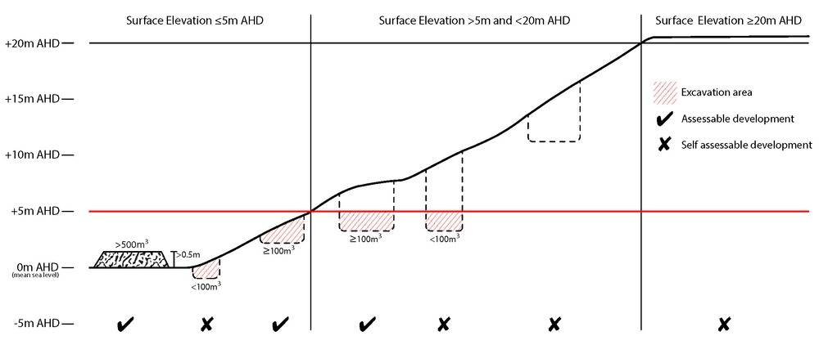
Bushfire hazard (refer Overlay map - Bushfire hazard to determine if the following requirements apply)
Note - For the purposes of section 12 of the Building Regulation 2006, land identified as very high potential bushfire intensity, high potential bushfire intensity, medium potential bushfire intensity or potential impact buffer on the Bushfire hazard overlay map is the 'designated bushfire hazard area'. AS 3959-2009 Construction of buildings in bushfire hazard areas applies within these areas.

RAD85 | - Building and structures are:  - not located on a ridgeline  - not located on land with a slope greater than 15% (see Overlay map – Landslide hazard)  - Dwellings are located on east to south facing slopes.  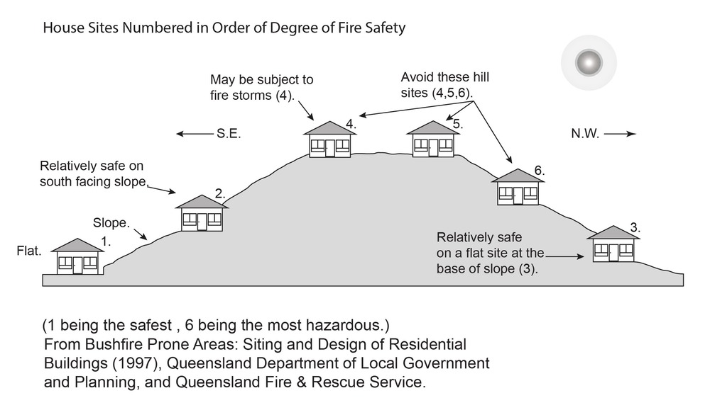
RAD86 | Buildings and structures have contained within the site:  - a separation from classified vegetation of 20m or the distance required to achieve a bushfire attack level (BAL) at the building, roofed structure or fire fighting water supply of no more than 29, whichever is the greater;  - a separation from low threat vegetation of 10m or the distance required to achieve a bushfire attack level (BAL) at the building, roofed structure or fire fighting water supply of no more than 29, whichever is the greater;  - a separation of no less than 10m between a fire fighting water supply extraction point and any classified vegetation, buildings and other roofed structures;  - an area suitable for a standard fire fighting appliance to stand within 3m of a fire fighting water supply extraction point; and  - an access path suitable for use by a standard fire fighting appliance having a formed width of at least 4m, a cross-fall of no greater than 5%, and a longitudinal gradient of no greater than 25%:  - to, and around, each building and other roofed structure; and  - to each fire fighting water supply extraction point.  Note - The meaning of the terms classified vegetation and low threat vegetation as well as the method of calculating the bushfire attack level are as described in Australian Standard AS 3959.
RAD87 | The length of driveway:  - to a public road does not exceed 100m between the most distant part of a building used for any purpose other than storage and the nearest part of a public road;  - has a maximum gradient no greater than 12.5%;  - have a minimum width of 3.5m;  - accommodate turning areas for fire fighting appliances in accordance with Qld Fire and Emergency Services' Fire Hydrant and Vehicle Access Guideline.
RAD88 | - A reticulated water supply is provided by a distributer retailer for the area or, where not connected to a reticulated water supply, on-site fire fighting water storage containing not less than 10 000 litres (tanks with fire brigade tank fittings, swimming pools) is provided and located within 10m of buildings and structures.  - Where a swimming pool is the nominated on-site fire fighting water storage source, vehicle access to within 3m of that water storage source is provided.  - Where a tank is the nominated on-site fire fighting water storage source, it includes:  - a hardstand area allowing medium rigid vehicle (15 tonne fire appliance) access within 6m of the tank;  - fire brigade tank fittings, comprising 50mm ball valve and male camlock coupling and, if underground, an access hole of 20mm (minimum) to accommodate suction lines.
RAD89 | Development does not involve the manufacture or storage of hazardous chemicals.
Environmental areas (refer Overlay map - Environmental areas to determine if the following requirements apply)
Note - The following are excluded from the native clearing provisions of this planning scheme:
- Clearing of native vegetation located within an approved development footprint;
- Clearing of native vegetation within 10m from a lawfully established building reasonably necessary for emergency access or immediately required in response to an accident or emergency;
- Clearing of native vegetation reasonably necessary to remove or reduce the risk vegetation poses to serious personal injury or damage to infrastructure;
- Clearing of native vegetation reasonably necessary to construct and maintain a property boundary fence and not exceed 4m in width either side of the fence where in the Rural, Rural residential and Environmental Management and Conservation zones. In any other zone, clearing is not to exceed 2m in width either side of the fence;
- Clearing of native vegetation reasonably necessary for the purpose of maintenance or works within a registered easement for public infrastructure or drainage purposes;
- Clearing of native vegetation in accordance with a bushfire management plan prepared by a suitably qualified person, submitted to and accepted by Council;
- Clearing of native vegetation associated with removal of recognised weed species, maintaining existing open pastures and cropping land, windbreaks, lawns or created gardens;
- Grazing of native pasture by stock;
- Native forest practice where accepted development under Part 1, 1.7.7 Accepted development.
Note - Definition for native vegetation is located in Schedule 1 Definitions.

Note - Native vegetation subject to this requirement primarily comprises of matters of national environmental significance (MNES), matters of state environmental significance (MSES). They also comprise some matters of local environmental significance (MLES). A MLES is defined in Schedule 1.2, Administrative definitions. A list of the elements that apply to the mapped MSES and MLES is provided in Appendix 1 of the Planning scheme policy - Environmental areas.

Editors' Note - The accuracy of overlay mapping can be challenged through the development application process (code assessable development) or by way of a planning scheme amendment. See Council's website for details.

Editors' Note - When clearing native vegetation within a MSES area, you may still require approval from the State government.

RAD90 | Where no suitable land cleared of native vegetation exists, clearing of native vegetation in High Value Area or Value Offset Area is for the purpose of a new dwelling house⁽²²⁾ and all associated facilities* or an extension to an existing dwelling house⁽²²⁾ only, and comprises an area no greater than 1500m².  Note - *All associated facilities includes: on-site wastewater treatment, all areas of disturbance, on-site parking, access and manoeuvring areas.  Editor's note - See in heading above for other uses excluded from native vegetation clearing requirements.  Editor's note - Where vegetation clearance is accepted development subject to requirements, care should be undertaken to avoid adverse impacts on koalas, koala habitat values and habitat connectivity and to encourage existing koala usage of the site. Measures to minimise impacts include:  - co-locating all associated activities, infrastructure and access strips;  - be the least valued area of koala habitat on the site;  - minimise the footprint of the development envelope area;  - minimise edge effects to areas external to the development envelope;  - location and design consideration to ensure koala safety and movement in accordance with the Koala-sensitive Design Guideline and Planning scheme policy – Environmental areas;  - sufficient area between the development and koala habitat trees to achieve their long-term viability.  Editor's note - Where vegetation clearing is accepted development subject to requirements, consideration should be given to avoid clearing habitat trees. Habitat trees may contain structural hollows where animals live, breed and shelter. The provision of nest boxes or salvaging of hollows will provide compensatory roosting and nesting opportunities for local wildlife including sugar gliders, possums and owls. For further information see Planning scheme policy – Environmental areas.
RAD91 | No clearing of native vegetation is to occur within the Value Offset Area MLES - Waterway buffer or Value Offset Area MLES - Wetland buffer.  This does not apply to the following:  - Clearing of native vegetation located within an approved development footprint;  - Clearing of native vegetation within 10m from a lawfully established building reasonably necessary for emergency access or immediately required in response to an accident or emergency;  - Clearing of native vegetation reasonably necessary to remove or reduce the risk vegetation poses to serious personal injury or damage to infrastructure;  - Clearing of native vegetation reasonably necessary to construct and maintain a property boundary fence and not exceed 4m in width either side of the fence where in the Rural, Rural residential and Environmental management and conservation zones. In any other zone, clearing is not to exceed 2m in width either side of the fence;  - Clearing of native vegetation reasonably necessary for the purpose of maintenance or works within a registered easement for public infrastructure or drainage purposes;  - Clearing of native vegetation in accordance with a bushfire management plan prepared by a suitably qualified person, submitted to and accepted by Council;  - Clearing of native vegetation associated with removal of recognised weed species, maintaining existing open pastures and cropping land, windbreaks, lawns or created gardens;  - Grazing of native pasture by stock;  - Native forest practice where accepted development under Part 1, 1.7.7 Accepted development.
Extractive resources separation area (refer Overlay map - Extractive resources (separation area) to determine if the following requirements apply)
RAD92 | Development does not result in more than one dwelling house⁽²²⁾ per lot within separation areas.
RAD93 | Development within the separation area does not include the following uses:  - caretaker's accommodation⁽¹⁰⁾;  - community residence⁽¹⁶⁾;  - dual occupancy⁽²¹⁾;  - dwelling unit⁽²³⁾;  - hospital⁽³⁶⁾;  - rooming accommodation⁽⁶⁹⁾;  - multiple dwelling⁽⁴⁹⁾;  - non-resident workforce accommodation⁽⁵²⁾;  - relocatable home park⁽⁶²⁾;  - residential care facility⁽⁶⁵⁾;  - resort complex⁽⁶⁶⁾;  - retirement facility⁽⁶⁷⁾;  - rural workers’ accommodation⁽⁷¹⁾;  - short-term accommodation⁽⁷⁷⁾;  - tourist park⁽⁸⁴⁾.
RAD94 | All habitable rooms within the separation area are:  - acoustically insulated to achieve the noise levels listed in Schedule 1 Acoustic Quality Objectives, Environmental Protection (Noise) Policy 2008;  - provided with mechanical ventilation.
RAD95 | Private open space areas are separated from the resource processing area by buildings or a 1.8m high solid structure.
Extractive resources transport routes (refer Overlay map - Extractive resources (transport route and buffer) to determine if the following requirements apply)
RAD96 | The following uses are not located within the 100m wide transport route buffer:  - Caretaker’s accommodation⁽¹⁰⁾, except where located in the Extractive industry zone;  - Community residence⁽¹⁶⁾;  - Dual occupancy⁽²¹⁾;  - Dwelling house;⁽²²⁾  - Dwelling unit⁽²³⁾;  - Hospital⁽³⁶⁾;  - Rooming accommodation⁽⁶⁹⁾;  - Multiple dwelling⁽⁴⁹⁾;  - Non-resident workforce accommodation⁽⁵²⁾;  - Relocatable home park⁽⁶²⁾;  - Residential care facility⁽⁶⁵⁾;  - Resort complex⁽⁶⁶⁾;  - Retirement facility⁽⁶⁷⁾;  - Rural workers’ accommodation⁽⁷¹⁾;  - Short-term accommodation⁽⁷⁷⁾;  - Tourist park⁽⁸⁴⁾.
RAD97 | Except for an existing vacant lot, development does not create a new vehicle access point onto an Extractive resources transport route.
RAD98 | A vehicle access point is located, designed and constructed in accordance with Planning scheme policy - Integrated design.
Heritage and landscape character (refer Overlay map - Heritage and landscape character to determine if the following requirements apply)
Note - Places, including sites, objects and buildings having local cultural heritage significance, are identified on Overlay map - Heritage and landscape character and listed in Schedule 1 of Planning scheme policy - Heritage and landscape character. Places also having cultural heritage significance at a State level and being entered in the Queensland Heritage Register, are also identified in Schedule 1 of Planning scheme policy - Heritage and landscape character.

RAD99 | Development is for the preservation, maintenance, repair and restoration of the site, object or building.  This does not apply to Listed item 99, in Schedule 1 - List of sites, objects and buildings of significant historical and cultural value of Planning scheme policy - Heritage and landscape character.  Note - Preservation, maintenance, repair and restoration are defined in Schedule 1 - Definitions
RAD100 | A cultural heritage conservation management plan is prepared in accordance with Planning scheme policy – Heritage and landscape character and submitted to Council prior to the commencement of any preservation, maintenance, repair and restoration works. Any preservation, maintenance, repair and restoration works are in accordance with the Council approved cultural heritage conservation management plan.  This does not apply to Listed item 99 in Schedule 1 - List of sites, objects and buildings of significant historical and cultural value of Planning scheme policy - Heritage and landscape character.
RAD101 | Development does not result in the removal of or damage to any significant tree identified on Overlay map – Heritage and landscape character and listed in Appendix 2 of Planning scheme policy – Heritage and landscape character.
RAD102 | The following development does not occur within 20m of the base of any significant tree, identified on Overlay map – Heritage and landscape character and listed in Appendix 2 of Planning scheme policy – Heritage and landscape character:  - construction of any building;  - laying of overhead or underground services;  - any sealing, paving, soil compaction;  - any alteration of more than 75mm to the ground level prior to work commencing.
RAD103 | Pruning of a significant tree occurs in accordance with Australian Standard AS 4373-2007 - Pruning of Amenity Trees.
Landslide hazard (refer Overlay map - Landslide hazard to determine if the following requirements apply)
RAD104 | Development does not:  - involve earthworks exceeding 50m³;  - involve cut and fill having a height greater than 600mm;  - involve any retaining wall having a height greater than 600mm;  - redirect or alter the existing flow of surface or groundwater.
RAD105 | Buildings, excluding domestic outbuildings:  - are split-level, multiple-slab, pier or pole construction;  - are not single plane slab on ground.
RAD106 | Development does not involve the manufacture, handling or storage of hazardous chemicals.
Infrastructure buffers (refer Overlay map - Infrastructure buffers to determine if the following requirements apply)
RAD107 | Development does not include the following uses within a Wastewater treatment site buffer:  - Caretaker’s accommodation⁽¹⁰⁾;  - Community residence⁽¹⁶⁾;  - Dual occupancy⁽²¹⁾;  - Dwelling house;⁽²²⁾  - Dwelling unit⁽²³⁾;  - Hospital⁽³⁶⁾;  - Rooming accommodation⁽⁶⁹⁾;  - Multiple dwelling⁽⁴⁹⁾;  - Non-resident workforce accommodation⁽⁵²⁾;  - Relocatable home park⁽⁶²⁾;  - Residential care facility⁽⁶⁵⁾;  - Resort complex⁽⁶⁶⁾;  - Retirement facility⁽⁶⁷⁾;  - Rural workers’ accommodation⁽⁷¹⁾;  - Short-term accommodation⁽⁷⁷⁾;  - Tourist park⁽⁸⁴⁾.
RAD108 | Development within a Water supply buffer does not include the incineration or burial of waste and all other waste is collected and stored in weather proof, sealed waste receptacles, located in roofed and bunded areas, for disposal by a licenced contractor.
RAD109 | Management, handling and storage of hazardous chemicals (including fuelling of vehicles) within a Water supply buffer, is undertaken in secured, climate controlled, weather proof, level and bunded enclosures.
RAD110 | Development does not restrict access to Bulk water supply infrastructure of any type or size, having regard to (among other things):  - buildings or structures;  - gates and fences;  - storage of equipment or materials;  - landscaping or earthworks or stormwater or other infrastructure.
RAD111 | On-site sewerage facilities in a Water supply buffer produce a minimum secondary treated effluent (90th percentile) and effluent application to ensure water quality is maintained and protected.
RAD112 | On-site sewerage facilities in a Water supply buffer for a dwelling house⁽²²⁾ include:  - emergency storage capacity of 1,000 litres and adequate buffering for shock loading/down time;  - a reserve land application area of 100% of the effluent irrigation design area;  - land application areas that are vegetated;  - the base of the land application field is at least 2 metres above the seasonal high water table/bedrock (whichever is the closest to the base of the application area);  - wastewater collection and storage systems must have capacity to accommodate full load at peak times.
RAD113 | On-site sewerage facilities in a Water supply buffer for development other than a dwelling house include emergency storage capable of holding 3-6 hours peak flow of treated effluent in the event of emergencies/overload with provision for de-sludging.
RAD114 | Development involving Permanent plantation⁽⁵⁹⁾ within a Water supply buffer maintains a minimum of 30% ground cover at all times.
RAD115 | Development does not involve the construction of any buildings or structures within a Bulk water supply infrastructure buffer.
RAD116 | Development involving a major hazard facility or an Environmentally Relevant Activity (ERA) is setback 30m from a Bulk water supply infrastructure buffer.
RAD117 | Development does not involve the construction of any buildings or structures within the Gas pipeline buffer.
RAD118 | All habitable rooms located within an Electricity supply substation buffer are:  - located a minimum of 10m from an electricity supply substation⁽⁸⁰⁾ ; and  - acoustically insulated to achieve the noise levels listed in Schedule 1, Acoustic Quality Objectives, Environmental Protection (Noise) Policy 2008.
RAD119 | Development does not involve the construction of any buildings or structures containing habitable rooms or sensitive land uses within a High voltage electricity line buffer.
Overland flow path (refer Overlay map - Overland flow path to determine if the following requirements apply)
RAD120 | Development for a material change of use or building work does not involve the construction of a building or structure in an Overland flow path area.
RAD121 | Development for a material change of use or operational work does not impede the flow of flood waters through the premises or worsen flood flows to other premises.  Note - A report from a suitably qualified Registered Professional Engineer Queensland is required certifying that the development does not increase the potential for significant adverse impacts on an upstream, downstream or surrounding premises.  Note - Reporting to be prepared in accordance with Planning scheme policy – Flood hazard, Coastal hazard and Overland flow
RAD122 | Development for a material change of use or building work ensures that fencing in an overland flow path area is at least 50% permeable.
RAD123 | Development for a material change of use or building work that involves a hazardous chemical ensures the hazardous chemicals is not located within an overland flow path area.
RAD124 | Development for a material change of use or building work for a Park⁽⁵⁷⁾ ensures that work is provided in accordance with the requirements set out in Appendix B of the Planning scheme policy - Integrated design.
Riparian and wetland setbacks (refer Overlay map - Riparian and wetland setback to determine if the following requirements apply)
Note - W1, W2 and W3 waterway and drainage lines, and wetlands are mapped on Schedule 2, Section 2.5 Overlay Maps – Riparian and wetland setbacks.

RAD125 | No development is to occur within:  - 50m from top of bank for W1 waterway and drainage line  - 30m from top of bank for W2 waterway and drainage line  - 20m from top of bank for W3 waterway and drainage line  - 100m from the edge of a Ramsar wetland, 50m from all other wetlands.  Note - W1, W2 and W3 waterways and drainage lines, and wetlands are mapped on Schedule 2, Section 2.5 Overlay Maps – Riparian and wetland setbacks.  Note - In some cases, the top of bank may not be easily defined, as such a hydraulic measurement may be applied instead. Moreton Bay Regional Council will provide further direction on how to determine and locate the setback boundary in these locations.  Note - The minimum setback distance applies to the each side of waterway.
Scenic amenity - Regionally significant (Hills) and Locally important (Coast) - (refer Overlay map - Scenic amenity to determine if the following requirements apply)
RAD126 | Where located in the Regionally significant (Hills) scenic amenity overlay, buildings and structures are not:  - located on a hill top or ridge line; and  - all parts of the building and structure are located below the hill top or ridge line.  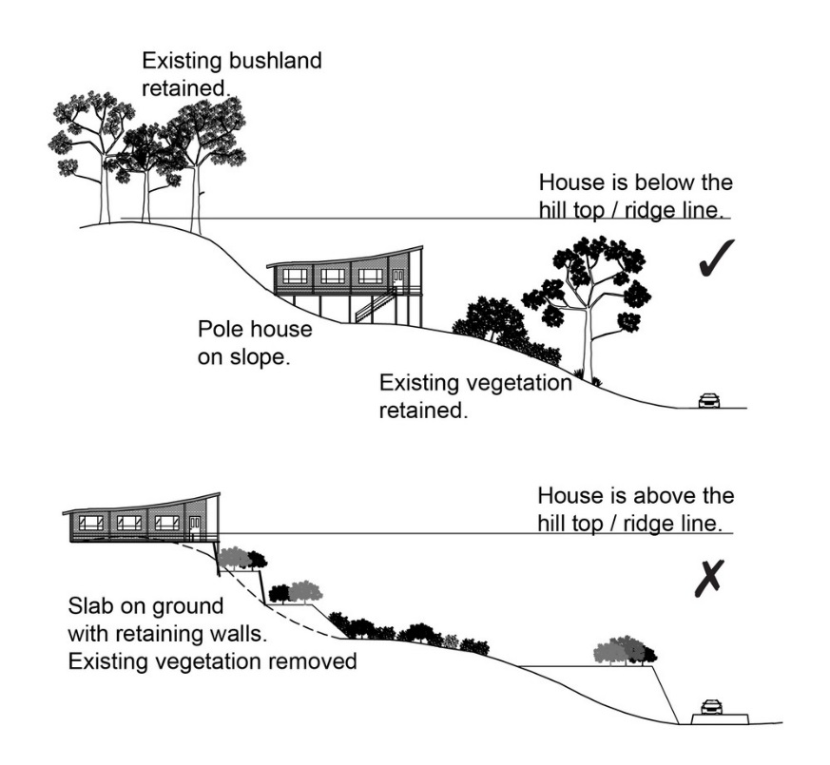
RAD127 | Where located in the Regionally significant (Hills) scenic amenity overlay, driveways and accessways:  - go across land contours and do not cut straight up slopes;  - follow natural contours, not resulting in batters or retaining walls being greater than 1m in height.  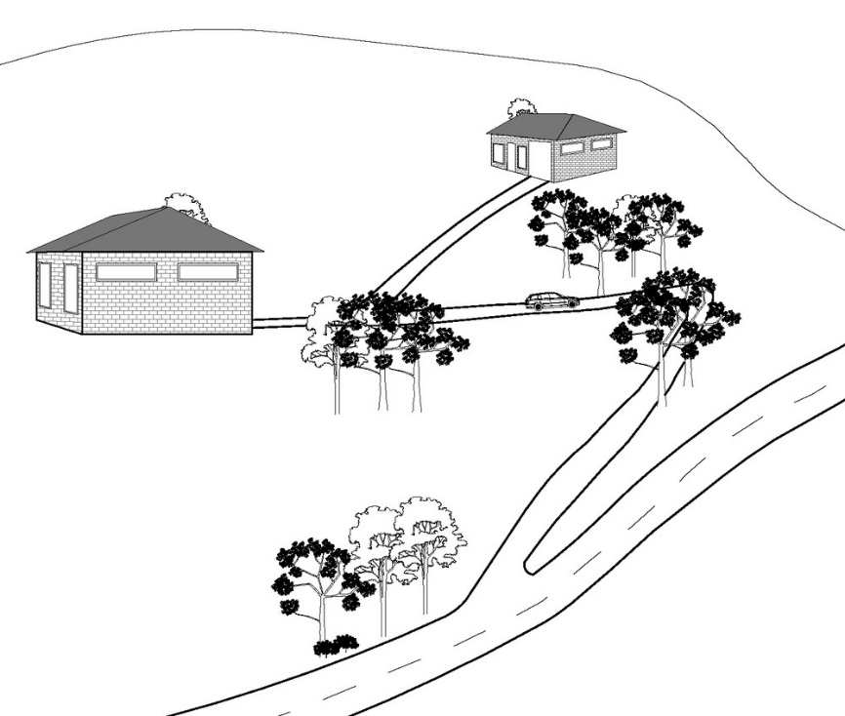
RAD128 | Where located in the Regionally significant (Hills) scenic amenity overlay, roofs and wall surfaces of buildings and structures adopt the following colours:  Colours from Australian Standard AS2700s – 1996  G12 – Holly G53 – Banksia N44 – Bridge Grey  G13 – Emerald G54 – Mist Green N45 – Koala Grey  G14 – Moss Green G55 – Lichen N52 – Mid Grey  G15 – Rainforest Green G56 – Sage Green N54 – Basalt  G16 – Traffic Green G62 – Rivergum N55 – Lead Grey  G17 – Mint Green G64 – Slate X54 – Brown  G21 – Jade G65 – Ti Tree X61 – Wombat  G22 – Serpentine N25 – Birch Grey X62 – Dark Earth  G23 – Shamrock N32 – Green Grey X63 – Iron Bark  G24 – Fern Green N33 – Lightbox Grey Y51 – Bronze Olive  G25 – Olive N35 – Light Grey Y61 – Black Olive  G34 – Avocado N41 – Oyster Y63 – Khaki  G52 – Eucalyptus N42 – Storm Grey Y66 – Mudstone  N43 – Pipeline Grey  Note - In the Rural Zone, netting, shade cloth and similar coverings associated with agricultural operations are exempt.
RAD129 | Where located in the Regionally significant (Hills) scenic amenity overlay, roofs and wall surfaces of buildings and structures are painted or finished such that reflectivity is less than 35%.
Transport noise corridors (refer Overlay map - Transport noise corridors)
This is for information purposes only. No requirements for accepted development or criteria for assessable development apply. Development located within a Transport Noise Corridor must satisfy the requirements of the Queensland Development Code.

TABLE A – CEDARTON FORESTER’S COOPERATIVE – LAND MANAGEMENT PLAN

Development in the Cedarton Forester’s Cooperative site subject to a land management plan (see Figures 1 – 6)

1.1 Purpose of the land management plan
The site is situated at 1965 Maleny Stanley River Road, Booroobin on land described as Lot 357 SP119036.
The purpose of the land management plan is to achieve the following identification of:
- The nature and extent of development permitted to occur on the site, subject to a land management plan process, namely:
  - A maximum of 22 dwelling sites, associated dwellings and driveways;
  - outbuildings associated with dwellings;
  - 1 community hall for the exclusive use of Cedarton Forester’s Cooperative members only and is not available to members of the public for public use or hire;
  - 1 plant nursery for the exclusive use of Cedarton Forester’s Cooperative members only and the propagation of plants for use on the land management plan site only. The plant nursery is not to be available to the public or sell to the public;
  - 1recycling centre exclusive use of Cedarton Forester’s Cooperative members only;
  - Accessways and associated passing bays throughout the land management plan site.
- The location of development, except for outbuildings listed in (a)(ii) above.
- Any additional works required to facilitate and support the development listed in (a) above.

1.2 Outcomes sought
The outcomes sought by the land management plan are as follows:
- To acknowledge the presence of a multiple dwelling of 22 units associated with the Cedarton Forester’s Cooperative site;
- To limit development to that which existed on the day the planning scheme is adopted. Expansion or addition of land use and building is avoided;
- To ensure that any recognised development occurs in accordance with a land management plan.
Note - Development permitted to occur on the site - This is based on unlawful development currently existing on the site.

Note - The exact location and number of outbuildings to remain on site is unknown at time of preparing the land management plan. At this stage the Cedarton Forester’s Cooperative members have yet to determine which outbuildings are to be retained and upgrade to the necessary standard to obtain building consent. Any outbuilding that has not applied for a building consent to upgrade the building or structure to the necessary standard under the Building Act within the timeframes specified in the land management plan is to be demolished and removed from the site. Failing this, enforcement action will be taken by Council.

Note - Figures 1 – 6 form the Land management plan for the site
Table 1 - Land management plan outcomes to be achieved
No | Subject | Applicability | Outcome to be achieved
1. | Development subject to land management plan | The land management plan site | - Development comprises the following:  - A maximum of 22 dwelling sites, associated dwellings, and driveways.  - Outbuildings associated with dwellings.  - 1 community hall for the exclusive use of Cedarton Forester’s Cooperative members only and is not available to members of the public for public use or hire.  - 1 plant nursery for the exclusive use of Cedarton Forester’s Cooperative members only and the propagation of plants for use on the land management plan site only. The plant nursery is not to be available to the public or sell to the public.  - 1 recycling centre exclusive use of Cedarton Forester’s Cooperative members only.  - Accessways and associated passing bays throughout the land management site.  - Development is to occur in accordance with Figure 1 Cedarton Forester’s Cooperative land management plan – Dwelling and building location.
2. | Accessways | The land management plan site | - Within 2 years of the adoption of the Moreton Bay Planning scheme, the Cedarton Forester’s Cooperative will:  - Undertake all necessary remedial work to the accessway.  - Construct the passing bays PB1 – PB8 as identified on Figure 3 Cedarton Forester’s Cooperative land management plan – Accessway and driveway improvement areas. Passing bays have a minimum length of 20m and a 6m minimum trafficable width measured at the passing bay;  - Seal accessway sections as identified on Figure 3 Cedarton Forester’s Cooperative land management plan – Accessway and driveway improvement areas. Accessways are to be sealed in accordance with Council’s access standards.
3. | Energy | The land management plan site | Electricity is provided by means of solar power.
4. | Water course separation | The land management plan site | No development is located closer than 40m from the top of the bank of a water course identified on Figure 4 – Cedarton Forester’s Cooperative land management plan – Contours, accessway and water courses.
5. | Northern vinculum-connected | The land management plan site | - Residential development is limited to that part of the site lying south of the Maleny-Stanley River Road.  - 2. The area lying north of the Maleny-Stanley River Road is to be retained in its natural state or re-vegetated with local native species.
6. | Dwellings and dwelling sites | 22 Dwelling and dwelling sites | - Dwellings are to be located on sites in accordance with Figure 1 Cedarton Forester’s Cooperative land management plan – Dwelling and building location.  - Dwellings are to be designed and constructed to comply with the Building Act 1975 and the Building Code of Australia.  - Dwellings do not exceed their current building height at time of adopting the scheme and any new dwellings do not exceed a height of 8m.  - The gross floor area of a dwelling is to remain as it is at time of adopting the scheme, or at a maximum of 100m2, whichever is the greater.  - Development applications are to be accompanied by the reports and study requirements identified in Table 2.
7. | Driveways | 22 Dwelling and dwelling sites | Driveways are located on longitudinal gradients not exceeding 1:6 with short sections of no more than 20m length up to 1:4 and constructed driveway cross fall of not more than 1:20.
8. | Out buildings, including nursery and recycling station | All existing out buildings, nursery and recycling station | - All outbuildings, including nursery and recycling station are to be designed and constructed to comply with the Building Act 1975 and the Building Code of Australia.  - Buildings do not exceed a height of 8m.
9. | Community Hall | Community hall | - Community hall is located in accordance with Figure 1 Cedarton Forester’s Cooperative land management plan – Dwelling and building location.  - Community hall is designed and constructed to comply with the Building Act 1975 and the Building Code of Australia.  - Community hall does not exceed a height of 8m.  - The gross floor area of the Community hall is to remain as existing at the time of adopting the scheme.  - Development applications are to be accompanied by the reports and study requirements identified in table 2.
10. | Vegetation Clearing | The land management plan site | No clearing of vegetation, except for the following:  - Clearing associated with establishing a building site for a dwelling;  - Clearing necessary to maintain a driveway to a dwelling or accessway serving the site;  - Clearing required for bushfire management purposes.
11. | Bushfire |  | - All bushfire assessment reports as identified in Table 2, are provided in support of building work.  - A fire maintenance trail is constructed in accordance with Figure 6 Cedarton Forester’s Cooperative land management plan – Accessway and fire maintenance trail:  - For fire fighting purposes, each dwelling is to have an on-site water storage of not less than 5000 litres (e.g accessible dam or tank with fire brigade tank fittings).
12. | Effluent and wastewater treatment and disposal | All dwelling sites, Community hall | All development is to comply with the Plumbing and Drainage Act 2002 and the Queensland Plumbing and Wastewater Code.
13. | Hazardous substance storage | The land management plan site | - All development that involves the storage or handling of hazardous chemicals listed in Schedule 9, Development involving hazardous chemicals, Table 9.0.1 Quantity thresholds for hazardous chemicals stored as accepted development subject to requirements complies with Table 9.0.3 Hazardous chemicals.  - Development does not involve the storage or handling of hazardous chemicals listed in Schedule 9, Development involving hazardous chemicals, Table 9.0.2 Hazardous chemicals assessable thresholds.

Note - Figures 1 – 6 form the land management plan for the site
Table 2 – Existing and Proposed building location and site attributes
Dwelling Site Number  (Dwelling site) | Name of Cedarton Forester’s Cooperative member | Gross Floor area of existing dwelling less than 100m2 | Dwelling remain in existing location | Dwelling to relocate to new location  (Proposed Dwelling site) | Reports and study requirements to support Development Application to legalise and establish dwelling at location.
D1 | M Clark | No | No | PD1 | - Bushfire assessment for dwelling
D2 | K Manning | Yes | Yes | - | - Bushfire assessment for dwelling
D3 | G Fitton | Yes | No | PD3 | - Bushfire assessment for dwelling
D4 | T Bright | No | No | PD4 | - Bushfire assessment for dwelling
D5 | K Avery | Yes | No | PD5 | - Bushfire assessment for dwelling
D6 | Haining & Goodreid | Yes | Yes  (Note – may possibly relocate to PD6 on basis of bushfire assessment) | PD6  (If required to be relocated) | - Bushfire assessment for dwelling in either location
D7 | Burnett & Nolan | No | No | PD7 | - Bushfire assessment for dwelling  - Bushfire assessment for site
D8 | C Adams | Yes | Yes | - | - Bushfire assessment for dwelling  - Bushfire assessment for site.
D9 | M Parks | No | Yes | - | - Bushfire assessment for house
D10 | R Lyndon | No | Yes | - | - Bushfire assessment for house
D11 | Hands & Liddington | Yes | Yes | - | - Bushfire assessment for house
D12 | T Woodhouse | No | Yes | - | - Bushfire assessment for dwelling  - Bushfire assessment for site
D13 | B Kommer | No | No | PD13 | - Bushfire assessment for dwelling
D14 | P May | Yes | Yes | - | - Bushfire assessment for dwelling  - Geotechnical stability for dwelling  - Geotechnical stability and slope for driveway
D15 | R Knight | Yes | Yes | - | - Bushfire assessment for dwelling  - Bushfire assessment for site
D16 | Willoughby & Conrad | Yes | Yes | - | - Bushfire assessment for dwelling  - Bushfire assessment for site
D17 | R Davis | Yes | No | PD17 | - Bushfire assessment for dwelling  - Bushfire assessment for site
D18 | J Turner | Yes | No | PD18 | - Bushfire assessment for dwelling  - Bushfire assessment for site  - Geotechnical stability and slope for driveway
D19 | S Lyne | No | No | PD19 | - Bushfire assessment for dwelling  - Bushfire assessment for site  - Geotechnical stability and slope for driveway
D20 | P McCudden | Yes | No | PD20 | - Bushfire assessment for dwelling
D21 | Jones & Bruzova | Yes | Yes | - | - Bushfire assessment for dwelling  - Bushfire assessment for site  - Bushfire vegetation land management plan  - Geotechnical stability for dwelling  - Geotechnical stability for site  - Geotechnical stability and slope for driveway
D22 | P Hawker | Yes | Yes | - | - Bushfire assessment for dwelling  - Bushfire assessment for site  - Bushfire vegetation land management plan  - Geotechnical stability for dwelling  - Geotechnical stability for site  - Geotechnical stability and slope for driveway
CH | Community hall | Yes | Yes | - | - Bushfire assessment for community hall
RS | Recycling station | No | Yes | - | -
N | Nursery | Yes | Yes | - | -
FFP | Fire fighting pump | - | - | - | -
PB | Access improvements: - Passing bay 1 - 8 | - | - | - | -
____ | Access improvements: Sealing (CFC to undertake) | - | - | - | -
_____ | Accessway (CFC maintain) | - | - | - | -
------- | Driveway (Member maintain) | - | - | - | -
_____ | Watercourse | - | - | - | -

The following table details the outcomes anticipated for the required studies and reports. These are not exhaustive but provide guidance as to the minimum information requirements each report is to contain. It is anticipated that actual content of any of the below stated reports will be more extensive and go beyond the minimum report requirements listed below given the complicated physical and topographical characteristics associated with the site.
Table 3 – Guidance to Information requirements
Reports and study requirements to support Development Application | Minimum Report Requirements
Bushfire assessment report for dwelling and for site | - Report is prepared by a suitably qualified person.  - Report to consider, and be consistent with:  - State Planning Policy Guideline, State interest – natural hazards, Guidance on flood, bushfire and landslide;  - The Moreton Bay Regional Council Planning Scheme Policy – Bushfire hazard;  - The bushfire related matters identified in Table 1 land management plan outcomes to be achieved;  - The recommendations identified in the Bushfire Risk Assessment and Bushfire Risk Land Management plan for Cedarton Forester’s Cooperative prepared by Ecological Natural Area Management, Revision 6, July 2013.
Bushfire vegetation land management plan | - Report is prepared by a suitably qualified person.  - The report is to detail:  - Confirm all vegetation clearance is for bushfire management purposes only;  - The extent of vegetation to be removed;  - The type of vegetation to be removed;  - Why it is necessary for the vegetation to be removed and why it cannot be avoided.
Geotechnical stability report | - Report is prepared by a suitably qualified person.  - Report is to identify and demonstrate any cut to fill pad, roads, retaining structures, outbuilding and dwelling construction has a minimal risk to the safety of people, property by landslide.  - Report to confirm all buildings are appropriately located to minimise erosion and risk of landslide.
Effluent and wastewater disposal report | - Report is prepared by a suitably qualified person.  - Report is to be prepared in accordance with Plumbing and Drainage Act 2002 and the Queensland Plumbing and Wastewater Code and associated guidelines to confirm the suitability of each site to accommodate an on-site sewerage facility; or where a centrally located group collection treatment system is proposed, confirmation as to the suitability of the designated site to accommodate the on-site sewerage facility.  - Detail the preventative measures to limit impact on environmentally sensitive areas such as, but not limited to, watercourses, natural habitat and vegetation.  - Address the cumulative effects of 23 on-site domestic and community hall treatment plants over the whole site. Alternatively, where a centrally located group collection treatment system is proposed, the cumulative effects of that system and any other on-site treatment plants over the whole site.

Figure 1 – Cedarton Forester’s Cooperative land management plan – Dwelling and building location
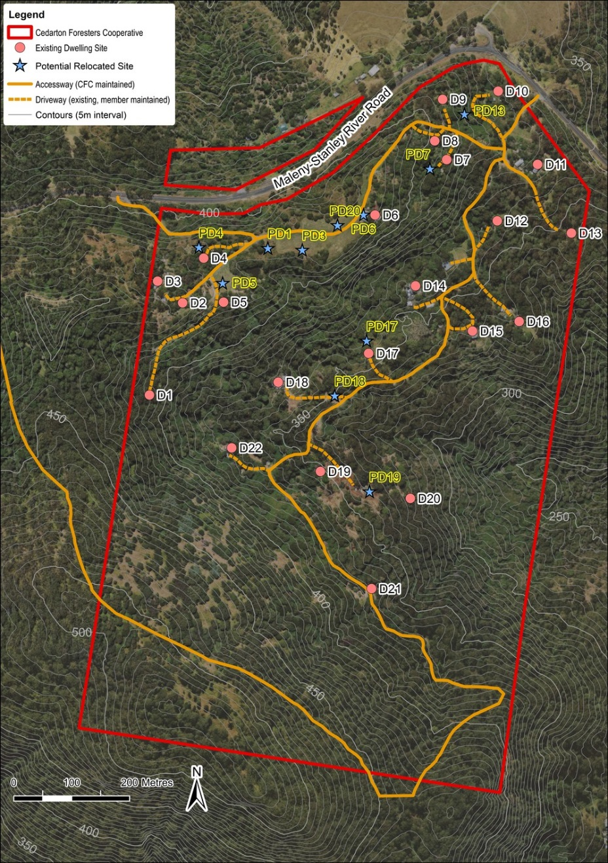

Figure 2 – Cedarton Forester’s Cooperative land management plan – Building development areas
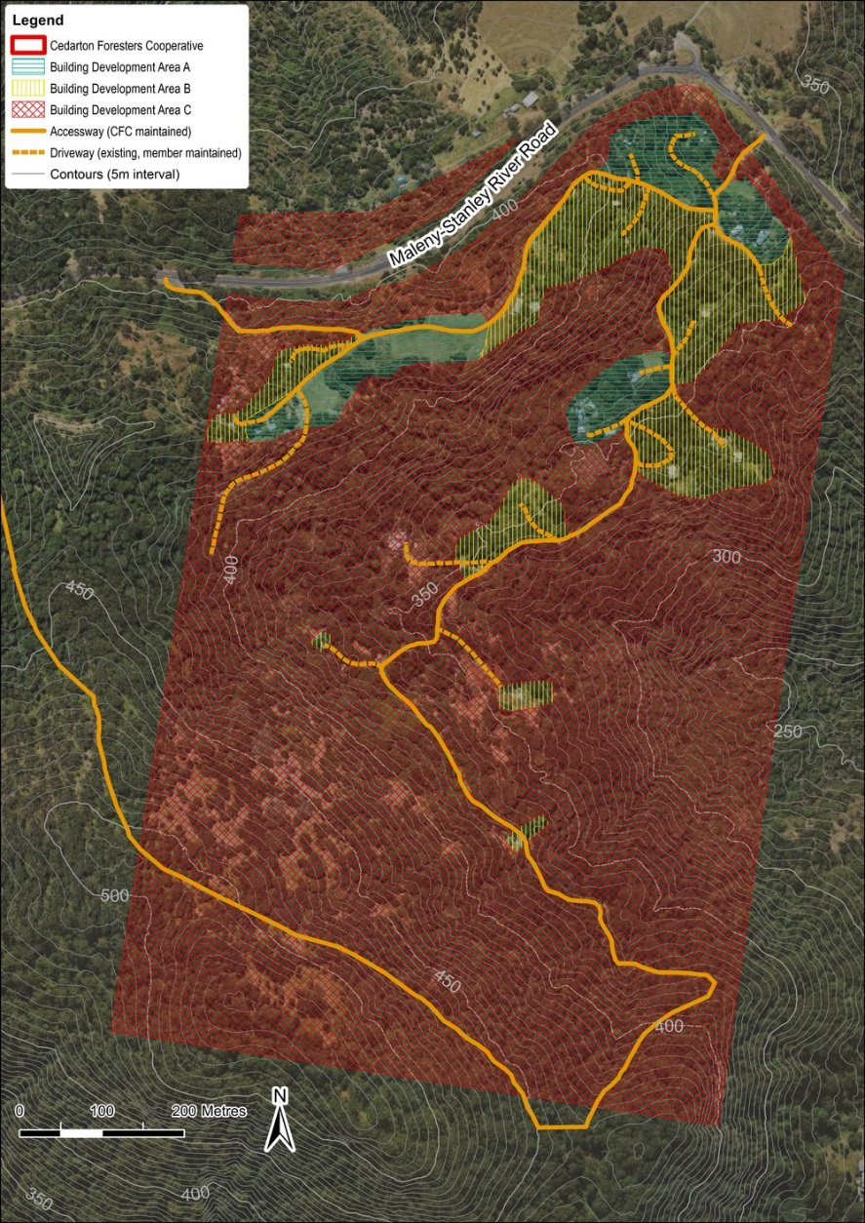

Figure 3 – Cedarton Forester’s Cooperative land management plan – Accessway and driveway improvement areas
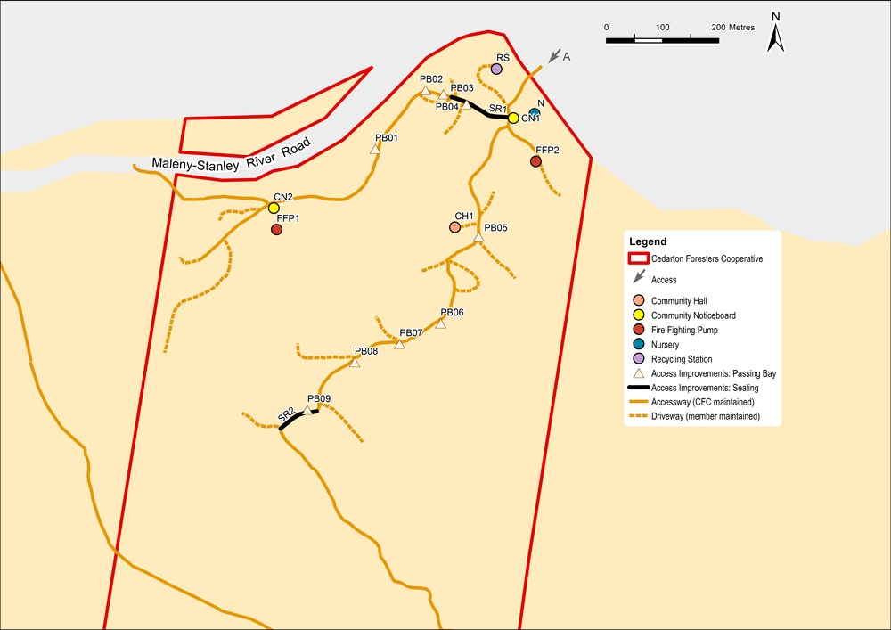

Figure 4 – Cedarton Forester’s Cooperative land management plan – Contours, accessway and water courses
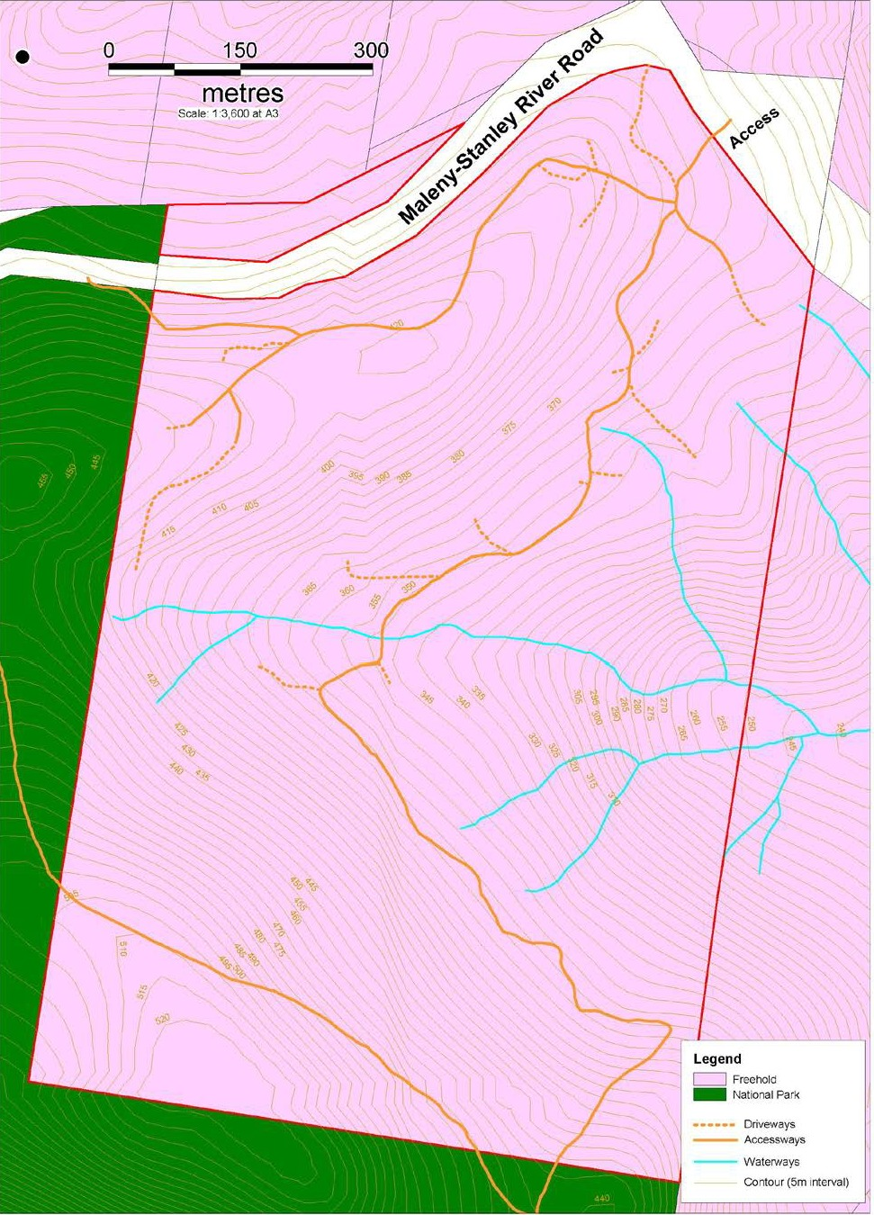
Figure 5 – Cedarton Forester’s Cooperative land management plan – Vegetation clearing areas for dwellings
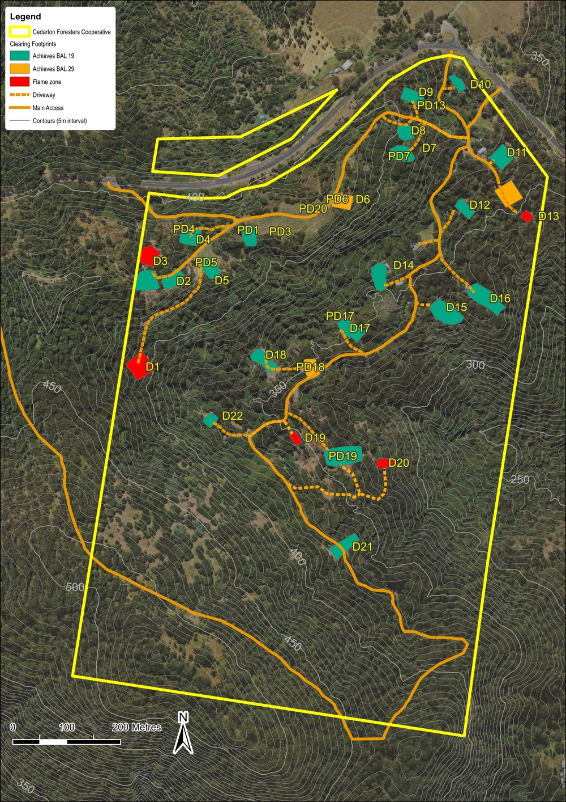
Figure 6 – Cedarton Forester’s Cooperative land management plan – Fire management information and fire maintenance trail
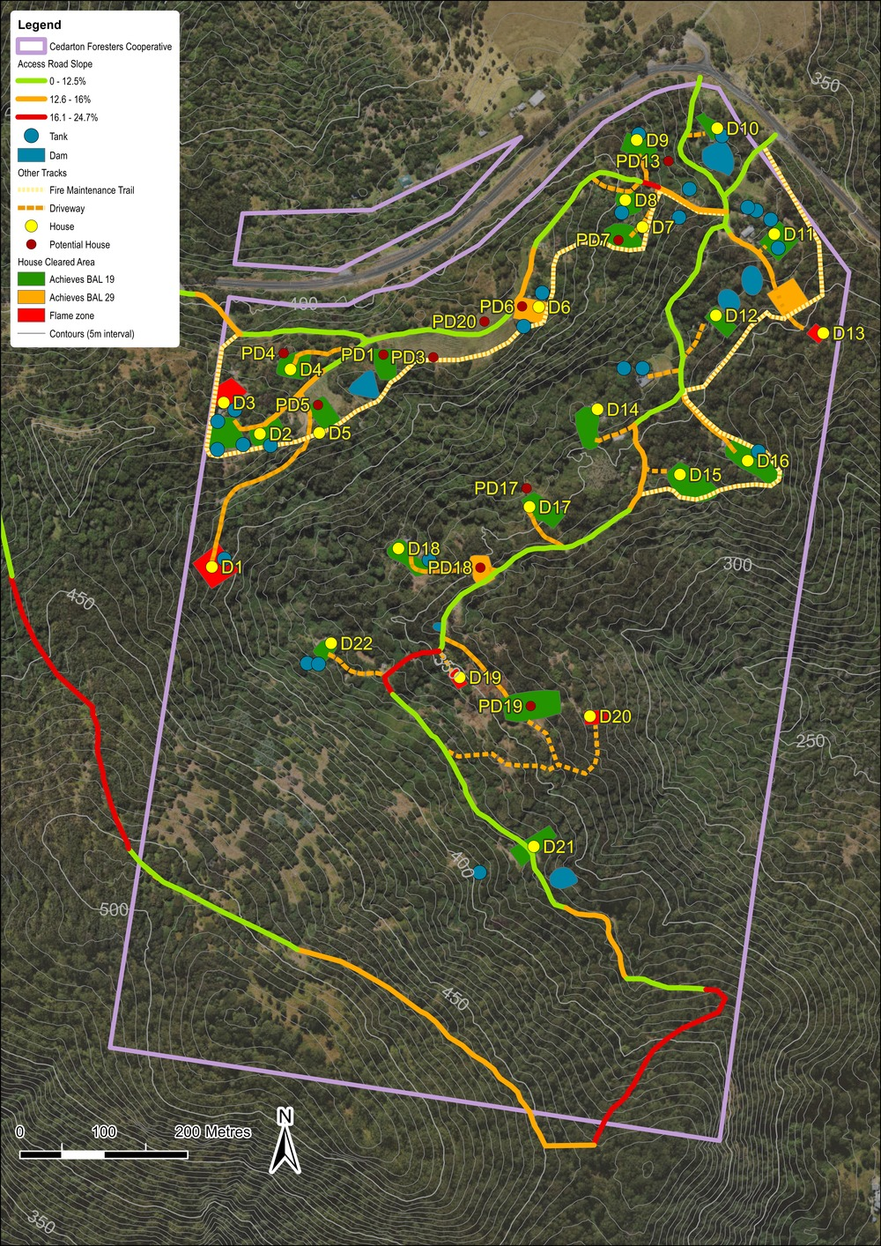
Background information
The following documents assisted to inform the detail and content of the land management plan:
- Cedarton Forester’s Cooperative Land Management Plan August 2013, prepared by Planning Strategies, printed 2 August 2013.
- Bushfire Risk Assessment and Bushfire Risk Land Management plan for Cedarton Forester’s Cooperative (Lot 357 on SP119036) – Revision 6, prepared by Ecological Natural Area Management July 2013.
A copy of these documents can be obtained from Council.

TABLE B – MT NEBO PLANT NURSERY – LAND MANAGEMENT PLAN

Development in the Mt Nebo Plant Nursery site subject to a land management plan (see Figure 1)

1.2 Purpose of the land management plan
The site is situated at 1871 Mt Nebo Road, Mt Nebo, on land described as Lot 2 RP139965.
The purpose of the land management plan is to achieve the following identification of:
- The nature and extent of development permitted to occur on the site, subject to a land management plan process, namely:
  - A maximum of 16 dwelling sites, associated dwellings and driveways;
  - Outbuildings associated with dwellings;
  - Community building comprising the following:
    - 1 community hall for the exclusive use of shareholders only and is not available to members of the public for public use or hire;
    - 1 plant nursery for the exclusive use of shareholders only and the propagation of plants for use on the land management plan site only. The plant nursery is not to be available to the public or sell to the public;
    - 1 administration/office building for the exclusive use of shareholders only;
    - 1 water tank.
  - Accessway throughout the land management plan site.
- The location of development identified in (I) – (IV) above;
- Any additional works required to facilitate and support the development listed in (a) above;

1.2 Outcomes sought
The outcomes sought by the land management plan are as follows:
- To acknowledge the presence of a multiple dwelling of 16 units associated with the Mt Nebo Plant Nursery site;
- To limit development to that which existed on the day the planning scheme is adopted. Expansion or addition of land use and building is avoided;
- To ensure that any recognised development occurs in accordance with a land management plan.

Note - Figure 1 forms the land management plan for the site
Table 1 - Land management plan outcomes to be achieved
No | Subject | Applicability | Outcome to be achieved
1. | Development subject to land management plan | The land management plan site | - Development comprises the following:  - A maximum of 16 dwellings and associated dwelling sites.  - Out buildings associated with dwellings.  - Community building comprising the following:  - 1 community hall for the exclusive use of shareholders only and is not available to members of the public for public use or hire;  - 1 plant nursery for the exclusive use of shareholders only and the propagation of plants for use on the land management plan site only. The plant nursery is not to be available to the public or sell to the public;  - 1 administration/office building for the exclusive use of shareholders only;  - 1 water tank.  - Accessway throughout the land management plan site.  - Development is to occur in accordance with Figure 1 Mt Nebo plant nursery land management plan – Dwelling and building location.
2. | Dwellings and dwelling sites D1 – D13 and D15 | 14 Dwellings and dwelling sites | - Dwellings D1 – D13, D15 are to be located on sites in accordance with Figure 1 Mt Nebo Plant Nursery land management plan – Dwelling and building location.  - Dwellings are to be designed and constructed to comply with the Building Act 1975 and the Building Code of Australia.  - Dwellings do not exceed their current building height at time of planning scheme adoption and any new structures not exceed a height of 8m.  - Dwellings retain their existing gross floor area, or a maximum of 100m2, whichever the greater (see Table 2).
3. | Alternate location for dwellings and dwelling site for D14 and D16 | D14 and D16 | - Dwelling D14 is located to a cleared position downslope or to the north of its current position.  - Dwelling D16 may locate in any position along the existing platform already create by a cut in that location.  - Dwellings are to be designed and constructed to comply with the Building Act 1975 and the Building Code of Australia.  - Dwellings do not exceed their current building height at time of planning scheme adoption and any new structures not exceed a height of 8m.  - Geotechnical and bush fire reports, as identified in Table 5, are required to confirm suitability of dwelling and dwelling site.
4. | All out buildings | All out buildings on-site, being listed or unlisted. | - All outbuildings are to be designed and constructed to comply with the Building Act 1975 and the Building Code of Australia.  - Buildings do not exceed a height of 8m.
5. | Identified Community Buildings CB1-4 | CB1. - Community hall (known as the Galaxy).  CB2 – Nursery (known as the Shadehouse).  CB3 – Administration /office (known as the Octagon).  CB4 – Water tank (known as Top Tank). | - CB1 – CB4 are located on the site in accordance with Figure 7 Mt Nebo Plant Nursery land management plan – Dwelling and building location.  - All buildings and structures are designed and constructed to comply with the Building Act 1975 and the Building Code of Australia.  - All buildings and structures do not exceed a height of 8m.  - The gross floor area associated with CB1 – 4 to be retained.
6. | Bushfire | The land management plan site | The installed pumps and associated reticulation system with around 50 hosecocks is maintained and available for fire fighting purposes.
 |  | Where D14 is to remain in current location | - D14 is to be built to a BAL 19 standard with an 8m separation from any fire source hazard.  - D14 is to be provided with a 3m wide driveway to the accessway identified in Figure 1 Mt Nebo Plant Nursery land management plan – Dwelling and building location.
7. | Effluent and wastewater treatment and disposal | All dwelling sites, Community hall, outbuildings where applicable. | All development is to comply with the Plumbing and Drainage Act 2002 and the Queensland Plumbing and Wastewater Code.
8. | Hazardous substance storage | The land management plan site | - Any development that involves the storage or handling of hazardous chemicals listed in Schedule 9, Development involving hazardous chemicals, Table 9.0.1 Quantity thresholds for hazardous chemicals stored as accepted development subject to requirements complies with Table 9.0.3 Hazardous chemicals assessment thresholds.  - Development does not involve the storage or handling of hazardous chemicals listed in Schedule 9, Development involving hazardous chemicals, Table 9.0.2 Hazardous chemicals assessment thresholds.

Table 2 – Existing building location and site attributes
Dwelling Site Number (Dwelling site) | Name of Mt Nebo Plant Nursery shareholder | Approximate Gross floor area of existing dwelling  (m2) | Identified large outbuildings and area (m2) | Reports and study requirements to establish dwelling at location
D1 | Millard | 105 | OB01  98
D2 | McKavangh & Layton | 94 | -
D3 | Carrigan | 17 | -
D4 | Colbert | 94 | -
D5 | Burkett | 72 | -
D6 | Lachowicz | 124 | OB6  65
D7 | Rice & Borchers | 101 | OB7  86
D8 | Scattini | 108 | OB8  50
D9 | Scattini | 272 | -
D10 | Boaler | 136 | -
D11 | Wills | 88 | -
D12 | Wills | 58 | -
D13 | Albinger & Sanders | 118 | -
D14 | Young | 15 | - | Where for current location:  - Bushfire assessment for dwelling  - Geotechnical stability and slope for driveway
Where for new location:
- Bushfire assessment for dwelling
- Bushfire assessment for site
- Geotechnical stability for dwelling
- Geotechnical stability for site
- Geotechnical stability and slope for driveway
D15 | Scattini | 45 | -
D16 | Wills | 11 | - | - Bushfire assessment for dwelling  - Bushfire assessment for site  - Geotechnical stability for dwelling  - Geotechnical stability for site
Community Buildings and notable outbuildings | Name of Mt Nebo Plant Nursery shareholder | Area of existing community building  (m2) | Identifier
Community hall  (Galaxy) | Scattini | 206 | CB1
Nursery  (Shadehouse) | Scattini | 221 | CB2
Administration office  (Octagon) | Scattini | 14 | CB3
Water Tank  (Top Tank) | Community | 9 | CB4

The following table details the outcomes anticipated for the required studies and reports. These are not exhaustive but provide guidance as to the minimum information requirements each report is to contain. It is anticipated that actual content of any of the below stated reports will be more extensive and go beyond the minimum report requirements listed below given the complicated physical and topographical characteristics associated with the site.
Table 3 – Guidance to Information requirements
Reports and study requirements to support Development Application | Minimum Report Requirements
Bushfire assessment report for dwelling and for site | - Report is prepared by a suitably qualified person.  - Report to consider, and be consistent with:  - State Planning Policy Guideline, State interest – natural hazards, Guidance on flood, bushfire and landslide,  - The Moreton Bay Regional Council Planning Scheme Policy – Bushfire hazard,  - The bushfire related matters identified in Table 1 land management plan outcomes to be achieved,  - The recommendations identified in the Bushfire Risk Assessment and Bushfire Risk Land Management Plan for Mount Nebo Plant Nursery prepared by Ecological Natural Area Management, Revision 4, March 2014.
Geotechnical stability report | - Report is prepared by a suitably qualified person.  - Report is to identify and demonstrate any cut and fill associated with driveways and accessway, cut to fill pad, retaining structures, outbuilding and dwelling construction has a minimal risk to the safety of people, property by landslide.  - Report to confirm buildings are appropriately located to minimise erosion and risk of landslide.
Effluent and wastewater disposal report | - Report is prepared by a suitably qualified person.  - Report is to be prepared in accordance with Plumbing and Drainage Act 2002 and the Queensland Plumbing and Wastewater Code and associated guidelines to confirm the suitability of each site to accommodate an on-site sewerage facility; or where a centrally located group collection treatment system is proposed, confirmation as to the suitability of the designated site to accommodate the on-site sewerage facility.  - Detail the preventative measures to limit impact on environmentally sensitive areas such as, but not limited to, watercourses, natural habitat and vegetation.  - Address the cumulative effects of 16 on-site domestic and community buildings treatment plants over the whole site. Alternatively, where a centrally located group collection treatment system is proposed, the cumulative effects of that system and any other on-site treatment plants over the whole site.

Figure 1 – Mt Nebo Plant Nursery Land Management Plan
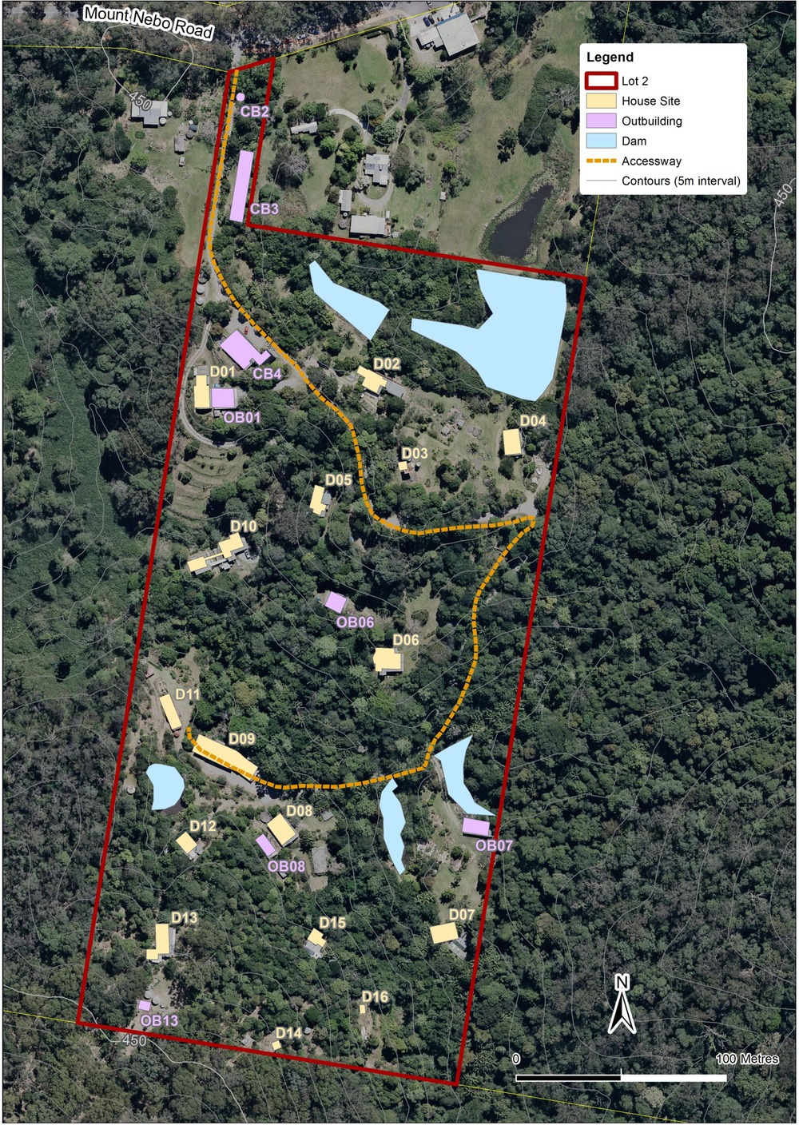
Background information
The following documents assisted to inform the detail and content of the land management plan:
- Mt Nebo Plant Nursery Management Plan March 2014, prepared by Paul Summers Planning Strategies, printed 4 March 2014.
- Mt Nebo Plant Nursery Report on Site Background and Current Circumstances February 2014, prepared by Paul Summers Planning Strategies, printed 20 March 2014.
- Bushfire Risk Assessment and Bushfire Risk Land Management Plan for Mt Nebo Plant Nursery (Lot 2 on RP139965) – Revision 4, prepared by Ecological Natural Area Management March 2014.
A copy of these documents can be obtained from Council.

