Table 6.2.11.1 Requirements for accepted development - Rural residential zone

Requirements for accepted development |  | E Compliance  - Yes  - No | Council confirmation
General requirements
Development footprint
RAD1 | Where a development footprint has been identified as part of a development approval for reconfiguring a lot, all development occurs within the development footprint.
Building height
RAD2 | Unless otherwise specified in this code, the building height of all buildings and structures does not exceed 5m.
Building on sloping land between 10% and 15%
RAD3 | Building and site design on slopes between 10% and 15%:  - use split-level, multiple-slab, pier or pole construction;  - avoid single-plane slabs and benching; and  - ensure the height of any cut or fill, whether retained or not, does not exceed 900mm.  Note - This provision does not apply to outbuildings or where a development footprint exists for a lot
Setback
RAD4 | Unless otherwise specified in this code, the minimum setbacks from a property boundary are as follows:  - road boundary – 6m  - side boundary – 4.5m  - rear boundary – 4.5m.  Note - This provision does not apply where a development footprint exists for a lot.  Note - Where located in a bushfire hazard area (see Overlay map - Bushfire hazard) a greater setback may be required. See values and constraints requirements Bushfire hazard.
Lighting
RAD5 | Artificial lighting on-site is directed and shielded in such a manner as not to exceed the recommended maximum values of light technical parameters for the control of obtrusive light given in Table 2.1 of Australian Standard AS 4282 (1997) Control of Obtrusive Effects of Outdoor Lighting.  Note - "Curfewed hours" are taken to be those hours between 10pm and 7am on the following day
Waste treatment
RAD6 | All concentrated animal use areas (eg sheds, pens, holding yards, stables, kennels) are provided with site drainage to ensure all stormwater run-off is directed to suitable detention basins, filtration or other treatment areas.
Site cover
RAD7 | Site cover of all buildings and roofed structures does not exceed:  - On lots equal to or less than 1 ha, 15% of the site or 750m², whichever is the lesser.  - On lots greater than 1 ha, 7.5% of the site or 1500m², whichever is the lesser.  Note - This is a quantifiable standard that is an alternative provision to the QDC, part MP1.2, A3. Non-compliance with this provision for a Dwelling house requires a concurrence agency response from Council.
Rural uses setbacks
RAD8 | The following uses and associated buildings and structures are setback from all property boundaries as follows:  - Animal husbandry⁽⁴⁾ (buildings only) - 10m  - Animal keeping⁽⁵⁾, excluding catteries and kennels - 20m  - Aquaculture⁽⁶⁾ involving ponds or water behind dams - 100m  - Aquaculture⁽⁶⁾ involving the housing of tanks - 20m  - Cropping⁽¹⁹⁾ (buildings only) - 10m  - Intensive horticulture⁽⁴⁰⁾ - 10m  - Permanent plantations⁽⁵⁹⁾ - 25m  - Rural Industry⁽⁷⁰⁾ - 20m  - Wholesale nursery⁽⁸⁹⁾ - 10m  - Veterinary services⁽⁸⁷⁾ - 10m.
Car parking (for other than Non-resident workforce accommodation and Rural workers' accommodation)
RAD9 | On-site car parking is provided in accordance with Schedule 7 - Car parking.
Hazardous Chemicals
RAD10 | All development that involves the storage or handling of hazardous chemicals listed in Schedule 9, Development involving hazardous chemicals, Table 9.0.1 Quantity thresholds for hazardous chemicals stored as accepted development subject to requirements complies with Table 9.0.3 Hazardous chemicals.
RAD11 | Development does not involve the storage or handling of hazardous chemicals listed in Schedule 9, Development involving hazardous chemicals, Table 9.0.2 Hazardous chemicals assessable thresholds.
Clearing of habitat trees where not located in the Environmental areas overlay map
RAD12 | Development does not result in the damaging, destroyed or clearing of a habitat tree. This does not apply to:  - Clearing of a habitat tree located within an approved development footprint;  - Clearing of a habitat tree within 10m from a lawfully established building reasonably necessary for emergency access or immediately required in response to an accident or emergency;  - Clearing of a habitat tree reasonably necessary to remove or reduce the risk vegetation poses to serious personal injury or damage to infrastructure;  - Clearing of a habitat tree reasonably necessary to construct and maintain a property boundary fence and not exceed 4m in width either side of the fence where in the Rural , Rural residential and Environmental management and conservation zones. In any other zone, clearing is not to exceed 2m in width either side of the fence;  - Clearing of a habitat tree reasonably necessary for the purpose of maintenance or works within a registered easement for public infrastructure or drainage purposes;  - Clearing of a habitat tree in accordance with a bushfire management plan prepared by a suitably qualified person, submitted to and accepted by Council;  - Clearing of a habitat tree associated with removal of recognised weed species, maintaining existing open pastures and cropping land, windbreaks, lawns or created gardens;  - Native forest practice where accepted development under Part 1, 1.7.7 Accepted development.  Editor's note - A native tree measuring greater than 80cm in diameter when measured at 1.3m from the ground is recognised as a ‘habitat tree’. For further information on habitat trees, refer to Planning scheme policy – Environmental areas and corridors. Information detailing how this measurement is undertaken is provided in Australian Standard AS 4970 2009 Protection of Trees on Development Sites - Appendix A.

Works requirements
Utilities
RAD13 | Where available, the development is connected to:  - an existing reticulated electricity supply;  - telecommunications and broadband;  - reticulated sewerage;  - reticulated water;  - sealed and dedicated road.
RAD14 | Where not in a sewered area, the development is serviced by an appropriate on-site sewerage facility.  Note - A site and soil evaluation report is generally required to demonstrate compliance with this outcome. Reports are to be prepared in accordance with AS1547 On-site domestic wastewater management and the Queensland Plumbing and Wastewater Code.
RAD15 | Where not in an existing connections area or a future connections area as detailed in the Unitywater Connections Policy, the development is provided with an adequate water supply of 45,000 litres by way of on-site storage which provides equivalent water quality and reliability to support the use requirements of the development.
Access
RAD16 | Any new or changes to existing site access and driveways are designed and located in accordance with:  - Where for a Council-controlled road, AS/NZS2890.1 section 3; or  - Where for a State-Controlled road, the Safe Intersection Sight Distance requirements in AustRoads and the appropriate IPWEAQ standard drawings, or a copy of a Transport Infrastructure Act 1994, section 62 approval.
RAD17 | Any new or changes to existing internal driveways and access ways are designed and constructed in accordance with AS/NZS2890.1 Parking Facilities – Off street car parking and the relevant standards in Planning scheme policy - Integrated design.
Stormwater
RAD18 | Any new or changes to existing stormwater run-off from the site is conveyed to a point of lawful discharge without causing nuisance or annoyance to any person, property or premises in accordance with Planning scheme policy – Integrated design.  Note - A watercourse as defined in the Water Act may be accepted as a lawful point of discharge providing the drainage discharge from the site does not increase the downstream flood levels during events up to and including the 1% AEP storm. An afflux of +20mm may be accepted on Council controlled land and road infrastructure. No worsening is ensured when stormwater is discharged into a catchment that includes State Transport Infrastructure.
Site works and construction management
RAD19 | The site and any existing structures are to be maintained in a tidy and safe condition.
RAD20 | Site construction works incorporate temporary stormwater run-off, erosion and sediment controls and trash traps designed in accordance with the Urban Stormwater Quality Planning Guidelines, Planning scheme policy - Stormwater management and Planning scheme policy - Integrated design.
RAD21 | Construction traffic including contractor car parking is controlled in accordance with a traffic management plan, prepared in accordance with the Manual of Uniform Traffic Control Devices (MUTCD) to ensure all traffic movements to and from the site are safe.
RAD22 | All native vegetation to be retained on-site is temporarily fenced or protected prior to and during development works.  Note - No parking of vehicles or storage of machinery or goods is to occur in these areas during development works.
RAD23 | Any damage to Council land or infrastructure is repaired or replaced with the same materials, prior to plan sealing, or final building classification.
RAD24 | Any material dropped, deposited or spilled on the road(s) as a result of construction processes associated with the site are to be cleaned at all times.
Earthworks
RAD25 | The site is prepared and the fill placed on-site in accordance with Australian Standard AS3798.  Note - The fill is to be inspected and tested in accordance with Planning scheme policy - Operational works inspection, maintenance and bonding procedures
RAD26 | Filling or excavation does not result in:  - a reduction in cover over any Council or public sector entity infrastructure to less than 600mm;  - an increase in finished surface grade over, or within 1.5m on each side of, the Council or public sector entity infrastructure above that which existed prior to the filling or excavation works being undertaken.  Note - Public sector entity is defined in Schedule 2 of the Act.
Fire services
Note - The provisions under this heading only apply if:
- the development is for, or incorporates:
  - reconfiguring a lot for a community title scheme creating 1 or more vacant lots; or
  - material change of use for 2 or more sole occupancy units on the same lot, or within the same community titles scheme; or
  - material change of use for a Tourist park⁽⁸⁴⁾ with accommodation in the form of caravans or tents; or
  - material change of use for outdoor sales⁽⁵⁴⁾, outdoor processing or outdoor storage where involving combustible materials.
AND

- none of the following exceptions apply:
  - the distributor-retailer for the area has indicated, in its netserv plan, that the premises will not be served by that entity’s reticulated water supply; or
  - every part of the development site is within 60m walking distance of an existing fire hydrant on the distributor-retailer’s reticulated water supply network, measured around all obstructions, either on or adjacent to the site.
Note - The provisions under this heading do not apply to buildings that are required by the Building Code of Australia to have a fire hydrant system complying with Australian Standard AS 2419.1 (2005) – Fire Hydrant Installations or other fire fighting facilities which provide equivalent protection.

RAD27 | External fire hydrant facilities are provided on site to the standard prescribed under the relevant parts of Australian Standard AS 2419.1 (2005) – Fire Hydrant Installations.  Note - For this requirement for accepted development, the following are the relevant parts of AS 2419.1 (2005):  - in regard to the form of any fire hydrant - Part 8.5 and Part 3.2.2.1, with the exception that for Tourist parks⁽⁸⁴⁾ or development comprised solely of dwellings and their associated outbuildings, single outlet above-ground hydrants or suitably signposted in-ground hydrants would be an acceptable alternative;  - in regard to the general locational requirements for fire hydrants - Part 3.2.2.2 (a), (e), (f), (g) and (h) as well as Appendix B of AS 2419.1 (2005);  - in regard to the proximity of hydrants to buildings and other facilities - Part 3.2.2.2 (b), (c) and (d), with the exception that:  - - for dwellings and their associated outbuildings, hydrant coverage need only extend to the roof and external walls of those buildings;  - - for caravans and tents, hydrant coverage need only extend to the roof of those tents and caravans;  - - for outdoor sales⁽⁵⁴⁾, processing or storage facilities, hydrant coverage is required across the entire area of the outdoor sales⁽⁵⁴⁾, outdoor processing and outdoor storage facilities; and  - in regard to fire hydrant accessibility and clearance requirements - Part 3.5 and where applicable, Part 3.6.
RAD28 | A continuous path of travel having the following characteristics is provided between the vehicle access point to the site and each external fire hydrant and hydrant booster point on the land:  - an unobstructed width of no less than 3.5m;  - an unobstructed height of no less than 4.8m;  - constructed to be readily traversed by a 17 tonne HRV fire brigade pumping appliance;  - an area for a fire brigade pumping appliance to stand within 20m of each fire hydrant and 8m of each hydrant booster point.
RAD29 | On-site fire hydrant facilities are maintained in effective operating order in a manner prescribed in Australian Standard AS1851 (2012) – Routine service of fire protection systems and equipment.
RAD30 | For development that contains on-site fire hydrants external to buildings:  - those external hydrants can be seen from the vehicular entry point to the site; or  - a sign identifying the following is provided at the vehicular entry point to the site:  - the overall layout of the development (to scale);  - internal road names (where used);  - all communal facilities (where provided);  - the reception area and on-site manager’s office (where provided);  - external hydrants and hydrant booster points;  - physical constraints within the internal roadway system which would restrict access by fire fighting appliances to external hydrants and hydrant booster points.  Note - The sign prescribed above, and the graphics used are to be:  - in a form;  - of a size;  - illuminated to a level;  which allows the information on the sign to be readily understood, at all times, by a person in a fire fighting appliance up to 4.5m from the sign.
RAD31 | For development that contains on-site fire hydrants external to buildings, those hydrants are identified by way of marker posts and raised reflective pavements markers in the manner prescribed in the technical note Fire hydrant indication system produced by the Queensland Department of Transport and Main Roads.  Note - Technical note Fire hydrant indication system is available on the website of the Queensland Department of Transport and Main Roads.

Use specific requirements
Community activities group adjoining Community activities and neighbourhood hubs
RAD32 | Development provides car parking spaces in accordance with Schedule 7 - car parking; or retains the number of car parking spaces currently provided on the site (except where reduction is required for the provision of cycle parking), whichever is the greater.
RAD33 | Car parking spaces (other than existing spaces) are not located in front of the main building line.
RAD34 | Development does not result in a reduction in bin storage areas.  Note - Bins and bin storage areas are provided, designed and managed in accordance with Planning scheme policy – Waste.
RAD35 | Development does not result in a reduction in the area (m²) or standard of established landscaping on-site.
Dwelling house ⁽²²⁾
RAD36 | Residential density does not exceed one dwelling house⁽²²⁾ per lot.
RAD37 | Building height for a dwelling house⁽²²⁾ does not exceed:  - that on Overlay map - Building heights for a dwelling house⁽²²⁾; or  - for domestic outbuildings and free standing carports and garages, building height does not exceed 4m.
RAD38 | Setbacks are as follows:  - Where a dwelling house⁽²²⁾ or outbuilding has a building height of 3m or less:  - road boundary - 6m  - side boundary - 1.5m  - rear boundary - 1.5m.  - Where a dwelling house⁽²²⁾ or outbuilding has a building height greater than 3m and less than 8.5m:  - road boundary - 6m  - side boundary - 4.5m  - rear boundary - 4.5m.  Note - Where located in a bushfire hazard area (see Overlay map - Bushfire hazard) a greater setback may be required. See values and constraints requirements Bushfire hazard.  Note - Note - This is a quantifiable standard that is an alternative provision to the QDC, part MP1.2, A1 (a), (b) and (c), A2 (a), (b) and (d). Non-compliance with this provision for a Dwelling house requires a concurrence agency response from Council.  Note - This provision does not apply where a development footprint exists for a lot.
RAD39 | Where a development footprint has been identified as part of a development approval for reconfiguring a lot, all development occurs within the development footprint.
RAD40 | Building and site design on slope between 10% and 15% must:  - use split-level, multiple-slab, pier or pole construction;  - avoid single-plane, and benching;  - ensure the height of any cut or fill, whether retained or not, does not exceed 900mm.  Note - This provision does not apply to outbuildings or any building work.  Note - This provision does not apply where a development footprint exists for a lot.
RAD41 | For Lake Samsonvale or Lake Kurwongbah, a setback of no less than 400m is maintained between the following nominated full supply levels to those lakes and any dwelling house⁽²²⁾ or outbuilding on the land:-  - RL 39.63m AHD being the full supply level of Lake Samsonvale; and  - RL 21m AHD being the full supply level of Lake Kurwongbah.  OR  No part of any dwelling house⁽²²⁾ or outbuilding on Lot 5 RP111651 or Lot RP111653 is any closer than 80m to the full supply level of RL 21m AHD to Lake Kurwongbah.  Editor's Note - The 400m buffer around Lake Samsonvale and Lake Kurwongbah is shown on Overlay map - Infrastructure buffers.
RAD42 | Waste/effluent disposal systems are localed at least:-  - 80m from the full supply level of RL 21m AHD to Lake Kurwongbah on Lot 5 RP111651 or Lot 10 RP111653; and  - 400m from RL 39.63m AHD being the full supply level of Lake Samsonvale and RL 21m AHD being the full supply level to Lake Kurwongbah.  Editor's Note - The 400m buffer around Lake Samsonvale and Lake Kurwongbah is shown on Overlay map - Infrastructure buffers.
Dwelling house⁽²²⁾ where including a secondary dwelling
RAD43 | The maximum GFA for a secondary dwelling is 100m².
RAD44 | The secondary dwelling obtains access from the existing driveway giving access to the dwelling house⁽²²⁾.
RAD45 | The secondary dwelling is located within 50m of the dwelling house⁽²²⁾.
Home based business ⁽³⁵⁾
RAD46 | The home based business(s)⁽³⁵⁾, including any storage, are fully contained within a dwelling or on-site structure.
RAD47 | Up to 2 additional non-resident , either employees or customers, are permitted on the site at any one time, except where involving the use of heavy vehicles, where no employees are permitted.  Note - This provision does not apply to Bed and Breakfast or farmstay business.
RAD48 | The maximum number of heavy vehicles, trailer and motor vehicles stored on-site is as follows:  - 1 heavy vehicle;  - 1 trailer;  - Up to 3 motor vehicles.  Note - The car parking provision associated with the dwelling house⁽²²⁾ is in addition to this requirement.
RAD49 | Vehicle parking areas, vehicle standing areas and outdoor storage areas of plant and equipment are screened from adjoining lots by either planting, wall(s), fence(s) or a combination at least 1.8m in height along the length of those areas.
RAD50 | Heavy vehicle storage buildings, parking areas and standing areas are setback a minimum of 30m from all property boundaries.
RAD51 | Hours of operation to be restricted to 8.00am to 6.00pm Monday to Saturday and are not open to the public on Sunday's, Christmas Day, Good Friday and Anzac Day, except for:  - bed and breakfast or farm stay business which may operate on a 24 hour basis,  - office or administrative activities that do not generate non-residents visiting the site such as book keeping and computer work,  - starting and warming up of heavy vehicles, which can commence at 7.00am.
RAD52 | The home based business(s)⁽³⁵⁾ do not generate noise that is audible from the boundary of the site.  Note - Guidance as acceptable noise is provided in the standards listed in the Environmental Protection (Noise) Policy 2008.  Note - This provision does not apply to the use of heavy vehicles or motor vehicles.
RAD53 | Activities associated with a use do not cause a nuisance by way of aerosols, fumes, light, noise, odour, particles or smoke.  Note - Nuisance is defined in the Environmental Protection Act 1994.
RAD54 | The home based business⁽³⁵⁾ does not involve vehicle servicing or major repairs, including spray painting or panel beating.  Note - Vehicle servicing excludes general maintenance of a vehicle such as, but not limited to, changing of tyres, engine fluids, filters, and parts such as batteries and plugs.
RAD55 | The home based business⁽³⁵⁾ does not involve an environmentally relevant activity (ERA) as defined in the Environmental Protection Regulations 2008.
RAD56 | Only goods grown, produced or manufactured on-site are sold from the site.
RAD57 | Display of goods grown, produced or manufactured on-site are contained within a dwelling or on-site structure and the display of goods is not visible from the boundary of the site.
RAD58 | For bed and breakfast and farmstays:  - overnight accommodation is provided in the dwelling house⁽²²⁾ of the accommodation operator;  - maximum 4 bedroom are provided for a maximum of 10 guests;  - meals are served to paying guests only;  - rooms do not contain food preparation facilities.
Non-resident workforce accommodation ⁽⁵²⁾
RAD59 | No more than 1 Non-resident workforce accommodation⁽⁵²⁾ use per site.
RAD60 | Non-resident workforce accommodation⁽⁵²⁾ is contained within 1 structure.
RAD61 | Non-resident workforce accommodation⁽⁵²⁾ obtains access from the existing driveway giving access to the Dwelling house⁽²²⁾.
RAD62 | Non-resident workforce accommodation⁽⁵²⁾ is located within 20m of the Dwelling house⁽²²⁾.
RAD63 | For Lake Samsonvale or Lake Kurwongbah, a setback of no less than 400m is maintained between the following nominated full supply levels to those lakes and any Non-resident workforce accommodation⁽⁵²⁾ on the land:-  - RL 39.63m AHD being the full supply level to Lake Samsonvale; and  - RL 21m AHD being the full supply level to Lake Kurwongbah.  OR  No part of any Non-resident workforce accommodation⁽⁵²⁾ on Lot 5 RP111651 or Lot 10 RP111653 is any closer than 80m to the full supply level of RL 21m AHD to Lake Kurwongbah.  Editor's note - The 400m buffer around Lake Samsonvale and Lake Kurwongbah is shown on Overlay map - Infrastructure buffers
RAD64 | Waste/effluent disposal systems are located at least:-  - 80m from the full supply level of RL 21m AHD to Lake Kurwongbah on Lot 5 RP111651 or Lot 10 RP111653; and  - 400m from RL 39.63m AHD being the full supply level to Lake Samsonvale and RL 21m AHD being the full supply level to Lake Kurwongbah.  Editor's note - The 400m buffer around Lake Samsonvale and Lake Kurwongbah is shown on Overlay map - Infrastructure buffers
Permanent plantation ⁽⁵⁹⁾
RAD65 | Planting only comprises native species naturally occurring in the area.
Retail and commercial activities and Community activities groups
RAD66 | Development provides car parking spaces in accordance with Schedule 7 - Car parking; or retains the number of car parking spaces currently provided on the site (except where reduction is required for the provision of cycle parking), whichever is the greater.
RAD67 | Car parking spaces (other than existing spaces) are not located in front of the main building line.
RAD68 | Development does not result in a reduction in bin storage areas.  Note - Bins and bin storage areas are provided, designed and managed in accordance with Planning scheme policy – Waste.
RAD69 | Development does not result in a reduction in the area (m²) or standard of established landscaping on-site.
Roadside stall ⁽⁶⁸⁾
Note - These provisions do not apply to a home based business⁽³⁵⁾.

RAD70 | No more than one roadside stall⁽⁶⁸⁾ per property.
RAD71 | Goods offered for sale are only goods grown, produced or manufactured on the site
RAD72 | The maximum area associated with a roadside stall⁽⁶⁸⁾, including any larger separate items displayed for sale, does not exceed 20m².
RAD73 | Car parking for 2 vehicles is provided off the road carriage way and on the property.
RAD74 | The roadside stall⁽⁶⁸⁾ is located no closer than 100m from an intersection.
Rural workers' accommodation ⁽⁷¹⁾
RAD75 | No more than 1 Rural workers' accommodation⁽⁷¹⁾ per site.
RAD76 | Rural workers' accommodation ⁽⁷¹⁾is contained within 1 structure.
RAD77 | Rural workers' accommodation obtains access from the existing driveway giving access to the dwelling house⁽²²⁾.
RAD78 | Rural workers' accommodation⁽⁷¹⁾ are located within 20m of the dwelling house⁽²²⁾.
RAD79 | For Lake Samsonvale or Lake Kurwongbah, a setback of no less than 400m is maintained between the following nominated full supply levels to those lakes and Rural workers' accommodation on the land:-  - RL 39.63m AHD being the full supply level to Lake Samsonvale; and  - RL 21m AHD being the full supply level to Lake Kurwongbah.  OR  No part of any Rural workers' accommodation⁽⁷¹⁾ on Lot 5 RP111651 or Lot 10 RP111653 is any closer than 80m to the full supply level of RL 21m AHD to Lake Kurwongbah.  Editor's note - The 400m buffer around Lake Samsonvale and Lake Kurwongbah is shown on Overlay map - Infrastructure buffers
RAD80 | Waste/effluent disposal systems are located at least:-  - 80m from the full supply level of RL 21m AHD to Lake Kurwongbah on Lot 5 RP111651 or Lot 10 RP111653; and  - 400m from RL 39.63m AHD being the full supply level to Lake Samsonvale and RL 21m AHD being the full supply level to Lake Kurwongbah.  Editor's note - The 400m buffer around Lake Samsonvale and Lake Kurwongbah is shown on Overlay map - Infrastructure buffers
Sales office ⁽⁷²⁾
RAD81 | A sales office⁽⁷²⁾ is located on the site for no longer than 2 years.
Telecommunications facility⁽⁸¹⁾
Editor's note - In accordance with the Federal legislation Telecommunications facilities⁽⁸¹⁾ must be constructed and operated in a manner that will not cause human exposure to electromagnetic radiation beyond the limits outlined in the Radiocommunications (Electromagnetic Radiation - Human Exposure) Standard 2003 and Radio Protection Standard for Maximum Exposure Levels to Radiofrequency Fields - 3Khz to 300Ghz.

RAD82 | A minimum of 45m² is available at ground level to allow for additional equipment shelters and associated structures for the purpose of co-locating on the proposed facility.
RAD83 | The development results in no net reduction in the minimum quantity and standard of landscaping, private or communal open space or car parking spaces required under the planning scheme or under an existing development approval.
RAD84 | Equipment shelters and associated structures are located:  - directly beside the existing equipment shelter and associated structures;  - behind the main building line;  - further away from the frontage than the existing equipment shelter and associated structures;  - a minimum of 10m from side and rear boundaries, except where in the Industry and Extractive industry zones, the minimum side and rear setback is 3m.
RAD85 | Equipment shelters and other associated structures are either the same type of colour or material to match the surrounding locality.
RAD86 | The facility is enclosed by security fencing or by other means to ensure public access is prohibited.
RAD87 | A minimum 3m wide strip of dense planting is provided around the perimeter of the fenced area, between the development and street frontage and adjoining uses.  Note - Landscaping is provided in accordance with Planning scheme policy - Integrated design.  Note - Council may require a detailed landscaping plan, prepared by a suitably qualified person to ensure compliance with Planning scheme policy - Integrated design.
RAD88 | All equipment comprising the telecommunications facility⁽⁸¹⁾ which produces audible or non-audible sound is housed within a fully enclosed building incorporating sound control measures sufficient to ensure no noise from this equipment can be heard, or felt at the site boundary.

Values and constraints requirements
Note - The relevant values and constraints requirements do not apply where the development is consistent with a current Development permit for Reconfiguring a lot or Material change of use or Operational work, where that approval has considered and addressed (e.g. through a development footprint plan (or similar in the case of Landslide hazard) or conditions of approval) the identified value or constraint under this planning scheme.

Acid sulfate soils - (refer Overlay map - Acid sulfate soils to determine if the following requirements apply)
Note - Planning scheme policy - Acid sulfate soils provides guidance for requirements for accepted development that has the potential to disturb acid sulfate soils i.e. development involving filling or excavation works below the thresholds of 100m³ and 500m³ respectively.

RAD89 | Development does not involve:  - excavation or otherwise removing of more than 100m³ of soil or sediment where below 5m Australian Height Datum AHD, or  - filling of land of more than 500m³ of material with an average depth of 0.5m or greater where below the 5m AHD.  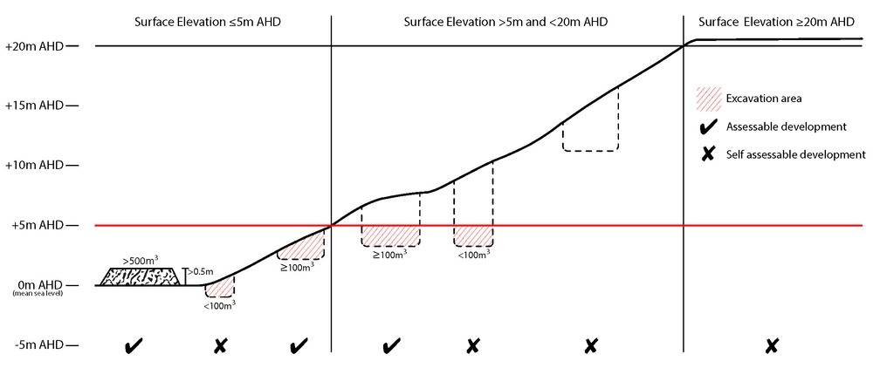
Bushfire hazard (refer Overlay map - Bushfire hazard to determine if the following requirements apply)
Note - For the purposes of section 12 of the Building Regulation 2006, land identified as very high potential bushfire intensity, high potential bushfire intensity, medium potential bushfire intensity or potential impact buffer on the Bushfire hazard overlay map is the 'designated bushfire hazard area'. AS 3959-2009 Construction of buildings in bushfire hazard areas applies within these areas.

RAD90 | - Building and structures are:  - not located on a ridgeline  - not located on land with a slope greater than 15% (see Overlay map – Landslide hazard)  - Dwellings are located on east to south facing slopes.  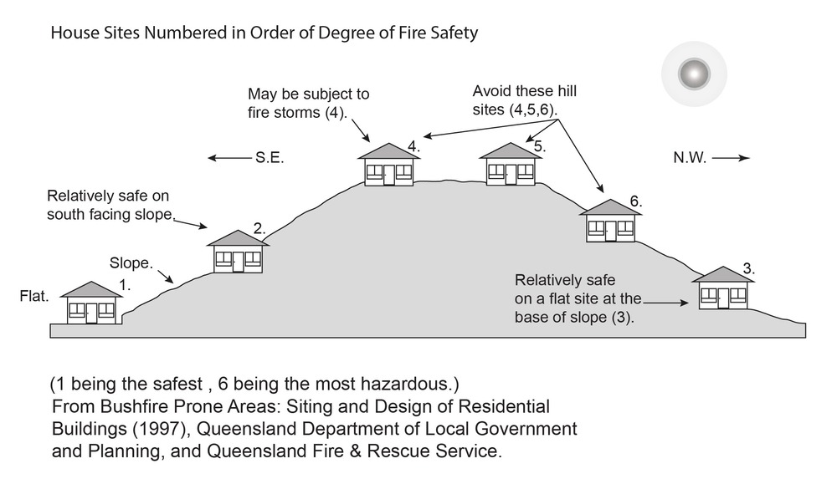
RAD91 | Buildings and structures have contained within the site:  - a separation from classified vegetation of 20m or the distance required to achieve a bushfire attack level (BAL) at the building, roofed structure or fire fighting water supply of no more than 29, whichever is the greater;  - a separation from low threat vegetation of 10m or the distance required to achieve a bushfire attack level (BAL) at the building, roofed structure or fire fighting water supply of no more than 29, whichever is the greater;  - a separation of no less than 10m between a fire fighting water supply extraction point and any classified vegetation, buildings and other roofed structures;  - an area suitable for a standard fire fighting appliance to stand within 3m of a fire fighting water supply extraction point; and  - an access path suitable for use by a standard fire fighting appliance having a formed width of at least 4m, a cross-fall of no greater than 5%, and a longitudinal gradient of no greater than 25%:  - to, and around, each building and other roofed structure; and  - to each fire fighting water supply extraction point.  Note - The meaning of the terms classified vegetation and low threat vegetation as well as the method of calculating the bushfire attack level are as described in Australian Standard AS 3959.
RAD92 | The length of driveway:  - to a public road does not exceed 100m between the most distant part of a building used for any purpose other than storage and the nearest part of a public road;  - has a maximum gradient no greater than 12.5%;  - have a minimum width of 3.5m;  - accommodate turning areas for fire fighting appliances in accordance with Qld Fire and Emergency Services' Fire Hydrant and Vehicle Access Guideline.
RAD93 | - A reticulated water supply is provided by a distributer retailer for the area or, where not connected to a reticulated water supply, on-site fire fighting water storage containing not less than 10 000 litres (tanks with fire brigade tank fittings, swimming pools) is provided and located within 10m of buildings and structures.  - Where a swimming pool is the nominated on-site fire fighting water storage source, vehicle access to within 3m of that water storage source is provided.  - Where a tank is the nominated on-site fire fighting water storage source, it includes:  - a hardstand area allowing medium rigid vehicle (15 tonne fire appliance) access within 6m of the tank;  - fire brigade tank fittings, comprising 50mm ball valve and male camlock coupling and, if underground, an access hole of 20mm (minimum) to accommodate suction lines.
RAD94 | Development does not involve the manufacture or storage of hazardous chemicals.
Environmental areas (refer Overlay map - Environmental areas to determine if the following requirements apply)
Note - The following are excluded from the native clearing provisions of this planning scheme:
- Clearing of native vegetation located within an approved development footprint;
- Clearing of native vegetation within 10m from a lawfully established building reasonably necessary for emergency access or immediately required in response to an accident or emergency;
- Clearing of native vegetation reasonably necessary to remove or reduce the risk vegetation poses to serious personal injury or damage to infrastructure;
- Clearing of native vegetation reasonably necessary to construct and maintain a property boundary fence and not exceed 4m in width either side of the fence where in the Rural, Rural residential and Environmental Management and Conservation zones. In any other zone, clearing is not to exceed 2m in width either side of the fence;
- Clearing of native vegetation reasonably necessary for the purpose of maintenance or works within a registered easement for public infrastructure or drainage purposes;
- Clearing of native vegetation in accordance with a bushfire management plan prepared by a suitably qualified person, submitted to and accepted by Council;
- Clearing of native vegetation associated with removal of recognised weed species, maintaining existing open pastures and cropping land, windbreaks, lawns or created gardens;
- Grazing of native pasture by stock;
- Native forest practice where accepted development under Part 1, 1.7.7 Accepted development.
Note - Definition for native vegetation is located in Schedule 1 Definitions.

Note - Native vegetation subject to this requirement primarily comprises of matters of national environmental significance (MNES), matters of state environmental significance (MSES). They also comprise some matters of local environmental significance (MLES). A MLES is defined in Schedule 1.2, Administrative definitions. A list of the elements that apply to the mapped MSES and MLES is provided in Appendix 1 of the Planning scheme policy - Environmental areas.

Editors' Note - The accuracy of overlay mapping can be challenged through the development application process (code assessable development) or by way of a planning scheme amendment. See Council's website for details.

Editors' Note - When clearing native vegetation within a MSES area, you may still require approval from the State government.

RAD95 | Where no suitable land cleared of native vegetation exists, clearing of native vegetation in High Value Area or Value Offset Area is for the purpose of a new dwelling house⁽²²⁾ and all associated facilities* or an extension to an existing dwelling house⁽²²⁾ only, and comprises an area no greater than 1500m².  Note - *All associated facilities includes: on-site wastewater treatment, all areas of disturbance, on-site parking, access and manoeuvring areas.  Editor's note - See in heading above for other uses excluded from native vegetation clearing requirements.  Editor's note - Where vegetation clearance is accepted development subject to requirements, care should be undertaken to avoid adverse impacts on koalas, koala habitat values and habitat connectivity and to encourage existing koala usage of the site. Measures to minimise impacts include:  - co-locating all associated activities, infrastructure and access strips;  - be the least valued area of koala habitat on the site;  - minimise the footprint of the development envelope area;  - minimise edge effects to areas external to the development envelope;  - location and design consideration to ensure koala safety and movement in accordance with the Koala-sensitive Design Guideline and Planning scheme policy – Environmental areas;  - sufficient area between the development and koala habitat trees to achieve their long-term viability.  Editor's note - Where vegetation clearing is accepted development subject to requirements, consideration should be given to avoid clearing habitat trees. Habitat trees may contain structural hollows where animals live, breed and shelter. The provision of nest boxes or salvaging of hollows will provide compensatory roosting and nesting opportunities for local wildlife including sugar gliders, possums and owls. For further information see Planning scheme policy – Environmental areas.
RAD96 | No clearing of native vegetation is to occur within the Value Offset Area MLES - Waterway buffer or Value Offset Area MLES - Wetland buffer.  This does not apply to the following:  - Clearing of native vegetation located within an approved development footprint;  - Clearing of native vegetation within 10m from a lawfully established building reasonably necessary for emergency access or immediately required in response to an accident or emergency;  - Clearing of native vegetation reasonably necessary to remove or reduce the risk vegetation poses to serious personal injury or damage to infrastructure;  - Clearing of native vegetation reasonably necessary to construct and maintain a property boundary fence and not exceed 4m in width either side of the fence where in the Rural, Rural residential and Environmental management and conservation zones. In any other zone, clearing is not to exceed 2m in width either side of the fence;  - Clearing of native vegetation reasonably necessary for the purpose of maintenance or works within a registered easement for public infrastructure or drainage purposes;  - Clearing of native vegetation in accordance with a bushfire management plan prepared by a suitably qualified person, submitted to and accepted by Council;  - Clearing of native vegetation associated with removal of recognised weed species, maintaining existing open pastures and cropping land, windbreaks, lawns or created gardens;  - Grazing of native pasture by stock;  - Native forest practice where accepted development under Part 1, 1.7.7 Accepted development.
Extractive resources separation area (refer Overlay map - Extractive resources (separation area) to determine if the following requirements apply)
RAD97 | Development does not result in more than one dwelling house⁽²²⁾ per lot within separation areas.
RAD98 | Development within the separation area does not include the following uses:  - caretaker's accommodation⁽¹⁰⁾;  - community residence⁽¹⁶⁾;  - dual occupancy⁽²¹⁾;  - dwelling unit⁽²³⁾;  - hospital⁽³⁶⁾;  - rooming accommodation⁽⁶⁹⁾;  - multiple dwelling⁽⁴⁹⁾;  - non-resident workforce accommodation⁽⁵²⁾;  - relocatable home park⁽⁶²⁾;  - residential care facility⁽⁶⁵⁾;  - resort complex⁽⁶⁶⁾;  - retirement facility⁽⁶⁷⁾;  - rural workers’ accommodation⁽⁷¹⁾;  - short-term accommodation⁽⁷⁷⁾;  - tourist park⁽⁸⁴⁾.
RAD99 | All habitable rooms within the separation area are:  - acoustically insulated to achieve the noise levels listed in Schedule 1 Acoustic Quality Objectives, Environmental Protection (Noise) Policy 2008;  - provided with mechanical ventilation.
RAD100 | Private open space areas are separated from the resource processing area by buildings or a 1.8m high solid structure.
Extractive resources transport routes (refer Overlay map - Extractive resources (transport route and buffer) to determine if the following requirements apply)
RAD101 | The following uses are not located within the 100m wide transport route buffer:  - Caretaker’s accommodation⁽¹⁰⁾, except where located in the Extractive industry zone;  - Community residence⁽¹⁶⁾;  - Dual occupancy⁽²¹⁾;  - Dwelling house;⁽²²⁾  - Dwelling unit⁽²³⁾;  - Hospital⁽³⁶⁾;  - Rooming accommodation⁽⁶⁹⁾;  - Multiple dwelling⁽⁴⁹⁾;  - Non-resident workforce accommodation⁽⁵²⁾;  - Relocatable home park⁽⁶²⁾;  - Residential care facility⁽⁶⁵⁾;  - Resort complex⁽⁶⁶⁾;  - Retirement facility⁽⁶⁷⁾;  - Rural workers’ accommodation⁽⁷¹⁾;  - Short-term accommodation⁽⁷⁷⁾;  - Tourist park⁽⁸⁴⁾.
RAD102 | Except for an existing vacant lot, development does not create a new vehicle access point onto an Extractive Industry Zone transportation route.
RAD103 | A vehicle access point is located, designed and constructed in accordance with the Planning scheme policy - Integrated design.
Heritage and landscape character (refer Overlay map - Heritage and landscape character to determine if the following requirements apply)
Note - Places, including sites, objects and buildings having local cultural heritage significance, are identified on Overlay map - Heritage and landscape character and listed in Schedule 1 of Planning scheme policy - Heritage and landscape character. Places also having cultural heritage significance at a State level and being entered in the Queensland Heritage Register, are also identified in Schedule 1 of Planning scheme policy - Heritage and landscape character.

RAD104 | Development is for the preservation, maintenance, repair and restoration of the site, object or building.  This does not apply to Listed item 99, in Schedule 1 - List of sites, objects and buildings of significant historical and cultural value of Planning scheme policy - Heritage and landscape character.  Note - Preservation, maintenance, repair and restoration are defined in Schedule 1 - Definitions
RAD105 | A cultural heritage conservation management plan is prepared in accordance with Planning scheme policy – Heritage and landscape character and submitted to Council prior to the commencement of any preservation, maintenance, repair and restoration works. Any preservation, maintenance, repair and restoration works are in accordance with the Council approved cultural heritage conservation management plan.  This does not apply to Listed item 99 in Schedule 1 - List of sites, objects and buildings of significant historical and cultural value of Planning scheme policy - Heritage and landscape character.
RAD106 | Development does not result in the removal of or damage to any significant tree identified on Overlay map – Heritage and landscape character and listed in Appendix 2 of Planning scheme policy – Heritage and landscape character.
RAD107 | The following development does not occur within 20m of the base of any significant tree, identified on Overlay map – Heritage and landscape character and listed in Appendix 2 of Planning scheme policy – Heritage and landscape character:  - construction of any building;  - laying of overhead or underground services;  - any sealing, paving, soil compaction;  - any alteration of more than 75mm to the ground level prior to work commencing.
RAD108 | Pruning of a significant tree occurs in accordance with Australian Standard AS 4373-2007 - Pruning of Amenity Trees.
Landslide hazard (refer Overlay map - Landslide hazard to determine if the following requirements apply)
RAD109 | Development does not:  - involve earthworks exceeding 50m³;  - involve cut and fill having a height greater than 600mm;  - involve any retaining wall having a height greater than 600mm;  - redirect or alter the existing flow of surface or groundwater.
RAD110 | Buildings, excluding domestic outbuildings:  - are split-level, multiple-slab, pier or pole construction;  - are not single plane slab on ground.
RAD111 | Development does not involve the manufacture, handling or storage of hazardous chemicals.
Infrastructure buffers (refer Overlay map - Infrastructure buffers to determine if the following requirements apply)
RAD112 | Development does not include the following uses within a Wastewater treatment site buffer:  - Caretaker’s accommodation⁽¹⁰⁾;  - Community residence⁽¹⁶⁾;  - Dual occupancy⁽²¹⁾;  - Dwelling house;⁽²²⁾  - Dwelling unit⁽²³⁾;  - Hospital⁽³⁶⁾;  - Rooming accommodation⁽⁶⁹⁾;  - Multiple dwelling⁽⁴⁹⁾;  - Non-resident workforce accommodation⁽⁵²⁾;  - Relocatable home park⁽⁶²⁾;  - Residential care facility⁽⁶⁵⁾;  - Resort complex⁽⁶⁶⁾;  - Retirement facility⁽⁶⁷⁾;  - Rural workers’ accommodation⁽⁷¹⁾;  - Short-term accommodation⁽⁷⁷⁾;  - Tourist park⁽⁸⁴⁾.
RAD113 | Development within a Water supply buffer does not include the incineration or burial of waste and all other waste is collected and stored in weather proof, sealed waste receptacles, located in roofed and bunded areas, for disposal by a licenced contractor.
RAD114 | Management, handling and storage of hazardous chemicals (including fuelling of vehicles) within a Water supply buffer, is undertaken in secured, climate controlled, weather proof, level and bunded enclosures.
RAD115 | Development does not restrict access to Bulk water supply infrastructure of any type or size, having regard to (among other things):  - buildings or structures;  - gates and fences;  - storage of equipment or materials;  - landscaping or earthworks or stormwater or other infrastructure.
RAD116 | On-site sewerage facilities in a Water supply buffer produce a minimum secondary treated effluent (90th percentile) and effluent application to ensure water quality is maintained and protected.
RAD117 | On-site sewerage facilities in a Water supply buffer for a dwelling house⁽²²⁾ include:  - emergency storage capacity of 1,000 litres and adequate buffering for shock loading/down time;  - a reserve land application area of 100% of the effluent irrigation design area;  - land application areas that are vegetated;  - the base of the land application field is at least 2 metres above the seasonal high water table/bedrock (whichever is the closest to the base of the application area);  - wastewater collection and storage systems must have capacity to accommodate full load at peak times.
RAD118 | On-site sewerage facilities in a Water supply buffer for development other than a dwelling house include emergency storage capable of holding 3-6 hours peak flow of treated effluent in the event of emergencies/overload with provision for de-sludging.
RAD119 | Development involving Permanent plantation⁽⁵⁹⁾ within a Water supply buffer maintains a minimum of 30% ground cover at all times.
RAD120 | Development does not involve the construction of any buildings or structures within a Bulk water supply infrastructure buffer.
RAD121 | Development involving a major hazard facility or an Environmentally Relevant Activity (ERA) is setback 30m from a Bulk water supply infrastructure buffer.
RAD122 | Development does not include the following uses located within a landfill site buffer:  - caretaker’s accommodation⁽¹⁰⁾;  - community residence⁽¹⁶⁾;  - dual occupancy⁽²¹⁾;  - dwelling house;⁽²²⁾  - dwelling unit⁽²³⁾;  - hospital⁽³⁶⁾;  - rooming accommodation⁽⁶⁹⁾;  - multiple dwelling⁽⁴⁹⁾;  - non-resident workforce accommodation⁽⁵²⁾;  - relocatable home park⁽⁶²⁾;  - residential care facility⁽⁶⁵⁾;  - resort complex⁽⁶⁶⁾;  - retirement facility⁽⁶⁷⁾;  - rural workers’ accommodation⁽⁷¹⁾;  - short term accommodation⁽⁷⁷⁾;  - tourist park⁽⁸⁴⁾.
RAD123 | All habitable rooms located within an Electricity supply substation buffer are:  - located a minimum of 10m from an electricity supply substation⁽⁸⁰⁾ ; and  - acoustically insulated to achieve the noise levels listed in Schedule 1, Acoustic Quality Objectives, Environmental Protection (Noise) Policy 2008.
RAD124 | Development does not involve the construction of any buildings or structures containing habitable rooms or sensitive land uses within a High voltage electricity line buffer.
Overland flow path (refer Overlay map - Overland flow path to determine if the following requirements apply)
RAD125 | Development for a material change of use or building work does not involve the construction of a building or structure in an Overland flow path area.
RAD126 | Development for a material change of use or operational work does not impede the flow of flood waters through the premises or worsen flood flows to other premises.  Note - A report from a suitably qualified Registered Professional Engineer Queensland is required certifying that the development does not increase the potential for significant adverse impacts on an upstream, downstream or surrounding premises.  Note - Reporting to be prepared in accordance with Planning scheme policy – Flood hazard, Coastal hazard and Overland flow
RAD127 | Development for a material change of use or building work ensures that fencing in an overland flow path area is at least 50% permeable.
RAD128 | Development for a material change of use or building work that involves a hazardous chemical ensures the hazardous chemicals is not located within an overland flow path area.
RAD129 | Development for a material change of use or building work for a Park⁽⁵⁷⁾ ensures that work is provided in accordance with the requirements set out in Appendix B of the Planning scheme policy - Integrated design.
Riparian and wetland setbacks (refer Overlay map - Riparian and wetland setback to determine if the following requirements apply)
Note - W1, W2 and W3 waterway and drainage lines, and wetlands are mapped on Schedule 2, Section 2.5 Overlay Maps – Riparian and wetland setbacks.

RAD130 | No development is to occur within:  - 50m from top of bank for W1 waterway and drainage line  - 30m from top of bank for W2 waterway and drainage line  - 20m from top of bank for W3 waterway and drainage line  - 100m from the edge of a Ramsar wetland, 50m from all other wetlands.  Note - W1, W2 and W3 waterways and drainage lines, and wetlands are mapped on Schedule 2, Section 2.5 Overlay Maps – Riparian and wetland setbacks.  Note - In some cases, the top of bank may not be easily defined, as such a hydraulic measurement may be applied instead. Moreton Bay Regional Council will provide further direction on how to determine and locate the setback boundary in these locations.  Note - The minimum setback distance applies to the each side of waterway.
Scenic amenity - Regionally significant (Hills) and Locally important (Coast) - (refer Overlay map - Scenic amenity to determine if the following requirements apply)
RAD131 | Where located in the Regionally significant (Hills) scenic amenity overlay, buildings and structures are not:  - located on a hill top or ridge line; and  - all parts of the building and structure are located below the hill top or ridge line.  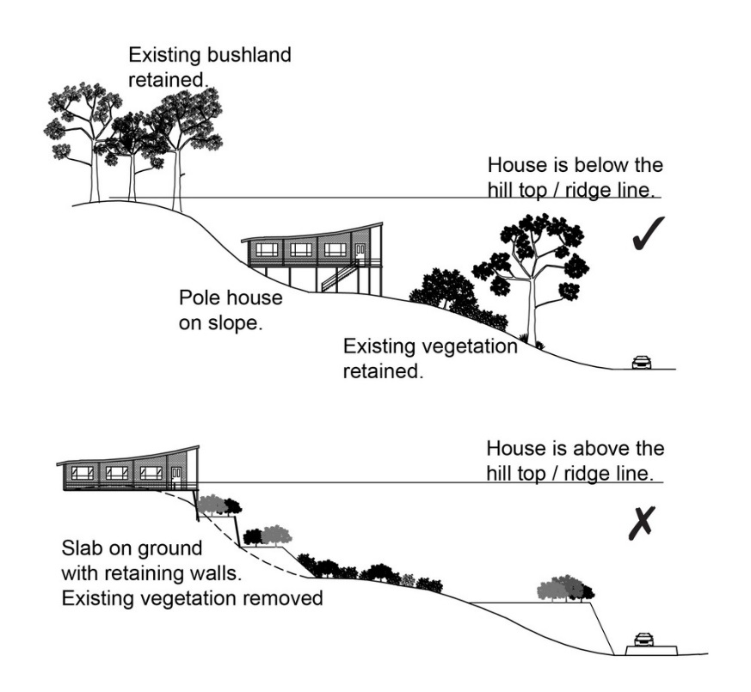
RAD132 | Where located in the Regionally significant (Hills) scenic amenity overlay, driveways and accessways:  - go across land contours and do not cut straight up slopes;  - follow natural contours, not resulting in batters or retaining walls being greater than 1m in height.  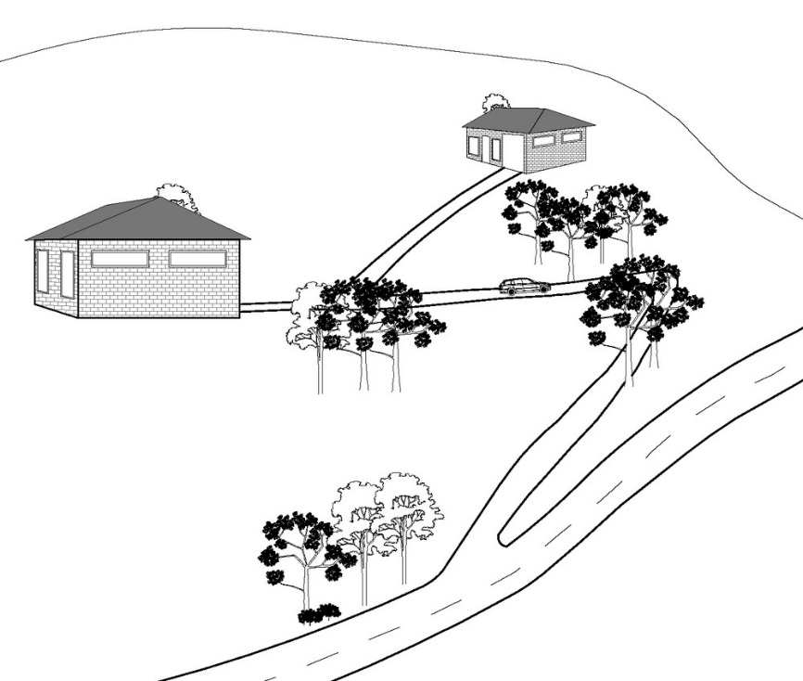
RAD133 | Where located in the Regionally significant (Hills) scenic amenity overlay, roofs and wall surfaces of buildings and structures adopt the following colours:  Colours from Australian Standard AS2700s – 1996  G12 – Holly G53 – Banksia N44 – Bridge Grey  G13 – Emerald G54 – Mist Green N45 – Koala Grey  G14 – Moss Green G55 – Lichen N52 – Mid Grey  G15 – Rainforest Green G56 – Sage Green N54 – Basalt  G16 – Traffic Green G62 – Rivergum N55 – Lead Grey  G17 – Mint Green G64 – Slate X54 – Brown  G21 – Jade G65 – Ti Tree X61 – Wombat  G22 – Serpentine N25 – Birch Grey X62 – Dark Earth  G23 – Shamrock N32 – Green Grey X63 – Iron Bark  G24 – Fern Green N33 – Lightbox Grey Y51 – Bronze Olive  G25 – Olive N35 – Light Grey Y61 – Black Olive  G34 – Avocado N41 – Oyster Y63 – Khaki  G52 – Eucalyptus N42 – Storm Grey Y66 – Mudstone  N43 – Pipeline Grey  Note - In the Rural residential zone, netting, shade cloth and similar coverings associated with agricultural operations are exempt.
RAD134 | Where located in the Regionally significant (Hills) scenic amenity overlay, roofs and wall surfaces of buildings and structures are painted or finished such that reflectivity is less than 35%.
Transport noise corridors (refer Overlay map - Transport noise corridors)
Note - This is for information purposes only. No requirements for accepted development or criteria for assessable development apply. Development located within a Transport Noise Corridor must satisfy the requirements of the Queensland Development Code.

