Table 9.4.1.7.2 Assessable development - Industry zone

Performance outcomes | Examples that achieve aspects of the Performance Outcomes | E Compliance  - Yes  - No See PO or  - NA | Justification for compliance
Lot size and design
PO1  Lots have appropriate area and dimension for the establishment of uses consistent with the applicable precinct of the Industry zone, having regard to areas required for:  - convenient and safe access;  - on-site car parking;  - on-site manoeuvring to ensure vehicle egress and access in forward gear;  - appropriately sited loading and servicing areas;  - setbacks, buffers and landscaping where required.  Note - Refer to the overall outcomes for the Industry zone (applicable precinct) for uses consistent in this precinct. | E1.1  Lots comply with the following minimum lot sizes:  - 1000 m² in the Mixed industry business precinct;  - 2500m² in the Light industry precinct;  - 4000m² in the General industry precinct;  - 6000m² in the Restricted industry precinct.  - 4000m² in the Marine industry precinct.
E1.2
Lots have a minimum width to depth ratio of 1:2 or 2:1.

Figure - Frontage to Depth Ratio Examples
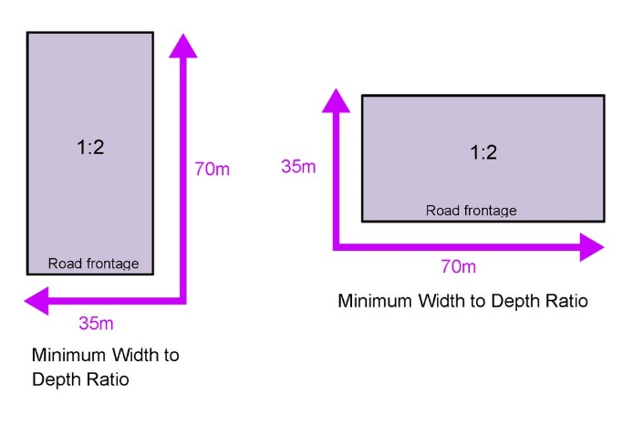
PO2  Road layouts facilitate regular and consistent shaped lots through the use of rectilinear grid patterns where not unduly constrained by topographical barriers. | No example provided.
PO3  Road layouts provides for:  - safe and efficient access and movement for the expected levels and type of traffic;  - an efficient and legible movement network with high levels of connectivity within and external to the development;  - increased active transport through a focus on safety and amenity for pedestrians and cyclists;  - retention of special features such as significant trees and vegetation.  Note - Refer to Planning scheme policy - Integrated design and Planning scheme policy - Neighbourhood design for guidance on how to demonstrate achievement of this performance outcome. | No example provided.
Movement network
PO4  Street layouts are designed to connect to surrounding neighbourhoods by providing an interconnected street, pedestrian and cyclist networks that connects nearby centres, neighbourhood hubs, community facilities, public transport nodes and open space to residential areas for access and emergency management purposes. The layout ensures that new development is provided with multiple points of access. The timing of transport works ensures that multiple points of access are provided during early stages of a development.  Note - Refer to Planning Scheme Policy - Neighbourhood design for guidance on when alternative access points should be provided for emergency management purposes. | E4.1  Development provides and maintains the connections shown on Figure 1 - Dakabin.
E4.2
For land located at Deception Bay, all vehicle access to Deception Bay Road is via a future 4-way signalised intersection at Deception Bay Road and Zammit Street, as illustrated in Figure 2 - Deception Bay Road Mixed Industry and Business, except where an alternative access has been previously approved by TMR or allowed through an existing development approval. No direct property access is provided to Deception Bay Road.
E4.3
All other areas, no example provided.
Note - Refer to Planning Scheme Policy - Neighbourhood design for guidance on when alternative access points should be provided for emergency management purposes.

PO5  The road network creates convenient access to arterial and sub-arterial roads for heavy vehicles and commercial traffic without introducing through traffic to residential streets. | No example provided.
PO6  The road network has sufficient reserve and pavement widths to cater for the current and intended function of the road in accordance with the road type. | E6  Roads are designed and constructed in accordance with the appropriate road type in Planning scheme policy - Integrated design.
PO7  Movement networks encourage walking and cycling and provide a safe environment for pedestrians and cyclists. | E7  Pedestrian paths, bikeways and on-road bicycle facilities are provided for the street type in accordance with Planning scheme policy - Integrated design.
PO8  Upgrade works (whether trunk or non-trunk) are provided where necessary to:  - ensure the type or volume of traffic generated by the development does not have a negative impact on the external road network;  - ensure the orderly and efficient continuation of the active transport network;  - ensure the site frontage is constructed to a suitable urban standard generally in accordance with Planning scheme policy - Integrated design.  Note - An Integrated Transport Assessment (ITA) may be required to demonstrate compliance with this performance outcome refer to Planning scheme policy - Integrated transport assessment for guidance on when an ITA is required. An ITA should be prepared in accordance with Planning scheme policy - Integrated transport assessment.  Note - The road network is mapped on Overlay map - Road hierarchy.  Note - The primary and secondary active transport network is mapped on Overlay map - Active transport.  Note - To demonstrate compliance with c. of this performance outcome, site frontage works where in existing road reserve (non-trunk) are to be designed and constructed as follows:  - Where the street is partially established to an urban standard, match the alignment of existing kerb and channel and provide carriageway widening and underground drainage where required; or  - Where the street is not established to an urban standard, prepare a design that demonstrates how the relevant features of the particular road as shown in the Planning scheme policy - Integrated Design can be achieved in the existing reserve.  Note - Refer to Planning scheme policy - Integrated design for road network and active transport network design standards. | No example provided.
Reticulated supply
PO9  Each lot is provided with an appropriate level of service and infrastructure commensurate with the Industry zone. All services, including water supply, stormwater management, sewage disposal, electricity, telecommunications and gas (if available) are provided in a manner that:  - is efficient in delivery of service;  - is effective in delivery of service;  - is conveniently accessible in the event of maintenance or repair;  - minimises whole of life cycle costs for that infrastructure;  - minimises risk of potential adverse impacts on the natural and built environment;  - minimises risk of potential adverse impact on amenity and character values;  - recognises and promotes Councils Total Water Cycle Management policy and the efficient use of water resources; | E9  Lots are provided with:  - a connection to the reticulated water supply infrastructure network;  - a connection to the sewerage infrastructure network;  - a connection to the reticulated electricity infrastructure network; and  - a physical connection to the telecommunication network, that where available to the land is part of the high speed broadband network.
Boundary realignment
PO10  Boundary realignments do not result in existing land uses on site becoming non-compliant due to:  - lot size;  - parking requirements;  - servicing;  - dependant elements of an existing or approved land use being separately titled.  Note - Examples may include but are not limited to:  - Where a commercial or industrial land use contains an ancillary office⁽⁵³⁾, the office⁽⁵³⁾ cannot be separately titled as it is considered part of the commercial or industrial use. | No example provided.
PO11  Boundary alignments ensure that infrastructure and services are wholly contained within the lot they serve. | No example provided.
Reconfiguring a lot other than creating freehold lots
PO12  Reconfiguring a lot which creates or amends a community title scheme as described in the Body Corporate and Community Management Act 1997 is undertaken in a way that does not result in existing uses on the land becoming unlawful or otherwise operating in a manner that is:  - inconsistent with any approvals on which those uses rely; or  - inconsistent with the requirements for accepted development applying to those uses at the time that they were established.  Note -An examples of land uses becoming unlawful includes, but are not limited to the following land on which a building has been established is reconfigured in a way that precludes lawful access to required communal facilities by either incorporating some of those facilities into private lots or otherwise obstructing the normal access routes to those facilities. Those communal facilities may have been required under the requirements for accepted development for the use or conditions of development approval.  Editor's note - To satisfy this performance outcome, the development application may need to be a combined application for reconfiguring a lot and a material change of use or otherwise be supported by details that confirm that the land use still satisfies all relevant land use requirements. | No example provided.
Reconfiguring by Lease
PO13  Reconfiguring a lot which divides land or buildings by lease in a way that allows separate occupation or use of those facilities is undertaken in a way that does not result in existing uses on the land becoming unlawful or otherwise operating in a manner that is:  - inconsistent with any approvals on which those uses rely; or  - inconsistent with the requirements for accepted development applying to those uses at the time that they were established.  Note - An example of a land use becoming unlawful is a building over which one or more leases have been created in a way that precludes lawful access to some of the required communal facilities. Some of the communal car parking facilities have been incorporated into lease areas while other leases are located in a way that obstructs the normal access routes to other communal facilities. Those communal facilities may have been required under the requirements for accepted development for the use or conditions of development approval, but they are no longer freely available to all occupants of the building.  Editor's note -To satisfy this performance outcome, the development application may need to be supported by details that confirm that the land use still satisfies all relevant land use requirements.  Editor’s note – Under the definition in Schedule 2 of the Act, the following do not constitute reconfiguring a lot and are not subject to this performance outcome:  - a lease for a term, including renewal options, not exceeding 10 years; and  - an agreement for the exclusive use of part of the common property for a community titles scheme under the Body Corporate and Community Management Act 1997. | No example provided.
Volumetric subdivision
PO14  The reconfiguring of the space above or below the surface of the land ensures appropriate area, dimensions and access arrangements to cater for uses consistent with the zone and does not result in existing land uses on site becoming non-compliant.  Note - Example include but are not limited to:  - Where a commercial or industrial land use contains an ancillary office⁽⁵³⁾, the office⁽⁵³⁾ cannot be separately titled as it is considered part of the commercial or industrial use. | No example provided.
Stormwater location and design
PO15  Lots are of a sufficient grade to accommodate effective stormwater drainage to a lawful point of discharge. | E15  The surface level of a lot is at a minimum grade of 1:100 and slopes towards the street frontage, or other lawful point of discharge
PO16  The development is planned and designed considering the land use constraints of the site and incorporates water sensitive urban design principles. | No example provided.
PO17  Stormwater drainage pipes and structures through or within private land are protected by easements in favour of Council with sufficient area for practical access for maintenance.  Note - Refer to Planning scheme policy - Integrated design for guidance on how to demonstrate achievement of this performance outcome. | No example provided.
PO18  Stormwater management facilities are located outside of riparian areas and prevent increased channel bed and bank erosion. | No example provided.
PO19  Natural streams and riparian vegetation are retained and enhanced through revegetation. | No example provided.
PO20  Areas constructed as detention basins are adaptable for passive recreation. | No example provided.
PO21  Development maintains the environmental values of waterway ecosystems. | No example provided.
PO22  Constructed water bodies which are not dedicated as public assets. | No example provided.
Stormwater management system
PO23  The major drainage system has the capacity to safely convey stormwater flows for the defined flood event (DFE). | E23  The roads, drainage pathways, drainage features and waterways safely convey the stormwater flows for the defined flood event (DFE) without allowing flows to encroach upon private lots.
PO24  Overland flow paths (for any storm event) from newly constructed roads and public open space areas do not pass through private lots. | E24  Drainage pathways are provided to accommodate overland flows from roads and public open space areas.
PO25  Where located within the Upper Pine, Hays Inlet and Burpengary Creek catchments, development achieves the greater pollutant removal of:  - 100% reductions in mean annual loads from unmitigated development for total suspended solids, total phosphorus, total nitrogen and gross pollutants >5mm;  - the stormwater management design objectives relevant for Moreton Bay Regional Council identified in Table A and B in Appendix 3 of the SPP.  Note - To demonstrate compliance with this PO a stormwater quality management plan is to be prepared by a suitable qualified person demonstrating compliance with the Urban Stormwater Planning Guideline 2010, Planning Scheme Policy – Stormwater Management, Planning Scheme Policy - Integrated Design and considering any local area stormwater management planning prepared by Council.  Note - Refer to Overlay map - Stormwater catchments for catchment boundaries. | No example provided.
PO26  Where located outside the Upper Pine, Hays Inlet and Burpengary Creek catchments, development achieves the stormwater management design objectives relevant for Moreton Bay Regional Council identified in Tables A and B in Appendix 2 of the SPP.  Note - To demonstrate compliance with this PO a stormwater quality management plan is to be prepared by a suitable qualified person demonstrating compliance with the Urban Stormwater Planning Guideline 2010, Planning Scheme Policy – Stormwater Management, Planning Scheme Policy - Integrated Design and considering any local area stormwater management planning prepared by Council.  Note - Refer to Overlay map - Stormwater catchments for catchment boundaries. | No example provided.
PO27  The stormwater management system is designed to:  - protect the environmental values in downstream waterways;  - maintain ground water recharge areas;  - preserve existing natural wetlands and associated vegetation buffers;  - avoid disturbing soils or sediments;  - avoid altering the natural hydrologic regime in acid sulphate soil and nutrient hazardous areas;  - maintain and improve receiving water quality;  - protect natural waterway configuration;  - protect downstream and adjacent properties;  - protect and enhance riparian areas. | No example provided.
PO28  Design and construction of the stormwater management system:  - utilise methods and materials to minimise the whole of lifecycle costs of the stormwater management system;  - are coordinated with civil and other landscaping works.  Note - Refer to Planning scheme policy - Integrated design for guidance on how to demonstrate achievement of this performance outcome. | No example provided.
Native vegetation where not located in the Environmental areas overlay
PO29  Reconfiguring a lot facilitates the retention of native vegetation by:  - incorporating native vegetation and habitat trees into the overall subdivision design, development layout, on-street amenity and landscaping where practicable;  - ensuring habitat trees are located outside a development footprint. Where habitat trees are to be cleared, replacement fauna nesting boxes are provided at the rate of 1 nest box for every hollow removed. Where hollows have not yet formed in trees > 80cm in diameter at 1.3m height, 3 nest boxes are required for every habitat tree removed.  - providing safe, unimpeded, convenient and ongoing wildlife movement;  - avoiding creating fragmented and isolated patches of native vegetation.  - ensuring that biodiversity quality and integrity of habitats is not adversely impacted upon but are maintained and protected;  - ensuring that soil erosion and land degradation does not occur;  - ensuring that quality of surface water is not adversely impacted upon by providing effective vegetated buffers to water bodies. | No example provided
Noise
PO30  Noise attenuation structure (e.g. walls, barriers or fences):  - contribute to safe and usable public spaces, through maintaining high levels of surveillance of parks, streets and roads that serve active transport purposes (e.g. existing or future pedestrian paths or cycle lanes etc);  - maintain the amenity of the streetscape.  Note - A noise impact assessment may be required to demonstrate compliance with this PO. Noise impact assessments are to be prepared in accordance with Planning scheme policy - Noise.  Note - Refer to Planning Scheme Policy – Integrated design for details and examples of noise attenuation structures. | E30  Noise attenuation structures (e.g. walls, barriers or fences):  - are not visible from an adjoining road or public area unless;  - adjoining a motorway or rail line; or  - adjoining part of an arterial road that does not serve an existing or future active transport purpose (e.g. pedestrian paths or cycle lanes) or where attenuation through building location and materials is not possible.  - do not remove existing or prevent future active transport routes or connections to the street network;  - are located, constructed and landscaped in accordance with Planning scheme policy - Integrated design.  Note - Refer to Planning Scheme Policy – Integrated design for details and examples of noise attenuation structures.  Note - Refer to Overlay map – Active transport for future active transport routes.

Values and constraints criteria
Note - The relevant values and constraints criteria do not apply where the development is consistent with a current Development permit for Reconfiguring a lot or Material change of use or Operational work, where that approval has considered and addressed (e.g. through a development footprint plan (or similar in the case of Landslide hazard) or conditions of approval) the identified value or constraint under this planning scheme.

Bushfire hazard (refer Overlay map - Bushfire hazard to determine if the following assessment criteria apply)
Note - The preparation of a bushfire management plan in accordance with Planning scheme policy – Bushfire prone areas can assist in demonstrating compliance with the following performance criteria. The identification of a development footprint will assist in demonstrating compliance with the following performance criteria.

PO31  Lots are designed to:  - minimise the risk from bushfire hazard to each lot and provide the safest possible siting for buildings and structures;  - limit the possible spread paths of bushfire within the reconfiguring;  - achieve sufficient separation distance between development and hazardous vegetation to minimise the risk to future buildings and structures during bushfire events;  - maintain the required level of functionality for emergency services and uses during and immediately after a natural hazard event. | E31  Reconfiguring a lot ensures that all new lots are of an appropriate size, shape and layout to allow for the siting of future buildings being located:  - within an appropriate development footprint;  - within the lowest hazard locations on a lot;  - to achieve minimum separation between development or development footprint and any source of bushfire hazard of 20m or the distance required to achieve a Bushfire Attack Level BAL (as identified under AS3959-2009), whichever is the greater;  - to achieve a minimum separation between development or development footprint and any retained vegetation strips or small areas of vegetation of 10m or the distance required to achieve a Bushfire Attack Level BAL (as identified under AS3959-2009), whichever is the greater;  - away from ridgelines and hilltops;  - on land with a slope of less than 15%;  - away from north to west facing slopes.
PO32  Lots provide adequate water supply and infrastructure to support fire-fighting. | E32  For water supply purposes, reconfiguring a lot ensures that:  - lots have access to a reticulated water supply provided by a distributer retailer for the area; or  - where no reticulated water supply is available, on-site fire fighting water storage containing not less than 10000 litres and located within a development footprint.
PO33  Lots are designed to achieve:  - safe site access by avoiding potential entrapment situations;  - accessibility and manoeuvring for fire-fighting during bushfire. | PO33  Reconfiguring a lot ensures a new lot is provided with:  - direct road access and egress to public roads;  - an alternative access where the private driveway is longer than 100m to reach a public road;  - driveway access to a public road that has a gradient no greater than 12.5%;  - minimum width of 3.5m.
PO34  The road layout and design supports:  - safe and efficient emergency services access to all lots; and manoeuvring within the subdivision;  - availability and maintenance of access routes for the purpose of safe evacuation. | E34  Reconfiguring a lot provides a road layout which:  - includes a perimeter road that separating the new lots from hazardous vegetation on adjacent lots incorporating by:  - a cleared width of 20m;  - road gradients not exceeding 12.5%;  - pavement and surface treatment capable of being used by emergency vehicles;  - Turning areas for fire fighting appliances in accordance with Qld Fire and Emergency Services' Fire Hydrant and Vehicle Access Guidelines.  - Or if the above is not practicable, a fire maintenance trail separates the lots from hazardous vegetation on adjacent lots incorporating:  - a minimum cleared width of 6m and minimum formed width of 4m;  - gradient not exceeding 12.5%;  - cross slope not exceeding 10%;  - a formed width and erosion control devices to the standards specified in Planning scheme policy - Integrated design;  - a turning circle or turnaround area at the end of the trail to allow fire fighting vehicles to manoeuvre;  - passing bays and turning/reversing bays every 200m;  - an access easement that is granted in favour of the Council and the Queensland Fire and Rescue Service or located on public land.  - excludes cul-de-sacs, except where a perimeter road with a cleared width of 20m isolates the lots from hazardous vegetation on adjacent lots; and  - excludes dead-end roads.
Environmental areas (refer Overlay map - Environmental areas to determine if the following assessment criteria apply)
Note - the identification of a development footprint will assist in demonstrating compliance with the following performance standards.

Editors' Note - The accuracy of overlay mapping can be challenged through the development application process (code assessable development) or by way of a planning scheme amendment. See Council's website for details.

PO35  No new boundaries are located within 2m of High Value Areas. | No example provided.
PO36  Lots are designed to:  - minimise the extent of encroachment into the MLES waterway buffer or a MLES wetland buffer;  - ensure quality and integrity of biodiversity and ecological values is not adversely impacted upon but are maintained and protected;  - incorporate native vegetation and habitat trees into the overall subdivision design, development layout, on-street amenity and landscaping where practicable;  - provide safe, unimpeded, convenient and ongoing wildlife movement;  - avoid creating fragmented and isolated patches of native vegetation;  - ensuring that soil erosion and land degradation does not occur;  - ensuring that quality of surface water is not adversely impacted upon by providing effective vegetated buffers to water bodies.  AND  Where development results in the unavoidable loss of native vegetation within a MLES waterway buffer or a MLES wetland buffer, an environmental offset is required in accordance with the environmental offset requirements identified in Planning scheme policy - Environmental areas. | E36  Reconfiguring a lot ensures that no additional lots are created within a Value Offset Area.
Extractive resources transport route buffer (refer Overlay map - Extractive resources to determine if the following assessment criteria apply)
Note - the identification of a development footprint will assist in demonstrating compliance with the following performance standards.

PO37  Lots provide a development footprint outside of the buffer. | No example provided.
PO38  Access to a lot is not from an identified extractive industry transportation route, but to an alternative public road. | No example provided.
Heritage and landscape character (refer Overlay map - Heritage and landscape character to determine if the following assessment criteria apply)
Note - the identification of a development footprint will assist in demonstrating compliance with the following performance standards.

PO39  Lots do not:  - reduce public access to a heritage place, building, item or object;  - create the potential to adversely affect views to and from the heritage place, building, item or object;  - obscure or destroy any pattern of historic subdivision, historical context, landscape setting or the scale and consistency of the urban fabric relating to the local heritage place. | No example provided.
PO40  Reconfiguring a lot retains significant trees and incorporates them into the subdivision design, development layout and provision of infrastructure. | No example provided.
Infrastructure buffers (refer Overlay map - Infrastructure buffers to determine if the following assessment criteria apply)
Note - the identification of a development footprint will assist in demonstrating compliance with the following performance standards.

High voltage electricity line buffer
PO41  New lots provide a development footprint outside of the buffer. | No example provided.
PO42  The creation of new lots does not compromise or adversely impact upon the efficiency and integrity of supply. | E42  No new lots are created within the buffer area.
PO43  The creation of new lots does not compromise or adversely impact upon access to the supply line for any required maintenance or upgrading work. | E43  No new lots are created within the buffer area.
PO44  Boundary realignments:  - do not result in the creation of additional building development opportunities within the buffer;  - result in the reduction of building development opportunities within the buffer. | No example provided.
Landfill buffer
PO45  Lots provide a development footprint outside of the buffer. | No example provided.
PO46  Boundary realignments:  - do not result in the creation of additional building development opportunities within the buffer;  - results in the reduction of building development opportunities within the buffer. | No example provided.
Wastewater treatment site buffer
PO47  New lots provide a development footprint outside of the buffer. | No example provided.
PO48  Boundary realignments:  - do not result in the creation of additional building development opportunities within the buffer;  - results in the reduction of building development opportunities within the buffer. | No example provided.
Overland flow path (refer Overlay map - Overland flow path to determine if the following assessment criteria apply)
Note - The applicable river and creek flood planning levels associated with defined flood event (DFE) within the inundation area can be obtained by requesting a flood check property report from Council.

PO49  Development:  - minimises the risk to persons from overland flow;  - does not increase the potential for damage from overland flow either on the premises or on a surrounding property, public land, road or infrastructure. | No example provided.
PO50  Development:  - maintains the conveyance of overland flow predominantly unimpeded through the premises for any event up to and including the 1% AEP for the fully developed upstream catchment;  - does not concentrate, intensify or divert overland flow onto an upstream, downstream or surrounding property.  Note - Reporting to be prepared in accordance with Planning scheme policy – Flood hazard, Coastal hazard and Overland flow.. | E50  Development ensures that any buildings are not located in an Overland flow path area.  Note: A report from a suitably qualified Registered Professional Engineer Queensland is required certifying that the development does not increase the potential for significant adverse impacts on an upstream, downstream or surrounding property.
PO51  Development does not:  - directly, indirectly or cumulatively cause any increase in overland flow velocity or level;  - increase the potential for flood damage from overland flow either on the premises or on a surrounding property, public land, road or infrastructure.  Note - Open concrete drains greater than 1m in width are not an acceptable outcome, nor are any other design options that may increase scouring.  Note - A report from a suitably qualified Registered Professional Engineer Queensland is required certifying that the development does not increase the potential for significant adverse impacts on an upstream, downstream or surrounding premises.  Note - Reporting to be prepared in accordance with Planning scheme policy – Flood hazard, Coastal hazard and Overland flow | No example provided.
PO52  Development ensures that overland flow is not conveyed from a road or public open space onto a private lot, unless the development is in a Rural zone. | E52  Development ensures that overland flow paths and drainage infrastructure is provided to convey overland flow from a road or public open space area away from a private lot, unless the development is in the Rural zone.
PO53  Development ensures that Council and inter-allotment drainage infrastructure, overland flow paths and open drains through private property cater for overland flows for a fully developed upstream catchment flows and are able to be easily maintained.  Note - A report from a suitably qualified Registered Professional Engineer Queensland is required certifying that the development does not increase the potential for significant adverse impacts on an upstream, downstream or surrounding premises.  Note - Reporting to be prepared in accordance with Planning scheme policy – Flood hazard, Coastal hazard and Overland flow | E53.1  Development ensures that roof and allotment drainage infrastructure is provided in accordance with the following relevant level as identified in QUDM:  - Urban area – Level III;  - Rural area – N/A;  - Industrial area – Level V;  - Commercial area – Level V.
E53.2
Development ensures that all Council and allotment drainage infrastructure is designed to accommodate any event up to and including the 1% AEP for the fully developed upstream catchment.
PO54  Development protects the conveyance of overland flow such that easements for drainage purposes are provided over:  - a stormwater pipe if the nominal pipe diameter exceeds 300mm;  - an overland flow path where it crosses more than one property; and  - inter-allotment drainage infrastructure.  Note - Refer to Planning scheme policy - Integrated design for details and examples.  Note - Stormwater drainage easement dimensions are provided in accordance with Section 3.8.5 of QUDM. | No example provided.
Additional criteria for development for a Park⁽⁵⁷⁾
PO55  Development for a Park⁽⁵⁷⁾ ensures that the design and layout responds to the nature of the overland flow affecting the premises such that:  - public benefit and enjoyment is maximised;  - impacts on the asset life and integrity of park structures is minimised;  - maintenance and replacement costs are minimised. | E55  Development for a Park⁽⁵⁷⁾ ensures works are provided in accordance with the requirements set out in Appendix B of the Planning scheme policy - Integrated Design.
Riparian and wetland setbacks (refer Overlay map - Riparian and wetland setback to determine if the following assessment criteria apply)
Note - - W1, W2 and W3 waterway and drainage lines, and wetlands are mapped on Schedule 2, Section 2.5 Overlay Maps – Riparian and wetland setbacks.

PO56  Lots are designed to:  - minimise the extent of encroachment into the riparian and wetland setback;  - ensure the protection of wildlife corridors and connectivity;  - reduce the impact on fauna habitats;  - minimise edge effects;  - ensure an appropriate extent of public access to waterways and wetlands. | E56  Reconfiguring a lot ensures that:  - no new lots are created within a riparian and wetland setback;  - new public roads are located between the riparian and wetland setback and the proposed new lots.  Note - Riparian and wetlands are mapped on Schedule 2, Section 2.5 Overlay Maps – Riparian and wetland setbacks.

Figure 1 - Dakabin
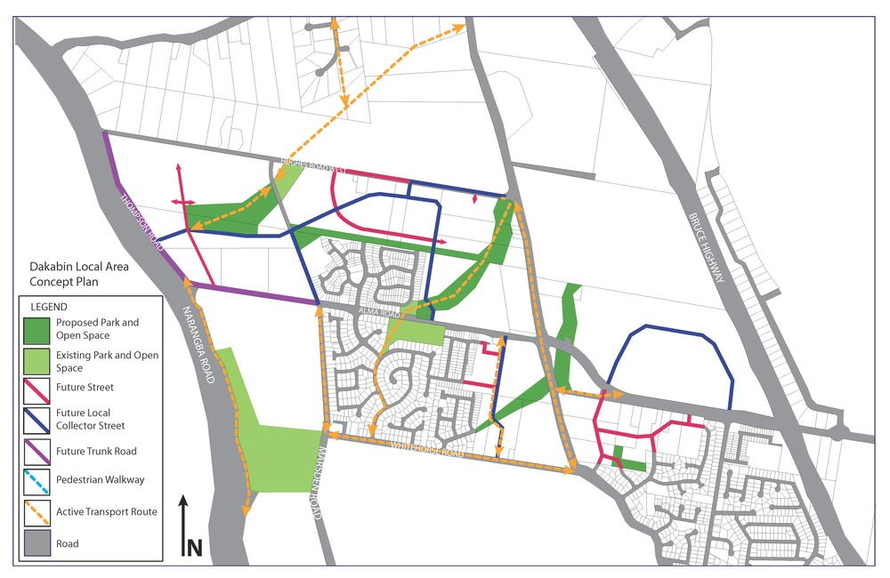

Figure 2 - Deception Bay Road Mixed Industry and Business
