Table 8.2.2.2 Assessable development - Flood hazard overlay

Performance outcomes |  |  | Acceptable outcomes |  |  | AO Compliance  - Yes  - No See PO or  - NA |  |  | Justification for compliance
Material change of use or building work for a dwelling house ⁽²²⁾
PO1  Development in the High risk flood hazard area included in the Limited development zone for:  - a material change of use and associated building work for a Dwelling house⁽²²⁾ does not occur;  - building work not associated with a material change of use for a Dwelling house⁽²²⁾ only occurs for an existing lawful use. |  |  | No acceptable outcome provided.
PO2  Development is resilient to flood events by ensuring design and built form account for the potential risks of flooding.  Note - New buildings within the High risk area or Medium risk area will require a structural engineering design capable of withstanding the nature of the hazard(s) to which the building will be subject consistent with the requirements of the relevant building assessment provisions, to be supported by a report (or multiple reports) prepared by a Registered Professional Engineer Queensland that identifies the flood hazard and the structural approach to be utilised. Information on the flood hazard for individual sites is available on Council’s Floodcheck website via https://www.moretonbay.qld.gov.au/floodcheck/.  Note - Reporting to be prepared in accordance with Planning scheme policy - Flood hazard, Coastal hazard and Overland flow. |  |  | AO2.1  Development ensures that a habitable floor is located, designed and constructed to at least the flood planning level in Table 8.2.2.3 ‘Flood planning level for a habitable floor (residential development) and a non-habitable floor (non-residential development) and levels for hazardous chemicals’.  Note - The highset 'Queenslander' style house is a resilient low-density housing solution. Higher density residential development should also ensure only non-habitable rooms (e.g. garages) are located on the ground floor.  Note - New buildings within the High risk area or Medium risk area will require a structural engineering design capable of withstanding the nature of the hazard(s) to which the building will be subject consistent with the requirements of the relevant building assessment provisions, to be supported by a report (or multiple reports) prepared by a Registered Professional Engineer Queensland that identifies the flood hazard and the structural approach to be utilised. Information on the flood hazard for individual sites is available on Council’s Floodcheck website via https://www.moretonbay.qld.gov.au/floodcheck/.  Note - Reporting to be prepared in accordance with Planning scheme policy - Flood hazard, Coastal hazard and Overland flow.
AO2.2
Development ensures that building work for non-habitable rooms below the flood planning level in Table 8.2.2.3 ‘Flood planning level for a habitable floor (residential development) and a non-habitable floor (non-residential development) and levels for hazardous chemicals’ has a high water resistance.
Note - The Queensland Government Fact Sheet ‘Rebuilding after a flood’ provides information about water resilient products and building techniques. Available at http://www.hpw.qld.gov.au/SiteCollectionDocuments/WaterResilient ProductsAndBuildingTechniquesForRebuildingAfterAFlood.pdf

 |  |  | Development in the High risk area or Medium risk area
AO2.3
Development ensures that a fence is at least 50% permeable.
PO3  Development maintains a functional and attractive relationship with the adjacent street frontage.  Note - This is particularly relevant for commercial uses in centres with a strong ‘town-centre’ pedestrian realm that also may be affected by flood, or for residential uses to maintain an attractive presentation to the street. |  |  | AO3  Development for a residential dwelling where pier and pole construction is utilised:  - uses screening around the understorey of the dwelling to ensure the understorey is not visible from the street;  - allows for the flow of flood water through the understorey
PO4  Development does not increase the potential for erosion, scour or flood damage either on the premises or on other premises, public land, watercourses, roads or infrastructure or elsewhere in the floodplain.  Note - To demonstrate achievement of the performance outcome, an engineering report is to be prepared by a suitably qualified person. Guidance on the matters to be addressed in the report is provided in Planning scheme policy - Flood hazard, Coastal hazard and Overland flow. |  |  | If in the High risk area or Medium risk area of the Flood planning area
AO4.1
Earthworks do not occur in the High risk area or Medium risk area of the Flood planning area.
 |  |  | If in the Balance flood planning area
 |  |  | No acceptable outcome provided.
For material change of use or building work (excluding material change of use or building work for a dwelling house) in the Balance flood planning area
PO5  Development is resilient to a flood hazard event by ensuring design and built form account for the potential risks of flooding. |  |  | Development involving building work for a residential use
AO5.1
Development ensures that a habitable floor is located, designed and constructed to at least the flood planning level in Table 8.2.2.3 ‘Flood planning level for a habitable floor (residential development) and a non-habitable floor (non-residential development) and levels for hazardous chemicals’.
 |  |  | Development involving building work for a non-residential use
AO5.2
Development ensures that the finished floor level is located, designed and constructed to at least the flood planning level in Table 8.2.2.3 ‘Flood planning level for a habitable floor (residential development) and a non-habitable floor (non-residential development) and levels for hazardous chemicals’.
AO5.3
Development ensures that a non-habitable room below the flood planning level in Table 8.2.2.3 ‘Flood planning level for a habitable floor (residential development) and a non-habitable floor (non-residential development) and levels for hazardous chemicals’ has a high water resistance.
Note - The Queensland Government Fact Sheet ‘Rebuilding after a flood’ provides information about water resilient products and building techniques. Available at http://www.hpw.qld.gov.au/SiteCollectionDocuments/WaterResilient ProductsAndBuildingTechniquesForRebuildingAfterAFlood.pdf

PO6  Development ensures earthworks complies with the requirements of Table 8.2.2.4 ‘Fill Requirements’ and does not:  - directly, indirectly and cumulatively cause any increase in water flow velocity or level;  - increase the potential for erosion, scour or flood damage either on the premises or other premises, public land, watercourses, roads or infrastructure or elsewhere in the floodplain;  - change the timing of the flood wave or impact on flood warning times.  Note - To demonstrate achievement of the performance outcome, an engineering report is to be prepared by a suitably qualified person. Guidance on the matters to be addressed in the report is provided in Planning scheme policy - Flood hazard, Coastal hazard and Overland flow. |  |  | No acceptable outcome specified.
PO7  Development ensures that a use which requires an interface with the public realm, including a commercial and residential use, maintains a functional and attractive relationship with the adjacent street frontage.  Note - This is particularly relevant for commercial uses in centres with a strong ‘town-centre’ pedestrian realm that also may be affected by flood, or for residential uses to maintain an attractive presentation to the street. |  |  | AO7.1  Development for a residential use where pier and pole construction is utilised:  - uses screening around the understorey of the dwelling that is a minimum of 50% permeable to ensure the understorey is not visible from the street;  - allows for the flow of flood water through the understorey.
AO7.2
Development for a commercial building or structure maintains an active street frontage through:
- providing clear pedestrian access from any adjacent footpath to the floor level of the commercial activity;
- providing a retail or food and beverage use, if consistent with the overall outcomes of the applicable zone and precinct, which interfaces with and overlooks the street;
- urban design treatments which screen the understorey of the building from view from the adjacent street frontage must not impede flood flow.
PO8  Development ensures that public safety and risk to the environment are not adversely affected by a detrimental impact of floodwaters up to the Defined Flood Event on a hazardous chemical located or stored on the premises. |  |  | AO8  Development ensures that a hazardous chemical is located or stored at least above the flood planning level in Table 8.2.2.3 ‘Flood planning level for a habitable floor (residential development) and a non-habitable floor (non-residential development) and levels for hazardous chemicals’.  Note - Refer to the Work Health and Safety Act 2011 and associated Regulation and Guidelines, the Environmental Protection Act 1994 and the relevant building assessment provisions under the Building Act 1975 for requirements related to the manufacture and storage of hazardous substances.
For all other material change of use or building work
PO9  Development is:  - limited in the High risk flood hazard area included in the Limited development zone to avoid the extremely unacceptable intolerable risk of the flood hazard;  - managed in the High risk flood hazard area not included in the Limited development zone to mitigate the unacceptable intolerable risk of the flood hazard;  - managed in the other sub-categories of the Flood planning area to mitigate the tolerable risk of the flood hazard.  Note - The overall outcomes of this code identify the development outcomes which are intended so as to avoid or mitigate the intolerable or tolerable risk of the flood hazard applicable to the premises in the relevant sub-categories of the Flood planning area. |  |  | No acceptable outcome provided.
PO10  Development maintains personal safety at all times, such that:  - a vulnerable land use (flood and coastal) is not located in the High risk flood hazard area or Medium risk flood hazard area;  - new buildings are not located in the High risk flood hazard area included in the Limited development zone;  - a residential accommodation building is located in the following:  - Balance flood planning area; or  - the Medium risk area where located in the Medium risk storm tide inundation area of the Coastal hazard overlay or Balance coastal planning area of the Coastal hazard overlay ;  - evacuation capability from the development or other premises is not hindered or made more complicated and there is no significant additional burden placed on emergency services personnel;  - the isolation of persons in the Defined Flood Event is avoided. |  |  | No acceptable outcome provided.
PO11  Development is resilient to a flood hazard event by ensuring design and built form account for the potential risks of the flood hazard event.  Note - New buildings within the High risk or Medium risk area will require a structural engineering design capable of withstanding the nature of the hazard(s) to which the building will be subject consistent with the requirements of the relevant building assessment provisions, to be supported by a report (or multiple reports) prepared by a Registered Professional Engineer Queensland that identifies the flood hazard and the structural approach to be utilised. Information on the flood hazard for individual sites is available on Council’s Floodcheck website via https://www.moretonbay.qld.gov.au/floodcheck/.  Note - Reporting to be prepared in accordance with Planning scheme policy - Flood hazard, Coastal hazard and Overland flow. |  |  | Development involving building work for a residential use
AO11.1
Development ensures that a habitable floor is located, designed and constructed to at least the flood planning level in Table 8.2.2.3 ‘Flood planning level for a habitable floor (residential development) and a non-habitable floor (non-residential development) and levels for hazardous chemicals’.
Note - New buildings within the High risk area or Medium risk area will require a structural engineering design capable of withstanding the nature of the hazard(s) to which the building will be subject consistent with the requirements of the relevant building assessment provisions, to be supported by a report (or multiple reports) prepared by a Registered Professional Engineer Queensland that identifies the flood hazard and the structural approach to be utilised. Information on the flood hazard for individual sites is available on Council’s Floodcheck website via https://www.moretonbay.qld.gov.au/floodcheck/.
Note - Reporting to be prepared in accordance with Planning scheme policy - Flood hazard, Coastal hazard and Overland flow.

 |  |  | Development involving building work for a non-residential use
AO11.2
Development ensures that the finished floor level is located, designed and constructed to at least the flood planning level in Table 8.2.2.3 ‘Flood planning level for a habitable floor (residential development) and a non-habitable floor (non-residential development) and levels for hazardous chemicals’.
Note - New buildings within the High risk area or Medium risk area will require a structural engineering design capable of withstanding the nature of the hazard(s) to which the building will be subject consistent with the requirements of the relevant building assessment provisions, to be supported by a report (or multiple reports) prepared by a Registered Professional Engineer Queensland that identifies the flood hazard and the structural approach to be utilised. Information on the flood hazard for individual sites is available on Council’s Floodcheck website via https://www.moretonbay.qld.gov.au/floodcheck/.
Note - Reporting to be prepared in accordance with Planning scheme policy - Flood hazard, Coastal hazard and Overland flow.

 |  |  | Development involving building work for all uses
AO11.3
Development ensures that a fence is at least 50% permeable.
AO11.4
Development ensures that building work for non-habitable rooms below the flood planning level in Table 8.2.2.3 ‘Flood planning level for a habitable floor (residential development) and a non-habitable floor (non-residential development) and levels for hazardous chemicals’ has a high water resistance.
Note - The Queensland Government Fact Sheet ‘Rebuilding after a flood’ provides information about water resilient products and building techniques. Available at http://www.hpw.qld.gov.au/SiteCollectionDocuments/WaterResilient ProductsAndBuildingTechniquesForRebuildingAfterAFlood.pdf

PO12  Development ensures that where earthworks alone cannot ensure the development achieves the flood planning level in Table 8.2.2.3 ‘Flood planning level for a habitable floor (residential development) and a non-habitable floor (non-residential development) and levels for hazardous chemicals’, a building is designed and constructed using pier and pole construction to achieve the required flood immunity in the Defined Flood Event. |  |  | No acceptable outcome specified.
PO13  Development ensures that earthworks complies with the requirements of Table 8.2.2.4 ‘Fill Requirements’ and does not:  - directly, indirectly and cumulatively cause any increase in water flow velocity or level;  - increase the potential for erosion, scour or flood damage either on the premises or on other premises, public land, watercourses, roads or infrastructure or elsewhere in the floodplain;  - change the timing of the flood wave or impact on flood warning times.  Note - To demonstrate achievement of the performance outcome, an engineering report is to be prepared by a suitably qualified person. Guidance on the matters to be addressed in the report is provided in Planning scheme policy - Flood hazard, Coastal hazard and Overland flow. | No acceptable outcome provided.
PO14  Development supports and does not unduly burden, disaster management responses and recovery capacity and capabilities for a flood hazard event up to and including the Defined Flood Event. | No acceptable outcome provided.
PO15  Development has access which, having regard to the hydraulic hazard, provides for safe vehicular and pedestrian movement and emergency services access. | No acceptable outcome provided.
PO16  Development ensures that a use which requires an interface with the public realm, including a commercial and residential use, maintains a functional and attractive relationship with the adjacent street frontage.  Note - This is particularly relevant for commercial uses in centres with a strong ‘town-centre’ pedestrian realm that also may be affected by flood, or for residential uses to maintain an attractive presentation to the street. | AO16.1  Development for a residential dwelling where pier and pole construction is utilised:  - uses screening around the understorey of the dwelling that is a minimum of 50% permeable to ensure the understorey is not visible from the street;  - allows for the flow of flood water through the understorey.
AO16.2
Development for a commercial building or structure maintains an active street frontage through:
- providing clear pedestrian access from any adjacent footpath to the floor level of the commercial activity;
- providing a retail or food and beverage use, if consistent with the overall outcomes of the applicable zone and precinct, which interfaces with and overlooks the street;
- urban design treatments which screen the understorey of the building from view from the adjacent street frontage but do not impede flood flow.
Reconfiguring a lot (boundary realignment)
PO17  Development is designed to:  - ensure personal safety at all times;  - not increase the potential for erosion, scour or flood damage either on the premises or other premises, public land, watercourses, roads or infrastructure or elsewhere in the floodplain;  - not increase the risk to people, property and infrastructure located on the premises and other premises and where applicable the risk for future occupants is mitigated. | AO17.1  Development ensures that the development footprint is located in an area other than a High risk area.
AO17.2
Development ensures that the entry points into the development are located to provide a safe and clear evacuation route path.
 | If in the Drainage investigation area
AO17.3
Development occurs in accordance with a drainage master plan for the Drainage investigation area.
Reconfiguring a lot (other than boundary realignment)
PO18  Development is compatible with the intolerable or tolerable level of risk of the flood hazard applicable to the premises such that reconfiguring a lot for creating lots by subdividing another lot:  - in the High risk area, is only for the purposes of Park or Permanent plantation unless:  - in the Rural residential zone where; the minimum lot size for each rural residential lot is provided outside the High risk area; or  - in the Rural zone; or  - in the Medium risk area, is only for the purposes of Park or Permanent plantation unless:  - in the Centre zone, Industry zone, Recreation and open space zone, or Township zone, where not for a residential purpose or vulnerable use (flood and coastal); or  - in the Rural zone; or  - in the Rural residential zone, where the minimum lot size for each rural residential lot is provided outside the Medium risk area; or  - in any other zone, where all resultant lots are located outside the High risk or Medium risk area other than those for the purposes of Park or Permanent plantation; or  - In the Balance flood planning area, is consistent with the overall outcomes of the applicable zone and precinct.  Note - The overall outcomes of this code identify the development outcomes which are intended so as to avoid or mitigate the intolerable or tolerable level of risk applicable to premises in the High risk area, Medium risk area and Low risk area of the Flood planning area. | No acceptable outcome provided.
PO19  Development is designed to ensure personal safety at all times such that:  - flood immunity up to the Flood planning level is achieved;  - the road layout avoids isolation in a flood hazard event and does not impede evacuation;  - signage is utilised to ensure that community members have a clear understanding of the nature of the flood risk in the area. | If the ground level is to be filled to the Flood planning level as permitted by Table 8.2.2.4 ‘Fill Requirements’
AO19.1
Development ensures that the finished ground level for all additional lots (excluding a Park⁽⁵⁷⁾) complies with the requirements of Table 8.2.2.4 ‘Fill Requirements’.
AO19.2
Development ensures that the road and pathway layout:
- ensures residents are not physically isolated from an adjacent flood-free urban area;
- provides a safe and clear evacuation route path by:
  - locating entry points into the development above the requirements set out in Appendix C of the Planning scheme policy - Integrated design and avoiding cul-de-sac or other non-permeable layouts;
  - direct and simple routes to a main carriageway.
Note - 'Pathway’ in this instance relates to pedestrian and non-pedestrian routes internal to a development site that are not specifically roads – for example, pedestrian pathways within a hotel⁽³⁷⁾ development or internal roads in a large townhouse development.
Note - It is important to ensure that new reconfigurations are not isolated from other urban areas in the event of a flood.

AO19.3
Development in a greenfield area protects a flood conveyance area by providing an easement or reserve over the area of the premises up to the Defined Flood Event.
AO19.4
Development ensures that a new road and development access are provided in accordance with the requirements set out in Appendix C of the Planning scheme policy - Integrated design.
AO19.5
Development ensures that:
- signage is provided on a road or pathway indicating the position and path of all safe evacuation routes off the premises;
- if the premises contains or is within 100m of a waterway, hazard warning signage and depth indicators are provided at each key hazard point, such as at a waterway crossing or an entrance to a low-lying reserve.
Note - 'Pathway’ in this instance relates to pedestrian and non-pedestrian routes internal to a development site that are not specifically roads – for example, pedestrian pathways within a hotel⁽³⁷⁾ development or internal roads in a large townhouse development.

 | If the ground level is to be filled other than as permitted by Table 8.2.2.4 ‘Fill Requirements’
 | No acceptable outcome specified
PO20  Development ensures that infrastructure (excluding a road):  - is located outside of the High risk flood hazard area and Medium risk flood hazard area; or  - is otherwise located in the High risk flood hazard area or Medium risk flood hazard area to function during and after all flood hazard events up to and including the Defined Flood Event. | If in the Balance flood planning area
AO20
Development ensures that:
- any component of infrastructure which is likely to fail to function or may result in contamination when inundated by flood is located above the Flood planning level; or
- infrastructure is designed, located and constructed to resist the hydrostatic and hydrodynamic forces as a result of inundation by the Defined Flood Event.
 | If in the High risk area or Medium risk area
 | No acceptable outcome provided.
PO21  Reconfiguring a lot does not result in:  - directly, indirectly and cumulatively cause any increase in water flow velocity or level;  - increase the potential for erosion, scour or flood damage either on the premises or other premises, public land, watercourses, roads or infrastructure or elsewhere in the floodplain;  - change the timing of the flood wave or impact on flood warning times  - adverse impacts on the local drainage and the flood conveyance of a waterway;  - increased flood inundation of surrounding properties;  - any reduction in the flood storage capacity of the floodplain and any clearing of native vegetation.  Note - To demonstrate achievement of the performance outcome, an engineering report is to be prepared by a suitably qualified person. Guidance on the matters to be addressed in the report is provided in Planning scheme policy - Flood hazard, Coastal hazard and Overland flow. | If in the Balance flood planning area
AO21
All earthworks are undertaken outside of the Defined Flood Event, or where required to regularise allotment shape, earthworks are undertaken in accordance with Planning scheme policy – Flood hazard, Coastal hazard and Overland flow.
 | If in the High risk area or Medium risk area
 | No acceptable outcome provided.
Additional criteria for works whether or not associated with a material change of use, building work or reconfiguring a lot
PO22  Development ensures that works complies with the requirements of Table 8.2.2.4 ‘Fill Requirements’ and does not:  - directly, indirectly and cumulatively cause any increase in water flow velocity or level;  - increase the potential for erosion, scour or flood damage either on the premises or other premises, public land, watercourses, roads or infrastructure or elsewhere in the floodplain;  - change the timing of the flood wave or impact on flood warning times;  - adverse impacts on the local drainage and the flood conveyance of a waterway;  - increased flood inundation of surrounding properties;  - any reduction in the flood storage capacity of the floodplain and any clearing of native vegetation.  Note - To demonstrate achievement of the performance outcome, an engineering report is to be prepared by a suitably qualified person. Guidance on the matters to be addressed in the report is provided in the Planning scheme policy Flood Hazard, Coastal Hazard and Overland Flow. | No acceptable outcome provided.
Additional criteria for development involving hazardous chemicals
PO23  Development ensures that hazardous chemicals are not located or stored in the High risk flood hazard area. | No acceptable outcome provided.
PO24  Development not in the High risk area ensures that public safety and risk to the environment are not adversely affected by a detrimental impact of floodwaters up to the Defined Flood Event on a hazardous chemical located or stored on the premises. | AO24  Development ensures that a hazardous chemical is located or stored at least above the flood planning level in Table 8.2.2.3 ‘Flood planning level for a habitable floor (residential development) and a non-habitable floor (non-residential development) and levels for hazardous chemicals’.  Note - Refer to the Work Health and Safety Act 2011 and associated Regulation and Guidelines, the Environmental Protection Act 1994 and the relevant building assessment provisions under the Building Act 1975 for requirements related to the manufacture and storage of hazardous substances.
Additional criteria for development for community infrastructure
PO25  Development for community infrastructure is not located in the High risk flood hazard area or Medium risk flood hazard area. | No acceptable outcome specified.
PO26  Development for community infrastructure not located in the High risk area or Medium risk area:  - remains functional to serve community needs during and immediately after the Defined Flood Event;  - is designed, sited and operated to avoid adverse impacts on the community or the environment due to the impacts of flood inundation on infrastructure, facilities or access and egress routes;  - retains essential site access during the Defined Flood Event;  - is able to remain functional even when other infrastructure or services may be compromised in the Defined Flood Event. | No acceptable outcome provided.
Additional criteria for development of premises subject to a drainage master plan
PO27  Development of premises included in the General residential zone – Next generation neighbourhood precinct or General residential zone – Urban neighbourhood precinct located in a Drainage investigation area identified on Figures 8.2.2.1 to 8.2.2.10 is supported by drainage works and specific building design responses to mitigate the risk posed by the flood hazard.  Note - Planning scheme policy - Flood hazard, Coastal hazard and Overland flow provides direction on the preparation of a drainage master plan, or similar, for the Drainage Investigation Area. | If the Council has an adopted drainage master plan for the Drainage master plan area
AO27.1
Development:
- undertakes identified works, internal and external, or transfers land as required to mitigate the impact of the flood hazard and any coastal hazard;
- is designed to mitigate the impact of the flood hazard and any coastal hazard in accordance with the design standards identified in the drainage master plan in the Planning scheme policy - Flood hazard, Coastal hazard and Overland flow.
 | If the Council does not have an adopted drainage master plan for the Drainage investigation area
AO27.2
Development:
- occurs in accordance with a drainage master plan prepared by an applicant and approved by the Council;
- undertakes identified works, internal and external, or transfers land as required to mitigate the impact of the flood hazard and any coastal hazard;
- is designed to mitigate the impact of the flood hazard and any coastal hazard in accordance with the design standards identified in the approved drainage master plan.
Note - Planning scheme policy - Flood hazard, Coastal hazard and Overland flow provides direction on the preparation of a drainage master plan.

PO28  Development of premises included in General residential zone – Next generation neighbourhood precinct or General residential zone – Urban neighbourhood precinct located in a Drainage investigation area identified on Figures 8.2.2.1 to 8.2.2.10 must ensure that the land is filled:  - where there is an adopted drainage master plan, in accordance with the levels in the drainage master plan;  - where there is no adopted drainage master plan, in accordance with the fill requirements in Table 8.2.2.4 ‘Fill Requirements’ or such that the filling of the land does not:  - directly, indirectly and cumulatively cause any increase in water flow velocity or level;  - increase the potential for erosion, scour or flood damage either on the premises or other premises, public land, watercourses, roads or infrastructure or elsewhere in the floodplain.  Note - To demonstrate achievement of the performance outcome, an engineering report is to be prepared by a suitably qualified person. Guidance on the matters to be addressed in the report is provided in Planning scheme policy - Flood hazard, Coastal hazard and Overland flow. |  | AO28  No acceptable outcome provided.
Additional criteria for development for a Park⁽⁵⁷⁾
PO29  Development for a Park⁽⁵⁷⁾ ensures that the design and layout responds to the nature of the flood hazard affecting the premises in order to:  - maximise public benefit and enjoyment;  - minimise impacts on the asset life and integrity of park⁽⁵⁷⁾ structures;  - minimise maintenance and replacement costs. |  | AO29  Development for a Park⁽⁵⁷⁾ ensures works are provided in accordance with the requirements set out in Appendix B of Planning scheme policy - Integrated design.
Additional criteria for material change of use for Permanent plantation⁽⁵⁹⁾ or Cropping⁽¹⁹⁾ (where involving forestry for wood production)
PO30  Development:  - adopts management practices to minimise release of woody debris load into floodwaters during flood events up to the Defined Flood Event;  - complies with other relevant environmental setbacks and requirements. |  | No acceptable outcome provided.

Table 8.2.2.3 Flood planning level for a habitable floor (residential development) and a non-habitable floor (non-residential development) and levels for hazardous chemicals
Flood planning area | Defined freeboard | Flood planning level
Flood planning area (east of the Bruce Highway and inside the Erosion Prone Area in the Coastal hazard overlay) | 500mm | Defined Flood Event + 500mm
Flood planning area (east of the Bruce Highway and outside the Erosion Prone Area in the Coastal hazard overlay) | 300mm | Defined Flood Event + 300mm
Flood planning area (west of the Bruce Highway) | 750mm | Defined Flood Event + 750mm

Note - If the premise is subject to another overlay which states a flood planning level, the flood planning level that provides the highest level of immunity applies.

Table 8.2.2.4 Fill Requirements
Flood planning area | Fill level
Land in the High risk area included in the Limited development zone. | No filling permitted.
Land in the High risk area not included in the Limited development zone. | No filling permitted.
Land in the Medium risk area and not located in a Drainage investigation area. | No filling permitted.
Land located in a Drainage investigation area identified on Figures 8.2.2.1 to 8.2.2.10. | Filling in accordance with the relevant adopted Drainage master plan.
Land in the Balance flood planning area. | Filling permitted - Development Footprint as a minimum to the Defined Flood Event.

Figure 8.2.2.1 - Albany Creek
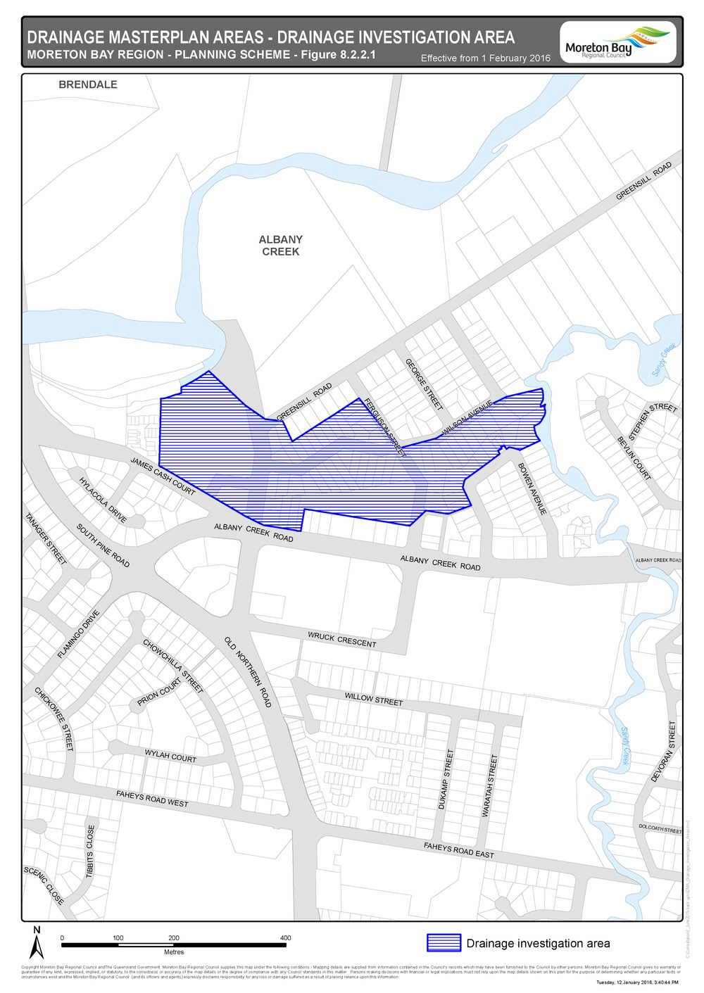

Figure 8.2.2.2 - Clontarf
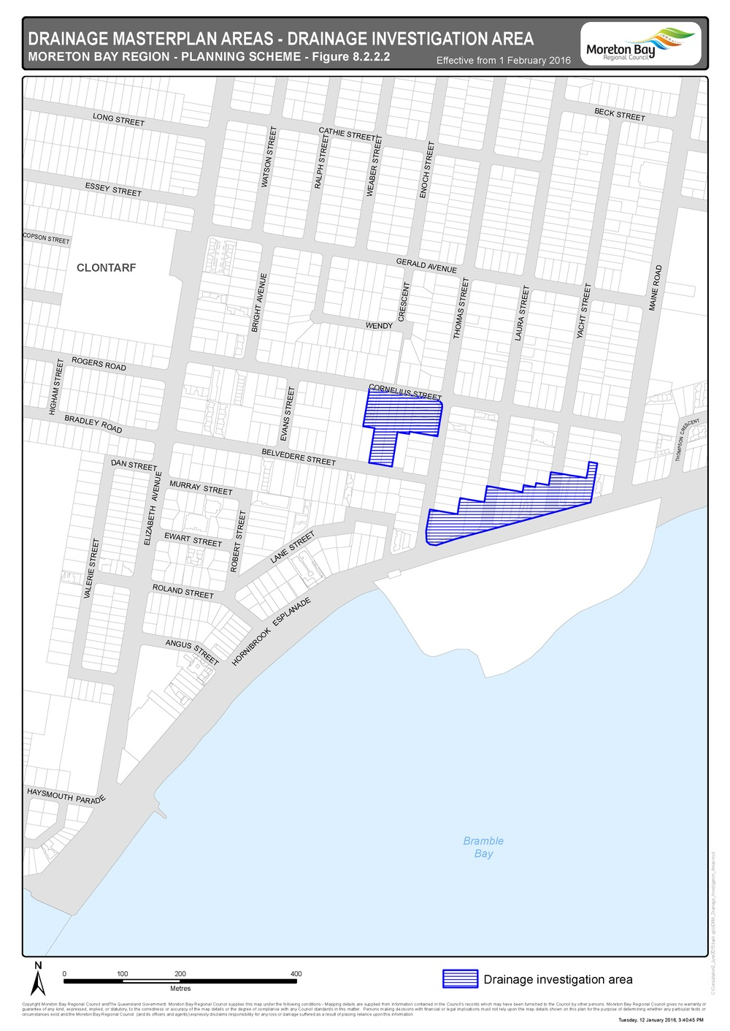
Figure 8.2.2.3 - Woody Point
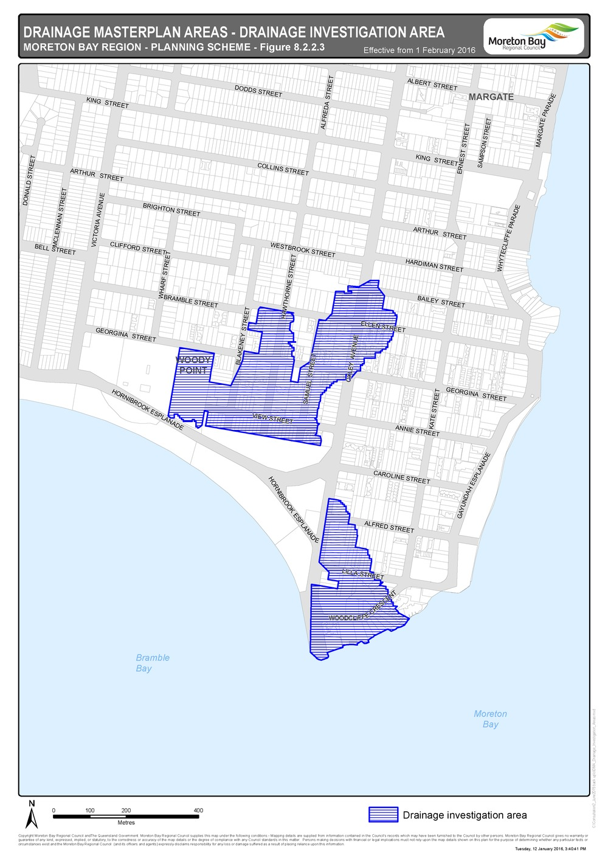

Figure 8.2.2.4 - Margate
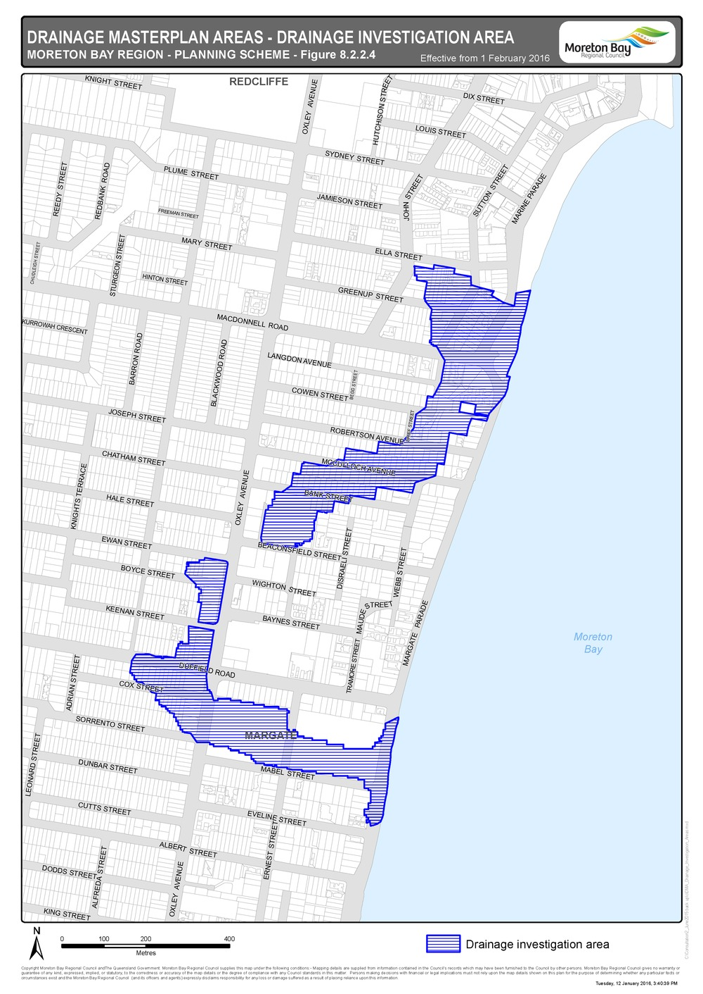

Figure 8.2.2.5 - Redcliffe - Scarborough
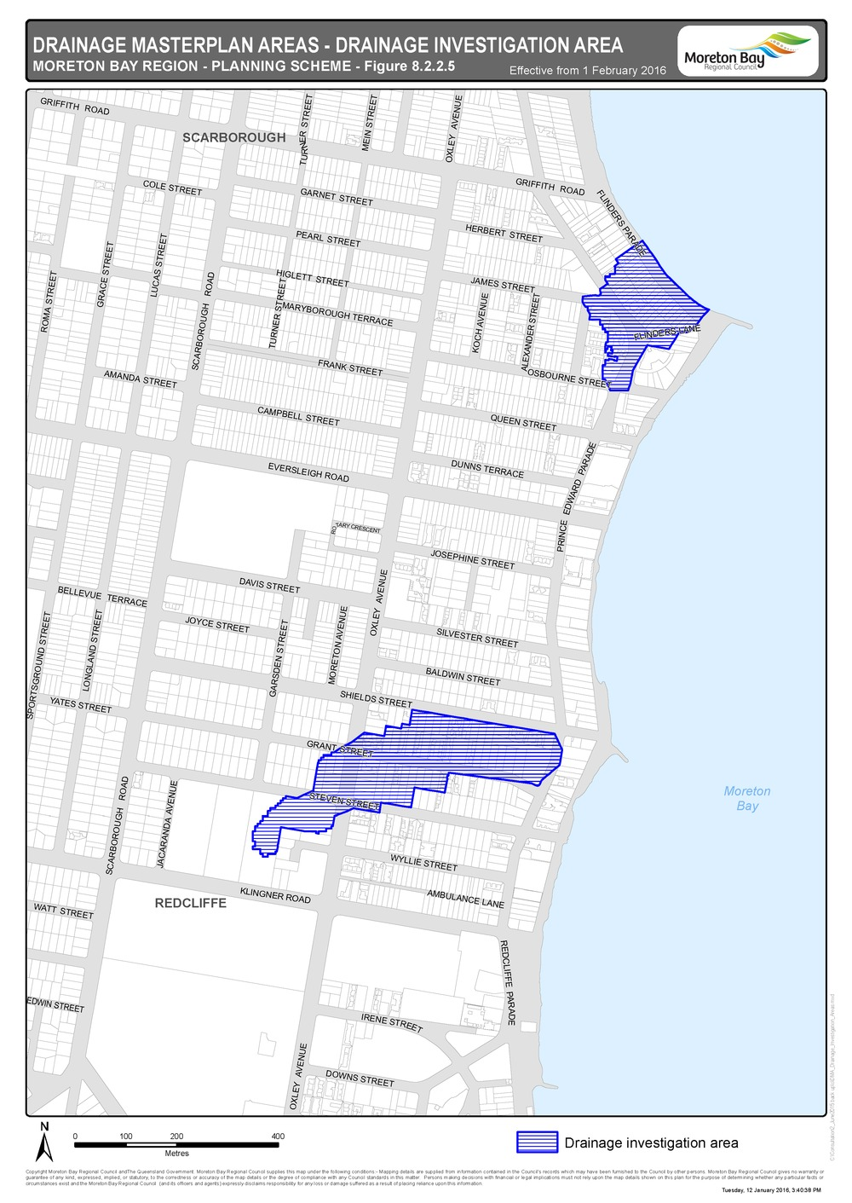
Figure 8.2.2.6 - Scarborough
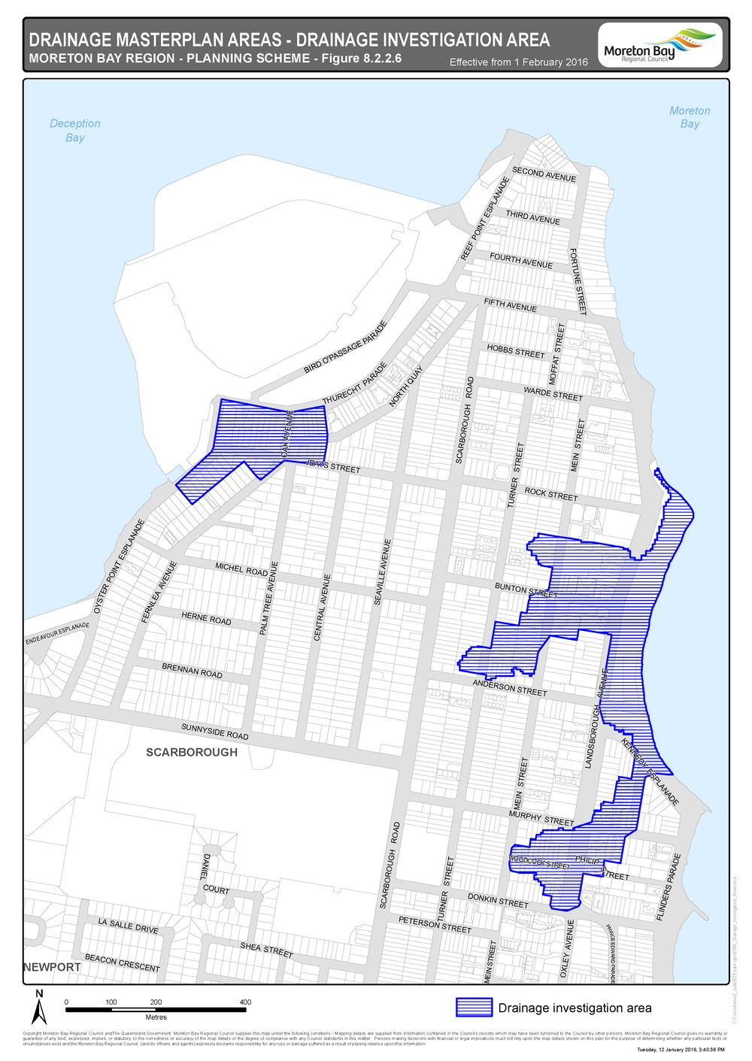

Figure 8.2.2.7 - Rothwell
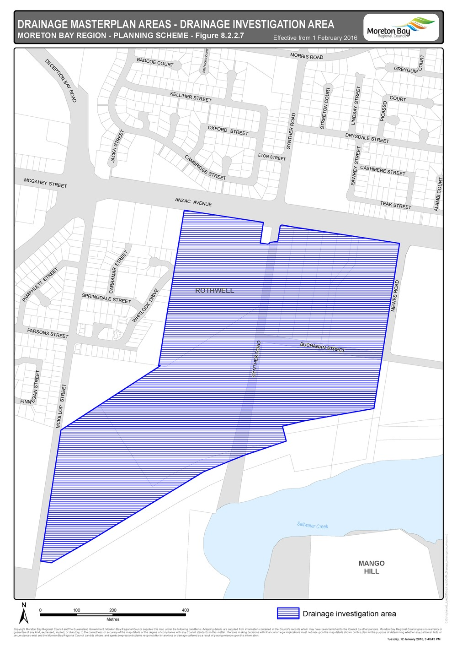

Figure 8.2.2.8 - Deception Bay
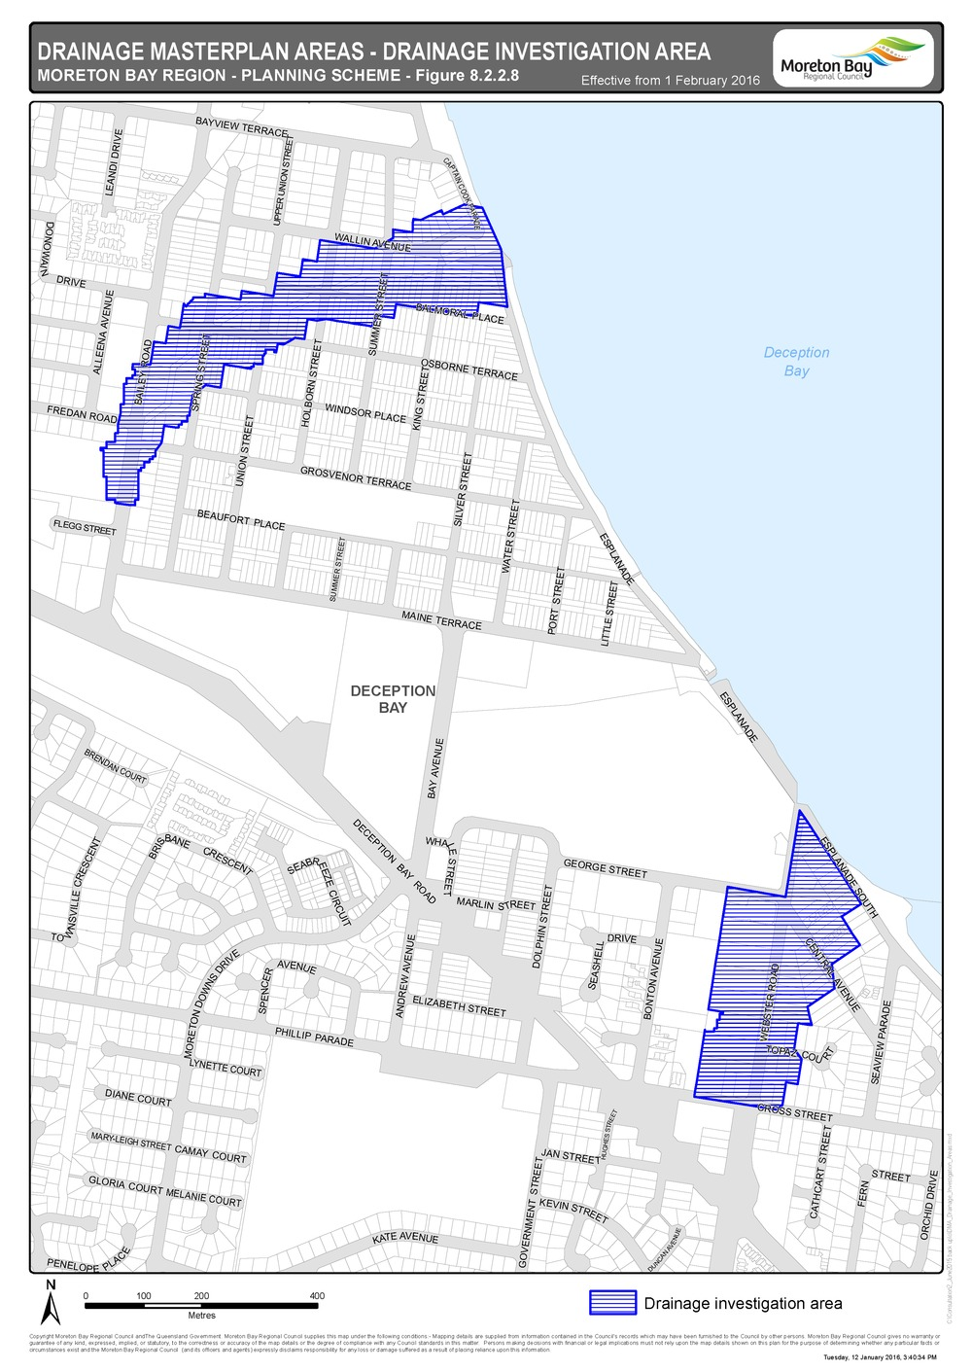

Figure 8.2.2.9 - Burpengary
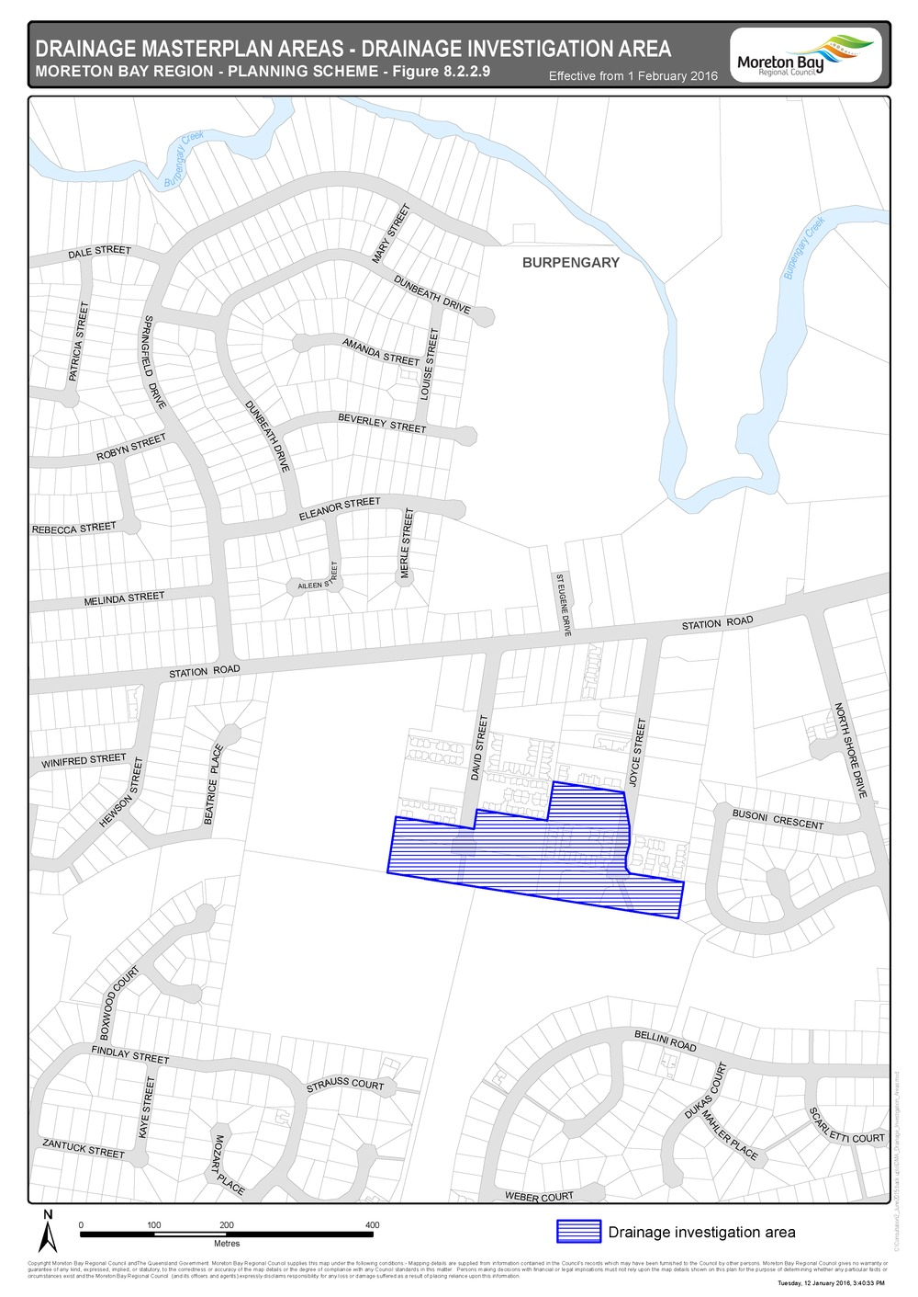

Figure 8.2.2.10 - Caboolture
