Table 9.4.1.6.3.1 Requirements for accepted development - General residential zone - Next generation neighbourhood precinct

Requirements for accepted development |  | E Compliance  - Yes  - No | Council confirmation
General requirements
Boundary realignment
RAD1 | Lots created by boundary realignment:  - contain all service connections to water, sewer, electricity and other infrastructure wholly within the lot they serve;  - have constructed road access;  - do not require additional infrastructure connections or modification to existing connections.  - do not result in the creation of any additional lots;
RAD2 | Boundary realignment does not result in existing land uses on-site becoming non-compliant with planning scheme requirements.  Note - Examples may include but are not limited to:  - minimum lot size requirements;  - minimum or maximum required setbacks  - parking and access requirements;  - servicing and Infrastructure requirements;  - dependant elements of an existing or approved land use being separately titled, including but not limited to:  - Where premises are approved as Multiple dwelling⁽⁴⁹⁾ with a communal open space area, the communal open space cannot be separately titled as it is required by the Multiple dwelling⁽⁴⁹⁾ approval.  - Where a commercial or industrial land use contains an ancillary office⁽⁵³⁾, the office⁽⁵³⁾ cannot be separately titled as it is considered part of the commercial or industrial use.  - Where a Dwelling house⁽²²⁾ includes a secondary dwelling or associated outbuildings, they cannot be separately titled as they are dependent on the Dwelling house⁽²²⁾ use.
RAD3 | Lots comply with the following minimum lot sizes and dimensions:  Zone (Precinct) Area Frontage Depth  General Residential - Next generation neighbourhood precinct - 7.5 m 25 m  Editor's note - Lots containing built to boundary walls should also include an appropriate easement to facilitate the maintenance of any wall within 600mm of a boundary. For boundaries with built to boundary walls on adjacent lots a 'High Density Development Easement' is recommended; or for all other built to boundary walls a 'easement for maintenance purposes' is recommended.
RAD4 | Boundary realignment in the precinct does not result in more than 4 adjoining lots of the same lot type, as defined in ‘Table 9.4.1.6.3.3 - Lot Types’ - Lot Types.
RAD5 | Boundary realignment does not result in the creation of additional building development opportunity within an area subject to an overlay map.
RAD6 | No new boundaries are located within 2m of High Value Areas as identified in Overlay map - Environmental areas.
RAD7 | Boundary realignment does not result in the clearing of any Habitat trees.

Table 9.4.1.6.3.3 - Lot Types
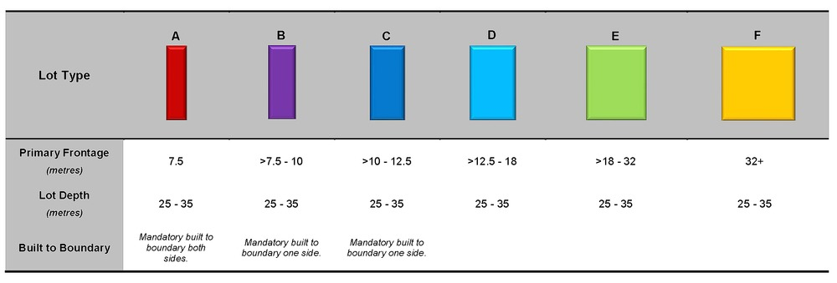

Figure 1 - Dakabin
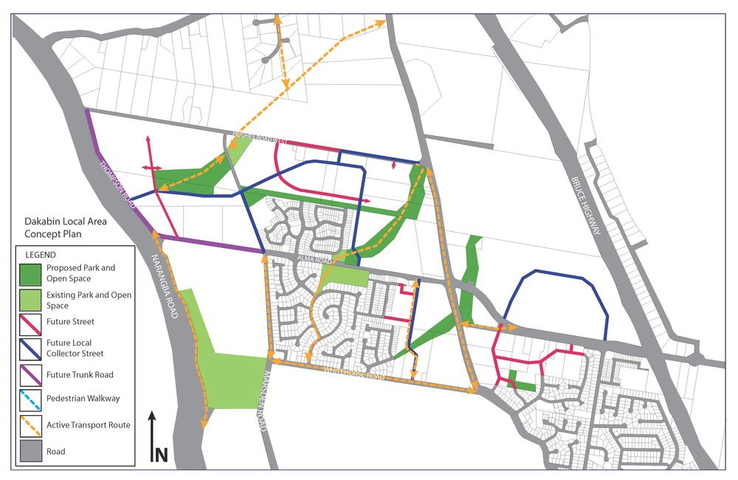

Figure 2 - Griffin
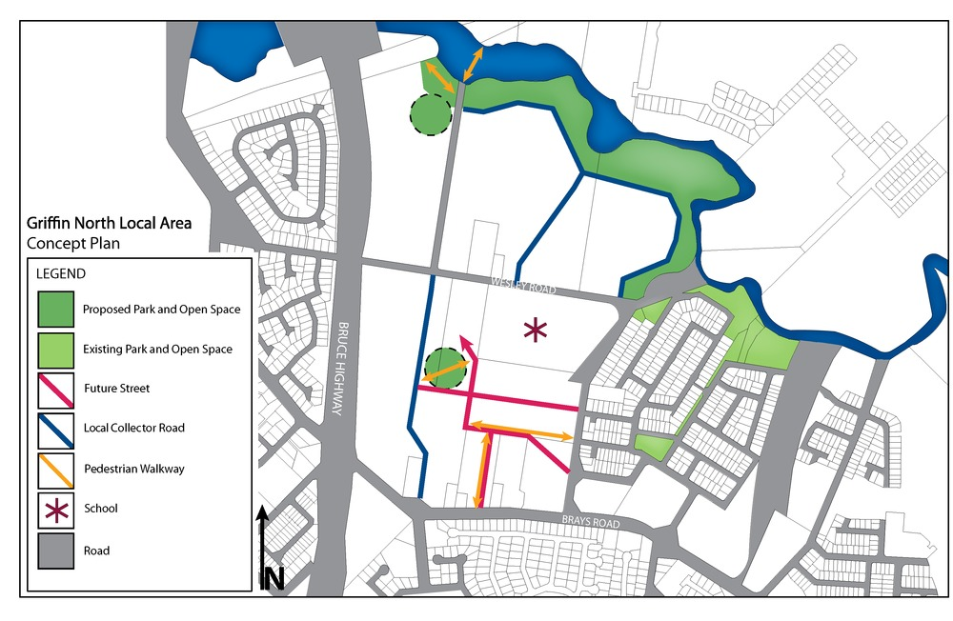

Figure 3 - Mango Hill East
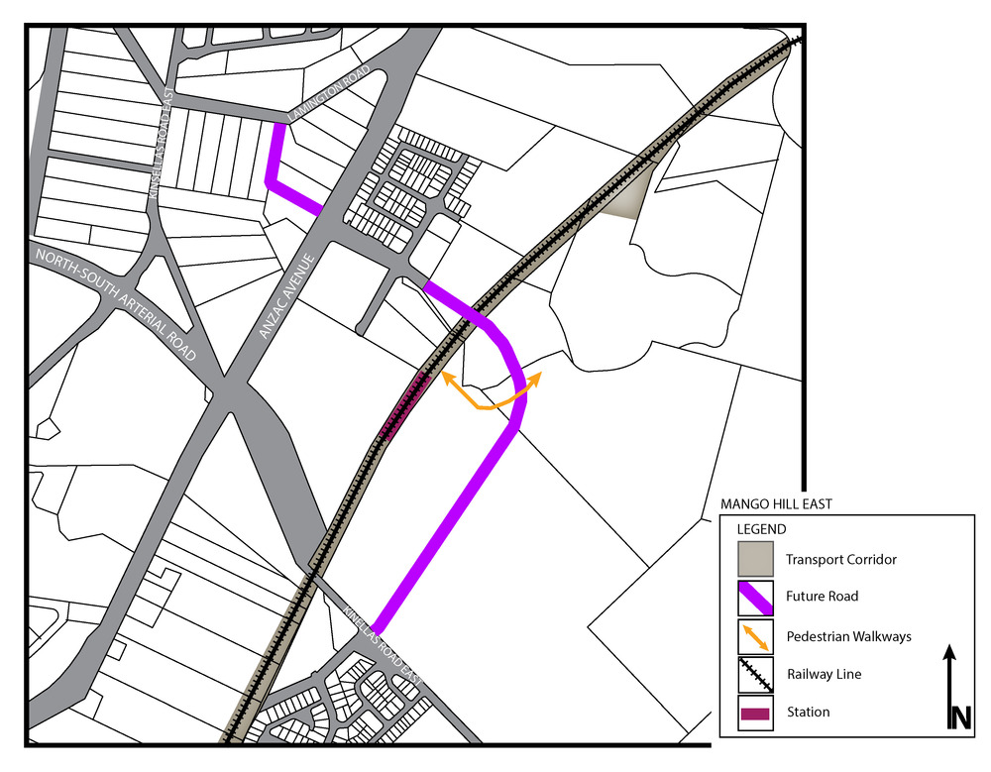

Figure 4 - Murrumba Downs
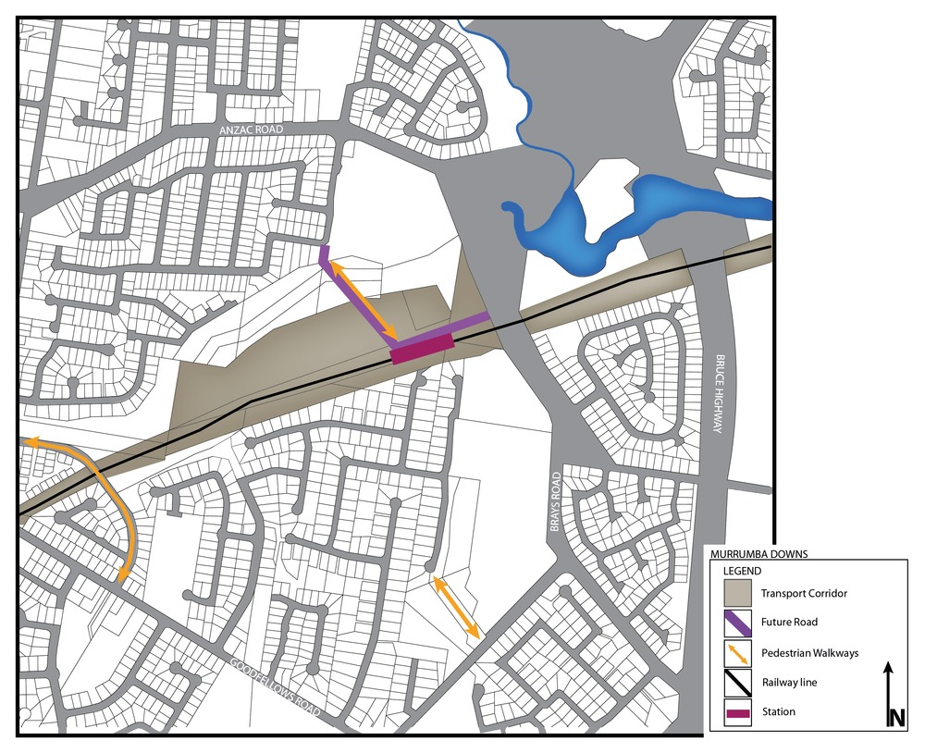

Figure 5 - Narangba east
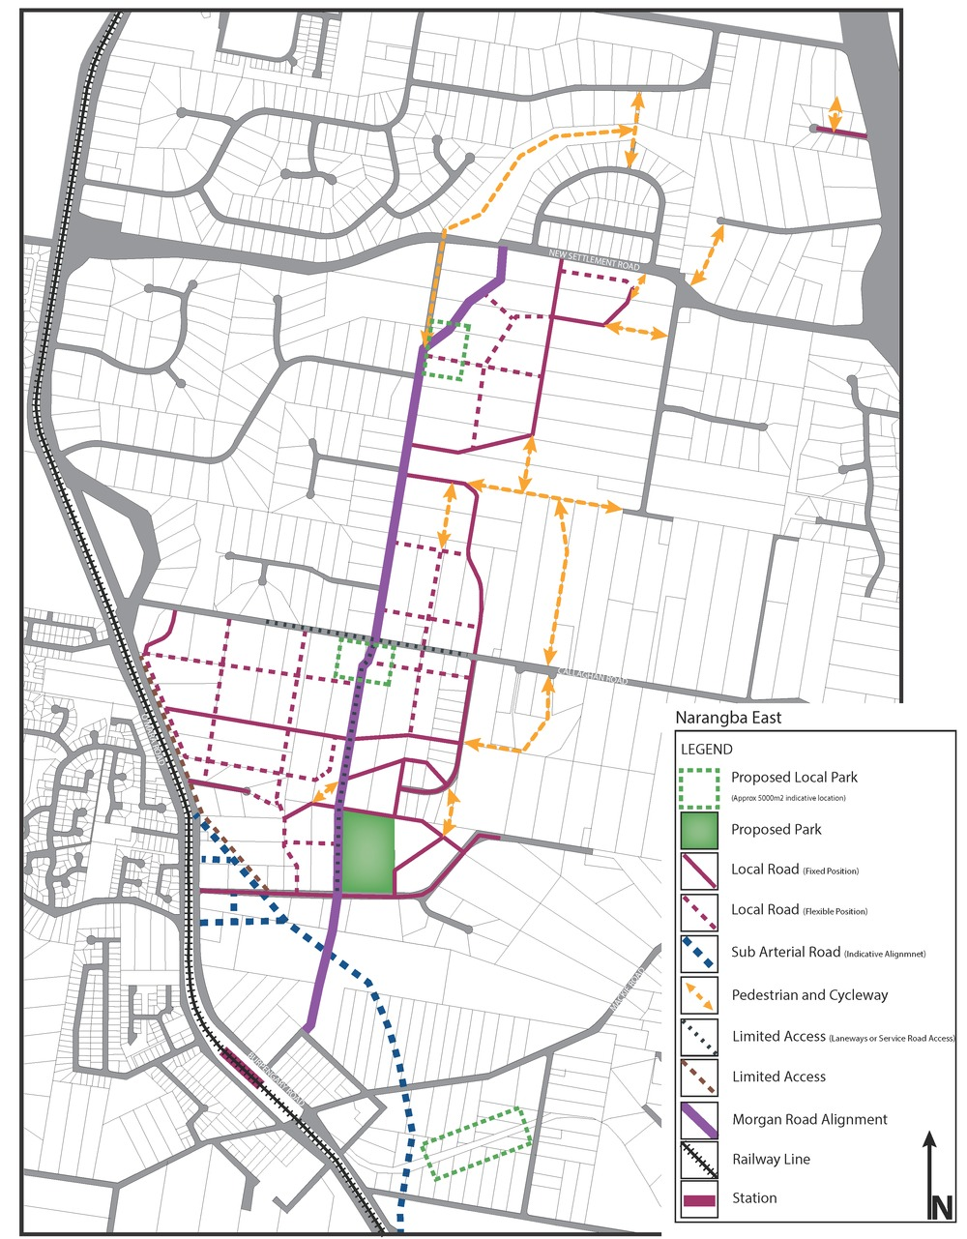

Figure 6 - Rothwell
