Table 9.4.3.1 Requirements for accepted development - Site earthworks

Requirements for accepted development |  | E Compliance  - Yes  - No | Council confirmation
General requirements
Construction management
RAD1 | Works incorporate temporary stormwater runoff, erosion and sediment controls and trash traps designed in accordance with the Urban Stormwater Quality Planning Guidelines, Planning Scheme Policy - Stormwater management and Planning scheme policy - Integrated design including, but not limited to the following:  - stormwater is not discharged to adjacent properties in a manner that differs significantly from pre-existing conditions;  - stormwater discharged to adjoining and downstream properties does not cause scour and erosion;  - stormwater discharge rates do not exceed pre-existing conditions;  - the 10% AEP storm event is the minimum design storm for all temporary diversion drains;  - the 50% AEP storm event is the minimum design storm for all silt barriers and sedimentation basins.
RAD2 | Stormwater run-off, erosion and sedimentation controls are constructed prior to commencement of any filling or excavation and are maintained and adjusted as necessary at all times to ensure their ongoing effectiveness.  Note - The measures are adjusted on-site to maximise their effectiveness.
RAD3 | The completed earthworks area is stabilised using turf, established grass seeding, mulch or sprayed stabilisation techniques to control erosion and sediment and dust from leaving the property.
RAD4 | No dust emissions extend beyond the boundaries of the site during soil disturbances and construction works.
RAD5 | All native vegetation to be retained on site is temporarily fenced or protected prior to and during development works.  Note - Refer to Values and constraints RAD's in this table for classes of vegetation to be retained for accepted development subject to requirements.  Note - No parking of vehicles or storage of machinery or goods is to occur in these areas during development works.
RAD6 | All declared weeds, stumps, fallen trees, rubbish, car bodies, scrap metal and the like are removed and disposed of in a Council land fill facility.
RAD7 | Disposal of cleared vegetation is managed in one or more of the following ways:  - cleared vegetation is taken off site to an approved waste disposal facility; or  - all native vegetation with a diameter below 400mm is to be chipped and stored on-site.
RAD8 | Any material dropped, deposited or spilled on the road(s) as a result of construction processes associated with the site are to be cleaned at all times.
Earthworks
RAD9 | All cut and fill batters are provided with appropriate scour, erosion protection and run-off control measures including catch drains at the top of batters and lined batter drains as necessary.
RAD10 | Stabilisation measures are provided, as necessary, to ensure long-term stability and low maintenance of steep rock slopes and batters.  Note - Inspection and certification of steep rock slopes and batters may be required by a suitably qualified and experienced RPEQ.
RAD11 | All fill and excavation is contained on-site.
RAD12 | All fill and excavation is free draining.
RAD13 | All fill placed on-site is:  - limited to that required for the necessary approved use;  - clean and uncontaminated (i.e. no building waste, concrete, green waste or contaminated material etc. is used as fill).
RAD14 | The site is prepared and the fill placed on-site in accordance with AS3798.  Note - The fill is to be inspected and tested in accordance with Planning scheme policy - Operational works inspection, maintenance and bonding procedures.
RAD15 | No filling or excavation is undertaken in an easement issued in favour of Council or a public sector entity.  Note - Public sector entity is defined in Schedule 2 of the Act.
RAD16 | Filling or excavation that would result in any of the following is not carried out on-site:  - a reduction in cover over any Council or public sector entity infrastructure service to less than 600mm;  - an increase in finished surface grade over, or within 1.5m on each side of, the Council or public sector entity infrastructure above that which existed prior to the earthworks being undertaken.  Note - Public sector entity as defined in the Sustainable Planning Act 2009.
RAD17 | Where the earthworks is associated with a dam and on-site water impoundment (other than swimming pools), batter slopes are no steeper than the following:  - outer slope of dam wall – 1 vertical to 2 horizontal;  - all internal slopes – 1 vertical to 4 horizontal.
RAD18 | Cut and fill batters, (other than batters to dams and water impoundments), have a finished slope no steeper than the following:-  - any cut batter is no steeper than:-  - for sand – 2 horizontal to 1 vertical;  - for silt – 4 horizontal to 1 vertical;  - for firm clay – 1 horizontal to 1 vertical;  - for soft clay – 3 horizontal to 2 vertical;  - any fill batter, (other than a compacted fill batter), is no steeper than 4 horizontal to 1 vertical;  - any compacted fill batter is no stepper than:-  - for sand – 5 horizontal to 2 vertical;  - for silt – 4 horizontal to 1 vertical;  - for firm clay – 2 horizontal to 1 vertical.
RAD19 | Any retaining walls or embankments are setback at least the equivalent height of the wall or embankment from any boundary of the site.
RAD20 | Any embankments more than 1.5 metres in height are stepped, terraced and landscaped.  Figure - Embankment  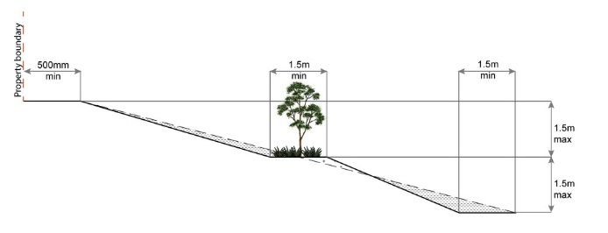
RAD21 | All filling or excavation works are completed within 3 months of the commencement date.
RAD22 | Stormwater discharge from dams and other water impoundments on the development site is undertaken in a manner which does not:  - concentrate the flow onto adjacent land; or  - cause scour and erosion on adjacent land; or  - increase the flow rates of stormwater over the affected section of the adjacent land above the pre-existing situation; or  - cause nuisance or annoyance to any person, property or premises.
RAD23 | A preliminary geotechnical assessment of the suitability of the dam site in terms of soil and slope stability has been carried out by an appropriately experienced and quality geotechnical engineer to confirm the dam site is suitable and stable.
RAD24 | All fill (including the embankment) for dams is setback a minimum of 10 metres from any property boundary.
RAD25 | The dam embankment is constructed with a clay core and cut-off trench to prevent seepage through the embankment. The cut-off trench is taken down a minimum of 600mm into impervious soil and back filled with good quality clay that is thoroughly compacted.
RAD26 | Earth embankments are fully and thoroughly compacted.
RAD27 | The top water surface in the dam is setback a minimum 10 metres from any property boundary.
RAD28 | When identified on Overlay map - Acid sulfate soils and excavating more than 100m³ of material below RL 5.0m AHD or filling (includes the dam embankment) more than 500m³ of material on land that is below RL 5.0m AHD:  - undertake a soil test to determine that Acid Sulfate Soils are not being disturbed (i.e. the soil contains no acid sulfate);  OR  - otherwise treat, any disturbed or excavated soil or sediment with fine agricultural lime to neutralise acidity. A minimum application rate of 80kg agricultural lime/m³ is used (assumes oxidisable sulphur of 1.0% and a bulk density of 1.7);  - the stockpiling and neutralisation of excavated sediment or soil is carried out on an impermeable treatment pad, which prevents acid leaching and contains stockpile runoff;  - any exposed sediment or soil in excavation puts or trenches is treated with agricultural lime to neutralise acidity and prevent further acid generation at a minimum application rate of 5.0kg agricultural lime/m³.
RAD29 | Dams with the following features are designed, constructed and inspected by a suitably qualified and experienced RPEQ:  - an embankment height greater than 3 metres at any point; or  - a top water level surface area greater than 5,000m²; or  - with an impoundment volume exceeding 5 megalitres; or  - where a dam break would threaten the lives of occupiers of downstream premises.
RAD30 | Dam embankments are constructed by a suitably experienced and qualified construction contractor.
RAD31 | The freeboard between the top water level and the top of the embankment is not less than 1 metre.
RAD32 | Dams with an embankment height up to 3 metres have a minimum embankment crest width of 2.5 metres
RAD33 | Dams have a spillway bypass with sufficient flow capacity to prevent floodwater overtopping the dam embankment.
RAD34 | Dam spillways have surface protection to prevent erosion and scour during all flood events.

Values and constraints requirements
Note - The relevant values and constraints requirements do not apply where the development is consistent with a current Development permit for Reconfiguring a lot or Material change of use or Operational work, where that approval has considered and addressed (e.g. through a development footprint plan (or similar in the case of Landslide hazard) or conditions of approval) the identified value or constraint under this planning scheme.

Acid sulfate soils - (refer Overlay map - Acid sulfate soils to determine if the following requirements apply)
Note - Planning scheme policy - Acid sulfate soils provides guidance for requirements for accepted development that has the potential to disturb acid sulfate soils i.e. development involving filling or excavation works below the thresholds of 100m³ and 500m³ respectively.

RAD35 | Filling or excavation works, other than dams, does not involve:  - excavation or otherwise removing of more than 100m³ of soil or sediment where below 5m Australian Height Datum AHD, or  - filling of land of more than 500m³ of material with an average depth of 0.5m or greater where below the 5m AHD.  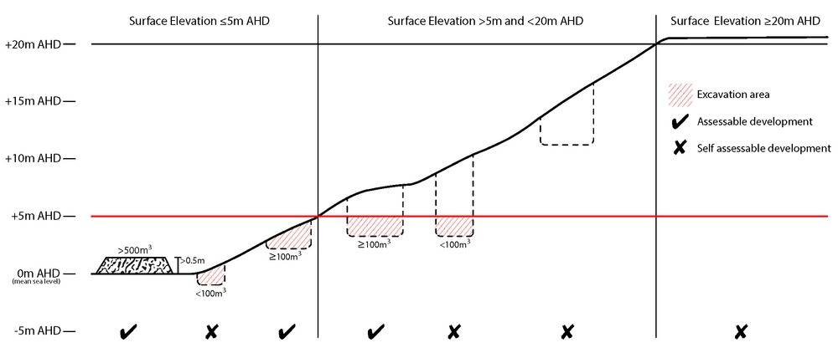
Environmental areas (refer Overlay map - Environmental areas to determine if the following requirements apply)
Note - The following are excluded from the native clearing provisions of this planning scheme:
- Clearing of native vegetation located within an approved development footprint;
- Clearing of native vegetation within 10m from a lawfully established building reasonably necessary for emergency access or immediately required in response to an accident or emergency;
- Clearing of native vegetation reasonably necessary to remove or reduce the risk vegetation poses to serious personal injury or damage to infrastructure;
- Clearing of native vegetation reasonably necessary to construct and maintain a property boundary fence and not exceed 4m in width either side of the fence where in the Rural, Rural residential and Environmental Management and Conservation zones. In any other zone, clearing is not to exceed 2m in width either side of the fence;
- Clearing of native vegetation reasonably necessary for the purpose of maintenance or works within a registered easement for public infrastructure or drainage purposes;
- Clearing of native vegetation in accordance with a bushfire management plan prepared by a suitably qualified person, submitted to and accepted by Council;
- Clearing of native vegetation associated with removal of recognised weed species, maintaining existing open pastures and cropping land, windbreaks, lawns or created gardens;
- Grazing of native pasture by stock;
- Native forest practice where accepted development under Part 1, 1.7.7 Accepted development.
Note - Definition for native vegetation is located in Schedule 1 Definitions.

Note - Native vegetation subject to this requirement primarily comprises of matters of national environmental significance (MNES), matters of state environmental significance (MSES). They also comprise some matters of local environmental significance (MLES). A MLES is defined in Schedule 1.2, Administrative definitions. A list of the elements that apply to the mapped MSES and MLES is provided in Appendix 1 of the Planning scheme policy - Environmental areas.

Editors' Note - The accuracy of overlay mapping can be challenged through the development application process (code assessable development) or by way of a planning scheme amendment. See Council's website for details.

Editors' Note - When clearing native vegetation within a MSES area, you may still require approval from the State government.

RAD36 | Filling or excavation does not result in clearing of native vegetation in High Value Area or Value Offset Area.
Extractive resources transport routes (refer Overlay map - Extractive resources (transport route and buffer) to determine if the following requirements apply)
RAD37 | Filling or excavation is not carried out in the Extractive resources transport route or buffer, other than on public roads.
Heritage and landscape character (refer Overlay map - Heritage and landscape character to determine if the following requirements apply)
Note - Places, including sites, objects and buildings having local cultural heritage significance, are identified on Overlay map - Heritage and landscape character and listed in Schedule 1 of Planning scheme policy - Heritage and landscape character. Places also having cultural heritage significance at a State level and being entered in the Queensland Heritage Register, are also identified in Schedule 1 of Planning scheme policy - Heritage and landscape character.

RAD38 | A cultural heritage conservation management plan is prepared in accordance with Planning scheme policy – Heritage and landscape character and submitted to Council prior to the commencement of any preservation, maintenance, repair and restoration works. Any preservation, maintenance, repair and restoration works are in accordance with the Council approved cultural heritage conservation management plan.  This does not apply to Listed item 99 in Schedule 1 - List of sites, objects and buildings of significant historical and cultural value of Planning scheme policy - Heritage and landscape character.
RAD39 | Development does not result in the removal of or damage to any significant tree identified on Overlay map – Heritage and landscape character and listed in Appendix 2 of Planning scheme policy – Heritage and landscape character.
RAD40 | The following development does not occur within 20m of the base of any significant tree, identified on Overlay map – Heritage and landscape character and listed in Appendix 2 of Planning scheme policy – Heritage and landscape character:  - construction of any building;  - laying of overhead or underground services;  - any sealing, paving, soil compaction;  - any alteration of more than 75mm to the ground level prior to work commencing.
RAD41 | Pruning of a significant tree occurs in accordance with Australian Standard AS 4373-2007 - Pruning of Amenity Trees.
Infrastructure buffers (refer Overlay map - Infrastructure buffers to determine if the following requirements apply)
RAD42 | Filling or excavation does not occur in the Bulk water supply infrastructure buffer.
RAD43 | Filling or excavation does not not occur in the Gas pipeline buffer.
RAD44 | Filling or excavation does not occur in the High voltage electricity line buffer.
Landslide hazard (refer Overlay map - Landslide hazard to determine if the following requirements apply)
RAD45 | Development does not:  - involve earthworks exceeding 50m³;  - involve cut and fill having a height greater than 600mm;  - involve any retaining wall having a height greater than 600mm;  - redirect or alter the existing flow of surface or groundwater.
Overland flow path (refer Overlay map - Overland flow path to determine if the following requirements apply)
RAD46 | Development for a material change of use or building work does not involve the construction of a building or structure in an Overland flow path area.
RAD47 | Development for a material change of use or operational work does not impede the flow of flood waters through the premises or worsen flood flows to other premises.  Note - A report from a suitably qualified Registered Professional Engineer Queensland is required certifying that the development does not increase the potential for significant adverse impacts on an upstream, downstream or surrounding premises.  Note - Reporting to be prepared in accordance with Planning scheme policy – Flood hazard, Coastal hazard and Overland flow
RAD48 | Development for a material change of use or building work ensures that fencing in an overland flow path area is at least 50% permeable.
RAD49 | Development for a material change of use or building work that involves a hazardous chemical ensures the hazardous chemicals is not located within an overland flow path area.
RAD50 | Development for a material change of use or building work for a Park⁽⁵⁷⁾ ensures that work is provided in accordance with the requirements set out in Appendix B of the Planning scheme policy - Integrated design.
Riparian and wetland setbacks (refer Overlay map - Riparian and wetland setback to determine if the following requirements apply)
Note - W1, W2 and W3 waterway and drainage lines, and wetlands are mapped on Schedule 2, Section 2.5 Overlay Maps – Riparian and wetland setbacks.

RAD51 | No development is to occur within:  - 50m from top of bank for W1 waterway and drainage line  - 30m from top of bank for W2 waterway and drainage line  - 20m from top of bank for W3 waterway and drainage line  - 100m from the edge of a Ramsar wetland, 50m from all other wetlands.  Note - W1, W2 and W3 waterways and drainage lines, and wetlands are mapped on Schedule 2, Section 2.5 Overlay Maps – Riparian and wetland setbacks.  Note - In some cases, the top of bank may not be easily defined, as such a hydraulic measurement may be applied instead. Moreton Bay Regional Council will provide further direction on how to determine and locate the setback boundary in these locations.  Note - The minimum setback distance applies to the each side of waterway.

