Table 7.2.3.7.1.2 Assessable development - Reconfiguring a lot code - Urban living precinct

Performance outcomes | Examples that achieve aspects of the Performance Outcome | E Compliance  - Yes  - No see PO or  - NA | Justification for compliance
Where on a developable lot or creating developable lots
Lot size and design
PO1  Reconfiguring a lot does not result in additional lots. | No example provided.
Boundary realignment
PO2  Boundary realignments do not result in the:  - fragmentation or alienation of the land or result in the loss of land for future urban purposes;  - delay the use of the land for urban purposes;  - adverse impacts on the quality and integrity of the biodiversity and ecological values inherent to a High Value Area identified in Overlay map - Environmental areas;  - existing land uses on-site becoming non-compliant due to:  - lot size;  - parking requirements;  - servicing;  - dependant elements of an existing or approved land use being separately titled.  Note - An example may include but are not limited to where a Dwelling house⁽²²⁾ includes a secondary dwelling or associated outbuildings, they cannot be separately titled as they are dependent on the Dwelling house⁽²²⁾ use. | No example provided.
Where on a developed lot or creating developed lots
Site density
PO3  Reconfiguring of a lot achieves a net residential density between 11 - 30 lots per hectare to maintain a diverse medium density neighbourhood character.  Note - Future residential development on lots will be required to achieve a minimum net density of 30 dwellings per hectare when located within 400m walking distance of a local centre.  Note - Future residential development where not located within 400m walking distance of a local centre will be required to achieve a minimum net density of 20 dwellings per hectare. | E3  Development is in accordance with a Neighbourhood development plan.
Lot design, mix and location
PO4  Lots have a sufficient area and dimension for them to accommodate:  - dwelling(s) including all domestic outbuildings;  - areas for car parking, access and manoeuvring;  - areas for private open space. | E4.1  Lot sizes and dimensions (excluding any access handles) comply with Lot Types A, B, C, D, E or F in accordance with Table 7.2.3.7.1.3: Lot Types.  Note - For the purpose of rear lots, frontage is the average width of the lot (excluding any access handle or easement)
E4.2
Development is in accordance with a Neighbourhood development plan.
PO5  Reconfiguring a lot provides for a variety of housing options, by way of a mix of lot sizes and dimensions consistent with the medium density character of the precinct, whilst facilitating delivery of diversity within the streetscape. | E5.1  For reconfiguring a lot which creates in excess of 5 new lots, a mix of lot types in accordance with Table 7.2.3.7.1.3 are to be incorporated into the development as follows:  - 5 - 10 lots - 2 lot types  - 11 - 20 lots - 3 lot types  - 21 - 50 lots - 4 lot types (must include lot type A)  - >50 lots - 5 lot types (must include lot type A)  Editor's note - Lots containing built to boundary walls should also include an appropriate easement to facilitate the maintenance of any wall within 600mm of a boundary. For boundaries with built to boundary walls on adjacent lots a 'High Density Development Easement' is recommended; or for all other built to boundary walls and 'easement for maintenance purposes' is recommended.
E5.2
For reconfiguring a lot which creates in excess of 20 new lots, the following minimum percentages of lot types in accordance with Table 7.2.3.7.1.3 apply:
- Lot Type A - 10% of new lots and Lot Type F - 5% of new lots; or
- Lot Type A - 15% of new lots and Lot Type F - 2% of new lots; or
- Lot Type A - 15% of new lots and Lot Type B - 15% of new lots.
E5.3
Development is in accordance with a Neighbourhood development plan.
PO6  A range of different lots are distributed throughout the development with no one lot type concentrated within a single location, to create diversity within the streetscape and minimise conflicts between vehicle access and on street parking.  Note - Built to boundary walls and driveway locations for lots with frontages of 12.5 metres or less are to be shown on a plan of development in accordance with the requirements of section 9.3.1 - Dwelling house code. | E6.1  Where not accessed via a laneway, a maximum of 4 adjoining lots of the same type in accordance with Table 7.2.3.7.1.3 are proposed where fronting the same street.
E6.2
Where accessed via a laneway, a maximum of 8 adjoining lots of the same type in accordance with Table 7.2.3.7.1.3are proposed where fronting the same street.
E6.3
Development is in accordance with a Neighbourhood development plan.
PO7  Lots that facilitate medium to high density residential uses (freehold or community titles) are located in proximity to recreational opportunities, commercial and community facilities and public transport nodes. | E7  - Development is in accordance with a Neighbourhood development plan.  OR  - Lots with frontages of 7.5 metres or less are located within 200 metres of:  - a park; or  - a public transport stop or station; or  - a higher order centre, district centre, local centre or neighbourhood hub (refer Overlay map - Community activities and neighbourhood hubs).  AND  - Lots with frontages of 32 metres or greater are predominately located on corner lots or lots with dual road frontages, and within 200 metres of:  - a park; or  - a public transport stop or station; or  - a higher order centre, district centre, local centre or neighbourhood hub (refer Overlay map - Community activities and neighbourhood hubs).
PO8  Narrow lots do not adversely affect the character and amenity of the precinct. Residential uses establish in a manner which facilitates an integrated streetscape, maximises the efficient use of land and achieves a safe and efficient street network.  Note - Built to boundary walls and driveway locations for lots with frontages of 12.5 metres or less are to be shown on a plan of development in accordance with the requirements of section 9.3.1 - Dwelling house code | E8  Development is in accordance with a Neighbourhood development plan.
PO9  Group construction and integrated streetscape solutions are encouraged through the location and grouping of lots suitable for terrace and row housing. | E9.1  Any lot sharing a boundary with a Lot Type A must contain a mandatory built to boundary wall on the shared boundary.
E9.2
Driveway crossovers for lots with frontages of less than 10m are paired up to facilitate on-street parking.
Note - Built to boundary walls for lots with frontages of 12.5 metres or less are to be shown on a plan of development in accordance with the requirements of section 9.3.1 - Dwelling house code.

E9.3
Development is in accordance with a Neighbourhood development plan.
Rear lots
PO10  Rear lots:  - contribute to the mix of lot sizes;  - are limited to 1 behind any full frontage lot (i.e. a lot with a street frontage that is not an access handle);  - Provide sufficient area for vehicles to manoeuvre on-site allowing entry and exit to the rear lot in forward gear. | E10  Development is in accordance with a Neighbourhood development plan.
PO11  Access handles for rear lots are:  - a minimum of 5m wide to allow for safe vehicle access and service corridors from the rear lot to the street;  - are located on 1 side of the full frontage lot;  - limited to no more than 2 directly adjoining each other. | E11  Development is in accordance with a Neighbourhood development plan.
Street design and layout
PO12  Street layouts facilitate regular and consistent shaped lots through the use of rectilinear grid patterns, or modified grid patterns where constrained by topographical and other physical barriers.  Note - Refer to Planning scheme policy - Integrated design for guidance on how to achieve compliance with this outcome. | E12  Development is in accordance with a Neighbourhood development plan.
PO13  Street layouts are designed to connect to surrounding neighbourhoods by providing an interconnected street, pedestrian and cyclist networks that connects nearby centres, neighbourhood hubs, community facilities, public transport nodes and open space to residential areas for access and emergency management purposes. The layout ensures that new development is provided with multiple points of access. The timing of transport works ensures that multiple points of access are provided during early stages of a development.  Note - Refer to Planning scheme policy - Neighbourhood design for guidance on when alternative access points should be provided for emergency management purposes. | E13  Development is in accordance with a Neighbourhood development plan.
PO14  Street layouts provide an efficient and legible movement network with high levels of connectivity within and external to the to the site by:  - facilitating increased active transport with a focus on safety and amenity for pedestrians and cyclists;  - providing street blocks with a maximum walkable perimeter of 500m (refer Figure - Street block design);  - providing a variety of street block sizes;  - reducing street block sizes as they approach an activity focus;  - facilitating possible future connections to adjoining sites for roads, green linkages and other essential infrastructure.  Note - Refer to Planning scheme policy - Integrated design for guidance on how to achieve compliance with this outcome. | E14  Development is in accordance with a Neighbourhood development plan.
PO15  Street layouts create convenient and highly permeable movement networks between lower and higher order roads, whilst not adversely affecting the safety and function of the higher order road.  Note - Refer to Planning scheme policy - Integrated design for guidance on how to achieve compliance with this outcome. | E15  Development is in accordance with a Neighbourhood development plan.
PO16  Streets are designed and constructed to cater for:  - safe and convenient pedestrian and cycle movement;  - on street parking adequate to meet the needs of future residents;  - efficient public transport routes;  - expected traffic speeds and volumes;  - utilities and stormwater drainage;  - lot access, sight lines and public safety;  - emergency access and waste collection;  - waste service vehicles;  - required street trees, landscaping and street furniture.  Note - Refer to Planning scheme policy - Integrated design for determining design criteria to achieve this outcome. | E16  Development is in accordance with a Neighbourhood development plan.
PO17  Intersections are designed and constructed to provide for the safe and efficient movement of pedestrians, cyclists, public transport and private vehicles.  Note - Refer to Planning scheme policy - Integrated design for guidance on how to achieve compliance with this outcome. | E17  Development is in accordance with a Neighbourhood development plan.
PO18  Cul-de-sac or dead end streets are not proposed unless:  - topography or other physical barriers exist to the continuance of the street network or vehicle connection to an existing road is not permitted;  - there are no appropriate alternative solutions;  - the cul-de-sac or dead end street will facilitate future connections to adjoining land or development.  Note - Refer to Planning scheme policy - Integrated design for guidance on how to achieve compliance with this outcome. | E18  Development is in accordance with a Neighbourhood development plan.
PO19  Where cul-de-sacs are proposed due to connection to existing roads not being permitted, they are to be designed to allow a 10m wide pedestrian connection through to the existing road with no lots proposed at the head of the cul-de-sac generally as shown in the figure below.  Figure - Cul-de-sac design  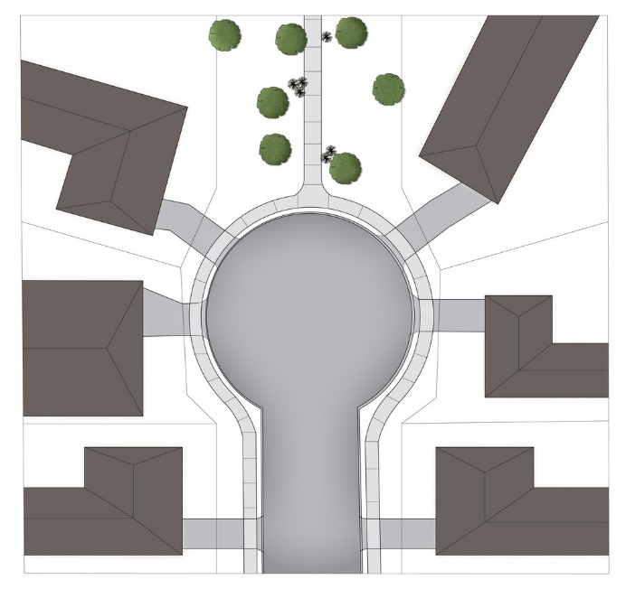  Note - Refer to Planning scheme policy - Neighbourhood design for guidance on how to achieve this outcome. | E19  Development is in accordance with a Neighbourhood development plan.
PO20  Streets are designed and oriented to minimise the impact of cut and fill on the amenity of the streetscape and adjoining development. | E20  - Development is in accordance with a Neighbourhood development plan.  OR  - Street alignment follows ridges or gullies or runs perpendicular to slope.
PO21  Streets are oriented to encourage active transport through a climate responsive and comfortable walking environment whilst also facilitating lots that support subtropical design practices, including:  - controlled solar access & shade provision;  - cross-ventilation.  Note - Refer to Planning scheme policy - Residential design for guidance on how to achieve subtropical design solution. | E21.1  - Development is in accordance with a Neighbourhood development plan.  OR  - Where not unduly constrained by topography or other physical barrier, streets are primarily oriented within 20 or 30 degrees of North-South or East-West in accordance with Figure - Preferred street orientation below.  Figure - Preferred street orientation  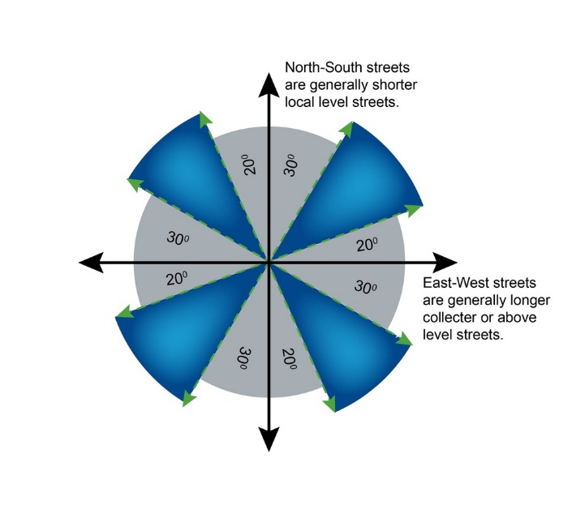
E21.2
- Development is in accordance with a Neighbourhood development plan.
OR
- The long axis of a street block is oriented east-west to facilitate a north-south orientation for a majority of lots as per Figure - Street block design below.
E21.3
- Development is in accordance with a Neighbourhood development plan.
OR
- Where lots are oriented east west, they are 14m or wider so as to allow for alternative dwelling design to achieve solar access and cross-ventilation as per Figure -Street block design below.
Figure - Street block design
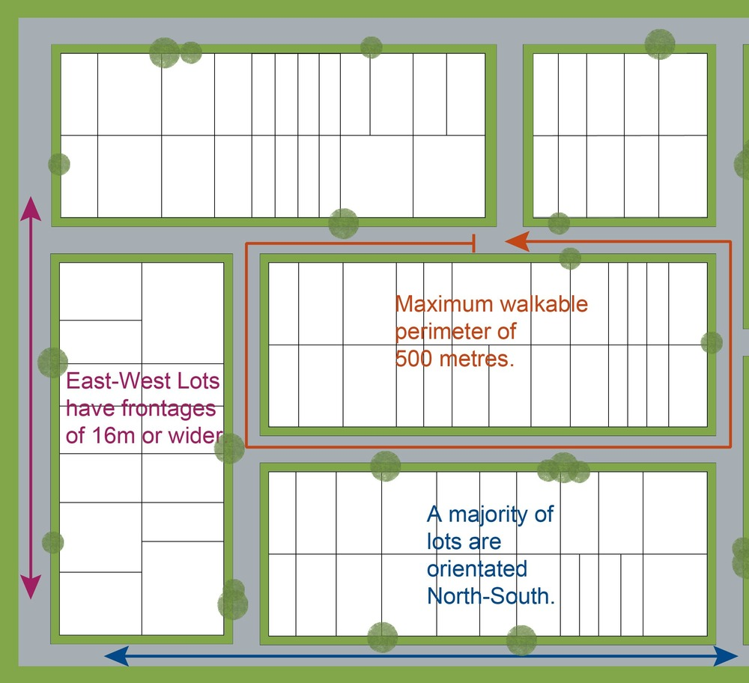

Movement network
PO22  The street network creates convenient access to major streets roads for heavy vehicles and commercial traffic without introducing through traffic to residential streets. The street network is designed in accordance with a Neighbourhood development plan that reflects the urban structure concept shown indicatively on Figure 7.2.3.2 - Movement, Major streets. | E22  Development is in accordance with a Neighbourhood development plan.

PO23  The road network has sufficient reserve and pavement widths to cater for the current and intended function of the road in accordance with the road type in accordance with Planning scheme policy - Integrated design. | E23  Development is in accordance with a Neighbourhood development plan.
PO24  The street networks encourage walking and cycling and a safe environment for pedestrians and cyclists. The street network is designed in accordance with a Neighbourhood development plan that reflects the urban structure concept shown indicatively on Figure 7.2.3.3 - Movement, walking and cycling. | E24  Development is in accordance with a Neighbourhood development plan.
Laneway design and location
PO25  Laneway location contributes to a high standard of amenity for adjoining lots and the streetscape.  Note - Refer to Planning scheme policy - Neighbourhood design for determining locational criteria for laneways. | E25  - Development is in accordance with a Neighbourhood development plan.  OR  - Laneways are primarily used where:  - vehicle access is not permitted from the primary street frontage; or  - limiting vehicle access from the primary street frontage results in a positive streetscape outcome; or  - where lots directly adjoin a local, district or regional Park⁽⁵⁷⁾.
PO26  Laneways service a limited number of allotments, creating a sense of place and enclosed feeling for the pedestrian environment whilst contributing to the high level of connectivity of the street network  Note - Refer to Planning scheme policy - Integrated design and Planning scheme policy - Neighbourhood design for determining design criteria for Laneways. | E26  - Development is in accordance with a Neighbourhood development plan.  OR  - Laneways are limited to 130m in length; and  - Laneways are not designed as dead ends or cul-de-sacs, and are to have vehicle connections to an access street at both ends; and  - Where laneways exceed 100m in length, a mid lane pedestrian connection is to be provided between the adjacent access streets and the laneway.
PO27  Laneway design ensures the safety of pedestrians, cyclists and motorists by way of site lines, and sufficient road reserve for vehicle movements and the provision of street lighting.  Note - Refer to Planning scheme policy - Integrated design and Planning scheme policy - Neighbourhood design for determining design criteria for Laneways. | E27  - Development is in accordance with a Neighbourhood development plan.  OR  - Laneways are designed with minor meanders only, and maintain direct lines of sight from one end of the laneway to the other; and  - Laneways provide road dedication at strategic locations along the laneway to allow the construction of street lighting and any electrical pillars associated with the street lighting in accordance with current Australian Standards.  Note - The dedication must allow for street lights to be provided on Council’s standard alignment
Park⁽⁵⁷⁾ and open space
PO28  A hierarchy of Park⁽⁵⁷⁾ and open space is provided to meet the recreational needs of the community in accordance with a Neighbourhood development plan that reflects the urban structure concept shown indicatively on Figure 7.2.3.4 - Green network and open space.  Note - District level parks or larger may be required in certain locations in accordance with Part 4: Local Government Infrastructure Plan. | E28  Development is in accordance with a Neighbourhood development plan.
PO29  Park⁽⁵⁷⁾ are provided within walking distance of all new residential lots as follows:  - district parks are provided within 15 minutes walking distance time of houses;  - local and neighbourhood parks are provided within 5 minutes walking distance time. | E29  Development is in accordance with a Neighbourhood development plan.
PO30  Park⁽⁵⁷⁾ is of a size and design standard to meet the needs of the expected users. Parks⁽⁵⁷⁾ are provided as per the following table and seek to:  - retain stands of trees in Parks⁽⁵⁷⁾ – for environmental ‘stepping stones’ and for urban relief;  - locate on hilltops, gullies, river banks and between neighbourhoods.  Open space type Minimum area Walking catchment Rate  Small local park⁽⁵⁷⁾ recreation 0.3 ha - 0.5 ha 150-300m 0.5ha/1000 persons  Local park⁽⁵⁷⁾ recreation 0.5 ha - 1ha 400m  District park⁽⁵⁷⁾ recreation 4 ha 1.2km 0.5 ha/1000 persons  District Civic park⁽⁵⁷⁾ (town centre only) 3000m² n/a n/a – only 1 needed in the town centre  Regional/District sports* 4 parks add up to 80ha n/a 4 parks @ 80ha each  * Regional and district parks have been identified on the Figure 7.2.3.4 - Green network and open space. | E30  Development is in accordance with a Neighbourhood development plan.
PO31  The safety and useability of parks is ensured through the careful design of the street network and lot locations which provide high levels of surveillance and access into the park⁽⁵⁷⁾ or open space area. The provision of parks will consider the following:  - local and district parks are bordered by streets and not lots wherever possible;  - where lots do addresses local and district parks⁽⁵⁷⁾, fencing is provided along the park⁽⁵⁷⁾ boundary at a maximum height of 1m prior to the sealing of the plan of subdivision;  - the design of fencing and retaining features allows for safe and direct pedestrian access between the park⁽⁵⁷⁾ and private allotment through the use of private gates and limited retaining features along park⁽⁵⁷⁾ boundaries. | E31  Development is in accordance with a Neighbourhood development plan.
Boundary realignment
PO32  Boundary alignments ensure that infrastructure and services are wholly contained within the lot they serve. | No example provided.
PO33  Boundary realignment does not result in:  - existing land uses on-site becoming non-complying with planning scheme criteria;  - lots being unserviced by infrastructure;  - lots not providing for own private servicing  - adverse impacts on the quality and integrity of the biodiversity and ecological values inherent to a High Value Area identified in Overlay map - Environmental areas . | No example provided.
PO34  Boundary realignment results in lots which have appropriate size, dimensions and access to cater for uses consistent with the precinct, sub-precincts and any relevant other precinct. | E34  Lot sizes and dimensions (excluding any access handles) comply with Lot Types A, B, C, D, E or F in accordance with Table 7.2.3.7.1.3: Lot Types.
Reconfiguring existing development by Community Title
PO35  Reconfiguring a lot which creates or amends a community title scheme as described in the Body Corporate and Community Management Act 1997 is undertaken in a way that does not result in existing uses on the land becoming unlawful or otherwise operating in a manner that is:  - inconsistent with any approvals on which those uses rely; or  - inconsistent with the for accepted development requirements applying to those uses at the time that they were established.  Note - Examples of land uses becoming unlawful include, but are not limited to the following:  - Land on which a Dual occupancy⁽²¹⁾⁽²²⁾ has been established is reconfigured in a way that results in both dwellings no longer being on the one lot. The reconfiguring has the effect of transforming the development from a Dual occupancy⁽²¹⁾ to two separate Dwelling houses⁽²²⁾⁽²³⁾, at least one of which does not satisfy the requirements for accepted development applying to Dwelling houses⁽²²⁾.  - Land on which a Multiple dwelling⁽⁴⁹⁾ has been established is reconfigured in a way that precludes lawful access to required communal facilities by either incorporating some of those facilities into private lots or otherwise obstructing the normal access routes to those facilities. Those communal facilities may have been required under the requirements for accepted development for the use or conditions of development approval.  Editor's note - To satisfy this performance outcome, the development application may need to be a combined application for reconfiguring a lot and a material change of use or otherwise be supported by details that confirm that the land use still satisfies all relevant land use requirements. | No example provided.
Reconfiguring by Lease
PO36  Reconfiguring a lot which divides land or buildings by lease in a way that allows separate occupation or use of those facilities is undertaken in a way that does not result in existing uses on the land becoming unlawful or otherwise operating in a manner that is:  - inconsistent with any approvals on which those uses rely; or  - inconsistent with the for accepted development requirements applying to those uses at the time that they were established.  Note - An example of a land use becoming unlawful is a Multiple dwelling⁽⁴⁹⁾ over which one or more leases have been created in a way that precludes lawful access to some of the required communal facilities. Some of the communal car parking facilities have been incorporated into lease areas while other leases are located in a way that obstructs the normal access routes to other communal facilities. Those communal facilities may have been required under the requirements for accepted development for the use or conditions of development approval, but they are no longer freely available to all occupants of the Multiple dwelling⁽⁴⁹⁾.  Editor's note - To satisfy this performance outcome, the development application may need to be supported by details that confirm that the land use still satisfies all relevant land use requirements.  Editor's note - Under the definition in Schedule 2 of the Act, the following do not constitute reconfiguring a lot and are not subject to this performance outcome:  - a lease for a term, including renewal options, not exceeding 10 years; and  - an agreement for the exclusive use of part of the common property for a community titles scheme under the Body Corporate and Community Management Act 1997. | No example provided.
Volumetric subdivision
PO37  The reconfiguring of the space above or below the surface of the land ensures appropriate area, dimensions and access arrangements to cater for uses consistent with the precinct and does not result in existing land uses on-site becoming non-complying with planning scheme criteria.  Note - Examples may include but are not limited to:  - where a dwelling house⁽²²⁾ includes a secondary dwelling or associated outbuildings, they cannot be separately titled as they are dependent on the Dwelling house⁽²²⁾ use. | No example provided.
Reticulated supply
PO38  Each lot is provided with an appropriate level of service and infrastructure commensurate with the precinct. All services, including water supply, stormwater management, sewerage disposal, stormwater disposal, drainage, electricity, telecommunications and gas (if available) are provided in a manner that:  - is efficient in delivery of service;  - is effective in delivery of service;  - is conveniently accessible in the event of maintenance or repair;  - minimises whole of life cycle costs for that infrastructure;  - minimises risk of potential adverse impacts on the natural and built environment;  - minimises risk of potential adverse impact on amenity and character values;  - recognises and promotes Councils Total Water Cycle Management policy and the efficient use of water resources. | E38  Lots are provided with:  - a connection to the reticulated water supply infrastructure network;  - a connection to the sewerage infrastructure network;  - a connection to the reticulated electricity infrastructure network; and  - a physical connection to the telecommunication network, that where available to the land is part of the high speed broadband network.
Stormwater location and design
PO39  The development is planned and designed considering the land use constraints of the site and incorporates water sensitive urban design principles. | No example provided.
PO40  Stormwater drainage pipes and structures through or within private land are protected by easements in favour of Council with sufficient area for practical access for maintenance.  Note - Refer to Planning scheme policy - Integrated design for guidance on how to demonstrate achievement of this performance outcome. | No example provided.
PO41  Management facilities are located outside of riparian areas and prevent increased channel bed and bank erosion. | No example provided.
PO42  Natural streams and riparian vegetation are retained and enhanced through revegetation. | No example provided.
PO43  Areas constructed as detention basins are adaptable for passive recreation. | No example provided.
PO44  Development maintains and improves the environmental values of waterway ecosystems. | No example provided.
PO45  Constructed water bodies are not dedicated as public assets. | No example provided.
Stormwater management system
PO46  The major drainage system has the capacity to safely convey stormwater flows for the defined flood event. | E46  The roads, drainage pathways, drainage features and waterways safely convey the stormwater flows for the defined flood event without allowing flows to encroach upon private lots.
PO47  Overland flow paths (for any storm event) from roads and public open space areas do not pass through private lots. | E47  Drainage pathways are provided to accommodate overland flows from roads and public open space areas.
PO48  Development achieves the design objectives in Tables A and B in Appendix 2 of the SPP.  Note - To demonstrate achievement of this performance outcome, a stormwater quality management is prepared by a suitably qualified person in accordance with Planning scheme policy - Stormwater management. | No example provided.
PO49  The stormwater management system is designed to:  - protect the environmental values in downstream waterways;  - maintain ground water recharge areas;  - preserve existing natural wetlands and associated vegetation buffers;  - avoid disturbing soils or sediments;  - avoid altering the natural hydrologic regime in acid sulphate soil and nutrient hazardous areas;  - maintain and improve receiving water quality;  - protect natural waterway configuration;  - protect downstream and adjacent properties;  - protect and enhance riparian areas. | No example provided.
PO50  Design and construction of the stormwater management system:  - utilise methods and materials to minimise the whole of lifecycle costs of the stormwater management system;  - are co-ordinated with civil and other landscaping works;  - achieves Council's Total Water Management policy and the efficient use of water resources.  Note - Refer to Planning scheme policy - Integrated design for guidance on how to demonstrate achievement of this performance outcome. | No example provided.
PO51  Where associated with a minor green corridor identified on Figure 7.2.3.4 - Green network and open space, development will adopt bio-retention systems for stormwater treatment that recognises and promotes Councils Total Water Cycle Management policy and the efficient use of water resources.  Note - To determine the standards for stormwater management system construction refer to Planning scheme policy - Integrated design. | No example provided.
Clearing of native vegetation
PO52  Reconfiguring a lot facilitates the retention of native vegetation by:  - incorporating native vegetation and habitat trees into the overall subdivision design, development layout, on-street amenity and landscaping where practicable;  - ensuring habitat trees are located outside a development footprint. Where habitat trees are to be cleared, replacement fauna nesting boxes are provided at the rate of 1 nest box for every hollow removed. Where hollows have not yet formed in trees > 80cm in diameter at 1.3m height, 3 nest boxes are required for every habitat tree removed.  - providing safe, unimpeded, convenient and ongoing wildlife movement;  - avoiding creating fragmented and isolated patches of native vegetation.  - ensuring that biodiversity quality and integrity of habitats is not adversely impacted upon but are maintained and protected;  - ensuring that soil erosion and land degradation does not occur;  - ensuring that quality of surface water is not adversely impacted upon by providing effective vegetated buffers to water bodies. | E52  Development is in accordance with a Neighbourhood development plan.
Noise
PO53  Noise attenuation structure (e.g. walls, barriers or fences):  - contribute to safe and usable public spaces, through maintaining high levels of surveillance of parks, streets and roads that serve active transport purposes (e.g. existing or future pedestrian paths or cycle lanes etc);  - maintain the amenity of the streetscape.  Note - A noise impact assessment may be required to demonstrate compliance with this PO. Noise impact assessments are to be prepared in accordance with Planning scheme policy - Noise.  Note - Refer to Planning Scheme Policy – Integrated design for details and examples of noise attenuation structures. | E53  Noise attenuation structures (e.g. walls, barriers or fences):  - are not visible from an adjoining road or public area unless;  - adjoining a motorway or rail line; or  - adjoining part of an arterial road that does not serve an existing or future active transport purpose (e.g. pedestrian paths or cycle lanes) or where attenuation through building location and materials is not possible.  - do not remove existing or prevent future active transport routes or connections to the street network;  - are located, constructed and landscaped in accordance with Planning scheme policy - Integrated design.  Note - Refer to Planning Scheme Policy – Integrated design for details and examples of noise attenuation structures.  Note - Refer to Overlay map – Active transport for future active transport routes.

Values and constraints requirements
Note - The relevant values and constraints criteria do not apply where the development is consistent with a current Development permit for Reconfiguring a lot or Material change of use or Operational work, where that approval has considered and addressed (e.g. through a development footprint plan (or similar in the case of Landslide hazard) or conditions of approval) the identified value or constraint under this planning scheme.

Bushfire hazard (refer Overlay map - Bushfire hazard to determine if the following assessment criteria apply) for developable lots only
Note - The preparation of a bushfire management plan in accordance with Planning scheme policy – Bushfire prone areas can assist in demonstrating compliance with the following performance criteria. The identification of a development footprint will assist in demonstrating compliance with the following performance criteria.

PO54  Lots are designed to:  - minimise the risk from bushfire hazard to each lot and provide the safest possible siting for buildings and structures;  - limit the possible spread paths of bushfire within the reconfiguring;  - achieve sufficient separation distance between development and hazardous vegetation to minimise the risk to future buildings and structures during bushfire events;  - maintain the required level of functionality for emergency services and uses during and immediately after a natural hazard event. | E54  Reconfiguring a lot ensures that all new lots are of an appropriate size, shape and layout to allow for the siting of future buildings being located:  - within an appropriate development footprint;  - within the lowest hazard locations on a lot;  - to achieve minimum separation from any source of bushfire hazard of 20m or the distance required to achieve a Bushfire Attack Level (BAL) of more than 29 (as identified under AS3959-2009), whichever is the greater;  - to achieve a minimum separation from any retained vegetation strips or small areas of vegetation of 10m or the distance required to achieve a Bushfire Attack Level (BAL) of more than 29 (as identified under AS3959-2009), whichever is the greater;  - away from ridgelines and hilltops;  - on land with a slope of less than 15%;  - away from north to west facing slopes.
PO55  Lots provide adequate water supply and infrastructure to support fire-fighting. | E55  For water supply purposes, reconfiguring a lot ensures that:  - lots have access to a reticulated water supply provided by a distributer-retailer for the area; or  - where no reticulated water supply is available, on-site fire fighting water storage containing not less than 10,000 litres and located within a development footprint.
PO56  Lots are designed to :  - promote safe site access by avoiding potential entrapment situations;  - promote accessibility and manoeuvring for fire fighting during bushfire. | E56  Reconfiguring a lot ensures a new lot is provided with:  - direct road access and egress to public roads;  - an alternative access where the private driveway is longer than 100m to reach a public road;  - driveway access to a public road that has a gradient no greater than 12.5%;  - minimum width of 3.5m.
PO57  Lots ensure the road layout and design supports:  - safe and efficient emergency services access to sites; and manoeuvring within the subdivision;  - availability and maintenance of access routes for the purpose of safe evacuation. | E57  Reconfiguring a lot provides a road layout which:  - includes a perimeter road that separating the new lots from hazardous vegetation on adjacent lots incorporating by:  - a cleared width of 20m;  - road gradients not exceeding 12.5%;  - pavement and surface treatment capable of being used by emergency vehicles;  - Turning areas for fire fighting appliances in accordance with Qld Fire and Emergency Services' Fire Hydrant and Vehicle Access Guidelines.  - Or if the above is not practicable, a fire maintenance trail separates the lots from hazardous vegetation on adjacent lots incorporating:  - a minimum cleared width of 6m and minimum formed width of 4m;  - gradient not exceeding 12.5%;  - cross slope not exceeding 10%;  - a formed width and erosion control devices to the standards specified in Planning scheme policy - Integrated design;  - a turning circle or turnaround area at the end of the trail to allow fire fighting vehicles to manoeuvre;  - passing bays and turning/reversing bays every 200m;  - an access easement that is granted in favour of the Council and the Queensland Fire and Rescue Service or located on public land.  - excludes cul-de-sacs, except where a perimeter road with a cleared width of 20m isolates the lots from hazardous vegetation on adjacent lots; and  - excludes dead-end roads.
Heritage and landscape character (refer Overlay map - Heritage and landscape character to determine if the following assessment criteria apply)
Note - The identification of a development footprint will assist in demonstrating compliance with the following performance criteria.

PO58  Lots do not:  - reduce public access to a heritage place, building, item or object;  - create the potential to adversely affect views to and from the heritage place, building, item or object;  - obscure or destroy any pattern of historic subdivision, historical context, landscape setting or the scale and consistency of the urban fabric relating to the local heritage place. | No example provided.
High voltage electricity line buffer (refer Overlay map - Infrastructure buffers to determine if the following assessment criteria apply)
Note - The identification of a development footprint will assist in demonstrating compliance with the following performance criteria.

PO59  Lots provide a development footprint outside of the buffer. | No example provided.
PO60  The creation of lots does not compromise or adversely impact upon the efficiency and integrity of supply. | E60  No new lots are created within the buffer area.
PO61  The creation of new lots does not compromise or adversely impact upon access to the supply line for any required maintenance or upgrading work. | E61  No new lots are created within the buffer area.
PO62  Boundary realignments:  - do not result in the creation of additional building development within the buffer;  - result in the reduction of building development opportunities within the buffer. | No example provided.
Bulk water supply infrastructure buffer (refer Overlay map - Infrastructure buffers to determine if the following assessment criteria apply)
Note - The identification of a development footprint will assist in demonstrating compliance with the following performance criteria.

PO63  Lots provide a development footprint outside of the buffer. | No example provided.
PO64  The creation of lots does not compromise or adversely impact upon the efficiency and integrity of supply. | No example provided.
PO65  The creation of lots does not compromise or adversely impact upon access to the supply line for any required maintenance or upgrading work. | No example provided.
PO66  Boundary realignments:  - do not result in the creation of additional building development within the buffer;  - results in the reduction of building development opportunities within the buffer. | No example provided.
Overland flow path (refer Overlay map - Overland flow path to determine if the following assessment criteria apply)
Note - The applicable river and creek flood planning levels associated with defined flood event (DFE) within the inundation area can be obtained by requesting a flood check property report from Council.

PO67  Development:  - minimises the risk to persons from overland flow;  - does not increase the potential for damage from overland flow either on the premises or on a surrounding property, public land, road or infrastructure. | No example provided.
PO68  Development:  - maintains the conveyance of overland flow predominantly unimpeded through the premises for any event up to and including the 1% AEP for the fully developed upstream catchment;  - does not concentrate, intensify or divert overland flow onto an upstream, downstream or surrounding property.  Note - Reporting to be prepared in accordance with Planning scheme policy – Flood hazard, Coastal hazard and Overland flow. | E68  Development ensures that any buildings are not located in an Overland flow path area.  Note: A report from a suitably qualified Registered Professional Engineer Queensland is required certifying that the development does not increase the potential for significant adverse impacts on an upstream, downstream or surrounding property.
PO69  Development does not:  - directly, indirectly or cumulatively cause any increase in overland flow velocity or level;  - increase the potential for flood damage from overland flow either on the premises or on a surrounding property, public land, road or infrastructure.  Note - Open concrete drains greater than 1m in width are not an acceptable outcome, nor are any other design options that may increase scouring.  Note - A report from a suitably qualified Registered Professional Engineer Queensland is required certifying that the development does not increase the potential for significant adverse impacts on an upstream, downstream or surrounding premises.  Note - Reporting to be prepared in accordance with Planning scheme policy – Flood hazard, Coastal hazard and Overland flow | No example provided.
PO70  Development ensures that overland flow is not conveyed from a road or public open space onto a private lot, unless the development is in a Rural zone. | E70  Development ensures that overland flow paths and drainage infrastructure is provided to convey overland flow from a road or public open space area away from a private lot, unless the development is in the Rural zone.
PO71  Development ensures that Council and inter-allotment drainage infrastructure, overland flow paths and open drains through private property cater for overland flows for a fully developed upstream catchment flows and are able to be easily maintained.  Note - A report from a suitably qualified Registered Professional Engineer Queensland is required certifying that the development does not increase the potential for significant adverse impacts on an upstream, downstream or surrounding premises.  Note - Reporting to be prepared in accordance with Planning scheme policy – Flood hazard, Coastal hazard and Overland flow | E71.1  Development ensures that roof and allotment drainage infrastructure is provided in accordance with the following relevant level as identified in QUDM:  - Urban area – Level III;  - Rural area – N/A;  - Industrial area – Level V;  - Commercial area – Level V.
E71.2
Development ensures that all Council and allotment drainage infrastructure is designed to accommodate any event up to and including the 1% AEP for the fully developed upstream catchment.
PO72  Development protects the conveyance of overland flow such that easements for drainage purposes are provided over:  - a stormwater pipe if the nominal pipe diameter exceeds 300mm;  - an overland flow path where it crosses more than one property; and  - inter-allotment drainage infrastructure.  Note - Refer to Planning scheme policy - Integrated design for details and examples.  Note - Stormwater drainage easement dimensions are provided in accordance with Section 3.8.5 of QUDM. | No example provided
Additional criteria for development for a Park⁽⁵⁷⁾
PO73  Development for a Park⁽⁵⁷⁾ ensures that the design and layout responds to the nature of the overland flow affecting the premises such that:  - public benefit and enjoyment is maximised;  - impacts on the asset life and integrity of park structures is minimised;  - maintenance and replacement costs are minimised. | E73  Development for a Park⁽⁵⁷⁾ ensures works are provided in accordance with the requirements set out in Appendix B of the Planning scheme policy - Integrated Design.

Table 7.2.3.7.1.3 - Lot Types
